z.mubarik94@gmail.com
07593279648

Zain Mubarik
professional profile | Dynamic and professional individual with hands-on experience in the luxury automotive sector. Skilled in client relationship management, coordinating high-value vehicle logistics, and delivering exceptional customer experiences. Soon to be graduate in Bachelor of Arts in Leadership and Management Skills for the Workplace.
key skills | - Client Relationship Management: Building rapport, handling enquiries, and ensuring client satisfaction.  - Luxury Vehicle Operations: Pre- and post-hire inspections, maintenance checks, vehicle delivery and collection.  - Customer Service Excellence: Professional and personalised service tailored to high-end clientele.  - Administrative Proficiency: Booking systems, hire agreements, payments, and client database management.  - Attention to Detail: Maintaining vehicles to premium standards and ensuring operational accuracy.  - Problem Solving & Communication: Resolving client issues efficiently and professionally.
Professional Experience | SUpercar/luxury car hire team member  Central Vehicle Solutions LTD, Birmingham, 04.10.2018 - Present  - Prepared and executed hire agreements, ensuring compliance with insurance and company protocols.  - Delivered and collected high-value vehicles to clients, providing exceptional handover experiences.  - Conducted thorough vehicle inspections and minor maintenance to uphold luxury presentation standards.  - Addressed client queries professionally, providing guidance on vehicle features and services.  - Managed bookings, payments, and client records, contributing to efficient fleet operations.  Tyre fitter/servicing  TK Tyres LTD, Birmingham, 01.09.2015 – 05.08.2018  - Fitted, balanced, and rotated tyres, ensuring vehicles met safety and performance standards.  - Conducted tyre inspections, advising customers on replacements or repairs.  - Assisted with basic vehicle maintenance, including brakes, suspension, and fluid checks.  - Provided professional customer service, explaining maintenance work and offering guidance on tyre care.
Education | Small heath school & sixth form, GCSE’s and a levels, 01.09.2006 – 30.07.2013  11 GCSE’s – A* - C  3 A levels  Chemistry - C  Biology - D  Art - C

REFERENCES Available upon request

Zain Mubarik
z.mubarik94@gmail.com
07593279684
Starr Luxury Cars
London W1J
09/10/2025

To whom it may concern,
I wish to apply for the role of Client Relationship Executive, currently being advertised on the jobsite Indeed. Please find enclosed my CV for your consideration. As you can see from my attached CV, I have over 7 years’ experience in the Luxury/Supercar hire industry, and I believe my role as part of the hire team during this time makes me the right/perfect candidate for the role.
In my current role as a Supercar/Luxury Car Hire Team member at Central Vehicle Solutions, I will outline some key responsibilities:
• Prepared and completed hire agreements and documentation in line with company policy and insurance requirements.
• Coordinated vehicle deliveries and collections, ensuring punctual and professional handovers to clients across various locations.
• Conducted pre- and post-hire inspections, recording any existing or new damage and ensuring vehicles met high presentation standards.
• Performed general maintenance checks including oil levels, tyre pressure, cleaning, and fuelling to ensure vehicles were road ready.
• Delivered exceptional customer service by addressing client queries, explaining vehicle features, and ensuring a smooth rental experience.
• Managed booking schedules, assisted with vehicle availability updates, and liaised with the operations team to streamline workflow.
• Ensured all luxury vehicles were presented to showroom standards through thorough detailing and attention to aesthetics.
• Supported marketing and promotional events by preparing vehicles for display and assisting with brand presentation.
• Maintained accurate records of mileage, fuel usage, and service intervals to support fleet management.
• Assisted with administrative duties such as processing payments, managing deposits, and updating client databases.
All of this, coupled with my enthusiasm and dedication, strong customer service skills, attention to detail, and ability to work efficiently under pressure, has helped me deliver exceptional experience to clients and maintain the company’s high standards of professionalism and luxury presentation.
I am confident that I can bring this level of success with me to your organisation and help Starr Luxury Cars build upon their reputation as a leading name in premium and performance vehicle hire. With my previous experience and expertise, I believe my contribution will have a positive impact on client satisfaction, operational efficiency, and the overall brand image.
Thank you for considering my application. I look forward to the opportunity to discuss how my skills and experience can support your team and contribute to your continued success.
Yours faithfully,
Zain Mubarik

Job Advertisement/Person Specification:

Please find attached the job description and person specification.
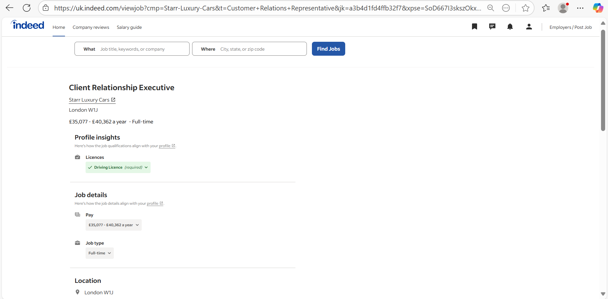

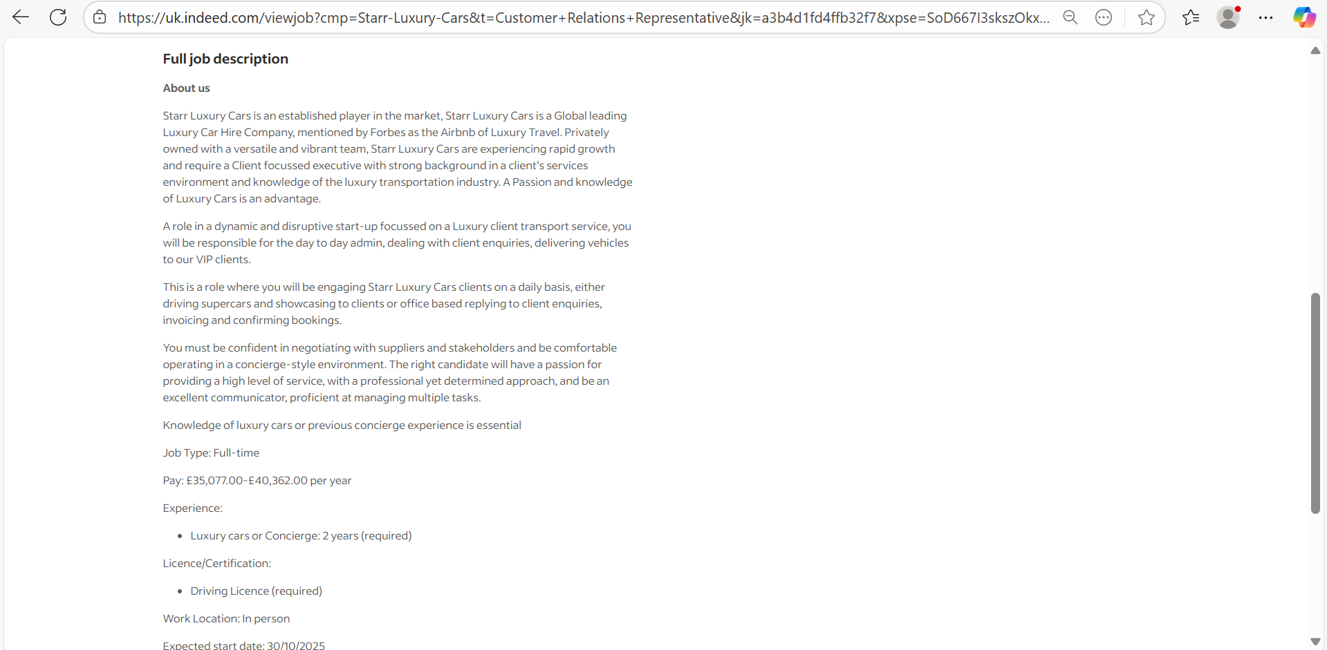

Employability Self-assessment and Personality Test

Please find attached the employability self-assessment and a personality test.


