

Business Skills for the Workplace LEVEL 4

Student Name: Abeer Abdelmagid
Student ID: 2440089
Lecturer’s Name: Fouziya Farheen
Module Code: LCLM4006
Module Name: Enterprise & Entrepreneurship
Component 1: Business plan

Executive Summary
Business name: Aura this name was selected based on the invisible feeling that beautiful tableware settings create around gatherings.
Business type: Retail online first, later possible showroom
Products: Elegant, unique Tableware — tea sets, coffee and tea thermals, serving trays, luxury home items
Target market: Women 25–65 from Arab/Gulf community in the UK who love gathering and
People who like luxury home aesthetics
Value proposition:
Stylish, high-quality Tableware inspired by Gulf elegance but available in the UK without high shipping cost.
Startup budget needed for the business is £5,500 with ROI 45% quarterly.

Contents
Business Overview 4

Legal format 5

PESTEL Analysis 6

SWAT Analysis

Marketing strategies 7

Funding 7

Reference 7

Business Overview
Business name: Aura
Business type: Retail online first, later possible showroom
Products: Elegant, unique Tableware — tea sets, coffee and tea thermals, serving trays, luxury home items
Target market: Women 25–65 from Arab/Gulf community in the UK who value gathering, hosting and like luxury home aesthetics.
Value proposition:
Stylish, high-quality Tableware inspired by Gulf elegance but available in the UK without high shipping cost.
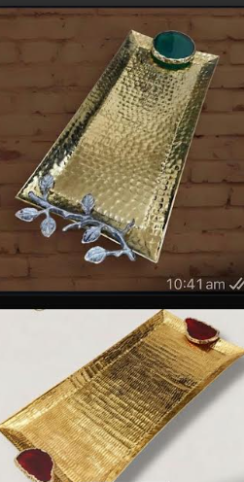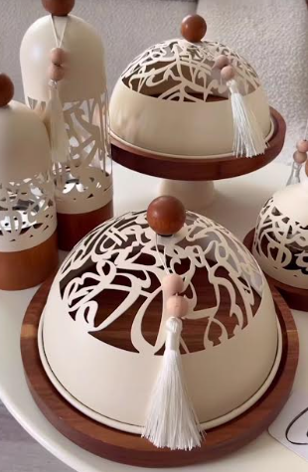

Legal format
Business structure: Private Limited Company (Ltd) and the reason to select this type of legal format is the personal assets are protected and it looks professional to suppliers and banks also in future it is easy to expand and raise finance
The future plans are business name registration and bank account opening

PESTEL Analysis
Political | Economic | Social | Technological | Environmental | Legal
Stable trade environment in the UK & customs duties impact pricing  (Eleni, D., 2024). | Rising cost of living could impact luxury spending and the currency fluctuations impact import prices  (Salah, A.R.M., 2025). | Rise of Arab and Middle Eastern communities in the UK also strong culture of hosting and gifting  (Sobh, R., Belk.,2013). | E-commerce platforms make it easier to enter the market and social media marketing platforms reduce advertising costs also the online payment and delivery infrastructure available  (Kumah, M., 2017). | Customers increasingly demand long-lasting products also the Opportunity to introduce eco-friendly packaging  (Kesa, D.D., 2025). | Must adhere to UK product safety regulations  And Consumer protection and returns policies should apply  (Nottage, L., 2018).

SWOT Analysis

Strengths | Weaknesses | Opportunities | Threats
Luxury brand positioning enables higher profit margins  Also, the Online-first business model keeps overhead costs low | Import dependence impacts stock delivery times and the business requires strong branding to support premium pricing | Rising demand for elegant hosting products.  Wholesale to boutiques and event planners | Competition from low-cost marketplaces like (shin, Timu or Alibaba) also shipping delays or customs duties

Marketing strategies
The global Tableware market size is expected to grow from USD 75.7 billion in 2025 to USD 109.7 billion in 2034 The market is driven by rapid urbanization and lifestyle changes across the globe along with growing hospitality sector. (Global Market Insights Inc. 2025).
Brand Positioning is Aura = Luxury hosting lifestyle brand, not just Tableware, but an experience of luxury and pride in hosting.
Marketing Channels will be through social media (Primary), Instagram product styling videos, Customer testimonials & Hosting inspiration reels.
Customer Experience Strategy is to perceived Aura as a luxury brand by fast response on WhatsApp, elegant product photography and Consistent brand colors & tone.

Funding

Startup Funding Sources

I have two options for business funding either Self-Funding (recommended as start) or get in touch with small business support grant to explore UK small business support schemes through local councils or British business bank initiatives.

For the self-funding, I need approximately £4,000 - £5,500 initial stock investment including product purchase, shipments & marketing for the business.

Item | Cost
Initial stock | 4,000
Shipping/import | 1,000
Packaging & branding | 300
Photos & launch marketing | 200
Total | 5,500
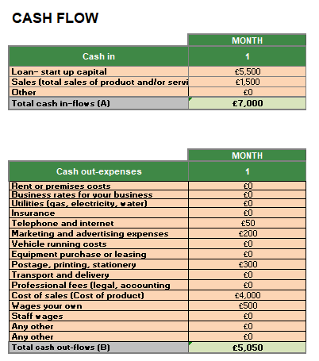

Reference
- McCahery, J.A. and Vermeulen, E.P., 2004. Limited partnership reform in the United Kingdom: A competitive, venture capital oriented business form. European Business Organization Law Review (EBOR), 5(1), pp.61-85.

- Yusop, Z., 2018. PESTEL analysis. Paper persented at COMRAP, pp.34-39.

- Matović, I.M., 2020, September. PESTEL analysis of external environment as a success factor of startup business. In ConScienS conference proceedings (pp. 96-102). Scientia Moralitas Research Institute.

- Khan, I., Ming, J., Ali, M. and Zhang, Z., 2022. Influence of government supports on small and medium enterprises development: Case study of Swat Valley. Journal of small business management, 60(6), pp.1484-1515.

- Soegoto, E.S. and Utomo, A.T., 2019, November. Marketing strategy through social media. In IOP Conference Series: Materials Science and Engineering (Vol. 662, No. 3, p. 032040). IOP Publishing.

- Celestin, M. and Vanitha, N., 2018. How to Fund Your Startup: Innovative Approaches for Aspiring Entrepreneurs. International Journal of Advanced Trends in Engineering and Technology (IJATET), 3(2), pp.43-49.

