
Team Services consultation
Effective Team Working and Communication (BMSW4002_LON)

2020
University of wales trinity saint david
LECTURER: Ms. Magdalena Wronska

Presented by:
Team Shaper Analyst- Ms. Mirela Bors (1920412) – Benefits of team working
Research Investigator- Ms. Aurora Copae (1919900) – Stages of team development
Team Co-Ordinator- Ms. Alexandra Nicut (1919639) – Teams roles / Leadership Roles
Monitor Evaluator- Ms. Maryam Malik (1919971) – Managing conflict
Marketing Specialist- Ms. Mariana Rusnac (1920419) – Successful team development

Introduction

Assuming the scenario of forming a team, Consultation Services ltd is highly recommending the model of Belbin (1981), Tuckman (1965), Thomas and Kilmann (1974), Hersey and Blanchard (1969).
The company is having a history of 5 years in providing consulting services, therefore collaborating with us gives you opportunity to achieve strong relationships, characters and communication which is essential tool for build a successful team (Morgan, 2016).
Please pay attention to the following details that is aiming to create, support, develop and sustain successful team working. Action plan will be exemplified before the conclusion.

The benefits of working in a team are as follows:
- Increase productivity and Quicker solutions
- Allows flexibility and Competitive motivation
- Combines knowledge and skills
- Increase qualitative services
- Promotes integrity, equality and diversity
- Motivates employee morale and confidence
- Faster learning capacity
- Increases creativity
- Establish strong relationships

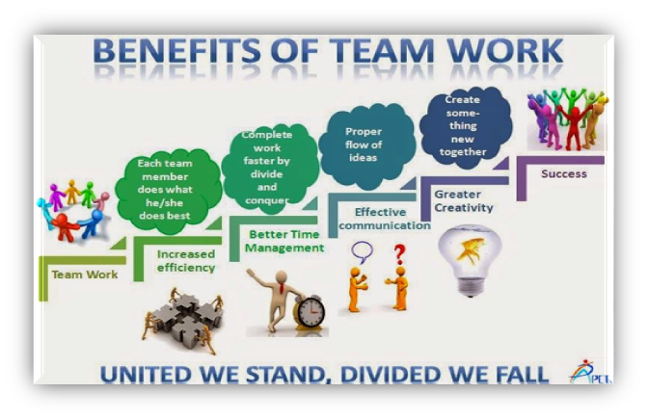
ADVANTAGES – SUKHAMPREET'S BLOG (wordpress.com)

These benefits are meant to empower your team development

Belbin describes: a particular tendency to behave, interrelate and contribute to the teamwork in a particular way (Twardochleb, 2017)
The team development roles and stages recommended by Belbin and Tuckman aims at establishing the roles and responsibilities of the team members according to the desired objective.
While working within a team, the ability of the team members to focus on the same goal despite facing different problem, gets increased (Twardochleb, 2017).
For the organisation, team working benefits are minimising the investment in team development, training, grooming and coaching of the employees (Jones, 2019)

The advantage of working in teams

According the notions developed by Reiter-Palmon (2017). The presence of multiple individuals working together towards finding a solution increases the probability of determining a suitable solution for the problem.
Team working within a business environment increases the scope of competitive motivation that enhances performance quality and level within the organisational framework (Mohanty and Mohanty, 2018).
According to the discussions by Jasinska (2020), the development of synergy within the business environment is dependent on the consistency and cooperation that exists within the teams and members for enhancing operational efficiency.
Notes to remember

The points noted above reflects that there are numerous benefits of teamwork, where the topmost importance being increased productivity and accessible solution to the existing identified problems. Besides, it allows flexibility among the team members, as the motivation and skills of the employees are aligned to the operations of the origination, making the implementation of innovation process easier (Dias et al., 2017).
Moreover, the companies can also achieve cost effective strategies for remaining competitive in the target market. The cash flow increases due to the efficiency, the team competes in the projects and meets the demands of the customers.
In terms of business operations for Team Services Company, the company can be benefitted by teamwork in its operations by the increased motivation of the employees to address the problems of the customers and come up with an effective solution according to the demand.

Stages of team development team building

Team or group development is the technique by which a person is not just only able to perform better but is also able to work cooperatively in the competing changing scenario.
According to Bonebright (2010), Tuckman’s group or team development focuses mainly on two essential points:
- interpersonal relationship
- as well as task responsibilities.
The five important stages of team development help a firm to accomplish various goals and targets in a set time while focusing on the essential points.

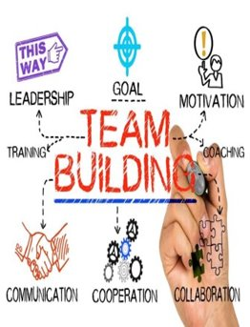This Photo by Unknown is licensed under:"TeamDevelopmentandTeam Building | Accelerate UK"

The 5 stages of team development
Forming is the first team development stage:
  - where a team leader selects its team members and develops rules and values while distributing works among them
  - the team role is to understand each other through behaviour and by following rules
The Storming stage is the stage of:
  - intergroup conflict as the staffs face difficulty in understanding each other
  - and the responsibility is to resolve conflicts and confusions so that the staffs can maximise their productivity (Kirk Lawlor and Allred, 2017).
In Norming stage:
  - group members start developing cohesive relation amongst themselves while learning to respect each other’s views, ideas and tactics
  - the role of team members is to listen and share each other’s ideas, opinions, and views and achieve opportunities to perform well. It is also easier to resolve conflicts as well (Jacobsson and Wilmar, 2019).
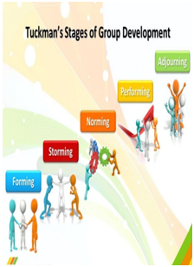
This Photo by Unknown is licensed under:“THE FIVE STAGES OF TEAM DEVELOPMENT” – KID- R- MY BUSINESS (wordpress.com)
Team development stages and
the impact

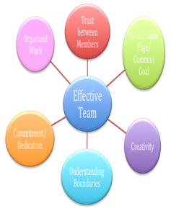
"This Photo by Unknown is licensed under - BUILDING EFFECTIVE TEAMS (weebly.com)"

Performing stage:
The members perform their responsibilities by using right skills, tactics, and information.
Under correct leadership and guidance, the members give their best while resolving problem resulting in successful fulfilment of tasks.
The final or adjourning stage
-the end of the journey,
-after successful fulfilment of tasks, the team role is to conduct self-evaluation, that they can improve and give their best in the future,
-and to discuss about learning experiences (Maund, et al., 2017, p. 12).

The correct execution of interpersonal relationship as well as task responsibilities not only helps to create an effective team but also help to maximises the benefits of team working (Natvig and Stark, 2016).

Challenges of developing team working

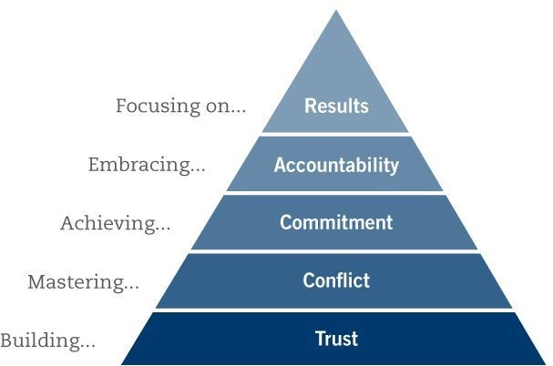
o by Unknown is licensed under Home | The Table Groupwww.pinterest.co.uk

Conflict is the disagreement about a particular matter among two or more people in a group (Rickards and Moger, 2000).
The disagreements start from the forming stage as the members are unknown to each other and continue till storming stage (Lo Coco et al., 2016).
Therefore, it is essential to manage conflicts by taking right initiatives at the right time, leading to the creation of successful team development.
Good leadership with focus on creativity, training and guidance can help the staff to resolve issues and perform better (Lo Coco et al., 2016).
In conclusion, the five important steps of Tuckman’s Team Development help to face any kind of situations by performing well along with developing better relationship.

TTeam roles - Who invented them

Lecturer: Ms. Magdalena Wronska
Student: Alexandra Nicut (1919639)
Module: Effective team working and communication-BMSW4002_LON

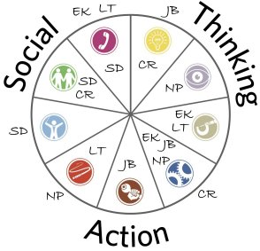

This Photo by Unknown author is licensed under CC BY-SA.

Mr. Meredith Belbin was the first to introduce the world to his theory that inspired team forming, development and encouraged team working. Every team player has a role, and each role has a task to accomplish. Each player uses their skills, but the strength of a team depends on how they combine those skills to become successful (Belbin, 2012, p. 93).

According to Belbin's theory (1981), 8 team roles have been divided into 3 categories:
- Action roles: Shaper, Implementer, Complete-Finisher.
- People roles: Coordinator, Team Worker, Resource investigator
- Thought roles: Plant, Monitor-Evaluator.
However, after doing a more recent research, the “Specialist” role, as part of the cerebral category was successfully implemented according to Belbin (2020).
How to create your team?

The leadership position may be either directive or supportive. The directive behaviour relates to monitoring, giving tasks and instructions followed by how, when and what needs to be done.
The supportive behaviour of the leader includes listening, encouraging, recognising, and communicating based on common respect, warmth, trust, understanding and human contact (Irgens, 1995).
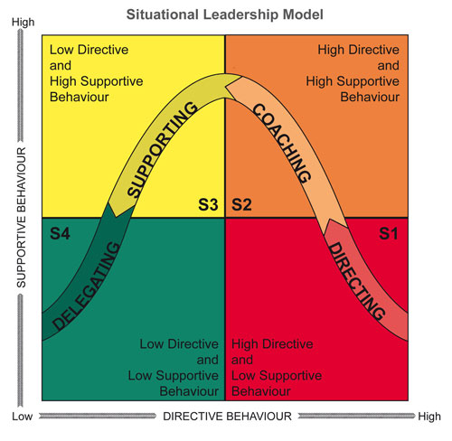
According to Hersey and Blanchard (1982), there are four main leadership categories. Coaching, directing, delegating, and supporting. Therefore, the relationship between the leader and the team players will be correctly directed and the supportive behaviour will decrease considerably, allowing the team to self-conduct while the leader is only monitoring and prepare new tasks ready to be accomplished as a successful team.

This Photo by Unknown author is licensed under CC BY-SA-NC.
Maturity levels and problem solving
Telling, selling, participating, and delegating, as part of the maturity levels, are part of the "normal" process that all teams go through.
Hypothetically if a team is formed with individuals such as dominators, resisters, attention seekers, and avoiders (Mound, et al., 2017, p. 26), would you be able to lead this team?
Different opinions and different perspectives can generate efficient ways towards problem solving and understanding but in the same time skepticism and disappointment (Griffith & Dunham, 2015).
Poor communication or lack of feedback are two of the main issues a team must consider and take appropriate measures to prevent and overcome when they occur. A successful team cannot be completed without training, resources, time management and participation. (Parker and Williams, 2001, p. 81).
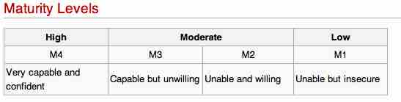

This Photo by Unknown author is licensed under CC BY-SA-NC.

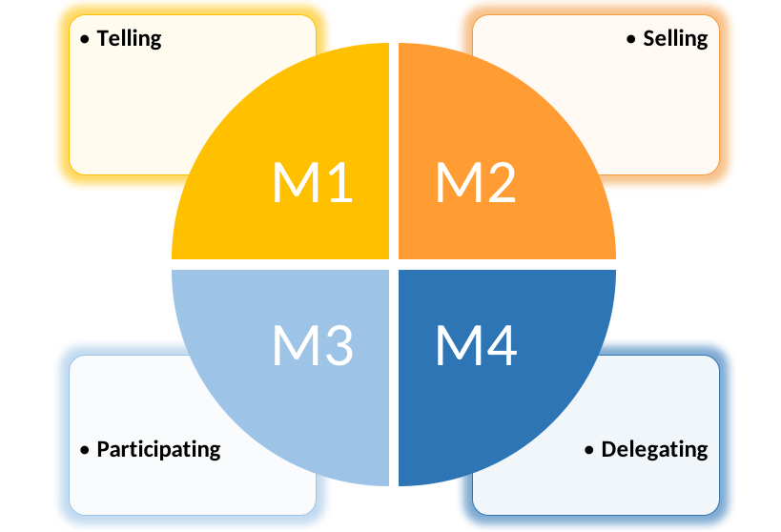

This by Photo Unknown author is licensed under CC BY.

Successful team working example

To prove how much we value our contractors, I have been persuading one of the most worldwide successful company that have been working in teams since the very beginning.
Amazon.com, Inc become a global giant e-commerce in 1994. With financial help of Mr. Jeff Bezos parents, his brother, his sister, friends, and potential investors, to attempt in opening his very first bookshop. Jeff Bezos held over 60 meetings and claimed $50,000 dollars from each one of them (Guardian, 2018).
However, only 22 out of 60 became part of Bezos team and if they kept on to the one percent share, their investments would be worth up to $7 billion dollars each according to South China Morning Post (2020).
The success begins with a construction project, and a team build by professionals from the very first stage of design to the participation and completion, where each professional understood their individual role into the structure of the group (Oke et al., 2016).
Ground rules are meant to set restrictions on the work in progress of development, and these may be different than the rules set outside of these meetings (Lyndas, 2019). A clarification, guidance, and an argumentative start can prevent after repercussions into regards of usual activities and facilitate appreciation of social outcomes and emotional impact (Lyndas and Academy, 2013).
And… do not forget! Communication, listening, and feedback are the key to progress.

Managing Conflict

Conflict is an “interactive state” that express different opinions and disagreement between individuals. Organizational conflicts are more effective if is been managed rather eliminated (Rahim, 1985, p.81).
Managing main factors of conflict
Communication – listening effectively, asking for feedback, sharing information creatively and using non-verbal skills positively.
STRUCTURAL – making sure everyone has equal load of tasks and everyone able to interact with each other effectively by building the right team size (Morgan, 2016).
PERSONAL– manager should be confident with its own belief, must keep full attention to everyone values and needs. Be ready to approach negative situation (Varney, 1989, cited in Works, 2007).
The best solution to successful result of problem solving is mutual respect and willingness to (Weiss,1997):
Listen-Focus on verbal and nonverbal message (Cottrell, 2015, p.135)
Acknowledge-Let them know that you understand them concern
Respond-Agree ore be ready to offer quality alternatives
Resolve differences-Reach agreement using conflict managing mode instrument (Thomas and Kilmann, 1974 cited in Aritzeta, Ayestaran and Swales, 2005)
How to Handle a Disagreement on Your Team

Dealing quickly and openly helps to avoid more complicated situation. Apply mediation skills rather your authority in that way you gain opportunity to approach issue from neutral perspective, therefore it calms atmosphere down and opens possibility to communicate successfully. Make clear that disagreement is harmful to them and the organization in that way both parties has main goal to resolve conflict. By giving opportunity to manage conflict themselves you are allowing them to learn from experience itself, therefore both parties would be able to apply learned skills in the future. Commit towards reaching agreement is very important. Gain understanding of the disagreement in that way you be able to apply the right methods to manage conflict. Use empathy instead of sympathy for example you may say I understand your feelings instead I am sorry that you feel in that way. Set some ground rules by making sure that both parties have opportunity to express them self without anyone interruption. Be ready to act as a boss for the best interest of the organization as in some situations that is the only way to manage conflict (Brett and Goldberg, 2017).

The Thomas-Kilmann Conflict Mode Instrument

Assertiveness:
Ability to stand your ground and share your ideas effectively (Maund, Schriek and Tinkler, 2017, p. 55). COMPETING – apply your own ideas with no concern to cooperate. Avoiding – you may decide to step back and ignore the proposition.
Compromising – A good short-term solution to get to equal level
Cooperativeness:
Pleasing and attempting to satisfy others. Accommodating – it is a good choice consider others have a better solution. Collaborating – working together effectively and meaningfully (Thomas and Kilmann, 1974 cited in CPP, 2007).

High
CCOMPETING
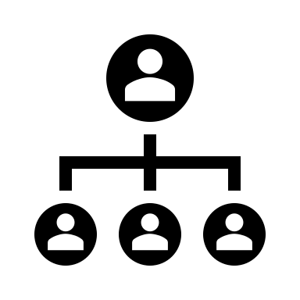
COLLABORATING



Assertiveness

COMPROMISING
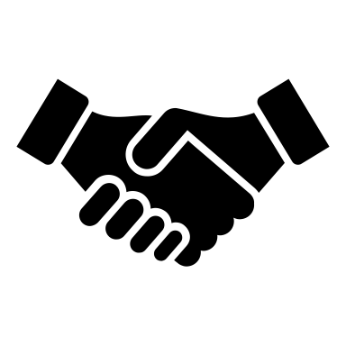

Igno
ring
AVOIDING


ACCOMMODATING

Low High
Cooperativeness

Successful Team Development

The steps in building an effective team are the following:
- Clear goals
- Relevant skills
- Mutual trust
- Unified commitment
- Good communication
- Negotiation skills
- Conflict management
- Internal and external support
- Leadership
- Company culture
(Genc, 2019)

Conditions for team success

For the optimal performance of the team these three elements must present:
- Trust among members, as Lencioni (2002) points out it is necessary for effective team functioning. Without it, problems such lack of commitment, avoidance of accountability and inattention raise. In a team, trust is related to each member capacity to perform their task and be benevolence toward others.
- A sense of team identity: unique norms, values, and characteristics can be built over time and these elements impact the performance.
- A sense of group efficacy, positive mindset and believing in the end goal motivate the members' work. Motivational quotes can help with it too.
(Druskat and Wolff, 2001, cited in Maund et al., 2017, pp. 8-10).

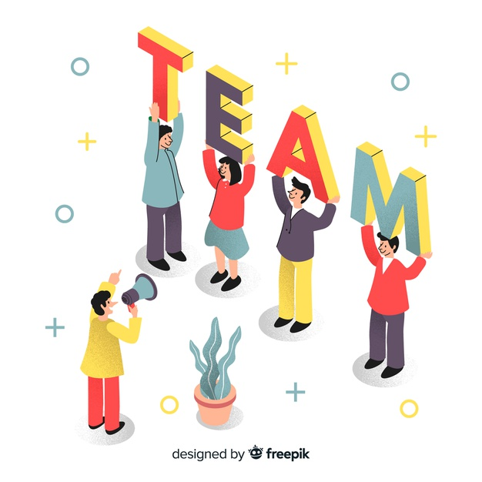
Why Teams Fails
There are several reasons why a team might not succeed, some of these are:
- Private agendas and mismatched needs, this happens when individual wishes do not match the team's end goal.
- Confused and cluttered goals, which can be too generics and create agitation among members.
- Confusing roles, two people with different points of view can have the same role.
- Bad leadership, the leader might not provide any goals, not engage in the process, and contradict himself.
- Lack of feedback, there is no reflection on past performances, so the team does not progress.
- Lack of tools and/or support, there are not enough resources and help when needed
(Robins and Finley, 1998, cited in Morgan, 2016, pp. 213- 214).



Diversity and Inclusion Build High-Performance Teams
According to Sakpal (2019), teams with diverse and inclusive culture are more productive than homogeneous ones.
- They have a lot of cognitive diversity, which represents thinking styles, habits, and prospects.
- Employees perform better by 12% in a diverse organization.
- Due to the variety of cultures present within it, the organization has a better understanding of customers' needs.
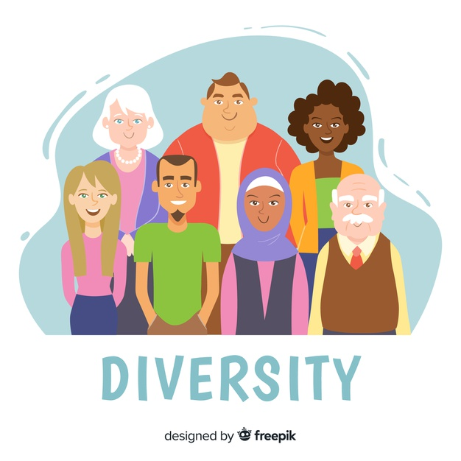

References
Aritzeta, A. Ayestaran, S. and Swales, S. (2005) ‘Team Role Preference and Conflict Management Styles’, The International Journal of Conflict Management, 16(2), pp. 157-182. Available at:
https://www.researchgate.net/profile/Stephen_Swailes/publication/228860172_Team_role_preference_and_conflict_management_styles/links/0c96052c1a15af3d6e000000/Team-role-preference-and-conflict-management-styles.pdf (Accessed: 29 November 2020).
Belbin, R. M. (1981) Management Teams-Why they Succeed or Fail. Oxford: Butterworth-Heinemann
Belbin, (2020) Belbin. [Online]
Available at: https://www.belbin.com/about/belbin-team-roles/ (Accessed: 19 November 2020).
Belbin, M. (2012) Team Roles at Work. In: Team Roles at Work. Routledge: Meredith Belbin, p. 93.
Griffith, B. A. & Dunham, E. B. (2015) WORKING in TEAMS Moving to High Potential to High Performance. London: SAGE Publications Ltd.
Bonebright, D.A. (2010) 40 years of storming: a historical review of Tuckman's model of small group development. Human Resource Development International, 13(1), pp.111-120.
Brett, J. and Goldberg, B.S. (2017) ‘How to Handle a Disagreement on Your Team’, Harvard Business Review, 10th July. Available at: https://hbr.org/2017/07/how-to-handle-a-disagreement-on-your-team (Accessed: 25 November 2020).
Cottrell, S. (2015) Skills for Success: Personal Development and Employability. 3rd edn. Hampshire: Palgrave MacMillan.
CPP, Inc. (2007) Thomas-Kilmann Conflict Mode Instrument Profile and Interpretive Report. Available at:
https://kilmanndiagnostics.com/wp-content/uploads/2018/03/TKI_Sample_Report.pdf (Accessed: 2 December 2020).
Dias, C.P., Ferreira, F.L. and de Carvalho, V.P. (2017) The importance of teamwork in patient air transportation. International Journal of Palliative Nursing, 11(6), pp.2408-2414. Available at: https://periodicos.ufpe.br/revistas/revistaenfermagem/article/download/23404/19068 (Accessed: 10 November 2020).
Genc, H. (2019)10 Features of Successful Teams. Available at: https://www.linkedin.com/pulse/10-features-successful-teams-hande-genc/ (Accessed: 15 November 2020).
Griffith, B. A. & Dunham, E. B. (2015) WORKING in TEAMS Moving to High Potential to High Performance. London: SAGE Publications Ltd.
Guardian, T. (2018) South China Morning Post. [Online]
Available at: https://www.scmp.com/news/world/united-states-canada/article/2143375/1994-he-convinced-22-family-and-friends-each-pay (Accessed: 23 November 2020).
Hersey, P. and Blanchard, K. H. (1969) Management of Organizational Behavior-Utilizing Human Resources. New Jersey, Prentice Hall
Irgens, O. M. (1995) Leadership & Organization Development Journal. Situational leadership: A modification Hersey and Blanchard. Leadership & Organization Development Journal, 16(2), p. 36.
Jacobsson, C. and Wilmar, M. (2019) Group processes–the links between team climate inventory and group development questionnaire. Clin Exp Psychol, 5, pp.1-4.
Jasinska, M. (2020) Synergy-an enhancement of learning organizational undergoing a change. Entrepreneurship and Sustainability Issues, 7(3), pp.1902-1920.
Jones, D. (2019) The Tuckman’s Model Implementation, Effect, and Analysis & the New Development of Jones LSI Model on a Small Group. Journal of Management, 6(4). Available at: https://papers.ssrn.com/sol3/papers.cfm?abstract_id=3525281 (Accessed: 10 November 2020).
Kirk-Lawlor, N. and Allred, S. (2017) Group development and integration in a cross-disciplinary and intercultural research team. Environmental management, 59(4), pp.665-683.
Lencioni, P. (2002) The Five Dysfunctions Of A Team. San Francisco: Jossey-Bass.
Lo Coco, G. et al. (2016) Group relationships in early and late sessions and improvement in interpersonal problems. Journal of Counseling Psychology, 63(4), p.419.
Lyndas, K. (2019) NHS Leadership Academy. [Online] Available at: https://www.leadershipacademy.nhs.uk/wp-content/uploads/2013/04/7428f23d7207f39da1eda97adbd7bf34.pdf (Accessed: 24 November 2020).
Maund, A., Schriek, M. and Tinkler, P. K. (2017) Certificate in Higher Education: Skills for the Workplace Student Yearbook. London: Sage Publications
Mohanty, A. and Mohanty, S. (2018) The impact of communication and group dynamics on teamwork effectiveness: The case of service sector organisations. Academy of Strategic Management Journal, 17(4), pp.1-14. Available at: https://www.abacademies.org/articles/The-impact-of-communication-and-group-dynamics-1939-6104-17-4-251.pdf (Accessed: 9 November 2020).
Morgan, P. (2016) The Business Student’s Guide to Study and Employability. 1st Ed. London: Sage Publications
Natvig, D. and Stark, N.L. (2016) A project team analysis using Tuckman's model of small-group development. Journal of Nursing Education, 55(12), pp.675-681.
Ogbonnaya, C., Tillman, C.J. and Gonzalez, K. (2018) Perceived organizational support in health care: The importance of teamwork and training for employee well-being and patient satisfaction. Group & Organization Management, 43(3), pp.475-503. Available at: https://journals.sagepub.com/doi/abs/10.1177/1059601118767244 (Accessed: 10 November 2020).
Oke, A. E. et al. (2016) ‘Importance of Team Roles Composition To Success of Construction Projects.’, International Journal of Construction Project Management.
Parker, S. K. and Williams, H. M. (2001)‘Effective Teamworking: reducing the psychosocial risks.
Rahim, A.M. (1985) ‘A strategy for managing conflict in complex organisations’, Human Relations, 38(1), Western Kentucky University. Available at: https://www.researchgate.net/profile/M_Rahim5/publication/247716433_A_Strategy_for_Managing_Conflict_in_Complex_Organizations/links/55eae38108ae21d099c4fe31/A-Strategy-for-Managing-Conflict-in-Complex-Organizations.pdf (Accessed: 27 November 2020).
Reiter-Palmon, R. ed. (2017) Team creativity and innovation. Oxford University Press.
Rickards, T. and Moger, S. (2000) Creative leadership processes in project team development: an alternative to Tuckman's stage model. British journal of Management, 11(4), pp.273-283.
Sakpal, M. (2019) Diversity and Inclusion Build High-performance Teams. Available at: https://www.gartner.com/smarterwithgartner/diversity-and-inclusion-build-high-performance-teams/ (Accessed: 15th November 2020)
Thomas, K. M. and Kilmann, R. H. (1974) The Thomas-Kilmann conflict Mode Instrument. Mountain View, CA: CPP
Tuckman, B. W. (1965) ‘Developmental Sequence in Small Groups’, Psychological Bulleting 6.
Twardochleb, M. (2017) Optimal selection of team members according to Belbin’s theory. ZeszytyNaukoweAkademiiMorskiej w Szczecinie. Available at: http://yadda.icm.edu.pl/baztech/element/bwmeta1.element.baztech-57af0722-4cb4-4369-8bdb-996db8bb84cc (Accessed: 10 November 2020).
Varney, G. H. (1989) Building productive teams: An action guide and resource book. San Francisco, CA: Josey-Bass
Weiss, D.H. (1997) Four steps for managing team storm. Getting Results For The Hand-on Manager, 42 (7), 7.
Works, T.B.T. (2007) Resolving Conflict in Work Teams [blog]. 25 September. Available at:
https://kontemplator.wordpress.com/2007/09/25/resolving-conflict-in-work-teams/ (Accessed: 5 December 2020).

