Module Name: Strategic Management and Sustainability
Module Code: LCBB6004_BIRM
Student Name: Gabriela Szkutnik
Student ID: 2130794
Executive Summary
The respective report has examined the strategic business process and plan in the context of the well-known retail brand in the UK named Lidl. Strategic management plays an indispensable role for a business in terms of staying competitive in the rapidly changing market. The formulation and successful incorporation of strategic management is effective for the business to gain long-term success and survive in the competitive marketplace. The following report has elevated the business overview of Lidl including a number of stores, operations, employee size and offerings. Additionally, the key objectives, vision, and mission statement of this firm have been stated here. The current sales growth, revenue and profit margin of Lidl GB have been also included here. Porter’s five forces have been conducted to analyse the external environment of the organisation. SWOT Analysis, VRIO framework, BGC matrix and value chain analysis have been conducted to elaborate on the internal environment of Lidl. These frameworks are used to explain the different internal factors that influence the internal environment. The strategic choices have been mentioned in the report for being responsive towards current scenarios of the business. Increased online appearance has been identified in the report to address the online business advantages. Along with that, the report has covered effective strategies for Lidl based on an analysis of the Blue Ocean Strategy. Recommendations like conducting career development programmes and effective supply chain management have been provided to deal with the current issues in the organisation.

Table of Contents
Introduction to the Strategy 4
Overview of the chosen firm named Lidl 5
Strategic Intent 6
The current performance of the selected company 7
Strategy Analysis, the selected company's competitive environment analysis 9
A. External Environmental Audit using Porter’s 5 Forces 9
B. Internal Environmental Audit 10
Strategy Formulation 15
Conclusion and Recommendation 17
References 18

Introduction to the Strategy
Strategic management is defined as the procedure of formulating, incorporating, evaluating as well as improvising proper plans so that an organisation can achieve its goals and objectives. This business practice is important for the modern organisation to create a competitive advantage, improve efficiency and performance and drive the business towards long-term sustainability. Strategic management plays a significant role in the businesses to allocate resources optimally on the basis of priorities. It allows firms to analyse their current performances and implement ways to improvise. The entire organisational performance of a firm can be improved by developing strategic plans. It includes forecasting market trends, enhancing employee engagement and motivation, and preparing cost-cutting strategies. An organisation is able to set clear goals, make informed decisions and adapt to changes effectively through implementing proper strategic road maps. It enables the venture to clarify its vision and mission and supports it to reach its goals successfully. Strategic management can protect businesses from uncertainties, and financial risks as well because this business practice is aligned with optimal investment. Digital workplace transformation is one of the notable examples of strategic management for a firm in recent times. Successful adoption of innovative technologies allows businesses like Lidl to meet customer demands and expectations through managing operations and integrating new and quality processes. The respective report will state a brief organisational overview of Lidl. Besides that, its strategic mission, vision, and objectives along with the current performance of the business will be discussed here. The strategic analysis of the external and internal environment of Lidl will be highlighted here. Furthermore, the report will mention the strategic choices of the chosen company and propose a new strategy as well for the long-term growth of the business.

Overview of the chosen firm named Lidl
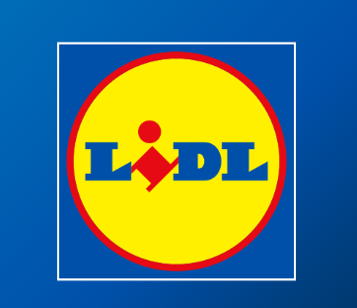
Source: (lidl, 2024)
Lidl started its operations in Germany in 1973 by employing around three employees and stocking 500 products. The first ten Lidl British shops were established in November 1994 and currently, it has around 960 stores as well as 14 regional distribution stores across the UK. The respective retail company has employed around 31,000 people to provide better quality customer service. In 2008, this organisation became the UK's leading retailer because of expanding the number of its British Stores. The current 960 stores of Lidl are situated in Scotland, England and Wales. The market share of this retail brand within the UK is around 8.1%. The regional distribution centres of Lidl are focused on delivering fresh quality foods across different cities in Britain (lidl, 2024). The key purpose of Lidl GB is to provide the highest quality and fresh frozen foods, vegetables, fruits, meat, seafood and bakery items at the lowest price range. Apart from that, the GB stores of Lidl are aimed at working with British suppliers and farmers ensuring local sourcing of their products. Lidl ensures more than two-thirds of the food items that are primarily sourced from local suppliers in Britain. The best offerings, quality of the products at affordable prices and sustainable initiatives have made Lidl become the top food retailer across Europe (Hellström and Danmyr, 2023).

Strategic Intent
Vision: The vision statement of Lidl is focused on being the best value retail brand in Europe, providing people with better standard quality products at reasonable prices. It is passionate about maintaining its efficiency, sustainability and simplicity while gradually developing its offerings (Scott and Fridenson, 2021).
Mission: The mission statement of Lidl is to offer its customers with best value and great quality products by operating its business in an effective, sustainable and simple way.
Objectives:
Customer-centric approach- The respective retail aims to improve the shopping experience by enhancing the store networks, ensuring stores are well-stocked and improving the customer service process.
Cost-effective and high-quality products- The objective of Lidl is to deliver fresh and high-quality products at low cost to appeal to price-sensitive customers.
Sustainability Commitment- To boost sustainability efforts by sourcing products from local suppliers, reducing waste and promoting eco-friendly products (Jones and Comfort, 2022).
Operational efficiency- To maintain cost-efficiency and simplicity in the business process to provide low-priced products to a wide range of customers.
Expansion and growth- To expand the market share by opening more stores across Britain while increasing the number of regional distribution centres and logistics.

The current performance of the selected company
The current performance of Lidl GB is expressed by the significant growth and good market presence. In 2024, the particular company captured around 8.1% of the market share accounting for around 9.4% significant growth in sales volume. The reasons behind it are incentivising buyers with more discounts and competitive pricing. In 2021, the net profit of Lidl GB operators was recorded as around £9.8 million before taxes. The entry of this retailer in the UK market indicates continuous success. The marketing campaign of this organisation is How Lidl grew a lot in 2014-2017 has become well-known and supported the business to achieve financial success within the competitive market.
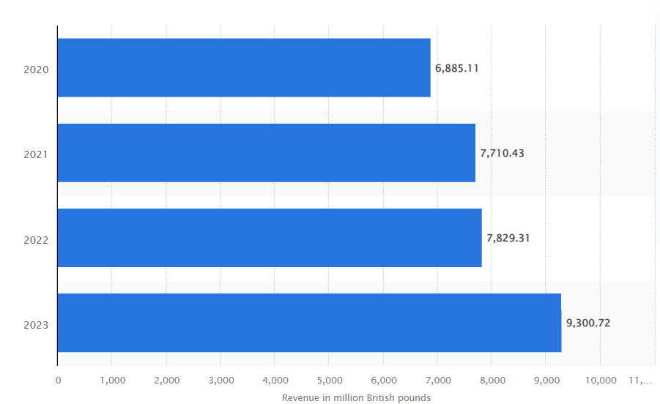
Figure: Revenue growth of Lidl for 2020-2023
Source: (Bedford, 2023)
The respective statistic showcases the revenue margin of Lidl GB between 2020 and 2023. It has made revenue of around £9.8 billion in FY2023 which was 18.8% more than the past year. In 2023, the company has opened around 50 new stores and has captured the attention of around 1.4 million loyal customers. Whereas, the revenue figure of this company was £6.88 billion in 2020 and this value has risen significantly since the pandemic. The reason is the company has undertaken major changes in its previous business strategy in the UK. The high sales record of Lidl during the initial month of 2023 was 26% which decreased by 15.2% in October 2023. It has been recognised as the 6th largest grocery store in the British food retail market with a market worth of 7.7% in that year. The significant rise in sales volume and income level of Lidl GB signifies the sustainable growth of this business in Great Britain (Bedford, 2024).

Strategy Analysis, the selected company's competitive environment analysis

A. External Environmental Audit using Porter’s 5 Forces
Porter’s five will be used to analyse the external environment of the company Lidl.
Competitive Rivalry: The competitive rivalry of the company Lidl is quite moderate in the country. Lidl faces competition from Sainsbury, Asda, Tesco and Morrisons. The competition is quite moderate as the company is famous for producing budget friendly products (lidl, 2023). The price of the products of Lidl is quite cheaper than its competitive companies. The company faces its competitive rivalry from the perspective of market share.
Potential for new entrants: Lidl is a successful grocery wholesaler supermarket chain in the United Kingdom that offers consumers with a wide range of products and services under one roof. The potential for new entrants to this company is thus, low. If any company enters into this industry, the company have to be successful to attract customers to its entity.
Supplier Power: The supplier power of Lidl is quite moderate as it has a strong supplier power in the entity. The suppliers of Lidl commit to producing top-quality products for the organisation. Being a supermarket chain in the industry, Lidl has limited suppliers in the entity (lidl, 2024). It is one of the most successful supermarket chains in the industry, thus, the supplier chain of the company is quite moderate.
Customer Power: The customer power of the company is also quite high. Lidl is a successful supermarket chain in the United Kingdom. It is the preference of the customer for this brand that makes this company so successful throughout the decades. The company aims to provide simple and transparent services to the targeted customers (lidl, 2024). Lidl has a strong base of customer loyalty and thus they have high power over the brands.
Threat of Substitutes: The threat of substitutes for Lidl is high in the UK since they provide homogenous products. It is high as the brand produces many similar products that are produced by other companies. If the company fails to provide quality products, customers will choose the other products that are available in the industry. Customers can easily switch to using other products if these company fails to satisfy its customers.

B. Internal Environmental Audit
SWOT analysis
Strengths | Weaknesses
Producing Products at a cheaper price: The products that are produced by Lidl are produced at a much cheaper price (lidl, 2022). Lidl is famous for its low prices and high-quality end products.  Customer Loyalty: The company have one of the strong brand loyalty in the entity. Customers often choose this company as their day-to-day market to purchase their food products from the shop. Thus, customer loyalty stands as one of the strengths of Lidl. | Slow Adaptation of Technology: Lidl is very slow in terms of adapting to technology. This stands as a weakness of the company as it lacked the company to gain a competitive advantage in the international market.  Restricted flow of Products: The company have a restricted flow of diverse product ranges in the entity (lidl, 2024). This stands as a weakness of this company. A limited flow of products has restricted the growth of the company.
Opportunities | Threats
Expansion of the market: Due to the above-mentioned strengths, Lidl can expand its markets into new regions. Lidl will also have the opportunity to expand its growth in the regions.  Enhancing the strategic management: Enhancing the strategic management of the entity will enhance its growth of the entity. Thus, this stands as an opportunity for the new company. | Restricting the growth of the company: The company can restrict its growth due to its marginal profit margins in the entity (Ilgar, 2023). This will significantly affect the growth of the entity.  High competition in the Economy: The brand has a wide number of competitors in the economy who offer similar products and services. Thus, with their high investment in their marketing activities, the brand will struggle to meet the competition.

VRIO Framework
Resources | Value | Rarity | Inimitability | Organisation | Impact of Competitive Advantage
Products | Yes | No | yes | yes | Competitive Parity
Brand Logo | Yes | Yes | No | Yes | Sustainable Competitive Advantage
Online Presence | Yes | No | Yes | Yes | Temporary competitive advantage

Analysis
The VRIO Framework is conducted to analyse the internal environment of the company. The products create an impact of a competitive advantage on the company. The brand logo represents a sustainable competitive advantage on Lidl. The online presence of the brand impacts a temporary competitive advantage. Thus, the VRIO framework has helped to analyse the different internal environments of the company.

BCG Matrix
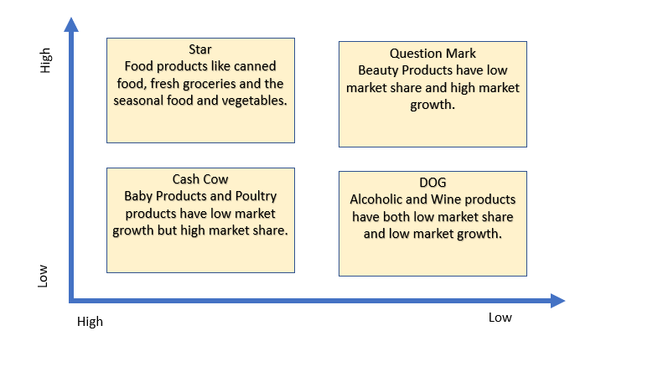
Source: Author

Value Chain
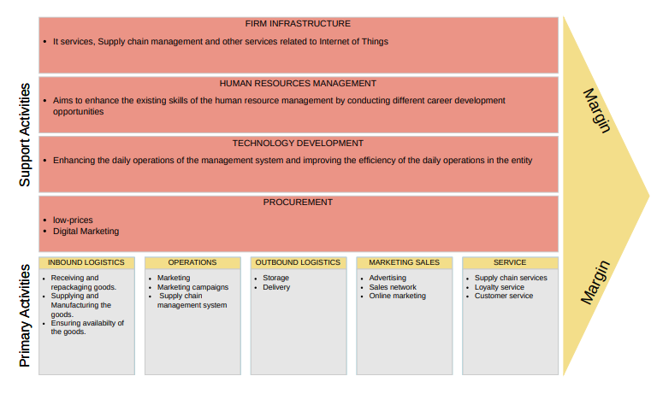Source: Author
The analysis of the value chain has been conducted to understand the internal environment of Lidl. Different primary and secondary activities have been analysed to elaborate on the internal environment of the company. The secondary activities have been discussed through the firm infrastructure, human resource management and the technological development of the entity. The inbound logistics, operations, outbound logistics and marketing sales are elaborated on Lidl.

Strategy Formulation
Strategic choices for Lidl
Strengthen online presence
Lidl focuses on its online presence for reaching a broader audience. Due to this, the company has developed their IT infrastructure as well as boosted its digital strategies for improving the efficiency of regular operations. Lidl can invest in its digitalisation approach which can help the company to advertise on diverse online platforms for attracting their customers. The company takes diverse initiatives to facilitate the customer's excellent experience of shopping. Customers of this modern world highly prefer online shopping and this trend insists every retail business to develop the scenarios of their online presence (Dolega et al., 2021). Digital marketing including social media marketing, and SEO are explored by Lidl to improve its digital presence. However, Lidl offer discounts on their products as a set of retail companies exists in the market with their exclusive offering in the e-commerce sites.
Market penetration
As per the Ansoff Matrix, Market penetration can be a strategic choice for the retail brand. Lidl can expand their brand in diverse destinations for addressing the issue in the UK market. Market penetration allows this company to dominate the existing market along with capturing the larger market share (Egan-Wyer et al., 2021). It can be beneficial for businesses to enter in a new market that enables the company to develop its sales along with strengthening its revenue. Market penetration can be a strategic choice for Lidl to get opportunities to merge along with acquisition. Due to this, the company mitigates the risk factors that ensure the business development of this company. Lidl uses diverse marketing campaigns for sending a consistent message regarding its effective marketing channels. Along with that, the company has adopted the strategy of omnichannel that facilitates Lidl to provide a seamless experience of shopping.
Recommended strategy for Lidl
Value innovation can be an effective strategy for Lidl to pursue differentiation along with low cost that creates value for a business and its customers. This strategy can be beneficial for Lidl for accelerating the high value of the service at a lower cost. As per the Blue Ocean Strategy, value innovation involves in creation of new demand by focusing on the uncontested space in the market. Lidl needs to follow the ethics of the Blue Ocean strategy that can facilitate the company to achieve profitability along with high growth. It can be achieved by redefining the boundaries of the market instead of battling with competitors. Initially, Lidl needs to cut down on the features that offer little concern and value to the customer while competitors provide more facilities (Parnell, 2024). Along with that, the company can increase the elements that offer more value as well as introduce exclusive features. However, Lidl can identify the market scenarios and demand that can be addressed by their product differentiation. The company needs to develop their products by modifying the products. Based on this context, Lidl needs to adopt a strategic plan and goal that needs to be aligned with employees, business partners and clients. It will be facilitated for the company to expand their business along with function in diverse regions by overcoming all the challenges.

Conclusion and Recommendation
This report has critically evaluated and analysed the company Lidl. The report has explained the concept of strategic management. The importance of strategic management in Lidl has been elaborated in the report. Strategic intents like the mission, vision and sustainable commitment of Lidl have also been highlighted. The current performance of Lidl with the relevant data has been provided in the report. Strategic choices and a new strategy for Lidl have been discussed in the report. Porter’s five forces have been analysed to understand the external forces of the company. SWOT Analysis, VRIO, BCG and Value chain have been analysed to elaborate on the internal factors of Lidl.
Recommendations:
Conducting career development programmes: Career development programmes should be conducted by the company to engage the employees in the entity. Career development programmes will also help the organisation adapt to the latest technologies in the entity ( Laurinavicius & Main, 2024). Employees would be trained so that they can adapt to technologies that will help the company run their operations more smoothly.
Effective supply chain management: Effective supply chain management in the entity will help the company deal with the limited products in the entity. It will also help the entity attract customers to the entity, thus, enhancing the growth of Lidl. Thus, effective supply chain management will help the company deal with the lack of products in the entity.

References
Bedford, E., (2023). Revenue of Lidl in Great Britain (GB) from 2020 to 2023 (in million GBP)*. [Online] Available at: https://www.statista.com/statistics/919806/lidl-turnover-in-the-united-kingdom/#:~:text=Revenue%20of%20Lidl%20in%20GB%202020%2D2023&text=In%20the%20financial%20year%20ending,around%206.88%20billion%20British%20pounds. [Accessed 7 October 2024].
Bedford, E., (2024). Percentage change in sales at Lidl in Great Britain compared to a year earlier from March 2014 to October 2023. [Online] Available at: https://www.statista.com/statistics/386773/lidl-sales-percentage-change-great-britain-uk/ [Accessed 7 October 2024].
Dolega, L., Reynolds, J., Singleton, A. and Pavlis, M., (2021). Beyond retail: New ways of classifying UK shopping and consumption spaces. Environment and Planning B: Urban Analytics and City Science, 48(1), pp.132-150.
Egan-Wyer, C.J., Burt, S., Hultman, J., Johansson, U., Beckman, A. and Michélsen, C., (2021). Ease or excitement? Exploring how concept stores contribute to a retail portfolio. International Journal of Retail & Distribution Management, 49(7), pp.1025-1044.
Hellström, D. and Danmyr, D., (2023). Closed Loop Supply Chains: A qualitative study of the Swedish food retail industry.
Ilgar, O., (2023). How The Evolving Supply Chain Affects Worldwide Business Models And Economies. [Online] Available at: https://www.forbes.com/sites/sap/2023/04/28/how-the-evolving-supply-chain-affects-worldwide-business-models-and-economies/ [Accessed 08 October 2024].
Jones, P. and Comfort, D., (2022). Animal Welfare and major food retailers. Athens journal of business & economics, 8(1), pp.9-20.
Laurinavicius, T. & Main, K., (2024). Employee Development Plan: How To Guide & Template. [Online] Available at: https://www.forbes.com/advisor/business/employee-development-plan/ [Accessed 08 October 2024].
lidl, (2022). A LIDL BIT LESS! LIDL SCORES HAT TRICK AS IT’S NAMED CHEAPEST SUPERMARKET FOR THIRD TIME IN A ROW. [Online] Available at: https://corporate.lidl.co.uk/media-centre/pressreleases/2022/grocer33 [Accessed 08 October 2023].
lidl, (2023). UK’S MOST POPULAR SUPERMARKET REVEALED – AND IT’S ALSO A LIDL BIT CHEAPER THAN RIVALS. [Online] Available at: https://corporate.lidl.co.uk/media-centre/pressreleases/2023/grocer-super-33-september#:~:text=Scoring%2079%20per%20cent%2C%20it,including%20fresh%20fruit%20and%20veg [Accessed 08 October 2024].
lidl, (2024). About Lidl GB. [Online] Available at: https://corporate.lidl.co.uk/ [Accessed 6 October 2024].
lidl, (2024). Buying Policy Raw Materials. [Online] Available at: file:///C:/Users/lenovo/Downloads/Buying%20Policy%20Raw%20Materials%202024_FINAL.pdf [Accessed 08 October 2024].
lidl, (2024). LIDL REVEALED AS UK’S MOST TRUSTWORTHY SUPERMARKET. [Online] Available at: https://corporate.lidl.co.uk/media-centre/pressreleases/2023/lidl-retail-trust-index [Accessed 08 October 2024].
lidl, (2024). Supplier Information. [Online] Available at: https://corporate.lidl.co.uk/supplier-information [Accessed 2024 October 2024].
Parnell, S., (2024). How To Leverage Blue Ocean Strategy For Explosive Growth. [Online] Available at: https://www.forbes.com/councils/forbesagencycouncil/2024/05/17/how-to-leverage-blue-ocean-strategy-for-explosive-growth/ [Accessed 9 October 2024].
Scott, P. and Fridenson, P., (2021). Introduction: New perspectives on 20th-century European retailing. In New Perspectives on 20th Century European Retailing (pp. 1-18). Routledge.

