Can we blame the increase of radicalisation on the breakdown of the ‘traditional’ family unit, especially when there is an absent male role model?

https://alphabetformation.files.wordpress.com/2016/05/stamp-alphabet.jpg?w=402&h=178
 This blog is informed by my recent attendance at the Prevent Awareness Training. During the training I noticed a pattern emerging during the presentation; that many of the young men who became radicalised were from families where their parents had separated, and their fathers were absent from the home.

The United Nations Development Programme (UNDP) published a report in 2016 which acknowledged the recent wave of violent extremism; groups which glorified their extreme ideologies whether they are religious, ethnic or political, and with no regard to tolerance or inclusivity.
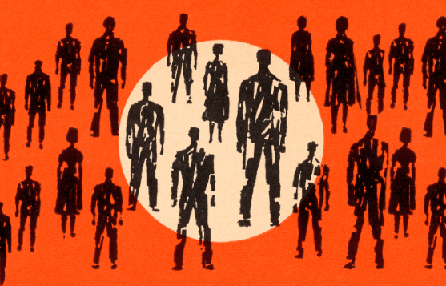

https://www.flicklearning.com/blog/what-is-radicalisation-why-do-i-need-to-know
Firstly, children and young people can be vulnerable during their informative years; particularly during adolescence, some identified this period as being from the age of 11 (Erikson, 1968). It is a phase of life stretching from childhood to adulthood.
Childhood Adolescence

Steinberg (2005) describes adolescence as a time when vulnerability is heightened; due to the disconnectedness between the developing brain, behavioural and cognitive systems. Erikson (2005) labelled this period as Identity versus role confusion; it is a time when a young person is more likely to be influenced by their peer group and question who they are, what is their role in society, their sexuality and their identity in general which, it could be argued, will be affected by their culture, ethnicity, or religion. Therefore, it could be argued that because of this period of questioning they are more at risk of being marginalised and have feelings of isolation; which some argue makes them more vulnerable to being radicalised. Adolescence can be also seen as a time of increased risk; should they be allowed to experiment, have strong views and challenge ideas? Steinberg explains that in the adolescence brain there are ‘regions and systems that are key to the regulation of behaviour and emotion and to the perception and evaluation of risk and reward’ (2005, p. 1).
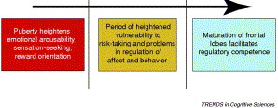
(Steinberg, 2005)

Secondly, currently in the UK there are 1.8 million single parents with 90% of these being women, according to the Office of National Statistics (ONS) (2019). ONS report that 53% of these families have one child, 32.1% have two and 13% have three or more children (2019). However, these figures do not represent families where there has been a breakdown in the relationship and have become single parent families, but it is estimated that nearly half of them were born when their parent was in a relationship (ONS, 2019).

There is much interest about the impact that separation and single parent families has on children and young people. According to Amato (2010) children whose parents have divorced ‘score lower on a variety of emotional, behavioural, social, health and academic outcomes’ than children of continuously married couples (p. 653). Evidence that children or young people can experience negative outcomes in these new family configurations. However, Benson and McKay (2017) argue that parental conflict is an insufficient explanation for the prevalence of teenage problems. Teicher et al. (2016, cited in Public Health Wales, p. 35, 2019) argue that experiences during ‘childhood impact on the structure of the developing brain’, and are a major influence for ‘psychological and social processes and the ‘balance of control between rational and emotional behaviour’. Pechtel and Pizzagalli (2011) argue that children who are exposed to violence, abuse and other forms of chronic stress and trauma experience problems regulating emotions and managing social interactions, as well as adverse impacts on cognition, memory and learning.
So far, the evidence identifies the vulnerability of children and young people during adolescence and the impact from the breakdown of parental relationships. So now let’s look at what happens to those young people who do not interact with their fathers.

(Canada, no date)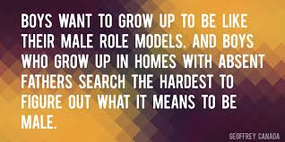

According to Muza (1998, cited in Eizirik and Bergmann, 2004) children who do not interact with their fathers often have problems with recognising limits and the rules of social interaction. Muza (1998) argues that the lack of a relationship with a male figure impacts on the children’s morals and can lead to an increased tendency to engage in anti-social behaviour.

“Crime Linked to absent fathers: Boy lacking dad more at risk of turning to crime”. The Guardian, 2001.
“Gang crime: Absentee dads blamed for rise in gang killings”. The Express, 2018.
This blog will use the terminology ‘radicalisation’ tentatively. Hesketh (2017) suggests that the word has been hijacked by the war on terror. However, its generic meaning refers to the process through which a person comes to support or be involved in extremist ideologies (NSPCC, 2019), these could be religious, social or political ideals.
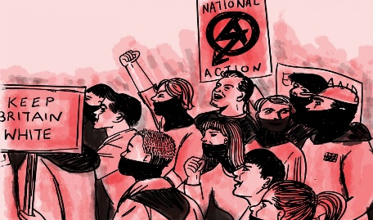  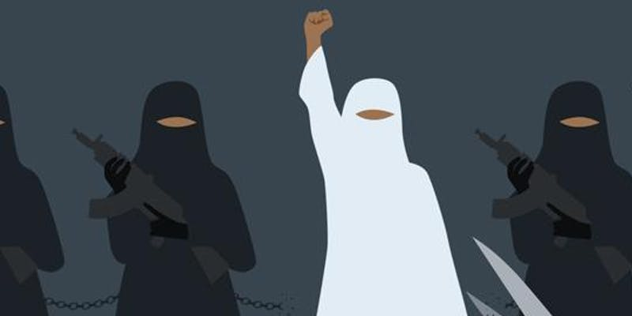https://crestresearch.ac.uk/comment/mcgarry-far-right-reciprocal-radicalisation/ https://slyp.org.uk/article/gang-culture/ https://henryjacksonsociety.org/event/womensvoicesinextremism/
Hesketh (2017) argues that children and young people are being racialised every day. He does not make a direct link with family breakdowns and absent fathers, however; his research suggests that belonging to a gang gives young people a sense of belonging. Hesketh also blames the lack of opportunities, caused by unemployment, a cut in services, and an increase in poverty as some of the reasons why some turn to becoming gang members. Public Health Wales (2019, p. 2) agree, adding that inequalities, isolation, abusive childhoods, difficulties with identity and mental ill-health can also contribute to this situation and lead to feelings of disenfranchisement and social exclusion. What Hesketh (2019) does highlight is that the results of his study of 22 young people proved that they all needed to be part of a group and had been influenced by an older mentor. Lützinger (2012, cited in Sikkens, et al., 2017) state that young people can be lured into radical groups in their search for substitute families and father figures.
Could this be the evidence needed to prove the question posed in this blog?

So, what’s the solution?
Hesketh (2019) suggests that reshaping communities and creating more opportunities should help to improve the outcomes for children and young people who live in neighbourhoods which are often subjected to poverty and violence. Public Health Wales (2019) report that early intervention is required and that we all have a duty to safeguard children and young people and protect them from harm. Finally, Van San et al. (2013) suggests that questions need to be asked as young people search for their sense of purpose and belonging and for them to be steered in the right direction and away from becoming extreme in their ideology. Parents, family members, teachers, youth workers and neighbours all have a duty to listen to adolescents to ensure they are being listened to and guided through this period of life that can often seem confusing and frightening at times.

County Lines:
Is there a hidden epidemic of girls being coerced into modern day slavery in the UK?
 https://www.youthandchildrens.work/Past-Issues/2019/April-2019/County-lines
Should we be shocked that girls as young as 10 are being exploited for sex and drug running? (Bulman, 2019), or children even younger as reported by the Children’s Society who uncovered evidence that children as young as 7 are being targeted (2019). Who is responsible for tackling this dilemma? What should be done to protect children and young people who may be at risk of exploitation?

Could tackling poverty be the answer? Many of those being groomed are initially attracted by the lure of financial rewards. Any child can become a victim; however, those that tend to be most at risk are four times more likely to have grown up in poverty (Timpson, 2019). Joseph Rowntree Foundation (JRF) (2016) suggests that one way of tackling poverty is by addressing the public perception of it and increase the support for policy and practice reform. However, poverty is not the only factor that can have a negative impact on children and young people. The following list is not exhaustive: mental and emotional problems, unemployment, lack of positive role models, family breakdowns and discrimination (Stroud, 2009).
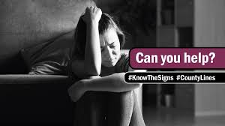
https://encrypted-tbn0.gstatic.com/images?q=tbn%3AANd9GcS7aFkxVPj4S362SOzLb0mNIdYvJeEbr9PA3RJNh27UZ4NiFOMk
https://www.youthandchildrens.work/Past-Issues/2019/April-2019/County-lines

County lines is a terminology which is used to describe the process where organised criminal groups exploit vulnerable people to expand their drug operations in areas outside of the city they usually operate in (National Crime Agency, NCA, no date). NCA report that this criminal activity is becoming more mainstream and it is reported that it exists in most parts of the UK. Windle, Moyle and Coomber (2020) define it as out-of-town dealers (OTD) who target small rural or costal locations.
The Children’s Society (2018) outlines the stages that take place to recruit ‘runners’:-
Trapped Stage
Experience Stage
Targeting Stage

Hooked Stage

The criminal groups frequently target children and young people from all backgrounds; often with mental health or addiction problems (NCA, no date) but mostly are deprived or troubled, and even including some from private schools according to Dodd (2019). One thing those that are recruited all seem to have in common is a sense of hopelessness, a vulnerability.
Risks to children and young people (CYP) are becoming ever more complex, especially since the use of technology is increasing. Social media, such as Instagram or Snapchat, is reported as some of the methods used to groom or recruit; and is a preferred method for making the initial contact. NSPCC (no date) also report that CYP have been even groomed in shopping centres and schools.

https://www.google.com/url?sa=i&url=http%3A%2F%2Fwww.russellwebster.com%2Fchildsocce%2F&psig=AOvVaw2egO_ePOEX9rYFcs9InQZS&ust=1581963799414000&source=images&cd=vfe&ved=0CAIQjRxqFwoTCJj51uXY1ucCFQAAAAAdAAAAABAa
The Violence and Vulnerability Unit produced a report in 2018 which acknowledged that young males were more likely to be involved in criminal gangs and make up 86% of the typical 14 to 17 year old boys that are involved (NCA, 2016). Coomber and Moyle (2018) report that the use of boys is more common practice. However, Bulman (2019) explains that girls are being used for sexual exploitation, shoplifting or money laundering and referred to as ‘victim associates’; it is argued that they are recruited because they are more likely to go under the radar of the authorises because of gender bias, as they are less likely to be viewed as offenders (NCA, 2018).
Bulman’s (2019) shocking article stresses the under reporting of girl’s role in the county lines epidemic. Bulman reports that in 2017 nearly 500 girls under the age of 18 were referred to the Home Office for support for being victims of sexual exploitation. Although the article does not specifically link the statistics with county lines, the NCA does attribute the numbers to gang exploitation. However, Windle et al. (2020, p. 5) report that the ‘overall level of girls’ involvement in county lines is currently unknown’. Which should be a serious cause for concern.

Is this making you think?
No one is 100% sure of the exact reasons for girls becoming involved with criminal activity and violence, however some of it may be due to the excitement or even because they are attracted to the male members of the criminal gangs (Densley, 2014). Perhaps you could also argue that they feel wanted because of the attention the boys give them, using gifts and affection to entice them, or maybe the financial reward is worth the risk of being sexually exploited. However, according to Storrod and Densley (2017) the girls may not be fully aware of the consequences of the intentions of the gang member whose attention may not last long after the initial testing of their viability for recruitment into County Lines operations. What is known is that girls make up the majority of young people not in employment, education or training according to Bennett and Daly’s (2014) research; making them even more vulnerable to being groomed and exploited, some may even see their involvement in County Lines as being a ‘respectable’ occupation which gives them status amongst their peers.


So, what does this have to do with poverty? Is there a link with poverty and criminal activity?
McAra and McVie (2010) argue that there is a definite link with poverty and violent offending amongst young people; blaming poor family functioning, neighbourhood deprivation and drug use. Controversary, they argue that violence is part of the identity of poor young people. However, no one can directly blame young people living in poverty for all the crimes being committed. It is being reported that child poverty will rise by 50% this year (Resolution Foundation, 2016, cited in Child Poverty Action Group (CPAG), no date) therefore will we see an increase in criminal activity amongst young people? With the income of lower paid families going down, to changes to tax and benefits, impacting further the increase of absolute poverty (CPAG, no date).
So, what can you do about it?
Cleary there is a problem in the UK of girls being exploited and groomed into County Lines activity, but it appears to be an area where little research has been carried out. Or does society not believe that girls can become active protagonists in the drug market and mirror the operations of their male counterparts? Therefore, this is not a problem? We all need to be more observant in our daily lives; challenge and question the vulnerability of girls. Something to think about?

What’s the
Who’s Right? What’s the point!

point
So, what’s it all about?
The United Nations Convention on the Rights of the Child (CRC) was adopted in 1989, however, this was not the beginning of the journey of ‘rights’ for children and young people. Records go back as far as 1841 when laws were introduced to protect children in the workplace. Initially these started in France and then spread across Europe. The beginning of the 20th century saw protection grow in other areas such as health. In 1924 the Declaration of the Rights of the Child was adopted. Following on in 1947, after the second World War, the United Nations Fund for Urgency for the Children was created. In 1953 this became a permanent international organisation and was renamed the United Nations International Children’s Emergency (UNICEF); it applies to all children and young people under 18. Its aim is to recognise the rights of children and young people and ensure that they grow up in the spirit of peace, dignity, tolerance, freedom, equality and solidarity (UNICEF, 1989).

of
Rights?
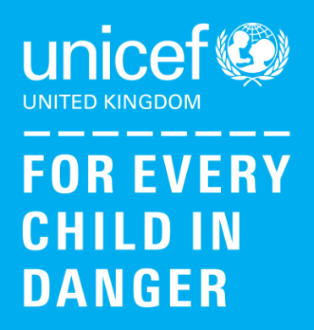
Further evidence that CYP are not being protected by the UNCRC. Who is going to challenge this?

Article 19 is meant to be protecting CYP from all forms of physical and mental abuse and Article 34 from all forms of sexual exploitation (UNCRC, 1989). The UNCRC also considers verbal abuse and intimidation as a form of violence as they can cause harm to CYP minds.
Technology has undoubtedly connected CYP around the world and provided unprecedented ways to communicate, however, is this at the detriment of CYP rights?

Furthermore…

Article 30 (CRC, 1989) theoretically outlines the right to protection from poverty and social exclusion (Council of Europe, 2019). This is the only provision under international human rights law that explicitly outlines a right to protection from poverty. However, in 2016 figures released showed that 29% of children living in Wales were living in poverty (Children in Wales, no date).

There have been many arguments in favour for the re-writing of the UNCRC, this is well overdue, after all when it was written in 1989 the world was not aware of the impact of the digital age.
Livingstone (no date) argues that it had been written to be timeless and flexible; initially seen as ‘visionary, authoritative, comprehensive and influential’. It now needs to be interpreted differently as children and young people’s (CYP) rights are becoming increasing exploited by the internet?
The impact of technology on the health and well-being of CYP is evident. Child exploitation in the form of web streaming of child sexual abuse, images of self-harm, grooming for the purpose of county lines, are among the dangers they are being exposed to. Along with breaches of personal data and forms of persuasion such as self-harm messages on Instagram.
So, who is going to protect CYP?
Littman’s (2018) research has identified the increased impact of social media and the internet on CYP’s gender and body dysphoria. She refers to this as peer or social contagion; which is impacting on an individual’s development.

Image available at: https://www.unicef.org.uk (Accessed: 21 March 2020).

In fact, according to Fundamental Rights Agency (FRA, 2018) combating child poverty is fundamental. Their report draws on the promise of the European Pillar of Social Rights (2017) to protect Europe’s children from poverty and respect their right to equal opportunities.
Principle 11 says it all: Children have the right to protection from poverty (2017).

We know poverty affects a child’s life: it can lead to poor physical health, make a child feel unsafe, leads to social deprivation and is associated with lower academic attainment (The Children’s Society, no date; Child Poverty Action Group, 2020; Tucker, 2018). Who cares?

In January 2019 the UK Government were set to legislate on Online Harms; due to the growth of social media and screen use. The intention is to review evidence of the harm these maybe causing and whether new measures or controls should be introduced (Parliament. House of Commons, 2019). We shall wait and see….

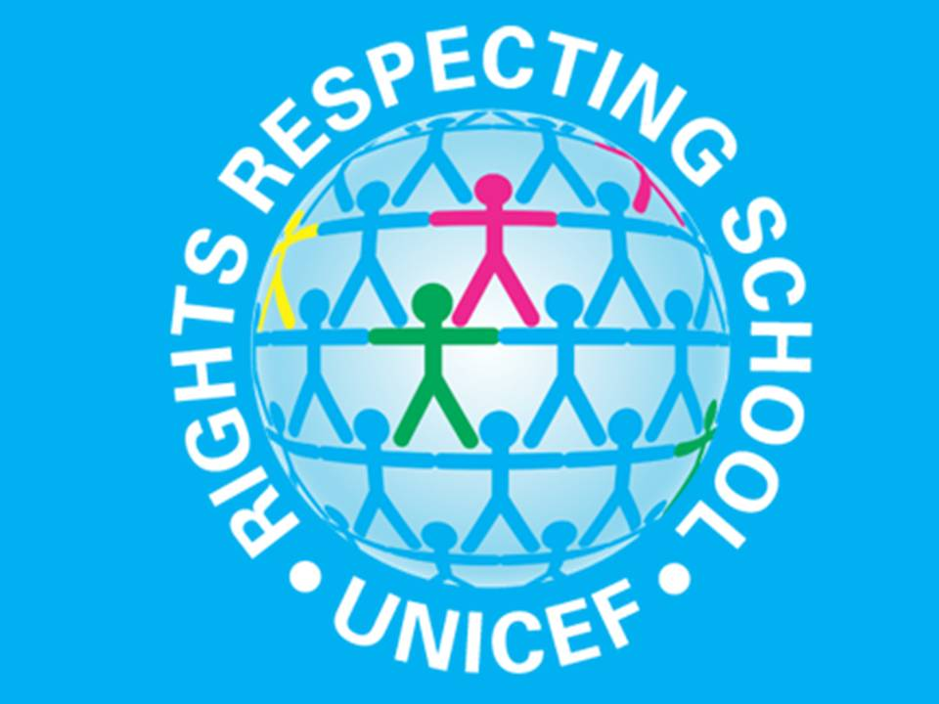
Image available at: https://www.unicef.org.uk/rights-respecting-schools/ (Accessed: 21 March 2020).

Arguably Children’s Rights should be placed at the fore front of everyone’s agenda. The Children’s Commissioner for Wales (2017) did just that; announcing that children and young people should have an equal chance to be the best they can. Holland (2017) declares that many children in Wales already lead safe, happy and active lives.
However, Save the Children reported that there were approximately 200,000 children living in poverty in Wales, with as many as 90,000 living in severe poverty. 53% of these are concerned about access to food, heating and clothes with 25% reporting that they frequently skip meals (Chamberlain & Mullineux, 2012). Pollock (2019) reports that there has even been a rise of 1% of CYP living in poverty in Wales, being the only nation to see an increase. Should we be shocked by these statistics?
If we are going to make sure that all CYP in Wales has access to all their rights a logical place to start would be to ensure that all schools became Rights Respecting Schools. As of today, it would seem there is only a handful of schools who have achieved either the Bronze, Silver or Gold award. Maybe if CYP knew more about their entitlements the government would have to step up and support CYP in achieving them.
Arguably the CRC is likely to be the most ratified UN Convention, however, my question is are children’s rights western constructs which impose western ideals on ‘developing countries’ and not really relevant to Wales in the 21st century? If they are relevant, then shouldn’t we all be horrified that CYP living in Wales do not have all their ‘Rights’ fulfilled?

