

University of Wales Trinity Saint David
Abstract
This report has tried to demonstrate the suitability of the present structure of NHS Wales with a general view over the seven Health Boards and three trusts. NHS Wales is providing healthcare services to 3 million people who are living in Wales, with more than 78,000 staff which is making the biggest employer in the country. Funding chain towards NHS Wales is starting from central government who are given a whole spending budget to National Assembly of Wales, here the money is segmented and sent to Welsh Government which will go progressively increasingly significant in the division and send forward to Department of Health and Social Care where the financial limit for NHS be given.
A Report into Effectiveness of the current Structure of NHS wALES

Lecture: Tania Davies
Student: Tabrea Adrian Vasile

Table of Contents

Introduction 2
NHS Wales Structure 2
How Management Structure are working in the Health Boards. 3
NHS Wales Funding 4
Influences over NHS Wales Funding 5
Evaluation of Current Structure 6
- Positive aspects …………………………………………………………………………….….……6
- Negative aspects ………………………………………………………………………………….7
Conclusion ……………………………………………………………………………………………………………………….9
Recommendations ………………………………………………………………………………………………………..9
References list ……………………………………………………………………………………………………………..10

Introduction
This assignment type report will present the effectiveness of the current structure of NHS Wales with an general overview over the seven health boards and trusts on how the management structures are working in each of them and where the funding is coming from; what are the influences, with recommendations over efficiency and other concerns and issues related to this topic. NHS stand for ‘’National Health Service’’ which is the national healthcare provider for all UK citizens in light of their requirement for healthcare services rather than to their financial capacity to pay for it, funded with money from taxpayers (The King's Fund, 2017). NHS was created on 5th July 1948 by a Welshman Aneurin Bevan, minister of health, having at the onset three main principles; meeting the healthcare needs of everybody, being free of charge at the point of delivery and that is funded on clinical needs not on the ability of paying (National Health Service, 2018). NHS Wales is part of NHS UK, providing healthcare to three million people who reside in Wales, with over 78,000 staff which makes it the biggest employer in Wales; providing a large range of healthcare services from giving up to smoking, routine treatments, surgery, accident and emergency to end -of-life care, covering all the medical care needs of the population (Wales National Health Service, 2019a).
NHS Wales Structure
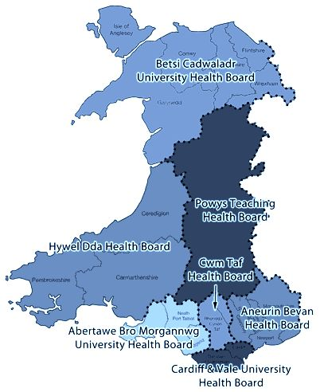
In the structure of NHS Wales are seven Local Health Boards (LHBs); Aneurin Bevan Health Board, Abertawe Bro Morgannwg University Health Board, Cardiff & Vale University Health Board, Hywel Dda Health Board, Cwm Taf Health Board, Betsi Cadwaladr University Health Board and Powys Teaching Health Board with hospitals, clinics and other type of unities under them (Welsh Government, 2016). There are three trusts adding to the structure; Welsh Ambulance Services NHS Trust who operates from 90 ambulances stations, three control centres and three regional offices; attending to over 250,000 emergency calls a year, transporting 1,3 million persons to treatment centres per year, taking over 50,000 urgent calls a year. Velindre NHS Trust is providing specialised treatments for patients with cancers and blood services. Public Health Wales Trust have functions of national public heath services over Wales (Wales National Health Service, 2019b).
Source: NHS Wales

How Management Structure are working in the Health Boards.
Local Health Boards are made up of around 20 to 30 members including; Chair of Board with role of managing and developing the board, Chief Executive is the operational leader, Vice Chair to support the Chair of Board, Executive Directors having dual role as board members and executive leads and other members without the right to vote are; Special Advisors, Trade union and Independents members from University, Community, Social Services, Local Authority and third sector. All of the members have responsibilities in the management of structure (National Health Service Wales, 2019c). Health Boards deliver health care service to the population via; Primary care services, Secondary health care services, Tertiary care services and Community care services. LHBs indirectly respond to the Health and Social Services Minister through Chief Executive and having the responsibilities over; planning, designing, developing, funding, quality, security over delivering the health care and meeting them, identified the new needs within the national policy and the framework established by the minister (Gpone.wales.nhs.uk, 2014). LHBs in Wales merge in; 13 Major A&E Units, 21 Minor Injures Units (MIU), 2 Acute Units, 3 CHC Units, 19 Clinics, 30 Community Hospitals, 3 Community Hospitals for Elderly with Mental Infirm (EMI), 5 Day Hospital, 1 Major Acute, 2 Psychiatric: Learning disability, 17 Psychiatric: Mental illness, 2 Mix Mental illness and Learning disability and 3 Special Acute, bringing a total of 118 with direction of management from one of the Local Health Board (University Health Board, 2018). All members LBHs have shared responsibilities in ensuring that the board is operates effectively, in the Good Governance Guidance chapter four are highlighted the roles of members in delivering Healthcare in Wales. Under the Board are committees and subcommittees who are taking specific function on behalf of board or given advice to board regarding the exercise of its functions (Auditor General for Wales, 2015a).

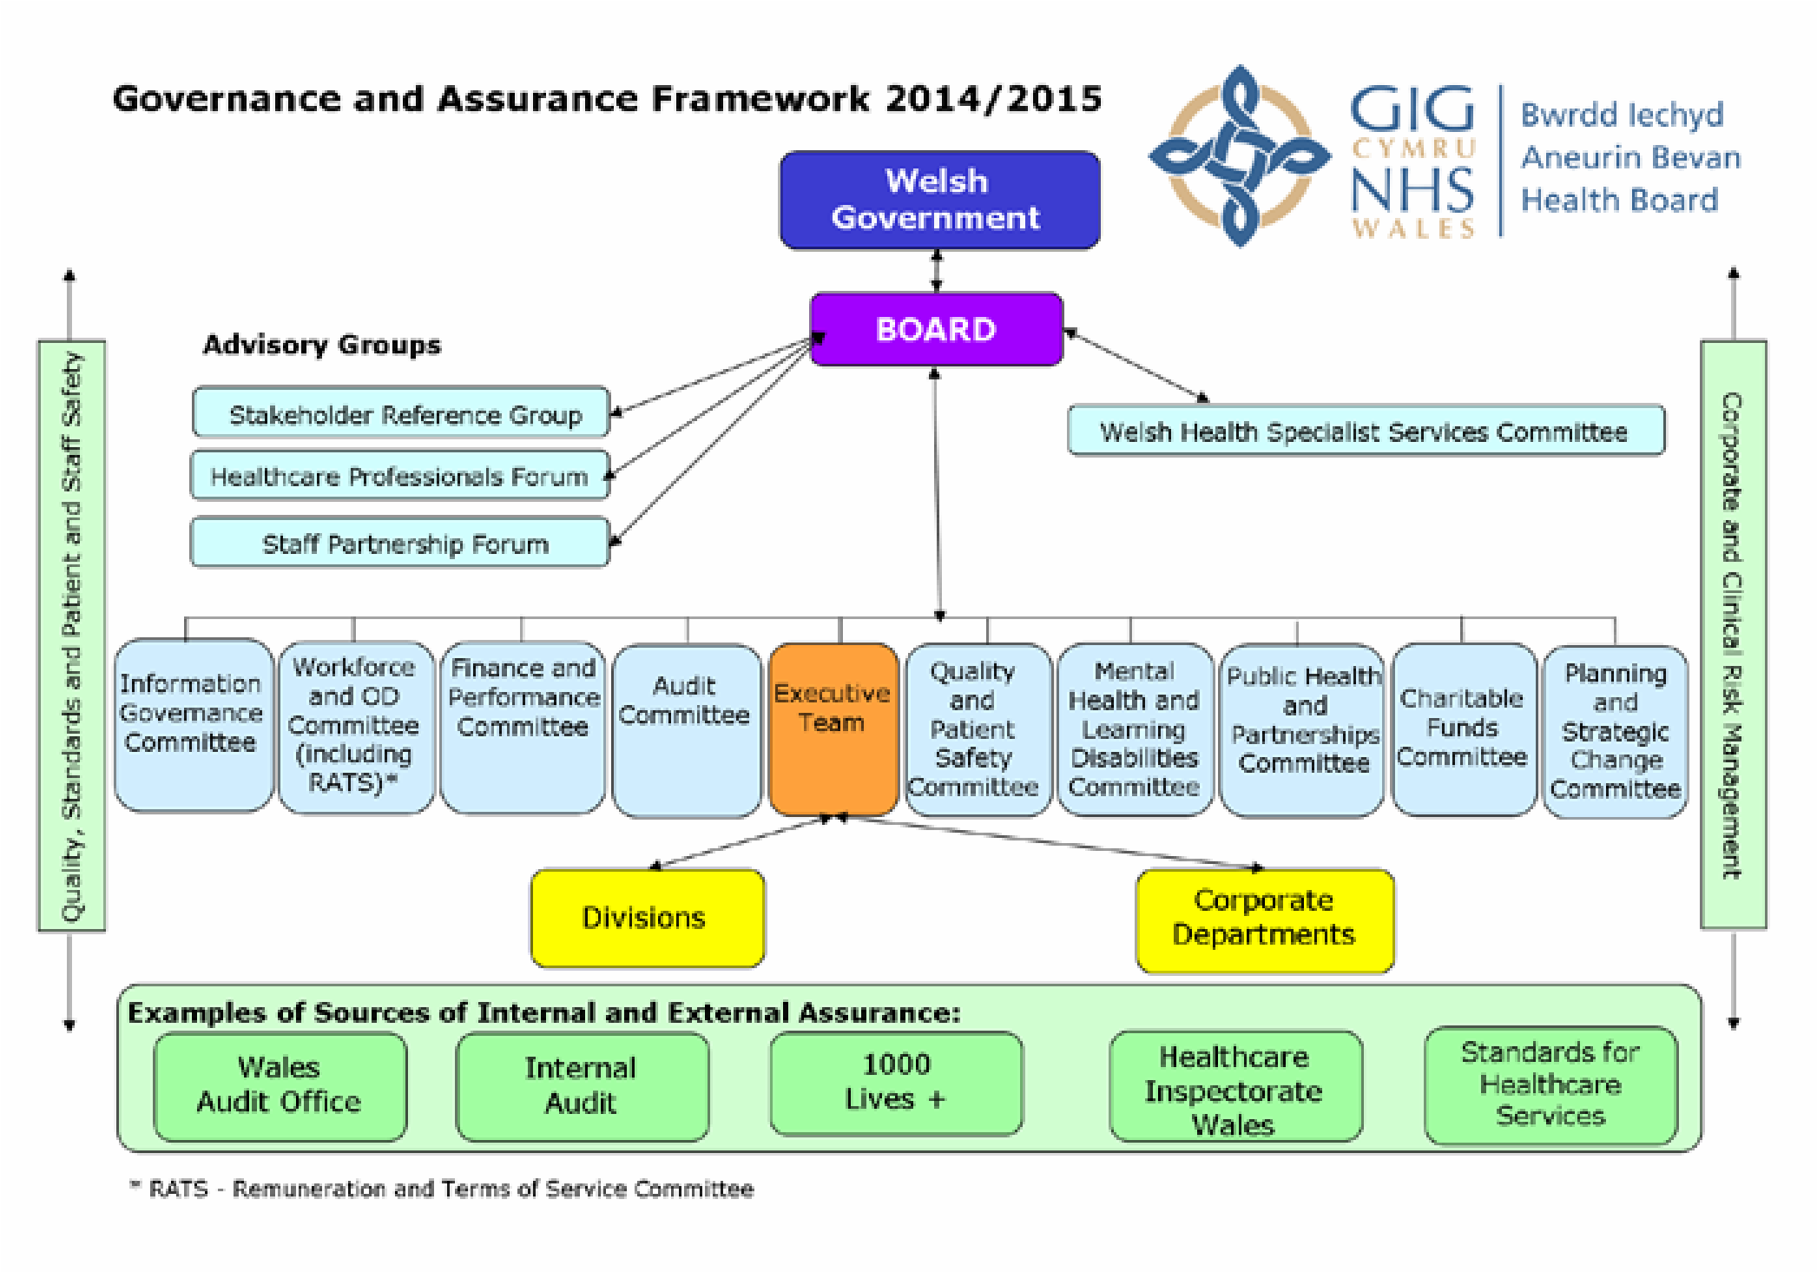
Source: Governance in the NHS in Wales, Memorandum for the Public, Accounts Committee.

NHS Wales Funding
The funding chain for the NHS Wales is starts from central government who give a whole budget to National Assembly of Wales, here the money is segmented and sent to Welsh Government which will go more deeper in the segmentation of the budget and will give a budget towards Department of Health and Social Care; an integrated delivery board made up from minister of Health and Social Care , Chief executive of NHS Wales and other members will decide what budgets towards the seven Local Health Boards and three Trusts to be given. The money from the central government send as a whole budget towards National Assembly of Wales are from National Insurance Number and general taxation of population and companies of United Kingdom (Auditor General for Wales, 2015b). The Health Boards and Trusts are sending their own prebudget towards the Chief Executive of NHS Wales which will presented or discuss with the Minister of Health and Social Care before the general budget to be made towards NHS Wales (Appleby J, 2016).
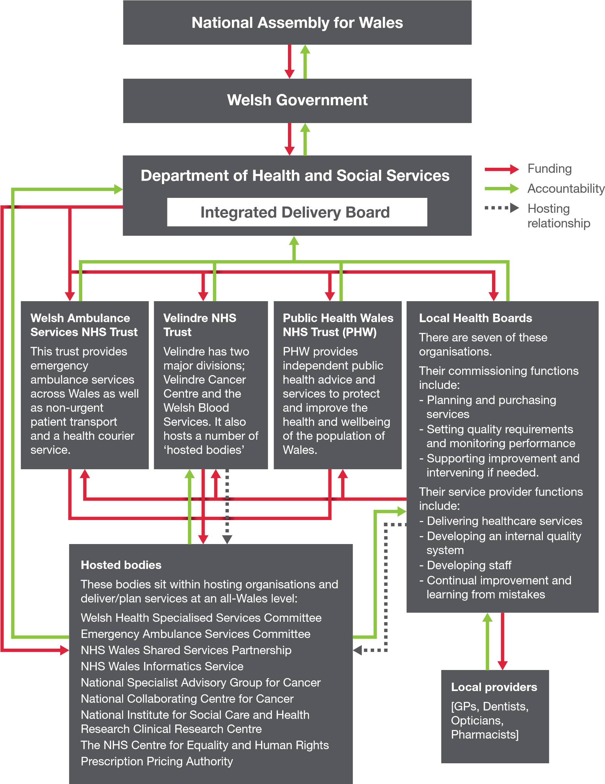
Source: Governance in the NHS in Wales, Memorandum for the Public, Accounts Committee.

Influences over NHS Wales Funding
There are many factors and aspects which have influences over the NHS Wales budget, but this report will be enumerate just a few of them;
- Barnett formula over the allocation of budget by the Central Government through National Treasury towards Welsh Government is a factor which is influences directly NHS Wales because money is allocated on based population numbers not their needs; where in Wales there is a higher percentage poverty in additional to aging population compared to the rest of the United Kingdom (Keep, 2018).

- Political influences over the NHS Wales are strong and brings changes when one government is changes in regarding the; new view of NHS Wales, how the money should be spend, what priorities should be, new budgets for the LHBs, changes in the senior levels of staff in NHS Wales, new policy and many more (Jervis and Plowden, 2002)

- Increases demand of population over the health care services is another influence over the NHS Wales budget with research showing that by the end of 2028, 66% of Welsh budget will have to go into NHS Wales. Currently £6bn are going to NHS Wales out of £14,5bn budget of National Assembly of Wales (British Broadcasting Corporation, 2018).

- Other influences and aspects can be; workforces’ salaries, procurement processes, agency staff, estate, facilities, energy consumption, water consumption, food, inflation, digital health technology and many more (Trickey, 2016).

Evaluation of Current Structure
- Positive Aspects
‘’The right to free healthcare services should be a human right - Uk has one of the fairest, most effective and most socially accountable forms’’. This highlights that all of people indifferent of their skin colour, religion, sexual orientation, cultures, rich, poor should not be discriminated in the ground of not having money to pay for healthcare services (Ranade, 1997).
Stephen Hawking now deceased, one of the most intelligent man of his generation argue that public system NHS is more efficient that a private one “International comparisons indicate that the most efficient way to provide good healthcare is for services to be publicly funded and publicly run.” and should not be taken by the government on privatisation “towards a US-style insurance system, run by... private companies”, and insisted “We must prevent the establishment of a two-tier service.” (cited in The Week UK, 2019).
A study made in the last 3 years in several country over the world are showing that the most expensive healthcare system it is the private sector not public, with United States privately run by insurance-based system being the most expensive in the world, other aspect that come out of study were regarding luck of transparency in the system, short life expectations and prices of treatments and medication being uncontrollably; an example can be of an echocardiogram in Japan cost less than $100 when the same procedure in Massachusetts will be $1,714 or New Jersey $5,4345 (Ridic, Gleason and Ridic, 2015).
A short brief of advantages of public sector can be; healthcare universally accessible, life expectation, jobs for people due to NHS being the 5th biggest employer in world and over 1 million staff, increased number of treatments available to people, increased drugs and medication available, freedom towards women through access to contraceptives, pills and abortions treatment and many more (Getrevising.co.uk, 2019).
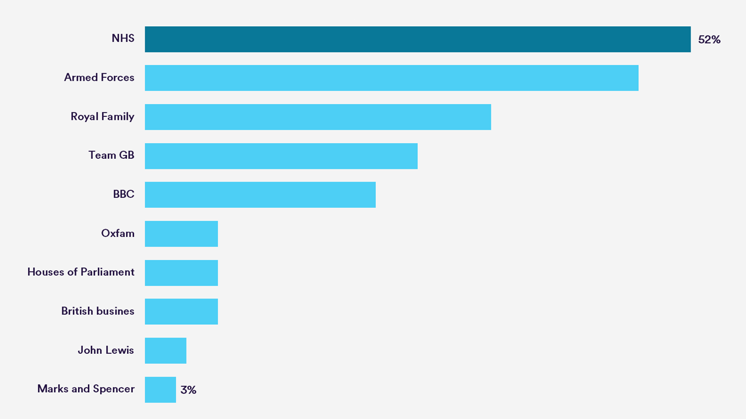
Source: Ipsos Mori (2018) - Most appreciated institution in United Kingdom.

- Negative Aspects
“The country cannot continue pumping money into something which doesn’t work’’. The amount of money put into the budget of NHS is unavoidable unfavourable factor of the actual system, with the finances at the breaking point and the research showing an increase in the budget needed in future (Robertson, 2016).
The level of Bureaucracy in NHS can be shocking for people from outside of the system or dealing with, but unfortunately it is a reality that will appear in front, starting from a paper work needed form a simply admission in the hospital to a contract to be sign is a long way with many obstacle to the good housekeeping of practicality and efficiency (Rose, 2015).
The waiting time for appointments is a big failure of the system when one non-urgent referral from a doctor in five out of seven health boards in Wales is longer than 36 weeks and a cancer referrals can be longer than 3 months in some of health boards, in top of that is adding the waiting list for surgeries other medical examinations of speciality where in some cases can be up to years of waiting (Clarke, 2018).
Because it is a system designed to failed in pieces at anytime with community services for elderly people pushing over the limits, mental health service non present in many areas, GP overwhelmingly leaving the system, nurses not enough in hospitals and underpaid, management and cleric staff overpaid, hospitals unable to recruit enough staff and a general fear that if refusing and passing to look down to major reforms over the NHS system, could fold completely down even with increases budgets over the time (Pinching, 2019).
Another important factors can be; the element of choice given to a patient with more options, less bureaucracy, bigger wages for nurses and doctors, less paperwork, less waiting time for treatment, surgeries, appointments and many more (Economicshelp.org, 2019).
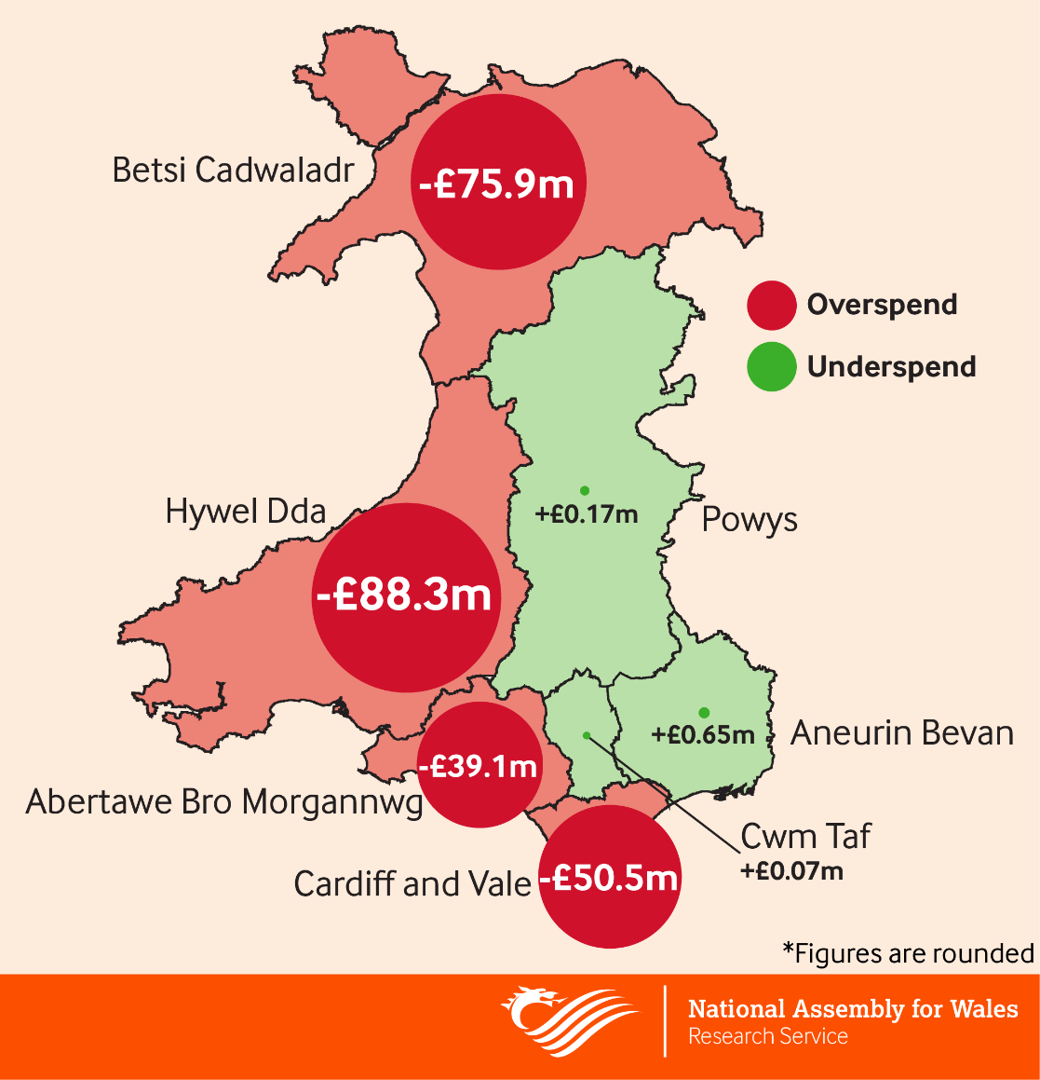
Source: National Assembly for Wales - NHS Wales spending report 2018.

Conclusion
This assignment type report has endeavoured to show the viability of the present structure of NHS Wales with a general view over the seven Health Boards and three trusts. NHS Wales is providing healthcare services to three million individuals who are living in Wales, with more than 78,000 staff which is making biggest employer in the area. Local Health Boards are comprised of around 20 to 30 individuals and having the purposes of points of delivering health care service towards population through; Primary care services, Secondary health care services, Tertiary care services and Community care services. The funding chain towards NHS Wales is beginning from central government who are given an entire spending budget towards National Assembly of Wales, here the cash is sectioned and sent to Welsh Government which will go increasingly more deeply in the division and send forward to Department of Health and Social Care where the budget for NHS be given. There are numerous elements having impacts over the NHS Wales funding, some of them being; Barnett formula over the allocation of budget by the Central Government, Political influences, Increases request of populace over healthcare services. Stephen Hawking was arguing that public system NHS is more efficient that a private one “International comparisons indicate that the most efficient way to provide good healthcare is for services to be publicly funded and publicly run.”.
The amount of cash put into the NHS budget is unavoidable a dreadful factor of the actual system, with the funds at the limit and research showing an expansion in the monetary budget required in future.

Recommendations
The follow recommendations will be based on the resources and materialise used for this assignment.
- Urgent reforms on how the budget is managed and a stricter control over the spending of the health boards and trusts.
- Urgent actions in lowering the bureaucracy from system and simplification of actual procedures.
- Increasing the staff number needed by recruiting more efficiently and quickly and cutting agency staff used in hospital will save money and cut the waiting time for people.
- Cutting the free transport patients for hospital appointments, just keep this service for people who really cannot afford.
References list

Appleby, J. (2017) How the NHS is funded. Available at: https://www.kingsfund.org.uk/projects/nhs-in-a-nutshell/how-nhs-funded (Accessed: 22 April 2019).

Auditor General for Wales (2015) Governance in the NHS in Wales. Memorandum for the Public. Cardiff: Auditor General for Wales.

British Broadcasting Corporation (2018) Welsh NHS 'will need 66% of budget'. Available at: https://www.bbc.co.uk/news/uk-wales-44708356 (Accessed: 23 April 2019).

Clarke, O. (2018) £13m claw back over waiting time failures. Available at: https://www.bbc.co.uk/news/uk-wales-44213640 (Accessed: 24 April 2019).

Economicshelp.org. (2019) Advantages of Privatisating Public Services. Available at: https://www.economicshelp.org/microessays/market-failure/privatisation-public-services/(Accessed: 24 April 2019).

Getrevising.co.uk. (2019) Advantages and Disadvantages of the NHS. Available at: https://getrevising.co.uk/grids/advantages-and-disadvantages-of-the-nhs (Accessed: 23 April 2019).

Gpone.wales.nhs.uk. (2014). GP-one | Structure. Available at: http://www.gpone.wales.nhs.uk/nhs-wales-structure (Accessed: 22 April 2019).

Jervis, P. and Plowden, W. (2002) THE IMPACT OF POLITICAL DEVOLUTION ON THE UK'S HEALTH SERVICES. 3 Report. London: The Nuffield Trust, Available at: https://www.nuffieldtrust.org.uk/files/2017-01/impact-of-political-devolution-web-final.pdf (Accessed: 23 April 2019).

Keep, M. (2018) The Barnett formula By Matthew Keep. House of Commons Library. Available at: https://researchbriefings.files.parliament.uk/documents/CBP-7386/CBP-7386.pdf (Accessed: 22 April 2019).

National Health Service (2018) Principles and values that guide the NHS. Available at: https://www.nhs.uk/using-the-nhs/about-the-nhs/principles-and-values/ (Accessed: 20th April 2019).
National Health Service Wales (2018c) Health in Wales | Local Health Boards. Available at: http://www.wales.nhs.uk/ourservices/directory/localhealthboards (Accessed: 22 April 2019).

National Health Service Wales (2019a) Health in Wales | NHS Wales - About Us. Available at: http://www.wales.nhs.uk/nhswalesaboutus (Accessed: 20 April 2019).

National Health Service Wales (2019b) Aneurin Bevan University Health Board | The Health Board Members. Available at: http://www.wales.nhs.uk/sitesplus/866/page/40442 (Accessed: 22 April 2019).

Pinching, J. (2019). Should the NHS be privatised? - Pharmafield. Available at: https://pharmafield.co.uk/in_depth/should-the-nhs-be-privatised/ (Accessed: 24 April 2019).

Ranade, W. (1997) A future for the NHS? Health care for the Millennium. 2nd ed. London: Addison Wesley Longman Limited.

Ridic, G., Gleason, S. and Ridic, O. (2015). Comparisons of Health Care Systems in the United States, Germany and Canada. Mater Sociomed., 24(2), pp.112–120.

Robertson, R. (2016) Six ways in which NHS financial pressures can affect patient care. Access to care. Available at: https://www.kingsfund.org.uk/publications/six-ways (Accessed: 24 April 2019).

Rose, L. (2015) Better leadership for tomorrow NHS Leadership Review. Available at: https://assets.publishing.service.gov.uk/government/uploads/system/uploads/attachment_data/file/445738/Lord_Rose_NHS_Report_acc.pdf (Accessed: 24 April 2019).

The Week UK. (2019). Privatising the NHS: pros and cons. Available at: https://www.theweek.co.uk/nhs/63360/privatising-the-nhs-pros-and-cons (Accessed: 23 April 2019).
The King's Fund (2017). How the NHS is funded. Available at: https://www.kingsfund.org.uk/projects/nhs-in-a-nutshell/how-nhs-funded (Accessed: 24th April 2019).

Trickey, M. (2016) Efficiency and the NHS Wales Funding Gap. Cardiff: Queen’s Printer. Available at: http://ppiw.org.uk/files/2016/09/Efficiency-and-the-NHS-Wales-Funding-Gap.pdf (Accessed: 23 April 2019).

University Health Board (2018) Annual Report and Accounts 2017/18. Available at: http://www.wales.nhs.uk/sitesplus/documents/862/ANNUAL%20REPORT%20%26%20ACCOUNTS%202017-18%20BILINGUAL.pdf (Accessed: 22 April 2019).

Welsh Government (2016) Law Wales - Local Health Boards. Available at: https://law.gov.wales/publicservices/health-services/health-service-bodies/lhbs/?lang=en#/publicservices/health-services/health-service-bodies/lhbs/?tab=overview&lang=en (Accessed: 24th April 2019).

