To what extent did apathy play a role in the rejection of Devolution by the Welsh people in March 1979, as opposed to a basic opposition to the provisions? Your answer should pay due attention to regional variations.
Devolution was something that had been growing in Wales from the last part of the 19th century when Cymru Fydd (literally young wales) and other calls from the liberals for ‘home rule’ in Wales began but what was devolution? The campaign for devolution was grounded by a “widely held view that the Welsh people deserved a better deal than the UK government based in Westminster seemed capable of delivering”. It’s easy to get tied up in the devolution vote itself but as Ron Davies said “devolution is a process not an event” which I think is important to remember while analysing the mindset of the people at the time.
In order to fully answer the question above it is crucial to explore what the government was actually proposing, what the people were voting for. The referendum consisted of one yes or no question “Do you want the provisions of the Wales Act 1978 to be put into effect?” The Wales Act of 1978 was a preliminary act in government proposed by Michael Foot that outlined the chance for Wales to have an Assembly devoid of all law making and tax-raising powers. The Assembly would have certain responsibilities and therefore some level of power. These responsibilities covered housing, education, health, the environment, planning, and had the power to aid museums and galleries, and other cultural and recreational activities. This included the Welsh Language. The referendum saw a record loss shown in the graph below:
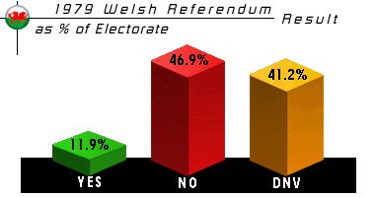
Figure 1

With less than 12% of the population of Wales (who were eligible to vote) voting Yes, and yet with the results being completely different less than two decades later, there must have been several contemporary influences that shaped the results of the first referendum.
There seems to be many reasons why Wales as a country voted against Devolution and there’s no denying that apathy was one of them. Kenneth Morgan emphasises that “most Welsh people were content with their dual identity, which stressed their Britishness as well as their Welshness” and that unlike in Ireland, people wanted equality “within the framework of the United Kingdom and the empire” – they wanted to work within the British Government, whereas Ireland were fighting to be free of the government all together. This is one thing that could have birthed apathy when it came to the devolution, Welsh people didn’t want to be separate from England and Britain, they wanted things to remain as they were, mostly, but with perhaps more respect to welsh culture and how they felt they deserved to be treated.
The ‘no’ campaign of the 1979 referendum portrayed the devolution as the first step on the “slippery slope” towards a completely independent Wales. Large parts of wales, as mentioned above, were completely against an independent Wales, they wanted to remain part of the United Kingdom, and part of the British Government.
People in Wales were probably made increasingly apathetic by the attempts and failures of the Labour government to implement previous promises of increased power in Wales. Labour, around the time of the general election in 1945 had listed five main promises:
“A Secretary of State, a separate Welsh Broadcasting Corporation, an end to the forced transference of labour from Wales to England, a new North-South Wales trunk road, and a central body to plan and develop the Welsh economy”
However, Labour failed to make any of these promises a reality, and when, years later, after increasing pressure from Welsh Nationalists (and when the Conservatives promised to give the nationalists what they wanted), they did grant Wales a Council for Wales that drew from all sides of the economy, it was a “distinctly minor one”. It was an unelected body that did nothing but advise the British “government on Welsh affairs” Morrison was worried that giving it too much power would increase the demand for a Secretary of State for Wales which they had already refused as it would be nothing but a mirror of the English Secretary of State and had been deemed unnecessary. This council was not what welsh people were asking for, was nothing near what they thought they deserved, and yet Labour leaders seemed “quite unwilling to go any further”. It wasn’t until 1964 that Labour actually did what they promised in 1945 and created a Secretary of State for Wales and established a Welsh Office. But it wasn’t what people expected and both the Secretary of State and the Welsh Office had limited power and only controlled “housing, local government and roads”, though more roles were added over the years. The fact that Labour had proved to be unreliable in fulfilling the things they were offering could be part of the reason that labour support saw an almost constant decrease in voters from the mid 1930’s until it hit an all time low in the early 1970’s:

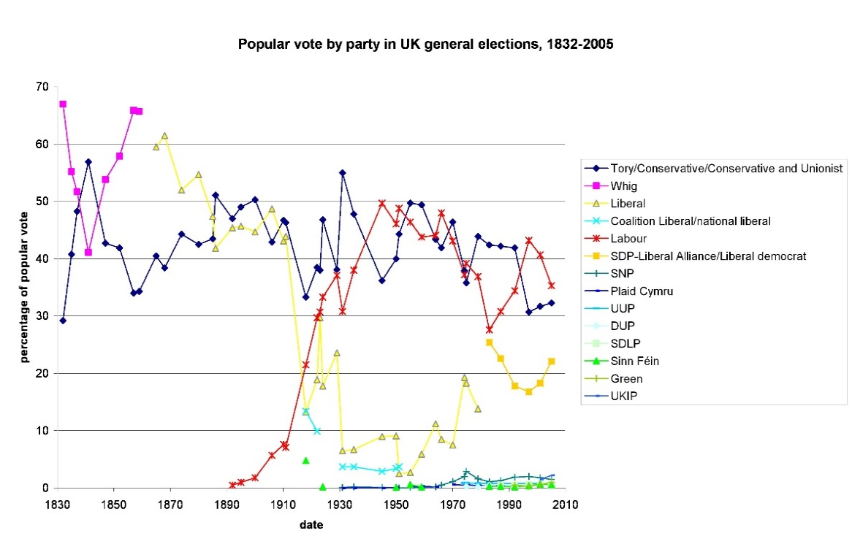

Figure 2

Not to forget the winter of discontent in which a series of strikes took place that left the country reeling and had effects such as leaving rubbish uncollected and the dead unburied, which is often cited as the reason of the “perception that Labour was unfit to govern”
It was also a leading member of the Council for Wales, Henry Brooke Minister of Housing and Local Government, that approved the flooding of the Tryweryn valley despite outrage by the people of Wales and it’s elected MP’s (including those who were against the Nationalistic ideals of some of the population). Brooke was also known for refusing to endorse the economic development of Wales on behalf of the council. This created increasing levels of hostility and mistrust towards the Council which may have increased apathetic or even resentment to the very idea of creating another version of the Welsh Council which clearly did not have the needs or wants of the Welsh people at heart.
While I couldn’t find any statistics that spoke of apathy in the vote that took place in 1979 there have been many studies into the apathetic approach of the Welsh towards independence in any form in 1997 and I think it’s safe to assume that these attitudes didn’t wake up overnight. They had been there for years, and that if anything they would have been less prominent in 1997 than in 1979 since devolution was voted for in the later referendum.
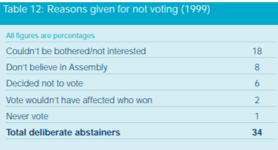

Figure 3

The figure above shows that in 1997 34% of the voting population of Wales deliberately decided not to vote for several reasons (there is a separate figure for people who couldn’t vote due to work commitments or other reasons). 18% of these reported they just weren’t interested in the vote, and 8% admitted they didn’t believe in having a Welsh Assembly at all. It could be argued that therefore 26% of these “deliberate abstainers” didn’t vote due to feelings of apathy, rather than not believing in the Assembly or basic opposition to the provisions. I think that it would be fair to say that this figure would have been reflected in the 1979 referendum as well, and would account for at least an equal amount of the 41.1% of people who didn’t vote in the first devolution vote (as seen in figure 1)
The Independent recognised that apathy played more of a role in “former mining towns” than the ‘no’ campaign did. Kenneth Morgan attributes this to “clear signs of cultural divergence between North and mid-Wales and the Southern coalfields”. Oftentimes it seemed like there was a bigger gap in between the Welsh-speaking Welsh communities and the English-speaking Welsh communities, than there was between English-speaking Welsh communities and England. At the time of the referendum in 1979 the ‘no’ campaign fed off the fact that the English-speaking industrialised Welsh population feared “domination of Welsh life by minority Nationalists, Welsh speakers and/or a narrow inward-looking Welsh elite”. The ‘no’ campaign assured the English-speaking communities that the devolution would put them under the control of the Welsh-speaking rural communities, which was something they did not want at all.
Below is a figure showing the votes for the referendum in 1979 by individual counties, ranked in descending order based on the amount of yes votes:
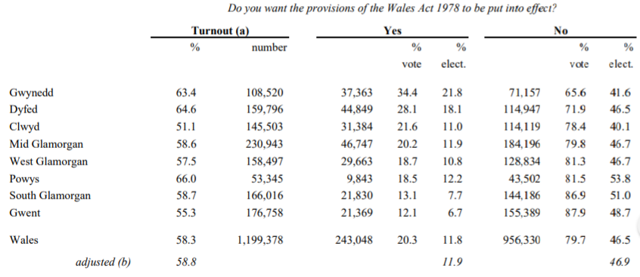
Figure 4
It would be almost impossible pay due attention to regional variations in the results of the referendum without looking at these figures. However, I also realised that when looking at these figures compared to a regional map of the time, they helped to validate the point made above:
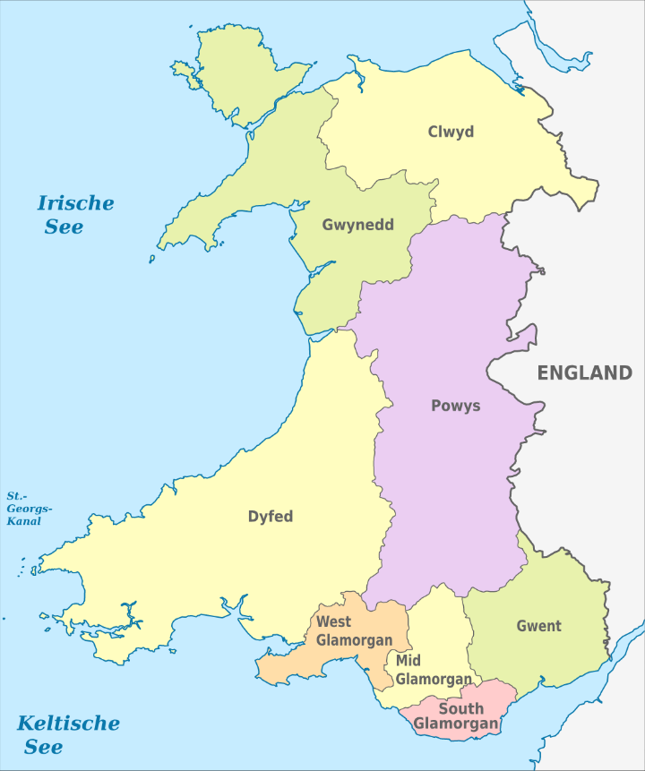

Figure 5

Looking at the map above you can see that Gwynedd, which had the highest percentage of yes votes across all the counties, 34.3% is situated at the very North of Wales. Dyfed and Clwyd, which had 28.1% and 21.6% respectively, are also situated towards the mid-north of Wales.
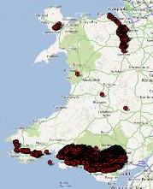

Figure 6

Looking at figure six, it also becomes clear that most of the mining communities in Wales are situated in the counties of Mid Glamorgan, West Glamorgan, South Glamorgan, and Gwent, which, respectively, had 20.2%, 18.7%, 13.1%, 12.1% of the population voting yes. With South Glamorgan and Gwent having the lowest percentage of yes votes of the entire country. Which could show that the Welsh-speaking Welsh communities of North and Mid Wales, were enthusiastic in their support of Devolution, whereas the Southern communities feared the results of the referendum (perhaps because of the enthusiasm of those of the North.)
Many high positioned Ministers in the British government (including Aneurin Bevan, Minister for Health) understood that the English-speaking communities in Wales made up a significantly larger percentage of the population. And so, a lot of them publicly and vehemently condemned any form of devolution that looked like a surrender to the welsh-speaking nationalists. However, condemning it publicly Aneurin Bevan and others may have fed into this fear held by the English-speaking Welsh communities.
Between 1851 and 1911 alone 366,000 people migrated into the South Wales Coalfields, many from other counties in Wales. However, after 1890, large amounts of English people began to move into the Coalfields (of course there were people coming from Ireland, Scotland and Australia as well). These migrants (or their descendants) would have been invited to vote in the referendum and may have held ties to their English heritage and not wanted to have been separated from that, in any form.
The aims of the Welsh-speaking nationalists probably weren’t being conveyed across Wales as easily as those of the Ministers and the English-speaking anti-nationalists. As already mentioned above, Labour failed to fulfil their promise to create a separate Welsh Broadcasting Corporation, which meant that much like now a lot of the news fed into Wales is created and broadcasted by English broadcasting corporations (like the BBC), which, were reporting on the words of men like Aneurin Bevan and other ministers in the British government, who were against the devolution. On top of this, Welsh papers were being bought up or run out of business by English run papers, and most of them were only printed and delivered around Northern rural Wales. A lot of Welsh news at the time was printed in the Welsh language, which would have been useless to English speaking populations..
Despite all of this, it is clear that not all welsh people were feeling apathetic towards devolution. As mentioned above several high profile members of Parliament were loud and vehement in their dismissal of any form of independence for Wales. But there was something else that seemed to have woken the “Welsh Nation from its slumber”. The whole of Wales seemed to come together to protest the drowning of the Tryweryn Valley from the people who lived there, to welsh politicians of all parties, and even the Lord Mayor of Cardiff and 300 local government representatives met up. There were delegations sent to Liverpool to speak up on behalf of the Welsh people, there were Rallies held in Wales and Gwynfor Evans even led a procession through Liverpool in 1956
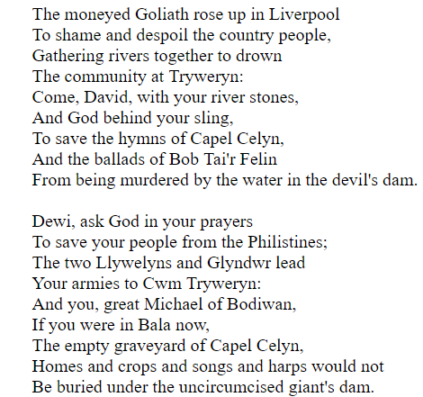
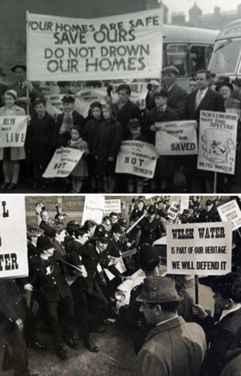

Figure 7
Figure 8

The demonstrations against the flooding of the Valley got more intense as it seemed the people were being ignored, and there were protests that included the Free Wales Army in full military uniforms and even some bombings performed by members of Mudiad Amddiffyn Cymru (the Movement for the defence of Wales. These bombings seemed to begin a number of bombings that took place throughout the whole of the 60’s. It seemed the people of Wales were tired of not having a voice, of not being able to defend themselves from the attacks coming from England. Events like this, and this rising feeling of nationalism, is believed to have inspired Plaid Cymru to be better, and also “provided an impetus to its campaigns”, it’s no surprise that soon after these events Plaid Cymru won its first political campaign. When Gwynfor Evans succeeded in the election of 1966, he won by a 2,436 majority and 2,000 people crowded around to sing the national anthem and waved welsh flags. I think this demonstrates how Nationalism was high in this period, that Wales had truly woken from its slumber.

This time also saw the rise of Direct Action, which was a group of young people protesting and campaigning for a Welsh Language Act, and a Welsh television channel. It escalated from marching in London, to painting a slogan on Nelson’s column to sawing the English off signposts or simply covering it up.

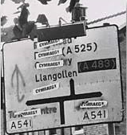

Figure 9

Figure 9 is clearly showing the word ‘Cymraeg’ stuck over what I assume is English place names in protest. These protests did in fact lead to a Welsh Language Act being brought into place in 1967. The Welsh Language Act of 1967 extended the provisions of respect to the Welsh Language that had previously been in place, it allowed the Welsh language to be used in all official or public businesses and said that Wales should be understood as being separate from England in all following Acts of Parliament.

In conclusion, I think that apathy played a substantial role in the rejection of Devolution by the Welsh people in the March of 1979. I think the Yes campaign failed to move the generally apathetic population of Wales and failed to convey the provisions of the Wales Act of the previous year. They were also, in my opinion, unsuccessful of showing the benefits such an act could have for the whole of Wales and not just the Welsh speaking minority. Of course, it would be foolish to completely ignore the fact that there were people who opposed the provisions of the Wales Act, but I think if people hadn’t felt so apathetic towards it, the vote would’ve been a lot closer, and may even have been a completely different result, than it was.

Reference List
BBC News, Plaid Cymru’s First MP ‘Helped Change Course of a Nation’ (2016), https://www.bbc.co.uk/news/uk-wales-36772269> [Accessed: 28th January 2019]
Betts, Clive, Culture in Crisis; The Future of the Welsh Language, (Wirral: FFynnon Press, 1976) p.142
Coalfield Web Materials, Migration to the South Wales Coalfied (2002) <http://www.agor.org.uk/cwm/themes/life/society/migration.asp> [Accessed 28th January 2019]

Crump, Eryl, ‘Protests over Drowning of Tryweryn Remembered 50 Years on’, North Wales Live, 18th April 2013, <https://www.dailypost.co.uk/news/local-news/protests-over-drowning-tryweryn-remembered-2638329> [Accessed 28th January 2019]

Day, Graham, The Long Road to Welsh Devolution (2014) <https://msds.open.ac.uk/signon/SAMSDefault/SAMS001_Default.aspx?URL=http://www.open.edu/openlearncreate/mod/oucontent/view.php?id=56099&printable=1> [Accessed 25th January 2019]

Davies, John, Gwenallt Calls Down Judgement on the City of Liverpool (2009) <http://www.johndavies.org/2009/07/gwenallt-calls-down-judgement-on-city.html> [Accessed 29th January 2019]
Dewdney, Richard, Results of Devolution Referendums (1979 & 1997), (1997) <researchbriefings.files.parliament.uk/documents/RP97-113/RP97-113.pdf> [Accessed: 27th January 2019]
Duclos, Nathalie, ‘The 1997 Devolution Referendums in Scotland and Wales’, French Journal of British Studies, XIV.1. (2016) 151-164 <https://journals.openedition.org/rfcb/1187> [Accessed: 24th January 2019)
Heath, Tony, ‘Welsh Devolution Finds Apathetic Audience’, The Independent, 14th August 1997 <https://www.independent.co.uk/news/welsh-devolution-message-finds-apathetic-audience-1245325.html> [Accessed 26th January 2019]
Humphries, John, ‘Wales’s Forgotten War’, Wales Online (2013), <https://www.walesonline.co.uk/news/wales-news/waless-forgotten-war-2136664> [Accessed 28th January 2019]
Morgan, Kenneth, Rebirth of a Nation (Oxford: Oxford University Press, 1981), p. 120
Moss, Brian, ‘Models from ecohydrology and hydrobiology can inform our human future’, Elsevier, 14.1 (2014), https://doi.org/10.1016/j.ecohyd.2014.01.001 [Accessed 28th January 2019]
National Assembly for Wales, History of Welsh Devolution (2019), <https://www.assembly.wales/en/abthome/role-of-assembly-how-it-works/Pages/history-welsh-devolution.aspx> [Accessed: 17th January 2019)
National Library of Wales, Tynged yr Iaith, The Welsh Language Society, Broadcasting in Welsh, The Welsh Language Act (2012), <https://archive.is/fSwz> [28th January 2019]
Northern Mine Research Facility, Collieries of the British Isles (2018), <https://www.nmrs.org.uk/mines-map/coal-mining-in-the-british-isles/collieries-of-the-british-isles/>[Accessed: 27th January 2019]
Roderick, Vaughan, Welsh Devolution (1996), <https://www.bbc.co.uk/news/special/politics97/devolution/wales/briefing/westminster.shtml> [Accessed: 26th January 2019]
Shipton, Martin, ‘Winter of discontent’, Wales Online, 31st March 2013 <https://www.walesonline.co.uk/news/wales-news/winter-of-discontent-2418432> [Accessed 17th January 2019]
The Electoral Commission, Wales Votes? Public Attitudes Towards Assembly Elections (2002), <http://www.electoralcommission.org.uk/__data/assets/electoral_commission_pdf_file/0013/16123/Fourthproof_13404-6695__W__.pdf> [Accessed: 26th January 2019]
The National Archives, Welsh Language Act 1967 (1967), <http://www.legislation.gov.uk/ukpga/1967/66/introduction/enacted> [Accessed 28th January 2019]
Tomos, Angharad, Cymdeithas at age 50 (2012) < https://www.iwa.wales/click/2012/01/cymdeithas-at-50-when-dreams-become-reality/> [Accessed 28th January 2019]
Towers, Lynda, ‘Devolution is a Process not an Event’ Local Government Lawyer, 13th October 2017 <http://www.localgovernmentlawyer.co.uk/index.php?option=com_content&view=article&id=32815%3Adevolution-is-a-process-not-an-event&catid=62%3Aprojects-articles&Itemid=30>[Accessed: 26th January 2019]
Wikipedia, History of the Labour Party (N.A.), <https://en.wikipedia.org/wiki/History_of_the_Labour_Party_(UK)> [Accessed: 26th January 2019]
Wikipedia, Wales, Administrative Divisions (preserved counties), (2012) <https://commons.wikimedia.org/wiki/File:Wales,_administrative_divisions_(preserved_counties)_-_de_-_colored.svg> [Accessed 27th January 2019]

National Assembly for Wales, History of Welsh Devolution (2019), <https://www.assembly.wales/en/abthome/role-of-assembly-how-it-works/Pages/history-welsh-devolution.aspx> [Accessed: 17th January 2019)
Graham Day, The Long Road to Welsh Devolution (2014) <https://msds.open.ac.uk/signon/SAMSDefault/SAMS001_Default.aspx?URL=http://www.open.edu/openlearncreate/mod/oucontent/view.php?id=56099&printable=1> [Accessed 25th January 2019]
Lynda Towers, ‘Devolution is a Process not an Event’ Local Government Lawyer, 13th October 2017 <http://www.localgovernmentlawyer.co.uk/index.php?option=com_content&view=article&id=32815%3Adevolution-is-a-process-not-an-event&catid=62%3Aprojects-articles&Itemid=30>[Accessed: 26th January 2019]
Nathalie Duclos, ‘The 1997 Devolution Referendums in Scotland and Wales’, French Journal of British Studies, XIV.1. (2016) 151-164 <https://journals.openedition.org/rfcb/1187> [Accessed: 24th January 2019)
Vaughan Roderick, Welsh Devolution (1996), <https://www.bbc.co.uk/news/special/politics97/devolution/wales/briefing/westminster.shtml> [Accessed: 26th January 2019]
Vaughan Roderick, Welsh Devolution (1996),
Kenneth Morgan, Rebirth of a Nation (Oxford: Oxford University Press, 1981), p. 120
Kenneth Morgan p.120
Graham Day, The Long Road to Welsh Devolution (1996)
Graham Day, The Long Road to Welsh Devolution (1996)
Kenneth Morgan, p. 378
Kenneth Morgan, p.378
National Assembly for Wales, History of Welsh Devolution
Kenneth Morgan, p.378
National Assembly for Wales, History of Welsh Devolution
Wikipedia, History of the Labour Party (N.A.), < https://en.wikipedia.org/wiki/History_of_the_Labour_Party_(UK)> [Accessed: 26th January 2019]
Martin Shipton, ‘Winter of discontent’, Wales Online, 31st March 2013 < https://www.walesonline.co.uk/news/wales-news/winter-of-discontent-2418432> [Accessed 17th January 2019]
Kenneth Morgan p.379
The Electoral Commission, Wales Votes? Public Attitudes Towards Assembly Elections (2002), <http://www.electoralcommission.org.uk/__data/assets/electoral_commission_pdf_file/0013/16123/Fourthproof_13404-6695__W__.pdf> [Accessed: 26th January 2019]
The Electoral Commission, Wales Votes? (2002)
Vaughan Roderick, Welsh Devolution (1996)
Tony Heath, ‘Welsh Devolution Finds Apathetic Audience’, The Independent, 14th August 1997 <https://www.independent.co.uk/news/welsh-devolution-message-finds-apathetic-audience-1245325.html> [Accessed 26th January 2019]
Kenneth Morgan, p.120
Graham Day, The Long Road to Welsh Devolution (2014)
Richard Dewdney, Results of Devolution Referendums (1979 & 1997), (1997) <researchbriefings.files.parliament.uk/documents/RP97-113/RP97-113.pdf> [Accessed: 27th January 2019]
Wikipedia, Wales, Administrative Divisions (preserved counties), (2012) <https://commons.wikimedia.org/wiki/File:Wales,_administrative_divisions_(preserved_counties)_-_de_-_colored.svg> [Accessed 27th January 2019]
Richard Dewdney, Results of Devolution Referendums (1979 & 1997), (1997)
Northern Mine Research Facility, Collieries of the British Isles (2018), < https://www.nmrs.org.uk/mines-map/coal-mining-in-the-british-isles/collieries-of-the-british-isles/>[Accessed: 27th January 2019]
Kenneth Morgan, p.376
Coalfield Web Materials, Migration to the South Wales Coalfied (2002) <http://www.agor.org.uk/cwm/themes/life/society/migration.asp> [Accessed 28th January 2019]
Clive Betts, Culture in Crisis; The Future of the Welsh Language, (Wirral: FFynnon Press, 1976) p.142
Eryl Crump, ‘Protests over Drowning of Tryweryn Remembered 50 Years on’, North Wales Live, 18th April 2013, <https://www.dailypost.co.uk/news/local-news/protests-over-drowning-tryweryn-remembered-2638329> [Accessed 28th January 2019]
Eryl Crump, ‘Protests over Drowning of Tryweryn
Brian Moss, ‘Models from ecohydrology and hydrobiology can inform our human future’, Elsevier, 14.1 (2014), https://doi.org/10.1016/j.ecohyd.2014.01.001 [Accessed 28th January 2019]
John Davies, Gwenallt Calls Down Judgement on the City of Liverpool (2009) <http://www.johndavies.org/2009/07/gwenallt-calls-down-judgement-on-city.html> [Accessed 29th January 2019]
Eryl Crump, ‘Protests over Drowning of Tryweryn
John Humphries, ‘Wales’s Forgotten War’, Wales Online (2013), < https://www.walesonline.co.uk/news/wales-news/waless-forgotten-war-2136664> [Accessed 28th January 2019]
Eryl Crump, ‘Protests over Drowning of Tryweryn
Eryl Crump, ‘Protests over Drowning of Tryweryn
BBC News, Plaid Cymru’s First MP ‘Helped Change Course of a Nation’ (2016), <https://www.bbc.co.uk/news/uk-wales-36772269> [Accessed: 28th January 2019]
Angharad Tomos, Cymdeithas at age 50 (2012) < https://www.iwa.wales/click/2012/01/cymdeithas-at-50-when-dreams-become-reality/> [Accessed 28th January 2019]
National Library of Wales, Tynged yr Iaith, The Welsh Language Society, Broadcasting in Welsh, The Welsh Language Act (2012), <https://archive.is/fSwz> [28th January 2019]
The National Archives, Welsh Language Act 1967 (1967), <http://www.legislation.gov.uk/ukpga/1967/66/introduction/enacted> [Accessed 28th January 2019]

