Project Management and Research Methods – ACDA5004
Can Gamification in the Classroom Reduce Teachers Stress Levels
Lecture – Mabrouka Abuhmida
Supervisor – James Williams
Richard Davies 1701574 Software Engineering

Contents
1 – Introduction 2
2 – Background 3
2.1 – Teachers Stress 3
2.2 – Classroom Gamification 4
2.3 - Conclusion 5
3 - Aims and Objectives 6
3.1 – Aim 6
3.2 – Main Objectives 6
3.3 - Expected outcome 6
4 - Research and Development Methods 7
4.1 - Research Methodology 7
4.2 - Development Methodology 8
4.3 – Risks 9
4.4 - Analysis and Deliverables 9
4.5 – Conclusion 9
5 - Resources and Planning 10
5.1 - Physical Resources 10
5.2 - Human Resources 10
5.3 – Timeline 11
6 - References 12

1 – Introduction

This project will centre on the stress of teaching at the secondary level (ages 11 to 16) [1] and will explore if the stress levels of the teachers can be reduced through gamification of the class room environment. This proposal will explore how teachers stress is directly linked to child’s behaviour which can be linked to low ability.

This project will build upon how games are easily accessible by all abilities in children and using this can make lessons easier for children which improves behaviour which will reduce stress levels. This will also have the added effect of increasing education levels in lower ability children, although this is not the direct aim of this project.

The proposal will cover the main objectives of the project and how the project will be a success and how that success will be measured. A timeline of the project in the form of a Gantt chart is present along with any resources that are needed.

2 – Background

There are two areas that are covered by the project; teachers stress levels and classroom gamification.

2.1 – Teachers Stress

The stress levels of teachers are a personal issue for the author since the authors partner is a teacher and according to this person many teachers are very stressed [2] which is then confirmed by The Guardian

‘1 out of every 83 teachers are on long-term leave for stress’ [3]

Following on from this TES has reported that the 83 percent of teachers feel stressed in the job and that 7 main areas where routinely mention as causes [4] these areas include –
- Marking
- Inspections
- Changing Policy
- Behaviour
- Lesson Planning

Primary findings from teachers [5] [2] reveal that classroom behaviour caused by lack of motivation is the main cause of their personal stress.

Research found that one of the causes of this issue could be the misuse of positive and negative reinforcement, according to the article Rewarded by Punishment

‘Techniques based on positive reinforcement have been, and continue to be, ignored and misunderstood’ [6]

The article justifies this by explaining that this misunderstanding could be caused by living in a society in which people are free to do as they wish, if they do it in a socially acceptable way [6].
The article explains the problem with negative reinforcement as

‘the trouble is that when we punish a person for behaving badly, we leave it up to him to discover how to behave well’ [6]

According to the teachers that were interviewed one of the major factors that cause bad classroom behaviour is when a child is at risk [2] [5]. At risk refers to poor life outcomes [7] caused by; the child living in a less affluent area, being in care or coming from a broken home.

This leads to the reason why behaviour is a major issue, according to the article Rewarded by Punishment
‘Adult attention, even if it is negative, is a powerful reinforcer – especially for students …who typically receive very little positive attention’ [6]

From this we can assume that children behave badly because it is the only attention or motivation they are receiving.

2.2 – Classroom Gamification

Gamification is the term used when something is turned into a game or is played like a game [REF].
It is well known that children enjoy playing games, According to the article Gamification

‘Nearly all (91 percent [8]) of today’s adolescents (ages 12-17) are gamers who primarily play games socially in household or online environments’ [9]

And while many adults have a negative view on video games and don’t always understand the reason children play games, it is important to understand why children play games and the various reasons are alluded to in this article

‘I often find that the games kids love are not the easiest games to “beat,” they are the challenging and difficult games that take time to learn, explore, and master. Many of their favorite games require learning’ [10]

Both these articles point towards the benefits of gamification in the classroom and this is confirmed in the article Gamification
‘Game-Based learning (GBL), or the use of video games for educational purposes, has been shown to be an effective means of enhancing both learning motivation and academic performance.’ [9]
‘Students are learning content and practicing literacy as if they were playing a game’ [9]
This will have an effect on behaviour because students will look forward to the gamified lessons as learning will be easier [9] and when asked if gamification would help with the learning of topics? One of the teachers answered

‘Yes, especially for lower ability pupils, because you would ‘trick them into learning’ [5]

2.3 - Conclusion

From this we can conclude that as a subject becomes easier to access the children will start to enjoy it and this will help with classroom behaviour which will reduce the stress levels of teachers.

Children’s learning will also be affected by this project by ‘tricking them into learning’ [5] which is an interesting secondary outcome and it would be interesting to be able to reduce stress in teachers and the learning in children, simply making teaching a better job.

The only area of this proposal that is undecided is what exactly will be gamified, and this can’t be decided until the project goes ahead and has a school and teacher to work with.

The three areas of a teaching which could be gamified are –
- A specific lesson
- A Topic
- A Scheme of work

Which of these that will be chosen depends on two factors?
- The result of the questionnaire about which subject is most stressful to teach.
- The area to be gamified (lesson/topic/scheme) which will be chosen after consulting with a subject specialist.

It must also be noted that the misuse of positive and negative reinforcement is not due to the individual teacher but is a societal standard and is reinforced in many schools’ behavioural policies, if a child misbehaves they are sent out of the classroom and it is only very recently are we, as a culture, are starting to realise the effects that positive and negative reinforcement have on the long term behaviour and mental health of a person.

3 - Aims and Objectives

3.1 – Aim

The aim of this project is to attempt to reduce the stress levels found in teachers through gamification in the classroom.

3.2 – Main Objectives

1 – research a subject area that could benefit from gamificaition through questionnaires and interviews to discover which subject has the highest stress levels for teachers.
2 – work closely with the subject teacher to develop a piece of software with the aim of gamifying a lesson/topic/scheme of work.
3 - test of gamified lesson/topic/scheme of work (software)

3.3 - Expected outcome

The expected outcome of this project is to reduce the stress teachers feel when teaching through gamification in the classroom. This will be measured through an interview before and after a lesson with the subject teacher to ascertain if they feel less stressed about the lesson after the changes.

If the subject teacher personally feels less stress after the gamification then the project will be a success but it will be a very fine line to tread as any new changes to lessons or teaching can lead to increased stress levels which is why it is extremely important that the subject teacher is resent during the development of the software so they feel comfortable with it and it is useful tool they are able to use.

A secondary outcome of this project is that children will better learn the subject, while this is a known outcome it is not the aim of the project.

3.4 – Conclusion

While only three main objectives have been mentioned above these are by no means the only objectives that this project will have but the other objectives or tasks will only be able to be identified after a subject has been identified. This is due to the completely differing nature of subjects, for example, an art lesson will have a completely different set of tasks than a maths lesson.
The outcome of this project may also be affected by various other factors which cause added stress to teachers at various times of the year such as –
- January Mock G.C.S.E Examinations
- July G.C.S.E Examinations
- Key Stage 4 Coursework Marking
These factors are difficult to help with as they are needed for the education of children, they are still stress inducing times of the year, so it will be important to not interfere with these times

4 - Research and Development Methods

4.1 - Research Methodology

Using the Research Onion as a guide [Figure 1] it is possible to show the research philosophy, approach and strategies that have been chosen.
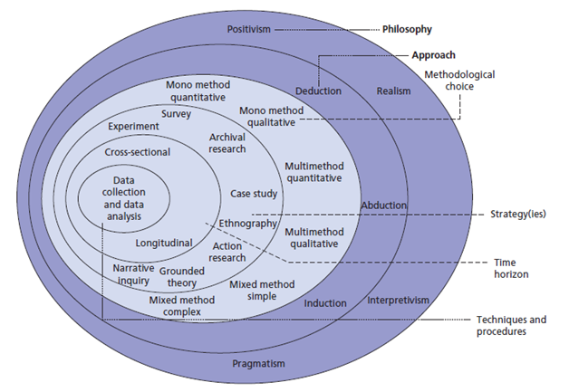
Figure 1 – Research Onion [11]

From this image the philosophy chosen would be interpretivism because most of the data collection will be conducted in interviews and possibly observations.

The approach will be inductive because a specific area of research (subject, lesson, topic) will only be known after the first set of interviews.

The three strategies chosen are –
- Case Study – the research aims to follow a single teacher and the gamification of a single lesson.
- Survey – a questionnaire before and after to test stress levels.
- Experiment – a test to see if the gamified lesson helps to reduce stress.

The interpretivism philosophy has been chosen because there is little to no hard data to analyse as the stress levels felt by teachers is personal and changes form teacher to teacher, even in the same subject. As the data will be collected through interviews and questionnaires the data will need to be analysed and will not be quantifiable as hard data (numbers) would be.

The approach will be inductive because before much of the development and research can be completed a set of interviews will need to be completed to ascertain which subject area would be chosen and which specific area would or can be gamified.

The first strategy is case study because the research will be conducted on a single teacher to see if the stress can be reduced through gamification, without the time deadline it would be better to complete this over multiple subjects using multiple teachers.

The second strategy is survey because the best way to find out what level of stress the teachers are feeling is to either have a questionnaire which would allow for direct comparison (using the Likert scale) or by interview which would not allow for easy direct comparison.

The last strategy is Experiment because the best way to test to see if the gamified lesson is going to reduce the stress caused by behaviour is for the teacher to teach the new lesson. As stress is something that is felt and can’t be easily observed this lesson doesn’t necessarily need to be observed but may only need an interview after.

4.2 - Development Methodology

According to Synopsys [12] the four top methodologies are –
- Waterfall
- Rapid Application
- Agile
- DevOps

Out of these four the method that is going to be followed is Agile.
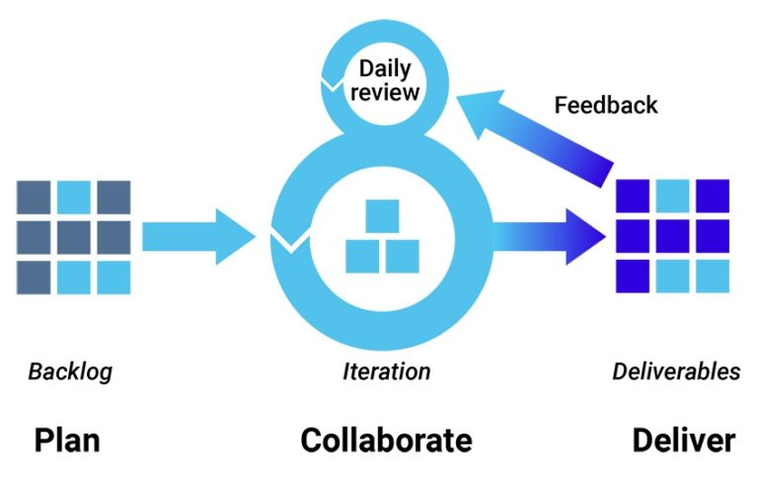
Figure 2 – Agile Method illustration [12]

This method was chosen over the others because of its incremental or iterative nature allowing for small changes to be made at regular intervals, it is also quick and relies in real-time communication with the end user which if they project goes ahead as planned (with the aid of a subject specialist) this will not be a problem.

The waterfall is considered the traditional method [12] and was not chosen because it can be slow due to the rigid structure and it requires clear objectives and stable requirements which the project will not have until the first set of interviews have been completed.

4.3 – Risks

The main risks identified are -
- School refusal to interview teachers
- School refusal to test new lesson
- No access to subject specialist
- School refusal to allow subject specialist to aid in development

These risks would be extremely detrimental to the project and would cause it to fail but can be minimised by asking many different schools if they are willing to participate in this and not just relying on a single school.

The secondary risks identified are –
- Subject teacher sickness
- Personal sickness

These risks would slow the development but can be overcome.

4.4 - Analysis and Deliverables

Interviewing teachers using a Likert scale style questionnaire will allow for simple analysis of the results and will show an easier to understand result when it comes to the stress a teacher feels of each subject, the main problem with this is that stress is personal and is difficult to quantify into numbers as people feel stress differently.

The final deliverable of this project is a gamified lesson that teacher can use in order to reduce the stress associated with the behaviour of children.

the project will be a success if the subject teacher feels less stress while teaching and less stress caused by a lesson.

4.5 – Conclusion

As previously stated there may be some risks that have not been identified but are subject specific especially under the art and design subjects and these will have to be identified after a subject has been identified.

Using the Likert scale when using questionnaires or interviews will allow for better analysis of the success of the project but may take away from the human element. Stress is a very personal feeling so it may be necessary to ignore the Likert scale and just centre on written responses to ascertain a more accurate but more difficult to analyse response.

5 - Resources and Planning

5.1 - Physical Resources

The physical resources that are needed are as follows –
- Visual Studio 2017
- App Game Kit
- Development Space
- Access to subject course material
- Access to a school

These are all the possible physical recourses needed to gamify a basic lesson, but more may be required after a subject has been identified.

5.2 - Human Resources

The human resources that are needed are as follows –
- Project Supervisor
- Subject Specialist
- Teachers to interview

There may be some unidentified human resources which will be identified once the subject has been chosen, these further recourses could be in the form of subject technicians or other support staff that will also have a good understanding of the subject and could prove an invaluable knowledge base on the occasions the main subject specialist is unavailable for consultation.

5.3 – Timeline

Below is a Gantt Chart showing the developmental timeline of the project starting with the proposal and shows the deadline on the project as the 1st of April 2020. This is a preliminary deadline as the actual deadline is unknown but will be before the end of the academic year while allowing time for it to be marked.

The 5 main areas shown are –
- Project Proposal – the written proposal and its deadline which outlines what the project is all about.
- Research Topic – this is necessary to find out which subject will be used through the use of teacher questionnaires and interviews.
- Literature Review - The Literature Review is the first section of the final report and critically analyses the research literature, checking if it can be trusted or used.
- Development - The developing to the project has been allotted the most time due to the fact that it will be completed with a subject specialist alongside there normal teaching hours and Richard Davies’ other commitments
- Final Report - The final report has also been put on the timeline overlapped with development, it is hoped that towards the end of the development stage the work load will be lessoned with only small changes or testing to be completed. It makes sense to start writing the final report at the same time to allow as much time as possible to write this correctly.

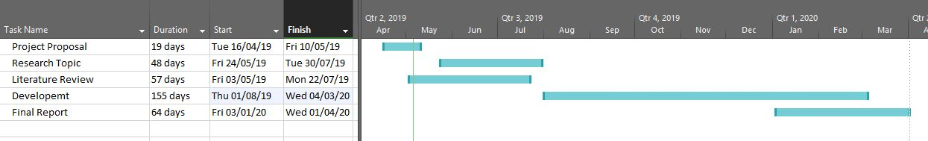
Figure 3 – Gantt Chart of Developmental timeline.

6 - References

[1] | “Secondary,” MW Educationa, [Online]. Available: https://www.theeducationwebsite.co.uk/index.php?page=secondary. [Accessed 25 March 2019].
[2] | H. Clarke, Interviewee, Miss. [Interview]. 10 March 2019.
[3] | M. B.-O. Anushka Asthana, “'Epidemic of stress' blamed for 3,750 teachers on long-term sick leave,” The Guardian, 11 Janurary 2018. [Online]. Available: https://www.theguardian.com/education/2018/jan/11/epidemic-of-stress-blamed-for-3750-teachers-on-longterm-sick-leave. [Accessed 26 April 2019].
[4] | J. Roberts, “Revealed: The seven biggest causes of teacher stress,” tes, 22 November 2018. [Online]. Available: https://www.tes.com/news/revealed-seven-biggest-causes-teacher-stress. [Accessed 27 Feburary 2019].
[5] | S. Willams, Interviewee, Mrs. [Interview]. 20 March 2019.
[6] | J. W. Maag, “Rewarded by Punishment: Reflections on the Disuse of Positive Reinforcment in Schools,” Exceptional Children, vol. 67, no. 2, pp. 173-186, 2001.
[7] | P. Kristin Anderson Moore, “DEFINING THE TERM “AT RISK”,” Research-to-Results, vol. 1, no. 12, p. 1, 2006.
[8] | D. Reisinger, “91 percent of kids are gamers, research says,” CNET, 11 October 2011. [Online]. Available: https://www.cnet.com/news/91-percent-of-kids-are-gamers-research-says/. [Accessed 20 April 2019].
[9] | T. L. K. &. M. M.Grabner-Hagen, “Gamification Questing to integrate Content Knowledge, Literacy, anf 21st Century Learning,” Journal of Adolescent & Adult Literacy, vol. 59, no. 1, pp. 51-61, 2015.
[10] | D. R. Kulman, “Why do Kids Love to Play Video Games?,” Learning Works for Kids, 16 September 2014. [Online]. Available: https://learningworksforkids.com/2014/09/why-do-kids-love-to-play-video-games/. [Accessed 10 April 2019].
[11] | J. Dudovskiy, “The Essence of Research Philosophy,” Research Methodology, 2019. [Online]. Available: https://research-methodology.net/research-philosophy/#_ftn1. [Accessed 25 April 2019].
[12] | S. E. Team, “Top 4 software development methodologies,” synopsys, 28 March 2017. [Online]. Available: https://www.synopsys.com/blogs/software-security/top-4-software-development-methodologies/. [Accessed 25 April 2019].
[13] | “Why Use Games to Teach?,” Science Education Resource Center, 07 May 2018. [Online]. Available: https://serc.carleton.edu/introgeo/games/whygames.html. [Accessed 26 Feburary 2019].
[14] | J. H. H. M. a. M. K. Michael Sailer1, “Psychological Perspectives on Motivation through,” Interaction Design and Architecture(s) Journal, no. 19, pp. 28-37, 2013.

