Question 1
A
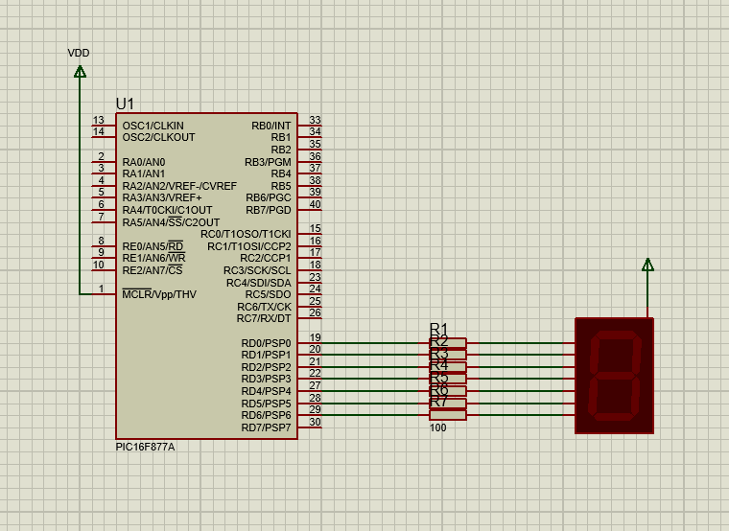
B
#include <16F877A.h>

#use delay(clock=1000000)

unsigned int vals[] = {0xC0, 0xF9, 0xA4, 0xB0, 0x99, 0x92, 0x82, 0xF8, 0x80, 0x90};

int main (void)
{
while (1)
{
for (unsigned int i = 0; i < 10; i++)
{
output_d(vals[i]);
delay_ms(2000);
}
}
return 0;
}

C
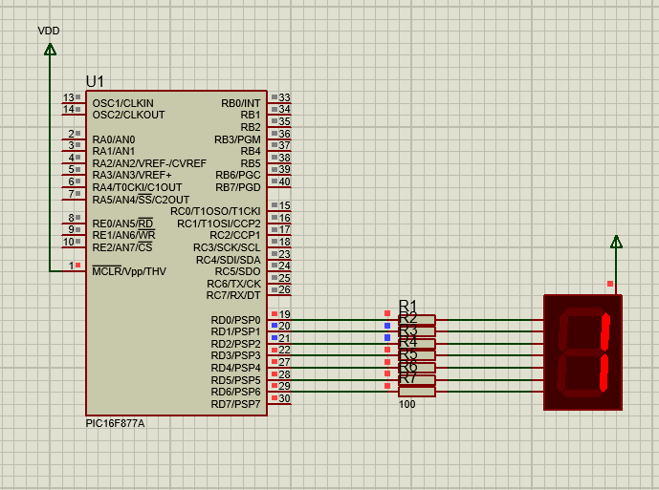
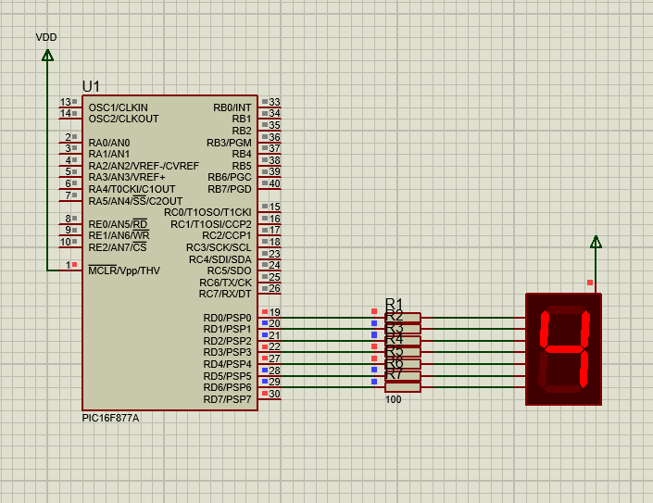
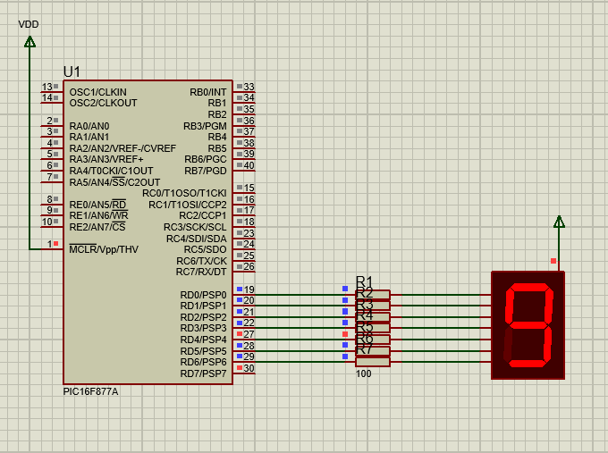
Question 2
A
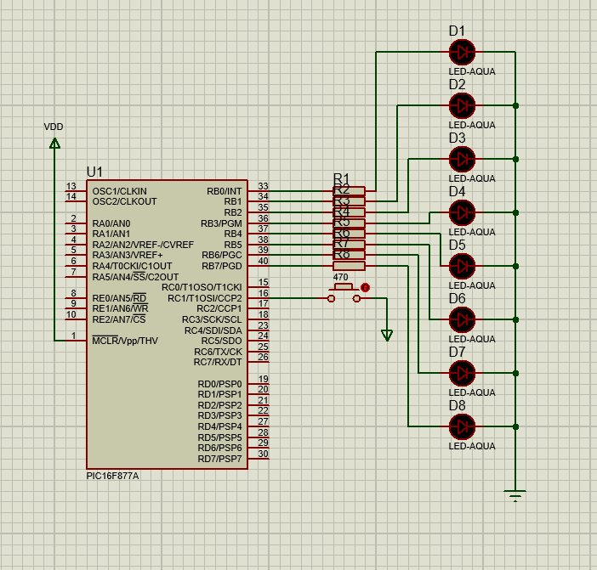
B
int main (void)
{
set_tris_c(0x2);
while (1)
{
if(input(PIN_C1))
output_b(0xFF);
else
output_b(0x0);
}
return 0;
}

C
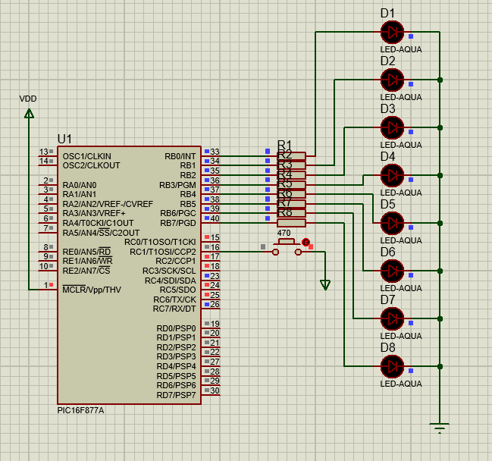
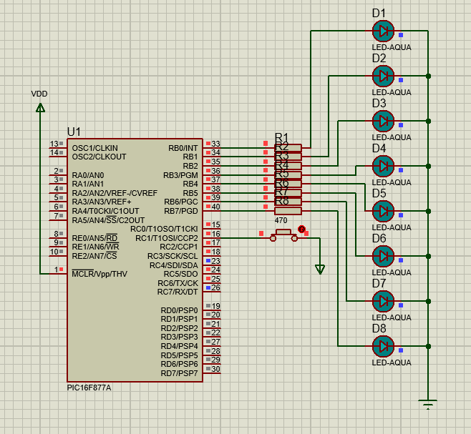

Question 3C
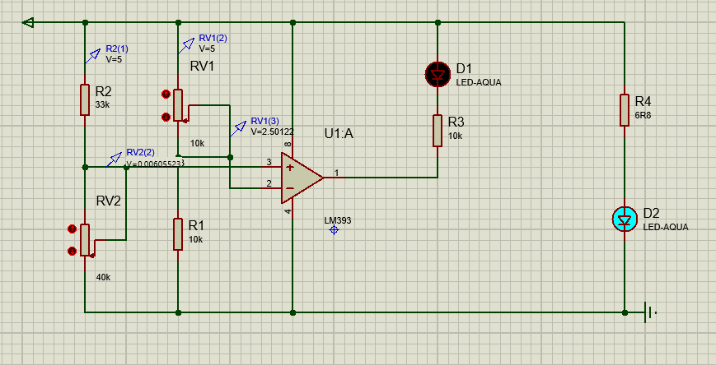

Question 4c


