
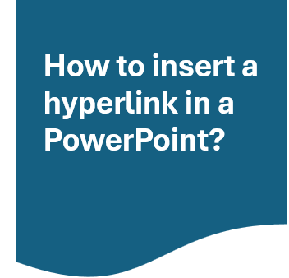
3.Choose the type of
A hyper link is a clickable element, such as text or an image, this allows for the link to take you to another location, like a different webpage or document

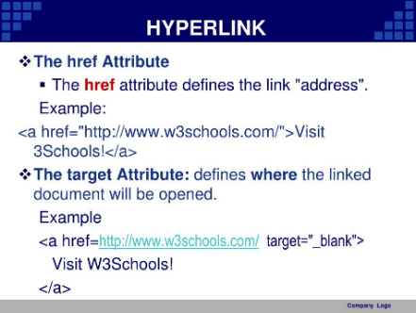
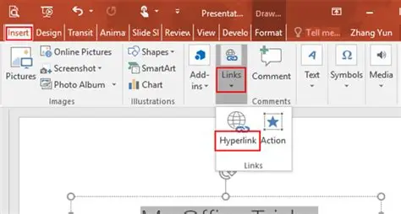

1.Select the text, shape, or picture you want to use as a hyperlink.
2.Go to the Insert tab and click on Link.

3.Choose the type of hyperlink you want to create:
Web Page: Link to a specific website.
Another Document: Link to another PowerPoint presentation.
Email Address: Link to a user's email address.

4. Enter the URL or email address in the appropriate field and click OK.
5. Adjust the hyperlink's appearance by right-clicking it and selecting Edit Link to change the colour or style
Enhanced Navigation: they allow user to navigate through the presentation easily, making it more interactive and user-friendly this allows students/teachers to understand a presentation better as it allow them to press on the link and it will take them straight to the information page or video.
Therefore, hyperlinks can help organize content and structure the presentation, adding depth and relevance to the presentation and guiding the audience through the information in a logical manner. By using hyperlinks in a presentation will it make your presentation look more professional and polished, as it shows that the presenter has considered the audience’s needs and preferences.
How can a hyperlink help in PowerPoint?
Hyperlinks are easy to use and help a lot in PowerPoint and can significantly enhance the interactively and professionalism of your presentations. This allows user tot to navigate seamlessly between different slides, access external resource, or even start an email conversation.
Interactive Table of Contents: create a clickable index slide that lets viewers jump to specific sections of the presentation
Quizzes and Training Modules: add ‘correct’ and Try Again’ slide with hyperlink for engaging learning experience
Clickable Buttons: insert shapes styles as buttons that link to resource, website, or forms, making your presentation more dynamic and user-friendly, by incorporating hyperlinks, you can create more engaging and informative presentation that keeps you audience on track and encourages interaction.

