

Undergraduate assignment feedback form
(to be completed by marker)

Student Name:
Emily Sykes
Module title:  Independent Classics Research Project (HPAH5028) | Student number:  1700547
For completion by marker:
Comments:

Marker’s signature: |  | Date:
Provisional mark:
NB. All marks are provisional until confirmed by the final examination board.

Interpreting the Snake Goddess of Knossos: An Investigation into her Role, Meaning, and Significance in Minoan Religion.
Abstract
The Snake Goddess of Knossos has been a figure of mystery and controversy since Evans first found statuettes of her in the ruins of the Minoan palace in 1903. To this day, she has remained an iconic and recognizable figure of Cretan culture. Evans was quick to identify her as the great Mother Goddess of the Minoans in his provisional excavation report (Evans, 1902-03). However, since then, scholars (Bonney 2011, Boze 2016) have questioned Evans’ interpretation. The Snake Goddess figurine HM65 found in the Palace of Knossos remains the best-preserved example of a number of representations of the goddess. A close analysis of the figurine using the material culture studies approach, as demonstrated by Boivin (2008), reveals important associations and concepts embodied by the goddess about the religious beliefs and practices of the Minoans. This approach explores the symbolism crafted into the figurine and how the figure might have been used in the ritual context of Minoan religion. This research uses an analysis derived from the material culture studies approach and examines the theories and scholarly debates surrounding the Snake Goddess and argues that, while new links can be made with Syrian and other snake iconography, much about the goddess still remains a mystery. Rather than accepting Evans’ simplistic ‘Mother Goddess’ interpretation, there is evidence to suggest that the Minoan snake figurine represents the worship of a creator goddess associated with the fertility of the earth and the people, divination, and connected with the cycle of life and death.

Introduction
The Snake Goddess of Knossos must be seen within the wider world of the Eastern Mediterranean. This enables an interpretation of the goddess as more than simply a Mother Goddess. She can be seen as a central creator goddess, connected with the Underworld, the cycle of life and death, and as a powerful goddess for the fertility of the earth and people.

Discovered by Sir Arthur J. Evans during his excavation from 1902 to 1903 at the Palace of Knossos, the Snake Goddess figurines HM65 and HM63 drew much scholarly attention. Evans was quick to interpret the Snake Goddess as a central Mother Goddess figure of the Minoans, linking her role to fertility and protection. This view has since been challenged and modern scholars are looking at other possible interpretations based on the limited evidence available.

Since the figurines’ discovery, many replicas and copies have been made. Evans was accompanied by Halvor Bagge, who helped in making replicas of the figurines. These artworks have become almost more famous than the originals, and are displayed prominently in museums. Care must be taken to not allow focus to be deflected from the originals when attempting a new interpretation. Some of these replicas were sold during the dig and many other forgeries were created, which add to the difficulty in determining authenticity. In light of this, this research focuses solely on two of the original figurines whose authenticity is not disputed (HM65 and HM63). As highlighted in Bonney’s work, Bagge recreated and replicated faces of the Snake Goddess figurines, as well as other body parts, which cannot be considered authentic.

The main sources on the Snake Goddess include Evans’ provisional excavation report (1902-03). This provides the initial details on the figurines, as well as Evans’ controversial conclusions. Bonney (2011) looks at the Syrian origins of the Snake Goddess, and the links the Minoans had with Syria. Boivin’s ‘Material Cultures, Material Minds’ presents the material culture approach as a way of investigating material objects. This approach looks at physical objects representing symbols and symbolic systems in an intended fashion. With this approach, the investigation into the meanings of the Snake Goddess and her role within Minoan religion finds that overall Evans’ interpretation may be too simplistic. Key to this examination of the goddess is the recognition that the Minoans did not live in an isolated world, but one surrounded by and connected to a variety of other cultures and influences. Extensive and prolonged trade in the Eastern Mediterranean meant that not only goods, but social, cultural, and artistic traditions, were exchanged and shared. Religious ideas cannot be excluded from the many other ideas that were exchanged and aspects of Syrian and Egyptian iconography and religious symbolism can be traced to the figurines found in the Palace of Knossos. Grinsell’s research into breaking objects as part of funerary rites examines the characteristics and purpose of such broken objects, and this sheds light on the significance of the damaged condition of the figurines.

Section 1 - The Snake Goddess Figurine

The Snake Goddess figurine HM65, thought to be votive, was found in the Palace of Knossos, and is currently held in the collection of the Heraklion Archaeological Museum, Iraklion, Crete. This votary figurine embodies a number of ancient Minoan religious beliefs and concepts. The figurine is one of two surviving near-complete examples of the Snake Goddess (with some parts being restored), although there were multiple damaged and incomplete figurines excavated from the site at the same time. She is known as the Snake Goddess, although very little is known about her meaning or place within the Minoan religious sphere. The figurine is thought to originate in the Middle Minoan (MM) IIIB period, but iconography featuring women and snakes then disappears and is entirely missing in the later Neopalatial periods of Cretan art.

Evans’ provisional report of the excavation, shows that the figurine’s head and left arm were missing when discovered. Thus, the description and analysis of the figurine will focus on the original parts to save any complications. Lee highlights that when the figurine was restored, inexplicably, an addition included a cat on her head. This analysis will be primarily of the clothing, the stance of the votary figurine, and the feminine body of the Snake Goddess, and the meanings behind each of these areas; this provides a focused look at the Snake Goddess votary figurine HM65 as well as the meanings behind the choices made when creating her.

To fully analyse the figurine, Boivin’s work, Material Cultures, Material Minds, is used. To summarise the relevant sections of her book, Boivin starts by discussing what the material culture studies approach is, referring back to when it was first used in Hodder’s 1982 work. Boivin argues ‘that material culture needed to be understood as ‘meaningful’ and ‘symbolic’’, and that the approach came to be known as ‘‘functionalist, ‘adaptive’, and ‘scientistic’’. Boivin introduces what she means by the word ‘material’, addressing it as anything the senses can experience, then covers how the term ‘material culture’ is problematic but necessary for her to use:

Its implied emphasis on culture makes it a less than ideal term relative to the points I am making, but it is hard to avoid when it is used to widely and systematically, particularly by archaeologists, to refer to the things, objects, and artefacts, made by people.

Looking at Boivin’s work, a number of elements are very useful for this topic. She uses anthropological examples to argue that ‘cultural cosmologies and understandings are very much rooted in the material and biological worlds’, thus evident in material objects. She explores the ‘semiotic and symbolic approaches to culture and material culture’ by looking at anthropological examples, and continues to use archaeological evidence to look at how material culture has had an effect on people ‘sensually, experimentally, and emotionally’. Boivin considers the ‘agency of matter’; using a range of thinkers including Karl Marx. She claims ‘Matter is not simply at the mercy of human design’, and that the materials from which objects are made have themselves an impact on our experience of an object. This approach provides a fascinating way to examine the choices made by the Minoan artists in their creation of the Snake Goddess.

The clothing of the votary figurine (Fig. 1 and 2) consists of a floor-length layered skirt, a bodice with sleeves, an apron, and a belt. Lady Evans describes the details clearly, saying it comprises ‘seven flounces fastened apparently on a ‘foundation,’ so that the hem of each flounce falls just over the head of the one below it’. The flounces are decorated with vertical stripes, which have no regular width, or regular pattern, and the stripes are separated by darker colours (Fig. 3). The top flounce has two horizontal lines, which, as Lady Evans comments, is ‘probably a ‘heading’ to finish off the flounces’. Crowley looks into the clothing of the Minoan elite in her work, and says that a floor or calf length skirt was typical clothing for women, and that the important women, those carrying special objects such as the Double Axe, at events would be wearing frilled skirts. Crowley also mentions that flounced skirts were often worn by women who served at a shrine or altar. Using Crowley’s information, the Snake Goddess votary figurine may not be seen as a goddess, as Crowley summarises at the end of her work that the most prestigious of clothing to be worn by a woman or goddess was flounced pants, not a skirt.

Lillethun also looks at the Minoan flounced skirt, saying that wearing the skirt is a sign of fertility. This statement certainly fits Evans’ depiction of the votary figurine being a Mother Goddess to the Minoans, which Lillethun supplies evidence for. When she was recreating the floor-length skirt, Lillethun found a large triangle-shaped piece of fabric that fell to the seat of the garment; Lillethun links this back to menstruation and fertility, as it ‘provides an additional layer or surface at the exact location where it would be useful or appropriate in relation to menstruation’. The flounced skirt was a popular choice for the Minoans according to Jones, who comments that this ‘fancier’ option has overshadowed the side-pleated skirt. It is possible that the attention given to the Snake Goddess is responsible for the skewing of our understanding of the relative popularity of the flounced skirt compared to the side-pleated one in the Bronze Age Aegean.

Bonney’s work focuses on Evans’ interpretation of the Snake Goddess, including the Syrian links found, one of which being made with the skirt. To quote, Bonney states ‘examination of the late Middle Bronze Age Syrian Art reveals many parallels for the non-traditional elements of the figurines’. Bonney continues to summarise and use Jones’ work to show what connections there are between Aegean and Levantine art, specifically referencing the Snake Goddess figurines to do so.

The votive figurine HM65 wears a bodice with sleeves, and Lady Evans comments that they are ‘rather longer’ than the typical length a bodice’s sleeves which, during the time of writing, would have ended just before the elbow. From what can be seen there is no pattern, which Lady Evans confirms by saying the material of the bodice is ‘plain’. Along the top of the arm there is a lighter-coloured line, which Lady Evans says could be braiding. She also comments on the ‘rope-like border’ that can be seen around the bodice and the sleeves. There is no top piece to the bodice, leaving the breasts exposed, which is likely what gave Evans his theory of the Snake Goddess being a mother-like figure to the Minoans. Lady Evans finishes her analysis of the bodice by commenting on the lacing of the piece; she says the braiding ‘from which the lacing springs, is not, perhaps, quite so rich’, emphasising that figurine HM65 is just a votary statue compared to the larger Snake Goddess figurine HM63.

Crowley comments on bodices in depictions of and by the Minoans, saying they always expose the breasts, despite it not being very obvious every time. She further explains that at times the way to see this is to look for lines and dots on the arms. Jones uses both the Snake Goddess figurine and a depiction from Thera’s House of Ladies to understand the fastening of the bodice, saying there appears to be laces stitched into the bodice that are also knotted ‘in loops on the dress of Thera’s bending lady’. She concludes by saying that the row of laces on the back ‘may indicate smocking or gathering to ensure a tight fit without custom tailoring’. The bodice emphasises the prominent hips and breasts of the figurine, as well as the small waist; these do the opposite of giving the maternal appearance, rather a sexual one. Chapin mentions that older women are usually depicted in Minoan art as having thicker waists, emphasising that the figurine is a depiction of a younger woman rather than a matured maternal figure. There are no signs of pregnancy or breastfeeding, typical and natural aspects of motherhood, suggesting the Snake Goddess figurines cannot be purely a mother goddess to the Minoans.

Over the skirt is what Lady Evans refers to as a ‘double apron or ‘polonaise’ similar to that of the Goddess’. There is a simple design on the apron, as Lady Evans refers to it as a ‘reticulated pattern, each reticulation being filled with horizontal lines in its upper half’. Jones attempted a recreation of the Snake Goddess votary’s costume, explaining that in order to create the apron she had to cut a U-shaped piece of fabric from two different lengths of cloth and sew them together at the sides to get the double apron. With there being no indication of a fastener on the votary figurine, Jones fitted a drawstring along the inside of the waist band. Jones comments that the apron must have had a meaning to be there, suggesting ‘marking the office of a high priestess’.

Lady Evans mentions there being a belt used in place of the ‘snake girdle of the Goddess’; she makes no other comment on this piece and there is not much scholarship work at all on Minoan belts. Verduci comments that the figurine is wearing a belt that has featured on two more faience figurines found in the Temple Repositories at Knossos as well: ‘a concave belt with out-turned, or flanged, upper and lower edges, decorated with vertical striations’. Verduci comments that this is ‘one of the more interesting depictions of a belt on a Minoan female’, and there is only one other depiction of this belt that can be compared to the votary figurine’s one, being the Necklace Swinger fresco from Thera. To finish the section, Verduci discusses the material of the belt, with options such as it representing gold or copper, as the belt is yellow in colour, or that the belt was made of ‘reinforced fabric that had been dyed yellow’.

Lee aims to look at the gender constructions in Minoan society through the way both men and women dressed, which helps with recognising the role and significance of the Minoan Snake Goddess. Lee refers to Hawkes’ work, saying the way the figurine is dressed is the same way in which Minoan women of high status were; this dress style can also be seen when looking at the Mycenaean wall paintings (Fig. 4), and more.

Gender construction based on analysis of the figurine’s clothing and other Minoan female iconography (wall paintings) is important for developing the understanding of the meaning of the Snake Goddess. Lee suggests that important aspects of status are shown through dress, including status and age. The Snake Goddess is clearly a young woman when looking at other representations of women through Minoan art, and appears in the dress of a high-status woman. Lee states it is not known if women wore such ‘elaborate dress on a regular basis’, she suggests that a more reasonable assumption would be that such clothing would likely only be worn by elite women on ritual occasions.

When Evans identified the Snake Goddess figurine, he also recognised the pattern or ‘code’ as Chapin refers to it as, to aid identifying male and female figures in Minoan art, and claims this is a link to the Egyptians. This pattern consisted of the male figures having red skin, whereas the female figures had white skin. This works with the Snake Goddess figurine HM65, as the breasts and right arm are pale, particularly the breasts. Newman summarises Evans’ findings with this connection, stating:

A relationship thus exists between white skin, breasts, and the breast-bearing bodice, which constructs a female gender identity. When these conditions are not present, the female gender identity does not materialise.

However, according to Newman this pattern does not always work. If the frescoes of the bull leapers were to be looked at using this information, the interpretation would be that they are women. However, there is a lack of breasts and a breast-exposing bodice, which would contradict the interpretation.

The snake itself, as a religious symbol, is interesting for a number of reasons. While we cannot know what connections Minoans made with snakes, Charlesworth suggests that there is strong evidence they are connected with divinity. Stone’s work, When God was a Woman, looks at the myth of Adam and Eve and the idea of a ‘female faith’ and the development of this. She claims that:

Symbols such as serpents, sacred fruit trees and sexually tempting women who took advice from serpents may once have been understood by people of biblical times to symbolize the then familiar presence of a female deity.

Stone discusses Evans’ suggestion that ‘snake tubes’ found in the Temple Repositories were used to feed ‘the sacred serpents that were kept at the sanctuaries of the Cretan Goddess’. If this could be verified, then there is strong evidence that snakes were part of Minoan religious rituals involving the Snake Goddess.

Snake imagery was not unique to the Minoans during the Bronze Age. The Minoan Snake Goddess must be seen within the wider regional context which featured a number of cults and religious practices featuring snakes and snake goddesses and which appear to share symbolic aspects associated with snakes. Charlesworth, in his wide-reaching study on snake symbolism, notes that ‘Long before the Greeks and Romans, Assyrians and Egyptians, as well as others, observe the snake and accorded it with mysterious chthonic knowledge’. He makes reference to many Egyptian gods who take ophidian forms, such as Amun, and the harvest goddess, Thermuthis. Charlesworth suggests that the Minoan goddesses or priestesses were connected with chthonic power, and perhaps helped protect against earthquakes, but more likely were involved in rituals concerning the fertility of the earth. As deities of the underworld, snakes would be important in fertility of the earth, as well as funerary contexts. Wunderlich mentions that those in the Underworld were able to visit the earth at times, and they would appear in the form of a bird, bee, or a snake.

The Snake Goddess within Minoan Religion

Snakes have often been associated with prophecy and oracular practices in the Eastern Mediterranean area. This can be seen in Apollodorus’ retelling of how Apollo went to Delphi where the Oracle’s guardian, ‘the serpent, Python’ attempted to protect her, but Apollo killed it. Snakes have also been associated with divinity in several parts of the region. While significantly later in time, when Olympia was pregnant with Alexander the Great of Macedonia, it is said that Zeus, in the form of a snake, lay beside her as she slept. Philip II stopped sleeping next to his wife, as he did not want to compete with ‘a superior being’. This shows the power with which snakes have been associated, and this continues later into Christianity with the Adam and Eve myth. Burkert writes about snake mythology and the afterlife, specifically that the Greeks believed that people would appear as snakes once they were deceased, seeming to travel between life and death. Burkert also comments that the ‘characteristic vessels of the Bronze Age snake cult, which was clearly a house cult, now appear only in the cult of the dead’. Stone points out that the ancient connection between snakes and goddesses, ‘a picture of a cobra was the hieroglyphic sign for the word Goddess’, for the very early Egyptian Cobra Goddess, Ua Zit.

The Minoan Snake Goddess survives but there is no textual evidence to explain her meaning or place within the Minoan religious sphere. This is despite the fact that the Minoans did write. There are plenty of tablets from Knossos written in the Linear B script, with there being 5000 between Knossos and Pylos. Olsen writes that some of these tablets depict ‘dedications to divinities… among other things’, and that they show a ‘highly gendered society with clear task differentiation between the sexes’. Men are never depicted with children, rather ‘older boys’ who are being trained. The woman’s role was to care for the children, even though Minoan art does not show this side. No information about the Snake Goddess herself stands out on these Linear B tablets, so only contextual evidence can be used to find information on her.

The Minoan world was not an isolated one, existing undisturbed on the island of Crete, instead it is important to understand that the Minoan world was connected in a number of ways to the surrounding peoples and cultures of the Eastern Mediterranean. Two places in particular have been debated among scholars as having had an impact on Crete - Egypt and Syria – and Bonney comments that there is plenty of ‘good evidence of interaction between the Aegean and the Levant during the decades around the construction of the New Palace’. Evans suggests that the worship of the Snake Goddess began around 3000BC, coinciding with the flight of the Egyptian people during the invasions of the time of the First Dynasty of Egypt. Alberti also discusses that the Minoans’ use of faience would be impossible without the Egyptians. Faience contains natron, a mineral which is ‘not locally obtainable’, and manganese was used for the black colouring of the figurines, which was also from Egypt. Bonney draws attention to the letters from the Syrian, Zimri-Lim, expressing his admiration for the art of the Minoans and Mycenaeans. Bonney continues to describe how he ‘acquired Cretan metal work which he almost certainly used as prestige gifts to his contemporaries in the region’. According to Caubet, Zimri-Lim also ordered a ‘“Cretan boat” trimmed with lapis lazuli and the importation from Crete of goods such as shoes, leather belts, and boots’. Trade connections between Crete, Egypt, and Syria undoubtedly also allowed transfer of religious ideas and practices.

The structured deposition of the figurines and their damaged state in deposition indicate the special status they had in life. Grinsell lists reasons for the breaking of objects as a funerary rite, and one of these fits well with the Snake Goddess. Ritual objects are broken in the funerary context, ‘To release the spirit in the object to accompany the dead to the after-life’. In the Temple Repository, the breaking of the figurine may have been to release the spirit of the Goddess, to de-sanctify the worn object before deposition, and the adoption of the next, newer figurine made to replace her. The wearing out of figurines suggests handling during worship. Grinsell identifies several types of ceremonial breaking and includes the ‘identification of sherds from ritually broken pottery’. While the votary figurine is not pottery, rather made of faience, both HM65 and HM63 were found missing their left arm, and the idea of their being deposited as a ritual object is reinforced through their deposition in a temple location.

Stone mentions how the snakes were clearly an ‘integral part of the religious practices’, as they are held in the hands of the figurines as well as being coiled around the bodies. Evidence for actual snakes in the form of the ‘snake tubes’ suggests that perhaps snake handling was part of worship.

Conclusion
This study set out to re-examine the interpretation of the Snake Goddess of Knossos. It aimed to re-evaluate Evans’ Mother Goddess interpretation in light of research from the wider context of the Eastern Mediterranean. The focus on an authentic surviving figurine revealed a representation in the form of an elite young woman. The imagery was more youthful and sexual rather than maternal, suggesting that a Mother Goddess interpretation was too simplistic. The elite nature of the costume suggests a woman of status and ritual authority. The ophidian imagery is likely to have far-reaching significance. Knossos was connected through trade and diplomacy to other cultural influences in the Eastern Mediterranean, including Egypt and Syria. These neighbours had religious traditions featuring snakes associated with goddesses, and the Snake Goddess of Knossos cannot therefore be seen in isolation from these close influences. The meanings and symbolisms of snakes in Egypt and Syria can be seen to overlap and share significant aspects and qualities associated with snakes. Therefore, it is likely that the Snake Goddess of Knossos would also share some of these aspects, in terms of the snake imagery. Snakes are associated with divinity and the Underworld, having chthonic power. Their power to travel between this life and the afterlife may well have made them symbols of fertility and the renewal of life.

The Snake Goddess of Knossos, wielding her snakes, could embody the Creator Goddess with power over life and death and the bringer of fertility to the land and her people. Snakes have been connected with prophecy and divination, which may indicate the nature of rituals and worship involving snakes. Evidence from the excavation of the Palace of Knossos strongly suggests live snakes were involved in ritual practice and undoubtedly, these would be connected with the Snake Goddess. The worn and broken condition of the figurines and their find site within the Temple Repositories strongly suggests the structured deposition of sacred objects no longer in use. The handling of snakes as well as of the Snake Goddess figurines as part of ritual practice is indicated.

A consideration of the wider cultural world, of the Eastern Mediterranean, enables further interpretations to be considered. The Minoan Snake Goddess is unique but is part of a wider system of beliefs shared and intertwined with those of neighbouring cultures.

Further study to explore the extent of religious connections within the region would be desirable, but also of interest would be a cross-cultural ethnographic study of ritual snake handling to shed light on the nature of Minoan worship.

Photographs and Images
Figure 1.
Figure 1. Snake Goddess HM65. Heraklion Archaeological Museum, Iraklion, Crete. Permanent Exhibition. By Emily Sykes, 2018.
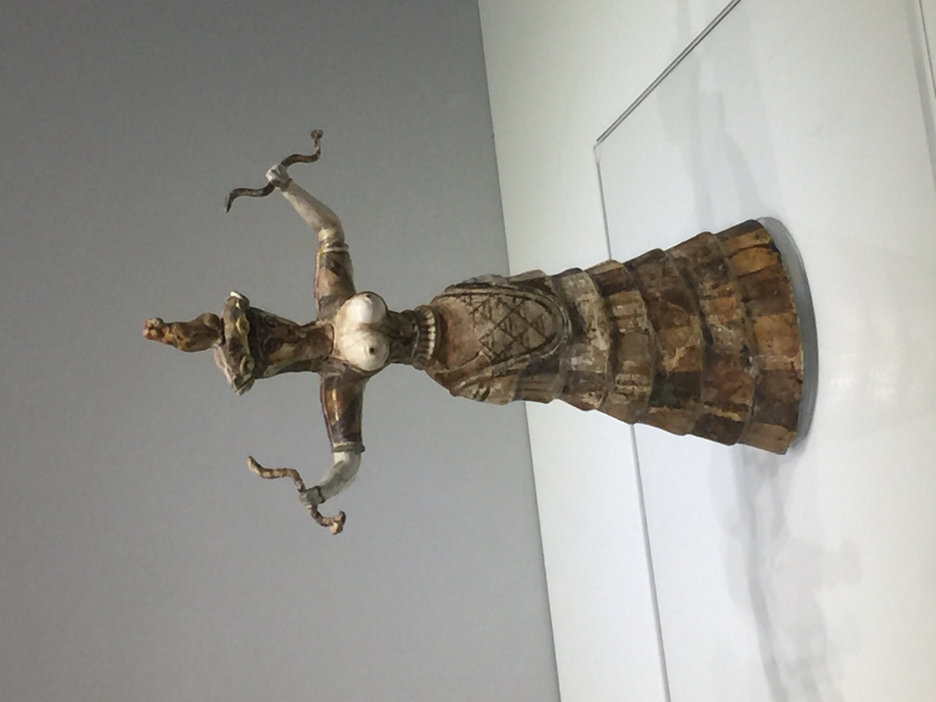

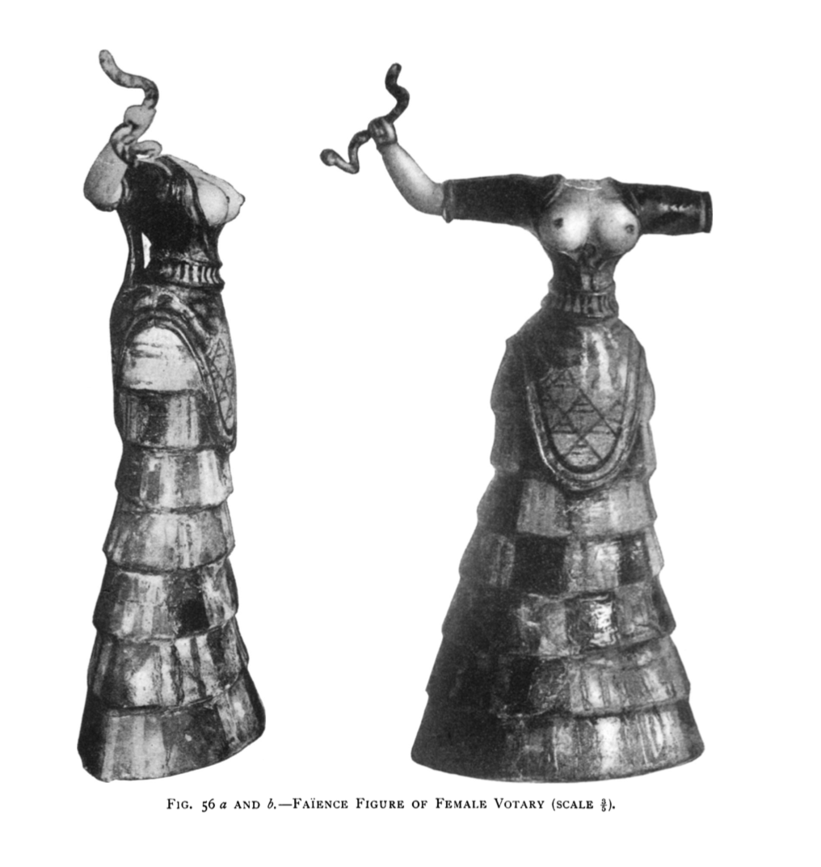
Figure 2.
Figure 2. Snake Goddess HM65. Evans 1902-03. pp. 77.

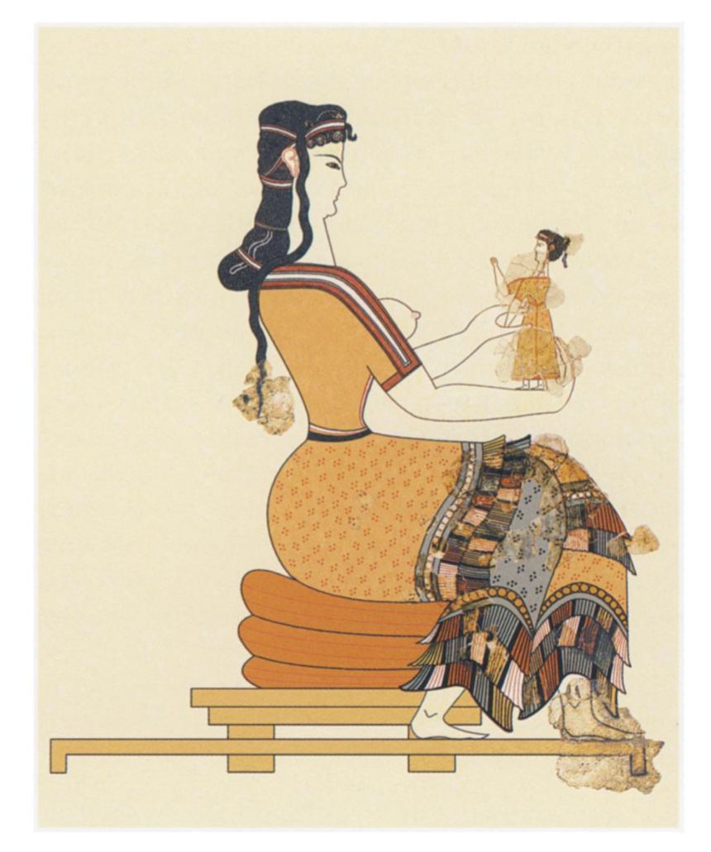
Figure 3.
Figure 3. Reconstruction of goddess with left and right hands holding a miniature (drawing by R. Ruppert). Jones 2009. pp. 315.

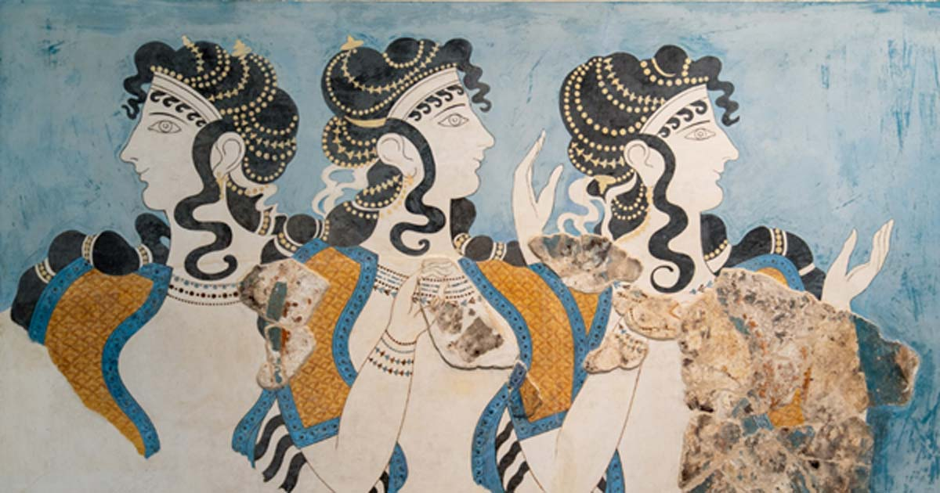
Figure 4.

Figure 4. The Ladies in Blue fresco. Palace of Knossos, Crete. Ancient Origins, February 2019.

Bibliography
Ancient Sources
Apollodorus. The library of Greek Mythology. R. Hard (trans.). 1997. New York: Oxford University Press.
Plutarch. Lives, Volume VII: Demosthenes and Cicero. Alexander and Caesar. B. Perrin (trans.). 1919. Cambridge, MA: Harvard University Press.
Modern Scholarship
Alberti, B. (2001) ‘Faience Goddesses and Ivory Bull-Leapers: The Aesthetics of Sexual Difference at Late Bronze Age Knossos’, World Archaeology, 33(2), pp. 189-205.
Ashmolean Museum of Art and Archaeology (YEAR) snake goddess figurine. Available at: https://www.ashmoleanprints.com/image/322175/knossos-crete-snake-goddess-figurine (Accessed: 5 December 2018).
Boivin, N. (2008) Material Cultures, Material Minds: The Impact of Things on Human Thought, Society, and Evolution. New York: Cambridge University Press.
Bonney, E. M. (2011) ‘Disarming the Snake Goddess: A Reconsideration of the Faience Figurines from the Temple Repositories at Knossos’, Journal of Mediterranean Archaeology, 24(2), pp. 171-190.

Boze, D. (2016) ‘Creating history by re-creating the Minoan Snake Goddess’, Journal of Art Historiography, 15, pp. 15-DB1 [Peer Reviewed Journal].
Burkert, W. (1985) Greek Religion. United States of America: Harvard University Press.
Caubet, A. (1998) ‘The international style: a point of view from the Levant and Syria’, Aegaeum, 18, pp. 105-14.

Chapin, A. P. (2012) ‘Do Clothes Make the Man (or Woman?): Sex, Gender, Costume, and the Aegean Color Convention’, Aegaeum, 33, pp. 297-304.

Charlesworth, J. H. (2010) The Good and Evil Serpent: How a Universal Symbol Became Christianized. United States of America: Yale University Press.

Crowley, J. L. (2012) ‘Prestige Clothing in the Bronze Age Aegean’, Aegaeum, 33, pp. 231-240.
Does anybody still wear that? Notes on (representations of) Minoan female dress in Mycenaean Greece (2017) Recording Archaeology YouTube Channel, 3 February.
Eller, C. (2012) ‘Two Knights and a Goddess: Sire Arthur Evans, Sir James George Frazer, and the Invention of Minoan Religion’, Journal of Mediterranean Archaeology, 25(1), pp. 75-98.
Evans, A. J. (1902-3) The Palace of Knossos: provisional report for the year 1903. The Annual of the British School at Athens 9: 1-153.
Foster, K. P. (1987) ‘Reconstructing Minoan palatial faience workshops’ in Hagg, R. and Marinatos, N. (ed.) The Function of the Minoan Palaces. Stockholm: Paul Astroms Forlag.
Foster, K. P. and Kaczmancsk, A. (1982) ‘X-ray fluorescence analysis of Minoan faience’, Archaeometry, 24(2), pp. 143-157.
Grinsell, L. V. (1961) ‘The Breaking of Objects as a Funerary Rite’, Folklore, 72(3), pp. 475-491.
Hawkes, J. (1968) Dawn of the Gods. Toronto: Chatto and Windus Ltd.
Jones, B. R. (2000) ‘Revealing Minoan Fashions’, Archaeology, 53(3), pp. 36-41.
Jones, B. R. (2009) ‘New Reconstructions of the “Mykenaia” and a Seated Woman from Mycenae’, American Journal of Archaeology, 113(3), pp. 309-337.
Jones, B. R. (2016) ‘The Three Minoan ‘Snake Goddesses’’, in Koehl, R. (ed.) Studies in Aegean Art and Culture: A New York Aegean Bronze Age Colloquium in Memory of Ellen N. Davies. Philadelphia: INSTAP Academic Press.
Lapatin, K. D. S. (2001) ‘Snake Goddesses, Fake Goddesses’, Archaeology, 54(1), pp. 33-36.
Lee, M. M. (2000) ‘Deciphering Gender in Minoan Dress’, in Rautman, A. E. (ed.) Reading the Body: Representations and Remains in the Archaeological Record. Philadelphia: University of Pennsylvania Press.
Lillethun, A. (2012) ‘Finding the Flounced Skirt (Back Apron)’, Aegaeum, 33, pp. 251-254.
Museum of Fine Arts Boston (2019) Artwork: Statuette of a snake goddess. Available at: https://www.mfa.org/collections/object/statuette-of-a-snake-goddess-150499 (Accessed on: 5 December 2018).
Newman, A. N. (2017) ‘Queering the Minoans: Gender Performativity and the Aegean Colour Convention in Fresco Painting at Knossos’, Journal of Mediterranean Archaeology, 30(2), pp. 213-236.
Olsen, B. A. (1998) ‘Women, Children and Family in the Late Aegean Bronze Age: Differences in Minoan and Mycenaean Constructions of Gender’, World Archaeology, 29(3), pp. 380-392.
Panagiotaki, M. (1993) ‘The Temple Repositories of Knossos: New Information from the Unpublished Notes of Sir Arthur Evans’, The Annual of the British School at Athens, 88, pp. 49-91.
Prent, M. (2004) ‘Cults activities at the Palace of Knossos from the end of the Bronze Age: continuity and change’, British School at Athens Studies, 12, pp. 411-419.
Stone, M. (1976) When God was a Woman. United States of America: Harcourt Brace Jovanovich, Publishers.
Verduci, J. (2012) ‘Wasp-Waisted Minoans: Costume, Belts and Body Modification in the Late Bronze Age Aegean’, Aegaeum, 33, pp. 639-646.
Wunderlich, H. G. (1983) The Secret of Crete. America: Macmillan Publishing Co.

Evans 1902-03: 85.
Boze 2016; Eller 2012; Jones 2016.
Bonney 2011: 173.
Ashmolean Museum of Art and Archaeology: University of Oxford; Museum of Fine Arts Boston.
Bonney 2011: 173.
Evans 1902-03: 74-87.
Bonney 2011: 171-190.
Boivin 2008: 30-180.
Grinsell 1961: 475-491.
Evans 1902-03: 74-76.
Evans 1902-03: 79.
Jones 2016: 93.
Bonney 2011: 173.
Evans 1902-03: 75.
Lee 2000: 115.
Boivin 2008: 30-180.
Boivin 2008: 10.
Boivin 2008: 10.
Boivin 2008: 26.
Boivin 2008: 26.
Boivin 2008: 26.
Boivin 2008: 50.
Boivin 2008: 27.
Boivin 2008: 27.
Boivin 2008: 27.
Boivin 2008: 146.
Boivin 2008: 27.
Boivin 2008: 27.
Evans 1902-03: 80.
Evans 1902-03: 80.
Crowley 2012: 233.
Crowley 2012: 236.
Crowley 2012: 236.
Crowley 2012: 237.
Lillethun 2012: 251.
Lillethun 2012: 253.
Jones 2012: 221.
Bonney 2011: 179.
Evans 1902-03: 81.
Evans 1902-03: 81.
Evans 1902-03: 81.
Evans 1902-03: 81.
Evans 1902-03: 81.
Crowley 2012: 234.
Crowley 2012: 234.
Jones 2000: 39.
Jones 2000: 39.
Chapin 2012: 298.
Evans 1902-03: 80.
Evans 1902-03: 81.
Jones 2000: 39.
Jones 2000: 39.
Jones 2000: 39.
Evans 1902-03: 81.
Verduci 2012: 642.
Verduci 2012: 642.
Verduci 2012: 642.
Lee 2000: 114.
Thaler (Recording Archaeology): 00:45-00:54.
Lee 2000: 121.
Chapin 2012: 297.
Newman 2017: 213.
Evans 1902-03: 77.
Newman 2017: 217.
Newman 2017: 229.
Stone 1976: 198.
Stone 1976: 200-201.
Charlesworth 2010: 243.
Charlesworth 2010: 243.
Wunderlich 1983: 293.
Apollod. 4.1
Plut. Alex. 2.6
Stone 1976: 197.
Burkert 1985: 195.
Burkert 1985: 195.
Stone 1976: 201.
Olsen 1998: 383.
Olsen 1998: 383.
Olsen 1998: 384.
Olsen 1998: 381.
Bonney 2011: 178.
Stone 1976: 201.
Alberti 2001: 196.
Foster 1987: 287.
Foster and Kaczmancsk 1982: 150.
Bonney 2011: 179.
Caubet 1998: 106-108.
Bonney 2011: 179.
Grinsell 1961: 476.
Grinsell 1961: 478.
Panagiotaki 1993: 54.
Stone 1976: 200.

