Premium Inn Hotel
Student Name: Luminita Malanciuc
Student ID:2211340
Module title: Sustainable Hospitality and Tourism Management
Module code: BMIH5006
Lecture’s name: Lissa Bassler
Date: 03/06/2024

Table of Contents
Introduction 3
Implementation of Sustainable Accreditation 3
Carroll’s Pyramid of CSR 5
Benefits and Challenges of the Sustainable Options 8
Future Aspects for the Hotel 9
References 11

Introduction
The report reflects on the implementation of the sustainable effects in the services of Premium Inn hotel that is located in the UK. There are different policies that are used to maintain successful position in the competitive industry (Sun et al., 2020). The benefits and challenges are implemented to learn about possibilities in the services to Premium In hotel. Sustainability plays a greater part in the hotel industry that cannot be overstated. Sustainability is a considered as the definite approach that is applied to make balances in the economic growth, environmental management through conservation, and maintenance of the social responsibility. Oriade et al. 92021) stated that the hotel industry in the UK is particularly applying the sustainable features through using significant environmental impact, with the provision of the higher energy, and water consumption that is contributing towards the environmental deterioration internationally.

Implementation of Sustainable Accreditation
The premium Inn hotel is introducing soon to a general public, to start a business of a hotel it is mandatory task to go through with all the system which gives benefits to a business as well as to a country (Olya et al., 2021). The country benefits is the another name of a person’s benefits who are living there, a clean and good environment in beneficial for each human living in the surrounding, there are many environmental factors which help to create a green and clean environment with the help of opening a hotel.
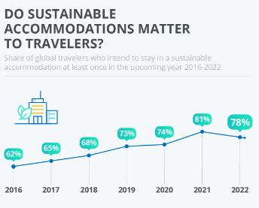
Figure 1: Customer Preference towards Sustainable Hotels in the UK
Source: (Haldorai et al., 2022)
Consumption of Power Supply: It is the first cause of the some country who are going to a downfall who do not have an electricity creating material and inside the country and they are buying it from outside, so it is difficult for them if someone opens the big project and expanding most of the power energy there (Moise et al., 2021). The premium hotel inn can use a low volt lights, and different things which gives shining itself at night, also they can use solar system which the solar is taking wind or air to charge the battery and giving a double energy supply as the need.
Wastage Materials: The organization can recycle the things which are going on wastage items and giving a bad environment like the plastic bottles and the bags can be recycle easily which causes a good start up of using the bags on low cost also the environment will be become neat and clean (Mandić and Petrić, 2021).
Giving Local Materials Priority: It can create a big difference in organisation that offers economics of the country if the organization can use the materials and food items which are inventing locally and do not buy the things by export, if the local products are selling efficiently there is high chance that the organizations can give benefits to a country economic growth.
Efficiency of Water: The water efficiency can be earn if we use a dam and little river water by recycling it and also to slow down the taps of washroom and kitchen to use water with proper management, also can use tissue papers and different mops for floors which consumes less water as compared to other water chores. The less water usage is beneficial for the country and also the surrounding humans who are living, they can use the water easily and have not to survive without water (Floričić 2020).

Carroll’s Pyramid of CSR
The Carroll Pyramid model is considered effective for the provision of the wider description using the framework for the management of the corporate social responsibility (CSR). The model is applied to the services of Premium Inn hotel for making enhancement in the sustainable practices (Duric and Potočnik Topler, 2021).
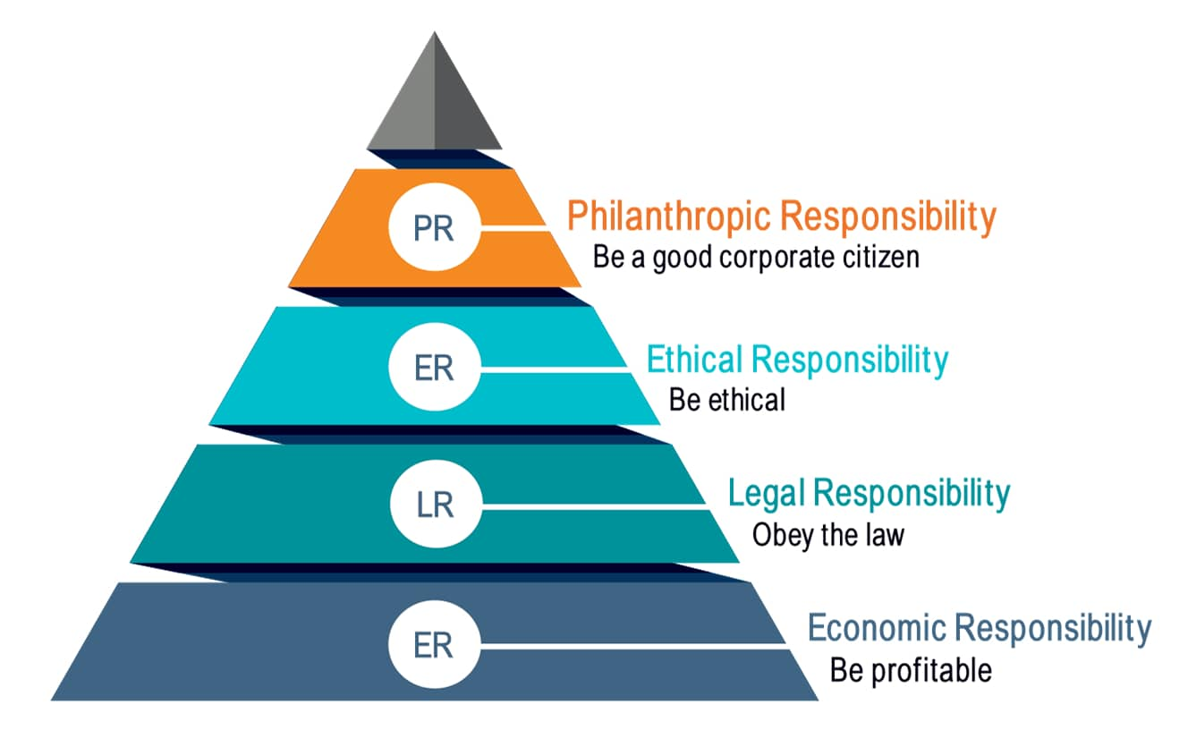
Figure 2: Carroll’s Pyramid of CSR
Source: (dos Santos et al., 2020)
Chung (2020) elaborated that the pyramid is associated with four different dimensions such as economic, legal, ethical, and philanthropic, with the implication of the environmental responsibility and providing definite component of the fulfilment of the ethical dimension. Some of the common ways applied on the services of the Carroll Pyramid model are defined as under:
Economic Dimension
It seems in implementing definite resources for the energy-efficient technologies and make relevant practices that are helpful for the reduction in the energy consumption and costs. It is considered as the potential source for the economic dimension.
The adaptation of the local suppliers helps in making efficiency in the food and different essential services for the reduction in the carbon footprint of the hotel and provide effective support local communities that are accurately aligned with the possible economic dimension.
Legal Dimension
Premium Inn hotel must comply with the implication of the environmental regulations and standards that are fulfilled using definite sustainable practices and related certifications. The possibilities are aligned with possible legal dimensions (Boronat-Navarro and Pérez-Aranda 2020).
Ethical Dimension
The hotel needs consumption of the significant amounts of energy and water that are also imposing negatively impact on the environment. The implementation in the sustainable practices seems in reducing the energy consumption, increase in the renewable energy sources, and make definite resources for the conserving water for reducing the carbon footprint of hotels and make aligning with the ethical dimension. The hotel also needs engagement in the community involvement projects with adopting different cultural values and make contribution to the long-term value with positive social impact that is aligning with the potential ethical dimension.
Philanthropic Dimension
Premium Inn hotel needs support from the local community within the development projects that seems in contributing to the long-term value and make positive impact to the social practices that are aligned with the definite philanthropic dimension.
Environmental Dimension
The hotel needs adaptation of the green manufacturing processes, green supply chain management, and green production that are used for the reduction in the environmental impact and make aligning with the definite system of the environmental dimension. It needs obtaining of the green certifications that are useful for making the demonstration for a hotel's commitment towards sustainability and make attraction to the conscious customers towards environment. It seems in aligning with the definite environmental dimension (Assaker, 2020).
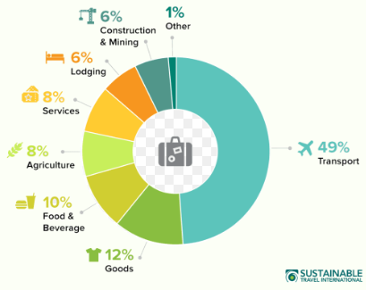
Figure 3: Sustainability in the UK Hotel Industry
Source: (Asadi et al., 2020)
There must be a positive corporate image that is essential for hotels to determine the long-term sustainable growth and make effective resources for the competitive advantage. Hotel must adopt the sustainable practices for making improvements in the corporate image and reputation that are aligned with the corporate image dimension (Aboramadan et al., 2021). The hotel needs adaptation of the innovative strategies like management of the organizational innovation for the enhancement in the performance and competitiveness for successful implementation of the sustainable effects. The hotel management should educated the guests regarding sustainable practices and make engagement with the community projects that seems enhancing the culture of sustainability within the hotel and make alignment with the philanthropic dimension. Abdou et al. (2020) illustrated that it is essential to make definite engagement of the employees in the provision of the sustainable initiatives for make increase in the sustainable satisfaction and retention for the provision of the ethical dimension.

Benefits and Challenges of the Sustainable Options
The business and a daily live operations all have some benefits and some disadvantages too, the benefits are:
As the discussion went above the usage of the wastage material will be the great source of the organization which is beneficial to control the cost ratio for example it reduces an amount consumption by using a full new products which are costing them high (Sun et al., 2022). The water process which the organization can produce a pure water by recycle it from a dam also be an advantage for the country as well as Premium hotel Inn they do not have to buy expansive water from outside and by this they do not have to take huge amount from the customers who check inn to the hotel. By doing all this recycling thing the hotel will give a good message to a public which is advantageous for the hotel to set their brand name on public’s mind also it gives an attractive news for the media to spread it all over which will increase their clients too.
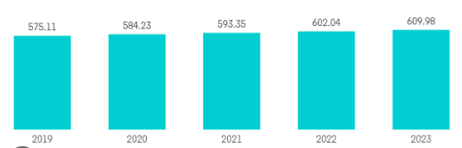
Figure 4: Revenue of Premium Inn Hotel after Sustainable Initiatives
Source: (Papademetriou et al., 2023)
The another benefit the hotel can get is giving their customers local food which are preparing inside the country and the ingredients are preparing locally, it is cost efficient and also can be organic which the organization knows what it mixing inside the food, another part is the huge benefit for the food making agency or a small business of a food who can become the team of hotel for making food and it can be the dawn for them too (Haldorai et al., 2022).
There are some challenges too which to face to have developed a sustainably by a hotel and some of them are:
The high cost of investment can be spend by the owner initially by which they buy a new technology machines and also hire the employees with high salary who know how to work with efficiently and eco-friendly, also by giving the employees training about sustainability also cost them high. Another challenge is to satisfy all the customers by using local products and in house making of food, some the customers want everything as per their standard and will not compromise on less ever (Floričić, 2020). They want everything according to their need and which is of high brand. The products cost ratio is also a key challenge the fluctuation in the cost of products can cause the hotel inn organization to think about it every time how to save the money from another side. The products which the hotel are delivery from inside the country and are cost efficient can be checked on a daily basis a full team the management will must have to engage on it, for not a single mistake a company can afford and this team creating cost them high as per their eco-friendly budget (dos Santos et al., 2020).

Future Aspects for the Hotel
The future of the hotel business is cut and clear it has gone through with many of the majors which effect the economy stability also work on the country benefits and the economic growth too. The hotel companies have follows several keys to adopt a todays technologies these are as follows:
The eco stable system emerges a good affect in countries development and also can give an amazing future to an organization (Chung, 2020). The reuse of plastic bags and bottles after recycling it cause a budget friendly process. Also by using the paper bags can discard easily and can give a neat and clean environment in the surroundings. Moreover, the technology can be used in the checking system of the hotel, the step of every person can be saved in CCTV recording also the card check in check out system becomes more easy and timeless work which the customer can do fast, the mobile application also gives a customer’s satisfactory feedback, they can book their room or food with one touch mobile app (Boronat-Navarro and Pérez-Aranda, 2020).
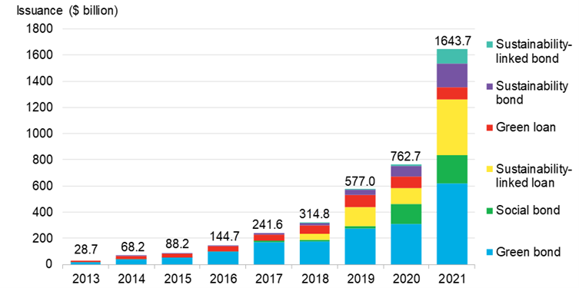
Figure 5: Green Financing in Hotel Industry UK
Source: (Sun et al., 2022)
The hotel can also give a different setups for a customer’s where they can do their office work peacefully, a different activity areas a gym swimming pool area, by all this the customer get the stress out and focuses on their jobs which affect the country’s betterment. The important part which gives the sustainability to a hotel by technology is using the different machines and robot style machines which can do cleaning, servicing and all the service related work which can be done after a customer check out and before another customer to check inn in the room, this robot machinery can work full time without taken of any revert cost (Asadi et al., 2020). Also the cleaning the room by machinery can cause a better cleaning as by the human, it causes more chances of not become ill and other health issue causes by a dirty environment. A system can be enhanced by the non-touch system for entrance and exit the room, people are more preferring the non-touch system because of the pandemic faced last few years. The customer importantly looking for a hotels and other restaurants where they believe the full of hygienic food is provided which do not destroy their health, also the wellbeing of the customer is first priority for them they want full of hygienic and clean environment for them and their children too (Abdou et al., 2020).
References List

Abdou, A.H., Hassan, T.H. and El Dief, M.M., 2020. A description of green hotel practices and their role in achieving sustainable development. Sustainability, 12(22), p.9624.
Aboramadan, M., Kundi, Y.M. and Farao, C., 2021. Examining the effects of environmentally-specific servant leadership on green work outcomes among hotel employees: the mediating role of climate for green creativity. Journal of Hospitality Marketing & Management, 30(8), pp.929-956.
Asadi, S., Pourhashemi, S.O., Nilashi, M., Abdullah, R., Samad, S., Yadegaridehkordi, E., Aljojo, N. and Razali, N.S., 2020. Investigating influence of green innovation on sustainability performance: A case on Malaysian hotel industry. Journal of cleaner production, 258, p.120860.
Assaker, G., 2020. The effects of hotel green business practices on consumers’ loyalty intentions: an expanded multidimensional service model in the upscale segment. International Journal of Contemporary Hospitality Management, 32(12), pp.3787-3807.
Boronat-Navarro, M. and Pérez-Aranda, J.A., 2020. Analyzing willingness to pay more to stay in a sustainable hotel. Sustainability, 12(9), p.3730.
Chung, K.C., 2020. Green marketing orientation: Achieving sustainable development in green hotel management. Journal of Hospitality Marketing & Management, 29(6), pp.722-738.
dos Santos, R.A., Méxas, M.P., Meirino, M.J., Sampaio, M.C. and Costa, H.G., 2020. Criteria for assessing a sustainable hotel business. Journal of Cleaner Production, 262, p.121347.
Duric, Z. and Potočnik Topler, J., 2021. The role of performance and environmental sustainability indicators in hotel competitiveness. Sustainability, 13(12), p.6574.
Floričić, T., 2020. Sustainable solutions in the hospitality industry and competitiveness context of “green hotels”. Civil Engineering Journal, 6(6), pp.1104-1113.
Haldorai, K., Kim, W.G. and Garcia, R.F., 2022. Top management green commitment and green intellectual capital as enablers of hotel environmental performance: The mediating role of green human resource management. Tourism Management, 88, p.104431.
Mandić, A. and Petrić, L., 2021. The impacts of location and attributes of protected natural areas on hotel prices: Implications for sustainable tourism development. Environment, development and sustainability, 23(1), pp.833-863.
Moise, M.S., Gil-Saura, I. and Ruiz Molina, M.E., 2021. The importance of green practices for hotel guests: does gender matter?. Economic research-Ekonomska istraživanja, 34(1), pp.3508-3529.
Olya, H., Altinay, L., Farmaki, A., Kenebayeva, A. and Gursoy, D., 2021. Hotels' sustainability practices and guests' familiarity, attitudes and behaviours. In Sustainable Consumer Behaviour and the Environment (pp. 43-61). Routledge.
Oriade, A., Osinaike, A., Aduhene, K. and Wang, Y., 2021. Sustainability awareness, management practices and organisational culture in hotels: Evidence from developing countries. International Journal of Hospitality Management, 92, p.102699.
Papademetriou, C., Anastasiadou, S. and Papalexandris, S., 2023. The effect of sustainable human resource management practices on customer satisfaction, service quality, and institutional performance in hotel businesses. Sustainability, 15(10), p.8251.
Sun, H., Samad, S., Rehman, S.U. and Usman, M., 2022. Clean and green: the relevance of hotels' website quality and environmental management initiatives for green customer loyalty. British Food Journal, 124(12), pp.4266-4285.

