Name:_Christian Evans_______________________________

Student Number: _2526458___________________
__________________________________________________________

WORKSHEET 5 – TESTING (Pointless)

For this worksheet, there are several possible approaches to the problem.
Create your own test set to show the strengths and/or limitations of your solution. Use as many of the boxes below as you need.

Test 1: Player 1 types “Football”

Screenshot(s) of output:
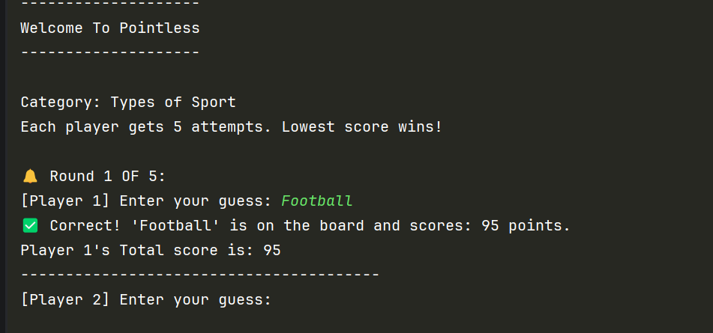
Result: Did the programme behave as expected ie syntactically and logically correct?
YES (delete as appropriate)
If NO, what went wrong?

Test 2: Player 2 types a number on their guess.

Screenshot(s) of output:
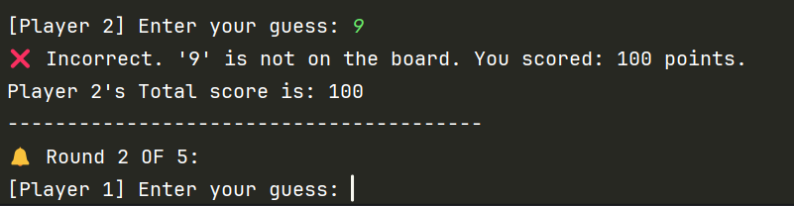
Result: Did the programme behave as expected ie syntactically and logically correct?
YES (delete as appropriate)
If NO, what went wrong?

Test 3: Player 2 types “Tennis”

Screenshot(s) of output:
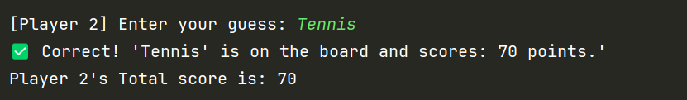
Result: Did the programme behave as expected ie syntactically and logically correct?
YES (delete as appropriate)
If NO, what went wrong?

Test 4: Player 1 types “Cheese Rolling”

Screenshot(s) of output:
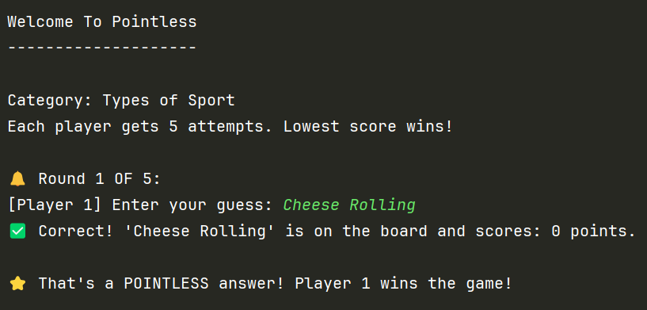
Result: Did the programme behave as expected ie syntactically and logically correct?
YES (delete as appropriate)
If NO, what went wrong?

Test 5: Player 2 types “Swimming”

Screenshot(s) of output:
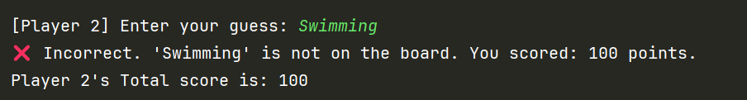
Result: Did the programme behave as expected ie syntactically and logically correct?
YES (delete as appropriate)
If NO, what went wrong?

Test 6: Player 1 types “cRiCket”

Screenshot(s) of output:
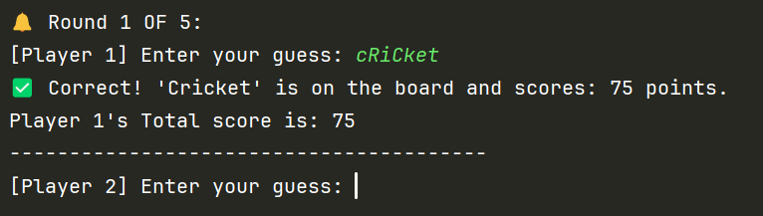
Result: Did the programme behave as expected ie syntactically and logically correct?
YES (delete as appropriate)
If NO, what went wrong?

Test 7: Player 1 types a “Football” on round 2 after entering it on the first round

Screenshot(s) of output:
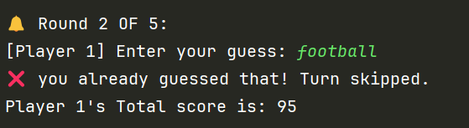
Result: Did the programme behave as expected ie syntactically and logically correct?
YES (delete as appropriate)
If NO, what went wrong?

Test 8: Player 2 types a “Tennis” on round 2 after guessing it on the first round

Screenshot(s) of output:
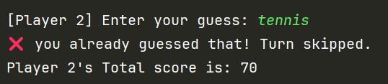
Result: Did the programme behave as expected ie syntactically and logically correct?
YES (delete as appropriate)
If NO, what went wrong?

Test 9: Player 1 types “Fencing” on round 1 and then Player 2 guesses “Fencing” on their turn

Screenshot(s) of output:
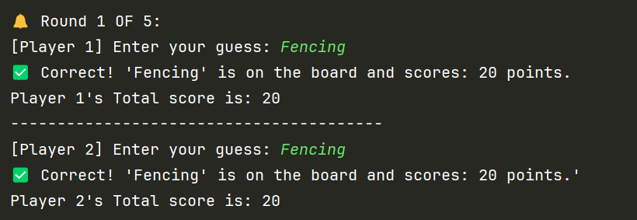
Result: Did the programme behave as expected ie syntactically and logically correct?
NO (delete as appropriate)
If NO, what went wrong?
If player 1 has guessed an answer and scored points from that answer, then player 2 shouldn’t be able to guess the same answer and score points.

Test 10: Both players complete all 5 rounds without a POINTLESS answer.

Screenshot(s) of output:
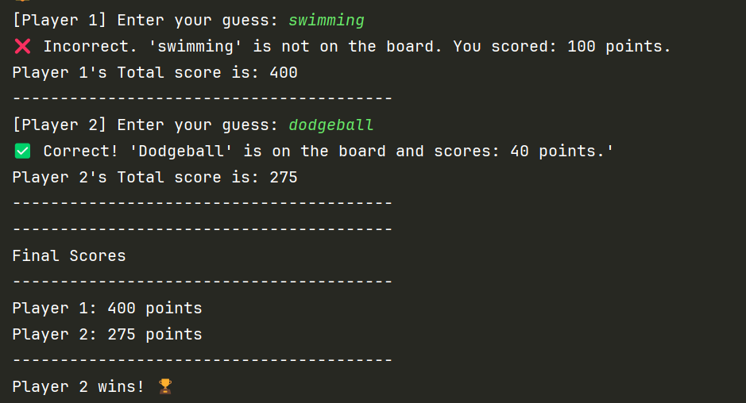
Result: Did the programme behave as expected ie syntactically and logically correct?
YES (delete as appropriate)
If NO, what went wrong?

Test 11: Player enters “ ” empty string for answer.

Screenshot(s) of output:
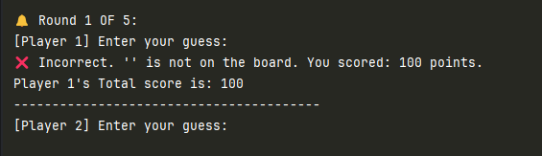
Result: Did the programme behave as expected ie syntactically and logically correct?
NO (delete as appropriate)
If NO, what went wrong?
The user should be informed that they must enter a guess.

Final code:

[Copy and paste your code here – note, do not use a screenshot.

Note that there is no “before” and “after” code for this Worksheet because it is “Open” – not done in class. Therefore just post your final code below]

def checkGuess(userGuess, dictionary):
cleanGuess = userGuess.lower()
for sport in dictionary:
if sport.lower() == cleanGuess:
return dictionary[sport], sport, True
return 100, userGuess, False
def playGame():
sportAnswers = {
"Football": 95,
"Rugby": 85,
"Cricket": 75,
"Tennis": 70,
"Darts": 60,
"Basketball": 50,
"Dodgeball": 40,
"Rounders": 30,
"Fencing": 20,
"Cheese Rolling": 0,
"World Conker Championships": 0,
"Marbula One": 0
}
maxGuesses = 5
score1 = 0
score2 = 0
guesses1 = []
guesses2 = []
print("--------------------")
print("Welcome To Pointless")
print("--------------------\n")
print("Category: Types of Sport")
print(f"Each player gets {maxGuesses} attempts. Lowest score wins!\n")
for roundNum in range(1, maxGuesses + 1):
print(f"🔔 Round {roundNum} OF {maxGuesses}:")
guess1 = input("[Player 1] Enter your guess: ").strip()
while guess1.lower() == "":
print("You have to enter something!")
guess1 = input("[Player 1] Enter your guess: ").strip()
if guess1.lower() in guesses1:
print("❌ you already guessed that! Turn skipped. You scored: 100 points.")
points = 100
elif guess1.lower() in guesses2:
print("Player 2 has already guessed that! Turn skipped. You scored: 100 points.")
points = 100
else:
guesses1.append(guess1.lower())
points, properName, isCorrect = checkGuess(guess1, sportAnswers)
if isCorrect:
print(f"✅ Correct! '{properName}' is on the board and scores: {points} points.")
if points == 0:
print("\n⭐ That's a POINTLESS answer! Player 1 wins the game!")
return
else:
print(f"❌ Incorrect. '{guess1}' is not on the board. You scored: 100 points.")
points = 100
score1 += points
print(f"Player 1's Total score is: {score1}")
print("-" * 40)
guess2 = input("[Player 2] Enter your guess: ").strip()
while guess2.lower() == "":
print("You have to enter something!")
guess2 = input("[Player 2] Enter your guess: ").strip()
if guess2.lower() in guesses2:
print("❌ you already guessed that! Turn skipped. You scored: 100 points.")
points = 100
elif guess2.lower() in guesses1:
print("Player 1 has already guessed that! Turn skipped. You scored: 100 points.")
points = 100
else:
guesses2.append(guess2.lower())
points, properName, isCorrect = checkGuess(guess2, sportAnswers)
if isCorrect:
print(f"✅ Correct! '{properName}' is on the board and scores: {points} points.")
if points == 0:
print("\n⭐ That's a POINTLESS answer! Player 2 wins the game!")
return
else:
print(f"❌ Incorrect. '{guess2}' is not on the board. You scored: 100 points.")
points = 100
score2 += points
print(f"Player 2's Total score is: {score2}")
print("-" * 40)
print("-" * 40)
print("Final Scores")
print("-" * 40)
print(f"Player 1: {score1} points")
print(f"Player 2: {score2} points")
print("-" * 40)
if score1 < score2:
print("Player 1 wins! 🏆")
elif score2 < score1:
print("Player 2 wins! 🏆")
else:
print("It's a draw 🤝, brilliant play from both.")
playGame()

