Student Name: Lauren Thomas

P number: 2305489

Programme of study: Graphic Design

Module: Ways of perceiving (ADDA4023/C)

Essay: Curating an imaginary exhibition

Word count: 1377

Tutor name: Martin Bush

Curating an Imaginary Exhibition:
Threads of Change: A journey towards sustainable fashion

My exhibition will be on the topic of ‘sustainable fashion’. We are in a world where trends are changing all the time and the fashion industry has undergone a transformative shift, due to growing awareness of the environment. The colour of clothing is the main element in fashion, this is one of the reasons that causes environmental problems. The substituting fossil fuels that is in the production of clothes can be carried through renewable energy; nevertheless, these are crucial for manufacturing many textile materials, this includes textile colorants. [1] The term sustainable fashion would be used to typically surround the fashion or design production methods that would be environmentally or ethically conscious. However sustainable fashion does not have a standard definition. When you think of “sustainable” it is often words such as “green”, “organic” or “eco” you would think of. It would be almost impossible for the fashion world to be truly sustainable. The fashion cycle is guided on a style change, this means the old is quickly replaced with new. [2]

Sustainable fashion emerged in the late 60s due to certain groups like the ‘punks’ and ‘hippies. They refused the idea of customary fashion, they preferred distinctive and vintage garments. During the 80s recycled clothing and vintage shopping became more popular among citizens, new green policies would be introduced. Anti-fur movements also grew during this era. However, demand for trend-buying and fast fashion would only increase. Around the time of the 90s, businesses began to use sustainability to their advantage by using it as a selling point. Popular brands started to take a sustainable path, due to sustainable movements appearing. Fast fashion brands took off during the 00s, a cultural shift began towards ethical and sustainable fashion, the internet sped this up. After the Rana Plaza collapse in the 10s books and films would expose fashion secrets. Buyers would become more informed about brands and values. Even high street brands and luxury brands started to bring out “eco” collections. During current times, consumers request transparency from brands. More customers are changing how they consume fashion for the better. Nowadays there is higher demand for authentic sustainability. [3]
I have chosen to focus on sustainable fashion for my exhibition due to my deep passion for clothes, styles, and trends. Beyond my love for fashion, I am fascinated by its broader implications, particularly its environmental impact and long-term viability.
Additionally, sustainable fashion resonates with me because it represents a convergence of my interests in creativity, innovation, and social responsibility.

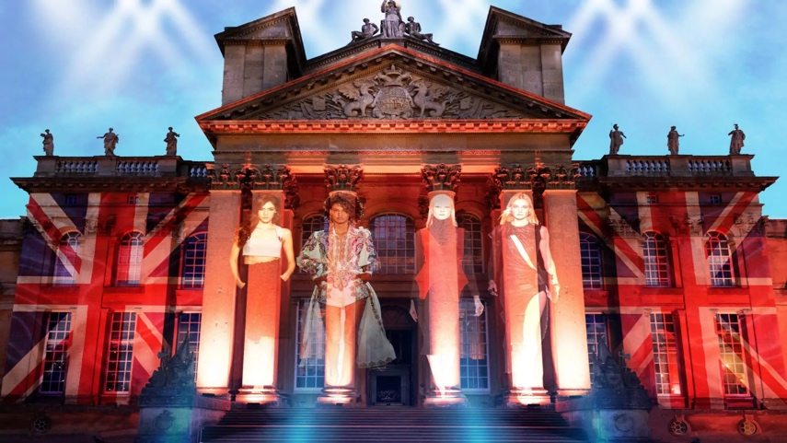

Fig 1. Icons of British Fashion Exhibition at Blenhein Palace, Oxfordshire [4]

The exhibition is located in Blenheim park, Woodstock, Oxfordshire, which has put on the largest exhibition in its 300 year history which is celebrating Britain’s most famous designers. [5] The icons of British exhibition has a history of its own British fashion as they have hosted many fashion shows, catwalks and photoshoots which were attended by high society and royalty. The palace is a great backdrop to showcase the forever lasting impact of British fashion over the years on the global stage. This year the exhibition is honouring the 150th anniversary of Sir Winston Churchill’s birth, visitors can see the original Churchill Siren Suits, which would be loaned by Turnbull and Asser. [6]
I believed that selecting this particular building for my exhibition would be ideal, given its location in London, one of the world's foremost fashion capitals. Hosting fashion exhibitions in this venue would serve as a promising preview of the aesthetic and atmosphere mine would embody. I believed that selecting this particular building for my exhibition would be ideal, given its location in London, one of the world's foremost fashion capitals. Hosting fashion exhibitions in this venue would serve as a promising preview of the aesthetic and atmosphere mine would embody.

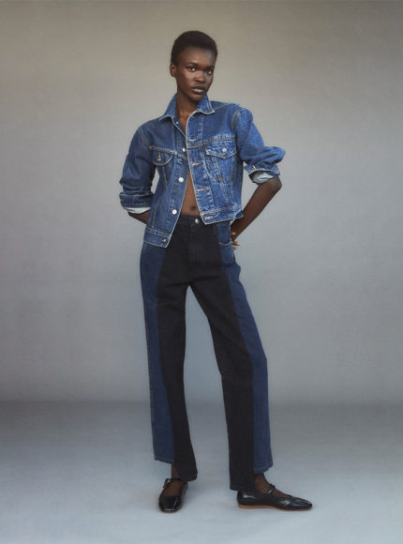

Fig 2. E.L.V Denim a sustainable fashion brand [7]

Based in East London studio, founded in 2018 by Anna Foster,[8] E.L.V Denim is the only Demin brand that exists that uses 100% upcycled materials, they always look out for good-quality pre-loved jeans. The brand only uses what they find in vintage warehouses across the UK on their sourcing trips twice-weekly. They have expanded their collections, they are on the look for more pre-loved garments and accessories, just like cotton skirts and silk scarves, this will help them create a truly sustainable capsule wardrobe. They take their pre-loved jeans to their local East London launderette. The denim process uses only seven litres of water, where as other fast-fashion production methods could use 10,000 litres to make a new pair of jeans. E.L.V Denim uses their own environmentally friendly branded buttons form YKK. By using their own branded buttons avoids using nasty chemicals which are put in other fast fashion metal finishings. [9]
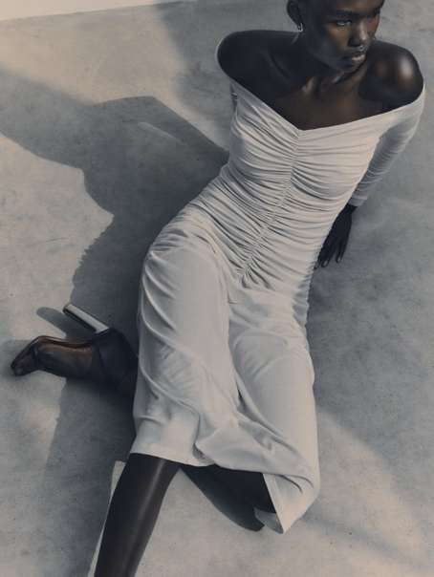

Fig 2. Ninety Percent a sustainable fashion brand [10]

Founded in 2018, Ninety Percent is a sustainable fashion brand based in London. This fashion brand is the first to offer online sustainable fashion. Their products include trousers, bottoms, bodysuits, skirts ect. Ninety Percent claim to produce eco friendly and made of organic cotton. [11] When designing their collections they prioritise renewable and natural materials. Their fabrics are vegan, which has the lowest impact on the global environment. All the buttons they use for their garments are plant-based and the metal they use is nickel-free. [12] The brand donates 90 per cent of their profits that help make the collections happen and five worthwhile causes. [13]

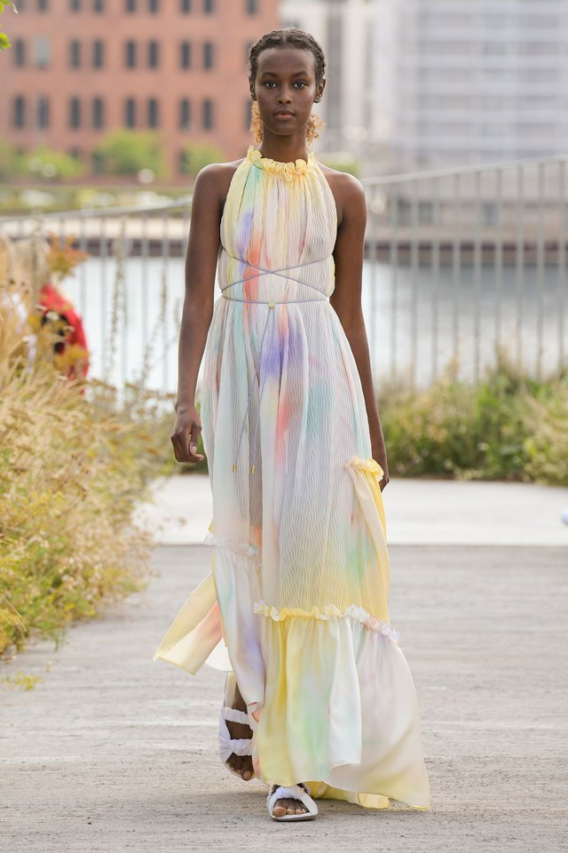
Fig 3. Brogger a sustainable fashion brand [14]

Brogger is a luxury clothing brand founded in 2017 by Julie Brogger. Her aim was to design clothes that can be cherished throughout the years and across all seasons. This fashion brand is all about ‘playful’ and ‘bold’ fashion that has craftmanship with a quality focus. Brogger also practises a low impact both environmentally and the social consequences of the fashion industry. New prints and fabrics are created each season by the designer, this builds on the Broggers distinctive handwriting of stand out and bold clothes. [15]
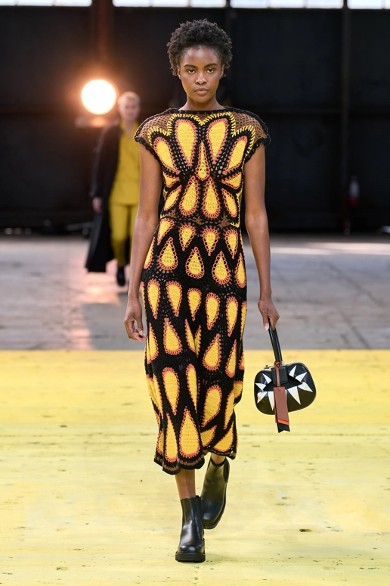
Fig 4. Gabriela Hearst a sustainable Fashion Brand [16]

Founded Gabriela Hearst is a New York designer who focuses on sustainability in her designs. She launched her sustainable company in 2015. After launching her first label in 2004 called Candela, a contemporary women’s line, she turned to working more with sustainability for her second ready-to-wear line. This would incorporate materials that already existed and unused stock from factories. [17] By creating a brand that reflects a slow pace process Gabriela is able to design garments with detail and care, where trends are not as important as tradition. Her aim is to create a ‘strong’ and ‘modern’ collection, she considers where the materials come from and who makes them. [18]

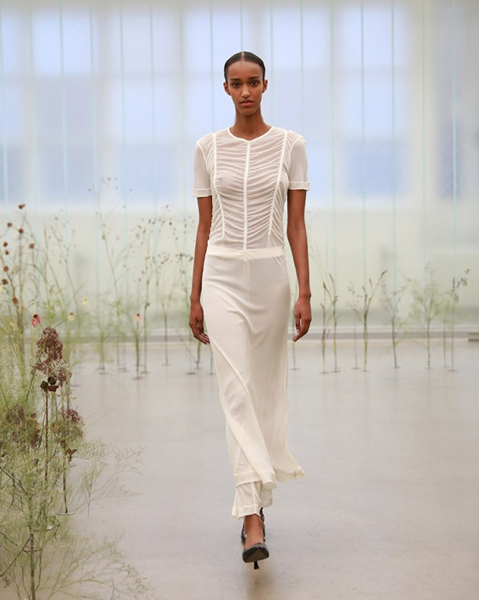
Fig 5. BITE studios a sustainable fashion brand [19]

BITE studios were founded by Veronika Kent and William Lundgren in 2016. Their collections has a combination of minimalism and expressive elements this results in a classic yet playful signatures that produces generations and trends. The very core of the brand is the fabrications, with organic methods that has a districted reflection on the soulful dressing experience. Every BITE garment is designed with the lightest environmental footprint. The company sets high goals, 95 per cent of the luxury materials are recycled, low-impact or organic in their collections. [20]

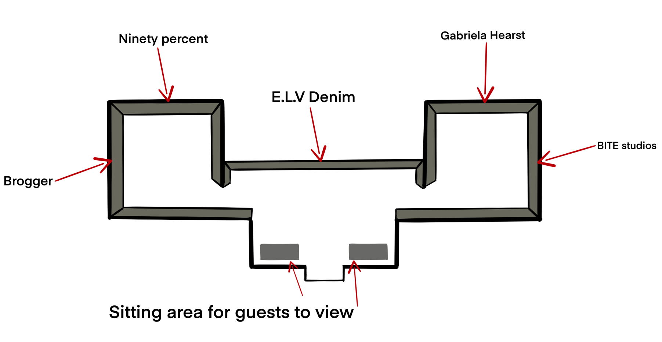
As for the exhibition layout, I strategically positioned E.L.V Denim directly in front of the entrance doors. I made this choice because, in my opinion, this brand exemplifies sustainable fashion exceptionally well. Therefore, as visitors enter, they are immediately greeted by the embodiment of sustainable practices in fashion.
Additionally, placing E.L.V Denim at the forefront of the exhibition serves to set the tone and capture visitors' attention right from the moment they enter, emphasizing the significance of sustainable fashion in today's industry landscape. The layout effectively showcases the clothing while also creating an immersive experience for visitors, allowing them to engage with the pieces and appreciate the craftsmanship and sustainable ethos behind each garment. The layout not only highlights the clothing but also invites visitors to explore the stories and values woven into each garment, fostering a deeper connection and appreciation for sustainable fashion principles.

Bibliography

[1] Chaves, B.L. and Villalobos, A.S., 2021. Sustainable Fashion. Sustainable Fashion and Textiles in Latin America, pp.327-344.

[2] Gordon, J.F., Farley, J. and Hill, C., 2015. Sustainable fashion: Past, present and future. Bloomsbury Publishing.

[3] Pomp MimxiMar, 7, 2023 https://pomp.store/blogs/journal/the-history-of-sustainable-fashion#:~:text=The%20'hippies'%20and%20'punks,a%20simpler%20way%20of%20life. Date accessed ; 21 Apr 2024, [article]

[4] The Oxford Magazine https://theoxfordmagazine.com/event/icons-of-british-fashion-exhibition/ Date accessed ; 21 Apr 2024 [photo]

[5] Jacob Manuschka, 25, March https://www.oxfordmail.co.uk/news/24207603.blenheim-palace-opens-icons-british-fashion-exhibition/#:~:text=Blenheim%20Palace%20has%20unveiled%20the,will%20run%20until%20June%2030. Date accessed ; 21 Apr 2024 [article]

[6] Blenheim Palace https://www.blenheimpalace.com/whats-on/events/icons-of-british-fashion/.
date accessed ; 21 Apr 2024 [website]

[7]Reve En Vert https://reve-en-vert.com/editorial/how-to-style-denim-sustainably-with-elv-denim/ Date accessed ; 22 Apr 2024 [photo]

[8] Jessica Davis, 22 April 2024 https://www.harpersbazaar.com/uk/fashion/what-to-wear/g19491797/the-best-and-still-chic-sustainable-brands/ date accessed ; 22 Apr 2024 [article]

[9]E.L.V Denim https://elvdenim.com/pages/our-sustainable-design-process#:~:text=As%20the%20only%20denim%20brand,a%20truly%20sustainable%20capsule%20wardrobe. Date accessed ; 22 Apr 2024 [website]

[10] Sustainably Influenced https://sustainablyinfluenced.com/2023/05/13/ninety-percent-the-fashion-label-rooted-in-community-sustainability/ Date accessed ; 22 Apr 2024 [photo]

[11] Tracxn, 18, Apr 2024 https://tracxn.com/d/companies/ninety-percent/__1n7PHN_nmE0ZHOGuXJ3otNhXKB18U5NTwfYBdhhAdiM Date accessed ; 23 Apr 2024 [wesite]

[12] Ninety Percent, 2024https://ninetypercent.com/pages/new-sustainability Date accessed ; 23 Apr 2024 [website]

[13] Jessica Davis, 22 Apr, 2024https://www.harpersbazaar.com/uk/fashion/what-to-wear/g19491797/the-best-and-still-chic-sustainable-brands/Date accessed ; 23 Apr [article]

[14] Jessica Davis, 22 Apr 2024 https://www.showstudio.com/collections/spring-summer-2022/brogger-ss22-womenswear/catwalk-imagery Date accessed ; 23 Apr 2024 [photo]

[15] Broggerhttps://brogger.co/sustainability Date accessed ; 23 Apr 2024 [website]

[16]Vogue runway https://www.vogue.com/fashion-shows/fall-2022-ready-to-wear/gabriela-hearst/slideshow/collection#1Date accessed ; 23 Apr 2024 [photo]

[17] Business Of Fashion https://www.businessoffashion.com/community/people/gabriela-hearst-1#:~:text=Gabriela%20Hearst%20is%20a%20New,boasts%20an%20extensive%20waiting%20list.Date accessed ; 24 Apr 2024

[18] Gabriela Hearst 2024 https://gabrielahearst.com/blogs/stories/about-the-brand Date accessed ; 24 Apr 2024 [website]

[19] Latesthttps://www.designscene.net/2023/09/bite-studios-spring-summer-2024.htmlDate accessed ; 24 Apr 2024 [photo]

[20] Bite https://bitestudios.com/pages/environmental-philosophy
Date accessed ; 25 Apr 2024 [website]

