Workplace Culture & Its Impact on Organizational Efficiency
LECTURER: HUSAM HELMI

STUDENT: ALINA NICOLETA MACARIE
1713499@studentuwtsd.co.uk

Table of Contents
Introduction 1
Case Study 2
Internal & External Analysis 5
PESTLE Analysis 5
Political Factors 5
Economic Factors 6
Social Factors 7
Technological Factors 8
Legal Factors 8
Environmental Factors 9
SWOT Analysis 9
Strengths 10
Weaknesses 11
Opportunities 12
Threats 12
Stakeholder Analysis 12
Customers/Consumers 13
Employees 13
Investors 13
Employees of Suppliers and Distributors 13
Culture and Ethics 14
Theoretical Perception 14
Leadership Style 15
Recommendations 16
Conclusion 17
References 19

Introduction
This paper mainly focuses on the leadership traits, organizational situation, market trend, competitive advantage, organizational culture and problem and prospects of Apple Inc. this whole study is conducted based on secondary research material and based on the sources an evaluated judgment has been developed regarding the organization.
‘Leadership’ is regarded as the driving force of the modern world (Burns, 2012). No matter what the project, goal, target or task is, a leader is a must for the completion of that task. Leadership in the inherent quality of a leader that organizes and accumulates the resources from different sources, direct the resources in the exact directions, rectify the deviations and manage everything to ensure the accomplishment of the task, objective or goal. The organizations like Apple, Samsung, Xiaomi and many more are seen to touch the peak of success mostly because of organized and efficient leadership (Davis and Womack, 2011). Again, the organizational environment, in which the leaders and the employees are nourished is also a great contributor to its success. Proper maintenance of a relevant and standard work environment can change the whole game – the negative deviation might lead to destruction and the positive one might ensure newer innovations. The components of an organization’s work environment are the key determinants of how the outcomes are going to be. For example, if the political environment of business seems unfavorable and due to political instability, the performance of the whole organization is hampered, in such instances, the possibility of innovation shrinks over time rather than increasing (Rouse, 2010).
The ‘Culture and Ethics’ is another major component of an organization’s business environment (HASAN, 2013). The cultural practice within an organization affects the way employees think or belief and molds the perception of the employees towards the organization. If the organizational culture is employee-friendly, the employees are expected to be more enthusiastic, motivate and eager towards their jobs. On the contrary, organizations where there is no existence of culture, the employees always suffer from ‘existential crisis’ and no attachments are developed between the organization and the employees. ‘How much ethical an organization is’ – is the most often asked question by the customers (Nelson and Pearson, 2015). Just doing business is not enough today. Maintaining organizational ethics has emerged as a trump card for the organizations today amid such extreme competition. What is the leadership style followed by Apple Inc, probable lacking or recommendations regarding the leadership, the cultural practices of the organizations, purposes the organization serves in the society, the ethical standards of the organization and the components of the internal and external environment of business– are the major point of discussion of this paper.

Case Study
Apple Inc. is one of the leading business models and an American multinational tech firm that designs and sells consumer electronics, computer programs and provide online support around the globe. It’s one of the four major contenders manipulating the whole tech industry all round the world. This international establishment came to existence in April 1976(HASAN, 2013). Although, initially the business started with a very compact arena, with the passage of time the business portfolio started to evolve and covered a wide range of products and services. The company is well recognized for its volume and market revenue. The annual revenue of Apple Inc. during the fiscal year 2018 was totaled $265 billion and for which it is regarded as “world’s largest technology company” and one of the most renowned companies around the globe (Rouse, 2010). Almost 123,000 full-time employees are employed by Apple Inc. and 504 retail outlets are well managed in 24 countries by the company (Rutherford, 2010). It also includes the operation of iTunes Store, which is regarded as the biggest music outlet in the world. Till February 2018, 1.3 billion products of Apple are available (in use) around the world. The company has a strong customer base along with secured brand loyalty which has brought the company a strong ground in the face of the contenders.
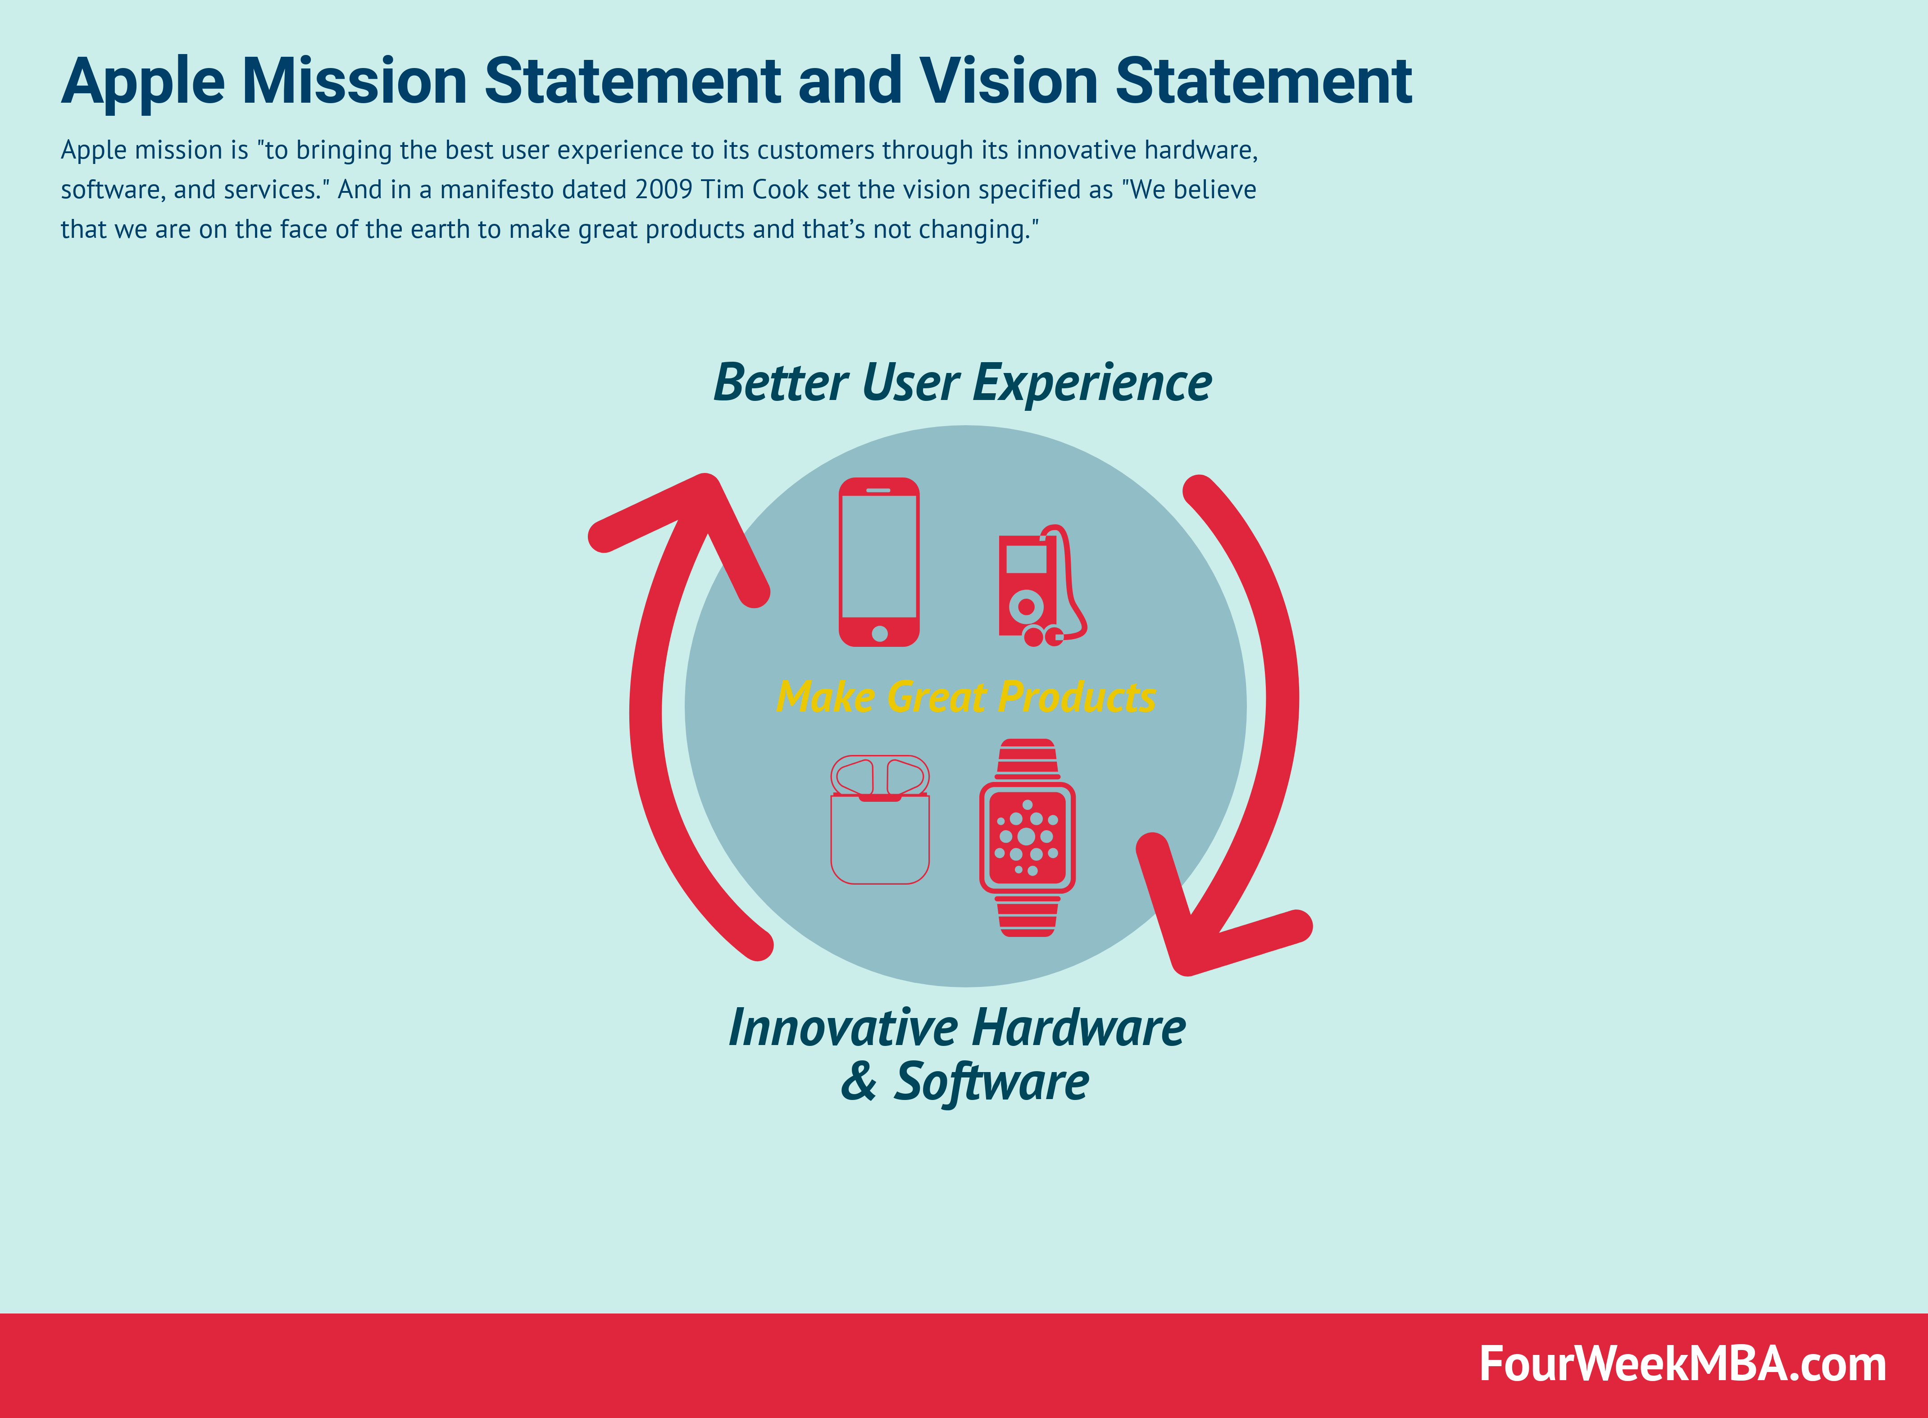
Figure 1: Mission & Vision Statement of Apple Inc.
Source: (Davis and Womack, 2011)
The mission statement of Apple is “to bringing the best user experience to the customers through its innovative hardware, software, and services.” And in a dated 2009, Tim Cook stated the vision of the company in a manifesto 2009 as “We believe that we are on the face of the earth to make great products and that’s not changing” (Saucier, 2018).The mission and vision statements of Apple Inc. are the basis of the grand success of the business and the tag of “one of the most valuable businesses in the world”. Again, the corporate mission and vision are interrelated in terms of the force they ensure for the continuous advancement of the company despite obstacles from the competitive perspective (Burns, 2012). The corporate mission and vision statements of the company ensure the employee motivation to strengthen and expand, along with ensuring contribution to innovate for gaining a higher competitive advantage. Apple Inc.’s generic tactics and intense advancement traits mark out such competitive advantage, specifically to counteract the contenders like Samsung, Google, Amazon, Dell, Lenovo, Sony, and PayPal (Nelson and Pearson, 2015). Remarkable alterations have been seen in the corporate vision and mission statements of Apple Inc. over time to reflect the alterations that took place in the company from Steve Jobs’ time to the present direction of Tim Cook.
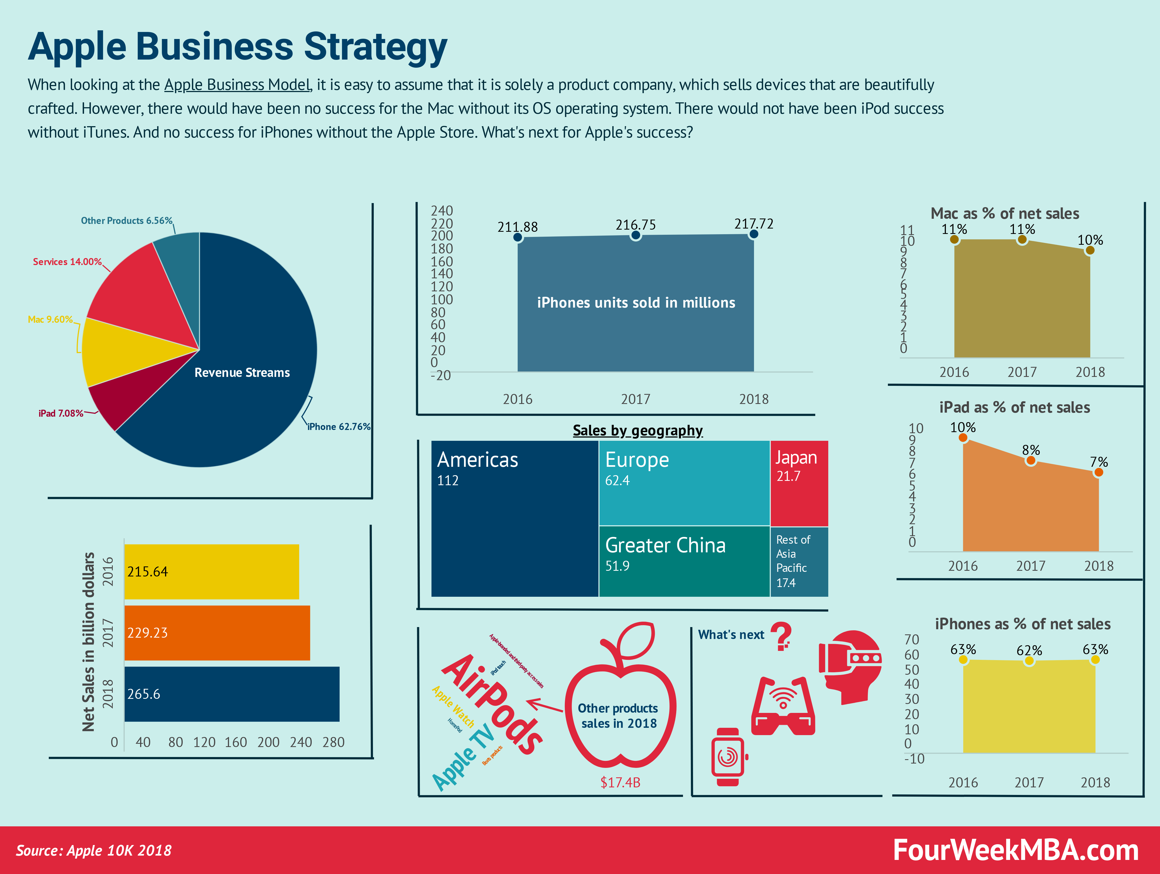
Figure 2: Business Strategy of Apple Inc.
Source: (Burns, 2012)

The core business strategy of Apple can be demonstrated as “Product Differentiation”. More precisely, the multinational tech firm Apple signifies its goods and services based on trifling, yet mesmerizing outlook and enhanced functionality. Usually, the organization follows the “autocratic Leadership” style but the trend is seen to somewhat alter over time. Now the organization is seen to move upmarket by introducing new user-friendly but reasonable devices to beat the contenders in the international market (Davis and Womack, 2011). Moreover, some newer production sites have been identified by the organization to reduce the cost of production, increase efficiency, expand the sale and grow further. The experienced management body with the fresher’s innovation is considered as the prime source of such speedy advancement and continuous growth of the tech giant Apple (HASAN, 2013).

Internal &External Analysis

PESTLE Analysis
PESTLE analysis is a significant tool for analyzing the external factors of a business that might bear some remarkable consequences on the performance of it (Daft and Lane, 2010). Proper evaluation and analysis of each of the components might provide a reader with a clear understanding of the external components, their depth and probable impact upon the business, their problems and problems along with a specified plan of action to maintain and manage any deviation. The PESTLE analysis of Apple Inc. is as follows:
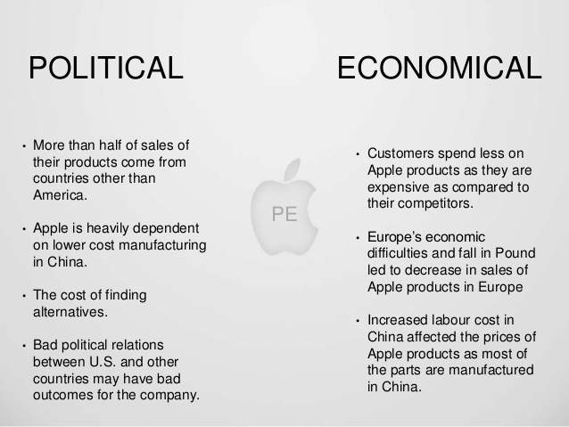
Figure 3: Political & Economic Factors of Apple Inc.
Source: (HASAN, 2013)

Political Factors
Some greater opportunities are consistent with the political components of Apple. Political factors incorporate and mainly deals with the legal aspect and govt. the limit to which govt. intervention might enhance or limit the activity of a business in a specified territory (Phillips and Freeman, 2011). Some significant external political components of Apple are as follows:
Improvement of Trade Policies and Higher ‘Free Trade’ Opportunities.
Political Stability in the Target Regions (Developed Countries).
The threat of Trade Disputes (between the U.S. and China).

The trade policy around the globe has emerged greatly in favor of companies like Apple Inc. over time. Such barrier-free trade opportunities created a wider market niche for Apple and such wider market niche made it possible to supply the goods and services of the company to a broader region of the world. And the political landscape of Apple is also remarkable. Since it deals mostly in the developed regions, the inexistence political turmoil made the business smoother, ensuring sustainable business growth for Apple (Burns, 2012). But the trade dispute persisting between China and the US might have a negative consequence upon the market share and profit growth of the firm.

Economic Factors
A number of opportunities are seen to follow the external economic components of Apple Inc. Economic Factors incorporate the industry and market condition, probable future growth potentials, probable financial obstacles, cost-benefit ratios, etc. (Saucier, 2018). Some significant external Economic components of Apple are as follows:
Economic Stability of Target Region (Developed Countries).
Fast Advancement of the Developing Countries.
Increment in the Disposable Income of the Target Segment.

Since Apple mainly targets the clients from the developed economy, the stability of financial aspects there affects the profit margin of Apple largely. Such stability in economic components allows and ensure the growth potential for firms like Apple. Again, the developing countries are seen to move rapidly towards the developed regions for which newer market segments are evolved over time (HASAN, 2013). And the evolution of newer market segments is ensuring higher market reach for the firm along with a handsome market share. Finally, the increment noticed in the target clients are noteworthy and quite significant for Apple. Since customers can now afford more, they would prefer higher and higher quality than before, ignoring the prices (Scott, 2018).
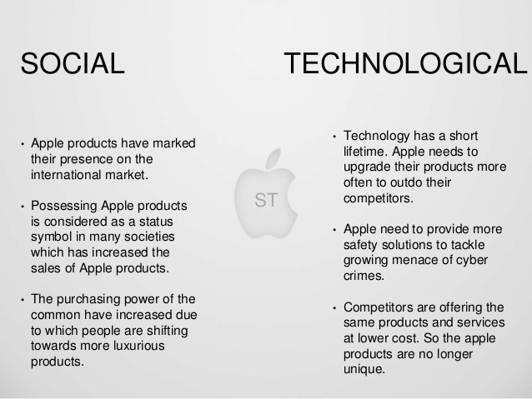
Figure 4: Social & Technological Factors of Apple Inc.
Source: (Davis and Womack, 2011)

Social Factors
The goods and services of Apple are such substances that affect social and socio-cultural trends of the world. Social Factors include consumer behavior, trend, customer expectation, demand analysis, market trend analysis and so on (Scott, 2018). Some significant socio-cultural trends in Apple are as follows:
Higher Accessibility to Mobile Phones.
Higher Reliability on Digital System.
Anti-Apple Aptitude of Target Segment.

With the progressive pace of the modern world, the usage of mobile phones and its accessibility has also evolved drastically. People at the furthest corner of the world can now access the globe via mobile phone. It can be regarded as a social trend nowadays. Moreover, with the passage of time, people are getting more and more dependent on digital technology. Once the works which were done manually are today completed using technology in a blink of eyes (HASAN, 2013). Such dependence on technology has expanded the market size for companies like Apple tremendously. But currently, an anti-Apple movement appeared as a concern for Apple since clients are questioning the business policy, customer sentiment, third party legalization, etc. These sociocultural components signify the CSR strategies of Apple. Such tactics ultimately assist in satisfying stakeholders, including clients, governments, and others(Davis and Womack, 2011).

Technological Factors
Several opportunities are seen to follow the external technological components of Apple Inc. Technological Component includes the analysis of persisting technologies, altering the trend in the technological segment, probable consequences and impact of such alterations on the business and so on (Scott, 2018). Some significant external technological components of Apple are as follows:
Increasing Demand for Cloud Computing.
Increment of Technological Integration.
Enhancing Market for Mobile.
Growth in Technological Capabilities.

The ever-rising demand for cloud computing in the current market has paved the way for Apple since it is one of the largest cloud computing service providers around the world. And the technological advancement and integration also create opportunities for Apple Inc. to expand the business arena (Mossell and Driver, 2010). Moreover, the external strategic factors also added in favor of Apple through growth potential and enhanced technological support.
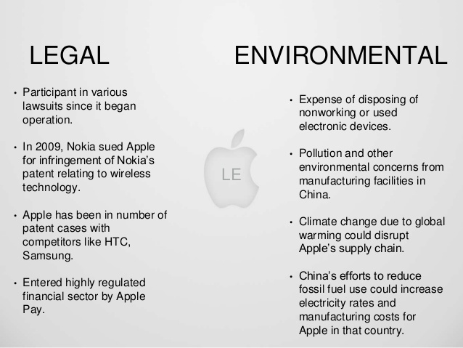
Figure 5: Legal & Environmental Factors of Apple Inc.
Source: (Nelson and Pearson, 2015)

Legal Factors
Some significant threats are seen to follow the external legal components of Apple Inc. legal components incorporate the analysis of legal consequences and the impact of rules and regulations upon the business (Daft and Lane, 2010).
This aspect of the PESTEL/PESTLE analysis framework indicates the impact of laws or regulations on businesses. Some most significant external legal components of Apple are as follows:

Increment in the Privacy Regulations.
The allegation against the Policies of Apple.

The target niche that Apple serves has evolved dramatically over time. The legal components in the target market are seen to alter the policy regulations of Apple. the increasing policy guidelines are regarded as a threat to the future enhancement of Apple (Davis and Womack, 2011).

Environmental Factors
Some remarkable opportunities are seen to follow the external environmental components of Apple Inc (Nelson and Pearson, 2015). Environmental components incorporate the environmental trends and their impact upon the business. Some most significant external environmental components of Apple are as follows:
Sustainable Trend of Business.
Higher Efficiency in Energy Consumption

The sustainable trend encourages business to adopt the environment-friendly measure and introduce newer technologies that preserve the environment. Such ecological balance maintenance helps in favor of the company by expressing a brighter image of the firm towards the clients. At the same time, energy-efficient technology also helped the firm to grab public attention, along with a secured and enhanced target market (O'Grady, 2019).

SWOT Analysis
The SWOT analysis allows an intended user to have a clear perception of the internal environment of a business. It evaluates the internal strength and weaknesses a business inherits along with the external opportunity to grow and threat to shrink (O'Grady, 2019). The SWOT analysis of Apple is as follows:

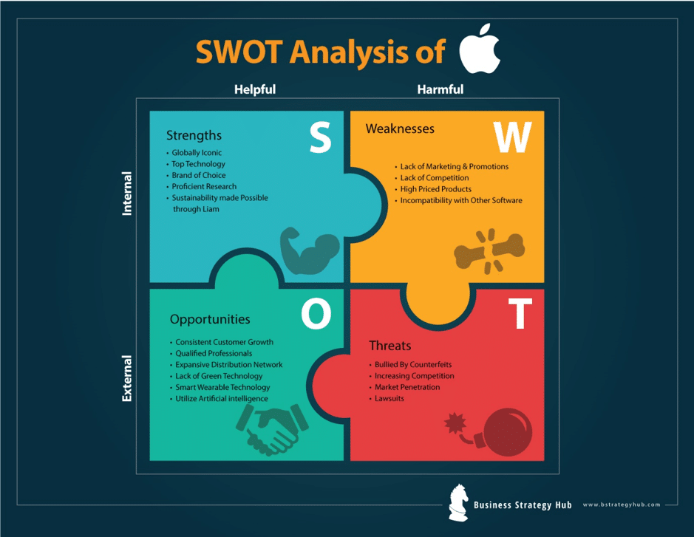
Figure 6: SWOT Analysis of Apple Inc.
Source: (Monsell and Driver, 2010)

Strengths
Elite brand value and prestige, highly loyal base of clients, spontaneous innovation and simplicity, innovative marketing and ad tools, enhanced profit margin are the remarkable strength factors of Apple (Davis and Womack, 2011).
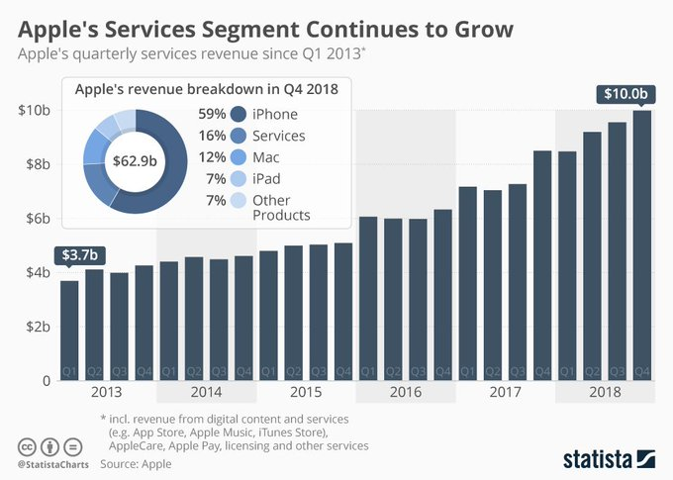
Figure 7: Revenue Breakdown of Apple Inc.
Source: (Daft and Lane, 2010)
Apple has s elite brand image because of the high-quality product it serves in the market. At the same time, Apple focuses on repeating and loyal customers rather than targeting more and more new clients for the firm. And the innovations that apple are bringing to the market are incredible and admiring (Dess, 2012). And more on to that the highly experienced marketing experts have made the products of apple more appealing towards the clients ultimately leading it towards securing a significant profit margin compared to the competitors.

Weaknesses
The narrow product line, high customer expectation and premium pricing of products are the remarkable weaknesses of Apple. Apple’s portfolio consists of almost 6 to 7 products and a few numbers of services (Monsell and Driver, 2010). Such a narrow portfolio fails to catch the larger market segment giving the contenders' loopholes to penetrate and move ahead in the competition. From the very beginning, Apple has brought about revolutionary advancement in technology. Such admiration has emerged as a weakness for Apple now since it can’t meet the ever-rising demand of the clients and constant growing expectation of innovation. More above that the price of Apple products is significantly higher than its competitors. Although Apple is not a cost leader, such a higher price is hardly justifiable to the customers (O'Grady, 2019). And such premium prices again causing Apple to shrink its customer base losing the potential scope to gain from the market.

Opportunities
Stable growth of customer base, efficient and experienced professionals, enhancing distributive network, the introduction of green technology, smart wearable technology and utilization of artificial intelligence are the opportunities found in the macro environment of Apple (O'Grady, 2019).
The loyal and trusting customers of Apple are ever on the rise. The market grab is also rising apparently. The employees appointed in different departments of Apple have a high reputation for their expertise and customer support (Washington, 2017). Moreover, their professionalism also adding value to the firm itself. A matter of fact is that Apple is introducing several new distribution channels throughout the globe. It will not only enhance the portfolio volume of Apple, rather it will secure a higher market reach for the firm. A revolution has already launched named “let’s go green”. None of the tech firms were able to introduce any green-friendly technology so far (Burns, 2012). But the newer innovation of Apple is green-friendly which will bear a notable impact on clients’ minds. And constant increment in artificial intelligence has paved the way of business for Apple to a greater extent.

Threats
Increased competition, market penetration and the lawsuits brought against Apple are the threatening factors in its macro environment. Tech world is getting introduced with newer contenders with the passage of time. And the newer competitors are bringing newer and newer technologies in the market (Dess, 2012). Such innovations are the constant threat that Apple is facing most at this moment. Apart from that, the market penetration of the contender firms through newer innovations, diversified portfolio or reduced market price are also posing threat for the firm. Close competitors like Samsung, Lenovo, LG, and HP are bringing out affective tools to compete harder in the market (Washington, 2017). However, Apple is facing notable criticism because of the faulty labor practices of its contractors, its environmental hazardous projects and the lack of business ethics, including ‘anti-competitive behavior’, as well as the generation of the core materials.

Stakeholder Analysis
Apple’s success is partly due to its ability to satisfy stakeholders and corporate social responsibilities (CSR). Stakeholder groups impose demands that translate to corporate social responsibilities, which influence firm performance. The significant stakeholders of Apple Inc. are as follows:
Customers/Consumers
Apple’s Employees
Investors
Employees of Suppliers and Distributors

Customers/Consumers
The most prioritized and significant stakeholders of Apple Inc. are the respective customers of the company. This group is composed of individual and organizational buyers (Monsell and Driver, 2010).
The prime focus of this group is to have effective, efficient and reasonably priced goods. The firm also has environmental concerns for the proper recycling of the dumped products and reliable sourcing to meet clients’ demands for the sustainability of the business (Washington, 2017). Thus, Apple’s CSR efforts meet the demand of the clients as the 1st priority of the business.

Employees
Employees are given the second priority in Apple’s list of stakeholders. Employees at Apple’s different outlets compose this group. The prime concern of this groupies proper remuneration and career development. Employees as a stakeholder are significant for their contribution in developing human resource capabilities to innovate and generate lucrative goods (Washington, 2017). The firm meets the demands of its workers by introducing, compensation packages, held in Silicon Valley.

Investors
Investors are the most influential stakeholders and controllers of CSR programs of the firm. In the case of Apple, the prime concern of the investors is the maximization of their returns on the investments. The company efficiently manages the stakeholder group through extraordinary financial performance (Daft and Lane, 2010). The financial position of Apple is also quite strong, which incorporate higher liquidity through a large sum of cash.

Employees of Suppliers and Distributors
Workers in the supply chain of Apple are also important considerations in the firm’s endeavors. These employees are quasi stakeholders of the business but influence the CSRs of the firm. The main concern of this group is proper remuneration and security. To meet these demands, Apple has developed a ‘Supplier Code of Conduct’. Suppliers who continue to fail or deny meeting this ‘Code of Conduct ‘are eventually terminated by Apple (O'Grady, 2019).

Culture and Ethics

Theoretical Perception
‘Ethical Relativism’ is the concept that signifies the fact that “morality is relative to the norms of one's culture”. That is, the legality or illegality of an action depends on the moral norms a society encompasses in its components and the context in which it is practiced (Dess, 2012). The same action which is morally legal in one context might be illegal in another one.
Apple Inc. is well known for its organized corporate culture and ethical practice around the globe. Still, to have a better perception of the business, the following are the major characteristics of the corporate culture of Apple:
Top-notch excellence
Creativity
Innovation
Secrecy
Moderate combativeness

Apple’s culture is formulated based on Top-notch excellence which incorporates the recruitment of only the best in the market. The firm maintains high caution and care in fresher recruitment to maintain the promised quality and to justify the premium prices. The management of the firm prefers, creativity, through wisdom, tactics, and capabilities of the employees. This characteristic enables the firm to maintain enough potentiality, especially among workers associated with product design and development. The corporate culture of Apple promotes faster innovation, which is the hidden treasure of Apple (Monsell and Driver, 2010). Rapid innovation ensures the continuous introduction of new goods that are both lucrative and attractive to target clients. Steve Jobs developed a culture of secrecy in Apple Inc. This cultural trait continually defines the advancement of the firm’s human resource. Secrecy can be identified as an indispensable part of the firm’s technique to decrease the theft of intellectual property or proprietary information.
The corporate culture of Apple introduces barriers because of giving extreme significance to the secrecy and the moderate degree of combativeness. An atmosphere of secrecy might reduce employee motivation and spontaneity among workers. At the same time, moderate combativeness encompasses the potential to shrink or decrease the morale employees. These cultural drawbacks might degrade the effectiveness of the business and increase the turnover of the employees.

Leadership Style
The Leadership Styles refer to the “behavioral patterns” that a leader resorts to affect the perception of the devotees, i.e. the way of providing commands to the followers and approach of motivating them to attain the organizational goals (Daft and Lane, 2010). Among different leadership styles, this paper mainly highlights the Participative Leadership approach of a leader.
Participative leadership is a managerial approach that welcomes responses from employees on most of the company concerns. The staffs are provided with the pertinent information relevant to the company issues, and the course of action will be determined based on the vote of the majority (Dess, 2012). It incorporates the organizational employees in the decision-making process and motivates them to think further for the wellbeing of the organization. But participative leadership has some prerequisites such as prudent employees, team playing mentality of the followers, strong leadership from the higher authority, the openness of the higher management, etc. absence of any of the components might hamper the credibility of such leadership style and end all the endeavors in smoke.
After analyzing Apple Inc., it can be demonstrated that this firm is basically run on following an autocratic leadership style. Here all the decisions are made by the higher authority and the employees have the minimal or no say in organizational decision-making. Although Apple is one of the most successful businesses of the current time, such leadership style might affect then employees of the firm adversely by reducing their work motivation, lower organizational attachment and ultimately disrupted the performance of the firm (Nelson and Pearson, 2015). So, to avoid such mishap, the firm must adopt the participative leadership style. Since most of the employees of such firms are efficient and prudent, this leadership style will be exactly perfect for the organizational context. Participative leadership trait includes some basic advantages for which this style is so popular within the organizations, viz.
Improves Employee Morale: when the employees are incorporated in the decision making of an organization, it develops a sense of responsibility and liability within them and thus enhances the morale of the employees.
Encourages Creative Solutions: There’s a saying, “Two heads are always better than one”. If the employees of the firms are included in the decision making, more effective, efficient and creative solutions can be expected to be developed (Dess, 2012).
Increases Employee Retention: When employees have a say in the crucial matter of the organization, they will start to feel a feeling of belongingness with the organization (O'Grady, 2019). Such belongingness again promotes employee retention and reduce turnover.
Decreases Competition, Increases Collaboration: When everyone is given the same opportunity and scope to say, the tendency of competition tends to reduce remarkably. In its place, a sense of collaboration develops which benefits the whole organization (Phillips and Freeman, 2011).
There’s no unmixed blessing on earth so as the leadership styles. Participative leadership expresses some demerits as well, viz.
Slow Decision Making: When abrupt decision making is mandatory, in such situations participative leadership is an unwise choice. Because taking everyone’s opinion is time-consuming and it reduces the efficiency of decision making by unnecessary delays.
Security Issue: When all the information ae publicly shared with a lot of employees, there rises another issue named “privacy concern” (Daft and Lane, 2010). If the secrets of the firm are somehow leaked to the contenders, the firm might face an acute loss and even come to the streets.

Recommendations
Today’s business is getting more and more competitive everyday than ever before. To sustain such aggressive and heinous competition, a well-organized business plan needs to be developed by the management (Phillips and Freeman, 2011). After studying the different perspectives of Apple Inc., the following recommendations can be proposed:
- Introduction of participative leadership instead of autocratic leadership might enhance the performance efficiency of the firm. At the same time, such an initiative will secure employee motivation, retention, and morale.
- The accumulation of top-notch excellence, creativity, and innovation in Apple Inc.’s culture aids industry leadership. The business is regarded as a price maker in the industry. But such premium pricing of the products is somehow making a ‘silent cutdown’ of the company growth potentials day by day. So, to face the competitor's strategies, the cost leadership approach should be adopted by Apple along with the reduction of the production costs.
- The firm is seen to put more emphasis on the task rather than the employees. Such task orient firms cannot sustain today's extreme competition. Because task-oriented firms do not care for their employees and such attitude of the organization hampers the employee morale drastically, ultimately belonging unbearable consequence for own selves. So, Apple should try to focus on employee orient rather than the task orientation.
- The cultural drawbacks such as combative approaches should be tackled more professionally, and the advantages should of the combativeness be reaped avoiding the negative consequences of it.
- The lawsuit lodged against Apple regarding the moral degradation, unethical behavior and hazardous work environment should be taken into serious considerations before late. If the clients make any negative perception regarding the firm based on such allegations, the fruits won’t be sweet for the firm soon.

Conclusion
Leadership is a buzzword in today’s business world. No initiatives can come to existence without proper and effective leadership. Leadership encompasses the personal traits of a leader – how he motivates, directs, run and retains the employees with the organization. Again, numerous leadership traits are available in society. The Leadership Styles alludes the “behavioral patterns” that a leader resorts to affect the perception of the devotees, i.e. the way of providing commands to the followers and approach of motivating them to attain the organizational goals. Among different leadership styles, this paper mainly highlights the Participative Leadership approach of a leader. Participative leadership is a managerial approach that welcomes responses from employees on most of the company concerns. This leadership style has been analyzed thoroughly incorporating the actual scenarios of Apple Inc. A thorough analysis of the culture and ethical dimensions are also been ensured by the researcher. The possible hindrance towards the successful completion of business endeavors are critically evaluated in this paper from the context of Apple Inc. and some effective recommendations are also suggested regarding the stated scenarios of the firm. The internal and external components of Apple Inc. are also analyzed using the PESTLE and SWOT. And the interrelation between different components of the internal and external components are also analyzed critically to develop a better perception of the business environment, culture, policy and strategy of Apple Inc. this paper is a compact evaluative statement of the business traits, prospects, hindrance, solutions and recommendations regarding Apple Inc., one of the leading business models and an American multinational tech firm that designs and sells consumer electronics, computer programs and provides online support around the globe.

References
Burns, J. (2012). Leadership. New York, NY: Open Road Integrated Media.
Daft, R. and Lane, P. (2010). The Leadership experiences.
Davis, T. and Womack, K. (2011). Mapping the ethical turn. Charlottesville: University Press of Virginia.
Dess, G. (2012). Strategic management. New York: McGraw-Hill/Irwin.
HASAN, M. (2013). APPLE INC. - AN ANALYSIS. [Place of publication not identified]: GRIN Publishing.
Monsell, S. and Driver, J. (2010). Control of cognitive processes. Cambridge, Mass.: MIT Press.
Nelson, P. and Pearson, J. (2015). Confidence in public speaking. Los Angeles, Calif.: Roxbury Pub.
O'Grady, J. (2019). Apple Inc. Westport, Conn.: Greenwood Press.
Phillips, R. and Freeman, R. (2011). Stakeholders. Cheltenham U.K.: Edward Elgar Publishing Ltd.
Rouse, K. (2010). Personal development. South Melbourne, Vic.: Oxford University Press.
Rutherford, J. (2010). Skills, drills & strategies for tennis.
Saucier, R. (2018). Marketing Ethics. Lewiston: Edwin Mellen Press.
Scott, M. (2018). Apple, Inc. Westport: Greenwood.
Washington, B. (2017). Teamwork. Charlottesville, Va.: University of Virginia Library.

