Cer HE Business Skills for Workplace

Employability and Career Development
LCLM4005

Lecturer: Rejwan Bin Sulaiman

COMPARISON JOBS

Present by; luz Mery Hernandez Galindo
2517632

Job 1

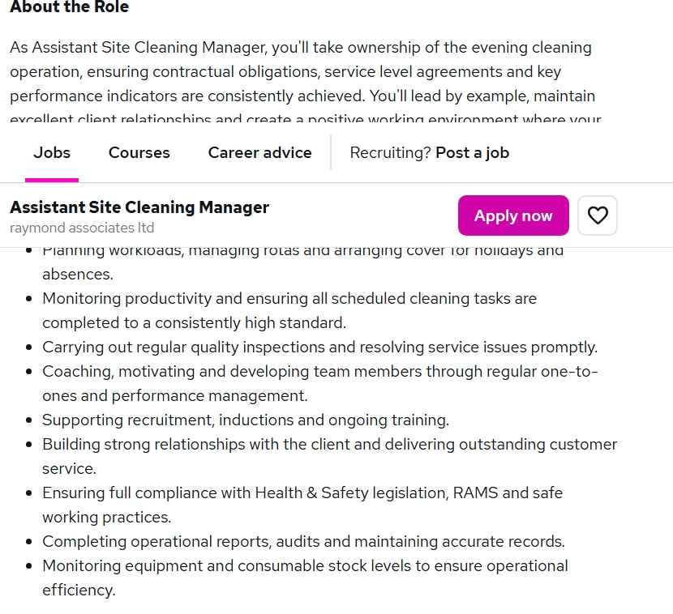

Job 2

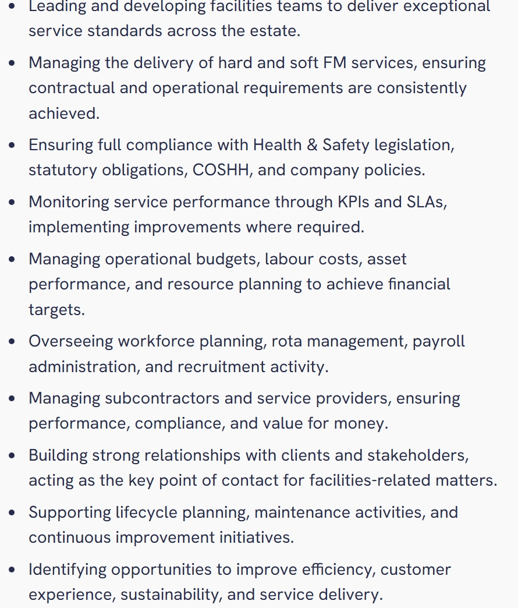

Task 1: Comparison of Key Skills and Areas of Knowledge

The two jobs job advertisement shows that both roles requirement a strong combination of leadership, communication, organization, health and safety knowledge, performance management and customer services skills. However, the Assistant site cleaning manager role is mainly focused on the daily management of cleaning operations, while.

Area  Planning and organizational | Job1 Assistant side  Cleaner Manager  Plans rotas, manages staff cover and ensure cleaning task are completed on time. | Job2  Facilities Manager  Manage workforce planning  rotas, resources and operation activities. | Common skills  Knowledge and future application  Both require excellent planning and organizational skills. I would use this skill to organize shift, allocate duties and ensure services operate efficiently.
Leadership and team Management | Leads, coaches and motivates cleaning staff, monitors performance and supports staff development | Leads facilities team and manages  workforce planning, recruitment and performance | Leadership is common to both roles. in my future role. I would motivate staff, delegate, responsibilities and support team members to achieve high standards.
Quality and performance | Carry out inspection, monitor productivity and resolve problems. | Uses KPls and SLAs to be monitoring service  performance and implement improving | Both require quality control and performance monitoring. In the future employments, I would
Health and safety | Ensure compliances with H&S RAMS and safe working practice | Requires compliance with health and safety legislation, COSHH and company policies. | Health and safety is essential in both positions. I would apply this knowledge by ensuring staff use chemicals safely and follow risk assessment procedure
Problem Solving | Identifies services issues and resolves promptly | identifies performance problems  and implement improvements where required | Both roles require problem solving skills. I would investigate problems, identify causes and take appropriate action to maintain services quality
Overall, Knowledge | Cleaning operations, supervision, Health& safety, customer service and team development | Facilities management, contracts, budgets,  compliance, contractors and services delivery | The two adverts show that progression requires of technical knowledge, management  Skills, communication and leadership
Administration and resources | Completes report, audits and maintains record, monitors, equipment and stocks. | Facilities management, contracts, budgets,  compliance  contractors and services delivery | Both involves resource and administrative management, although job 2 has greater financial responsibility. I would develop  These skills to control cost and use resource effectively
Communication and  Customer services | Build strong client relationship and provides outstanding customer service | Builds relations with clients and stakeholders and acts a key contact | Communication and customer service are important in both jobs. I would communicate clearly  With employees’ clients’ managers  And respond professionally to complaints or concerns
Task 2
Self -Assessment and SWOT Analysis for Employability and personal Advancement.
Strengths  - Practical understanding of leaning operations  - Good communication and interpersonal skills  - Willingness to learn and development  - good organization and time management  - practical understanding of cleaning operation | Weaknesses  - Need more experience managing contractors  - Limited experience with formal budget management  - Need to improve advance digital skills  - Further Health and safety knowledge is required  - Need greater knowledge of KPls and SLAs.
Opportunities  - Development digital skills  - Learning from managers, colleagues and clients.  - Gaining experience with budgets and KPls.  - Completing Health and safety and COSHH training  - Progression from cleaning supervision into facilities manager | Threats  - Lack of experience could slow career progression.  - Pressure and workload associated with management roles  - Increased expectation from clients and employers.  - Strong competition for management positions.  - Change in legislation and workplace requirements.

One of my main strengths is communications, in a cleaning or facilities environment, effective communication is essential because managers need to give clear instructions, listen to employees and communicate with clients. I believe I can communicate professionally with people from different backgrounds and explain task clearly. This a particularly important when organizing cleaning duties, dealing with services problems or responding to customer feedback.
Another important strength is teamwork and leadership. My experience and interest Ina supervisor responsibilities have helped me understand my colleagues, allocating duties and maintain motivation. A successful manager should not only give instruction by also lead by example. I can use this strength to encourage employees to maintain high standards and work effectively.
I also consider organization and time management. Cleaning and facilities operations require employees to complete several tasks with the specific time limits, planning rotas, allocating responsibilities, training, education checking completed work and responding to unexpected problems all require good organization. Developing these skills has prepared me to take greater responsibility in future management role.

Another strength is my willingness to learn. The facilities sector is constantly changing, particularly regarding to Health and safety requirements, technology, sustainability and managements practices. I am willing to improve my knowledge through training and education and practical experience. My commitment to personal professional development.

One area I need to develop further is my knowledge of facilities management systems and performance measurement. The facilities Manager advert refers to KPls and SLAs. I understand the general importance of measuring performance, but I would benefit from gaining more practical, knowledge of how these measure of how these measures are created, monitored and reported.

I also need to strengthen my Financial and budget-management skills. A facilities Manager may be responsible for labour, cost, budgets, resources and financial targets. Developing knowledge of budgeting, cost control and financial reporting would make me more prepared for higher management position.

Another development area is confidence with technology and administrative systems. Modern managers often use spreadsheets, reporting software, digital rota systems and another workplace technologies, improving my digital skills would allow me to manage information more efficiently and produce professional reports.

I would also like to development my knowledge of Health and safety, COSHH and RAMS further, Although I understand the importance of safe working practices, additional training would increase my confidence and ensure that I Can manage workplace risk effectively.

Evidence of Employability and personal Advancement

My experience provides opportunities to demonstrate problem solving and Customer service skills. For example, when a cleaning task is not completed correctly or a client raises a concern, I can identify the problem, communicate with relevant people and help find a suitable solution. This demonstrates that I Understand the importance of maintaining professional relationship and responding positively to the feedback.

My readiness for employment can demonstrate through my practical understanding of cleaning operations and supervisory responsibilities. Working in a cleaning environment requires punctuality. reliability, teamwork and attention to details. These qualities are directly relevant to the Assistant Site Cleaning Manager role because the manager must ensure that cleaning task are completed consistently and to the required standard.

My educations is another important form of evidence Studying Business related subjects has helped me develop knowledge of communication, teamwork, leadership, recruitment, and workplace responsibilities. It Has also encouraged me to reflect on my own skills rather the simply relying on practical experience.

Feedback from colleagues, supervisors, clients and peers can also support my development, positive feedback about reliability, attitude, teamwork or quality of work would provide evidence of my strengths. At the same time, constructive feedback can identify areas where I need to improve. I would use this feedback as part of a continuous professional development plan.

Task 3

Personal Development Plan

To achieve personal Advancement, I will focus on several objectives.

First: I will improve my knowledge of Health and safety, COSHH and RAMS I will complete relevant training and apply the procedures correctly in my workplace.

Second: I will development my digital skills, particularly Microsoft Excel and workplace reporting systems. I will measure progress by completing task indecently and asking a supervisor or colleague for feedback.

Third: I will learn more about KPls, SLAs and budgeting son that I Can understand the wider responsibilities of a Facilities to take additional responsibility at work, such as helping with rotas, inspections, training or team coordination my progress will be measure by my ability to explain performance indicators and contribute effectively.

Employments Goals
weakness | Short time | Medium time | Long time | action | Resource | measurement
Digital skills | 0 to 6 months |  |  | Practice, Excell, word, spreadsheets and digital reports | Online curse | Complete courses, and produce reports, rotas
Health and safety | 0 to 6 months |  |  | Complete COSHH RAMS and health and safety training | Training courses work practice guidance | Obtain and achieve certificates and supply procedures correctly at work
KPi  I/SLA knowledge |  | 6 To 12 months |  | Learn how performance targets and measured and participate in inspection |  | Explain Key KPIs/SLA and contribute with the inspection to at least two to performs review and audits
Financial management |  | 6 to 18 months |  | Learn budgeting labour cost and resource and control | Excel and management training | Prepare sample budgets and calculate cost
Leadership experience |  |  | 6 to 24 months | Take responsibility and organising task | Workplace and mentoring and feedback | Receive supervisor feedback and demonstrate effective team coordination

