Student Name: Gokhan Kapucu
Student Number: 1908941
Module Name: Effective Team Working and Communication
Module Number: BMSW4002
Module Lecturer: Afzal Munna

Contents
Introduction …………………………………………………………………………………………………3
Importance of Communication in Management……………………………………………3
Communication Models and Theory……………..………………………………………………4
Shannon and Weaver Model………………………………………….……………………………..4
Wilber Schramm’s Model………………………………………….……………………..…………..5
Berlo’s SMCR Model……………..……………………………………….……………………………..6
The Importance of Effective Communication…………..…….……………………………..6
Methods of Communication………………………………………….……………………………..8
Verbal Communication………………………………………………….……………………………..8
Written Communication…….………………………………………….……………………………..8
Unverbal Communication………………………………………………….………………………….8
Communication between Management and Employees….………………………..….9
Conclusion…………………………………………………………………….………………………….…11
References……………………………………………………………………………………………..……12
Appendices……………………………………………………………………………………………..…..13

INTRODUCTION
The purpose of this report is to research the importance of communication in an organization that we need to successfully establish in our workplace and improve effectively as communication is one of the vital elements necessary for sustaining corporate life and achieving goals.
By giving examples from my career and also touching on the models and methods, I will explain that the key point for successful career is good communication with everybody. An individual can only expressbhimself through what he tells. Therefore, it is very important to have the ability to communicate.
IMPORTANCE OF COMMUNICATION IN MANAGEMENT
Communication can be defined as the Exchange of all feelings, thoughts and information between people.Especially in the business World , computer skills , bilingual skills and graduating from university with first place are of course very important.But communication ability just reveals these skills.If we do not know how to communicate in the workplaces where we spend most of the day , we can have problems.
The correct management of the communication process can ensure the healthy conduct of communication between people, as well as preventing the disconnection in the working enviroment and providing integrity.This established integrity affects the success of the organization.
If the communication is performed correctly between employees and their managers, it results big impact in profit and how things go faster.When communication can not be conducted in a healthy way, interpersonal conflict may ocur and an uneasy working enviroment may ocur due to misunderstandings.It can trigger negative attitudes of employees towards each other , reflect on customers and lead to negative thoughts about the organization.
Without good communication, cooperation and coordination between staff and units is not possible.The coordination function of communication is to facilitate the realization of the organizational common objective.Communication also prevents duplication of the same work and prevents poor performers from ınfluencing other staff.
According to Owen Hargie,David Dickson and Dennis Tourish, communication is very important for business life as it provides perfect relationship between staff and sense of belonging for workplace.Therefore job satisfaction increasesand this affects cost and profit positively.(Hargie O.Dickson D.Tourish D.1999)

COMMUNICATION MODELS and THEORY

SHANNON and Weaver Model of Communication

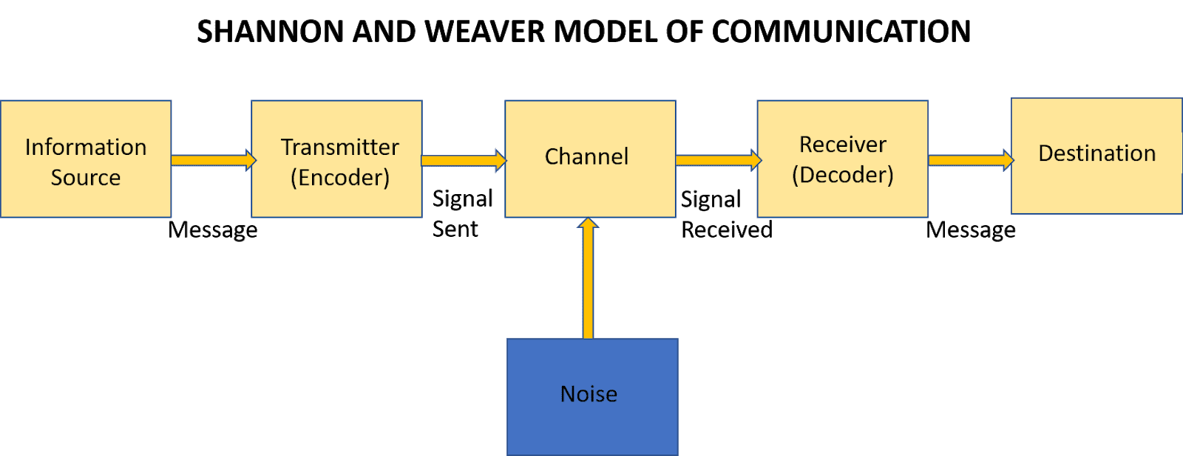
(Michelle S.2018)
This model is also called Information Theory and shows that the message comes to a destination via signal. The communication is started by the source that can be a person or cooperation.The source feels the desire to transmit any information he wants to a destination he wants.The message is conveyed by a tool.that is called the sender.When we talk to each other,the tool is the voice wires.The message sent from the first source becomes a signal in some way.Noise is the important element as it affects communication directly
For example; a manager phones a staff member about a conference.Staff member can not get whole message due to noise.
Manager: The conference will be at 10 am. ( Meeting room becomes lost because of phone line problem)
Worker: Where? ( feedback)
Sender:Manager - Encoder: Phone Line Company - Channel: Network - Noise:Creaking Sound - Decoder:Telephone - Receiver: Staff Member
Advantages:Noise factor makes the communication effective .Communication is taken as measurable in this model
Disadvantages:The messages are more important than feedback.To understand decoded message is questionable as there is no feedback.(Afficial A.C.2016)

WILBER SCHRAMM’s Model of Communication

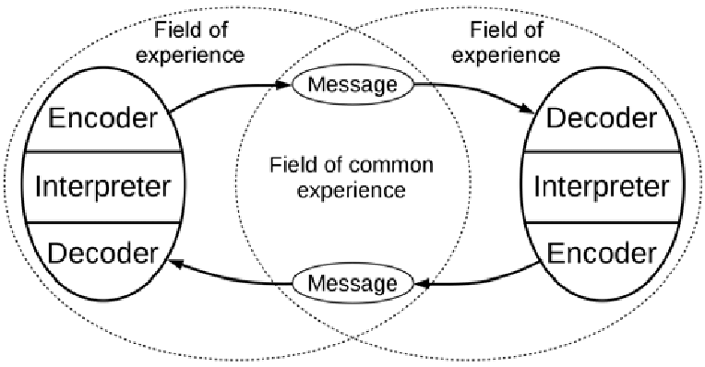
ND:https://www.researchgate.net/figure/The-interactive-model-of-communication-presented-by-Schramm-14_fig1_311739283

At the end of the communication process in this model, the main objective is that the sender and receiver have similar thoughts, attitudes on a certain subject.The three main elements of communication are the sender , message and the recipient.
A source can be a person or a professional Communicator in an organization that creates messages to send through various programs.A message is a set of information or meaning carried by sound,image,text…etc.The sender encodes the message it wants to forward to the receipent.Here, the sender and recipient must have a common framework of relevance.The common relevance here is the similarity of the language used and the cultural experiences.When the recipient gets the information , this is his responsibility to give feedback.
For example ; you share your ideas about your friend new hair style and your friend does not respond, this means communication is not completed.
Advantages:This circular model provides to both parts to say their opinion.Feedback provides effective communication.Field of experience makes communication more understandable.
Disadvantages:This is only two source communicaion , You can not use this model if the process is made difficult by many sources.(Afficial A.C.2016)

BERLO’s SMCR Model of Communication


ND:https://www.communicationtheory.org/berlos-smcr-model-of-communication/

In this model, the communication process is based on four basic elements: source, message,channel and receiver.Launguage , hand-arm movements,five sensory organs,knowledge,thinking,speaking,writing,drawing,imaging are coded as messages.Adressing such variables indicates feedback.
For effective communication,the source and the receiver should be on the same level according to this model.Just then good communication can be provided properly.
Affect is not considered as there is no concept of feedback,It is a complex model.

THE IMPORTANCE OF EFFECTIVE COMMUNICATION

Effective communication which is an indispensable part of daily life is also very important for workplaces.Effective communication skills which increase productivity as well as create trust between employers and employees are essential for strong teamwork.The main goal of workplaces should be productivity and jobs done smoothly.They can achieve this by developing effective communication skills .
Workplaces that communicate with their employees and direct their talents enable them to show themselves to get things done as soon as possible.
Uneffective communication such as unclear job descriptions and improperly assigned tasks may reduce employee motivation and create problems fort he sustainability of jobs.
Using effective communication skills is important fort he success of not only the workplaces but also the employees.Employees who feel that their opinions are given importance do not hesitate to express their problems in a transparent manner to provide maximum benefit.
For example, I am working as a housekeeping manager in my current workplace which is a health care company, before I started to work in this company ,according to my staff and colleauges feedback, there was not a good communication between my team and managers.They said me that they did not even know what was happening in the company.ın my first week , I talked to my each staff member face to face individually to learn their ideas , to find out the negative points.I needed to take quick actions as the cleaning score of council inspection was bad that was done by CQC.These are the points that I did to improve the job;
- İdentify the goals: I explained all my team the achievable goals.This ensured that all staff were aware of the objectives.
- Transmit my messages clearly: I did morning meetings to talk about daily job tasks before we started to work, set up a whatssapp group between team and myself for quick communication, the rota was sent to their emails therefore all team members were aware of their shifts.ı did job descriptions and gave to them in written so the staff were aware of what they need to do or what ı want them to do.I prepared presentations monthly to show the situation of the department and results.
- Keep staff involved: I was always accessable form y team so they did dialogue with me when they needed.
- Listen my team: I gained their respect by listening their suggestions and problems.I adressed the issues to the employer to sort out quickly
Those quick actions that I did for effective communication did bring success to the company as we passed the second inspection with very high score.According to Neil Thompson, a manager should always answer to complaints , prepare presentations in organization , improve cooperative relationship to help ,gain trust of his team for perfect communication(Thompson N.2018)

METHODS OF COMMUNICATION

VERBAL COMMUNICATION

All kinds of conversations and correspondes between individuals are called verbal communication.This type of communication is the exchange of messages between people with the help of letters and words.It takes place through language.Verbal communication are face-to-face interviews , speeches at meetings,oral presentations, telephone converstaions , training courses,conferences and staff meetings.
It has many advantages.According to me,it is the most effective method as you can answer the questions promptly , focus on the issues that are not understood as much as necessary and give feedback simultaneously.
For example, when I was working in Istanbul in the hotel, I was doing morning briefings daily basis with my team to give job tasks, talk about the department issues and give quick trainings. I was using this method especially to motivate them.

WRITTEN COMMUNICATION

Communication on a text or document is called written communication. It is used to transmit the information to be sent by the source without losing true natüre.Newspapers,manuals and brochures,bulletins,written reports and letters are the most commonly used tools of written communication.Although it is a legal and reliable way of communication , there are disadvantages such as lack of feedback, the ability to write and loss of time based on writing.
For example, in my workplace, when I hired a new staff, I give a hand book to him or her in first day.This book contains company policy, disciplinary rules,break times,attendance policy,smoking policy…etc.I also do the staff rotas and email to them.If I want to warn a staff member in written , ı do this with a warning letter in a legal procedure.

NON VERBAL COMMUNICATION

Gestures and body language are used by people to support their mention even if they are not aware. When you interact with someone , you send powerful messages to the other person by sitting, tone of voice, distance between you and eye contact.
For example, in my current workplace, two staff members argued in the morning meeting because of tools and they affceted the subject of the meeting and the other staff.I wanted to stop their discussion in polite way but they were still continueing to argue strongly so I increased my tone of voice to stop it.They understood that I became nervous and got the message from myself.

COMMUNICATION BETWEEN MANAGEMENT AND EMPLOYEES

Communication flows in 5 main directions in a company;
- DOWNWARD
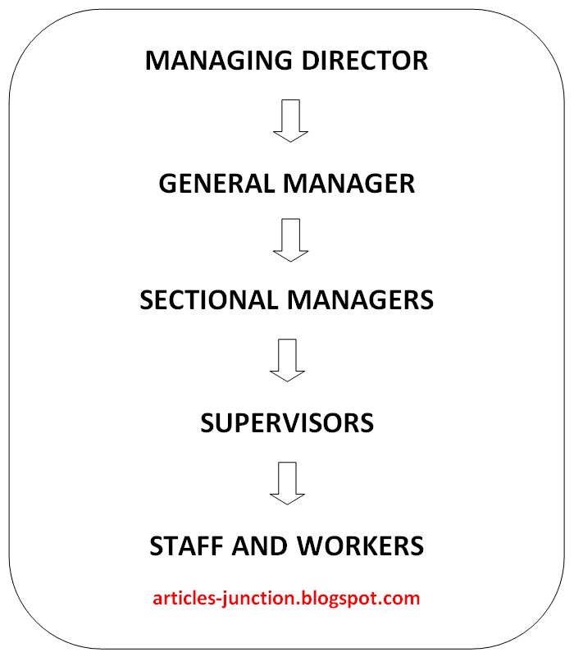
(Patil M.2013)

Within the hierarchical structure of the organization, it is the communication that starts from the top managerand follows down the chain of command.In this communication, business policies , rules , orders and information requests play a role in the transmission.Top-down communication should usually be written in plain language , understandable and without comment.In the company where I work , this communication flow is used.
- UPWARD

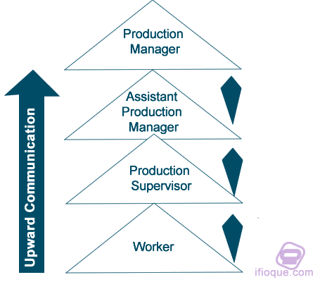
ND: https://www.ifioque.com/miscellaneous/upward_communication

This communication means that subordinates gives the necessary information to the superiors.Upward communication usually consists of reports and reactions from subordinates.They mention their thoughts about their work and management to the higher authorities.

- HORIZONTAL
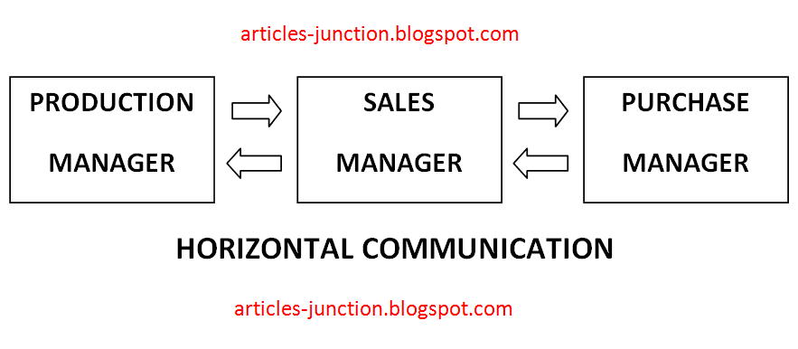
(Patil M.2013)

This communication is between individuals who are the same organizational level.Its most important function is to ensure the effectiveness and harmony of activities within various organizational units.

- DIAGONAL
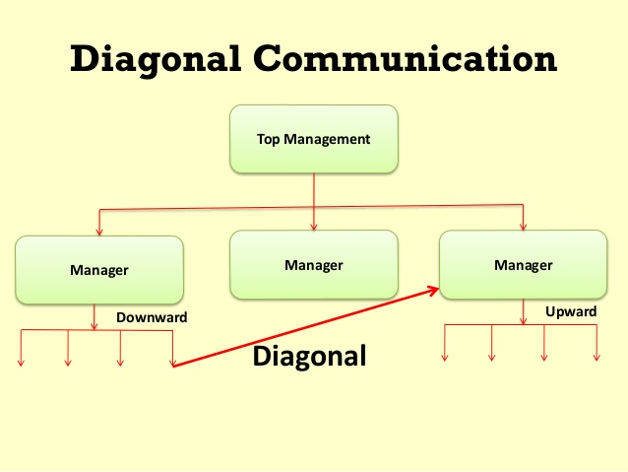
ND: https://courses.lumenlearning.com/wmopen-introbusiness/chapter/communication-channels-flows-networks/

We can explain this communication with an example.When an employer wants to know the technical features or results of a product in testing phase, he can go outside the hierarchical chain of command and consult the knowledge of an engineer.Such communication is called Diagonal.
- EXTERNAL

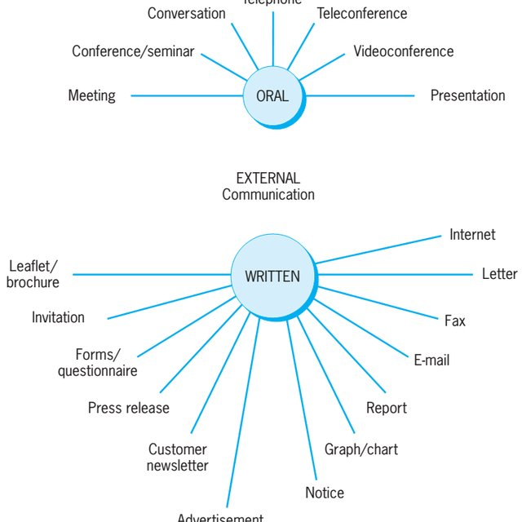

(Terzic E.2017)
Organizations are open systems.They have to use internal communication channels as well as external communication channels to sustain their lives.External information necessitates continues organization and adjustment of the organization’s decision center,structure,programs and behavior.

CONCLUSION

Through this report, we understand that the communication is very important for business life.We must examine every aspect of communication very well not to have walls and barriers between superiors and subordinates.Neither an organization nor an employee can not take dynamic steps in working enviroments where people can not communicate and share information.
The secret of success is through effective communication. In every aspect of your business, you will be asked to communicate in some way. It is important to know how effective communication is valuable and what impact it can have on your relationships and progress in the business world.
REFERENCES

Aficial A.C.(2016),Models of Communication, (Online)Available at: https://www.slideshare.net/judyanntulao/models-of-communication-63898369 Accessed on 11.07.2016

Hargie O.,DicksonD.,Tourish D.(1999),Communication in Management,1st Edition,Gower Publishing Limited,UK

Michelle S.(2018),Communication Studies,(Online)Available at: https://michellemathiasfsp.blogspot.com/2018/11/shannon-and-weavers-model-of.html Accessed on 30.11.2018

Patil M.(2013),Articles Junction, (Online)Available at:
http://articles-junction.blogspot.com/2013/08/define-downward-communication-and.html Accessed on 08.02.2013

Terzic E.(2017),Modern Communication Channels, (Online)Available at:https://www.researchgate.net/figure/Channels-of-external-communication_fig2_320167125 Accessed on Jun 2017

Thompson N.(2018),Effective Communication,3rd Edition,Red Globe Press,UK

ND: (Online)Available at: https://www.researchgate.net/figure/The-interactive-model-of-communication-presented-by-Schramm-14_fig1_311739283

ND: (Online)Available at: https://www.communicationtheory.org/berlos-smcr-model-of-communication/

ND: (Online)Available at: https://www.ifioque.com/miscellaneous/upward_communication

ND: (Online)Available at: https://courses.lumenlearning.com/wmopen-introbusiness/chapter/communication-channels-flows-networks/

APPENDICES





