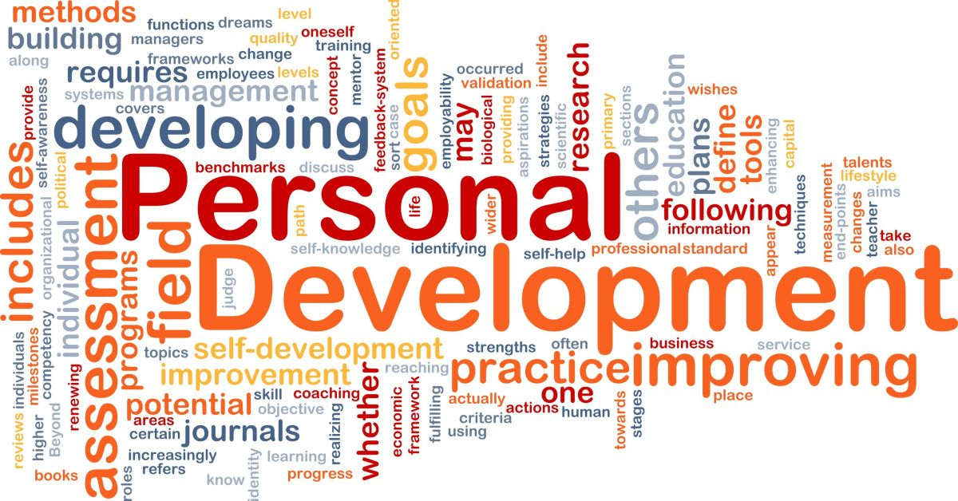
This Photo by Unknown Author is licensed under CC BY-NC-ND

Personal Development Skills
  - UWTSD
Thomas Bradley | 1817174 | 09/06/2019

Index

- My Journey So Far
- SWOT Analysis
- SMART
- Kolb
- Johari window
- Go Mad
- Personal development plan

My Journey So Far
So far since starting our journey into Higher Education (March 2019) we gained a good understanding with Personal Development Skills. We touched down on many things during each lecture.
Giving us a better understanding on how to develop these skills, in order for us to progress onto our chosen subject after completion, and also lead on to our future goals.
Also we have learned a lot about motivation and how this will benefit in helping us on our journey to what we would like to achieve during the course (personal development skills) and receiving Certificate of Higher Education. As well we have touched down on different theorists and how they explained their different methods like Abraham Maslow and his motivation theory hierarchy of needs and the Maslow’s pyramid.
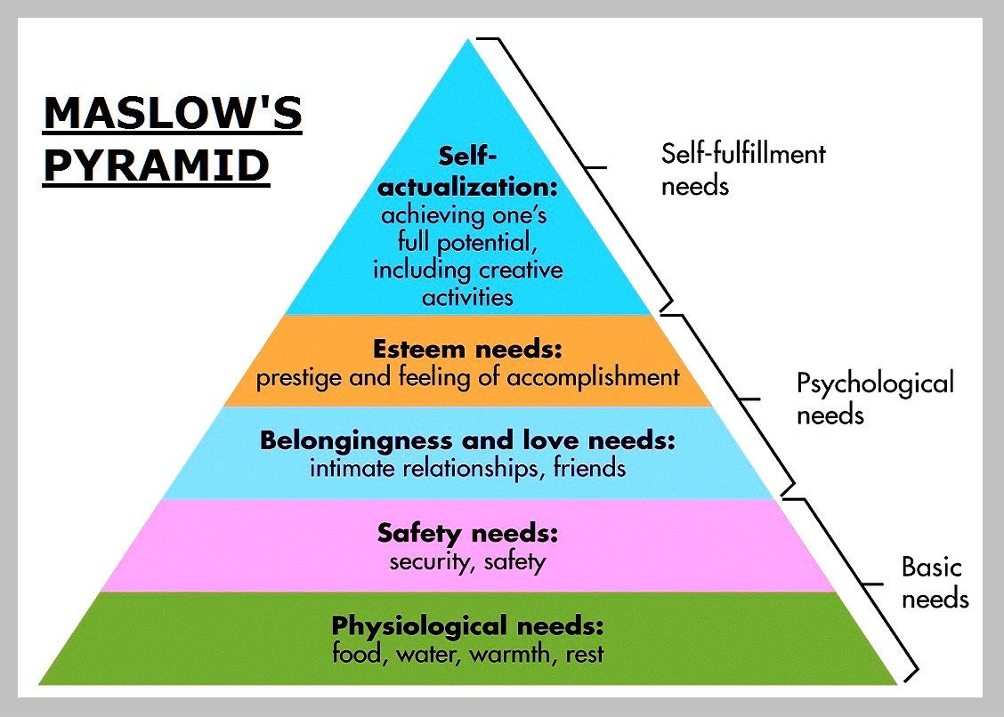
https://www.bing.com/images/maslowspyramid
We have performed a few different tasks along the way one of them being to write down our 3 year plan and what we will do to follow through with it , prioratise our order for example our 3 year plan would start of with completion of Certificate Of Higher Education march 2020. Then we will be in the position to chose where we go from there weather it be buisness management or similar rolls within the university mine being to continue on with a 3 year degree in Buisness Management And Eltrupenurship witch is going to help me on my journey.

S.W.O.T Analysis
What is a swot analysis?
A swot analysis is a strategic planning technique which will allow us to organize and recognize our strong points also our weak points the opportunities and lastly the threats witch we face. It will allow us to reflect and develop our skills in the business sector and see our internal and external strengths and weaknesses and how to adjust so that we can be more suited and also develop to gain more opportunity. It is basically a tool in strategic analysis.
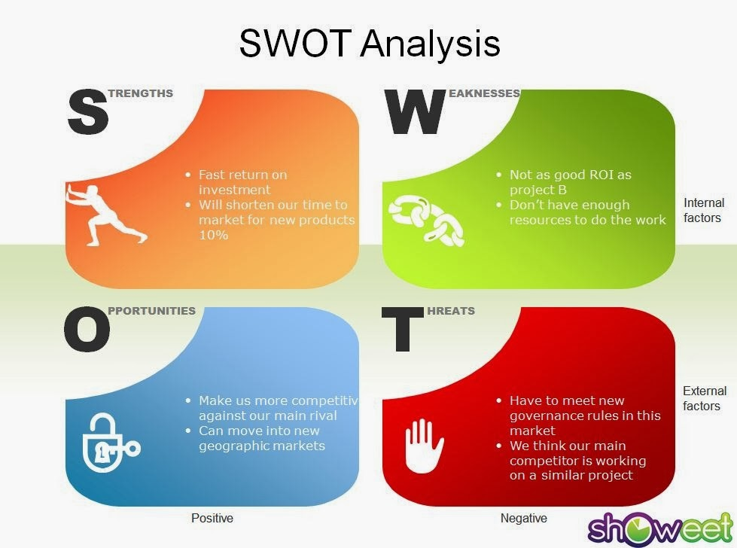

Personal S.W.O.T Analysis
What I have here is my personal S.W.O.T analysis which will enable me to look over and see how I can turn my threats into opportunities in order to be more successful in my future.

Strenghts Weakness.
*Comunication skills *Distracted
*Pick things up quickly *Lose focus
*Team player *Dout myself

Opportunity Threats
*Business opportunity *Cost me financially
*Career development *Affect opportunity
opportunity *Take me off track

S.M.A.R.T

To have a goal it must be S.M.A.R.T.
S = To be specific
M = It must be measurable
A = It must be achievable
R = To be realistic
T = Time bound
When taking on a goal all of these things must be taken into consideration in order to gain the full potential and also make in achievable, to say you will continue on with university and gain qualification by the end of this year is smart and realistic also achievable and measurable.
To say that you are going to fly to space in the next 6 months is not realistic it also is not achievable there for the goal you are setting yourself is not a smart goal.
We must set our self-time for example gaining degree it will take three years there for we have to be time bound about it.
To make our goal specific we need to vision it every single day and also plan how we are going to achieve it take time and list things step by step, take action start with the small make our way onto the big (walk before we can run).
We must measure all of this with revision looking over notes revising what we have learned along the way and seeing where things could be different in order to achieve what we work towards.

Kolb Learning Cycle
Now the kolb learning cycle was founded by none other than Dr. David Kolb who was born in America back in 1939. He was educational theorist also a social psychologist.
Hear we can find a lot more on Dr.Kolb and his theory
https://erinspencer.wixsite.com/edpsychologists/david-kolb

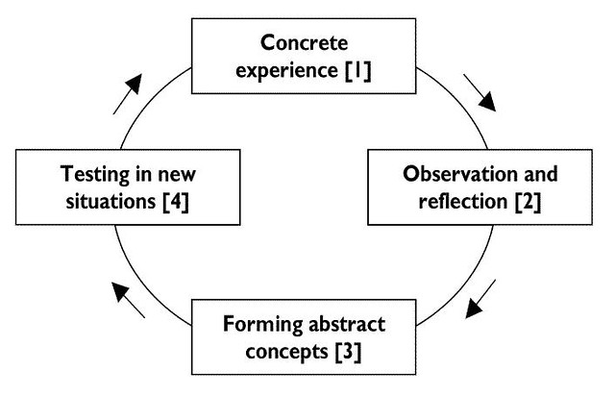
This Photo by Unknown Author is licensed under CC BY-NC-ND
Hear is kolb’s learning cycle.

Now I will give you an example of our learning cycle;
Concrete experience is to sit in our lectures and take in all of the information that has been provided to us.
Observation and Reflection has been to go away from each lecture and really break down each topic and look at the key points and details to see exactly what we have learned.
Certain lectures or information on these lectures might lead to forming something new something we didn’t see first time around.
Finally testing out all of the topics we have gone over seeing how we have gained new knowledge after breaking it all down again and going through it. we will then put these skills to the test when we do future learning or assignments to help us work around and adjust to any thing that we have not cleared

So, in simple terms what we do is :
- Do
- Think
- Conclude
- Adapt

First time around and then

- Do Again
- Think Again
- Conclude Again
- Adapt Again

So we are constantly progressing on with things that we have already touched down on. This also gives us time to reflect on the shaded areas where we might not of had an understanding to which we can then understand fully and explain our reflection.

Johari window

The Johari window will give us a better understanding on ourselves also at the same time giving people from the outside a better understanding on us and what we think also what they think.
Example being somebody might think they are a funny go luck person whereas the people they go to a class/ course may think that they are far from funny also quite slow and to relaxed.
It was created by psychologists Joseph Luft and Harrington Ingham in 1955, and is used primarily in self-help groups and corporate settings as a heuristic exercise.
https://www.bing.com/search?q=johari&form (18/06/2019)

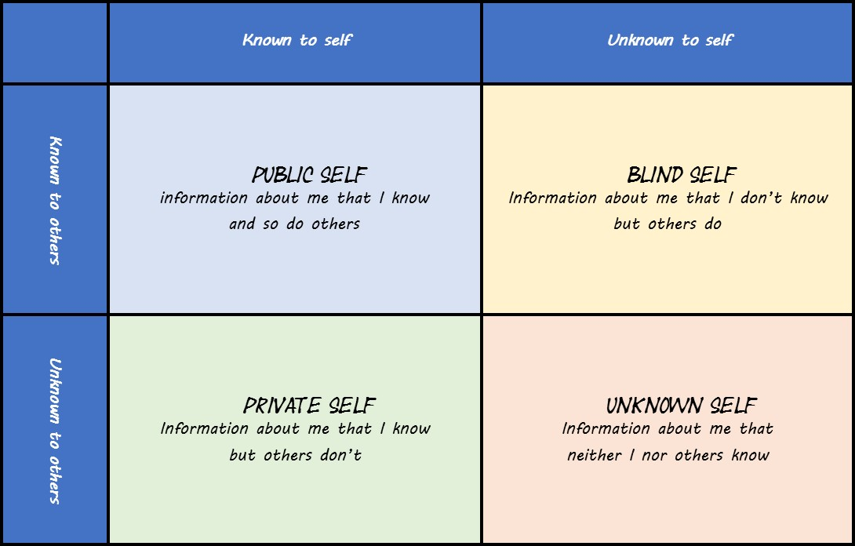

http://lifecoachingcentre.co.uk/wp-content/uploads/2015/10/johari11.jpg
This is a perfect Johari window example as seen above.

Go Mad

Go MAD stands for Go Make A Difference, this was founded and created by two gentlemen by the names of, Andy Gilbert and Ian Chakrvorty and they then went on to publishing the first book in( 1999).

Hear we have a link where you can access lots of information on the go mad framework and a few good in depth videos :
https://www.gomadthinking.com/about/our-story/
There is 3 different tears of the go mad framework and these are them:
Level 1
- Reason Why
- Define Goal
- Possibility & priorities

Level 2
- Self belief
- Personal Responsibility
- Involve Others

Level 3
- Take action & Measure Results

So these is the basic table of the Go Mad model and if you do all of these things then there is no reason why you cant really Make A Difference in the business field or even in everyday life.

My example;
My reason why = Financial freedom
My Defined Goal = continue university become a full-time forex trader/investor.
Possibility and priority = It is very possible for myself as long as I stick to the plan use all my self-belief and keep the end in mind.
I must have self-belief in myself in order to achieve great things doubt is a big goal killer.
Take personal Responsibility for the actions I take on my journey or it may not be as smooth as I expect it.
My journey may have to Involve Others in order to get to the final steppingstone for example my forex trading I may have to involve my self on courses with people teaching me different strategies along the way. I might have to meet with people in order to achieve the investment side of my plan
Finally, I will take all of this and put it into action in order to achieve financial freedom and make my way further up the ladder. So, there we have it my personal plan in the go mad model
‘In Order to Achieve Great Things We Have To Make A Difference’ .
Our goals must be smart and also affective to achieve them to a high standard.

Personal Development Plan
My personal development plan is to achieve what has been set in university.
Identify my goals
- Complete certificate of higher education
- Cover all sections of business
- Learn more on investments
- Fully understand (FOREX)

Break down

How I will achieve each of these goals in order:

- Attend all of my lectures on time and take on board all of the information provided
- Take time to chose carefully the business sector I want to work towards.
- Carry on with my research on investments starting small.
- Continue with my trading allow my self plenty of time to progress and gain knowledge.

Evaluate my progress

In order to do each of these goals I must evaluate (overlook) my progress.

- Go over all of the work have done in my lectures after the class and review it make sure all of the information is broken down.
- Take notes on buisness ideas and pointers in order to help me improve and gain knowledge before going onto study.
- When placing trades take notes to see how it has all gone what I could of done better also if there could have been a different approach two the trades placed. Revise all the notes I have written down over the time I have been learning this.

So finally, a conclusion on all that we have learned, It will help us all have a greater understanding of all of the skills required in order for us to achieve great things. Also it will allow us to gain a better understanding on how to develop the skills we need in order to get to our final destination. For myself if has given me a great insight of the skills I need to for fill my investment and trading journey. I have also learned that we can’t go into something with out a plan and that plan has to be smart so it is very important when setting our goal that is is specific, measurable, also be achievable, realistic and time bound.
This has been a massive help to us all in order for us to complete assignments and follow up on information , Learning about different
theorists and how to reflect on our self’s past and present in order to gain the full potential in ourselves.
After completion of university (2023) we can take all of the personal development skills we have gained and put them to the test in the big wide world as long as we remember all of the things that we have learned alon the way there is no reason why greatness can not be achieved.

