HPHI 5004 – Britain and The Great War
Essay question number 2 – Level 5.
Far from being persecuted and the subject of hostility, Conscientious Objectors in Britain were given a sympathetic hearing by the civil authorities during World War One. How accurate is this statement?
In this essay it will be argued that the attitude towards conscientious objectors during the First World war had much to do with the patriotism of the public, the actions of government, local authorities and the military. Persecution, hostility and sympathy prevailed; but the conscientious objections were strongly felt by those not wishing to take up arms but not necessarily understood in an atmosphere never felt by the British nation. This essay takes a chronological approach from the outbreak of war and developments that led to conscientious objectors being in the public eye and the resulting attitudes and behaviours of the civil authorities.
The term conscientious objector can be said to bring instant assumptions and dislike of a whole group of people without questioning who they are, from where do they come, and what religious beliefs were they brought up with? The attitudes of Britons in 1914 to 1918 were certainly mixed, not all citizens were being patriotic and supportive of the war. Calls for patriotism and protection of the Empire were fed to the public by the newspapers and propaganda posters of the day. The civil authorities had a balancing act to play out, they had to be seen to be proactive, they had to consider all walks of life and answer the questions: who to call to enlist? How to encourage enlistment? How to allow for exclusions? Who should be excluded? This was a war on a scale never experienced and men were needed; the government calling to men to replace their civilian clothing for the khaki uniform and to answer the call to take up arms and fight for the protection of the nation and indeed the Empire.
Following the declaration of war on the 4th August 1914, Britain needed soldiers and called out to the men of the British nation to volunteer. The famous poster illustration of Lord Kitchener, Secretary of State for War, (see illustration A) was in response to the government accepting that there was an immediate need to increase army numbers. The appeal read ‘Your King and Country Need You. A Call to Arms.[ ] General service for a period of three years, or until the war is ended’. Although patriotism was high and most wanted to do their bit, enlistment did not meet the demands of numbers that would be required for the war; no one had any idea that the war would go on for so long and bring about casualties on a scale never before experienced. However, it should be noted that in the months following the outbreak of war, ‘Britain raised the second-largest volunteer army in history’. In this day and age it would be explained as the media playing a huge part in encouragement and engagement.
It is also necessary to consider the attitudes of the public, the pressures that they put on menfolk and how women were manipulated by propaganda, encouraging them to strongly urge their men to go to fight in the war. De Groot in his book quotes from a letter sent to ‘The Times’ where a woman wrote ‘We women…recognise that, as women, we have no use for the man who will not fight for his king and country’. Even with all the propaganda, ‘White Feather campaign,’recruitment drives, local pressures and female encouragement, voluntary enlistment was still below what Kitchener’s army required.
There were men within industry and business that argued their employment was an asset to the country and therefore they had to stay on the home front. There were reasons for men not to enlist: family commitments, health, employment in work needed for the ‘business as usual’ ethos, but it was not acceptable to suggest that fear of death was a driving force for one not to enlist; In an atmosphere charged with patriotism, ‘…a straightforward admission of cowardice was unlikely to be met sympathetically’. Conscientious Objectors were amongst those not responding to Lord Kitchener’s calls to join up and fight but were perhaps less obvious amongst many others who were yet to answer the call to enlist. Strong recruitment campaigns and propaganda meant saying ‘no’ to enlistment was a difficult and contentious choice.
In September 1915 the government introduced the ‘National Registration Act, 1915’. This Act required of every man and woman from the age 15 to 65 to complete details for the National Register. Exclusions to this register were those already signed up in the military forces, ‘a prisoner in a prison, certified lunatic or defective, or inmate of any poor law institute, hospital, or any other prescribed institution…’ This can be suggested to be a forerunner to the idea of national conscription. A register of all eligible men enabled the government to use statistics and plan tactics for future enlistment campaigns. The register was able to identify not only eligibility of age but also noted the employment of all those included and if skills held were transferable or needed for the ‘home front’.
Compulsory conscription was becoming ever more likely as war progressed, the battles being fought on the ‘frontline’ meant huge numbers of casualties and therefore the need for more men ready for service. As compulsory conscription raised its head, then so did organisations against war and combatant actions and inclusion. One such group led by Clifford Allen was the ‘Non-Conscription Fellowship’. Members were against all combatant activity and any actions that were thought to aid the government in war. Other pacifist groups included the Quakers; however, it should be noted that although they were most definitely against war and killing of fellow man and they did have ‘Conscientious Objections‘ to the war, the ‘Friends’ did play their part in the war effort. Within the Quaker movement there was the creation of the ‘Friends Ambulance Movement’ and the ‘Friends War Victims Relief Committee’. The Quakers did resist conscription but this was not the case for all members: ‘a small but substantial number of Quaker men did choose to join the armed forces, feeling it was the quickest way to end the war’.
Wishing to be excluded from the war due to ‘Conscientious Objections’ came from many directions; religious beliefs, moral grounds and political opposition to the war were just some reasons to refuse to take up arms. What made the conscientious objector different to someone holding back from volunteering? It could be said that the conscientious objector would be the one to stand up and say ‘no’ to taking up arms and would continue to follow their beliefs and moral reasoning, regardless of attitudes of the public, military and the government. The final words of Wilfred Owen’s poem Dulce Et Decorum Est could be said to support objection to war, ‘…The Old Lie: Dulce et decorum est Pro patria mori’. For the conscientious objector it was most certainly a lie or at the very least against moralistic beliefs or religious following.
To encourage voluntary enlistment Lord Derby, who in October 1915 was appointed ‘Director-General of Recruiting’ formulated what was to be known as the ‘Derby Scheme’ . The scheme was to request that all men, 18 to 41, would ‘attest a willingness to volunteer’. As men were required for duty, the youngest would be called up first to honour their pledge to take up arms and go to battle. ‘Conscientious Objectors’ did not attest but were not the only men not to. Again, the government found that volunteer numbers were lacking. The answer to the problem had to be compulsory conscription of all men 18 to 41, and the ‘Military Service Act, 1916’ was implemented in March 1916. The Act was further revised in May 1916 to include married men and by 1918 further revisions were made to include men up to the age of 51 and those previously excluded because of their place within industry. Women were being utilised and filling roles vacated by men who were needed for war.
The ‘Military Service Act, 1916’, it must be noted, contained ‘exemptions for ministers of religion, the medically unfit, the Irish and conscientious objectors’. It is obvious that the government took conscientious objections into account and processes were put into place nationwide to allow for applications of exemption, to tribunals, to be made. The government had expected that those applying to tribunals would be seeking ‘ exemption from military […]service only; […] objections on religious grounds…’ What may be suggested is that those totally against all aspects of war, combatant and work aiding the war effort, would bring a new dimension to decision making. The ‘Absolutists’, as these conscientious objectors would be known, faced tribunals that were not necessarily sympathetic to their cause and beliefs. Those sitting on these tribunals were not necessarily qualified to make such important decisions on who qualified and who did not qualify for exemption, and conclusions could be reached based on personal bias and not necessarily to the letter of the law. Ceadel writes of the ‘…exemption procedure’ the ‘provisions proved unacceptable to the local worthies who had to implement them’ Illustrations B ,C, and D show an example of the forms used in the exemption process, which included decisions and appeals.
Many of those conscientious objectors looking for absolute exemption at tribunals found their applications refused, they would then have leave to appeal; but if again their exemption request was refused the authorities would see these men as being soldiers ‘absent without leave and […]subject to arrest’. The refusal of exemption and the following failure of appeal led to men automatically being placed in the army and treated as though they had refused orders. For those in this position a term of imprisonment was given. Initially, following compulsory conscription, these imprisonments were within the military domain but as war progressed most conscientious objectors were imprisoned in civil prisons.
Conscientious objectors at the end of their imprisonment term would be again asked to take up arms and the khaki uniform, if refusal was repeated then these men would be returned to face further imprisonment and the harsh treatments dealt out. The tribunals did not show compassion or empathy for those having absolutist beliefs. The military court martials were perhaps considered even less so and there are known cases of extreme cruelty towards those refusing to take up arms. The cruelty towards conscientious objectors by the military was discussed at parliamentary level on very many occasions. One case, amongst may, of abuse of a conscientious objector, being brought to the attention of the House, was that of a gentleman by the name of D S Parkes. Following his arrest Parkes was assaulted by an NCO, he was told he was to be shot at dawn; he had a rifle loaded and aimed at him; he had a bayonet pointed at his heart. There were many such abuses; such as being ‘…force fed, tied into strait-jackets, beaten, kept in filthy cells…’
Although there were ‘Absolutists’ there were also those known as ‘Alternativists’. These, broadly speaking, were the conscientious objectors that were opposed to fighting, killing and maiming; their objections on moral and religious standing. For these objectors to the war was the opportunity to serve their country in a non-combatant manner. There were roles available in the ‘Royal Army Medical Corps or Non-Combatant Corps’. Tribunals considering applications were able to offer exemption from military action but on condition that the conscientious objector would take up work to assist in the needs of the country. Many conscientious objectors still found themselves on the ‘frontline’ but not in a combatant capacity; many were stretcher bearers and ambulance drivers. They still faced death, fear and showed bravery but the stigma of conscientious objectors would remain.
In tackling the tribunal appeals for exemption the government set up the Pelham Committee, whose purpose was to find work and opportunities for those conscientious objectors who were willing to take up employment offered in return for combatant and military exemption. ‘3,964 accepted work at home under the Pelham Committee guidelines’. This shows that far from wishing to browbeat men to go to the ‘frontline’ the government was also willing to find use for those with objections. Agriculture and road building being examples of useful work.
In conclusion the civil authorities were mixed in their attitudes towards conscientious objectors. Differentiating between ‘absolutists’ and alternativists’ brought about different outcomes regarding persecution or a sympathetic hearing. It can be further concluded that public attitude towards those not wishing to enlist was exasperated by the implementation of compulsory conscription; had the Military Service Act,1916 not been enacted, the phenomenon that was the conscientious objector would not have been so prevalent.
The government did implement clauses and solutions within their ‘Military Service Act, 1916’ showing empathy for those expected to have conscientious objections; it can also be said that there was some sympathy and understanding towards those with either moral or religious objections. The downfall could be said to lie with the local tribunals and the military; the attitude in these areas was both negative and abusive and was most definitely not in line with the original governmental structures. The ‘Absolutists’ and the ‘Alternativists’ could have been equally treated had there been more control over propaganda and the newspapers; posters and campaigns aimed at those not enlisting may have had their origins in getting the voluntary numbers required for military interventions but they also created opinions that affected how conscientious objectors were treated.

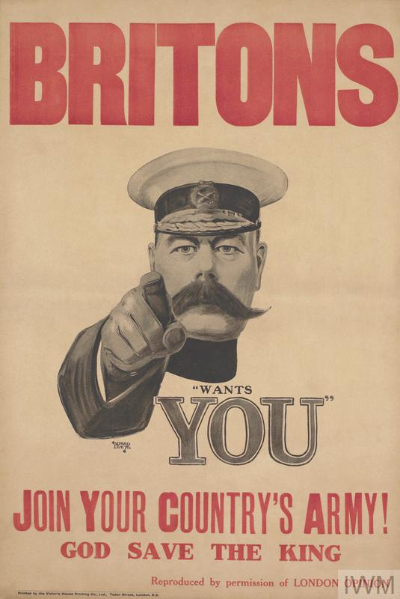
Illustration A - https://images.app.goo.gl/emu7KQovQ7n7qk7c8

Examples of Exemption Application, Decision and Appeal.
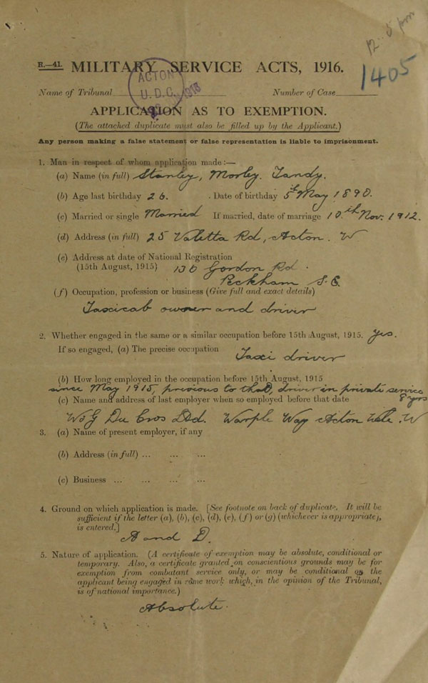
Illustration. B
Full application for exemption from military service (catalogue reference: MH 47/15/5
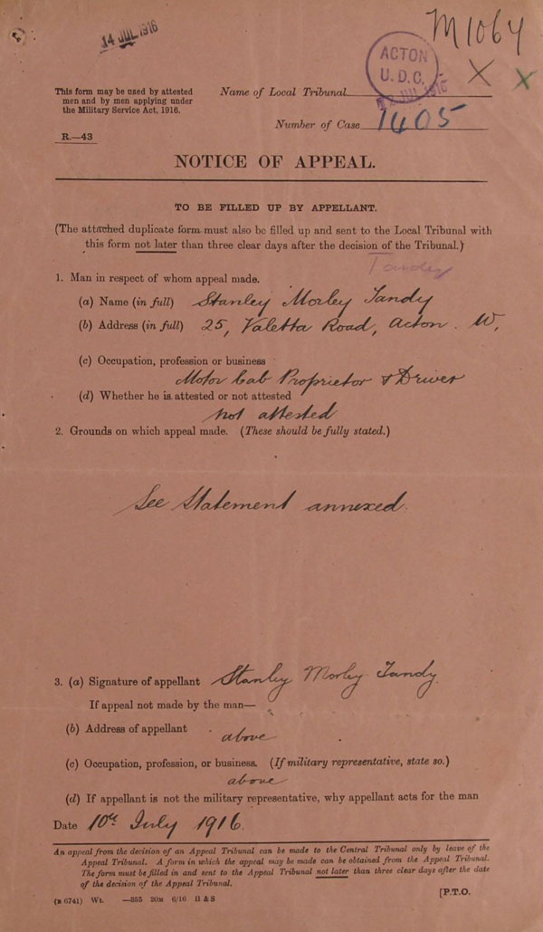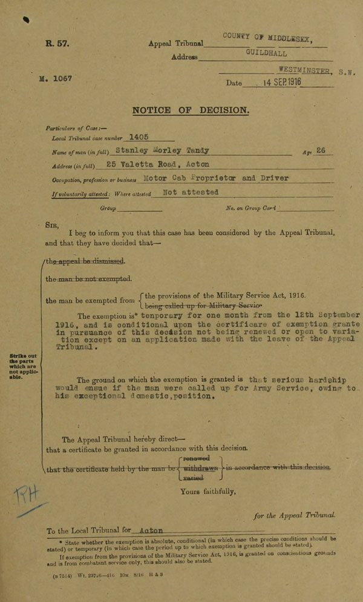
Illustration. C Illustration. D
Full notice of appeal (catalogue reference: MH 47/15/5) Full notice of decision (catalogue reference: MH 47/15/5)
References

Ceadel, M. Pacifism in Britain, 1914-1945 : the Defining of a Faith. (Oxford; Clarendon Press, 1980)

De Groot, G. Blighty: British Society in the Era of the Great War (Harlow; Pearson Education Limited, 1996)

Gregory, A. The Last Great War (Cambridge; Cambridge University Press. 2008)
Marwick, A. The Deluge 2nd Edition (London; Macmillan Press. 1991)

Silkin, J. Editor The Penguin Book of First World Poetry 2nd edition (Middlesex; Penguin books, 1981)

Socknat, Thomas P. "White Feather Campaign." The Oxford Companion to Canadian History (2004): The Oxford Companion to Canadian History. Web. {accessed via UWTSD Library resources 19/11/2019}

Internet References

https://ap/i.parliament.uk/historic-hansard/commons/1916/may/10/conscientious-objectors /{accessed 18/11/2019} CONSCIENTIOUS OBJECTORS. HC Deb 10 May 1916 vol 82 cc646-50 -

https://images.app.goo.gl/emu7KQovQ7n7qk7c8 [Accessed 18/11/2019]

https://www.iwm.org.uk/history/conscientious-objectors-in-their-own-words {accessed 16/11/2019}

https://www.parliament.uk/about/living-heritage/transformingsociety/private-lives/yourcountry/overview/conscription/ {accessed 16/11/2019}

https://www.quaker.org.uk/about-quakers/our-history/quakers-and-wwi [Accessed 18/11/2019]

https://images.app.goo.gl/emu7KQovQ7n7qk7c8 [Accessed 18/11/2019]
Marwick, A. The Deluge 2nd Edition (London; Macmillan Press 1991) p.75
Gregory, A. The Last Great War (Cambridge; Cambridge University Press. 2008) p.73
De Groot, G. Blighty: British Society in the Era of the Great War (Harlow; Pearson Education Limited. 1996) p.68 De Groot references a letter from the Times newspaper dated 16th January 1915
Socknat, Thomas P. "White Feather Campaign." The Oxford Companion to Canadian History (2004): The Oxford Companion to Canadian History. Web. This campaign began in the early days of the First World War in Great Britain, where women were encouraged to pin white feathers on young men who were not in military uniform. The hope was that this mark of cowardice would shame them into ‘doing their bit’ in the war
A. Gregory. P. 91
National Registration Act, 1915 [5 & 6 Geo. 5. Ch.60]
National Registration Act, 1915. P.6
Ceadel, M. Pacifism in Britain, 1914-1945 : the Defining of a Faith. (Oxford; Clarendon Press, 1980) p.42
https://www.quaker.org.uk/about-quakers/our-history/quakers-and-wwi [Accessed 18/11/2019]
Silkin, J. Editor The Penguin Book of First World Poetry 2nd edition (Middlesex; Penguin books, 1981) p.183 translation from Latin to English, ‘it is sweet and proper to die for one’s country’
A. Marwick, p.102
G. DeGroot, p.94
https://www.parliament.uk/about/living-heritage/transformingsociety/private-lives/yourcountry/overview/conscription/{accessed 16/11/2019}
G. DeGroot, p.96.
M. Ceadel, p.38.
ibid
https://www.iwm.org.uk/history/conscientious-objectors-in-their-own-words
CONSCIENTIOUS OBJECTORS. HC Deb 10 May 1916 vol 82 cc646-50 https://ap/i.parliament.uk/historic-hansard/commons/1916/may/10/conscientious-objectors /{accessed 18/11/2019}
G. DeGroot, p.156
Imperial War Museum
G. DeGroot, p.155

