REPORT

Module: Introduction to Web and Database Concepts (ACCA4023) Assignment: HTML & CSS Web Development
Eulalio Alesino Fernandes
Student Name:
Student ID:
(ACCA4023 ) HTML&Web Development
2441942
Course:
Submission Date:
23/04/2026

Table of Contents
INTRODUCTION : 3
REQUIREMENTS : 3
IMPLEMENTATION : 4
Screenshots : 5
Evaluation : 7
5.3 Validation : 9
Index Page Validation : 9
Style.css File Validation : 10
WEBSITE COMPARISON : 10
CONCLUSION : 11
REFERENCES : 12
APPENDICES : 13

INTRODUCTION :
This report explains the design and implementation of a multi-page restaurant website named “Delicious Bites,” constructed utilizing HTML5 and CSS3. This project aims to illustrate comprehension of essential web building principles, encompassing structure, styling, usability, accessibility, and search engine optimization (SEO).
The website was created to furnish users with vital information regarding the restaurant, encompassing menu selections, background details, and contact information. It additionally has features such as a booking form and customer testimonials to augment user interaction and foster a more authentic web experience.
The development procedure entailed strategizing the website architecture, executing numerous interlinked pages, and applying uniform design concepts throughout all areas. Priority was given to developing an intuitive interface characterized by clear navigation, a responsive layout, and aesthetically pleasing design features.
This analysis further assesses the website for usability, accessibility per WCAG 2.1 standards, and SEO methodologies. It additionally encompasses a comparison with current real-world websites to evaluate efficacy and pinpoint prospective enhancements.

REQUIREMENTS :
The aim of the site is to give the restaurant a professional online identity, and provide potential customers with the ability to view the restaurant's menu and other information such as its history and contact details. The site also aims to capture more interest through having the booking form available on the site and including testimonials.The main functional requirements of the website include:
- A multi-page structure consisting of Home, Menu, About, and Contact pages
- Clear navigation between all pages
- Display of menu items with images and pricing
- A contact form to allow user interaction
- A booking section to simulate reservation functionality
The non-functional requirements include:
- A responsive layout to ensure compatibility across different devices such as desktops and mobile phones
- A visually appealing and consistent design across all pages
- Fast loading performance through simple and efficient code
- Accessibility considerations such as readable text, clear structure, and use of alternative text for images
Overall, the website follows a user-centred design approach, ensuring that users can easily access information and interact with the website effectively.

IMPLEMENTATION :
The website was constructed with HTML5 for content organization and CSS3 for styling and layout. A multi-page framework was established, comprising Home, Menu, About, and Contact sections, all interconnected via a uniform navigation bar. This facilitates seamless navigation between various portions of the website.
Semantic HTML elements like header, nav, section and footer were introduced to improve accessibility and search engine optimisation (SEO). CSS layout skills such as Flexbox and Grid were utilized to prepare a responsive and modern layout.
A simulated hero section was included on the Home page with overlay to increase the legibility of the Text followed by the feature section, testimonials and a booking form. The Menu page was designed as a grid system to showcase the food items with associated images and prices.
The About section emphasizes images within a divided layout focused at engaging the user with the content about the restaurant. Also added to this page were the "Our Story" and "Why Choose Us" sections to give further content and to enhance the experience.
The website underwent testing on several screen sizes to guarantee uniform performance and usability. Validation instruments, including the W3C HTML and CSS validators, were employed to detect and rectify mistakes throughout the development process.

Screenshots :
Example:
Home Page Screenshot :
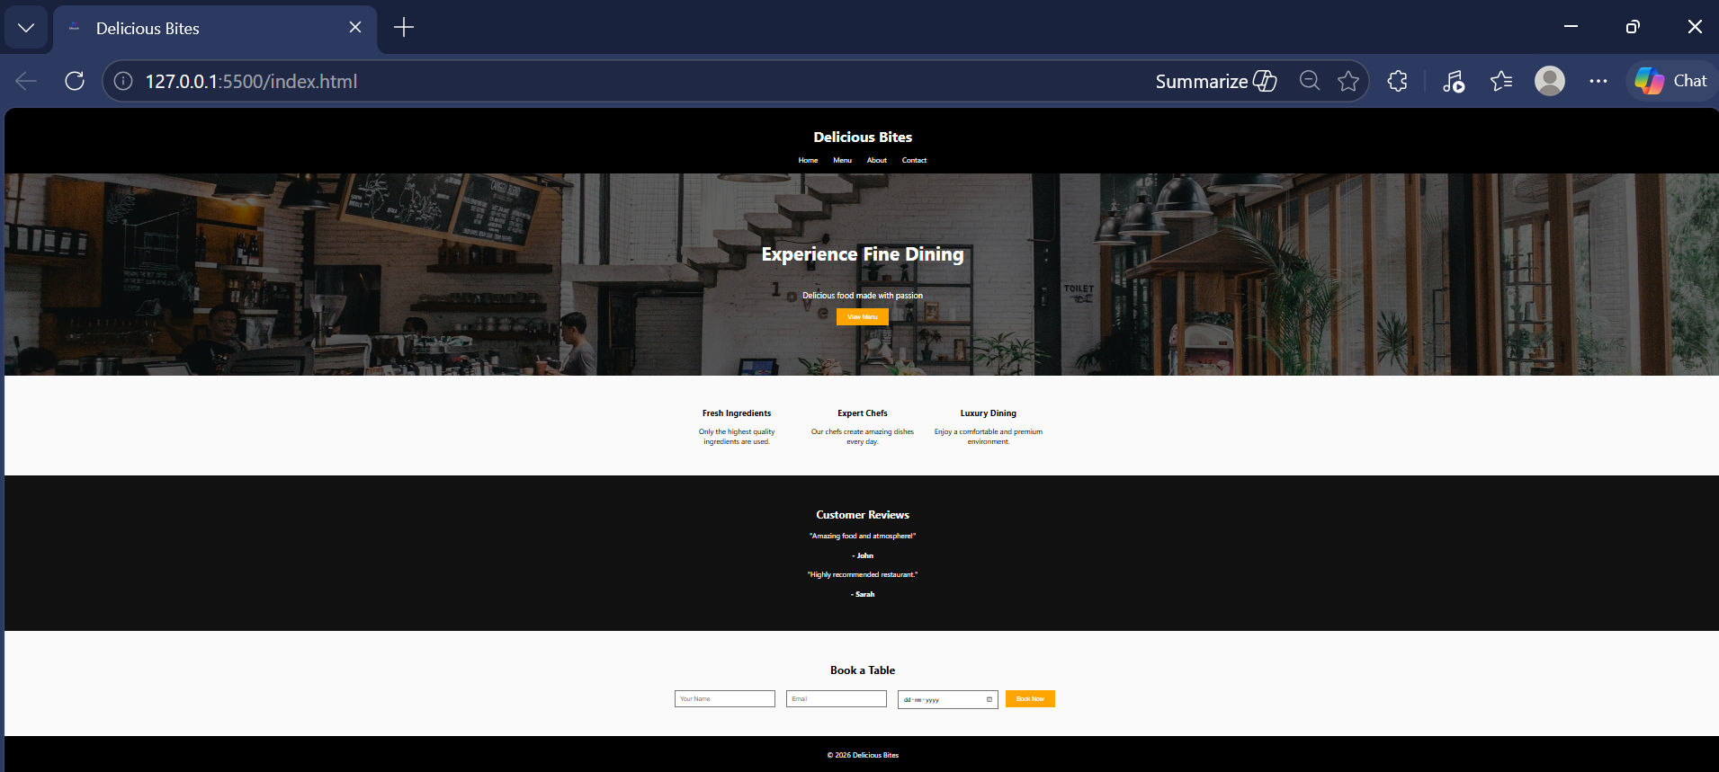
The above image shows the homepage of the website, including the hero section, navigation bar, and main features.
Menu Page Screenshot :
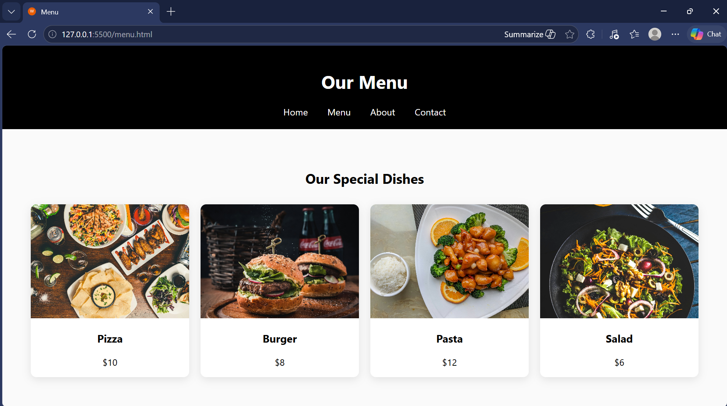
This page displays menu items using a grid layout with images and prices.

About Page Screenshot :
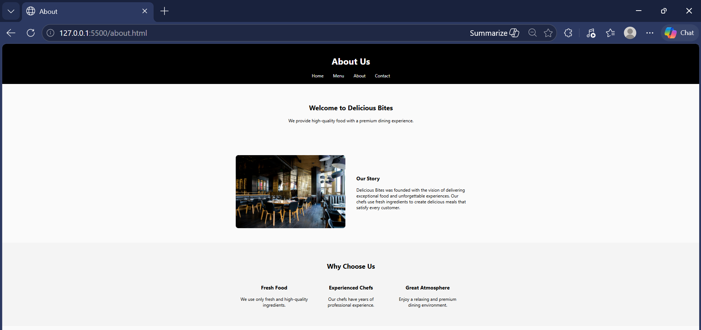
This page presents information about the restaurant using a structured layout with text and images.
Contact Page Screenshot :
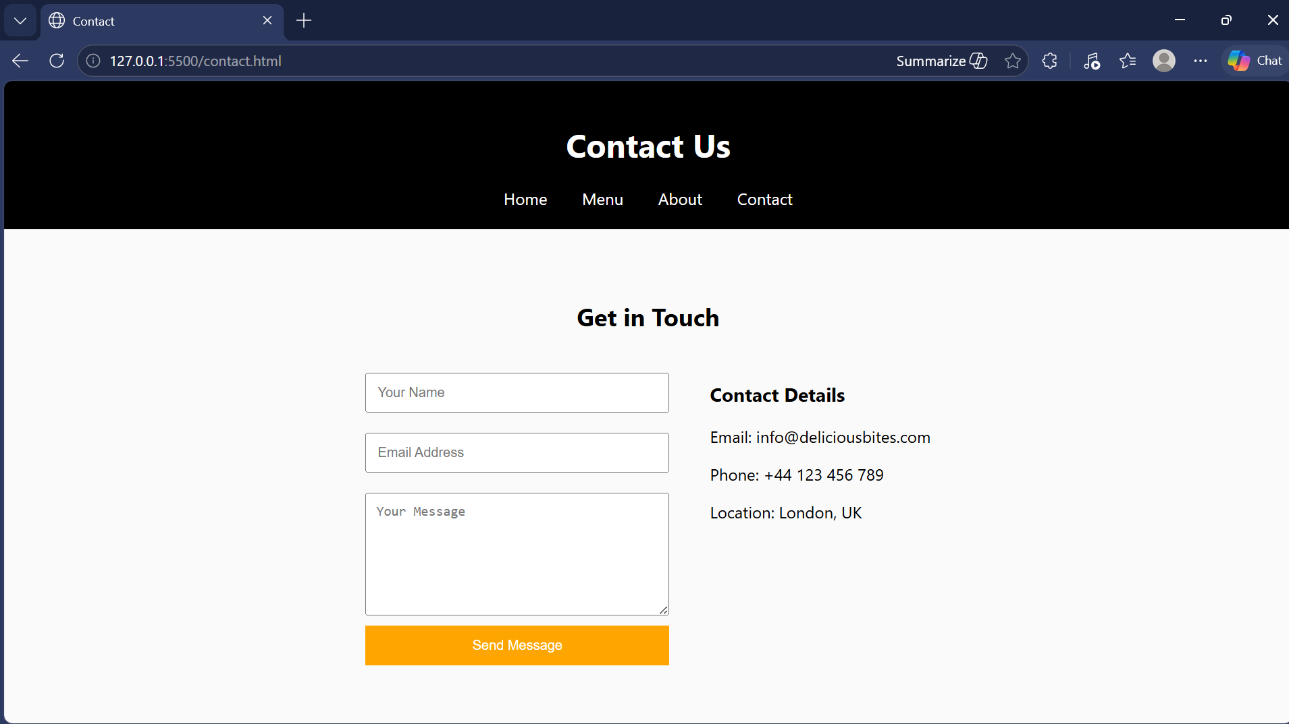
This page includes a contact form and user interaction elements.

Evaluation :
a) Research
Usability
Usability pertains to the effectiveness, efficiency, and satisfaction with which a user engages with a website. Nielsen (2012) asserts that usability is a critical determinant of a website's performance, since consumers favor systems that are intuitive and comprehensible. A website with optimal usability enables users to swiftly locate information, accomplish tasks with minimal exertion, and experience a seamless overall interaction.
Research has indicated that poorly designed usability can frustrate users and result in high bounce rates, with Nielsen (2012) explaining that users won't spare you more than a few seconds to use your site if they can't find their way around easily. User-friendly navigation, legible content and a unified presentation are all fundamental to web design.

Accessibility
Accessibility is about how websites are designed to be accessible by people with different abilities and disabilities. The Web Content Accessibility Guidelines (2.1), created by the World Wide Web Consortium (W3C), describes four principles of accessibility; perceivable, operable, understandable, and robust. Lazar et al. (2017) notes that accessible web design benefits everyone by making online experiences more usable for all users. Examples, such as correct colour contrast, text for images, and the obvious content layout, can make a web experience more pleasurable. Accessibility is crucial.

Search Engine Optimisation (SEO)
Search Engine Optimization (SEO) denotes the procedure of enhancing a website's prominence in search engine outcomes. Efficient SEO strategies encompass the utilization of relevant keywords, organized headings, meta tags, and superior content.
Google (2023) indicates that well-optimized websites are more likely to rank higher in search engine results, resulting in enhanced traffic and user engagement. Studies demonstrate that consumers are more inclined to access websites listed on the initial page of search results. Consequently, the application of SEO tactics is crucial for enhancing a website's reach and efficacy.

b) Website Evaluation
Usability and Utility
The website is highly usable due to the easy to understand navigation structure and consistent placement of images across all the pages. Navigation between the Home page, Menu, About and Contact pages is simple using the navigation bar, enhancing the usability of the web pages. Good use of structured sections, headings and images makes the information easy to understand.
The usefulness of the website can be seen to be increased through presenting some vital information such as items from the menu, details about the restaurant, ways to contact the restaurant etc. Incorporating a booking form and a testimonials area makes this site more functional and realistic and interesting. However, there are certain limitations to the usefulness of this website. The use of advanced interactive features is absent here and there are no live features such as submission of forms.

Search Engine Optimisation (SEO)
Basic on-page SEO technique has been done to the website. Including the use of proper headers (H1, H2) and META tags for description and keywords and well formatted contents etc which will benefit search engines to understand the contents of the website. Nonetheless, SEO can be further optimized with more detailed META description, better image file naming strategy and more relevant keywords including restaurant industry terms. Further addition of structured data and content depth will boost the search engine ranking.

Accessibility (WCAG 2.1)
There are a number of accessibility features on the website for example, simple language, clear structure and layout and well ordered content improve the accessibility and ease of use for the website. Alternative text has been used for all images and this is of value to anyone who cannot see well. However, the accessibility features of the website do not fully comply with all the WCAG 2.1 requirements. For example, the website lacks some advanced accessibility features, such as keyboard accessible version or ARIA labeling. The contrast of colors and accessibility for forms could be improved. The website complies with basic accessibility requirements, but does require some further improvements to fully comply with WCAG 2.1.

5.3 Validation :
The web page's HTML and CSS were valid at the time of writing, checked using the W3C Markup Validation Service and the W3C CSS Validator respectively. The validation revealed only a few small errors.
The HTML validation indicated that the majority of items were properly constructed, with just minor warnings that did not impact functioning. The CSS validation verified that the styling rules were valid and correctly implemented.
The validation procedure enhanced the quality and stability of the website by assuring adherence to conventional web development principles.

Index Page Validation :

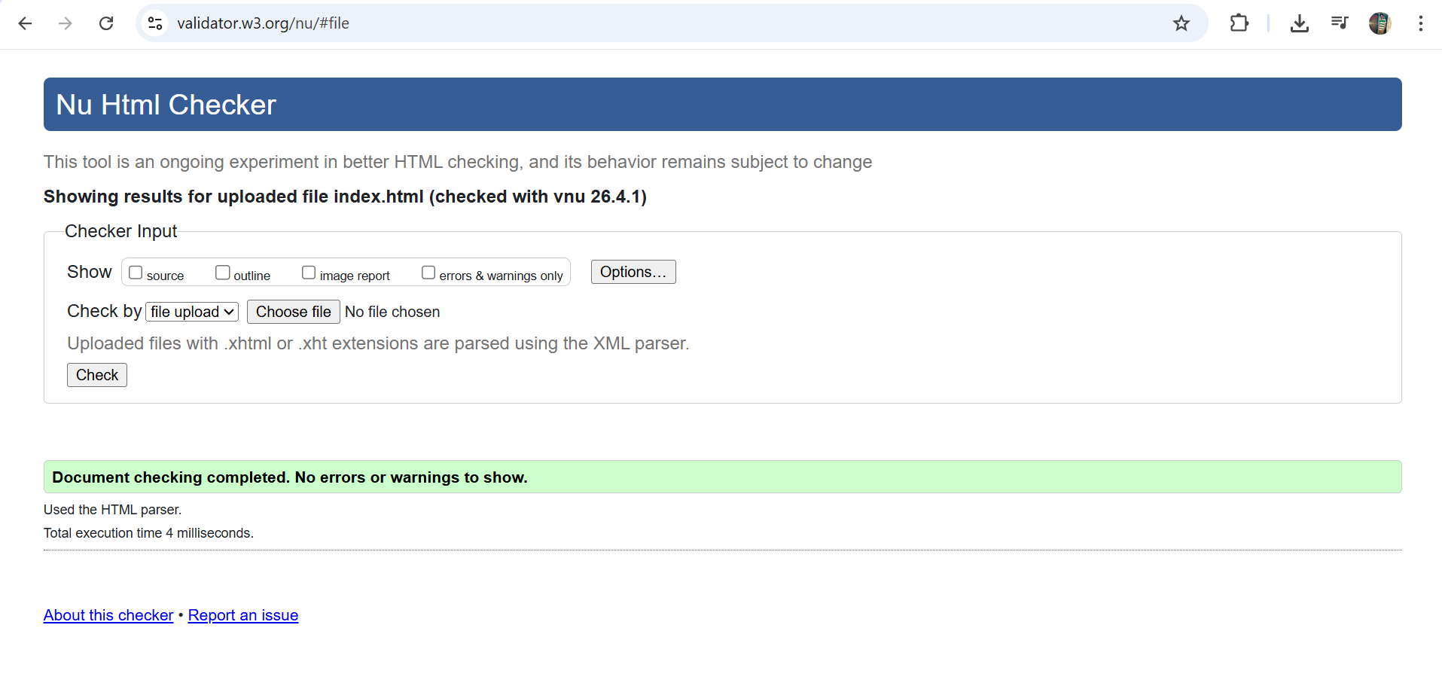

Style.css File Validation :
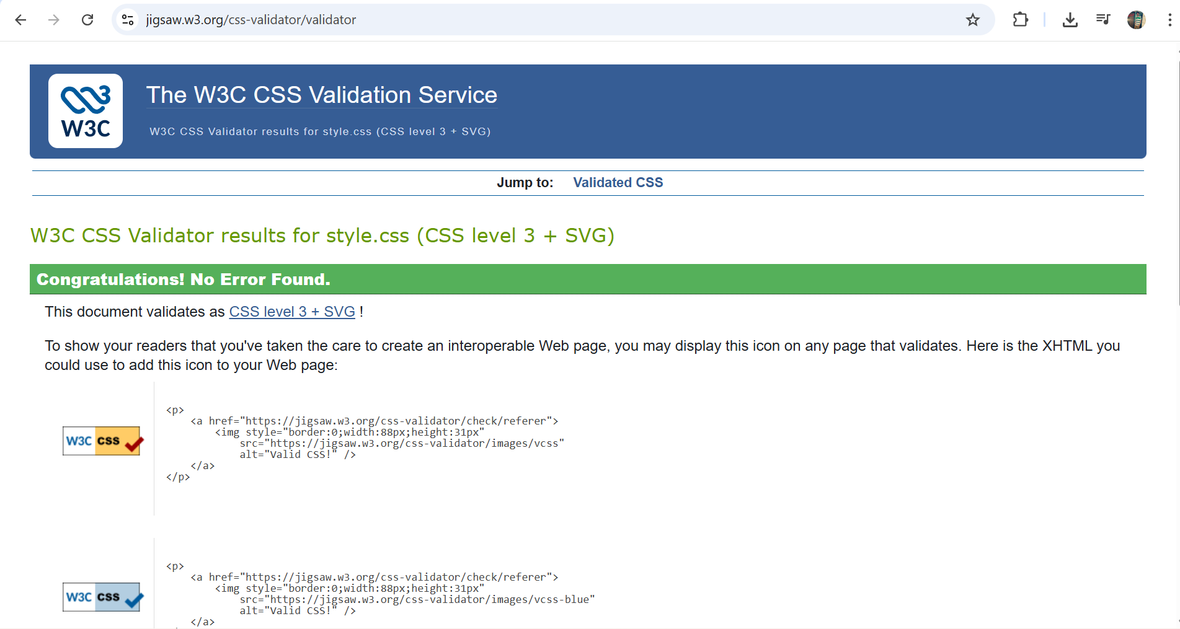

WEBSITE COMPARISON :
Website Comparison :
In this section, the website that has been created is compared with two real world websites: BBC (bbc.co.uk) and GOV.UK (gov.uk). The websites that have been chosen are very well known so provide some good points of comparison in the fields of usability, accessibility, SEO and mobile friendliness.
Usability
The BBC website provides extensive content with a convoluted style, which can occasionally hinder user navigation. Conversely, GOV.UK employs a straightforward and minimalist design that facilitates rapid information retrieval for users. The created website adopts a comparable methodology to GOV.UK by ensuring a minimalist design, intuitive navigation, and organized material, thereby enhancing usability.

Accessibility
GOV.UK is considered very accessible because it makes sure that accessibility guidelines and WCAG are followed properly for all users. While BBC does have some accessibility features, it is a much more complex page to utilize so may not be as accessible across all areas. Accessibility features included on the page my created are plain text, simple layout, alternative text for pictures, but yet not in the same way as GOV.UK.
Search Engine Optimisation (SEO)
Both GOV.UK and BBC use advanced SEO techniques such as well-structured content, meta information and keyword research. These all help the search engine to rank their pages higher than others. The final website has used some of the basic SEO techniques such as headings and meta tags, yet lacks the advanced techniques used on websites of this size.
Mobile Friendliness
Both BBC and GOV.UK are fully responsive and provide excellent performance across different devices. The developed website also includes responsive design using CSS media queries, allowing it to adapt to mobile screens. However, the level of optimisation and performance is more advanced in BBC and GOV.UK due to their larger development resources.

CONCLUSION :
This project effectively showcased the creation of a multi-page restaurant website with HTML5 and CSS3. The website was created to offer an accessible and aesthetically pleasing platform that conveys vital information about the restaurant, including its menu, history, and contact information.
Over the course of development, the website applied many fundamental web design principles such as usability, accessibility and SEO. The use of a flexible layout, consistent navigation and well-organised content contributed to the user experience. The addition of a booking form and testimonials added greatly to the usefulness and credibility of the website.
This project underscores the significance of user-centered design and compliance with web standards in contemporary web development. It also offered significant practical experience in the design, development, and evaluation of a website, applicable to future initiatives.

REFERENCES :
[1] J. Nielsen, “Usability 101: Introduction to Usability,” Nielsen Norman Group, 2012. [Online]. Available: https://www.nngroup.com/articles/usability-101-introduction-to-usability/
[2] W3C, “Web Content Accessibility Guidelines (WCAG) 2.1,” World Wide Web Consortium, 2018. [Online]. Available: https://www.w3.org/TR/WCAG21/
[3] Google, “Search Engine Optimization (SEO) Starter Guide,” Google, 2023. [Online]. Available: https://developers.google.com/search/docs/fundamentals/seo-starter-guide
[4] J. Lazar, D. Goldstein, and A. Taylor, Ensuring Digital Accessibility Through Process and Policy, Morgan Kaufmann, 2017.
[5] BBC, “BBC Homepage,” [Online]. Available: https://www.bbc.co.uk/
[6] GOV.UK, “GOV.UK Homepage,” [Online]. Available: https://www.gov.uk/

APPENDICES :
7. Appendices

Appendix A – HTML Code

index.html
<!DOCTYPE html>
<html>
<head>
<title>Delicious Bites</title>
<meta name="description" content="Premium restaurant with delicious food">
<link rel="stylesheet" href="style.css">
</head>
<body>

<header>
<h1>Delicious Bites</h1>
<nav>
<a href="index.html">Home</a>
<a href="menu.html">Menu</a>
<a href="about.html">About</a>
<a href="contact.html">Contact</a>
</nav>
</header>

<section class="hero">
<div class="overlay">
<h2>Experience Fine Dining</h2>
<p>Delicious food made with passion</p>
<button onclick="location.href='menu.html'">View Menu</button>
</div>
</section>

<footer>
<p>© 2026 Delicious Bites</p>
</footer>

</body>
</html>

menu.html
<!DOCTYPE html>
<html>
<head>
<title>Menu</title>
<link rel="stylesheet" href="style.css">
</head>
<body>

<header>
<h1>Our Menu</h1>
<nav>
<a href="index.html">Home</a>
<a href="menu.html">Menu</a>
<a href="about.html">About</a>
<a href="contact.html">Contact</a>
</nav>
</header>

<section class="menu-section">
<h2>Our Special Dishes</h2>

<div class="menu-grid">
<div class="menu-card">
<img src="images/pizza.jpg" alt="Pizza">
<h3>Pizza</h3>
<p>$10</p>
</div>

<div class="menu-card">
<img src="images/burger.jpg" alt="Burger">
<h3>Burger</h3>
<p>$8</p>
</div>
</div>
</section>

</body>
</html>

about.html
<!DOCTYPE html>
<html>
<head>
<title>About</title>
<link rel="stylesheet" href="style.css">
</head>
<body>

<header>
<h1>About Us</h1>
<nav>
<a href="index.html">Home</a>
<a href="menu.html">Menu</a>
<a href="about.html">About</a>
<a href="contact.html">Contact</a>
</nav>
</header>

<section class="about-intro">
<h2>Welcome to Delicious Bites</h2>
<p>We provide high-quality food with a premium experience.</p>
</section>

</body>
</html>

contact.html
<!DOCTYPE html>
<html>
<head>
<title>Contact</title>
<link rel="stylesheet" href="style.css">
</head>
<body>

<header>
<h1>Contact Us</h1>
<nav>
<a href="index.html">Home</a>
<a href="menu.html">Menu</a>
<a href="about.html">About</a>
<a href="contact.html">Contact</a>
</nav>
</header>

<section class="contact-section">
<form>
<input type="text" placeholder="Your Name">
<input type="email" placeholder="Email">
<textarea placeholder="Message"></textarea>
<button>Send</button>
</form>
</section>

</body>
</html>

Appendix B – CSS Code
The following section contains the CSS code used for styling the website.
body {
font-family: Arial;
margin: 0;
background: #fafafa;
}

header {
background: black;
color: white;
padding: 20px;
text-align: center;
}

nav a {
color: white;
margin: 10px;
text-decoration: none;
}

.hero {
background: url('images/hero.jpg') no-repeat center/cover;
height: 400px;
}

.menu-grid {
display: grid;
grid-template-columns: repeat(auto-fit, minmax(250px, 1fr));
}

.menu-card img {
width: 100%;
}

