‘The perception of the Female gender’

Bethan Price
P145689

BA Illustration

Julia Lockheart

Word Count: 5754

Abstract
This thesis is an investigation into the ways in which women are viewed, focusing on the psychology of men and what leads them to their understanding of the female sex. As well as gaining a further understanding of the Medias portrayal of women throughout key time periods, and how these aspects and views allow women to be viewed with the art industry.

Contents

Figure of images………………………………………………………………….Page 4

Introduction……………………………………………………………………….Page 5

Chapter 1: Psychology…………………………………………………………Page 7

Chapter 2: Gender………………………………………………………………Page 14

Chapter 3: Media……………………………………………………………….Page 20

Conclusion ………………………………………………………………………..Page 24

Bibliography………………………………………………………………………Page 25

Figure of images

Figure 1: ‘Propped’ ………………………………………………………………………………………………P7

Figure 2: A still from the film ‘Tomorrow Never Dies’…………………..…………………………….P8

Figure 3: A still from the film ‘Casino Royale’……………………………………………………………P8

Figure 4: ‘Do women have to be naked to get into the Met. Museum?’...…………………….P10

Figure 5: Stills from ‘Grease’…………………………………… …………………………………………..P12

Figure 6: A screen grab of a 1980 ‘Fairy’ advertisement…………………………………………….P12

Figure 7: ‘Me, Myself and I’……………………………………………………………………….……….…P14

Figure 8: Photograph of a figure coving her face.…………………….…………………………….. P16

Figure 9: Kensington Palace…………………………………………………………………..………….…P17

Figure 10: ‘The Daily Sketch’…………………………………..……………………………………………P18

Figure 11: ‘Everyone I have ever slept with’…………………….……………………………………...P21

Figure 12: ‘For the love of God’…………………………………………………………… ………….……P21

Figure 13: A table of statistics………………………………………………………………………………P23

Introduction
The aim of this dissertation is to investigate and gain knowledge about the way in which female gender is viewed psychologically by men and the media. I will be focusing on male perspectives and using psychological approaches to develop my general understanding of how and why they view women in the ways in which they do. I will focus on Sigmund Freud’s investigations into the human mind and specifically his exploration of gender views. In particular the most relevant texts are: ‘Freud, Race and gender 1995‘, ‘The Essentials of Psycho-Analysis Sigmund Freud 1991’, and ‘A General Introduction to Psychoanalysis by Sigmund Freud 1917 ‘. I also intend to assess how the media portrays women and how, as the media often influences society, this affects the way in which others view women. The investigation into the psychology of a person, will hopefully give a clearer understanding of how men and women see aspects of life differently, and whether this changes the way they experience art. Genderless art will also be discussed, as I want to investigate whether gender within the art affects the way in which it is viewed, or whether the gender of the viewer is what changes the way it is perceived. Theorists will also be included to back-up or counteract my discussion points, an example of them that I intend on looking at are: Toby Miller (2004), Judith Butler (2006) and Laura Mulvey (1975). The investigation into the subject of gender and sexism within film is a broad subject, and I intend on including artists of other Medias, such as painting and photography. Jenny Saville has always been a discussion point in terms of feminism and male objectification of women, and therefore is a valid topic to be included within the discussion (Saville, 2005).

The investigation will start by gaining a basic understanding of the key words, and I will work to comprehend them. The development of the basic ideas of these key words will help through the investigation, and will give a clear outline of how they are showcased throughout the film industry, art and media outlets. The main key words that will be used throughout the discussion are: gender, sexism, appropriation, psychology and feminism. Each chapter will use these terms to gain a clearer outcome. As I already have a small understanding of this subject, I have developed my own views so far. This essay will help me clarify where I stand within the perception of sexism within the media, and whether the psychological understanding of a person should have an effect on the way in which they view a particular gender.

Chapter 1 – Psychology
Psychology is a detailed look into the human mind and behaviours of individuals (Online Oxford Dictionary, 2017). To fully understand the reasoning behind why a piece of art has been created, the understanding of the artist, their behaviours, their dislikes and likes and childhood, which allows the viewer to gain a deeper more perceptive idea of the work. Through this research answers to the question of whether the psychology of the artist has an effect on their art, and whether the psychological analysis of the audience affects this too, will be established.
Is art created to be viewed by a particular audience, for example, male, female, age group or race? Jenny Saville’s work ‘Propped’ in particular, is created to address the ‘male gaze’ (Mulvey, 1975). This piece was painted in oil during 1992 where post modernism (during the mid to late 20th century) was at its height. ‘Propped’ is illustrated in figure 1. Saville’s work illustrates how the body is appreciated not admired:
Rather than being sexualised they are ‘fleshy’ and ‘real’, the skin tones are not olives and browns, they are natural blue and greens representing the ‘reclaiming of the female nude (Andrew Graham-Dixon, 1994).

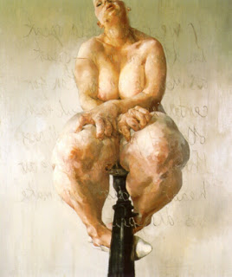

Figure 1
Figure 1

This shows how the viewer is looking at her works of the body and seeing the truth of what a body looks like, it shows the real and natural tones and movements of the skin.
Saville’s work contrasts highly with the work of film producer and director Roger Spottiswoode, who has worked on the James Bond franchise ‘Tomorrow Never Dies,’ released in 1997. It is widely known that the ‘Bond’ movies exploit and sexualise women, using their bodies to draw the attention of the male spectator. The term used to describe this by Laura Mulvey (1975) in her essay ‘Visual Pleasures and Narrative Cinema’ is scopophilia. This is sexual pleasure derived from watching others whist naked or engaged in sexual activity. So in terms of the film ‘Tomorrow Never Dies’ when Hallie Berry emerges from the water (seen here in figure 2) the “cinematic apparatus and the film position construct an ideal (for) male spectatorship” (Cook, 1998: 78), “the voyeuristic gaze is active, sadistic, and male” (Cook, 1998: 78). The panning of the camera from the base of her legs upwards to her head draws, the eye to mimic the camera, forcing the viewer to look and sexualise Berry. This scenario is repeated through media and presents the sexual exploitation of women. In recent years this has been noted by the film industry (Economist, 2016), and has been labelled ‘sexist’ and therefore has been flipped and now we have the male model, Daniel Craig rising from the water (figure 3), it could be argued, if this has solved the situation or simply reversed it to the male muse (Mulvey, 1981). This way of looking at Berry or Craig is still objectifying and sexualising the body.

How we are torn between the pleasure principle and the reality principle, how we often find ways both to express and to deny what we most fear, and why certain men need fetishes for their sexual satisfaction. His [Freud’s] study of our most basic drives, and how they are transformed, brilliantly illuminates the nature of sadism, masochism, exhibitionism and voyeurism (Stallabras, 2005: 102).


The Bond films and Saville’s work are representations of the body, which according to Freud are positioned within two key principles, pleasure and reality.

Figure 2
Figure 3

This, Freud discusses how men sexualise women for needs much more complicated than sexual pleasure and how this showcases the darker sides of male psychology. The film industries have picked up on the need of female sexualisation and therefore most often sexualise a female protagonist throughout the film.
The film and advertising industry meticulously exploit women for sales and views of products (Butler, 2006). The women that are included within these spreads are often typically described as desirable, leading the regular women to believe she must also look this way to achieve what is being sold, thus creating the idea of idealism. Saville’s work and others of the post-modern movement are actively attempting to change the way in which the woman is viewed within the art industry and media portrayal. Saville’s work is combating against the ideal and the male gaze; she creates vast flesh like paintings that stare down on the viewer intimidating and discomforting them, taking the power away from the male, as “these women know that they are arousing” and take their “pleasure from their own bodies” (Saville, 2005: 57). Saville’s work showcases how the male should be looking at the female body; it shows how the realistic female body looks. Her work brings the viewer closer to the flesh and therefore forces the viewer to appreciate the tone and movements.

Saville focuses her work on the female nude. Many of her exhibitions rarely contain male muses, if they are included they appear to be docile, almost mirroring how so many other artist showcase women within their work. A muse within the art industry is described by the Oxford Dictionary (2017) as “a person – especially a woman - or personified force that is the source of inspiration for a creative artist.” Why do women in particular hold so much inspiration for others? Psychologist Lucien Freud would argue that the ‘child’s psychosexual stage,’ (Freud, 1917) effects the development of a person’s future psyche. Sigmund Freud looked at how the mother/infant dependency is one of the greatest initial factors that contribute to an individual’s personality (Freud, 1916). Over indulgence or negligence from the mother will have a further effect on their relationships later in life with women, for example their wife (Freud, 1994). The child’s psychosexual stage will mould the way in which man views woman; this is exposed through life as well as through art. Within the art industry man has always triumphed, many of the ‘greatest artists’ are men, for example Picasso and Van Gogh, two of the most well-known artists that have been in existence. Suggesting that the female artists are not ‘great’, just there, existing and creating. It leads the viewer to question, why are all the ‘great’ artists men?
Within the Metropolitan Museum of Art (the Met) the Guerrilla girls had an exhibition that focused highly on the number of female artist that were showcased there. The image shown in figure 4 states:
Do women have to be naked to get into the met? Less than 5% of artists in the modern art section are women, but 85% of the nudes are female (Guerrilla Girls, 1989).
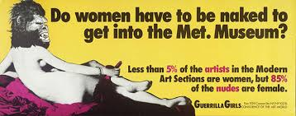
Figure 4

Twenty-seven years have passed and this continues to be as discouraging as it was in 1989, women are viewed as the muse, not the artist. From a female artist perspective this continues to be very disappointing. The Guerrilla girls work having such a great impact, suggests that this piece actively made people notice the inequalities between the male and female gender, and was showcased throughout many art museums and galleries. There have been nine creative directors of the Met since it opened; every single one of them has been male. During the time of the Guerrilla Girls exhibition, the director was Philippe De Montebello, who was arguably questioned as being a sexist:
The Metropolitan Museum of Art is one of the world's largest and finest art museums. Its collection includes more than two million works of art (The Met, 2017).

This presents how the creative director in charge of the museum is also the curator for the exhibitions; he decides who and what is on show there. This title holds immense power, which poses the question; do men in powerful positions take advantage of women? Similar behaviour has been observed through Donald Trump, the President of the United States referring to women as “beautiful piece of ass” (Trump, 1991). And Harvey Weinstein, a force within the film industry introducing his female intern as “fuckface” (Weinstein, 2008) we see their abuse of power; they believe that people, women in particular, should yield to them to gain a further stride on life. This suggests that women have always fallen into the routine of believing men are in control of what they should do. However, with the likes of modern artists, such as Jenny Saville and The Guerrilla Girls creating statement pieces, there is a movement within the art industry which means more female artists are getting recognition. This is resulting in female artists being exhibited in some of the world’s greatest and largest museums, showing the strength that a strong female force can have within the world (of men).

Upon further investigation of scopophilia and sexism within works, it is seen that:
Laura Mulvey’s essay ‘visual pleasures and narrative cinema’ has been seminal in suggesting the role the figure of women plays in patriarchal fiction. She has since explained it was to examine the Masculinisation of spectator position and identification in classic Hollywood cinema. This view has led to work by feminists on the possible aesthetic consequences of gender difference. (Cook, 1998: 27)

Pam Cook states that ‘Visual Pleasures and Narrative Cinema’ (Mulvey, 1975) is the greatest approach to the female protagonist within film (Cook, 1998: 29). Could this be because the author Mulvey is female? Cook argues that within a mixed genre film “the male voice of film combated the female voice of the woman’s” (Cook, 1998: 30). Is it only women that notice the inequalities and sexism showcased throughout cinema? The woman is portrayed to be frail and lacking of power in many classic Hollywood films, even as a child watching Grease, the character Sandy was the person to change her personality to win over the boy (see the comparison in figure 5). Claire Johnston states this is seen to be “an expression of the director’s world view rather than in terms of the film” (Cook, 1976: 78). Reiterating that the way in which the female character within film is shown, is down to how the director views women within his daily life, thus supporting Freud’s theory of the ‘child’s psychosexual stage’ affecting the future perspectives of women, which suggests that the woman is the reason for her being subjected to male based guilt and blame.

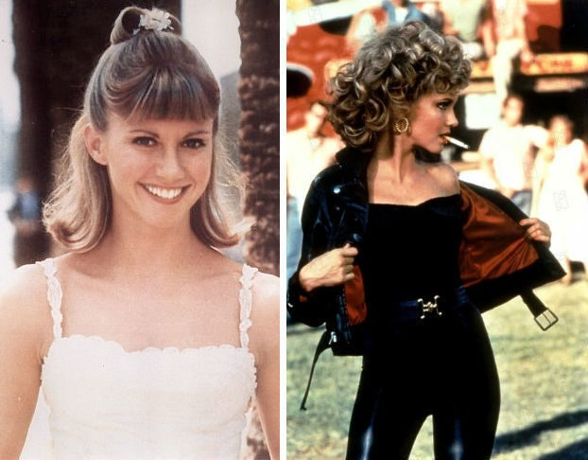

Figure 5

The essay ‘Sexism and psychiatry, American Journal of Orthopsychiatry’ (1974) suggests that, “Psychiatric theory and practice has been criticized as being sexist in orientation, as having perpetuated and encouraged inequalities between the sexes” (Levine, et al,1974). Sexism is the “prejudice, stereotyping or discrimination, typically against women, on the basis of sex” (Online Oxford Dictionary, 2017). Psychologists such as Freud revert all issues with the male psyche back to the mother; a woman that tried her hardest to care for the child that she had just brought in to the world, yet the father figure; the male, gets almost no blame for the developing issues of the child (Freud, 2015). Why is it that the woman has these responsibilities? It is believed that Social gender roles would be the most significant factor towards this, which has also been thrust upon women through media. It is explained that;
Gender roles are cultural and personal. They determine how males and females should think, speak, dress, and interact within the context of society. ... These gender schemas are deeply embedded cognitive frameworks regarding what defines masculine and feminine (Houghton, 2015).



Figure 6

For Example, during the 1980’s where cleaning product adverts were aimed at the female who strives for the ‘perfect’ American family. A stay at home mother, cleaning and looking after the children, and the father who comes home from a busy day at work. ‘Fairy’ washing up liquid is a good example of this, shown in image 6. The advertising companies wanted to portray what appears to be a happy family, and everyone has their roles. Women stay at home, be a mother, cook, cleaner and the men earn the ‘money’. These roles were what was expected and accepted at the time, and through magazines and television advertisements women believed this too is how they should act. The role of the mother is due to gender, and only recently have averts changed the way that they broadcast this. Thus suggesting that the female is the only one within the household that can cook and clean, and these perceptions are based from what society believes. This chapter has outlined the way that the male gender, the media, particularly in the creative industry, view women. Also the way that women are blamed for a child’s psychosexual stage; apparently men and the child itself; are never responsible for this. Gender view and sexism will be further discussed in chapter two.

Chapter 2 - Gender
Gender is defined as “The state of being male or female (typically used with reference to social and cultural differences rather than biological ones), which outlines the traditional concepts of gender” (Online Oxford Dictionary, 2017). There are many components that contribute to gender, these are cultural and social assumptions, the individual also needs to have an understanding of the differences between gender and sex. Sex is the physical aspects, for example the genitals in which a person is born with and gender is the way in which people choose to be seen, this is what the individual identifies as, and signifying gender is not just a physical state of being. Cindy Sherman quotes “gender is socially constructed and performed by individual’s everyday” (Sherman, 1978). Sherman’s work ‘Me, Myself and I’ shows her dressing up as a variety of different characters, both male and female and taking on different personalities. A still from the film is shown in figure 7 where she is dressed in her underwear laid across some sheets looking up to the ceiling. Through her work she shows that she has no identity based upon gender and that she identifies herself as being human, not gender specific. Sherman is ‘non-binary’ (Sherman, 1979), not limiting herself to anything be it male, female or other. Post structuralism is the term used to describe the opening up of categories within gender; it states that you cannot be restricted in terms of choice of sex. Androgynous clothing was created to allow males to wear female ‘styles’ and females to wear male styles. Some of the most well-known brands are ‘Original Tomboy’, ‘Androgyny’ and ‘Fourteen’.
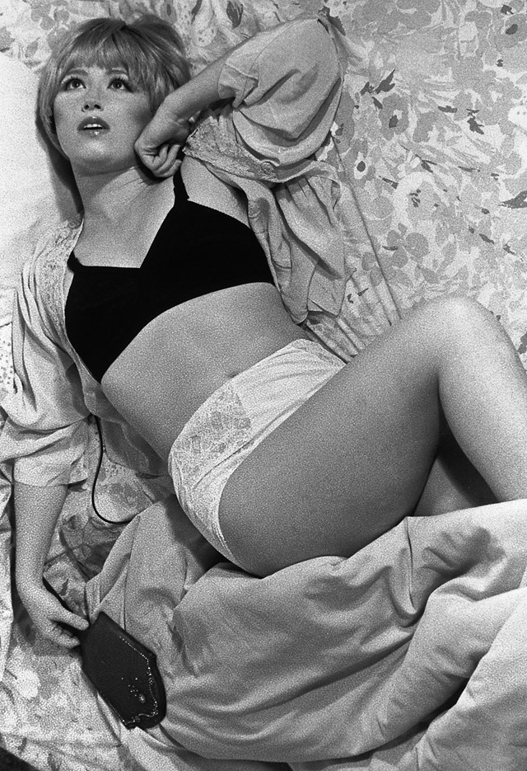
Figure 7

As more people start to accept gender fluidity and androgyny it pushes the audience to question whether sexism is starting to be combated? The media contributes to the acceptance or rejection of many socially known habits. Society is “the aggregate of people living together in a more or less ordered community” (Online Oxford Dictionary, 2017). Society in the past accepted the understanding of identity; the media used it to sell consumer culture. For consumerism to work the supplier needs to make assumptions about our identities, this is “the manipulation of the masses” (Lopez, 2012). Freud (1991) identifies this as ‘desire’. The producer of a product makes you feel deficient in what they are selling, and suggesting that through buying their product you gain your desire. The media tend to focus their products to a specific gender audience, female or male. Again ‘Fairy’ is an example of how the media manipulate the audiences, with them paying attention to women and the ‘housewife’.
The term ‘housewife’ is still used to describe a woman that stays at home during the day, (whist her husband is at work) that cleans, looks after the children and cooks. Yet the term ‘house husband’ is not used to describe a man that stays at home and cooks and cleans, as this is seen as being derogatory. Yet another sign that the culture we live in have appropriated sexism and have allowed it to happen to women but not men. Through America the term ‘Home maker’ has been adapted from house wife, the term states no sex and is therefore non-gendered, a more appropriate term some would state, as either parent can be the one to stay home and care for the family. This is showing how some societies are trying to make changes to allow the LGBT (lesbian, gay, bi-sexual, transgender) community to fit in to the ‘social norms’.

Gender throughout art has a long history. Gender is seen within art figuratively, and suggestively (Williams, 1987). Figuratively gender is seen through an image of a male or female muse, the viewer clearly sees a person within the image and can identify what the sex may be. The viewer can suggest the sex due to a number of physical factors (although this may vary throughout time periods) such as, hair length or style, clear use of make-up, their clothing attire, and whether any body parts are visible, such as breasts or genitals. There is also a number of suggestive factors that allow the audience to depict whether a man or woman is within the scene. Such as, if the muse falling in line with what was socially expected at the time, for example, cleaning, riding a horse, or dressed in a particular professions uniform (army for example). Another suggestive factor is whether there is references to suggest gender such as, the choice of colours, the style of line (curvaceous or jagged), and the scenery surrounding the muse (Perry, 1999). The image is to be perceived by the viewer, and therefore the viewer decides if, and what gender they see within it.
Figure 8 shows a photo by Alwin Poiana of an individual (non-gendered), the image is in black and white and the only colour is the lips (which are red), the person is dressed in a chequered dress, covering their face. The only assumption that the viewer has to the gender of this person is the clothing, hairstyle and make-up. Many of these aspects are physical, which suggests that the physical aspects of gender are more important than that of the psychological and emotional ones. The viewer uses the figurative and suggestive factors to gain an understanding of the scene depicted within the image. Gabriel Ann Maher and Alice Rawsthorn discusses:
How the evolution of an increasingly eclectic and fluid concept of gender identity is impacting design culture and redefining traditional feminist arguments on gender politics (Rawsthorn, Maher, 2013: 1).

They argue, “Can design be genderless?” (Rawsthorn and Maher, 2013: 2). “Alice Rawsthorn discusses the role of gender identity in design—from early prejudices toward women to contemporary theory”, in her book “Hello World: Where Design Meets Life” (Rawsthorn, 2013) she discusses the concept of gender identity, and how art and design creates a space where there is no need for a clear gender outline. Figure 8 presents a non-gendered figure with a hidden face; many would argue the lipstick is a sign that the individual is female, though Poiana purposely chose a toned physique, slim person to create the question “can design be genderless?” (Poiana, 2015).


Figure 8

Gender is often discussed within class and power is focused on due to the male abuse of power and their misogynistic attitude towards the female sex. This section will investigate the power women have within the social structure and the power they hold to influence it. This section will also address the historical evolution of sexism though snapshots of three key periods of time (the 17th century, the 19th century and the 20th century). This portrays how women affect the world around them in a variety of different ways, fashion industry, advertising, and architecture is all known to have strong feminine influences.
…The women, as they make here the language and fashion and meddle with politics and philosophy, so they sway also in architecture (Wren, 1670, 26).

Perry questions Wren, if he is referring here, to the feminisation of French buildings during the 17th century? Due to Christopher Wren previously stating he much prefers the strong masculine style of architecture, which he often used within his buildings in London (Wren) (shown in figure 9). He is one of London’s most critically acclaimed architects and has designed buildings, such as St Paul’s Cathedral, Kensington Palace, and the Royal Observatory. Wren’s comment being sexist in its nature may also be seen as harmless, due to the time period in which it was said during the 17th century, this in turn shows how the female sex has been viewed for lengths of time.

Figure 9

The second period of time discussed is the 20th century, here it is seen how the media and the art industry have discussed women for many years, and have used them within articles and works of art how they feel. In particular the advertising industry have used the female sex to gain more attention to their products and campaigns. One of the most famous female endorsed goods were cigarettes, and how well thought out advertisements and endorsements from the women’s suffragettes, helped with making them as widespread as they are today. At the start of 1848, the women’s suffragette movement was formed; women believed that they should have the right to vote and to be able to run for parliament. They fought for this right through marching the streets and protesting the male run parliament (Gerrard, 1982). Women finally got the vote in 1918, though this only applied to women over the age of thirty, in contrast with the new law that men over the age of 21 could now vote (again we now see the clear sexism within powerful men in parliament, referring back to Trump chapter 1). 1928 was the official year that women over the age of 21 could also vote equalising the age of men at the time (Gerrard, 1982). This movement was covered highly by the media (‘The Daily Mirror’, ‘The Daily Sketch’, ‘The Keys’), though much of the coverage was negative; the suffragettes were looking for the attention to their cause rather than praise.
Newspapers themselves were for or against women’s suffrage. The suffrage movement put the government under pressure and this was interesting to newspaper readers (Gerrard, 1982).

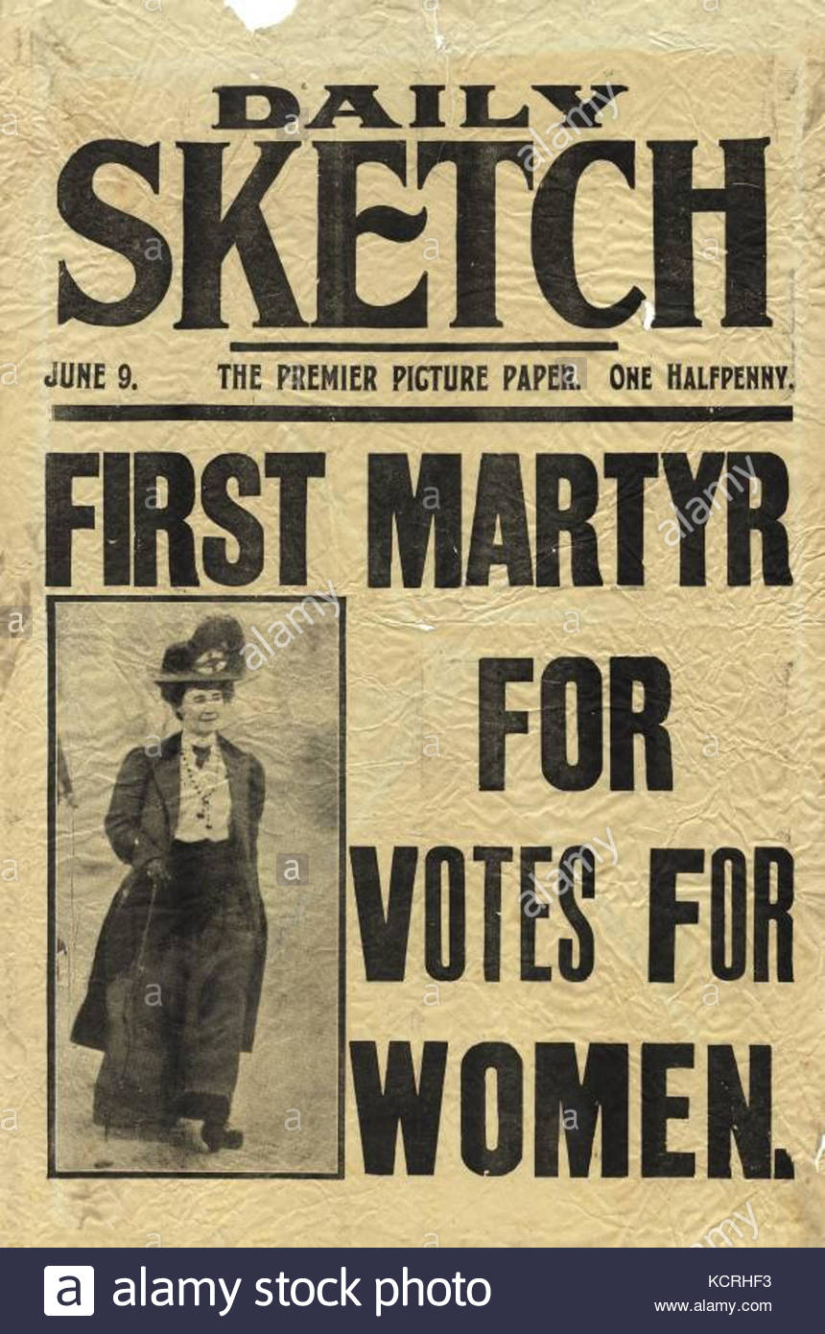

Figure 10

This represents how the media of the time is biased towards particular causes, showing how they chose who to support and who to oppose (figure 10 shows an example of a negative magazine example). The media have a large influence over the public, as their view is what many people read and learn from. The ‘Edwardian society valued modest, decent women who were happy to serve as wives and mothers’ (Parrat, 1989: 40), again illustrating the way in which men and women are expected to act within specific societies.
The final period of time is the 19th century, here it is seen how the cigarette was transformed into a fashion item to increase sales. This was an ingenious move in the advertising movement. In 1865 Washington Duke invented the cigarette (Kremer, 2012). His initial market was the soldiers at the end of the Civil War. Though James Bonsack invented the cigarette-making machine, in 1881 that smoking became widespread. People were initially concerned over the idea of cigarettes, which lead to slow sales, this is when they manipulated the women of the suffragette movement, giving them the cigarettes calling them ‘sticks of fire’. Thus opening up a whole new market, targeted towards women. This was also ‘free advertising’ as the women were in the public eye through the newspapers, this also meant that cigarettes were in the newspapers, and often front pages making them a fashion and political statement. This presents how the media use and manipulate women, they decide the light in which they want to portray the story, and in turn decide how the public will witness the situation.

Chapter 3- Media

The media’s coverage of politics is often centre of discussion, due to accusations of being bias. This section will investigate whether this bias is also seen through the media and art, such as film and paintings. It will also investigate how women are perceived by the media. The political side to the media will often support or oppose what is being discussed at the time (as seen in the previous section), though it is clear that all sources of media must be unbiased (Vallone, et al, 1985: 6). Through the works of strong female artists such as, Saville and Tracey Emin the viewer can start to explore the idea in which the media may also be biased towards them as female artists. Many female artists explore the idea of feminism, sexism and gender, Saville and Emin focus highly on this topic. Through Saville’s work ‘Propped’ (previously mentioned in chapter 1 (Figure 1), the viewer sees how she works to remove the male given power and damage the male gaze, thus creating an empowering piece of art for women within the feminist movement. It is also seen through Emin’s work in particular ‘Everyone I Have Ever Slept With 1963-1995’ (shown in figure 11), a textile tent with Appliquéd names of everyone she had actually slept with during that time). Emin’s work shows how she herself does not identify as a typical straight woman, due to the variety of male and female names included within the tent. Both artists are described as ‘Feminists’, though Saville herself would not identify as being one, Nochlin states in an interview with Saville that:

It is clear that Saville thinks of herself more as a painter of the flesh than as a feminist activist, her exploration of the female figure goes beyond aesthetics in order to address deeper issues related to the social construction of the body. (Nochlin, 2000: 96).

This presents how Saville uses her paintings (figure 1) to engage the viewer into thinking more thoroughly about the female nude, and how through mentally categorising women to fit in with social perceptions based upon their body types is unacceptable. The media is often quick to jump at calling any woman that believes in equality as a feminist, though many believe that simply addressing the need for equality to be natural and needed, rather than being labelled a feminist, in which they actively protest and work towards equality within the sexes.
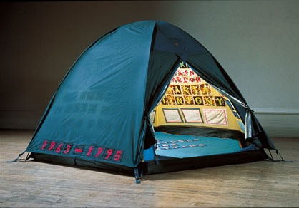
Figure 11

Both Saville and Emin attended the BA Fine Art course at Goldsmiths, in the late 1980s, along with fellow Young British artist (YBA) Damien Hirst (Stallabrass, 1999: 18). This section will investigate the differences between Hirst, a male YBA, and his fellow female artists Saville and Emin, and how the media approach them and their works. Hirst is widely known for selling his diamond encrusted skull titled ‘For the love of God’ (2007) (shown in figure 12) for £50 million in 2007. This being an extortionate price for the piece, many journalists have suggested that the skull has in fact not been sold. Christina Ruiz, “editor of ‘The Art Newspaper”, claims that Hirst had failed to find a buyer and had been trying to offload the skull for £38 million’ (Ruiz, 2007) yet:

With his exhibition Treasures from the Wreck of the Unbelievable, which fills not only a Venetian palace but also the capacious halls of the ship-shaped Punta della Dogana at the mouth of the Grand Canal, the arrogant, exciting, hilarious, mind-boggling imagination that made him such a thrilling artist in the 1990s is audaciously and beautifully reborn (Jones, 2017).
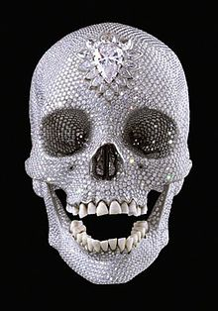

Figure 12
This statement gives the viewer the first indication of how the media portray Hirst, positively. The media and reporters portray Hirst to have been a ‘thrilling artist’, labelling his arrogance as a positive aspect of his personality, which many would argue is actually a considerably negative characteristic. The art sections of many newspapers such as, ‘The Guardian’ and ‘The Times’ have supported Hirst throughout his many lapses and ‘Arrogant’ behaviours, is this because he is a male artist? In comparison the media have previously commented on Saville and Emin’s work labelling it as “a violent mess of sex and death” (Shirwin, 2017). A clear indication of how male and female artists are treated differently is the way in which the media portray them, with increasingly biased reports from the media with negative undertones focused towards female artists, such as Saville and Emin, in comparison to the supportive tones of the male artists, for example Hirst (as seen above).
Another example of how they are media biased, is the way in which Teresa May, the Prime Minister of the United Kingdom, has been reported on by the newspapers, and news reporter’s through television. One of May’s own Members of parliament (MP) has referred to May as being “out of her depth” (Philippe Lamberts, 2017). May is one of the most powerful women in Britain and deserves respect for the position in which she holds for her country. Her own MPs often men, are below her in terms of power, and therefore should be looking up to her and respecting what she says and stands for, as she herself is attempting to do the best for this country. Through the media she is often referred to in masculine terms such as
‘Strong’ (Perry, 2017) and ‘stable’ (Perry, 2017), why does the media use masculine terms to describe women in power? Women should be able to hold a position of high power and still hold the title of femininity, as they themselves would refer to themselves as a female. May has previously been referred to as a ‘sidekick’ (Phillips, 2017), this shows the way in which men in power and the media think of women as the less powerful sex in general. This way of thinking needs to change, society needs to change the way in which it allows men to think of women and the way that women too, think of themselves. Donald Trump is a prime example of media bias; the next section looks into the media frenzy that followed Trumps accent to power. Trump is supported by newspapers such as: ‘The Wall Street Journal’ (2017), yet the ‘The Financial Times’ (2017) have a clear dislike towards him. Trumps coverage was shown to be mostly negative with 80% of the news coverage being against him, a graph showcasing this is shown in figure 13 (Patterson, 2017).
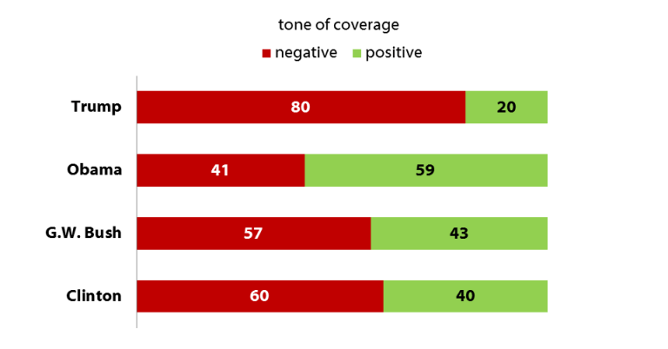
Thomas Patterson, Bradlee Professor of Government and the Press explains that:
Figure 13
The reason is clear enough. Trump is a journalist’s dream. Reporters are tuned to what’s new and different, better yet if it’s laced with controversy. Trump delivers that type of material by the shovel full (Patterson, 2017).

This in turn allows the media to broadcast their own opinions over the opinions of others within the groups of societies, thus allowing the public to be subtly manipulated into agreeing with their opinion.

Conclusion
I have investigated and researched the ideas of gender, sexism, appropriation, psychology and feminism within the media, and their portrayal of these. I have investigated the psychology of the male and found that according to Freud all issues revert back to the mother, leaving the man to deal with these issues that occurred as a child, with his future female partners. As many reporters and journalists that I have quoted are male this has lead me to believe that the media are clearly biased, positively towards the male and male artists. This too links with the psyche of the man and that of the ‘child’s psycho-sexual stage’ (Freud, 1994). I have found that the female gender as a whole is under constant tyranny, whether this is from the social pressures that they put on themselves, to look like the women advertised, or the pressures that the men in their lives put on them to make up for issues caused as a child. The female sex has to work harder to gain the respect that they deserve as seen through the many examples of May, Saville and Emin. Through my research I have found that the pressure that women feel has come from a variety of different aspects such as, men, the media and Freud’s theory of the ‘Psycho sexual stage’. This has lead me to question whether it is just the pressure put upon women from male society and the media or whether, this ‘pressure’ has come from women ourselves. There is a need for the female gender to compete and strive for the best bodies, hair and makeup. Women compete with each other, which leads to an unrealistic view on life; this is magnified by the media showcasing the ‘ideal’ woman within their campaigns, and the male gender having unrealistic expectations for what they expect from a wife and mother. The generation that we live in now has accepted that the pressure, in particular women, has led them to develop a ‘Fear of our own mortality’ (Freud, 1996). Everyone feels they must comply with the way in which it is ‘socially accepted’, and therefore follow crowds and media outlets to conform. Women feel a particular pressure to conform to the ways in which society has been trained to think and react. This needs to change.

Bibliography
Books

Belloc, H. (1967). On. Freeport, N.Y.: Books for Libraries Press.

Butler, J. (2006). Gender Trouble: Feminism and the Subversion of Identity. New York: Routledge.

Cook, P. (01 July 1976). Film culture: Exploration Films and Feminism (2 ed., Vol. 17).

Cook, P. (1998). The Cinema Book. London: British Film Inst.

Ellis, P., & Gallery, S. (2003). 100: The work that changed British art. London: Jonathan Cape in association with the Saatchi Gallery.

Freud, S., Freud, A. and Strachey, J. (1991). The essentials of psycho-analysis.
London: Penguin Books.
Freud, S. (06 October 2015). A general Introduction to Essentials of Psycho-analysis. London : Penguin books Ltd.

Freud, S. (1917). A General Introduction to Psychoanalysis. Create Space
Independent Publishing Platform, pp.106-109.

Garrard, B. (1982). Feminism and Art History: Questioning the litany. New York: Harper & Rowe.

Gilman, S. (1996). Freud, race, and gender. New Jersey: Princeton University Press

Isaak, J. A. (1996). Feminism and Contemporary Art: The Revolutionary Power of Women's Laughter. London: Routledge.

Levine, S. (1995). Race and Gender . New Jersey: Princeton University Press.

Matthews, T. G. (2014, August 14). The faminist Critique of Art History. The State of Research , 326-357.

Miller, T, & Stam, R. (1999). A Companion to Film Theory. Oxford: Blackwell.

Miller, , & Stam R (2004). A companion to Film Theory. [Second eddition] Oxford: Blackwell.

Mulvey, L. (1996). Fetishism and curiosity. London.

Mulvey, L. (2009). Visual and other pleasures. Basingstoke, Hampshire: Palgrave
Macmillan.

Pery, G. (1999). Art and its histories. (T. o. university, Ed.) Gender and art .

Saville, J. (2005). Jenny Saville. New York: Rizzoli.

Websites

Hudson, M. (2017). Jenny Saville: 'I like the down and dirty side of things'. [Online] Telegraph.co.uk.
Accessed From: http://www.telegraph.co.uk/culture/art/art-features/10920986/Jenny-Saville-I-like-the-down-and-dirty-side-of-things.html
[Accessed 11 Dec. 2017].

Kremer, W. (2012, november 13). News magazine. From Father of the Modern Cigarette Accessed From: http://www.bbc.co.uk/news/magazine-20042217.
[Accessed on November 02, 2017]

Mackenzie, S. (2017). Interview: Suzie Mackenzie meets artist Jenny Saville. [Online] the Guardian.
Accessed from: https://www.theguardian.com/artanddesign/2005/oct/22/art.friezeartfair2005
[Accessed 30 Sep. 2017].

Maher, A. R. (2016, January 27). Fresh Talk. (N. M. arts, Producer).
Accessed From: https://nmwa.org/events/fresh-talk-can-design-be-genderless.
[Accessed on November 06, 2017]

The Metropolitan Museum. From The Metropolitan Museum
Accessed From: https://www.metmuseum.org/
[Accessed on November 13, 2017]

Suffragetes and the Media. (n.d.). From Protest Law and Order in the Twentieth Century: Acessed From:
http://www.pearsonschoolsandfecolleges.co.uk/AssetsLibrary/SECTORS/Secondary/SUBJECT/HistoryandSocialScience/PDFs/PagesfromM06_HCAP_SB_GCSE_4417_T06.pdf.
[Accessed on October 22, 2017]

Shorenstein Center. (2017). News Coverage of Donald Trump’s First 100 Days –
Shorenstein Center. [Online]
Accessed From:
https://shorensteincenter.org/news-coverage-donald
trumps-first-100-days
[Accessed 11 Dec. 2017].

YouTube. (2017). Fairy Liquid - 1991 UK Advert. [online]
Accessed From: https://www.youtube.com/watch?v=3bI-uKniXpE
[Accessed 11 Dec. 2017].

Journals

Levine, S. V. (1974). Sexism and Psychology. (A. J. Orthopsychiatry, Producer)
Accessed From: http://psycnet.apa.org/record/2013-42006-004.
[Accessed on Ocrtober 22, 2017]

Patterson, M. and Elliott, R. (2002). Negotiating Masculinities: Advertising and the
Inversion of the Male Gaze. Consumption Markets & Culture, [online] 5(3), pp.231-
249.
Accessed From:
https://www.researchgate.net/profile/Maurice_Patterson/publication/247521938_Neg
otiating_Masculinities_Advertising_and_the_Inversion_of_the_Male_Gaze/links/544
7ee80cf2bcc9b1d2f4c3/Negotiating-Masculinities-Advertising-and-the-Inversion-of-
he-Male-Gaze.pdf [Accessed 19 Nov. 2017].

Pulzella, D. (2000). Differences in Reactions to Paintings by Male and Female
College Students. Perceptual and Motor Skills, 91(1), pp.251-258.
Accessed From:
href="https://ezproxy.uwtsd.ac.uk/login?url=http://search.ebscohost.com/login.aspx?
direct=true&db=asu&AN=3630839&site=ehost-live">DIFFERENCES IN
REACTIONS TO PAINTINGS BY MALE AND FEMALE COLLEGE STUDENTS
[Accessed on September 28, 2017]

Tröndle, Kirchberg and Tschacher (2014). Subtle Differences: Men and Women and
Their Art Reception. The Journal of Aesthetic Education, 48(4), p.65.
Accessed From:
https://ezproxy.uwtsd.ac.uk/login?url=http://search.ebscohost.com/log
n.aspx?direct=true&db=asu&AN=108447468&site=ehost-live">Subtle Differences:
Men and Women and Their Art Reception
[Accessed on September 30, 2017]

Tuman, D. (1999). Gender Style as Form and Content: An Examination of Gender
Stereotypes in the Subject Preference of Children's Drawing. Studies in Art
Education, 41(1), p.40.
Accessed From:
href=https://ezproxy.uwtsd.ac.uk/login?url=http://search.ebscohost.com/login
spx?direct=true&db=asu&AN=505836349&site=ehost-live">Gender style as formand
content: an examination of gender stereotypes in the subject preference of children's
drawing
[Accessed on December 06, 2017]

Images

Figure 1: https://www.google.co.uk/search?biw=1280&bih=667&tbm=isch&sa=1&ei=yKAuWvDFK8vDwQKAtb_4CA&q=propped+jenny+saville&oq=propped+jenny+saville&gs_l=psy-ab.3...116568.122172.0.122316.27.24.3.0.0.0.153.1934.18j6.24.0....0...1c.1.64.psy-ab..0.10.834...0j0i67k1j0i8i30k1.0.i7cDUzHGUug#imgrc=VDnDbSH7mqotBM
Accessed on: December 09 2017

Figure 2: https://www.google.co.uk/search?biw=1280&bih=667&tbm=isch&sa=1&ei=RKEuWpioC8PZwQLQmrP4CA&q=halle+berry+tomorrow+never+dies&oq=hallie+berry+tomo&gs_l=psy-ab.3.0.0i13k1.30626.33510.0.34710.17.16.0.1.1.0.94.1135.16.16.0....0...1c.1.64.psy-ab..0.15.1012...0j0i67k1j0i10k1j0i8i13i30k1.0.6PvREAaCglI#imgrc=BzXlekb38ptXIM:
Accessed on: December 09 2017

Figure 3: https://www.google.co.uk/search?biw=1280&bih=667&tbm=isch&sa=1&ei=aKEuWtPyGovTwQLV9pDQCA&q=daniel+craig+bond+ocean&oq=daniel+craig+bond+&gs_l=psy-ab.1.7.0l10.16157.19426.0.23036.18.13.0.5.5.0.178.1127.11j2.13.0....0...1c.1.64.psy-ab..0.18.1153...0i67k1.0.LXz0LgiKqd4#imgrc=ML8PuujOoNN2GM:
Accessed on: December 09 2017

Figure 4: https://www.google.co.uk/search?biw=1280&bih=667&tbm=isch&sa=1&ei=gKEuWtSAN8vDwQKAtb_4CA&q=do+women+have+to+be+naked+to+get+intpo+the&oq=do+women+have+to+be+naked+to+get+intpo+the&gs_l=psy-ab.3...27218.39950.0.40134.62.46.10.6.7.0.163.3802.35j11.46.0....0...1c.1.64.psy-ab..0.24.1198...0j0i67k1j0i13k1.0.ksJVxTNUBiY#imgrc=aju4MNvHJQctyM:
Accessed on: December 09 2017

Figure 5:
https://www.google.co.uk/search?biw=1280&bih=667&tbm=isch&sa=1&ei=qqEuWr34FsTUwAKi_a-4CQ&q=sandys+transformation&oq=sandys+transformation&gs_l=psy-ab.3..0i13i30k1l2j0i8i13i30k1l2.17728.23748.0.24027.21.20.0.1.1.0.123.1565.17j3.20.0....0...1c.1.64.psy-ab..0.15.1129...0j0i67k1j0i10k1j0i10i30k1j0i30k1j0i8i30k1j0i24k1j0i10i24k1.0.Ckq4bhBctKU#imgrc=nP1TrpbN2fWBaM:
Accessed on: December 09 2017

Figure 6: https://www.youtube.com/watch?v=3bI-uKniXpE
Accessed on: December 09 2017

Figure 7:
https://www.google.co.uk/search?biw=1280&bih=667&tbm=isch&sa=1&ei=w6EuWvyVOoXbwQL6vrioCA&q=cindy+sherman+me+myself+and+i&oq=cindy+sherman+me+m&gs_l=psy-ab.3.0.0i24k1.36088.42797.0.43875.24.15.3.6.6.0.138.1288.11j4.15.0....0...1c.1.64.psy-ab..0.24.1344...0j0i67k1j0i13k1j0i30k1j0i8i30k1.0.p-rCzTwaktY#imgrc=a_EstCcd6taLjM:
Accessed on: December 09 2017

Figure 8:
https://www.google.co.uk/search?biw=1280&bih=667&tbm=isch&sa=1&ei=EKIuWsewLYHUwALYt4S4CA&q=genderless+art&oq=genderless+art&gs_l=psy-ab.3..0j0i24k1.7003.9343.0.9694.14.9.0.5.5.0.101.615.7j1.8.0....0...1c.1.64.psy-ab..1.13.647....0.5R2C1YubRLE#imgrc=4FLxaHWVIDdFmM:
Accessed on: December 09 2017

Figure 9:
https://www.google.co.uk/search?biw=1280&bih=667&tbm=isch&sa=1&ei=G6IuWtnrHpLLwALngLuICA&q=kensington+palace&oq=kensin&gs_l=psy-ab.3.0.0j0i67k1j0l2j0i67k1j0l5.16626.18226.0.19459.6.6.0.0.0.0.108.485.5j1.6.0....0...1c.1.64.psy-ab..0.6.482....0.O2s0nkSUfws#imgrc=_QL11oiHvpY_xM:
Accessed on: December 09 2017

Figure 10:
https://www.google.co.uk/search?tbm=isch&q=kensidaily+sketch+suffragettes&spell=1&sa=X&ved=0ahUKEwiW8NOaoYLYAhXIKFAKHe71DYEQvwUIPCgA&biw=1280&bih=667&dpr=1#imgrc=Nt3pMPjoi8qtzM:
Accessed on: December 09 2017

Figure 11:
https://www.google.co.uk/search?biw=1280&bih=667&tbm=isch&sa=1&ei=RaIuWq-LCoXTwALrxr2ICA&q=everyone+i+have+ever+slept+with+1963%E2%80%931995&oq=everyone+i+hav&gs_l=psy-ab.3.0.0l4j0i8i30k1j0i24k1l4.30220.32745.0.33955.14.11.0.3.3.0.156.910.9j2.11.0....0...1c.1.64.psy-ab..0.14.923...0i67k1.0.7iznBWkKRtM
Accessed on: December 09 2017

Figure 12: https://www.google.co.uk/search?biw=1280&bih=667&tbm=isch&sa=1&ei=Z6IuWuX4LofJwQKg6YbYBg&q=for+the+love+of+god&oq=for+the+love+&gs_l=psy-ab.3.0.0l10.44123.46896.0.47823.15.8.1.5.5.0.148.740.6j2.8.0....0...1c.1.64.psy-ab..1.14.775...0i67k1.0.rkhYPoDE_HA#imgrc=OaO-yOUjj0rsAM:
Accessed on: December 09 2017

Figure 13: https://shorensteincenter.org/news-coverage-donald-trumps-first-100-days/
Accessed on: December 09 2017

