

Changemaker: Creativity and value creation (Assignment 2)
Module Code (BMHP5014)
Student Name: Beatrice Kusanu
Student Number: 2430427
Lecturer’s Name: Soban Sadiq

Care Connect UK: A Digital Care Plan for Older Adults

Poster Content
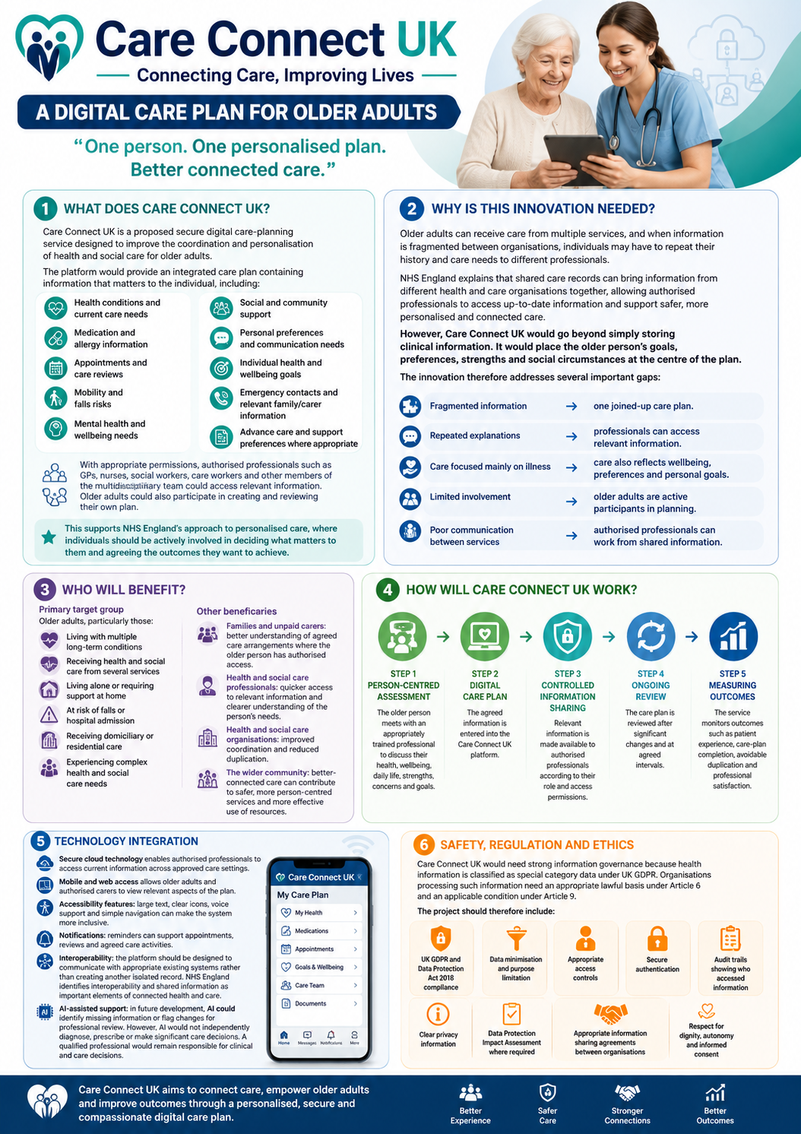

1. What is Care Connect UK?
Care Connect UK is a planned safe digital care-planning service designed to enhance the coordination and personalisation of health and social care for older adults.
The platform would give an integrated care plan including information that matters to the individual, including:
- Health conditions and current care needs
- Medication and allergy information
- Appointments and care reviews
- Mobility and falls risks
- Mental health and wellbeing needs
- Social and community support
- Personal preferences and communication needs
- Individual health and wellbeing goals
- Emergency contacts and relevant family/carer information
- Advance care and support preferences where appropriate
With appropriate approval, authorised professionals such as GPs, nurses, social workers, care workers and other members of the multidisciplinary team could access relevant information. Older adults could also participate in creating and reviewing their own plan (NHS England, 2021).

2. Why is this innovation needed?
Older adults can get care from various services, including general practice, hospitals, community nursing, social care, pharmacies, mental health services and voluntary organisations. When information is disconnected between organisations, patients may need to restart their history and care needs to other professionals.
NHS England elaborates that shared care records can also bring up information from various health and care organisations together, making it possible for authorised professionals to access updated information and support safer, more personalised and connected care.
However, Care Connect UK would go beyond simply storing clinical information. It would place the older person’s goals, preferences, strengths and social circumstances at the centre of the plan.
The innovation therefore addresses several important gaps:
Fragmented information → one joined-up care plan.
Repeated explanations → professionals can access relevant information.
Care focused mainly on illness → care also reflects wellbeing, preferences and personal goals.
Limited involvement → older adults are the active participants in planning.
Poor communication between services → authorised professionals can work from shared information.
3. Who will benefit?

Primary target group
Older adults, particularly those:
- Living with multiple long-term conditions
- Receiving health and social care from several services
- Living alone or requiring support at home
- At risk of falls or hospital admission
- Receiving domiciliary or residential care
- Experiencing complex health and social care needs

Other beneficiaries
Families and unpaid carers: better understanding of agreed care arrangements where the older person has authorised access.
Health and social care professionals: quicker access to relevant information and clearer understanding of the person’s needs.
Health and social care organisations: improved coordination and reduced duplication.
The wider community: better-connected care can added to safer, more person-centred services and more effective use of resources.

4. How will Care Connect UK work?

STEP 1 – PERSON-CENTRED ASSESSMENT
The older person meets with an appropriately trained professional to discuss their health, wellbeing, daily life, strengths, concerns and goals.

STEP 2 – DIGITAL CARE PLAN
The agreed information is entered into the Care Connect UK platform.

STEP 3 – CONTROLLED INFORMATION SHARING
Relevant information is available to authorised professionals based on their role and access permissions.
Step 4- Measuring Outcomes
The service monitors outcomes like patient experience, care-plan completion, avoidable duplication and professional satisfaction.

5. Technology Integration
Care Connect UK would use:
Secure cloud technology enables authorised professionals to access current information across approved care settings.
Mobile and web access allows older adults and authorised carers to view relevant aspects of the plan.
Accessibility features: large text, clear icons, voice support and simple navigation can make the system more inclusive.
Notifications: reminders can support appointments, reviews and agreed care activities.
Interoperability: the platform should be designed to communicate with appropriate existing systems rather than creating another isolated record. NHS England identifies interoperability and shared information as important elements of connected health and care (NHS England, 2022).

6. Safety Regulation and Ethics
Care Connect UK would need strong information governance, as health information is classified as special category data under the UK GDPR. Organisations processing such information need an appropriate lawful basis under Article 6 and an applicable condition under Article 9.
The project should therefore include:
- UK GDPR and Data Protection Act 2018 compliance
- Data minimisation and purpose limitation
- Appropriate access controls
- Secure authentication
- Audit trails showing who accessed information
Data Protection Impact Assessment where required
- Appropriate information-sharing agreements
- Safeguarding procedures
- Confidentiality and professional standards

The system should follow a privacy-by-design approach. Older adults should be able to understand how their information is used and, where applicable, who can access it.

7. Digital Inclusion
Technology must not create a new barrier to care.
Some older adults may have limited digital skills, visual or hearing impairments, cognitive difficulties, language barriers, or no access to suitable devices or reliable internet.
Therefore, Care Connect UK would provide:
Digital support: staff, community organisations and libraries could offer training.
Non-digital access: an older adult should not lose access to care because of their inability to use the application.
Assisted access: a trusted person could help where appropriate and legally authorised.
Accessible design: large fonts, high readability, simple language, voice functions and easy navigation.
The principle is simple:
Digital when useful – human when needed.

8. Implementation Plan

Where?
The first pilot could be implemented within one Integrated Care Board (ICB) area in England, involving:
- GP practices
- Community nursing
- Adult social care
- Care homes
- Hospitals
- Pharmacies

NHS England identifies ICBs as having responsibility for local delivery of shared care records, making an ICB-level pilot a realistic implementation environment.

Who?
Implementation would involve:
- Older adults and carers
- GPs
- Nurses
- Social workers
- Care workers
- Pharmacists
- Digital/IT specialists
- Information governance professionals
- Service managers
- Patient and public representatives

Timeline
Months 1–3: Co-design with older adults and professionals.
Months 4–6: Develop/procure platform, conduct security and information-governance assessments.
Months 7–9: Staff training and small-scale pilot.
Months 10–12: Evaluate pilot and improve the system.
Year 2: Expand to additional practices, social care providers and community services.
Year 3: Consider wider regional adoption based on evidence and evaluation.

9. Dissemination and Promotion
Care Connect UK would be promoted through:
- NHS and local authority communication channels
- GP practices and community centres
- Care homes and domiciliary care providers
- Older people’s charities and community organisations
- Social media and digital campaigns
- Posters and leaflets in healthcare settings
- Professional training and staff briefing
- Public engagement events
- Patient and carer advocacy groups
The campaign would use accessible language and real-world stories from older adults and professionals to prove how better information-sharing can enhance care.

10. Expected Impact
Care Connect UK aims to achieve:
For older adults
- Greater participation in care decisions
- Additional personalised care
- Boosted continuity
- Minimised repetition of personal information
- Higher confidence in care coordination
For professionals
- Quicker access to important information
- Better communication between services
- More informed decision-making
- Minimised duplication
For services
- Better coordination
- Enhanced continuity across organisational boundaries
- More effective information-sharing
- Improved patient and service-user experience

Success will be measured through:
- Patient/service-user satisfaction
- Digital inclusion and accessibility measures
- Professional satisfaction
- Completion and review of care plans
- Reported duplication of assessments
- Information-sharing incidents
- Care coordination measures
- Hospital readmission/avoidable admission indicators where appropriate

Conclusion
Care Connect UK is not about replacing human care with technology. But it is about using technology to strengthen human-centred care.
By bringing together health, social care and personal wellbeing information in a safe, accessible and person-centred plan, Care Connect UK can also help older adults have greater voice and control while helping professionals provide safer and better-connected care.
The Pitch writing

Introduction
The increasing complexity of health and social care needs among older adults creates a need for innovative approaches that improve communication, continuity and person-centred care. Older people may receive support from general practitioners (GPs), hospitals, community nurses, social workers, care workers and voluntary organisations. When information is held across different services, individuals may have to repeat their circumstances, while professionals may not always have access to relevant information. This pitch proposes Care Connect UK, a secure digital care-planning service designed to connect health and social care information while keeping the older person at the centre of decision-making.

The Problem and Proposed Innovation
Care Connect UK would provide older adults with a personalised digital care plan including relevant information about their health, social care and wellbeing. This could contain medical conditions, medication, allergies, appointments, mobility needs, falls risks, communication preferences, personal goals, social support and agreed care arrangements (NHS England, 2024).
The innovation responds to the need for more personalised and integrated care. NHS England explains personalised care and support planning as a process in which individuals are actively involved in decisions about their health and wellbeing. It emphasises understanding the person as a whole and developing a shared plan that reflects what matters to them (NHS England, 2023).
Care Connect UK would also complement the principle of shared care records. NHS England explains that shared care records can bring information from different health and care organisations together digitally, allowing authorised users to access relevant information for direct care. Such information may include medication, allergies, care plans, appointments, personal preferences and clinical contacts (NHS England, 2026).
However, Care Connect UK would concentrate particularly on what matters to the older person, rather than simply sharing clinical information. For example, an older adult whose main goal is to remain independent at home could have this goal clearly recorded alongside their mobility needs, social support, medication and care arrangements.

Target Audience and Expected Impact
The primary target group would be older adults with complex or multiple health and social care needs, particularly those receiving support from several professionals or organisations. The innovation could benefit people living at home, residents of care homes and older adults transitioning between hospital and community care.
For older adults, Care Connect UK could enhance involvement in care decisions, minimise the need to repeatedly explain their circumstances and support continuity between services. Family members or unpaid carers could also receive appropriate access that was authorised by the individual or otherwise legally permitted.
Health and social care professionals could benefit from quicker access to relevant information, potentially improving communication and reducing duplication. The wider benefit would be better coordination between health and social care services and a stronger focus on individual wellbeing and independence.

Technology and Implementation
Care Connect UK would be delivered through a safe web and mobile platform. The system would use role-based access, allowing professionals to view information appropriate to their responsibilities. Older adults could access their own care plan through a simple interface, while accessibility features such as larger text, clear language, voice functionality and simple navigation would support users with different needs.
The system should also be designed to work with existing digital health and care infrastructure instead of becoming another isolated database. NHS England identifies digital connection and information-sharing as important components of more joined-up health and care services (NHS England, 2026).
Implementation could initially take place as a 12-month pilot involving GP practices, community nursing, adult social care, care homes and hospital services within an English Integrated Care Board area. The first three months would involve co-design with older adults, carers and professionals. Months four to six would involve platform development, information-governance checks and security testing. Months seven to nine would involve staff training and a small pilot, followed by evaluation and improvement during months ten to twelve. Successful outcomes could support wider implementation.

Regulation, Ethics and Safeguarding
Data protection is essential because Care Connect UK would process sensitive health information. The Information Commissioner's Office identifies data regarding health as special category data under the UK GDPR. Organisations must identify an appropriate Article 6 lawful basis and an Article 9 condition when processing such information (ICO, 2026).
The proposed system would therefore need appropriate information governance, secure authentication, access controls, audit trails, data minimisation and transparent privacy information. A Data Protection Impact Assessment should be considered where required. Information should only be shared with authorised individuals for legitimate purposes.
Ethically, older adults should have meaningful control over their information and understand how it is used. Safeguarding procedures must also remain in place to identify and respond to abuse, neglect or other risks. Technology should support professional judgement rather than replace it.

Digital Inclusion
A key challenge is that some older adults may have limited digital literacy, lack access to devices or experience disability-related barriers. Care Connect UK should therefore operate on a “digital when useful, human when needed” principle. Older adults should not be deprived because they cannot use an application.
Training could be offered through GP practices, community centres, libraries, care organisations and voluntary-sector groups. Staff or appropriately authorised carers could provide assisted access. This approach would help prevent digital innovation from increasing existing inequalities (NHS England, 2023).

Dissemination and Evaluation
Care Connect UK would be promoted via GP practices, hospitals, care homes, local authorities, community organisations and older people's groups. Digital campaigns could be supported by printed information and face-to-face engagement to reach people with limited digital access.
The efficacy of the innovation should be evaluated using both quantitative and qualitative measures. These could include older people's satisfaction, professional feedback, care-plan completion and review rates, reported duplication of assessments, information-sharing incidents and measures of digital inclusion. Interviews and focus groups with older adults and professionals would provide further evidence about usability and acceptability (NHS England, 2021).

Conclusion
Care Connect UK offers an innovative approach to boosting the health and social care experience of older adults. By merging personalised care planning with secure digital information-sharing, the proposal aims to improve communication, continuity, involvement and person-centred care.
The innovation reflects NHS England's emphasis on personalised care, where individuals should be central to developing their care plan and identifying outcomes that matter to them. It also builds on the principles of shared care records by enabling appropriate professionals to access relevant information.

Reference List
Care Quality Commission. (2022). Innovation and why it is important - care quality commission. In www.cqc.org.uk. https://www.cqc.org.uk/publications/themes-care/innovation-why-it-important
Carevia. (2025, July 9). Digital care planning: Getting it right in adult social care - carevia. Carevia. https://carevia.co.uk/digital-care-planning-getting-it-right-in-adult-social-care/
England, N. (2024). NHS England » change NHS: Help build a health service fit for the future. In England.nhs.uk. https://www.england.nhs.uk/long-read/change-nhs-help-build-a-health-service-fit-for-the-future/

Information Commissioner’s Office (ICO) (2026) What are the rules on special category data? Available at: https://ico.org.uk/for-organisations/uk-gdpr-guidance-and-resources/lawful-basis/special-category-data/what-are-theEngland, N. (2024). NHS England » change NHS: Help build a health service fit for the future. In England.nhs.uk. https://www.england.nhs.uk/long-read/change-nhs-help-build-a-health-service-fit-for-the-future/
-rules-on-special-category-data/ (Accessed: 3 August 2026).
NHS England (2023) Personalised care and support planning: a brief summary guide. Available at: https://www.england.nhs.uk/long-read/personalised-care-and-support-planning-a-brief-summary-guide/ (Accessed: 3 August 2026).
NHS England (2026a) Personalised care and support planning. Available at: https://www.england.nhs.uk/personalisedcare/pcsp/ (Accessed: 3 August 2026).
NHS England (2026b) Shared care records. Available at: https://www.england.nhs.uk/digitaltechnology/connecteddigitalsystems/shared-care-records/ (Accessed: 3 August 2026).
Knight, F. (2025). Electronic care plans: Everything you need to know. In Birdie.care. https://www.birdie.care/blog/electronic-care-plans
Sinha, R. (2024). The role and impact of new technologies on Healthcare Systems. Discover Health Systems, 3(1), 1–14. https://doi.org/10.1007/s44250-024-00163-w

