AI and Machine Learning
Teronix AI/ML Appraisal

Table of Contents
Abstract 3
Introduction 4
Literature Review 5
Artificial Intelligence 5
Machine Learning 5
How can the supermarket sector use Machine Learning? 5
Types of data that can be collected 5
What can be done with the collected data? 6
Tools and Applications 8
KNIME 8
Orange 8
TensorFlow Extended (TFT) 9
Methods 10
Results 11
Conclusions 12
References 13
Figures 14

Abstract
Teronix Online is a B2C e-commerce platform that sells both electronics and household goods to consumers. They import and export certain products to select markets in Europe and the Americas. Recently, they have seen a significant increase in demand for their products and urgently require expert help.
The CEO of Teronix Online has given the task of evaluating the potential benefits of implementing Artificial Intelligence (AI) and Machine Learning (ML) techniques for improving data analysis at the company. A dataset created by a previous consultant has been provided and your report should clearly outline the findings to the company's senior management.

Introduction
Teronix Online is an online retail store that specializes in selling consumer electronics and household items to customers. The CEO of Teronix Online has requested the evaluation of the company and create a report outlining the potential benefits of implementing AI and ML for analysing the data currently possessed by Teronix Online.
And what applications / tools that the company can use to have a hands-on experience in what AI / ML is, and how they can be used to implement a system that uses the companies data.

Literature Review
Due to the nature of Teronix Online having no previous expertise on AI and machine learning. Some research will need to be conducted and an explanation on the basics of AI and machine learning will be supplied.

Artificial Intelligence
AI, or Artificial Intelligence, is the technology that allows machines to mimic human intelligence, such as the ability to learn, reason, and perform tasks that would normally require human cognition. This is achieved through the use of complex algorithms and computer programs. AI can be found in everyday technology such as virtual assistants, self-driving cars and image recognition software. There are two types of AI: general AI, which is capable of performing any intellectual task that a human can do, and narrow AI, which is designed to perform specific tasks, like recognizing speech or playing games.
If you want to do further reading into AI, a good reference to start from would be “Artificial Intelligence: A Modern Approach” [1]. It’s a widely used textbook and reference for learning the fundamentals of AI. It can provide a comprehensive introduction to the field and the covering topics such as logic, search, probability, etc.

Machine Learning
Machine learning is a technique that allows computers to automatically improve their performance on a task by analysing data and identifying patterns without human assistance. This is achieved by feeding a computer a large amount of data and allowing it to adapt its algorithms based on that data, in order to make more accurate predictions or decisions. Common examples of this include spam filters that use machine learning to detect and remove unwanted emails and recommendation systems that suggest products or services to customers based on their previous activity. To put it simply, machine learning enables computers to improve their performance on a task by learning from data, rather than being explicitly programmed.
If you want to do further research into machine learning. A book by Tom Mitchell on Machine Learning [2] is a well-regarded reference for learning about ML. It covers the fundamental ideas and methods of machine learning, such as supervised and unsupervised learning, decision trees, and neural networks.

How can the supermarket sector use Machine Learning?
Due to Teronix Online being a retailer. Some research needs to be conducted in the retail side of Artificial Intelligence and Machine Learning. Research needs to be conducted to show the different types of data that the company can collect. And how the company can convert it to its advantage.

Types of data that can be collected
These are the different types of ways the company can collect data, so that it can be used within machine learning:
- Website analytics: An e-commerce website can gather information on customer behaviour and likes by utilizing website analytics tools like Google Analytics, which monitors customer actions on the website, including clicks, page views, and duration of visit.
- E-commerce platform data: An e-commerce website can gather information on customer buying habits and behaviour through their e-commerce platform, including previous orders, viewed products, and abandoned shopping carts.
- Customer accounts: An e-commerce website can gather information on customer demographics, purchasing history and preferences through customer accounts and registration forms.
- Surveys and questionnaires: An online store can collect data on customer satisfaction, preferences, and demographics through surveys and questionnaires.
- Social Media: An online store can collect data on customer preferences and sentiment through social media platforms.
- Customer service interactions: An e-commerce website can gather information on customer behaviour, preferences, and buying habits through interactions with customer service, such as chat, email, and phone support.
- Third party data providers: An e-commerce website can also obtain data from external providers that specialize in supplying information on consumer behaviour, demographics, and purchase history.
Once the data is gathered, it can be cleaned and prepared for analysis, and then applied to train machine learning models. These models can be used for various purposes such as predicting demand, determining optimal pricing, personalizing marketing, detecting fraud, and providing product recommendations.
A good reference to retailers and the hordes of data that they can collect would be a study conducted from a reference about Retail Analytics [3]. The text is discussing the challenges that retailers face in understanding their customers through the large amount of data available to them. It states that while retail analytics is becoming increasingly important in managing a retail business, there is still a lack of research in the area of comprehensive store segmentation using data mining-based retail analytics. The results of the study suggest that this new approach to retail analytics allows retailers to identify clusters of stores using all transaction data and to make data-driven decisions in areas such as marketing, customer relationship management, supply chain management, inventory management, and demand forecasting.

What can be done with the collected data?
There are several ways that machine learning can be used within the company:
- Demand Forecasting: By using machine learning, supermarkets can anticipate customer demand for products, allowing them to efficiently manage their inventory and decrease unnecessary surplus.
- Price Optimisation: Machine learning can be employed to study market trends and provide suggestions for the most profitable prices for products, helping supermarkets to increase profits and remain competitive.
- Personalised Marketing: Machine learning can be employed to examine customer information and design personalized marketing strategies for specific customers, resulting in greater sales and customer satisfaction.
- Inventory Management: Machine learning can be used to optimize the stock levels, forecast the demand of certain products, and predict which products are more likely to be sold in certain periods of time.
- Product Placement: Machine learning can be applied to study customer behaviour, likes, and buying habits to enhance the positioning of products within the store, resulting in higher sales.
- Fraud Detection: Using machine learning, fraud detection systems can continuously learn from past data, making them adaptable to new forms of fraud as they arise. They can handle large volumes of data in real-time, enabling early identification of fraudulent activities. Additionally, automation of several tasks by these systems, reduces the burden on human analysts and improves the effectiveness of the fraud detection process.
All these methods can help supermarkets to improve their operations and increase their bottom line.
Another reference is the book "The AI Advantage: How to Put the Artificial Intelligence Revolution to Work" by Thomas Davenport and Rajeev Ronanki [4]. This book offers a deep understanding on how companies can use AI and machine learning to gain competitive advantages across different sectors and offers concrete examples of how retailers can apply AI and machine learning to enhance their operations, including forecasting demand, optimizing prices, personalizing marketing, and detecting fraud.

Tools and Applications
This section will go over the available tools that can be used by the company and what they offer.

KNIME
KNIME is a free, open-source platform that enables users to create data pipelines, perform data analysis, and access various data connectors and processing nodes. Designed to be user-friendly for both data scientists and business analysts, it can be used for various tasks including data exploration, pre-processing, machine learning, and big data processing. It also offers a range of plugins, including integration with R and Python, to facilitate advanced data analysis.
There are several benefits to using KNIME:
- Intuitive interface: The user-friendly drag-and-drop interface of KNIME allows for easy creation of data pipelines and data analysis, making it accessible to those with little programming knowledge.
- Wide range of functionality: KNIME offers a wide range of data connectors, data processing nodes, and machine learning algorithms, making it a versatile tool for a variety of data analysis tasks.
- Flexibility: KNIME is a versatile tool that can be utilized for different purposes such as exploring data, pre-processing data, implementing machine learning, and handling big data.
- Open-source and free: KNIME is free and open-source, which means that users can access the source code and make changes to the software as needed.
- R and Python integration: KNIME provides integration with R and Python, enabling more complex data analysis to be performed.
However, there are also some drawbacks that come with KNIME:
- Steep learning curve: While KNIME's drag-and-drop interface is relatively easy to use, there is a steep learning curve for more advanced tasks and features.
- Limited scalability: KNIME is not designed to handle very large datasets, which can be a limitation for some users.
- Limited support for deep learning: KNIME has some machine learning capabilities, however, it doesn't have the same level of deep learning support as other tools.
Overall, KNIME is a great tool for proof of concept when it comes to doing the base research for a piece of data.

Orange
Orange is a free, open-source software that allows users to analyse and visualize data. It is written in Python, utilizing libraries like NumPy, SciPy, and PyQt, and enables a wide range of data analysis tasks like data visualization, pre-processing, and machine learning. It has a user-friendly, drag-and-drop interface, making it accessible to non-technical users. It also features a built-in library of visualization widgets and add-ons that can be used to expand its functionality.
Orange as an application is very much like KNIME. Its very user friendly (even more friendly than KNIME), but has limitations like limited scalability and support for deep learning.

TensorFlow Extended (TFT)
TensorFlow Extended (TFX) is an open-source platform that enables building and deploying machine learning models on a large scale. It is an extension of TensorFlow and provides an end-to-end machine learning platform. TFX comprises a collection of libraries and tools covering the entire machine learning pipeline, from data preparation and pre-processing to model training and deployment. It can handle large datasets, and scale horizontally on a cluster of machines, it also includes libraries for data validation, feature engineering, model training, and model evaluation. TFX also includes a visualizer to monitor and debug the performance of machine learning models. It offers a set of reusable components, such as TensorFlow Transform, which is a library for pre-processing data with TensorFlow, and TensorFlow Model Analysis, a library for evaluating machine learning models. Additionally, TFX provides an easy-to-use API for building custom components, such as new data pre-processing algorithms or new model evaluation metrics. TFX serves as a comprehensive platform for building, deploying and managing machine learning models and workflows, allowing developers and data scientists to focus on the core logic of the model and not on the complexity of the underlying infrastructure.

Methods
Before doing anything with the data. It needs to be checked, to see what it can be used for. The data is full of invoices which are linked to products and customers. Also, the customers country is linked. With this we know the product, customer, origin, and invoice. With these details for different processes.
As talked about before. From the list of uses that retail companies can use their data for. From the previous research section, where we talked about what data can be used for. With this data we can basically do all the above topics, but certain topics like inventory management and fraud detection would be limited due to the data given.
Because we can pick from multiple, we are going to use the customer data to find out what types of customers we have. To do this we will need to separate the different types of data and then use some sort of classification model to classify the customers.
Now that the main goal was found. The data needs to be checked so that the data is accurate. From the received data it was found that there were missing bits of data in some record rows (see figure 1 for an example). It was also found that there were minus records (see figure 2). Lastly, from searching the dataset.
To import and process the data. KNIME was picked due to its simplicity with basic AI/ML techniques and its better manipulation compared to Orange. Due to the dataset being split between years, concatenation was needed to combine datasets (Figure 3). With this we can handle both datasets easily while also removing any duplicated records just in case.
Next was to clean the data given. To do so, as said above we need to filter out the records with missing data. To do that, rows with missing customer id’s were removed. Next records with negative quantities and prices were removed. And finally, the column product description was removed due to the data not being needed (Figure 4).
Now the recency (number of days since last purchase), frequency (number of transactions) and monetary (revenue contributed) data needs to be found for the customers (Figure 5).
Now the new dataset needs to be cleaned to remove any outliers (To improve reliability – see figure 6).
Finally, a K-Means cluster can be added onto the end to classify customers by the K-Means clusters. With this the data can be analysed to identify the different types of customers that purchase products from the company.

Results
Please note in this section you are expected to list the steps taken to analyse the given dataset and the creation of your AI/ML model.

Conclusions
It was found that Teronix Online has an abundant of data that can be used several ways. In the future it would be good to create a model that used regression to predict when products would become popular to maximise sales.

References
[1] Russell, Norvig, P., & Davis, E. (2010). Artificial intelligence : a modern approach (3rd ed.). Pearson.
[2] Tom M. Mitchell. 1997. “Machine Learning: A multistrategy approach”.
[3] Bilgic, Cakir, O., Kantardzic, M., Duan, Y., & Cao, G. (2021). Retail analytics: store segmentation using Rule-Based Purchasing behavior analysis. The International Review of Retail, Distribution and Consumer Research, 31(4), 457–480. https://doi.org/10.1080/09593969.2021.1915847
[4] Thomas H. Davenport. (2018). The AI Advantage: How to Put the Artificial Intelligence Revolution to Work.

Figures
[1] Missing data in records
[2] Negative records
[3] Concatenating data
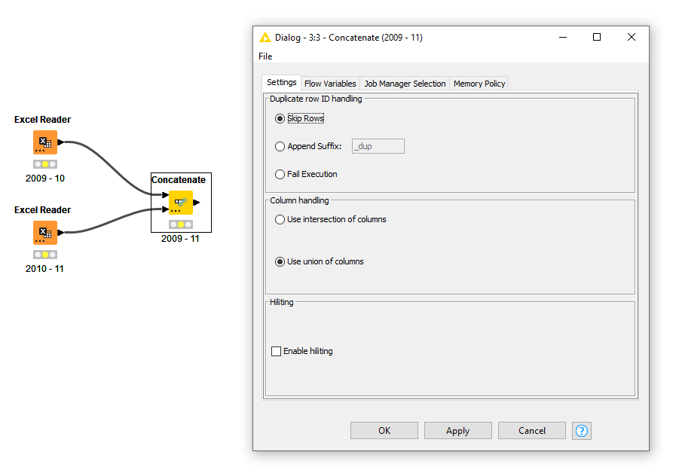
[4] Cleaning data
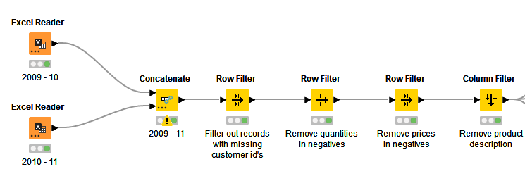
[5] Customer Data
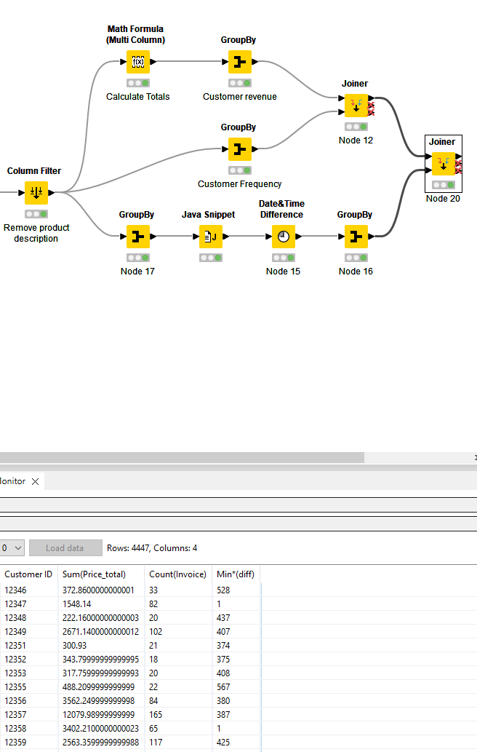
[6] Remove outliers and normalise.


