Assessment 2 Data handling & Business Intelligence
DATA ANALYSIS & VISUALISATION
Student name Patricia Constandache
Student Id 2020640

Table of Contents
Introduction 3
Part 1 3
Part 2 11
Conclusion 18
Reference List 19

Introduction
It is essential to understand that organizations are required to have the potential to analyze their data appropriately. In the given case, the analysis of sales and profit are going to be analyzed with the help of the superstore data that have been provided. In the given study, the usage of excel is going to be done. It is because excel happens to be among the major tools that are used for the analysis of a certain organization.

Part 1
Usage of excel for the determination of sales and profit of superstores
In the superstore data, the data have been given from the years 2009 to 2012. The analysis of the data is going to be done in the given study. The given data in the initial stages will be required to be pre-processed. To do the pre-processing activities such as sorting and filtering are required to be done.
Pre-processing of the data
It is important to understand that MS excel happens to be one of the essential tools that are used by organizations in their operations. According to Umer et al. (2019), the MS excel software happens to be the most suitable tool table and graph representation. In the case of the given data, it can be seen that it was not organized well. The data had been sorted from the oldest to the newest.
Developing the pivot tables
The order dates were put in a row. On the other hand, the count of sales, as well as the sum of profit, were put in the columns. Doing this in the pivot table allowed us to know the sales quantity as well as the profit of the business entity on any day of the year. In the same way, 3 other pivot tables were developed for the years 2010, 2011, and 2012 respectively.
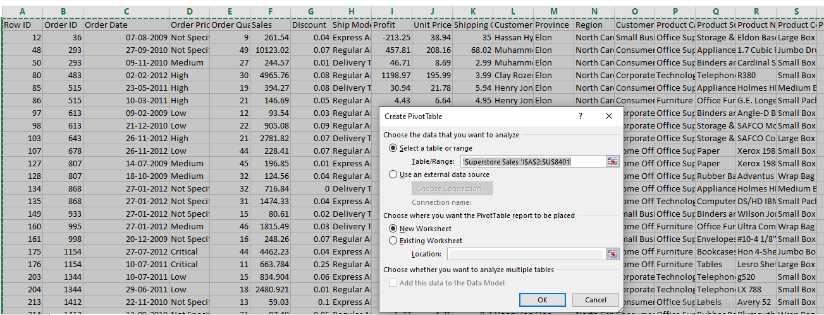
Figure 1: Creating the pivot table
(Source: Created by the learner)
Data and visualization of the mentioned years
After the creation of the pivot tables, it was time for developing the data plots. The analysis of different years has been done in the below section
Analysis for the year 2009
To do the analysis, the superstore's 2009 sales data were plotted on the excel line diagram. The line chart of the 200 sales data has been provided in the following figure.
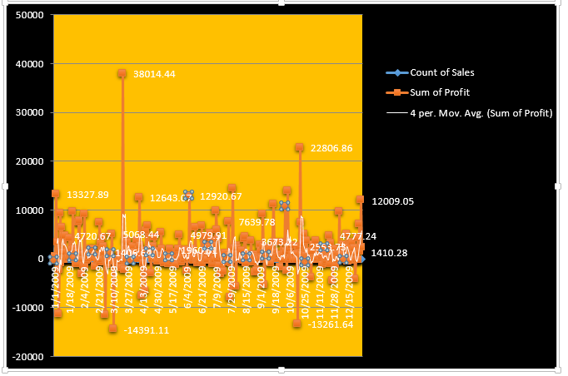
Figure 1: Analysis of the year 2009
(Source: Self-Created)
38014.44 was the maximum daily profit value that the organization was able to achieve. The organization was able to attain this number on 21st march. A 4-point moving average trend line was used to understand the variation that was occurring in the daily profit or loss. In the initial stages of the years, the profit was declining significantly. The organization was able to recover from its decline in March and July. However, the keynote that is to be taken is that the daily profit level of the organization witnessed a significant amount of fall during the times of October. In the first three months of the year, the profit level was 1400 pounds, on the other,m in the two months of the year the profit level of the organization was 2000 British pounds. Thus it can be said that the business can gain a decent level of profit in the ending stage of the year.
It is important to understand that excel happens to be a tool that allows you to do multiple functions. According to Katoch (2020), the data manipulation function, as well as plotting facilities in MS excel, happens to be significantly high. Due to this, it can be said that the data visualization in Excel can be done effectively.
Analysis for the year 2010
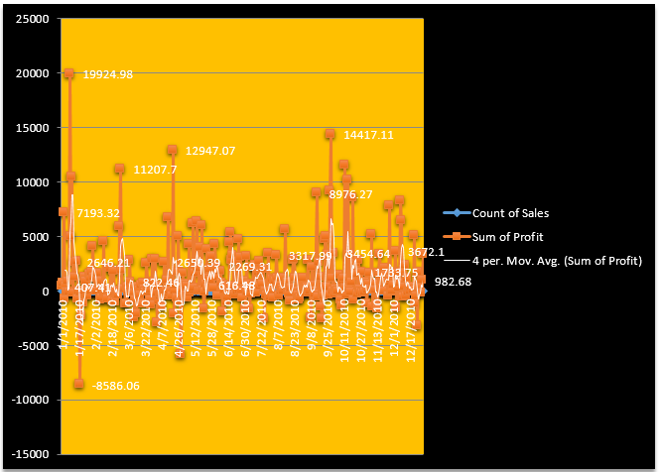
Figure 1: Analysis of the year 2010
(Source: Self-Created)
From the graph for 2010, it can be seen that the year was not favorable for the organization. In the earliest stages of the years, especially till April, the organization was able to maintain a certain amount of gain in its operations. However, it was not the case in April. The month of April saw the organization going into losses. The organization was able to make a recovery in May, however, from September onwards, it was seen that the business was witnessing significant amounts of losses in its operations. The trend of decline in the profit of the organization was present till September. After September the organization was able to avoid incurring losses, however, it can be said that the figures were not impressive in comparison to the previous years. The average profit of the organization in that year was about 1500 British pounds which is quite less in comparison to the figures of the previous year. One of the important factors that are to be taken into account is that, unlike the previous year, the organization was not able to attain the daily profit margin of 20000 British pounds in the year 2010. It can be highlighted that the performance of the organization in the year 2010 was quite low in comparison to that of their 2009 figures.
It is important to understand that one of the major benefits of data visualization is that it can make a piece of certain information more engaging. According to Cheng et al. (2017), it can be said that data visualization helps one to understand a certain issue more easily. the data visualization has been able to allow the readers to compare the trends of the two years in a more specific manner.
Data visualization of 2011

Figure 1: visualisation of data, 2011
(Created by the learner)
This chart shows the data plot for the superstore sales reflects that the company was not able to surpass the mark of £ 20000.00 in the area of its daily profit. It shows a massive loss in the area of its daily profit with the loss of £ 12034.35. The orange line has shown the sum of profit, the blue line is for displaying the count of total sales. This loss was seen in the month of November, in the year 2011. Based on the daily profit level of £ 20000.00 the superstore failed to reach the scale of profitability. Through the graph, it can be seen that in between July to September the superstore could not retain its desired profit level. From this instance, it can be ideated that it needs to turn its focus toward profitable strategies. As loss of profit decreases the financial strength of businesses, the significant profit decrease can hamper the efficiency of superstores to sustain their financial growth. In this regard, the instance of 2009 is also important to emphasise its inefficiency in attaining the targeted profit margin of £5000.00 mark on the Y-Axis for the daily profit level as its previous year of 2010. It reflects the high requirement for developing efficient selling techniques and production efficiency. Moreover focusing on a cost-effective business process can help to enlarge the path of reaching the targeted profit margin in the coming years. It can be observed in the graph that the 4-point moving average line of trend became able to stay at a float for a specific period since 2009. From this data, it can be estimated that the brand was at a risk of facing a massive loss of 50% in the next two years.
Data visualization of 2012

Figure 2: Visualisation of data plot analysis, 2012
(Created by the learner)
The data plot visualisation is containing analysed numerical data about sales of the Superstore on daily basis. The diagram interprets the sales performance of Superstore for the year 2012. From the total analysis, it can be seen that the sum of profits is at the level of 4% to average in the area of sales. The marked level of daily profit has been £2000.0 and in the year 2012, most of the daily sales performance stayed below this level. From the created diagram, it has become evident that, after September month, sales performance has been decreased significantly. It can be observed that the company has faced severe challenges to maintain its average profit mark by increasing the sum of profit averagely above the loss threshold. By the end of 2012, the value of the same was seen at an even lower level than the mark of £1000.00. Sales data helps businesses to track their performance in sales and identify whether it has been successful to attain targeted sales or not. The sales chart is a significant part of business operation to maintain data on the previous sales performance of brands and future aims of improvement and growth. This data is helping the brand to observe their exact lacking area and enabling them to attain the data of their ability to attain high sales in future.
Step 4: Using Excel functions like IF and LOOKUP for data analytics
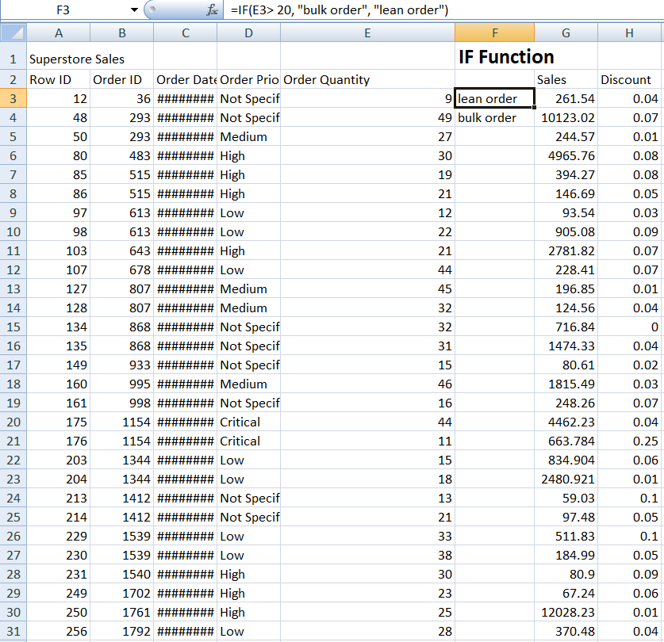
Figure 3: If the function
(Created by the learner)
If the function is a significant application of Excel that helps businesses to filter their information and identify important data with specific measures of sales and other aspects through high, low, not specific, critical and some other measures. Order quantities have been marked as lean based on orders less than 20. Order quantities more than 20 have been marked as bulk. The IF function works for allowing businesses to measure their performance in attaining sales and profits. Through this function, businesses become able to identify their low areas of sales and they work for improving results in the same areas in future. Through the image of IF function, sales performance and profit of Superstore has been displayed clearly. It works as one of the most useful features of MS Excel that includes the feature of testing data logically through comparison of returns and results. In such a way, the IF function has helped Superstore to measure its sales performance and focus on further growth strategies for the future through order quantities.

Part 2
2.1 how many students like the vanilla flavor
To analyze the given data, the SPSS tool has been incorporated into the given study. The SPSS tool is a descriptive analysis tool that can generate the frequency table. In the below frequency, people who have a preference for certain flavors have been highlighted.
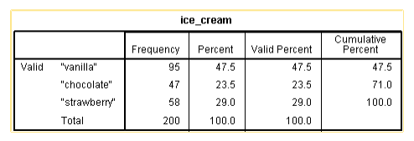
Frequency Table 1
(Source: Learner)

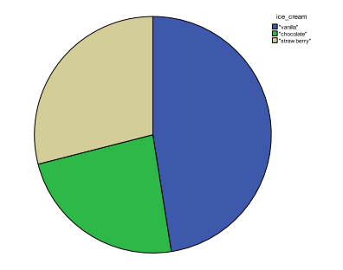
Figure 1: SPSS of question 1
(Source: Learner)
Understanding the frequency table, it can be seen that more than 47% of the people tend to have a preference for the vanilla flavor. The number of people opting for the vanilla flavor is 95. From the data, it can be understood that the dominant section of the students tends to have a preference for the vanilla flavor
2.2 How many students are male and female

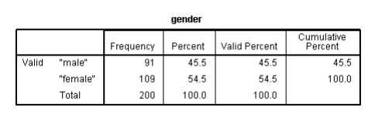
Frequency Table 1
(Source: Learner)

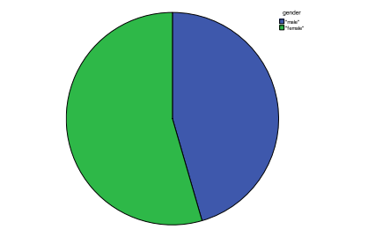
Figure 1: SPSS of question 2
(Source: Learner)
By utilizing the SPSS analysis tool, it can be said that there are 109 female students. Whereas on the other hand, it can be seen that there are mainly 91 male students. The percentage of male students happens to be 45.5%. On the other hand, the percentage of female participants happens to be around 54.5. From the SPSS figures, it can be understood that the number of female students happens to be slightly higher than the number of male participants.
2.3: What are the Mean and Median of participants who like chocolate and strawberry flavored ice cream?
To know the mean as well as median scores of the individuals who prefer the chocolate and strawberry flavors have been highlighted with the help of the SPSS tool and applying the box plot method in the given context.
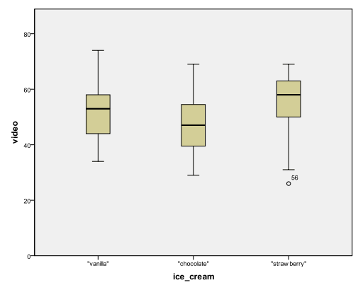
Figure 3: Video score to know the number of students who love chocolate and strawberry
(Source: Learner)
The mean and the median scores highlight that the score for the individuals who have a preference for chocolate is just above 45. On the other hand, the same score in the case of strawberries is 55.
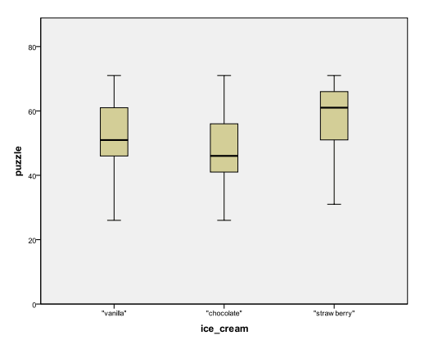
Figure 4: Video score to know the number of students who love chocolate and strawberry
(Source: Learner)
The above graph highlights that the chocolate team’s puzzle score is something around 45. On the other hand, the puzzle score for the people preferring strawberries is something around 65.
2.4: Using the dataset Ice_cream_csv provided in conjunction with SPSS, give a specific example of clustering (ex. K-Means). Show your workings with screenshots and clearly explain your results
K in the clustering technique is used for its ability to tackle large data. The users specify the number of cluster data that helps them to divide data into different segments based on their observation. Phases of cluster data include a choice of different variables, similarity of measures, hierarchical and non-hierarchical techniques, decisions about the numbers of clusters and lastly evaluation of significance. The clustering technique has helped the Ice-cream business to conduct data mining and analysis of the performance of the business through several hidden patterns. The major benefit of the Cluster technique is there is no such requirement of determining numbers or numeric fluster beforehand. By producing a good visual this technique helps businesses to join data. The cluster technique uses a dendrogram for graphical reorientation (Sibanda et al., 2019).
Quick Cluster
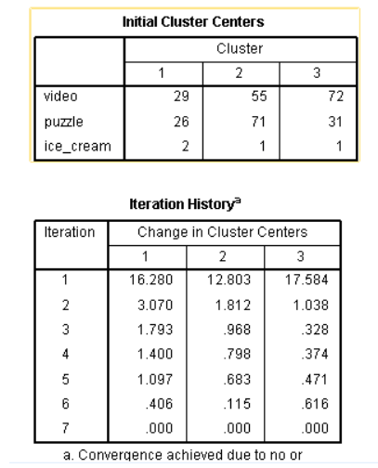
Clustering procedures include stages of hierarchical clustering, non-hierarchical clustering and two-step clustering. Hierarchical clustering includes agglomerative clustering and devising clustering. Non-hierarchical clustering includes types of sequential, parallel thresholds and optimizing partitioning methods. In the above cluster analysis, it can be interpreted that the cluster segments have been divided into three parts. The video cluster centre is in the first position. The second, puzzle cluster has been categorised and ice cream is in the third cluster. The sample numbers of the cluster for chocolate with puzzle and video have attained a score of 26 and 29. The second cluster of the vanilla segment has scored 55 and 71. At last, the third cluster reflects data where it has been evident that individuals preferred the vanilla ice cream with 72 and 31 as the puzzle and video have scored respectively.
2.5: Explain the most common data mining and text mining methods that can be used in business with real-world examples.
Clustering includes some most common data and text mining methods that businesses use to assess their business performance through mathematical algorithms. Data mining has added a new dimension to business by allowing it to measure complex data of business performance.
Clustering- Clustering is the process of dividing or diversifying data sets by pointing out their properties and it works as an essential operation for data mining through typical homogeneous subsets (Agbaje et al., 2019). Clustering is essential for achieving sharp decisions making process as a necessary aspect. More than 100 clustering methods exist to help businesses in data mining. Even in machine learning and AI technological operation, the process of clustering works effectively for synchronising unsupervised information. It also helps businesses to provide customer-centric data that helps to identify the preference of buyers and helps businesses to evolve accordingly to attain buyers' satisfaction. Business sectors that are highly dynamic and includes various types of customers’ preference such as the retail industry get high benefits from the cluster analysis system to track and specify customers’ preference. It eventually helps those businesses to attain the quality of production and service for attaining future growth for their business.
Association- Association rule is another significant data mining method that helps businesses to detect interrelation between several types of data in one sample (Sanmiquel et al., 2018). Through the use of multiple or single dimensions, rules of the association support the business practice of predicting several variables and their correlation. It helps businesses to be trendy and highly evolving with dynamic market trends by leading them towards finding out interlinked market components to benefit their business.
Classification- Classification helps businesses to manage their data mining process by classifying specific categories. It mainly aims to make accurate targets for businesses based on each data. In the case of the ice-cream business, the authority can be clear about their classification of targeted customers and other aspects by setting clear measuring techniques. It helps businesses to avoid risk levels and attain desired sales by reaching those categories that have been made through the classification data mining process. Classification is based on three stages such as data extraction, retrieval and categorisation. Through these data mining application processes businesses become able to extract data from unstructured text or information.
2.6 Advantages and disadvantages of using SPSS and Excel
Advantages and disadvantages of SPSS

Advantages | Disadvantages
- The reliability of the tool is significantly high  - The tool can be used for both qualitative as well as quantitative data  - Advanced-level statistical analysis is possible with such tools (Milovanović, and Perišić, 2020). | - It is difficult to use the SPSS software for the analysis of a large data set  - The software is expensive
Table 1: Advantages and disadvantages of the SPSS tool
(Source: Created by the learner)
Advantages and disadvantages of Excel

Advantages | Disadvantages
- The visual representation of the toll happens to be significant.  - The accessibility of tools is high  - The tool gives the opportunity to the users to use large data sets in their work  - Data storage in the excel tool can be done in an effective manner | - Excel can be difficult to control  - There are security threats associated with the tool  - The data handling of the tool happens to be low
Table 2: Table for advantages and disadvantages of the Excel tool
(Source: Created by the learner)

Conclusion
From the discussion that have been done above, it can be said that SPSS is an effective tool that allows individuals to do statistical analysis of a certain element appropriately. There are certain number of advantages associated with the SPSS and Excel files. With the incorporation of the SPSS tool, it has been found that the number of people who likes vanilla happens to be high. On the other hand, the number of female students is quite high.

Reference List

Agbaje, M.B., Ezugwu, A.E. and Els, R., 2019. Automatic data clustering using hybrid firefly particle swarm optimization algorithm. IEEE Access, 7, pp.184963-184984.
Cheng, C., Gilmore, T.J., Lougen, C. and Stovall, C., 2018, November. Statistical analysis, data visualization, and business intelligence tools for electronic resources in academic libraries. In What’s Past Is Prologue: Charleston Conference Proceedings 2017.
Katoch, S.K., 2020. MS-Excel Spreadsheet Applications in Introductory Under-Graduate Physics-A Review. Journal of Science and Technology, 5(3), pp.48-52.
Milovanović, M. and Perišić, J., 2020. Advantages and limitations of using SPSS in teaching statistics. MEFkon 2020 INNOVATION AS AN INITIATOR OF THE DEVELOPMENT “INNOVATIONS IN THE FUNCTION OF DEVELOPMENT”, p.274.
Sanmiquel, L., Bascompta, M., Rossell, J.M., Anticoi, H.F. and Guash, E., 2018. Analysis of occupational accidents in underground and surface mining in Spain using data-mining techniques. International Journal of Environmental Research and Public Health, 15(3), p.462.
Sibanda, V., Mpofu, K., Trimble, J. and Kanganga, M., 2019. Development of part families for a reconfigurable machine. Journal of Engineering, Design and Technology.
Umer, M., Awais, M. and Muzammul, M., 2019. Stock market prediction using machine learning (ML) algorithms. ADCAIJ: Advances in Distributed Computing and Artificial Intelligence Journal, 8(4), pp.97-116.

