University of Wales Trinity Saint David
Digital Skills and Research Methods
BMSW4003_BIRM
Nazmul Hasan

BOGDAN ANDREI LUPEA
2107488

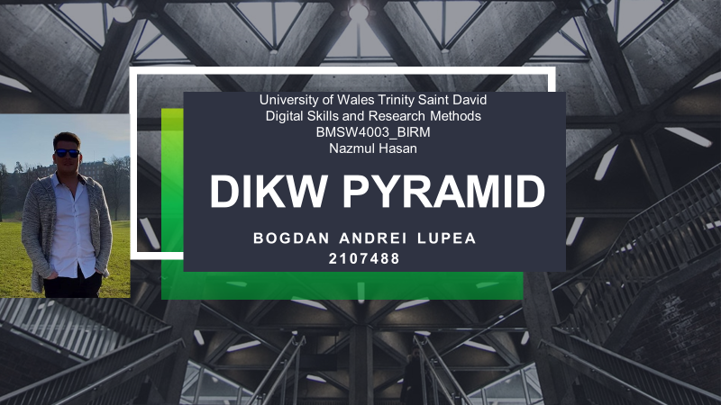
Abstract: Hello, my name is Bogdan Andrei Lupea and this paper describes the concept of DIKW Pyramid by Angela Duckworth. It also takes into consideration the results of GRIT Test and the way they influence the students. The Academic Levels are put into discussion as well as every student increased the responsibilities in the process of learning.
Key words: Data, Information, Knowledge, Wisdom, Grit Test.

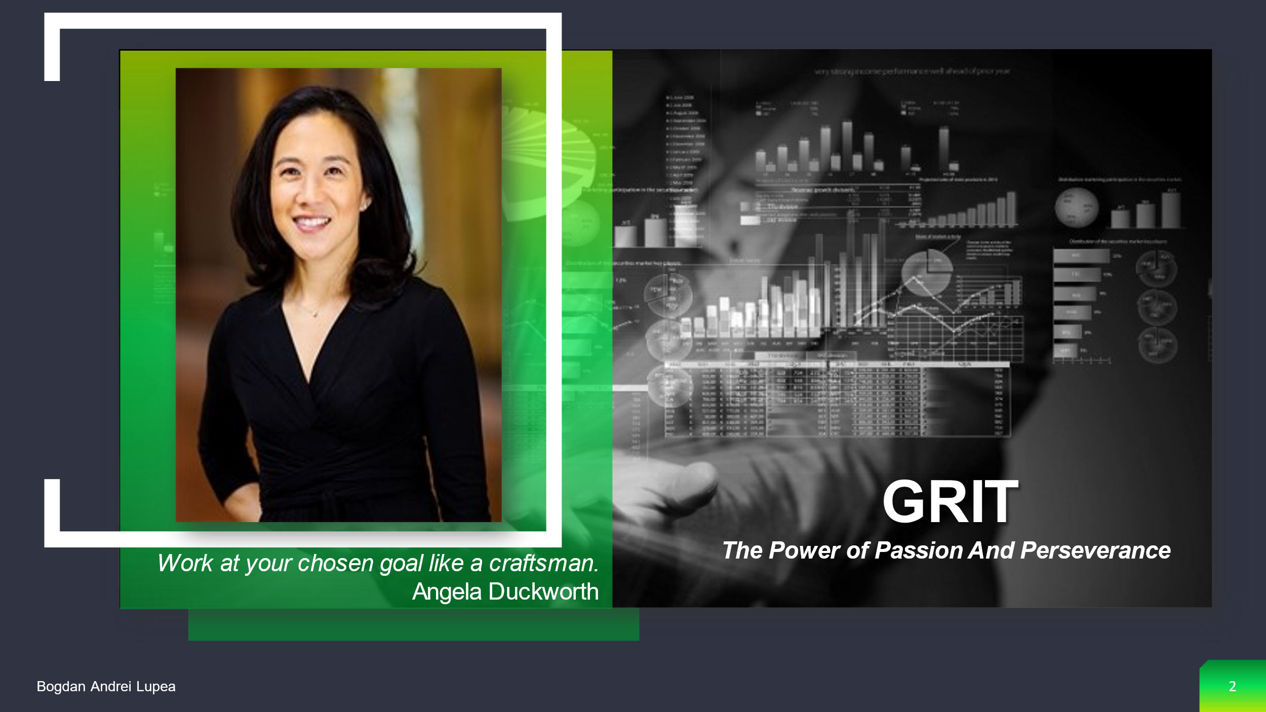

Angela Duckworth is the founder and CEO of Character Lab, a non-profit whose purpose is to explore scientific findings that aid children's development. She is also the Rosa Lee and Egbert Chang Professor of Business Administration at the University of Pennsylvania, as well as the faculty co-director of the Penn-Wharton Behaviour Change for Good Initiative and Wharton People Analytics.
Angela began her research career by founding a summer school for impoverished children, which was featured as a Harvard Kennedy School case study and celebrated its 25th anniversary in 2018. She has also worked as a management consultant for McKinsey and as a math and science teacher in New York City, San Francisco, and Philadelphia public schools. Angela earned magna cum laude at Harvard for her undergraduate degree in Advanced Studies Neurobiology. She earned an MSc in Neuroscience with Distinction from Oxford University with the help of a Marshall Scholarship. As a National Science Foundation Graduate Fellow at the University of Pennsylvania, she earned her PhD in Psychology.



Data is a collection of unorganised facts such as numbers or characters. Data, on the other hand, can be meaningless without context. For example, 12012012 is merely a series of numbers with no apparent significance. However, when viewed in the context of 'this is a date,' we can easily identify the 12th of January, 2012. The numbers now have more meaning because context and value have been added to them. We have transformed the raw sequence of numbers information in this manner. Data is represented as discrete facts about an objective reality in the form of signs and signals, such as numbers, words, or other signs. Data can be defined using objective metrics, allowing it to be checked and definitively proven right or erroneous. Data is a set of signs that indicate empirical stimulus or perception, and it is an orderly string of symbols that represents something. They are disorganised and devoid of interpretation, resulting in data that has no significance (Dwek, 2014).

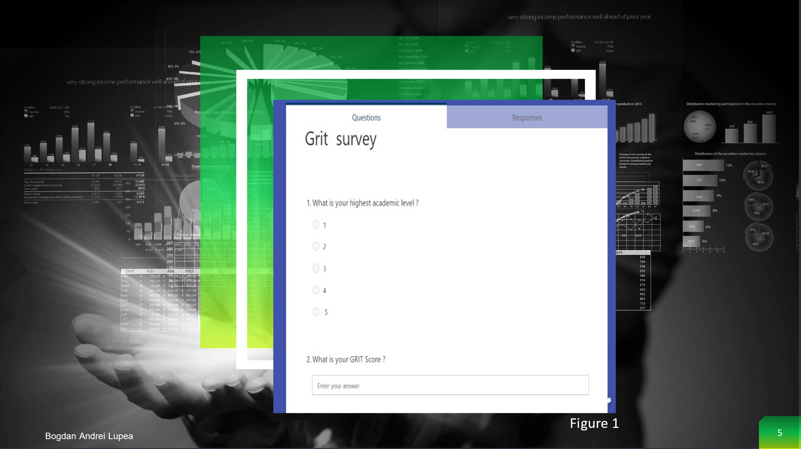

The first stage now is to gather data that will be turned into information. In my research, we created a survey using MS Forms and we shared it to a group of people. We collect the Primary Data from a group of people who responded to a survey that was exported from MF to Excel. I wanted to get two sets of quantitative data for this survey, which I could then export to Excel and turn into information, so I chose two easy questions (Figure 1).



The DIKW Pyramid's next building block is information. This is data that has been cleaned of errors and further processed so that it can be measured, visualised, and analysed for a specific purpose. Data processing can involve a variety of operations depending on the purpose, such as combining different sets of data (aggregation), ensuring that the collected data is relevant and accurate (validation), and so on. We can, for example, organise our data in such a way that it reveals relationships between seemingly disparate and disconnected data points. More particularly, we can analyse Dow Jones index performance by creating a graph of data points for a specific period of time, based on the data at the end of each day. By asking pertinent questions such as who, what, when, where, and so on, we can glean valuable information from the data and make it more useful to us. But it is the question of how that marks the transition from information to knowledge (Duckworth, 2013).



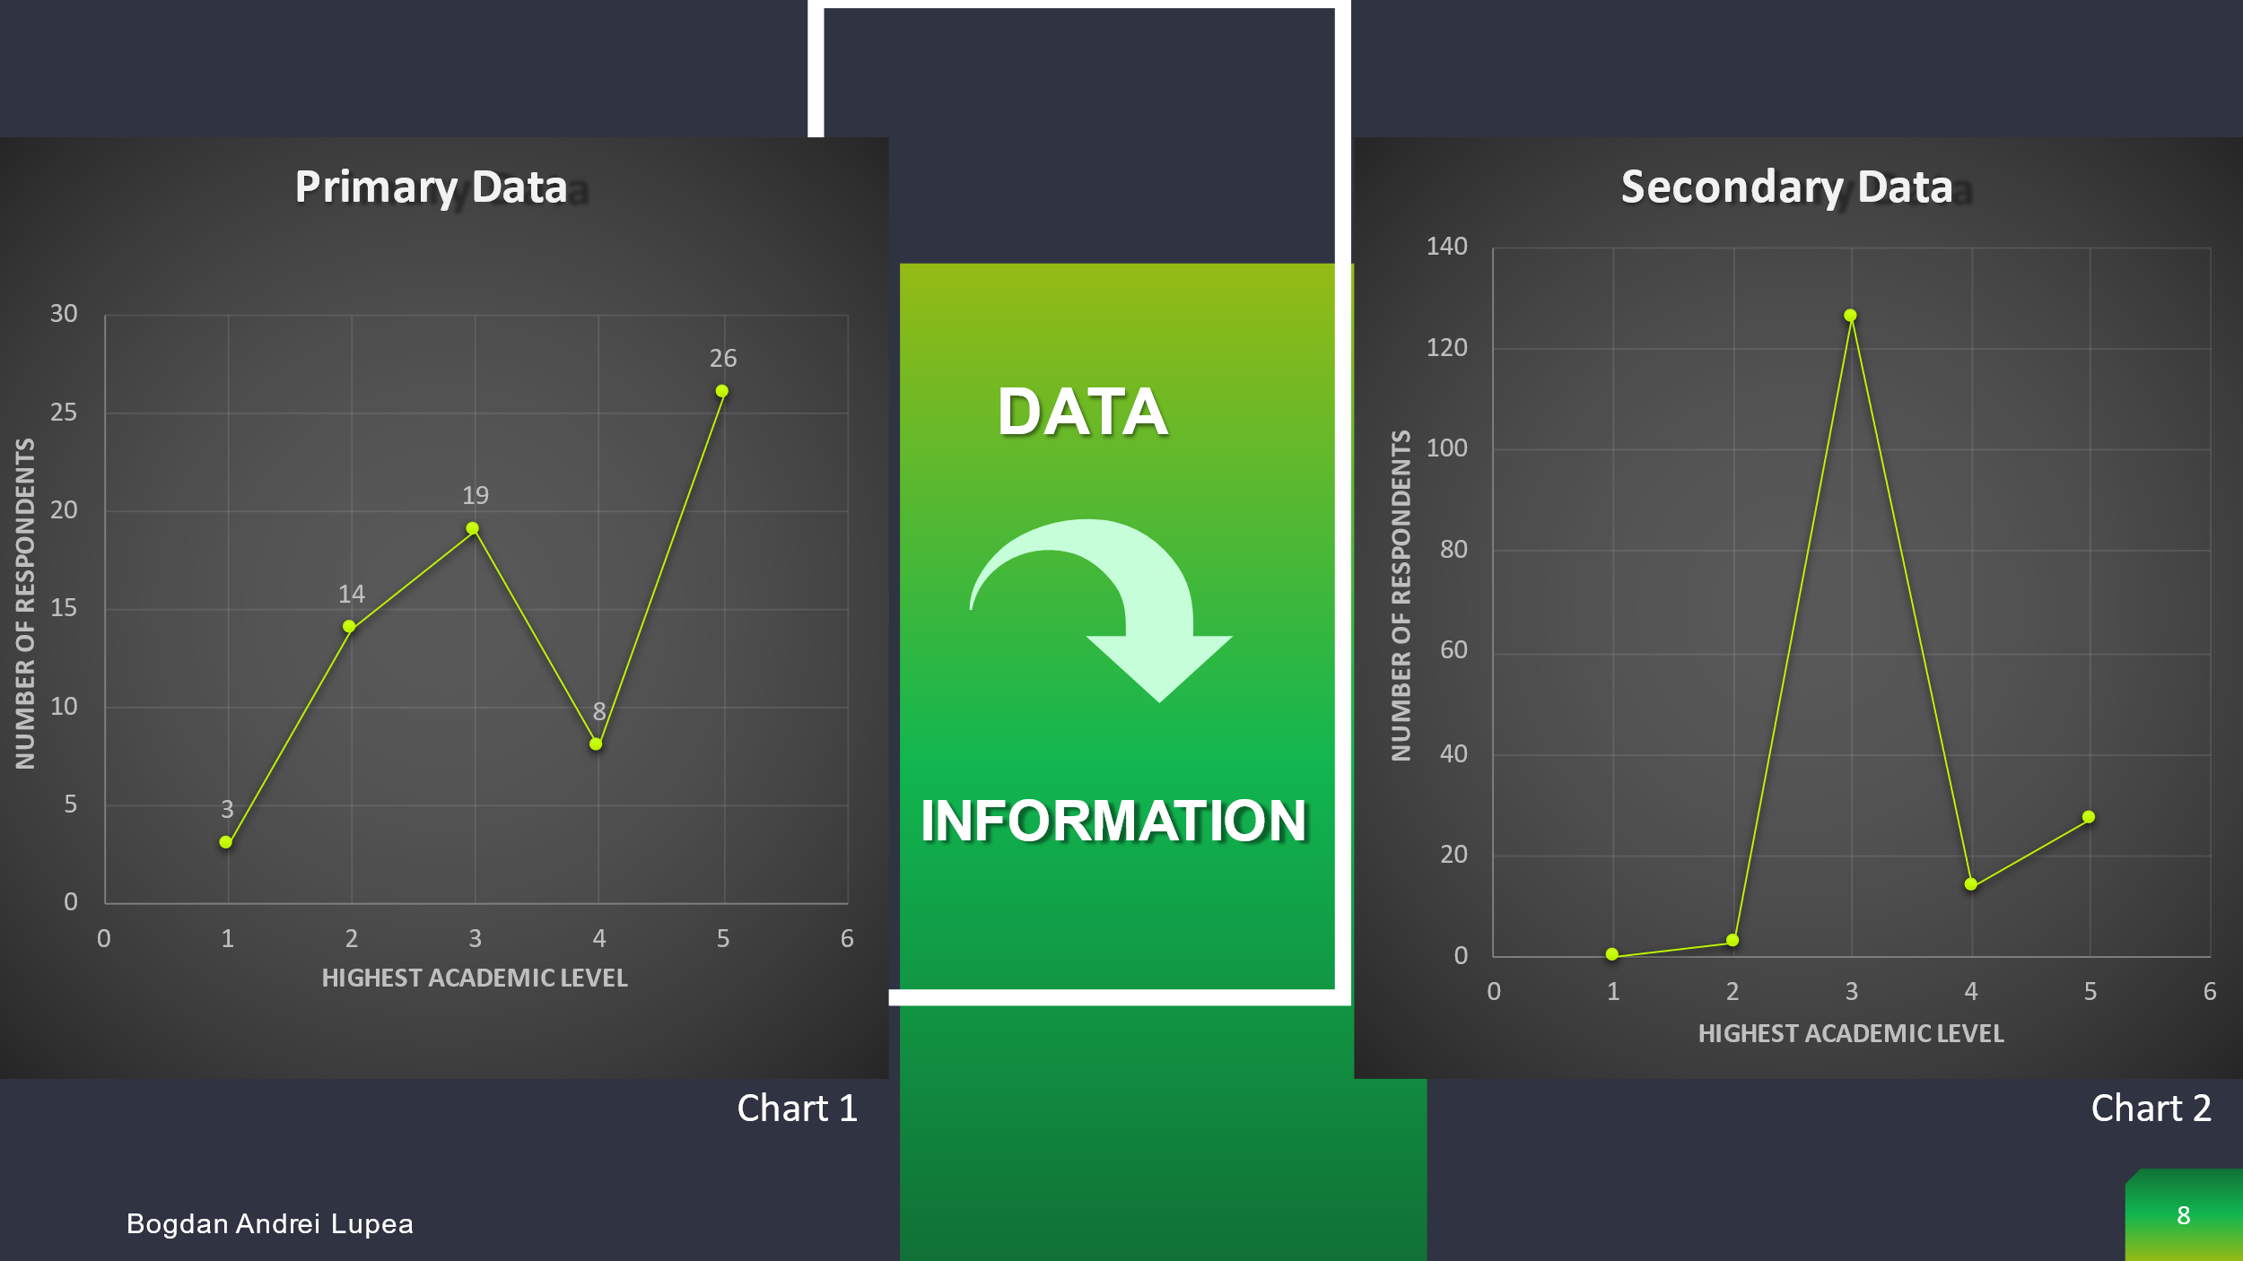

The Primary Data and Secondary Data must now be transformed into information. We must recognise that "statistics do not always speak for themselves," and we must work with the data to put it into a format that is easy to read and comprehend. Understanding the data is critical since a good analysis can help you make better decisions in the end. We can see in Chart 1 the highest amount of people who answered the questions have Level 5 and on the Chart 2 they have Level 3.

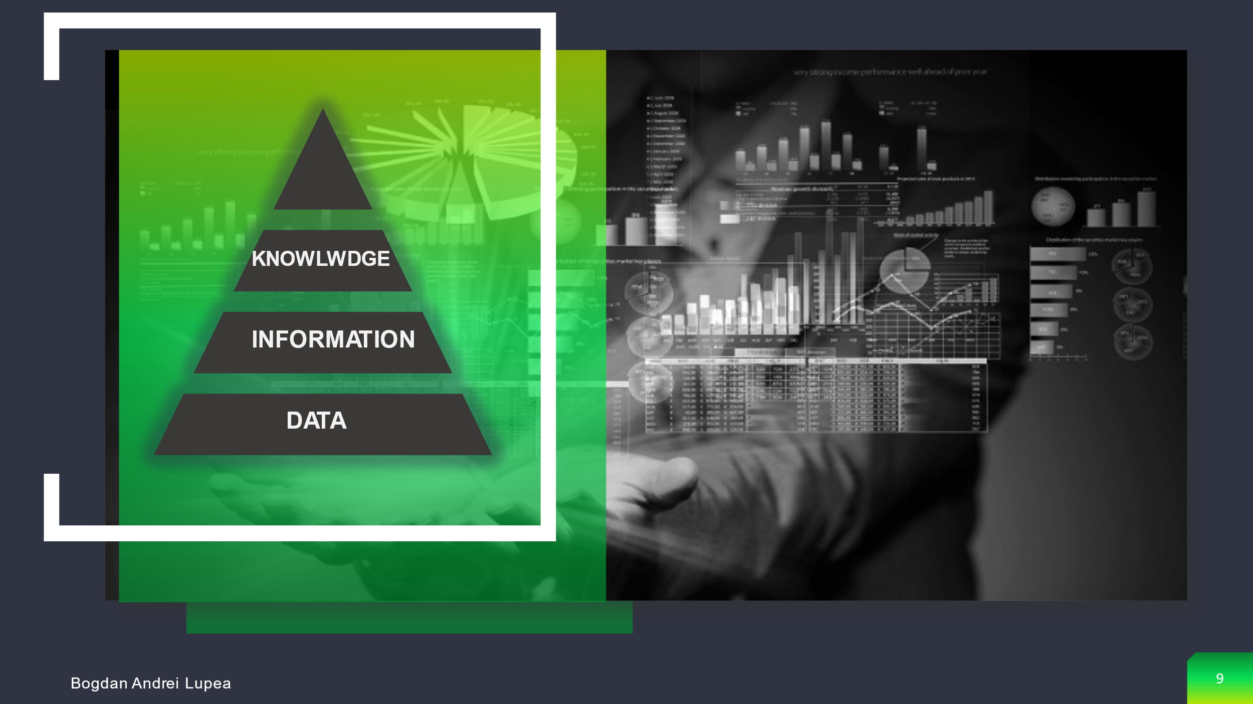

How does the information derived from the collected data relate to our objectives? "How" are the pieces of this information linked to one another to add meaning and value? And, perhaps most importantly, "how" can we use the information to accomplish our goal? When we see information as more than just a collection of facts, but also understand how to apply it to achieve our goals, we have transformed it into knowledge. This knowledge is frequently the competitive advantage that businesses have. We gain deeper insights as we uncover relationships that are not explicitly stated as information, propelling us higher up the DIKW pyramid. We can declare we've achieved the last – 'wisdom' – stage of the Knowledge Pyramid only when we apply the knowledge and insights gained from the information to make proactive decisions. Knowledge is the creation of conceptual frameworks, hypotheses, and axioms through the synthesis of different sources of knowledge across time. Through experiences, values, and understanding, knowledge provides context, allowing for judgement based on defensible belief. Knowledge is tacit; it has a subjective dimension; once rendered symbolic, knowledge is reduced to information; and once made objective, knowledge is reduced to information (A.L., 2007).
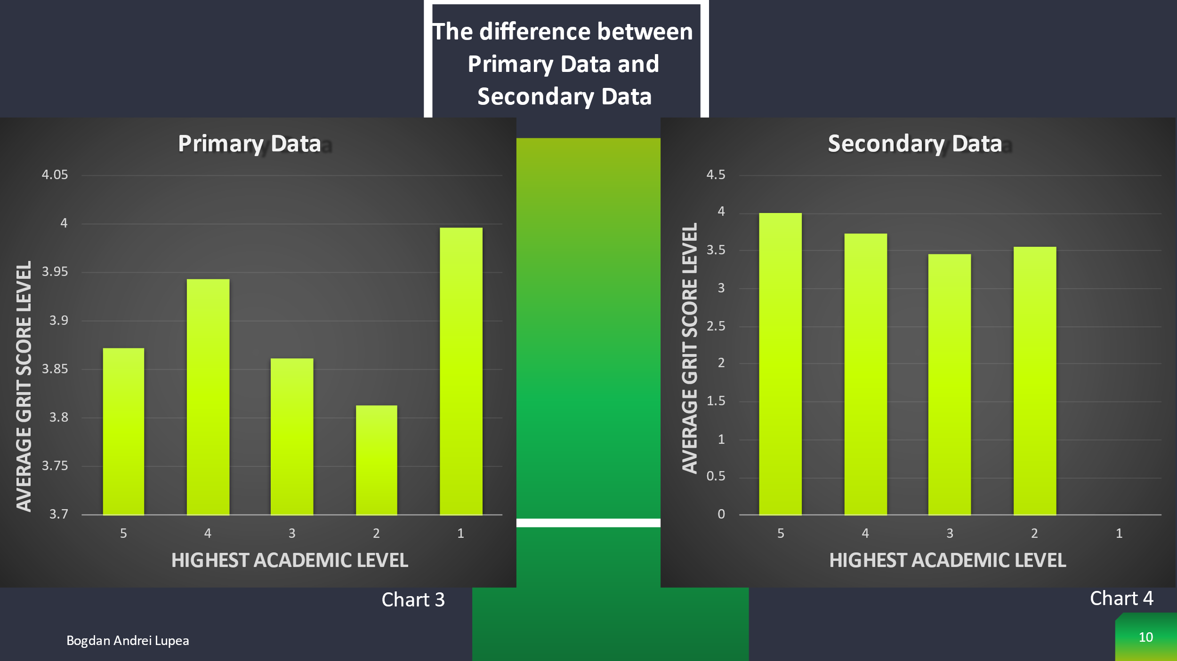

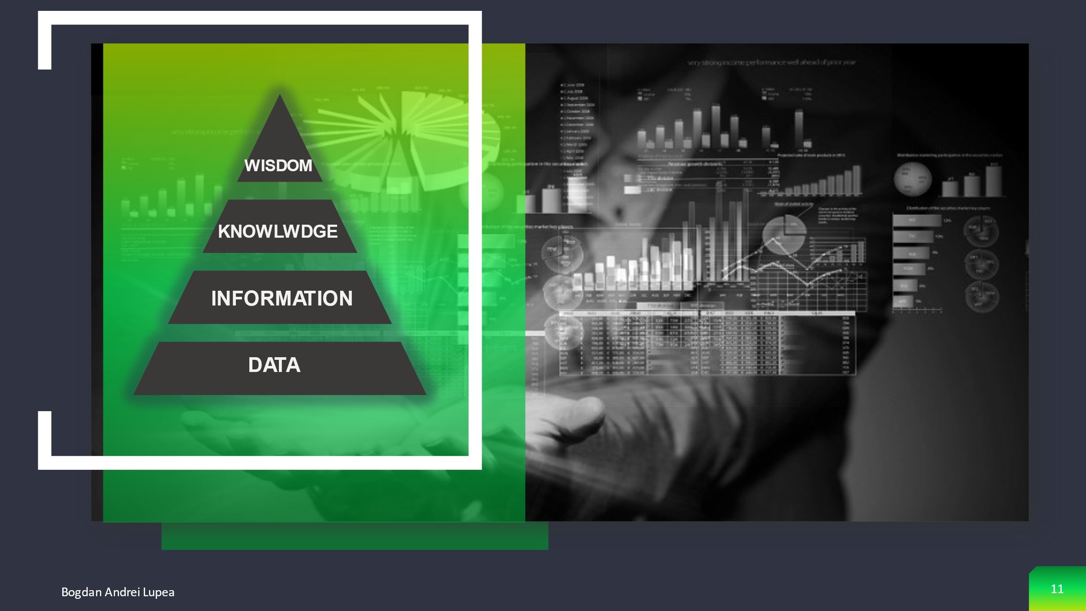
Wisdom is at the summit of the DIKW hierarchy, and we must answer questions like "why do something" and "what is best" to get there. Wisdom, in other terms, is knowledge put into practise. We might also say that, whereas data and information are related with what we do now and what we want to do in the future, knowledge and wisdom are associated with what we want to achieve in the future. Wisdom is the ultimate context and frame of reference; it is a state of awareness, a paradigm, or a collection of principles. Wisdom is the capacity to use information to make sound decisions in a given situation without relying on facts. Wisdom is knowing why something is the way it is, an assessed understanding, acceptance, and respect of why something is the way it is, and it is seeing the big picture. Knowing the appropriate things to do for the larger benefit is part of wisdom. It necessitates a feeling of right and wrong, ethical and unethical behaviour. It has a very human quality about it (Dweck, 2014).
The final step in the DIKW triangle is wisdom. Wisdom has less to do with frameworks and more to do with human instinct, acquisition, translation and actions. Wisdom can be used to put information and knowledge into context. This means that once we have the knowledge and the facts, we must think and contemplate in order to bring the wisdom to life.
Angela Duckworth, for example, conducted research on a variety of institutions, including West Point Military Academy, the National Spelling Bee, teachers, and private companies, and discovered that grit is a powerful indicator of achievement that outperforms social insight, actual well-being, and intelligence (Kuncel, 2004).
When I did my study, I discovered that grit is an indicator of performance. Whatever, after I analysed my survey I can say that Angela Duckworth's theory can not be applied in all the cases. As you can see in Chart 3, there was an amount of people with academic level 1 and all of them have higher rate on GRIT Test compared to people who have level 2 , level 3 , level 4 and level 5.
After I analysed Chart 3 which contents the Primary Data Information I can say that a higher level of education do not illustrate a higher Grit Test Score.

Bibliography
A.L., P. C. M. M. a. K. D., 2007. Grit: Perseverance and passion for long-term goals. Journal of Personality and Social Psychology.
Duckworth, A., 2013. Grit: The power of passion and perseverance.. [Online]
Available at: https://www.ted.com/talks/angela_lee_duckworth_grit_the_power_of_passion_and_perseverance?language=en
[Accessed 19 11 2021].
Dwek, C., 2014. [Online]
Available at: https://www.ted.com/talks/carol_dweck_the_power_of_believing_that_you_can_improve?language=en
[Accessed 9 11 2021].
Kuncel, N. R. S. A. &. O. D. S., 2004. Academic performance, career potential, creativity, and job performance: Can one construct predict them all? Journal of Personality and Social Psychology.



