Database Analysis and Design
Author: Robert Cook (2015030)

L4 – Introduction to Web and Database Concepts (ACCA4023)
School of Applied Computing
Wales Institute of Science and Art
Date and Time of submission:
1:30PM – 03/05/2021

Contents
Introduction 3
Context Level Diagram 4
Level 0 Diagram 5
Level 1 Diagram 6
Entity relationship diagram 7
Evidence of suitable tables created 8
Evidence of suitable fields created. 8
Evidence of Conditional formatting 9
Evidence of suitable foreign key. 10
Verify the design meets user requirements. 11
Evidence of use of Macros 12
Table design meets the rules of third normal form (3NF) 12
Produce calculation in a report. 13
Produce Master and Embedded forms 14
Menus are displayed immediately after the database opens. 15
Brief User guide 16

Introduction
This Document is going to give a brief outline of my access database solution, for Celtic Caterers and will provide evidence of different techniques, that I have used within the database.
It will also outline some data flow diagrams that helped me get a understanding for what processes happen within the system, to develop a database for it.

Context Level Diagram

This is my context Level Diagram which is the front layer of the processes of Celtic caterers. The further Diagrams break it down abit further in level 0 and level 1.
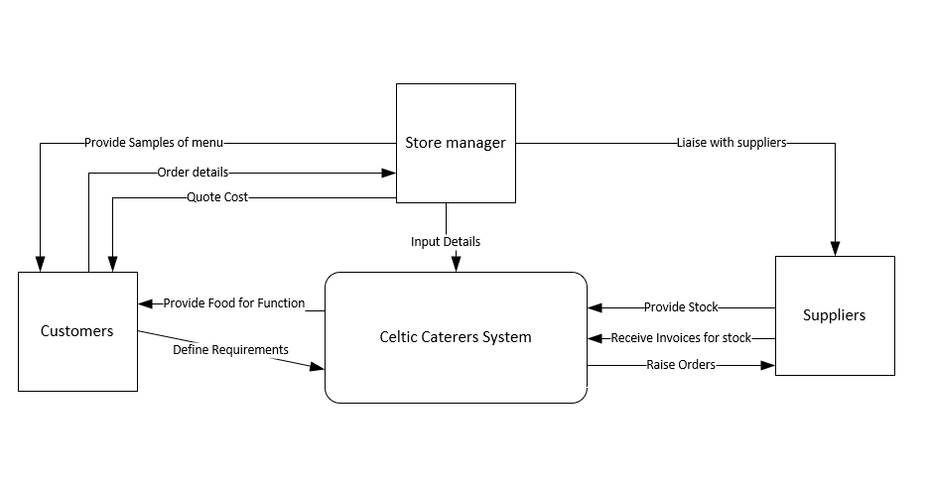

Level 0 Diagram
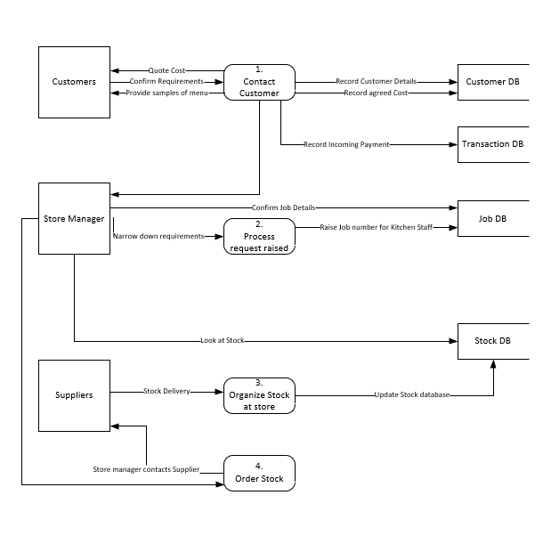

Level 1 Diagram
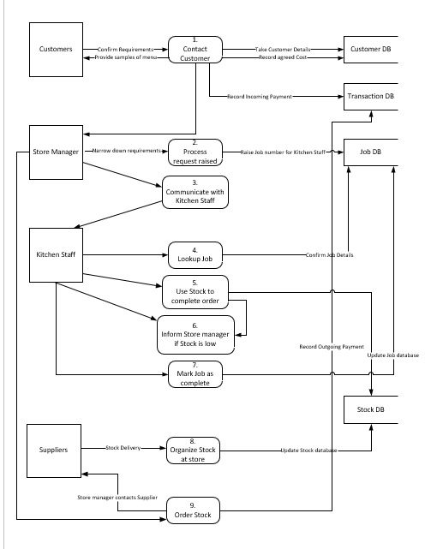

Entity relationship diagram

This Diagram shows how all the tables in my database link together.

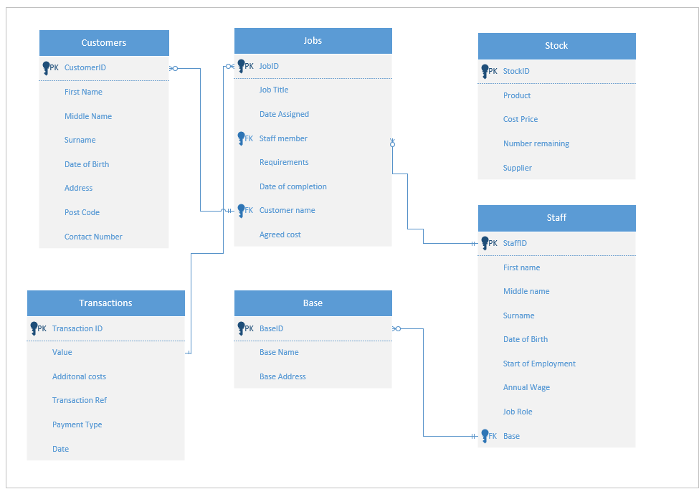

Evidence of suitable tables created

These are the tables I created which I felt were suitable for my database solution.

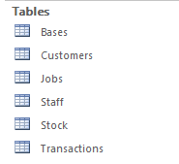
Each one is filled out with sample data.

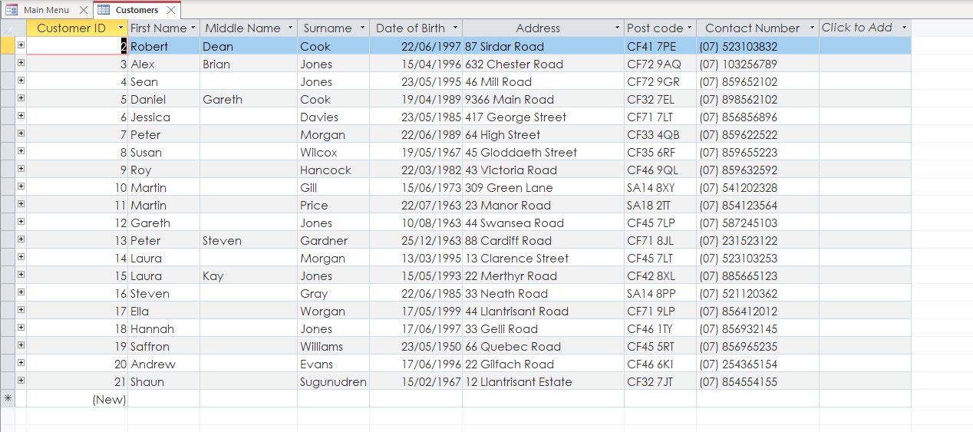

Evidence of suitable fields created.

As you can see the fields created were also suitable in my above table.

Evidence of Conditional formatting

On my transactions form – there is a conditional formatting rule – that if the transaction type says “IN” it fills green.
If the type says “OUT” then it fills with RED

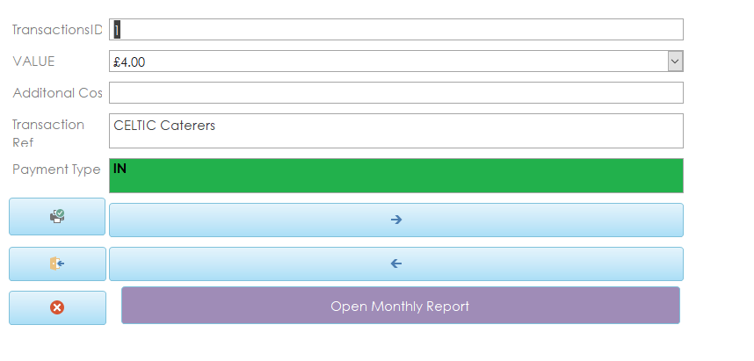
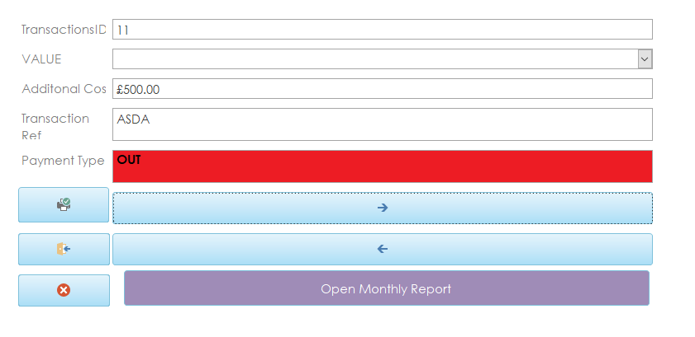

Evidence of suitable foreign key.

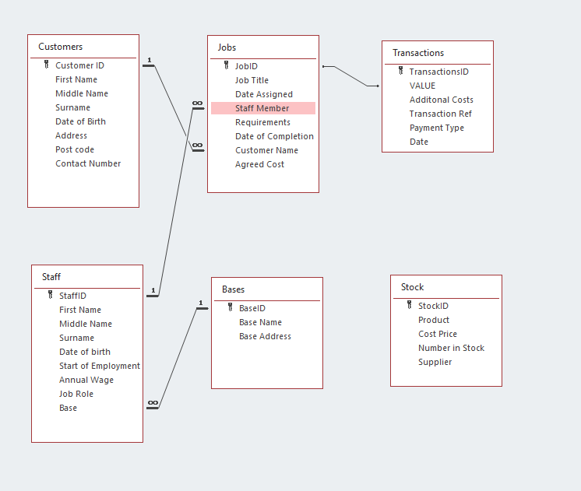

This diagram also shows that sensible relationships have been setup between the tables.

Verify the design meets user requirements.



I feel from the brief, my database meets the requirements of the end user.

- The user would like a system that will provide them with a designed invoice that they can view on screen or send to print. (Click View monthly invoice)
- When purchases are made from the supplier they would like to see a record of transactions recorded. (Click View transactions)
- When a catering event has been booked they would like to be able to query information about it. (Query Upcoming events)

Evidence of use of Macros

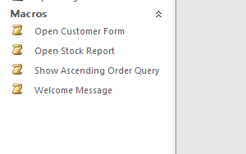

I created some macros within my Database, some of these allow you to open, Forms, reports and queries directly. I also tested a welcome message macro.

Table design meets the rules of third normal form (3NF)

I believe my tables meet the rules of 3NF

Produce calculation in a report.

In my stock report there is a calculation that works out the total value of the stock

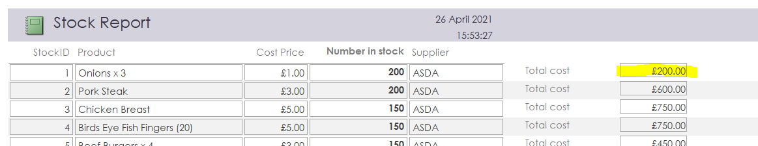

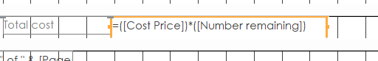

Produce Master and Embedded forms

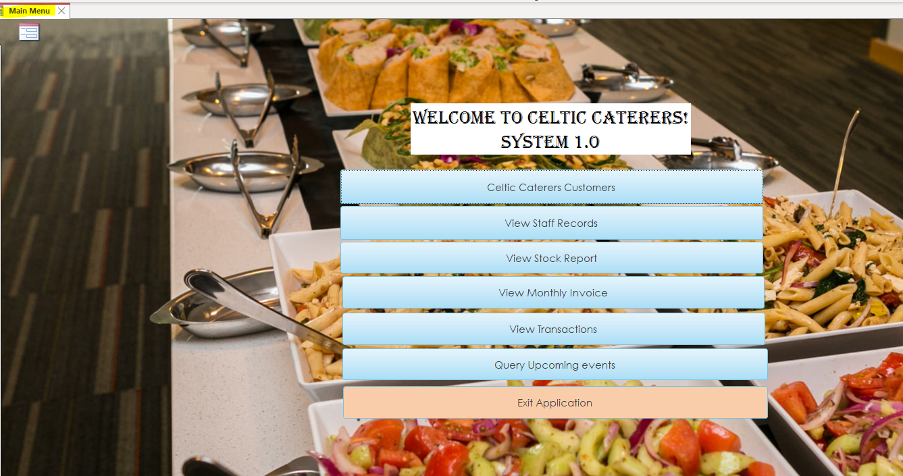
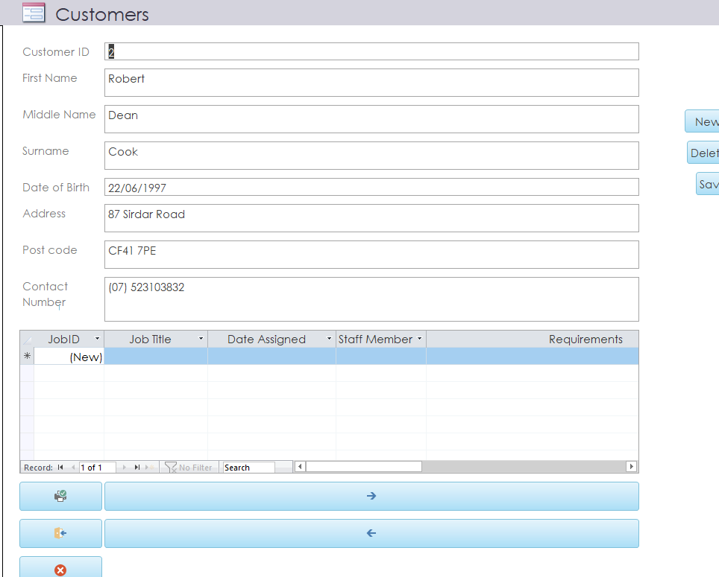

This is my master form which allows navigation to other areas in my database.

Menus are displayed immediately after the database opens.

The screenshot above is displayed as soon as the database is opened.

I have also left this section open to allow visibility of other work / queries within my database.

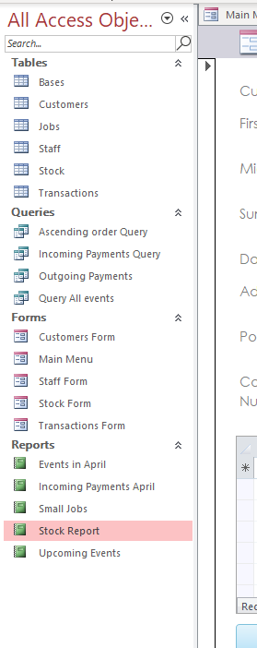

Brief User guide

When opening the access database – you will initially land on the main menu page

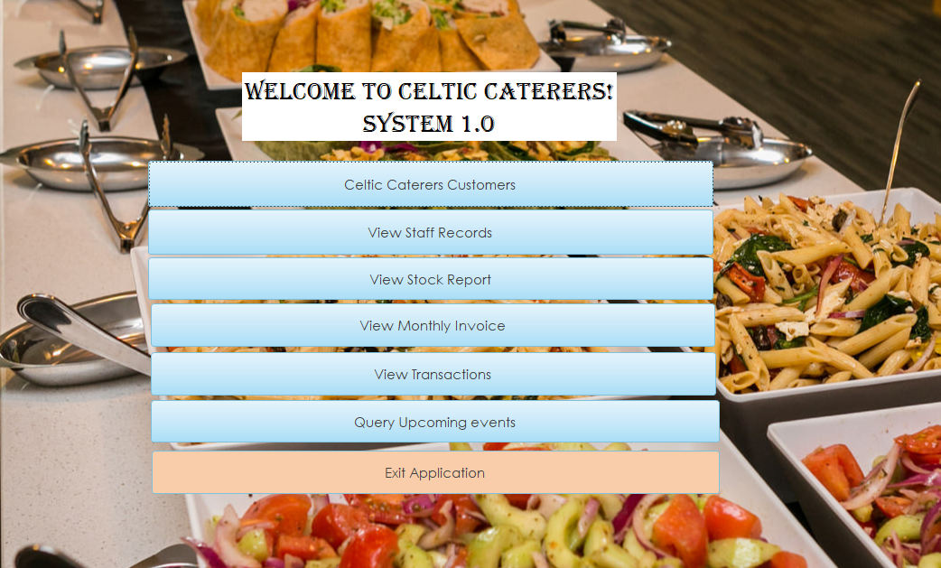

You are then presented with buttons that will take you to a section of my database.

For example : Celtic caterers’ customers option - allows you to view the customer records and add / edit any if needed.

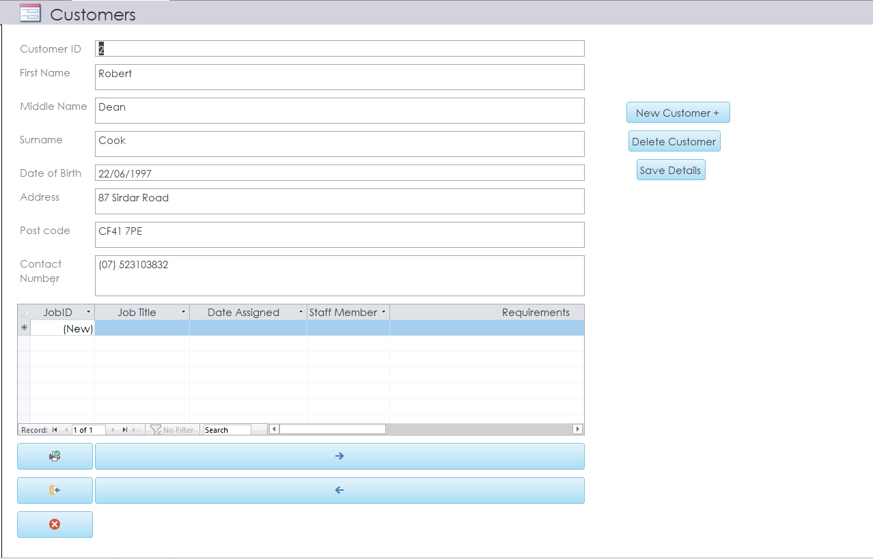

From this page you can – navigate to the next record , print and exit out to the main menu or close the application.

All options in the main menu should have navigation added which should easily allow you to explore the database and edit if needed.

If not – the page can be exited from the top left corner.



