Evaluating the use of GIS software as a modeling tool for environmental analysis.
-Microplastic contamination

Jake Davies - P151889
GIS & Data analysis

Table of Contents
Table of figures: 2
1.0 Introduction 4
1.1 Location 5
1.2 Geographical Information Systems in environmental analysis 5
1.3 Mapinfo Professional 5
2.0 Building a GIS model 6
3.0 Use of GIS within the environmental field 21
3.1 Benefits of GIS systems 21
3.1.1 Presentation of data 21
3.1.2 Analysis of data 22
3.1.3 Efficiency and record keeping 22
4.0 Conclusion 22
5.0 Literature cited 23

Table of figures:
Figure 1: Inserting 25k raster image (Edina Digimap, 2018). 6
Figure 2: Coordinate type choice to allow for plotting geographical data. 6
Figure 3: imported 25k raster image of study area. 7
Figure 4: Importing Welsh open river data (UK data service, 2018). 7
Figure 5: Location map with welsh rivers overlaid. 8
Figure 6: Style override for rivers. 8
Figure 7: Welsh river network defined via style override. 9
Figure 8: Process of selecting the river Loughor from the Welsh river network. 9
Figure 9: Saving the selected river course to add to the original workspace. 10
Figure 10: Selection saving process as Mapinfo.tab file. 10
Figure 11: The new layer "River Loughor" was added to the raster map. 11
Figure 12: Platted Loughor river within the workspace. 11
Figure 13: Style was overridden to clearly define the rivers course. 12
Figure 14: Imported excel spreadsheet containing GPS and environmental data. 12
Figure 15: Creating points from GPS longitude and latitude within the excel table. 13
Figure 16: GPS points (sample sites) represented by black stars along the course of the Loughor river. 13
Figure 17: Style override of GPS points to make them mover visible. 14
Figure 18: Style override selection. 14
Figure 19: Site locations along the course of the river Loughor. 15
Figure 20: Location of waste water discharge pipe. 15
Figure 21: Step one creating pie charts for microplastic data. 16
Figure 22: Fields are added from the selected table to make up the charts. 16
Figure 23: Style check and rename the charts. 17
Figure 24: Overview of all sites maps across the course of the Loughor. 17
Figure 25: View of site 3 and 4 microplastic composition charts. 18
Figure 26: SQL select for more than 16 fibres. 18
Figure 27: the 3 sites with more than 16 fibres present, portrayed by yellow circles. 19
Figure 28: Demonstration of information tool on Mapinfo. 20
Figure 29: Microplastic composition at site 5. 21

Introduction
Geographical information systems (GIS) have developed into vial assets for use within the environmental community. The use of GIS within the environmental sector is broad, encompassing and presenting physical, biological and environmental data (Gharehbaghi & Scott-Young, 2018). There will be two elements to this report:
- An understanding of GIS software will be demonstrated, by creating a data model for microplastic pollution across the course of the river Loughor, Carmarthenshire.
- Portray the key benefits of using a model built within a GIS software package compared to more traditional methods of data analysis and presentation.
The environmental problem explored within this report will be; abundance, distribution and drivers of microplastic pollution within the river Loughor, Carmarthenshire. In recent decades plastic has been expressed as an unpreventable form of environmental pollution, from this research into microplastic particles evolved. Microplastic pollution was first reported within marine environments, with research into its contamination within terrestrial and riverine environments only recently being presented. Plastic is regarded as a vital resource throughout the world, this is due to its durability and effortlessness of manipulation. Its due to that durability and ability to avoid physical, chemical or biological breakdown that plastics can reside within the environment for potentially hundreds to thousands of years (Barnes, et al., 2009) (Cole, et al., 2011) (Davies, Abundance, distrobution and drivers of microplastic pollution within the river Loughor, Carmarhenshire., 2019).

Location
The river Loughor is located in South Wales, defining the border between Carmarthenshire and Swansea. The river flows southerly from source at Llygad Llwchwr (Eye of the Loughor) within the Brecon beacons, to where it forms the Loughor estuary flowing into the Burry inlet just east of Llanelli. The catchment of the river Loughor is 262km² with varied land use, from rural/ agricultural communities, to urban and industrial areas.

Geographical Information Systems in environmental analysis
The general census is that GIS is underutilised within environmental analysis, primarily used for displaying data and the creation of ‘pretty maps’ (Larsen, 1999). The use of GIS within the environmental sector will allow any environmental organisation to (ESRI, 2005):
- Ensure accurate reporting and improved data collection.
- Improve decision making.
- Increased productivity.
- Improved data analysis and presentation.
- Model environmental phenomena.
- Create predictive scenarios for impact studies.
- Automate regulatory compliance processes.
GIS programs poses the above qualities, areas of the environmental management sector have become reliant on GIS systems. GIS can be used to understand the important process and procedures within environmental management and analysis. It plays a sizeable role in areas such as: (GrindGIS, 2018)
- Environmental Impact Assessments (EIA).
- Disaster management.
- Land zoning.
- Soil and wetland mapping.
- Flood and irrigation mapping.
- Natural resource mapping.

Mapinfo Professional
The GIS package used within this report was Mapinfo Professional, this software is an ideal beginner software due to its ease of use. ‘The software allows any user to visualise, analyse, edit, interpret, understand and output data to reveal relationships, patterns, and trends. MapInfo Pro allows users to explore spatial data within a dataset, symbolize features, and create maps’ (Pitney Bowes, 2016).

Building a GIS model

To create the geographical information system to portray the environmental data, ordnance survey maps of the area were downloaded from Edina Digimap, a 25k raster map was used for the background area. Firstly, the background raster image of the area needs to be imported, while importing the image the coordinate type needs to be selected to allow accurate plotting of geographical data, this is displayed in figure 2.
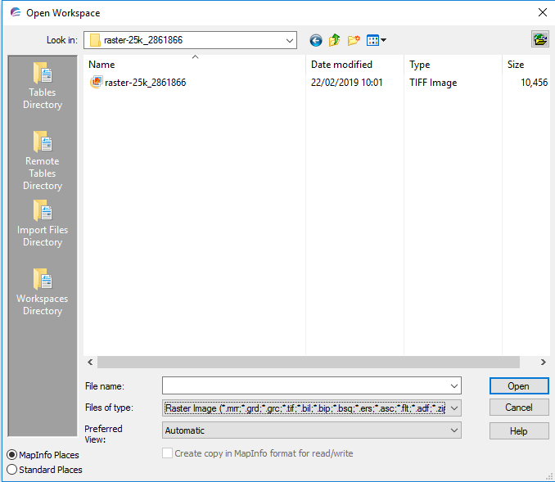
Figure 1: Inserting 25k raster image (Edina Digimap, 2018).
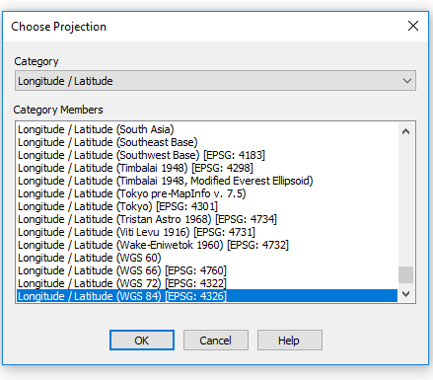
Figure 2: Coordinate type choice to allow for plotting geographical data.
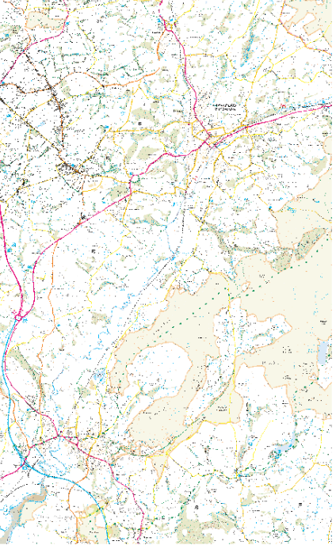
Figure 3: imported 25k raster image of study area.
Figure 3 portrays the imported raster image of the study area. In this image, it is difficult to define the course of the river therefore welsh open river data was downloaded from the UK data service to define the river course. It was then added and overlaid the current raster map, displayed in figures 4,5.
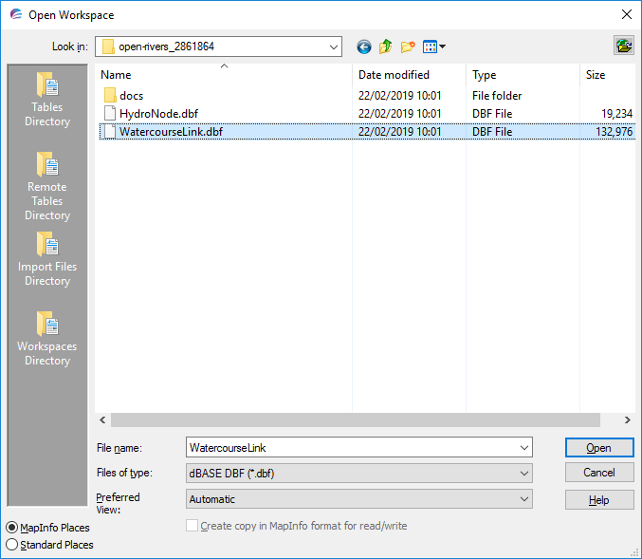
Figure 4: Importing Welsh open river data (UK data service, 2018).

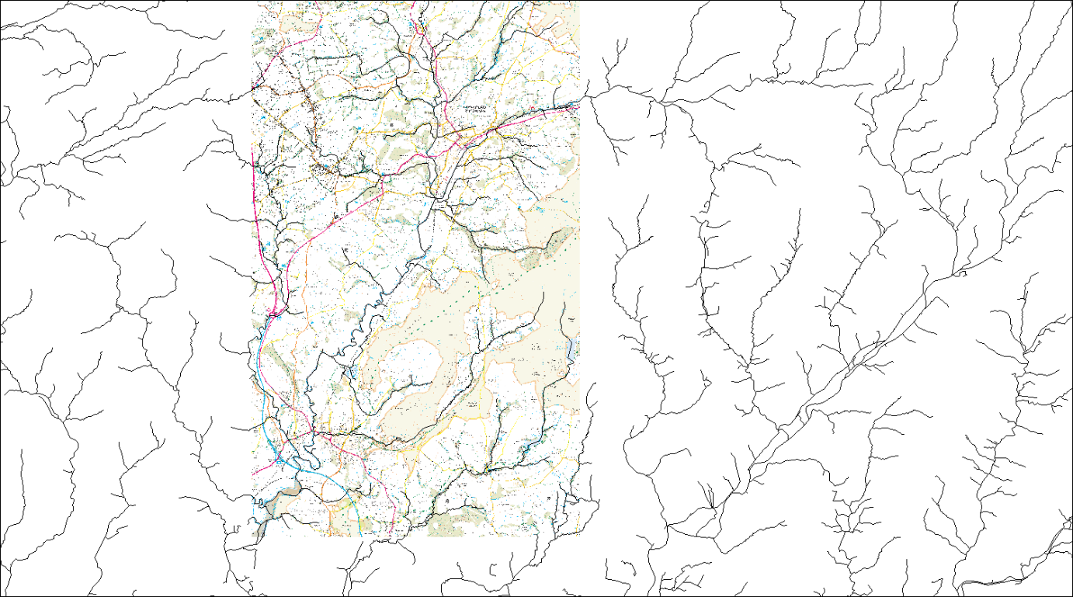
Figure 5: Location map with welsh rivers overlaid.

As can be seen in figure 5, the overlaid rivers cover the whole workspace not just the study area. To more easily define the Loughor river the line style of the rivers was changed via the style override feature (Figure 6).
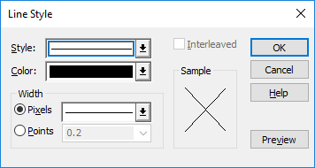
Figure 6: Style override for rivers.

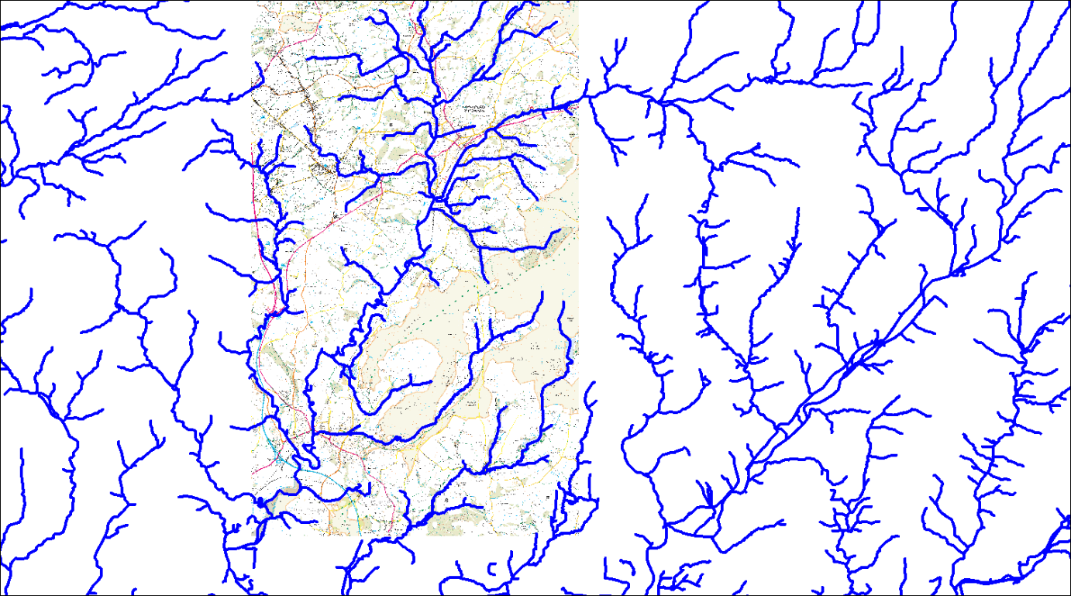
Figure 7: Welsh river network defined via style override.

To further define the river Loughor the rivers within the study map had to be removed. This was done by following the course of the Loughor upstream, highlighting it in order to create a new layer of just the course of the Loughor. The process can be seen in figures 8 – 13.
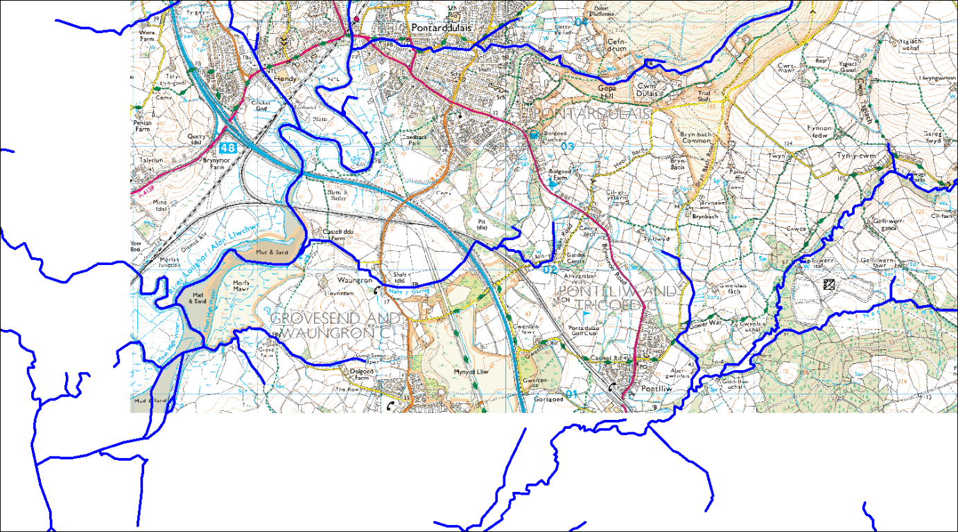
Figure 8: Process of selecting the river Loughor from the Welsh river network.

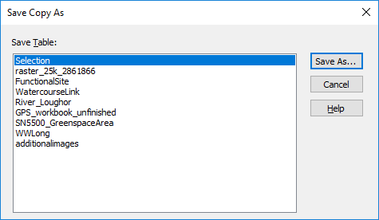
Figure 9: Saving the selected river course to add to the original workspace.
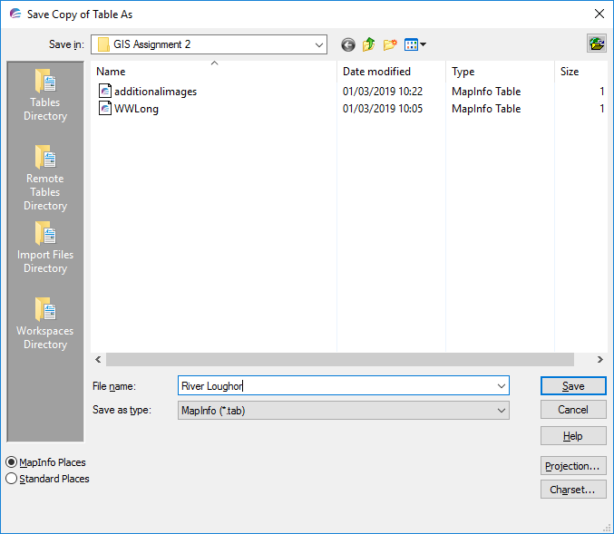
Figure 10: Selection saving process as Mapinfo.tab file.
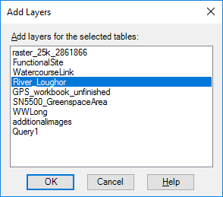
Figure 11: The new layer "River Loughor" was added to the raster map.

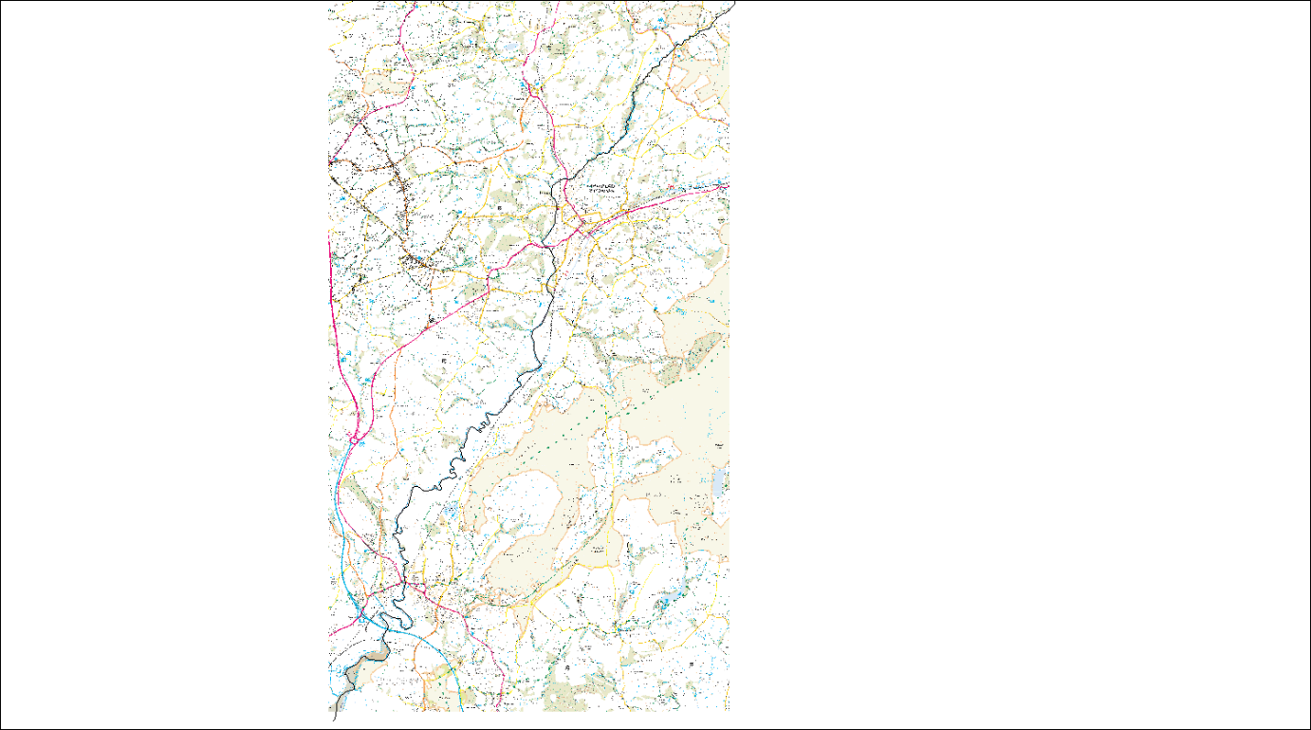
Figure 12: Platted Loughor river within the workspace.
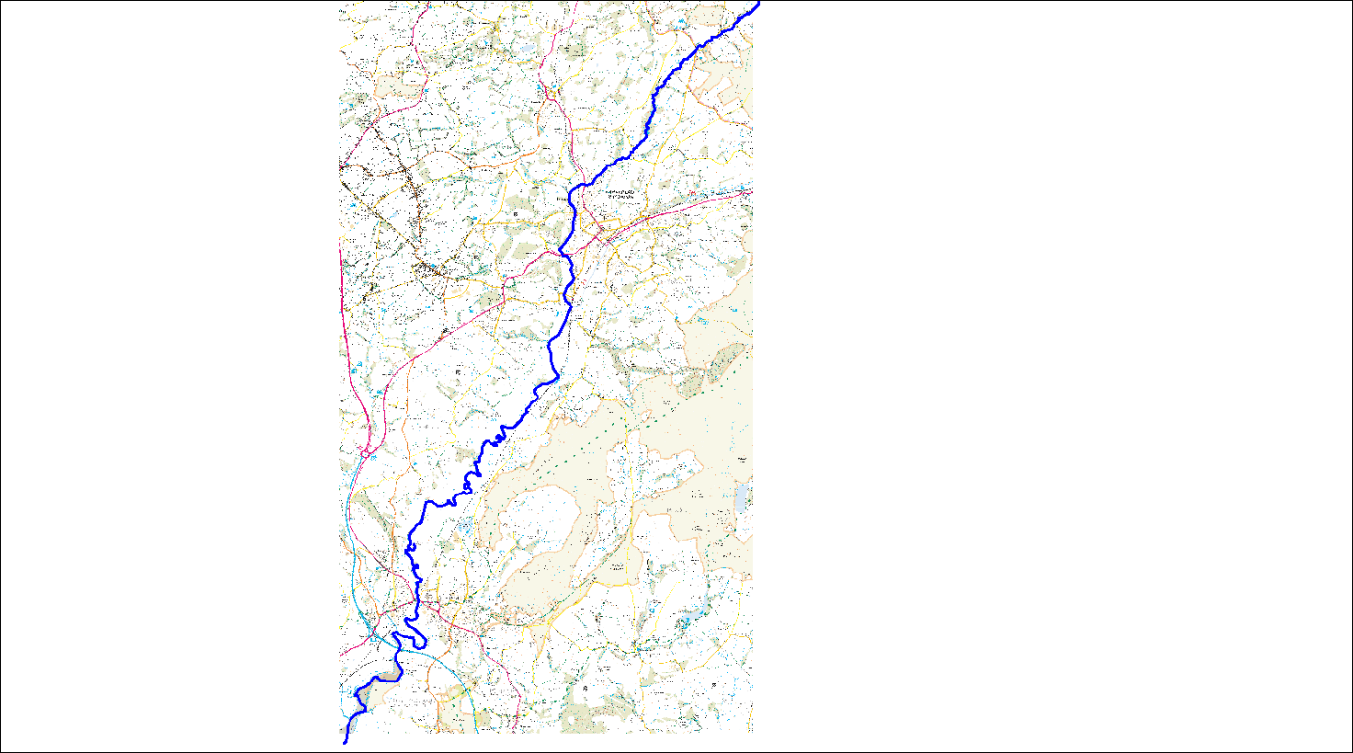
Figure 13: Style was overridden to clearly define the rivers course.

The defined river allows easy visual representation of the whole study area, with this geographical data can be plotted. GPS points were taken at 6 sites across the course of the River Loughor, these were plotted on the map using the British coordinate system. The GPS data was downloaded from the GPS onto Microsoft excel, the excel spreadsheet was the opened into Mapinfo to allow the points to be plotted. The excel spreadsheet also contained the environmental data collected from the study, this includes land use and quantitative data of microplastic type at each site.
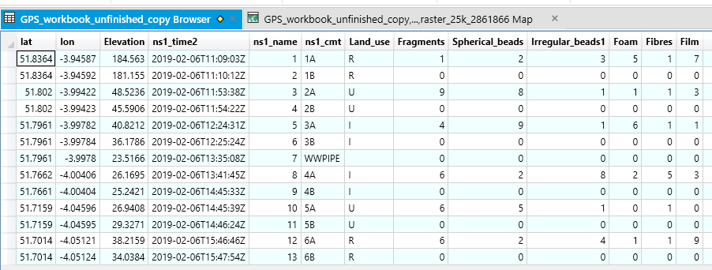
Figure 14: Imported excel spreadsheet containing GPS and environmental data.

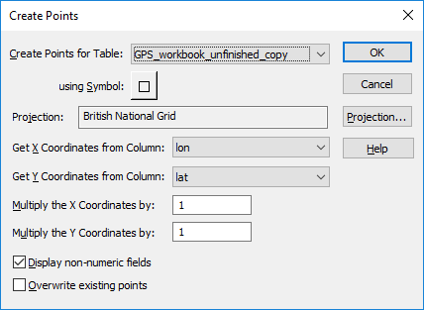
Figure 15: Creating points from GPS longitude and latitude within the excel table.
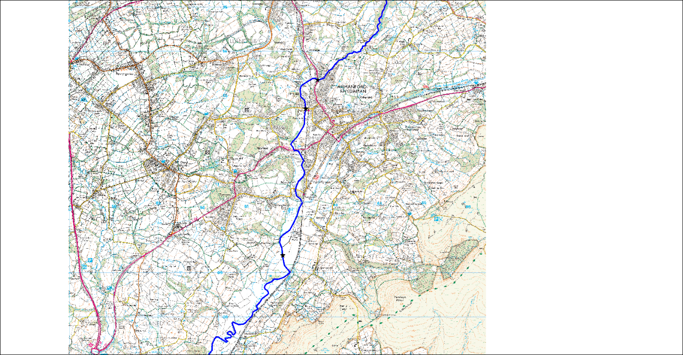

Figure 16: GPS points (sample sites) represented by black stars along the course of the Loughor river.
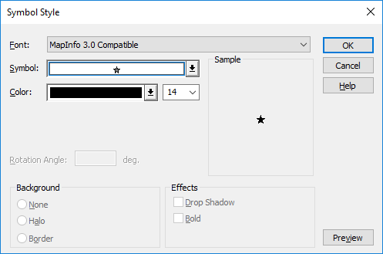
Figure 17: Style override of GPS points to make them mover visible.

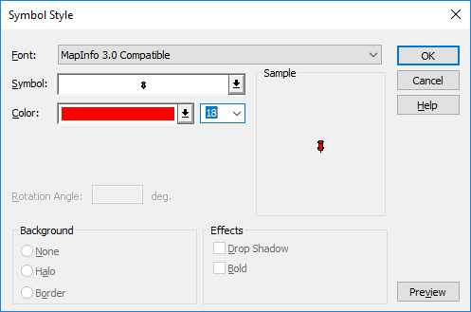
Figure 18: Style override selection.
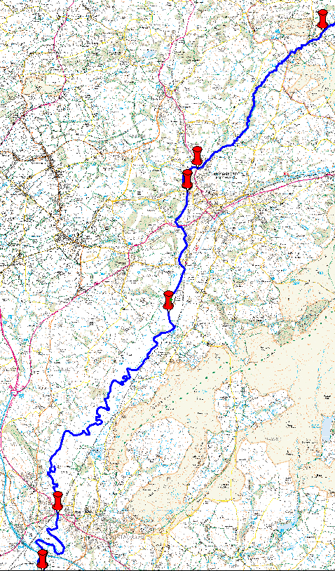
Figure 19: Site locations along the course of the river Loughor.

A second point type was created along the course of the river Loughor for the presence of a waste water discharge pipe. This location is represented as a green triangle.
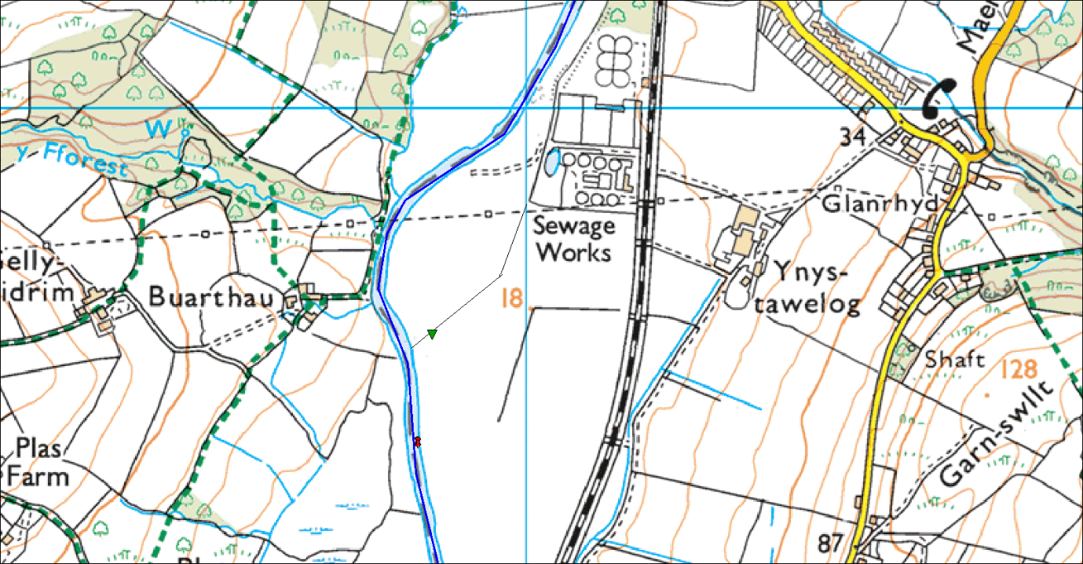
Figure 20: Location of waste water discharge pipe.
To display the recorded environmental data pie charts were created at each study site. Microplastic was split into 6 categories when found these are, fragment, film, fibre, foam, irregular beads, spherical beads. Creation of pie charts will lead to good visual representation of percentage of each fond at each site. Creating pie charts on Mapinfo is under the thematic mapping heading, the process is displayed between figures 21 - 25.
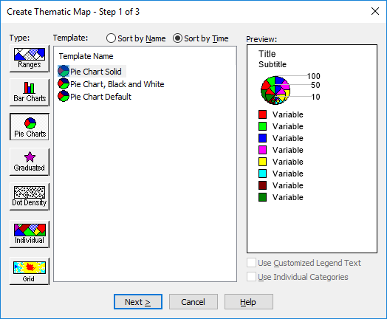
Figure 21: Step one creating pie charts for microplastic data.
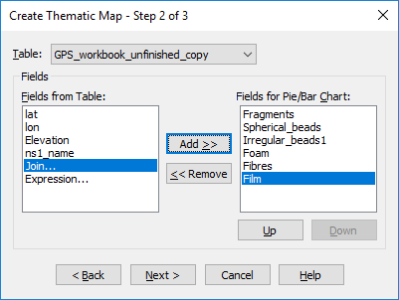
Figure 22: Fields are added from the selected table to make up the charts.
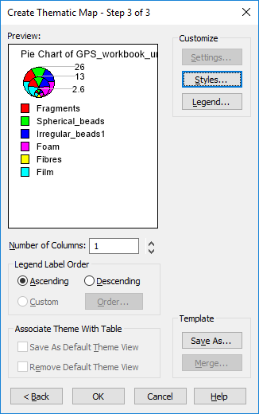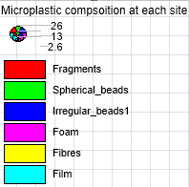
Figure 23: Style check and rename the charts.

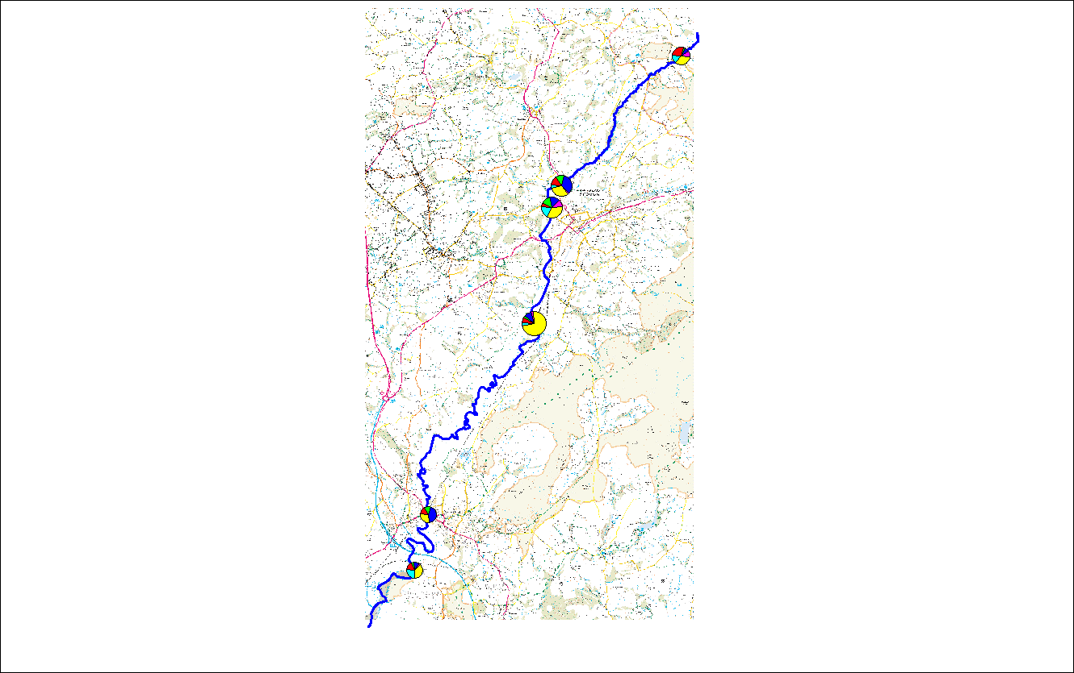
Figure 24: Overview of all sites maps across the course of the Loughor.
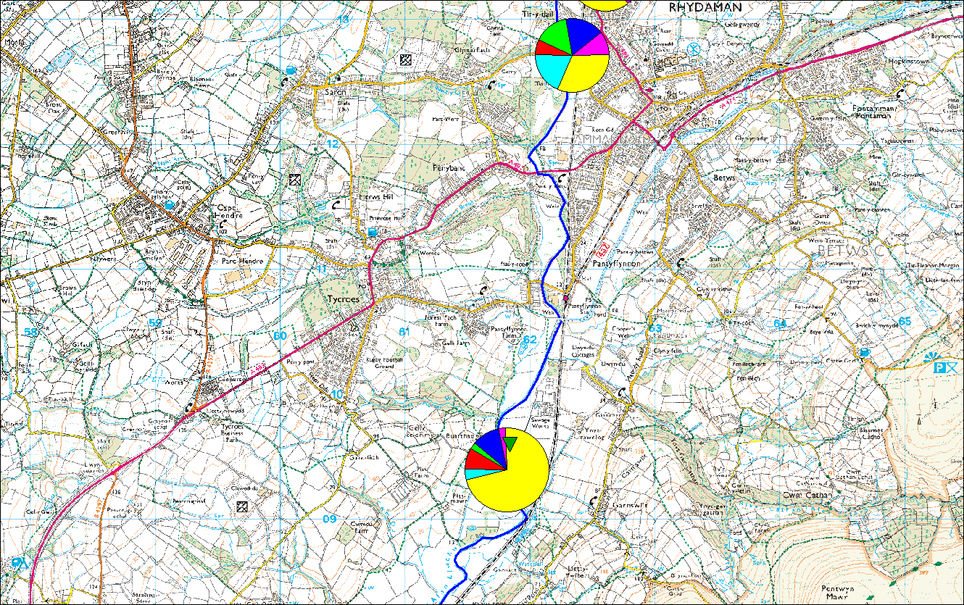
Figure 25: View of site 3 and 4 microplastic composition charts.

The GIS software can be used to query the environmental data imputed, this is achieved via the SQL (Structured Query Language) selector. Any table can be queried with any condition appropriate. an example is portrayed bellow of sites with more than 16 fibres present;
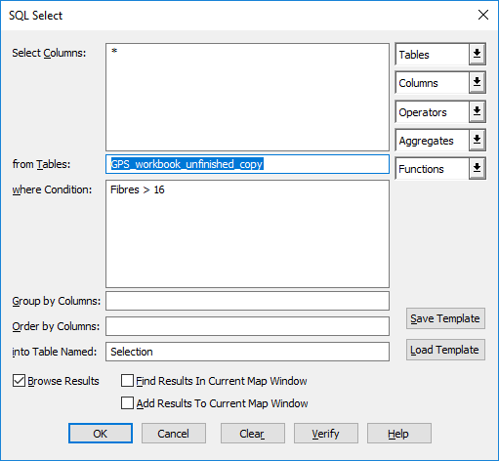
Figure 26: SQL select for more than 16 fibres.
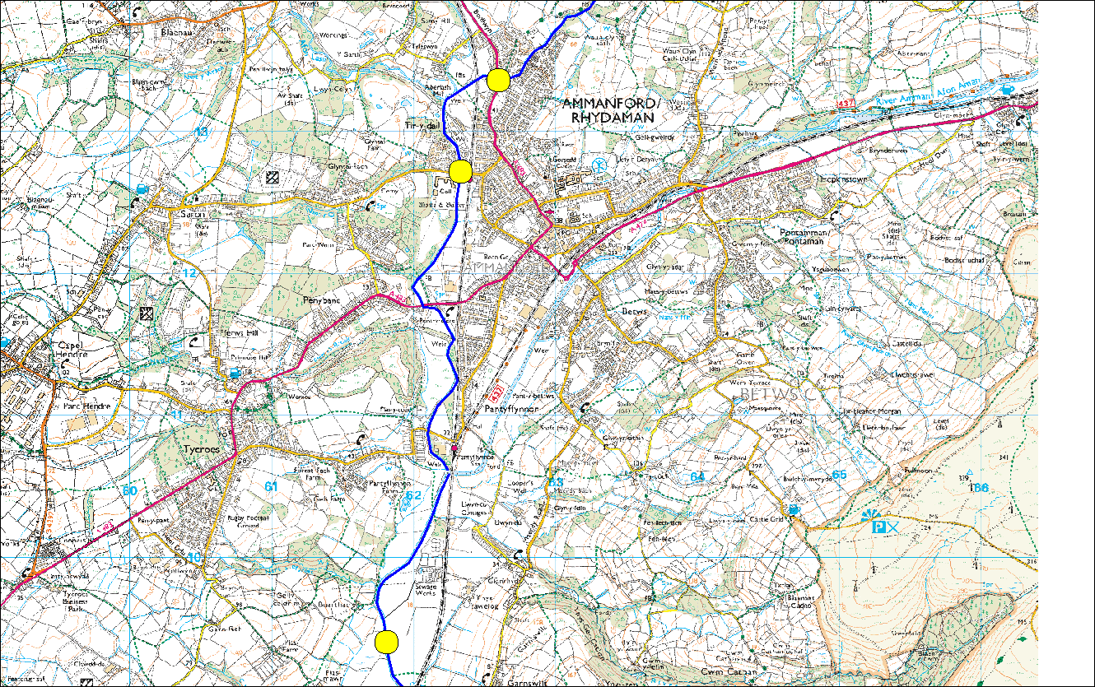
Figure 27: the 3 sites with more than 16 fibres present, portrayed by yellow circles.

The info tool within the GIS software can be used to find out any information about a point on the map. For example, a pie chat will display its longitude and latitude, elevation, site number, land use and microplastic composition data (Figure 28).

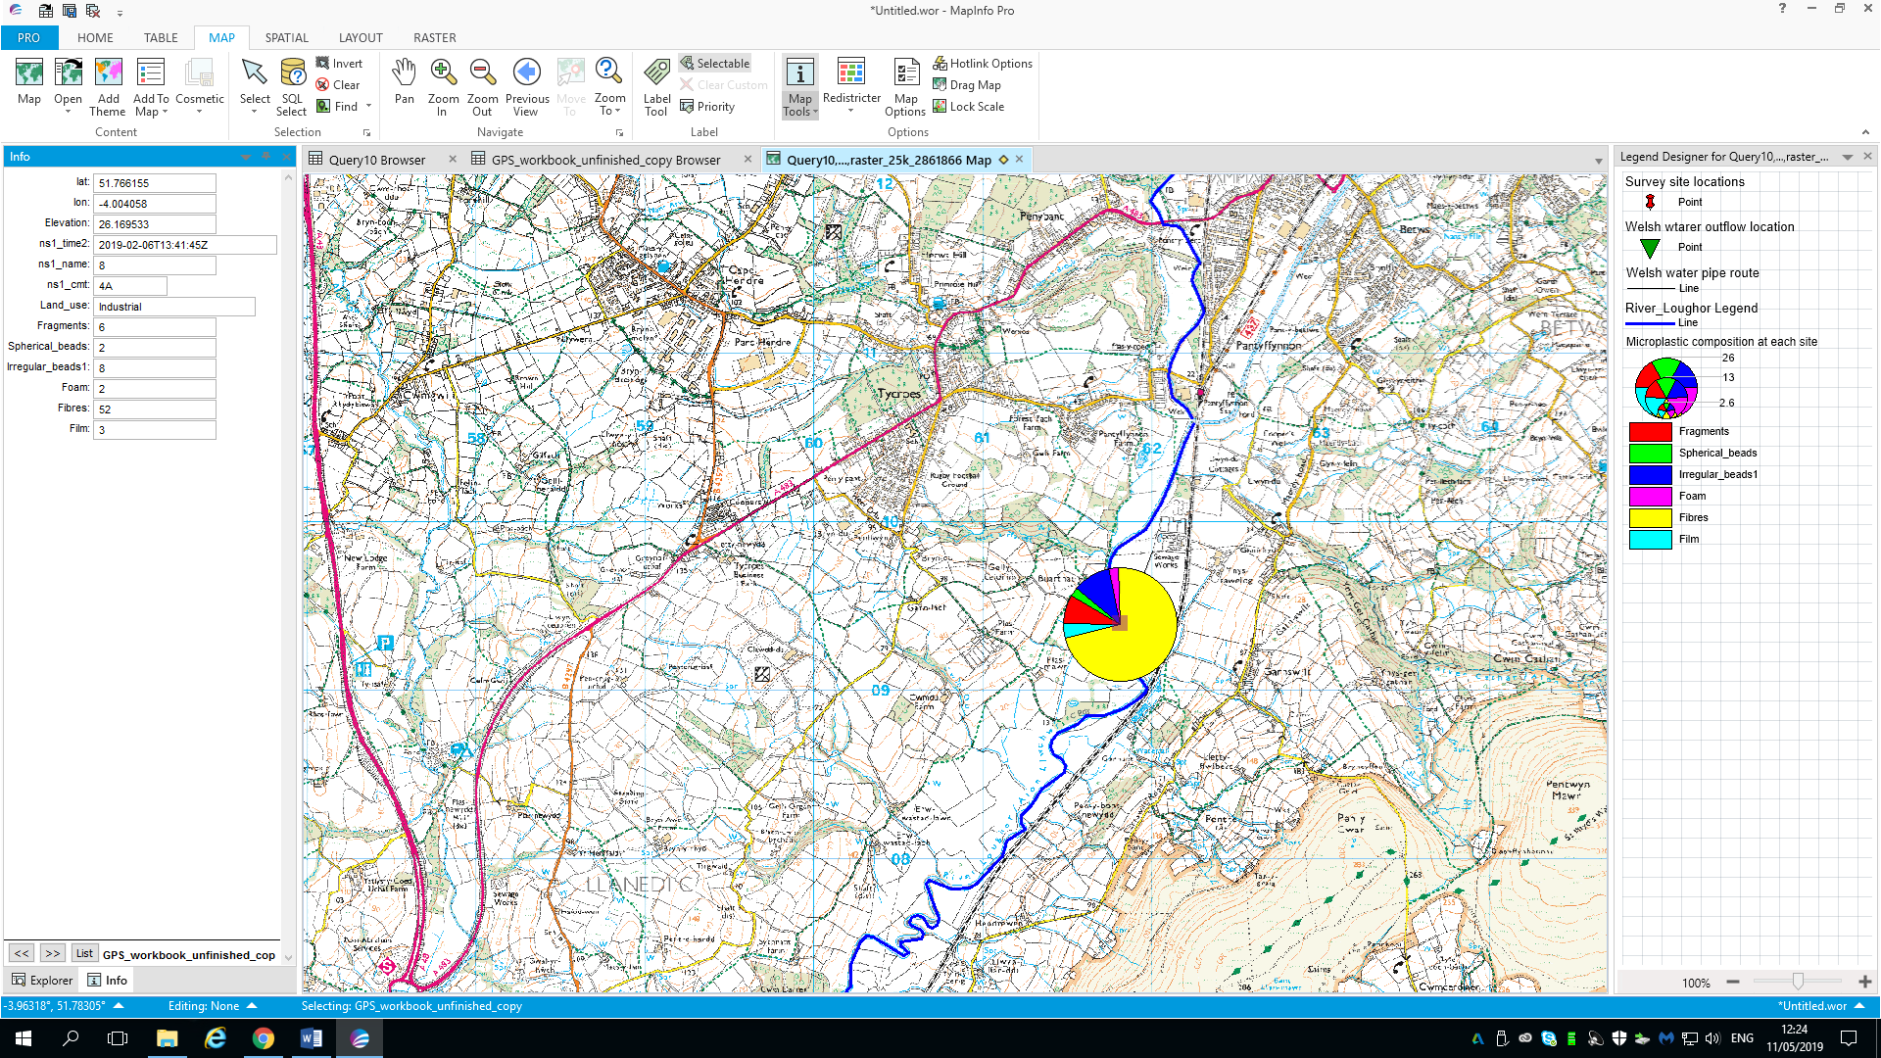
Figure 28: Demonstration of information tool on Mapinfo.

Use of GIS within the environmental field

The GIS model displayed with section 2.0 of this report was constructed following fieldwork on the 6th February 2019, the methodology used had three components;
- Sample collection.
- Detection of microplastics in collected samples.
- Distinguishing and analysing microplastic particles.
A fourth element of constructing a GIS model could be incorporated within this. There are multiple benefits to be discussed from the use of GIS.

Benefits of GIS systems

Presentation of data

Firstly, the use GIS for data presentation. Presenting data is a vital part of environmental research to get the reader engaged with emerging environmental problems. Presenting data in a simple and vibrant manner allow the reader to be simply engaged and understand the problem, leading them to continue reading to discover possible mitigation strategies. figure 19 of this report simply displays where the sample locations were in relation to the course of the river Loughor. Going into further detail figure 29 displays microplastic composition at site 5, by looking at the pie chart on the map it can simply be seen that irregular beads were the most abundant microplastic type and spherical beads were least abundant.
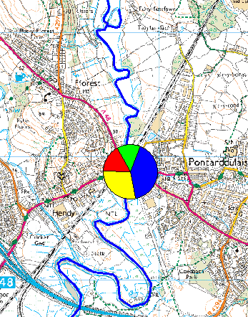
Figure 29: Microplastic composition at site 5.

Analysis of data

Performing spatial analysis is greatly enhanced by the use of a GIS package, as the manipulation and querying of data is easily achievable. “In the context of spatial analysis, the analysis focuses on the statistical analysis of patterns and underlying processes or more generally, spatial analysis addresses the question ‘what could have been the genesis of the observed spatial pattern?’” (Gimond, 2019). In the case of the environmental problem proposed within this report, a spatial representation of data collected has been presented and analysed. Analysis was preformed through the creation of pie charts, allowing comparison between sites of microplastic composition. The GIS package could have been used to conduct further analysis of microplastic size, stream velocity and overall microplastic abundance.

Efficiency and record keeping
The implementation of GIS systems across multiple agencies and companies will lead to cost savings. GIS can be used to improve schedules, this will lead to decreased staff costs. In terms of record keeping, the maintenance of valuable data is vital to any organisation. A GIS system can act as maintenance and keeper of valuable records, within the environmental field. Storing mapping records electronically over previous had copies leads to a sense of security, as these records are usually backed up. Therefore, if anything was to happen to the original storage site they would still be easily accessible in their original format.

Conclusion
GIS within the environmental sector has been examined and utilised within this report and when reviewing a current environmental issue. The report has displayed how data can be utilised within the software package and further analysed for the benefit of the user. The environmental sector is a multidisciplinary field that encompasses biological, social and physical sciences. Thematic mapping is a vital application of GIS in resource and population management areas of the environmental sector (Wright, et al., 2009) (Ahamad & Laituri, 2017) (Davies, 2018). The GIS package used within this report was found to be user-friendly and accurate this allowing a fantastic base for analysis of data. Creation of polygons and thematic maps, permits the user to overlay basic data with graphic styles to display information on a more sophisticated level (Pitney Bowes, 2016). The ability to display microplastic findings on the map at the GPS locations enables detailed analysis to be performed. Furthermore, allows the development of potential drivers of microplastic pollution as contamination type and land use can be reviewed simultaneously.

Literature cited

Ahamad, K., & Laituri, M. (2017, September 27). Use of GIS in Environmental Science. Retrieved Febuary 04, 2019, from Oxford Bibliographies: http://www.oxfordbibliographies.com/view/document/obo-9780199363445/obo-9780199363445-0081.xml
Barnes, D. K., Galgani, F., Thompson, R. C., & Barlaz, M. (2009). Accumulation and fragmentation of plastic debris in global environments. Philosophical Transactions of the Royal Society B, 364(1526), 1985 - 1998.
Cole, M., Lindeque, P., Halsband, C., & Galloway, T. (2011). Microplastics as contaminants in the marine environment: A review. Marine Pollution Bulletin, 62, 2588 - 2597.
Davies, J. (2018). Evaluating the use of GIS for environmental analysis. Swansea: University of Wales Trinity St Dvid.
Davies, J. (2019). Abundance, distrobution and drivers of microplastic pollution within the river Loughor, Carmarhenshire. Swansea: University of Wales Trinity St David.
ESRI. (2005). GIS Solutions for environmental Management. New York: ESRI.
Gharehbaghi, K., & Scott-Young, C. (2018). GIS as a vital tool for Environmental Impact Assessment and Mitigation. Earth and Environmental Science, 127.
Gimond, M. (2019). 1.2 What is Spatial Analysis? In M. Gimond, Intro to GIS and Spatial Analysis (p. 2). https://mgimond.github.io/Spatial/index.html.
GrindGIS. (2018, April 10). 10 Importance of GIS. Retrieved January 29, 2019, from https://grindgis.com/blog/10-importance-of-gis-in-environment
Larsen, L. (1999). GIS in environmental monitoring and assessment. Geographical information systems 2, 999- 1007.
Pitney Bowes. (2016). Product Documentation: MapInfo Pro. Retrieved Febuary 04, 2019, from Pintney Bowes: https://www.pitneybowes.com/us/support/products/software/mapinfo-pro-support.html

