BA BUSINESS MANAGEMENT

Assignment 1

Module- Marketing Fundamentals
Code- LCBB4004
Lecturer- Tushara Balendran
Name- Ramanpreet Kaur
Student ID-2216790
Topic- Blog on Apple
SUBMISSION DATE- 25th of November

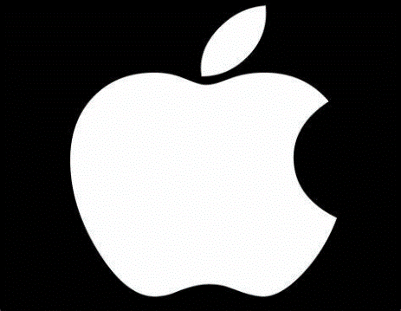
HISTORY OF APPLE-





In1976, Apple was manufactured by three men: Steve Jobs, Steve Wozniak and Ronald Wayne. Steve Jobs and Wozniak played a main role to invent the Apple company. The first product was the hand made personal computer and they decided to give a name to the product APPLE1.In APPLE1, there was only few features such as RAM, CPU and some basic textual video chips but later, they added a monitor and keyboard in the computer. This was the first company who faced a lot of problems in the market. They did not find any way to put the APPLE1 on sale, but, in july1976, APPLE1 was sold for $666.66. After that, Ronald Wayne decided to leave the company but after few weeks, when he got money around $800, he came back. He made a logo for the company which was designed by Rob Janoff in 1977. After getting success in it, in 1977, APPLE2 and APPLE3 was introduced by Wozniak. He had a great interest in electronics. He invented a new feature for APPLE 2 like colour graphics and tape- based storage. Steve Job was also trying to push the company to make the world’s best company. In 1978, apple had many employees in office. In the following years, the income of the company grew surprisingly (from775000 dollars to 118 million dollars) APPLE 3 was also introduced in the same year but it was not successful because of some technical flaws. Jobs and his employees invented a lot of computers with a good feature. APPLE was the best innovation of the time. It was the first company who was officially become the one trillion dollars company in history. (ResearchGate,2019)
PRODUCTS OF APPLE-
Apple company creates ample of products with amazing features and benefits. The name of the products is MacBook, air pods, iPhone, iPad, apple TV, Apple watches, iPod etcetera
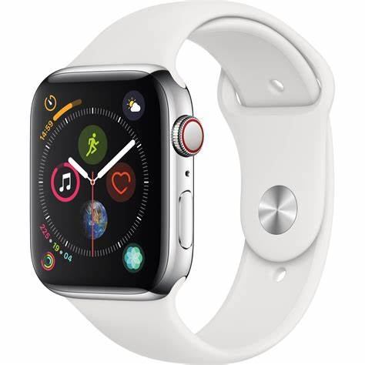
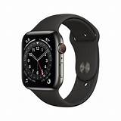
1.APPLE WATCH-

Apple watches have a great quality. These watches have high- tech features such as Siri, microphone, high quality speakers. Moreover, you can get any information with just one click. There is a tracking system in it you will get the whole information about your route. There are some other benefits of apple watches like when you wear the watch on your wrist, you will get a fitness partner, which will assist you to know about your heartbeat and blood oxygen levels. It also measures your footsteps. Furthermore, you can download any app on it without using a phone. You can listen music, make calls and send messages on it. (Apple, 2019)

2. APPLE PHONES –
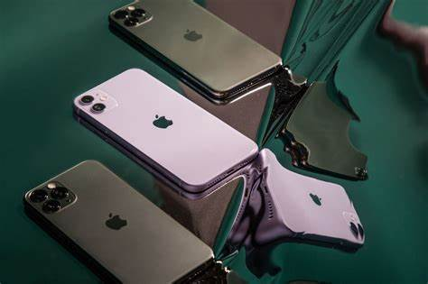

Apple phones are beautifully designed. There are many versions available in the market. The latest version of apple is iPhone 14 pro max. There are many features in these smartphones like, you can easily set a stylish time and date on it. Photos change automatically on lock screen .You can check the new updates throughout the day. Moreover, you can share an iCloud photo gallery with your family and friends. Another feature is Siri which is available in apple watches and in apple phones. Phones are really secure and safe you can save your important information in it without any fear because these phones are not easy to hack. If anybody try to hack the phone you will get the notification on your screen. (Apple,2022)
For more information visit on this website: https.//www.apple.com
3.APPLE IPAD-

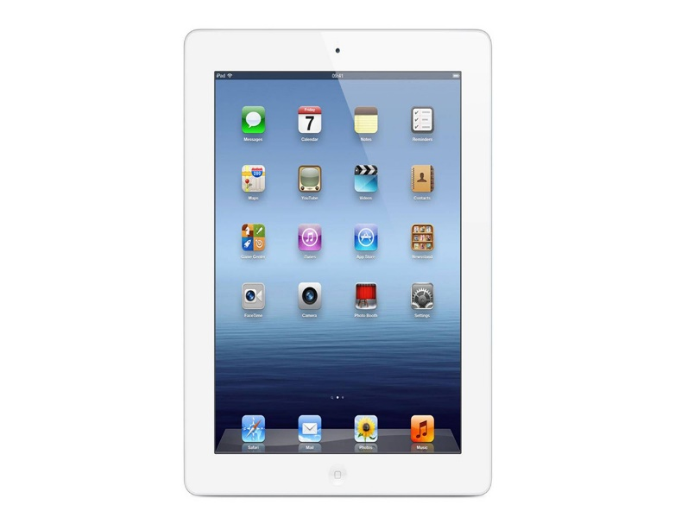

I pad has a more advanced features and advantages. It has a wide front camera so users can enjoy video calls with clear sound quality. The storage is double which is start with 64 GB. Now you can store more videos, games and photos on I pad. You can do a difficult work effortlessly on it. Another feature is language translator app which makes the conversation easier. You can save your essential information in a file. whenever, you need that you can get the whole information with just one click. I-pad is adaptable you can do countless things on it. (Apple (United Kingdom). (n.d.)
PRICE OF APPLE PRODUCTS: -
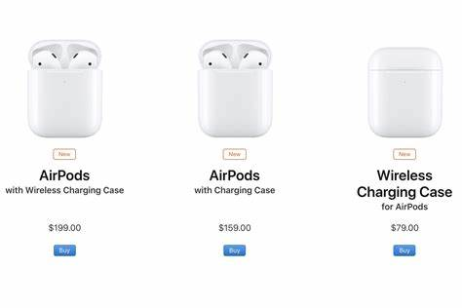
PRICE OF AIRPODS-

Apple has a really fantastic product in the market, which, is air pods. Air pods have wireless charging case. The sale of the apple air pods is increasing day by day. The price is reasonable for instance, price for air pods (2nd generation is £139) and air pods (3rdgeneration is £179). You can go and buy now.

Price of MacBook-
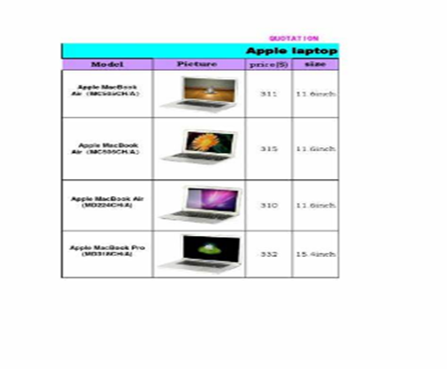
Apple have a lot of options for you. You can buy any MacBook according to your taste. MacBook air with M1chip and M2chip, MacBook 13 pro (£1,349) and MacBook 14 and 16(£1899) is available for you in the market. MacBook pro13 has 13.3” retina display and MacBook pro14 has 14.2” liquid retina XDR display. These products have high quality and the advantages. These are really good for you, you can save your documents, make presentations and assignments on it. So, go and buy apple MacBook. It is not only beneficial for you; it is also giving profit to the company. (Apple (United Kingdom). (n.d.)
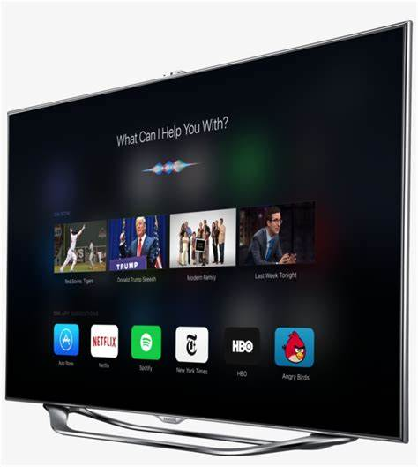
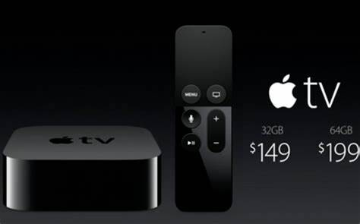
PRICE OF APPLE TV –

Apple tv is a full package of entertainment. This device provides free 7-day trial and its subscription is just £6.99 per month. There is a lot of apps are available on it such as prime video, Netflix, Disney+. You can watch a new web series on it. If you want Wi-Fi with 64 GB storage its price is £149 and with 128 GB storage its price is £169. The screen of the apple tv is full HD. Apple TV 4K has include a Siri remote which makes it easy to regulate
the TV. You can watch your favourite channels on a big screen. It is quite expensive but it is durable and high- quality device. (Apple (UK). (. n.d.)
PLACE: -
Apple company use both channels direct and indirect for marketing. Direct channel has no middlemen. Manufacturer directly gives the products to the customers. Indirect channel has an intermediary level in which manufacturer give the products to other distributors and then provide to the customers.
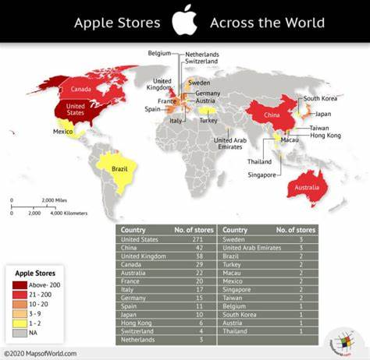

Apple is the one of the biggest brands in the whole world. It has 518 retail stores across the world and these stores are located in 25 countries. Apple is the one of the most profitable companies worldwide. There are 271 stores are available in America,50 stores in China and 38 in UK. In 2011, apple was on top as it has the highest sales in the market (more than $16 billion). Apple company try to make the customer happy and satisfied with the innovative devices. (thesmallbusinessblog.net. (2022)
APPLE STORE: -
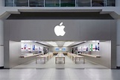
-

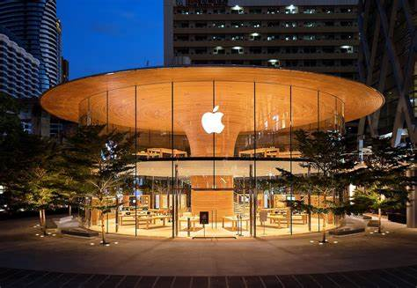

A unique apple store in Japan.
The biggest apple stores are available in Dubai, UK, Australia, United States, France, Japan, Canada. Apple stores have a good reputation in these countries. These stores have a good sale in the market. The most unique and beautiful store is located in Japan. The design of the store is totally different which attracts the customers. (Wise,2022)
MARKETING STRATEGY OF APPLE: -
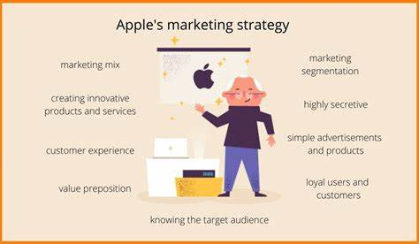

Apple always use his best strategy to satisfy the customers wants and needs. Apple tries to encourage the individuals to buy its products by promoting and advertising the product. Apple focus on manufacturing products according to the likes and dislikes of its targeting audience. They do not give too much choices. They just show the visuals simply on the screens. The secret behind the success of apple is the strategy that they use to attract the customers towards their devices. They are always faithful with customers. Whenever, a company release new product, they always provide vital information about the product and customers will get excited to know about the new device. (Vyshnavi,2021)


PROMOTION OF APPLE PR0DUCTS-
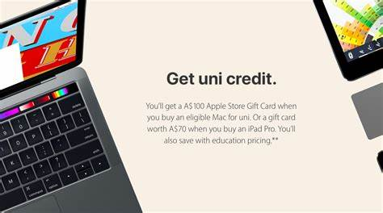
It is really important for the compnay to promote the products . In this way, customers are aware about the new products in the market. Company spend a plenty of money on the promotion of the products . However , company markets its product in a couple of ways, through ample of communication channels and parties. There are four communication tactics to show the product to the customers.First is advertising, company advertise apple items on google digital websites and technological news websites. Second one is personal selling, in this type of promotions apple store employees try to encourage the masses to buy the products. Third method of promotion is sales promotion, this promotion is occur at the stores where they provide old models on discount prices. The last one is public relations . For instance, press conferences, interviews, live apple events in which employees of the company try to convince the customers.Apple company does not use much social media like facebook, instagram.(Mage Plaza. (n.d.)
Apple use twitter to promote the apple items . Apple(@Apple)/Twitter https://twitter.com/apple
But people do not receive any replies on twitter now.

As you can watch videos on you-tube in which apple promotes apple items very effectively. In these videos tech- experts give the whole information about the new products in the market like new version of iphone14, new series of apple watch. Moreover, in the second link of you tube, that is an apple event in which they give the whole information about the new apple products.
For more information click on these links,
1.https://www.youtube.com/watch?v=eG0qMNvl1C8
2.https://www.youtube.com/watch?v=ux6zXguiqxM
so, apple is the number one brand in the whole world because of the best services and for
innovative devices that’s why marketing of the apple products is increasing exponentially.

REFERENCES-
Apple (2019). Apple. [Online] Available at: http://www.apple.com. (Accessed 10 November 2022).
https://tse2.mm.bing.net/th?id=OIP.qWPPa4PZbbJrQLza7a1pdQHaHa&pid=Api&P=o
https://tse1.mm.bing.net/th?id=OIP.y585FX2zd2ALskKfyl_39gHaHa&pid=Api&P=0
Apple. (2019). Apple. [Online] Apple. Available at: https://www.apple.com. (Accessed 11 November 2022).
https://tse3.mm.bing.net/th?id=OIP.sAXwfxb5QTeqUBorLuoIHwHaE7&pid=Api&P=0
Apple (United Kingdom). (n.d.). iPad pro. [Online] Available at: https://www.apple.com/uk/ipad-pro [ Accessed 11 November 2022]
Apple (UK). (n.d.). Buy Air pods with Charging case. [Online] Available at: https://www.apple.com/uk/shop/product/MV7N2ZM/A/airpods-with-charging-case.(Accessed 11 November 2022).
‌ https://tse2.mm.bing.net/th?id=OIP.SwcJqtd4R87_Y92Q5P4zxQHaE8&pid=Api&P=0
https://tse3.mm.bing.net/th?id=OIP.Wlsswx5heh5EO2wLzYswkwHaB8&pid=Api&P=0
Apple (United Kingdom). (n.d.). MacBook Pro. [Online] Available at: https://www.apple.com/uk/macbook-pro/. (Accessed 11 November 2022)
‌ https://tse2.mm.bing.net/th?id=OIP.YzjcMeD1oj8fXtLMTjY9pwHaJ4&pid=Api&P=0
Apple (UK). (n.d.). Buy Apple TV4K. [Online] Available at: https://www.apple.com/uk/shop/buy-tv/apple-tv-4k. (Accessed 11 November 2022).
‌ https://tse4.mm.bing.net/th?id=OIP.1NIgtoceB-ReF9RA7qfIAwHaEn&pid=Api&P=0
Mage Plaza. (n.d.). Apple Marketing Strategy:8 Precious Lessons to Learn. [Online] Available at: https://www.mageplaza.com/blog/apple-marketing-strategy.html. (Accessed 12 N November 2022).
https://tse1.mm.bing.net/th?id=OIP.M9j_WJDMdsB_OAJfSvwdiQHaEI&pid=Api&P=https://tse3.mm.bing.net/th?id=OIP.seHVX3StUZ0b6iO8y5C3IQHaEK&pid=Api&P=00
ResearchGate (2019). ResearchGate/ Share and discover research. [Online] ResearchGate. Available at: https://www.researchgate.net (Accessed 10 November 2022).
https://tse1.mm.bing.net/th?id=OIP.PCwGhvQbvSxIIcQfNZUzEgHaEo&pid=Api&rs=1&c=1&qlt=95&w=189&h=118
https://tse1.mm.bing.net/th?id=OIP.0BcwV0xQkYU8vFzEsiwTaAHaHb&pid=Api&rs=1&qlt=95&w=119&h=119
https://tse1.mm.bing.net/th?id=OIP.QX3GWA9xapuGccZeXlzXzwHaFX&pid=Api&rs=1&c=1&qlt=95&w=132&h=95
thesmallbusinessblog.net. (2022). How Many Apple Stores Are there in the US And World in 2022? – The Small Business Blog. [Online] Available at: https://thesmallbusinessblog.net/hoe-many-apple-stores-are-there/. (Accessed 12 November 2022).
https://tse4.mm.bing.net/th?id=OIP.bA6cYzhu_hBzRM_LdCMNsAHaHO&pid=Api&P=0
Vyshnavi, P. (2021). The Secret Behind Apple’s Successful Marketing Strategy. [Online] StartupTalky. Available at: https://startuptalky.com/apples-marketing-strategy/. (Accessed 12 November 2022).
https://tse1.mm.bing.net/th?id=OIP.DCsccDAmKvZwnCSQqSYlgwHaEU&pid=Api&rs=1& c=1&qlt=95&w=184&h=107
Wise, J. (2022). How Many Apple Stores Are there in 2022? – earth web. [Online] EARTHWEB. Available at: https://earthweb.com/how-many-apple-stores-are-there/.(Accessed 12 November 2022).
https://tse1.mm.bing.net/th?id=OIP.x3CBmsHgwYiBiPZvXNo6jgHaE8&pid=Api&rs=1&c=1&qlt=95&w=161&h=107
https://tse3.mm.bing.net/th?id=OIP.uqbrk2wz_cVQztZmhyjI0AHaFH&pid=Api&P=0

