Changemakers: Creativity and Value Creation

E-Portfolio

Madalina Blaglosov
2207678

Content
Research Question……………………………………………………………………………………………1
Task 2…………………………………………………………………………………………........................6

Video Presentation…………………………………………………………………………….................7

Task 4…….………………………………………………………………………………………………………….8

References………………………………………………………………………………………………………….9

Task 1

Research Question
How can companies harness the power of user-generated content and social media platforms to enhance their marketing strategies and create value for both the brand and its customers?

Value to the Field
Organisations now find themselves in a crucial situation as the quickly changing digital world continues to affect everything. In an overcrowded market, they must simultaneously find a way to stand out and have access to a multitude of platforms for that purpose.
These days' tech-savvy shoppers look for more than just a good deal; they want to feel connected to the companies they buy from. User-generated Content (UGC) is more than just a trend in digital material; it also represents the democratisation of media production (Kitsios et al., 2022). It's evidence of how customers have evolved from being receptive to being active participants in brand stories.
The authenticity of user-generated content is what gives it its strength. User-generated content is more authentic and relatable on a human level than professionally produced ads. When consumers talk about their real-life experiences, it may resonate with potential buyers in a way that traditional advertising can't (Santos, 2022). This not only encourages natural participation but also instills trust, a commodity that is becoming increasingly scarce in the online world. Brands may generate a snowball effect by incorporating UGC into their plans, strengthening bonds with current customers while drawing in new ones.
Using user-generated content can make advertising campaigns last longer. Brands may save time and resources by curating and reusing user-generated content instead of continuously producing fresh content from scratch (Kitsios et al., 2022). In addition to saving money on marketing, this guarantees a steady stream of fresh content that is naturally in line with what the audience wants to see. Furthermore, in a world where visibility is controlled by algorithms, user-generated content may naturally broaden a brand's audience. Because of its popularity and involvement, user-generated content is given priority by platforms, which benefits companies.

Research Approach
Choosing a proper research approach is crucial when addressing the complex environment of user-generated content and its significance in modern marketing. Understanding the complexities of how businesses might best utilise user-generated content is at the heart of our research. The most appropriate methodology with this goal in mind is the inductive approach, which is supported by multiple strong arguments.
The inductive approach is fundamentally grounded in the exploration of specific observations to arrive at broader generalizations or theories (Bonache and Festing, 2020). Given that the world of UGC is vast, dynamic, and still relatively uncharted in many aspects, it is essential to first immerse ourselves in the specifics.
Moreover, considering the primary aim is to fathom the human elements – the perceptions, motivations, and behaviours associated with UGC – a qualitative method of study becomes indispensable. Qualitative research, with its emphasis on exploring underlying motives and deciphering the 'why' behind behaviours, offers a depth of understanding that quantitative methods might overlook (Kaushik and Walsh, 2019). By employing qualitative techniques, such as in-depth interviews or focus group discussions, one can delve into the subtle nuances of consumer psyche, their emotional responses to UGC, and the factors that drive their engagement.

Data Collection Method
At the core of any robust research initiative is a meticulously designed data collection methodology. In the exploration of the intricate dynamics between UGC and brand marketing, primary data collection emerges as an indispensable instrument. Among the myriad tools at the disposal, surveys stand out as the most efficacious means for this particular study, and here’s why. Surveys, by design, offer a structured framework to solicit information (Muzari, Shava and Shonhiwa, 2022). This structured nature ensures uniformity, making the data amassed both comprehensive and comparable. As one ventures into deciphering people's nuanced perceptions, preferences, and interactions with UGC, such consistency becomes paramount.
With carefully crafted questionnaires, one can extract both quantitative metrics (like the frequency of UGC interactions) and qualitative insights (like the sentiments associated with certain UGC formats). Furthermore, in the digital age, the reach and accessibility of online surveys amplify their utility (Park, Konge and Artino Jr, 2020). One can effortlessly tap into a wide demographic, ensuring a diversity of perspectives. This diversity is vital when studying a domain as vast and varied as UGC, which resonates differently across different user segments.

Sampling Method & Sample Size
In the realm of research, the quality of insights often hinges on the representativeness of the sample chosen. Given the intricate nature of the study focused on user-generated content in brand marketing, it's imperative to employ a sampling method that mirrors the heterogeneity of the social media landscape. Stratified Random Sampling, at its essence, involves partitioning the population into distinct, non-overlapping subgroups or 'strata' based on specific criteria. In the context of the study, these strata would encapsulate various demographic segments—be it age, gender, geographic location, or even social media usage patterns (Kamal, 2019). From teenagers scrolling through feeds in urban centers to middle-aged individuals in suburban areas sharing their life's milestones, the spectrum is vast. A single, uniform sampling technique might overlook nuances, making Stratified Random Sampling invaluable. Each stratum offers a window into unique user behaviours, preferences, and motivations vis-à-vis UGC.
The selection of 11 participants as the target sample size provides a balance between scope and depth. A smaller sample can miss the desired diversity, but a bigger sample could overwhelm and complicate data processing. In addition to keeping data gathering and analysis manageable, having more participants allows one to cast a wider net and capture a greater variety of viewpoints.
Crucially, in allocating participants to each stratum, proportionality is the guiding principle (Park, Konge and Artino Jr, 2020).

Task 2

Primary and secondary research combined will provide a thorough understanding of how businesses use advertising to draw in customers. Acquiring new clients will be made easier with the help of the insights gained in determining the best advertising channels, fine-tuning targeting tactics, maximizing advertising expenditures, and creating more memorable marketing campaigns. Companies will be able to make more educated judgments with the help of this information, increasing their advertising its return on investment and drawing in more customers.
To perform primary research, the researcher needs to select a survey method, this means collection of primary data will be done through a survey where respondents can share important data and details with the researcher (Zawacki-Richter and et.al., 2020).
I made a survey specifically aimed at understanding the advertising strategies used by businesses. I Incorporated questions concerning the methods of advertising, spending allowance, demographic profile of the target market, main messaging, and metrics used to evaluate the efficacy of the ads.
According to the study results, 81.82% of participants said they use online platforms for purchases very frequently, while 18.18% said they do so frequently. Furthermore, 81.82% of respondents said they see online advertisements such as video advertising very frequently, and 18.18% said they see them infrequently.
The above study leads to the conclusion that online channels utilised by brands have a major impact on consumer behaviour and purchase intentions. When brands employ user-generated content to promote their goods and services, user-generated marketing methods continue to be the most successful. The previously mentioned study emphasized how social media platforms influence consumers' purchasing decisions and how they support advertising through digital marketing strategies.

Video Presentation

New Microsoft PowerPoint Presentation.pptx

Task 4
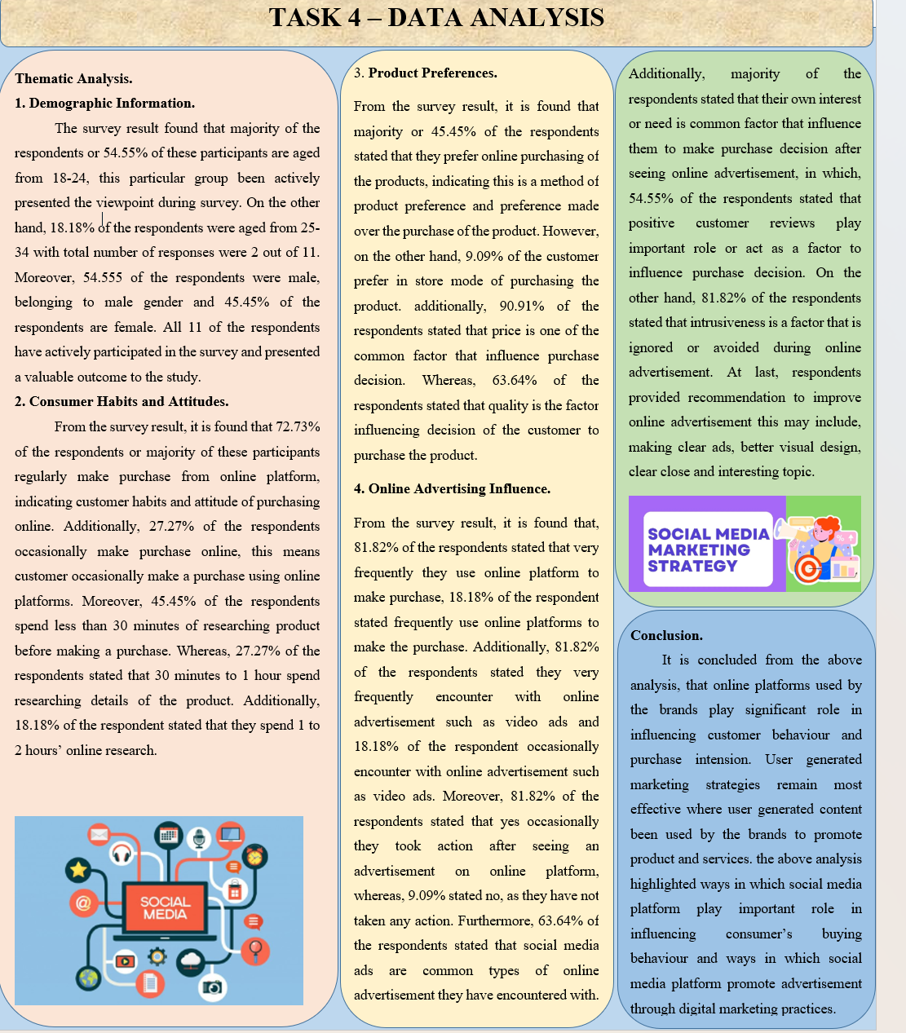

References
Bonache, J. and Festing, M., 2020. Research paradigms in international human resource
management: An epistemological systematisation of the field. German Journal of
Human Resource Management, 34(2), pp.99-123.
Kamal, S.S.L.B.A., 2019. Research paradigm and the philosophical foundations of a qualitative
study. PEOPLE: International Journal of Social Sciences, 4(3), pp.1386-1394.
Kaushik, V. and Walsh, C.A., 2019. Pragmatism as a research paradigm and its implications for
social work research. Social sciences, 8(9), p.255.
Khatri, K.K., 2020. Research paradigm: A philosophy of educational research. International
Journal of English Literature and Social Sciences (IJELS), 5(5).
Kitsios, F., Mitsopoulou, E., Moustaka, E. and Kamariotou, M., 2022. User-Generated Content
behavior and digital tourism services: A SEM-neural network model for information trust in
social networking sites. International Journal of Information Management Data Insights, 2(1),
p.100056.
Kumatongo, B. and Muzata, K.K., 2021. Research paradigms and designs with their application
in education. Journal of Lexicography and Terminology (Online ISSN 2664-0899. Print ISSN 2517
9306)., 5(1), pp.16-32.
Muzari, T., Shava, G.N. and Shonhiwa, S., 2022. Qualitative research paradigm, a key research
design for educational researchers, processes and procedures: A theoretical overview. Indiana
Journal of Humanities and Social Sciences, 3(1), pp.14-20.
Park, Y.S., Konge, L. and Artino Jr, A.R., 2020. The positivism paradigm of research. Academic
medicine, 95(5), pp.690-694.
Santos, M.L.B.D., 2022. The “so-called” UGC: an updated definition of user-generated content
in the age of social media. Online Information Review, 46(1), pp.95-113.

