Programme: MSc Public Health and Social Care in Practice
Module code: LCHS7003
Module: Community Care and Management of Longer-term Conditions
Assignment Title: Component 1 Information Booklet of Long-term Condition Management
Student ID:2214807
Student Name:Afshan Mirza

Programme: MSc Public Health and Social Care in Practice  Module code: LCHS7003  Module: Community Care and Management of Longer-term Conditions  Assignment Title: Component 1 Information Booklet of Long-term Condition Management  Student ID:2214807  Student Name:Afshan Mirza  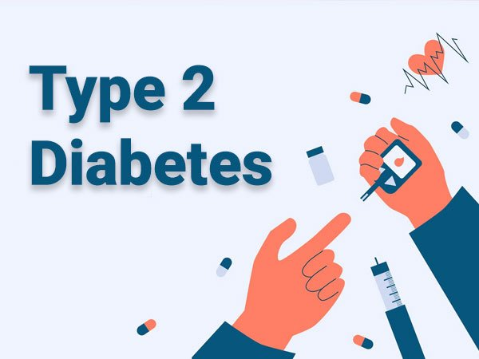
  Definition: Type 2 Diabetes Mellitus (T2DM)

Table of Contents
Definition: Type 2 Diabetes Mellitus (T2DM) 2
Definition: Type 2 Diabetes Mellitus (T2DM) 1
Burden and prevalence 1
Stats for the UK 1
Risk factors and how they happen 2
Burden of type 2 diabetes 3
An Evaluation of the condition 4
Physical implications 4
Psychological implications 5
Social implications 6
Impacts on families and carers 6
Evidence-based treatment in the UK (NHS) 7
Changes in lifestyle 7
Medicines 7
Monitoring and training 7
Long-Term Plan for the NHS in the UK (2019) 8
Key features 8
Evaluation 8
The Chronic Care Model (CCM) 9
Key features 9
Evaluation 9
Political health and social care agendas 9
Recommendations for improving person-centred care 10
Reference list 12

Definition: Type 2 Diabetes Mellitus (T2DM)
People with Type 2 Diabetes Mellitus (T2DM) have a long-term disease that changes how their bodies handle glucose, or blood sugar, and insulin is a hormone that is made by the pancreas. It helps glucose move from the blood into cells, where it is used for energy (Unger, 2023).
In people with Type 2 diabetes, either their bodies do not make enough insulin or their cells do not respond properly to insulin, and this is known as insulin resistance. This causes glucose to build up in the blood, which causes hyperglycemia, or high blood sugar.
Type 1 diabetes usually starts in childhood because the body's immune system attacks the cells that make insulin (Skinner et al., 2022). Type 2 diabetes, on the other hand, usually starts in adults and is strongly linked to lifestyle choices like poor diet, lack of exercise, and being overweight.

Burden and prevalence
- Type 2 diabetes is a big health problem around the world, and this is what the World Health Organisation (WHO, 2023) says:
- More than 530 million adults around the world have diabetes.
- About 90% to 95% of these people have Type 2 diabetes (Shen and Pierce, 2022).
- It is thought that by 2045, there will be 783 million people around the world who have diabetes.
- Diabetes is one of the top ten killers in the world, and conditions like heart disease, kidney failure, and stroke kill millions of people every year (Saldana, 2023).


Stats for the UK
- Diabetes is one of the most common long-term illnesses in the UK:
- Diabetes UK (2024) says that about 4.3 million people have been identified with diabetes and that another 850,000 are likely to have it but have not been told.
- About 90% of these people have Type 2 diabetes (Public Health England, 2020).
- Care for people with diabetes costs the NHS at least £10 billion a year, which is about 10% of the whole budget.
- More people over 40 have type 2 diabetes, but because more people are becoming overweight, more younger adults and even teens are getting it too (NHS England, 2023).
Type 2 diabetes is very common, which means that it is very hard on people, their families, and the healthcare system, and if it is not taken care of properly, it can cause major health problems like losing your sight, heart disease, kidney damage, and nerve issues.

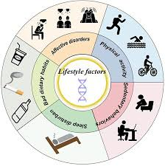

Risk factors and how they happen
Type 2 diabetes has a lot of different reasons, and a mix of genetic, social, and environmental factors plays a role.
Variables in lifestyle
Poor diet: When a person eats a lot of sugar, fat, and processed foods, they can gain weight and become insulin-resistant (Patel and Dupuis, 2022).
Lack of physical activity: Living a sedentary life makes it harder for the body to use insulin properly.
Overweight: Being overweight or fat is the most important risk factor that can be changed. Insulin resistance goes up when you have too much fat, especially around your stomach (NHS, 2024).
Genealogy and Family Tree
- People are more likely to get Type 2 diabetes if they have a parent or child who has it.
- People of South Asian, African-Caribbean, and Black African descent are more likely to get the disease and tend to get it at a younger age.
Age
- People who are older, especially those over 40, are more likely to get it (Monyeki and Kemper, 2021).
- Type 2 diabetes, on the other hand, is now being found in younger people and teens because they live unhealthy lives.
Different types of risk
- Diabetes is more likely to happen if you have high blood pressure or cholesterol (Mayo Clinic, 2025).
- Gestational diabetes, which happens during pregnancy, makes getting Type 2 diabetes later in life more likely.
Women who have Polycystic Ovary Syndrome (PCOS) are also more likely to get it.
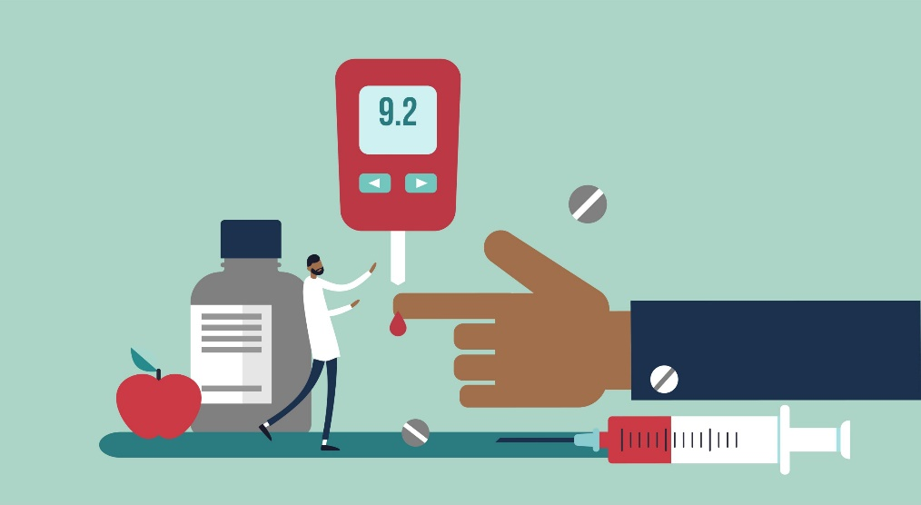

Burden of type 2 diabetes
If a person does not keep their type 2 diabetes under control, it can affect many parts of their body and cause serious problems. Some of these are:
Heart disease and blood valve disease: Diabetes makes people more likely to have heart attacks, strokes, and high blood pressure (Jamaludin, 2020).
Kidney disease: Over time, high blood sugar can hurt the kidneys and cause them to fail.
Nerve damage: Nerve damage, also called neuropathy, can make your feet and hands hurt, tingle, or lose their ability to feel.
Eye damage: Diabetes can hurt the blood vessels in the eyes, which can lead to retinopathy and vision loss or blindness (Hamim, 2023).
Problems with feet: Poor circulation and nerve damage can cause sores on a person’s feet and, in the worst cases, may require amputation.
Mental health effects: Having a long-term illness can also hurt a person’s mental health, causing them to feel anxious or depressed (Childs, Cypress and Spollett, 2022).
With good care, regular check-ups, and a healthy lifestyle, these problems can be avoided or put off.


An Evaluation of the condition
Type 2 diabetes can be controlled, but it can not be cured, and many people live long and healthy lives if they get the right care. The goal of treatment is to keep blood sugar levels under control, avoid complications, and encourage a healthy lifestyle (Aljaouni, Alharbi and Al-Nozha, 2024).
Positive aspects:
- Modern treatments and teaching programs, like the NHS Diabetes Prevention Programme, have made people more aware of the disease and helped them take better care of themselves.
- People can make changes to their lifestyles to reverse or delay the disease if they are diagnosed early (Abegaz and Ali, 2023).
Advantages and disadvantages:
A lot of people do not get a diagnosis until they have problems.
Taking care of the condition takes a long-term commitment to a healthy diet, regular exercise, and medication.
People from low-income or racial or ethnic minority groups are more likely to get diabetes and have trouble getting care, and this shows that there are health disparities (Mayo Clinic, 2025).

Physical implications
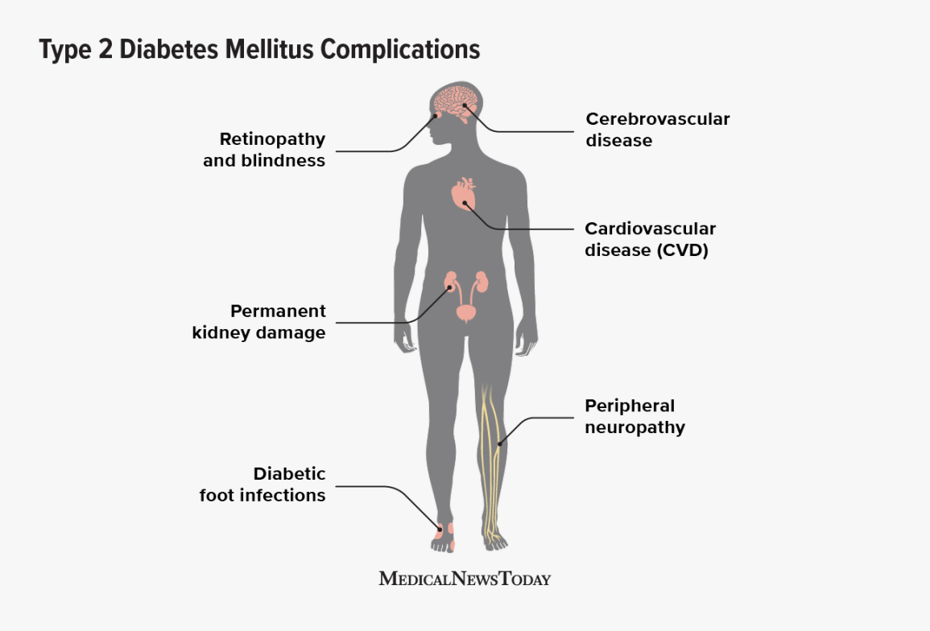
Type 2 diabetes often has long-lasting and worsening effects on the body, and blood sugar that stays high for a long time can hurt the body's processes and organs.
Fatigue and low energy: Because their bodies can not use glucose for energy properly, many people with diabetes are always tired (NHS, 2024).
Vision issues: Having high blood sugar can hurt the tiny blood vessels in the eyes, which can lead to diabetic retinopathy, and if not addressed, this condition can blur a person's vision or even go away completely.
Kidney disease: Diabetes can hurt the kidneys over time, which can lead to chronic kidney disease or kidney failure (Patel and Dupuis, 2022).
Nerve damage (Neuropathy): This can make your feet and hands hurt, tingle, or go numb, and it makes you more likely to get hurt or get an infection.
Heart disease and stroke: People with Type 2 diabetes are more likely to get heart disease and stroke because their blood vessels are damaged and their cholesterol levels are high (Saldana, 2023).
These consequences are very bad, but they can often be avoided or put off by finding the problem early, controlling blood sugar well, getting regular checkups, and doing what a person’s doctor tells them to do. Through lifestyle support and instruction, the NHS Diabetes Prevention Programme focuses a lot on keeping these health problems from happening (Skinner et al., 2022).

Psychological implications
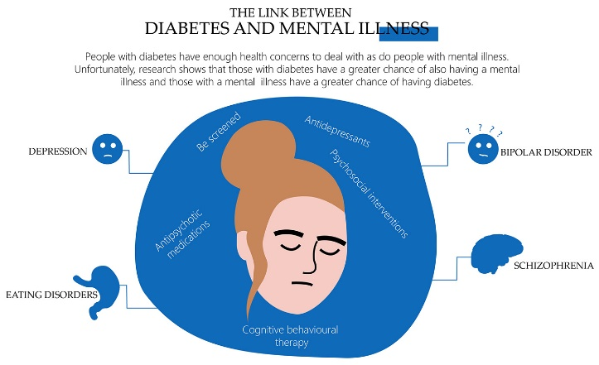
Having Type 2 diabetes can make a person feel and think very differently, and taking care of a condition that lasts a lifetime needs constant monitoring, which can cause stress or anxiety.
Emotional Stress: Keeping an eye on blood sugar, food, and taking medicine every day can make people feel overwhelmed, and some people with diabetes get ‘diabetes burnout’, which means they are tired of taking care of their sickness (Abegaz and Ali, 2023).
Stress and depression: Studies show that people with diabetes are more likely to be depressed, and this could be because they are afraid of problems, changes to their lifestyle, or being alone.
Low self-esteem: Some people may feel different or confined compared to others, especially if they have to check their blood sugar often or stick to a strict diet when they are with other people (Childs, Cypress and Spollett, 2022).
Fear of hypoglycemia: People who take insulin or certain other medicines may worry about low blood sugar episodes, which can make them feel dizzy or pass out.
The NHS provides mental health services like counselling, group therapy, and diabetes education classes to help people feel better emotionally. Diabetes UK also offers helplines and peer support groups so that people can deal with their feelings and share their stories with others who are going through the same things (Jamaludin, 2020).

Social implications

People with type 2 diabetes may also have trouble with their relationships, ability to work, and social life.
Lifestyle changes: A lot of the time, people need to make big changes to how they eat and how much they exercise, and this can make it harder to go to restaurants, family events, or travel (Monyeki and Kemper, 2021).
Effects on work: Some people may find it hard to manage their diabetes while they are at work, especially if they need to check their glucose levels or take their medicine daily.
Isolation: Some people may avoid social settings because they do not want to talk about their condition or because they are embarrassed about having to follow certain dietary rules.
But with education and help, a lot of people are able to keep up their social lives. To help people stay independent and social, the NHS supports community support programs and diabetes education classes (NHS England, 2023).

Impacts on families and carers

When helping someone with diabetes, families and carers also face emotional and physical problems and some of them are presented below:
Emotional burden: An emotional burden is when family members worry about the health of a loved one, especially when problems arise (Public Health England, 2020).
Financial stress: The costs of medical supplies, healthy food, and getting to and from meetings can put a strain on a person’s finances.
Changes in lifestyle: To help the person with diabetes, their family may need to change the way they eat and do things.
Carer Stress: People who give regular care may feel tired or anxious, especially if the patient has major problems like kidney disease or vision loss (Shen and Pierce, 2022).
But having a good relationship with your family can make a big difference, and studies have shown that having family support helps people with Type 2 diabetes stick to their diet, take their medications, and feel better emotionally.

Evidence-based treatment in the UK (NHS)
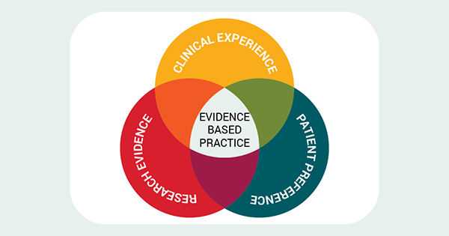
The NHS offers a variety of Type 2 diabetes treatments and management choices that have been shown to work, and these are meant to help people keep their blood sugar levels in check and avoid problems (Unger, 2023).

Changes in lifestyle
Eating Well: A healthy diet with lots of fruits, veggies, whole grains, and lean proteins can help keep blood sugar in check, and it is very important to eat less sugar, salt, and prepared foods.
Physical activity: Regular exercise, like walking, swimming, or riding a bike, makes insulin work better and helps a person control their weight (Aljaouni, Alharbi and Al-Nozha, 2024).
Weight loss programs: People with diabetes and obesity can get help from the NHS to control their weight, and it is possible to get better control of their blood sugar with just a 5–10% weight loss.

Medicines
- If making changes to a patient’s lifestyle is not enough, they may be given medicine.
- Metformin is the most popular first-choice drug; it makes insulin work better in the body (Hamim, 2023).
- There are new drugs called SGLT2 inhibitors, like dapagliflozin, and GLP-1 receptor agonists, like semaglutide, that lower blood sugar and keep the heart and kidneys healthy.
- If insulin pills do not work for some people, they may need insulin injections (Mayo Clinic, 2025).

Monitoring and training
Check-Ups: The NHS suggests getting regular foot checks, eye exams, and blood tests (HbA1c).
Programs for diabetes education: Classes like DESMOND (Diabetes Education and Self-Management for Ongoing and Newly Diagnosed) teach people how to take care of their condition well (NHS, 2024).

Long-Term Plan for the NHS in the UK (2019)

The NHS Long Term Plan is a big plan for the UK that aims to make care better for people with long-term conditions like Type 2 diabetes, and this plan shows how important it is to avoid problems, find them early, help people take care of themselves, and provide integrated care (Patel and Dupuis, 2022).

Key features
Prevention and early detection: The plan aims to lower the number of people who get Type 2 diabetes by teaching people about healthy lifestyles and checking them. A big part of this is the NHS Diabetes Prevention Programme (NDPP), which gives free advice on how to eat, exercise, and control a patient’s weight.
Personalised care: Patients are urged to plan and make decisions about their own care, which helps them become more independent and take care of themselves (Saldana, 2023).
Integrated care systems (ICS): To give people better care, the NHS encourages hospitals, GP surgeries, social care services, and community groups to work together.
Digital health tools: Patients are urged to use digital blood sugar monitors, online consultations, and health apps on their phones to help them take care of their condition from home (Skinner et al., 2022).

Evaluation
The NHS Long Term Plan has helped people become more aware of their conditions and improve their ability to take care of themselves, and there are still problems, though, like unequal access to services in poor places and long wait times for appointments with specialists. Overall, the model supports a community-based and patient-centred approach to treating Type 2 diabetes, with a focus on preventing it and giving people with it more power (Abegaz and Ali, 2023).

The Chronic Care Model (CCM)
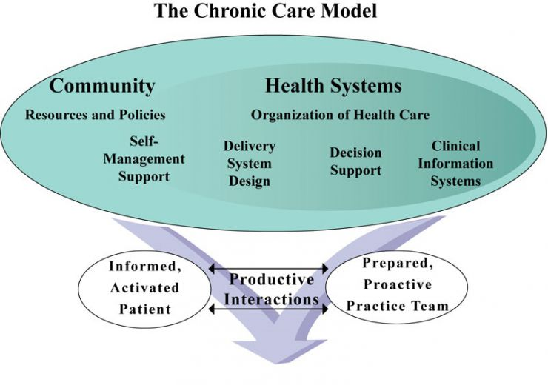
Edward H. Wagner created the Chronic Care Model (CCM) in the US in the 1990s, and it is now used all over the world to improve care for people with chronic illnesses like diabetes.

Key features
The CCM focuses on six main areas that help people with long-term illnesses do better:
Community Resources: Putting people in touch with public health programs and support groups (Childs, Cypress and Spollett, 2022).
Health system support: Encouraging healthcare groups to make managing chronic diseases a top priority.
Self-management support: Giving patients the information, courage, and skills they need to take charge of their own health.
Delivery system design: Encouraging healthcare workers to work together (Jamaludin, 2020).
Help with making decisions: Using clinical standards and methods that have been shown to work.
Through clinical information systems, doctors can keep track of patients' growth and make sure they get the care they need (Monyeki and Kemper, 2021).

Evaluation
Many countries, including the UK, have accepted the CCM because it encourages people to work together, educate patients, and make decisions based on facts, and it helps healthcare organisations switch from treating problems after they happen to preventing them in the first place. But this plan can be hard to use in places that do not have enough resources or staff (NHS England, 2023).

Political health and social care agendas
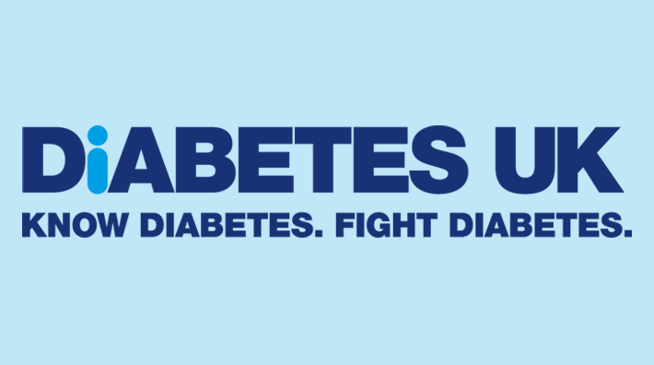
The way diabetes is cared for in the UK is heavily affected by government programs, and a number of local and national health plans help avoid and treat diabetes.
NHS diabetes prevention programme (NDPP): The NHS Diabetes Prevention Programme (NDPP) is a nationwide program that helps people who are very likely to get Type 2 diabetes, and it focuses on living well, keeping the patient’s weight in check, and being active (Public Health England, 2020).
Public Health England: Public Health England, which is now called the Office for Health Improvement and Disparities, promotes healthy living through public programs such as ‘Change4Life’ and ‘Better Health’.
Equality and access policies: The' Health and Social Care Act 2012, which was passed by the UK government, supports fair access to healthcare, and this means that everyone, no matter where they come from, can benefit from diabetes services (Shen and Pierce, 2022).
Local health strategies: Communities with diabetes can get check-ups, learn about their condition, and get help with self-care through programs run by local health groups and councils.
The goal of these policies is to even out health results, stop new cases of diabetes, and make long-term outcomes better for people who already have diabetes (Unger, 2023).

The NHS Long Term Plan (UK) and the Chronic Care Model (international) both aim to give people more power, make prevention better, and connect care systems, and together, these models help doctors and nurses give better, more person-centred care to people with Type 2 diabetes. These goals are supported even more by national and local health agendas in the UK, which work to improve protection, equality, and access to services (Aljaouni, Alharbi and Al-Nozha, 2024). Even though there are still problems, these guidelines and policies are very important for making the lives of people with Type 2 diabetes and their families better.

Recommendations for improving person-centred care
- At every stage of treating Type 2 diabetes, person-centred care means paying attention to the person's needs, wants, and values, and to make this method better, doctors and nurses should let patients have a say in how they are cared for and offer personalised help that fits their culture and way of life (Hamim, 2023).
- More people should be able to learn self-management skills like how to eat well, take their medications as prescribed, and check their blood sugar, and this can be done through education and training programs like the NHS DESMOND course. Digital health tools and neighbourhood clinics can help patients feel supported and cut down on hospital visits by setting up regular follow-ups.
- Families should also be involved in planning care to keep people motivated and improve their mental health, and patients who need long-term care should be able to get mental health support to help them deal with worry, anxiety, or depression that comes with it (Mayo Clinic, 2025).
- Comfort, dignity, and symptom control should be the main goals of care for people who are nearing the end of their lives, and patients and their families should be involved in all choices. To honour the patient's wants, early planning for future care should be pushed.
- Per person-centred methods, people with Type 2 diabetes can have a much better quality of life by getting their families involved, getting education, and getting compassionate end-of-life care (NHS, 2024).

Reference list
Abegaz, T.M. and Ali, A.A. (2023). Health-Related Quality of Life and Healthcare Events in Patients with Monotherapy of Anti-Diabetes Medications. Healthcare, 11(4), p.541.
Aljaouni, M.E., Alharbi, A.M. and Al-Nozha, O.M. (2024). Knowledge and Practice of Foot Care among Patients with Diabetes Attending Diabetes Center, Saudi Arabia. Healthcare, [online] 12(13), p.1244. Available at: https://www.mdpi.com/2227-9032/12/13/1244 [Accessed 1 Aug. 2024].
Childs, B.B., Cypress, M. and Spollett, G. (2022). Complete Nurse’s Guide to Diabetes Care. American Diabetes Association.
Hamim, A. (2023). Retracted: Study on the Nursing Effect of Diabetes Health Education Nursing Methods Applied to Diabetes Patients in the Endocrinology Department. Journal of Healthcare Engineering, [online] 2023, pp.1–1. Available at: https://www.ncbi.nlm.nih.gov/pmc/articles/PMC10567325/.
Jamaludin, S. (2020). Factor Influencing Decision for Eye Screening among Diabetes Patients: A Review. Nursing & Healthcare International Journal, 4(1).
Mayo Clinic (2025). Type 2 diabetes. [online] Mayo Clinic. Available at: https://www.mayoclinic.org/diseases-conditions/type-2-diabetes/symptoms-causes/syc-20351193.
Monyeki, K.D. and Kemper, H.C.G. (2021). Lifestyle and Epidemiology. BoD – Books on Demand.
NHS (2024). NHS England» Evidence-Based Interventions Programme. [online] www.england.nhs.uk. Available at: https://www.england.nhs.uk/evidence-based-interventions/.
NHS England (2023). NHS Diabetes Prevention Programme (NHS DPP). [online] NHS England. Available at: https://www.england.nhs.uk/diabetes/diabetes-prevention/.
Patel, D. and Dupuis, M. (2022). Understanding Patient Care Gaps in Diabetes: Perspective of Patients, Healthcare Professionals, and Healthcare Administrators. Canadian Journal of Diabetes, 32(4), p.317.
Public Health England (2020). Public health england. [online] GOV.UK. Available at: https://www.gov.uk/government/organisations/public-health-england.
Saldana, J.R. (2023). The Diabetes Textbook. Springer Nature.
Shen, Q. and Pierce, J. (2022). Supplementation of Coenzyme Q10 among Patients with Type 2 Diabetes Mellitus. Healthcare, 3(2), pp.296–309.
Skinner, T.C., Carey, M.E., Cradock, S., Daly, H., Davies, M.J., Doherty, Y., Heller, S., Khunti, K. and Oliver, L. (2022). Diabetes education and self-management for ongoing and newly diagnosed (DESMOND): Process modelling of pilot study. Patient Education and Counseling, 64(1-3), pp.369–377.
Unger, J. (2023). Diabetes Management in Primary Care. Lippincott Williams & Wilkins.

