Callum Cross
Student Number: 1705149
Lecturer: Michael Dacey
Module Code: ACCB6006
Advanced web development

Table of Contents
Introduction 1
Black Box Testing 2
Black Box Techniques 2.1
Boundary Value Analysis 2.2
Equivalence Class Partitioning 2.3
Error Guessing 2.4
Advantages of Black Box Testing 2.5
Disadvantages of Black Box Testing 2.6
White Box Testing 3
White Box Techniques 3.1
Statement Coverage 3.2
Decision Coverage 3.3
Condition Coverage 3.4
Advantages of White Box Testing 3.5
Disadvantages of White Box Testing 3.6
Behavior Driven Development 4
Jasmine Test Framework 5
Principal Components 5.1
Example Testing Jasmine Framework 6
Developing Node.js Web Application using Ajax 7
Web Application Requirements 8
Node.js 8.1
Express.js 8.2
Typescript 8.3
Ajax 8.4
Embedded JavaScript Templating 8.5
Mapbox API 8.6
Darksky API 8.7
Implementation 9
Ajax 8.1
Http Service Module 8.2
Geocoding Service Module 8.3
DarkskyData Service Module 8.4
Weather Service Module 8.5
Final Look 8.6
Conclusion 10
References 11

Introduction (1)
In this report, we will look at how a student created a web application that allows for real-time weather information from any location around the World. Additionally, we will look at what the students thought process was like while in the development of this project and why they chose some aspects of the project and why they thought it would be best suited for this project. Overall, we will look at how the final project turned out and find what they would have done otherwise if they could re-do the project over again.
Secondly, we will delve into software development testing and the differences between the methodologies of testing, more specifically, black and white box testing. Testing products is necessary for software development, as you cannot allow end-users to use your product without trial, as this could lead to security flaws that have not been thought about, and could potentially in this modern-day cause a corporation to shut down with hefty fines being issued towards them for this lack of testing.
Thirdly we will look over the benefits of Behavioural Driver Development (BDD), How teams can benefit from this type of development and how it allows for better collaboration between developers, which in turn could lead to better production of products being created.
Finally, we will look over the main characteristics of a Test Framework and how testing changes the way a development team will code so that it can become testable. We will be shown examples of how a testing framework functions and show some cases in action.

Black Box Testing (2)
Black box testing is a methodology in which is used to examine software functionality without having to know what the internal structure of code will be a good example of this is explained by Mark Down “The advantage of black box testing an application is that you can do it quickly and possibly have results almost immediately.”[5]. It can be applied to all types of software testing levels but is mostly used for developed high-level acceptant and systems.
To elaborate, black-box testing, which would be used by a professional, will only know the functional input and output of the application but will not know about the application's internal code, which helps the app reach the desired output. The professional will only use testing with valid inputs and outputs and will not use invalid scenarios, which allows the professional to determine expected results without having any depth of the internal application structure.

Black Box Techniques (2.1)
Test cases built for black-box are methods built around project specifications and the requirements of the project as you don’t have any knowledge of the internal system and only know what the inputs and outputs will be.

Boundary Value Analysis (2.2)
The most common black-box testing technique, BVA or Boundary Value Analysis, is mostly used to find errors in input values by using boundaries around those values they can either not go lower or higher than a specific amount.

Equivalence Class Partitioning (2.3)
This method is used to reduce the possibilities of inputs to a small but useful data, This is commonly used to test an application extensively and avoid redundancy of data being used, it is done by diving inputs into multiple classes and getting values from each individual class.

Error Guessing (2.4)
The experience of the tester is the sole dependent on how successful this method can be. There are no techniques or tools, but one can write the tests dependent on the requirements and specifications of the project and mostly guessing what those inputs and outputs would possibly be.

Advantages of Black Box Testing (2.5)
- Test cases can be created immediately after the requirements and specifications have been created.
- The tester is free of any knowledge of a specific programming language to test the functionality and reliability of a particular application or software.
- All tests are performed from the user’s point of view and not the designers.
- Tests performed are unbiased because the tester and designer work independently from each other.

Disadvantages of Black Box Testing (2.6)
- Tests cannot be used for complex structures of code.
- Results can and usually will be overestimated at times
- Testing every stream of the possibility of inputs is impossible because it can become time-consuming, which in turn would lead to many developer’s segments of code being untested.
- Test cases are tough to define unless the specification and requirements are clear and concise and will not change on a usual basis.

White Box Testing (3)
White box testing, which is also known as structural testing and code-based testing, is a method that validates application mechanisms, objects and components, and internal framework. This kind of testing not only verifies specifications according to the code-base but also uncovers application vulnerabilities that might have gone un-noticed until release. This is known as a transparent box and visualizes the software engineering team and the internal mechanisms of the software being built. [6]
With the white box testing phase, code is run with pre-determined input values created by the designer of the test, which in turn should validate the pre-selected output values. If a mismatch is to happen, it means the code that is being run may be incorrect or could possibly have a bug. This process does mean that writing code stubs and drivers are essential.

White Box Techniques (3.1)
The techniques used in white box testing are the most important as they allow for broad and comprehensive coverage of code analysis which allows a software engineering team to find the area of code that could be creating problems or outputting incorrect results, which allows for the smoother and faster transition of product updates and creation. [6]

Statement Coverage (3.2)
Statement coverage is a technique that involves the execution of all code statements at least once in the codebase. This is used to calculate and measure the number of statements that have been executed in the source code.

Decision Coverage (3.3)
Decision coverage or also commonly known as branch coverage, is a testing method that aims to ensure each possible branch from each decision in the source code is executed to ensure that the system is performing correctly if there is too be an error but also to guarantee that all reachable code is executed. [6]

Condition Coverage (3.4)
Condition coverage is a method that checks that all branching statements cover both TRUE and FALSE Statements. This is to make sure that if that value is considered incorrect that the software can handle that correction by throwing a log or letting a system administrator know that the code has failed. This is essential in large codebases because having to find a bug in millions of lines of code without any primary TRUE or FALSE statements can be easily overlooked and could end up causing severe bugs in the future.

Advantages of White Box Testing (3.5)
- It allows developers to optimize their code as it shows bugs and errors in the system.
- Test cases can easily be made to be automated without having to keep changing them.
- Covers the whole codebase for flaws and can notify developers on the area that the code is failing.

Disadvantages of White Box Testing (3.6)
- It can become complicated and expensive, which can require a lot more time than other testing methodologies.
- Some conditions might become untested because it’s unrealistic to test every single case.
- Must update the testing on a regular basis if the codebase is changed frequently or is in substantial development.
- Testing can become exhaustive if the application is extensive.

Behaviour Driven Development (4)
Behavior-driven development (BDD) is a methodology for developing applications and a process in the software development line. It allows continual example-based communication between an extensive range of teams from developers, quality assurance teams, and business analysts.
Behavior-driven development is used across many companies to this day, and it is implausible that this methodology will cease to exist in the near future, as said by John Ferguson “Today BDD is successfully practiced in a large number of organizations of all sizes around the world, in a variety of different ways.”.[3]
BDD is an extension of test-driven-development; these types of tests are simple and domain-specific languages. At the heart of BDD is rethinking the way unit-testing is completed in order to avoid issues that naturally occur within the software development cycle. It suggests for unit test cases to use whole natural sentence names and should be written towards business order of value.
The primary purpose of BDD is that the communication levels are taken to the next level and allows a lot more teams to be involved and have a voice in their opinions or suggestions. This allows for better productivity in the whole business but can also create a more social and enjoyable environment within work, and out of it, this is also explained by John Feguson “BDD is a highly collaborative practice, both between users and the development team, and within the team itself. Business analysts, developers, and testers work together with the end users to define and specify features”. [4]
BDD also encourages working in small and rapid development cycles to increase feedback and the flow of value towards a product being worked on. The principles of BDD are as follows the developer creating the test must define a test set for the unit of tests first, then make the tests fail. This allows the developer to understand that the test can fail and will fail if the output is incorrect.
Once they have completed the previous steps, they will design and implement the unit tests that have been created into the source code and then finally verify that the implementation of the unit tests can succeed. When all steps have been completed, they have successfully implemented the full capability of unit-testing of BDD.

Jasmine Test Framework (5)
Jasmine is a test framework built for JavaScript that allows applications to create and run unit tests on applications large or small and allows developers to automate the testing with expected inputs and outputs and will inform developers if a unit-test succeeded or failed.

Principal Components (5.1)
Jasmine is fast and has no external dependencies. This means that while it’s running will only effect results slightly or if done correctly and with experience could not affect performance at all. No external dependencies will allow it to be loosely coupled, and it can be exported without the need to download extra necessities for the application to be tested.
It’s a battery included library in the context which allows and offers everything from running on top of testable code and making it easy and straightforward to integrate into source code no matter the size.
Jasmine integration provides for smooth transitions no matter what framework or libraries you are currently using, making it ideal for applications that have many libraries that are required for the app or software to run. This could be extremely useful for applications that have more complexed internals that libraries upon libraries to run.
Behavior-driven development is the core of Jasmine as it has the tools to collaborate with a large number of people. This is mainly because all the code syntax in Jasmine is both clean and easily identifiable when needed. Jasmine has a great file structure as well because, rather than having the unit tests directly built into the source code, it is separated from the source via its in-built file structure.

Example Testing Jasmine (6)
In this section of the report, a demonstration will be shown of jasmine in action. In the image below, we have created a pure class with a bunch of calculation functions that will output the results depending on the inputs being sent in.
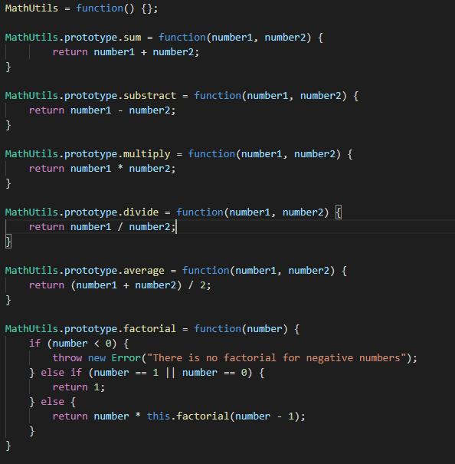
We have created these functions to demonstrate how jasmine works, as you can expect from mathematical functions. You would need these results to be precisely right; otherwise, this could have dramatic effects if the results were incorrect.
The unit tests for the mathematical functions shown above have been created in the image below. This will allow us to test if Jasmine is fully functional and how it works with unit testing.
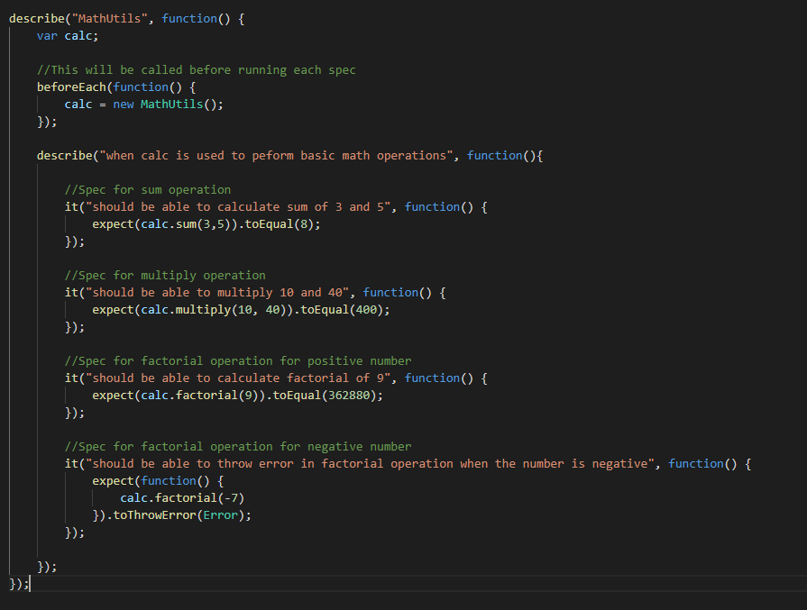
With jasmine, you must create files called Specs that represent a file of test cases, within these files, you must have what the functions being called expect their results with the inputs being imported. This will give us an indication of the service that it is working correctly, and it will output an error if incorrect.
When everything is compiled and setup, jasmine will show a results sheet once complete and will show you if functions are functional and if there were failures shown in the image below.
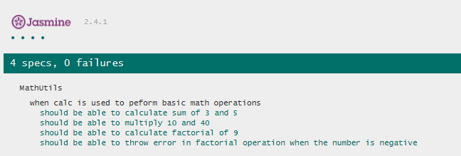

Developing Node.js Web Application using Ajax (7)
The student looked at creating all types of web applications and what would be best to create with AJAX as a leading contributor to the project. In the end, they decided to choose to create a live weather application that can tell users their current weather around them or the world. This could possibly allow users to find out the current temperature, humidity, and current weather situation.
The web application will be able to show the current weather in a location that can be searched, or the user can get their current location and get the latest weather of their area.
The target market for this web application is focused on children, as it is simple and easy to use with not much complex interaction and allows children to gain great insight into the weather around the World.

Web Application Requirements (8)
Node.js (8.1)
Node.js was chosen as the central web server architecture, as this was one of the main requirements for the task given to them. Node.js is lightweight and easily interactable, with many libraries supported. Many libraries can be found via the Node Package Manager, which is a large and great community of libraries built by individuals and teams.

Express.js (8.2)
Express is a web server framework that is both fast and minimalistic and takes all the complexed parts of a web server, e.g., web communication, data transmission, file types, and much more this allows developers to skip all the boring parts and instantly start developing without wasting time and increasing productivity.

Typescript (8.3)
Node.js is usually built with the language JavaScript but can also be made with many languages. Typescript is known as a superset language that is built upon JavaScript that allows developers to use typed variables in whilst creating the web server architecture this stop developers from making mistakes in the future by assigning variables with incorrect types, which leads overall to fewer bugs and more consistency within the source code.

Ajax (8.4)
Ajax is a library of web development techniques using many web technologies, all combined into one. It allows for asynchronous communication with web servers on the client, allowing for page updates without the server or client rendering an entirely new page.

Embedded JavaScript Templating (8.5)
Embedded JavaScript Templating (EJS) is used for creating templated web pages this permits developers from creating duplicate web pages for each individual change because the webserver will send details back to the user of what information will be displayed to the user and the client will render that information on the web page this is called dynamic templating and is hugely used within the industry.

Mapbox API (8.6)
Mapbox allows clients to collect information on locations based on a location name. This API will be beneficial for converting location names to geographical coordinates that would be used for weather information in a specific area.

Darksky API (8.7)
Darksky is a weather API that allows developers to collect the latest, future, and past weather information based on a geographical location using coordinates.

Implementation (9)
Ajax (9.1)
Ajax was used to interact with the web services provided by the webserver to allow clients to request weather data of a location and quickly see the weather changes without having to load or reload the web page. This allowed the developer to create instant updates of weather information every 60 seconds. Still, the user could also search for the weather of other locations, and it would update the page accordingly.

Http Service Module (9.2)
The HTTP service module is primarily used to interact with both API’s that have been mentioned this allows the server to send direct requests to the required web services and will enable us to gain insightful info into both location details and the latest weather from that location.
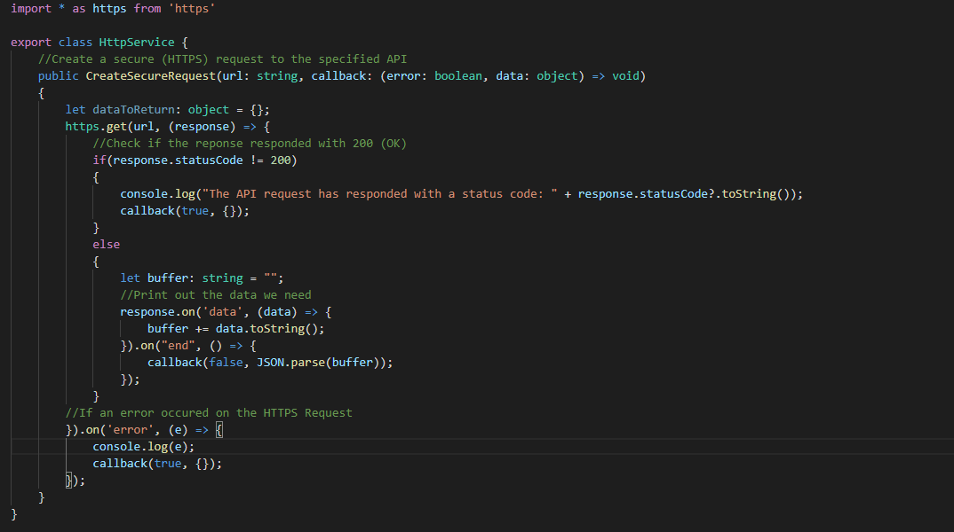

Geocoding Service Module (9.3)
The geocoding module interacts with the Mapbox API and allows for location names to be forward geocoded into latitude and longitude coordinates allowing us to use this to find weather information in the future. The module also has reverse geocoding, which allows the webserver to accept a latitude and longitude and request Mapbox to give us the location name and details of the coordinates if they are valid.
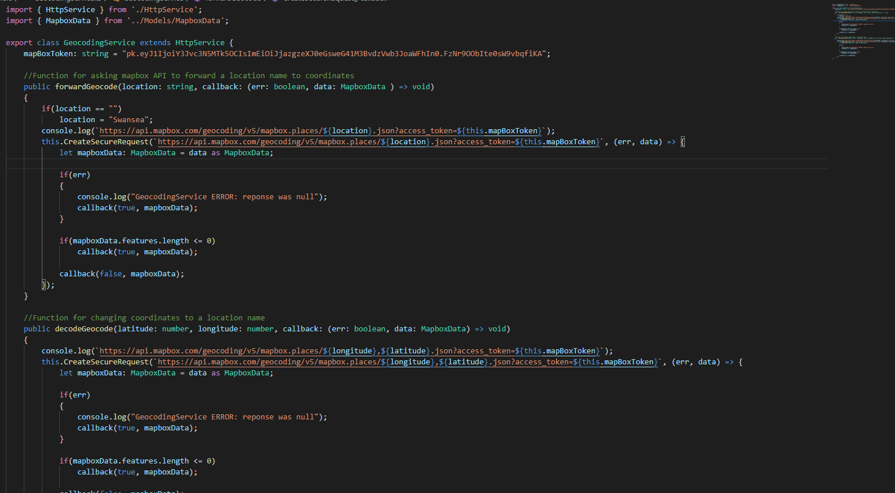

DarkskyData Service Module (9.4)
This module is inherited from the HttpService and requests specific data from the Darksky API allowing the webserver to collect the latest weather details in a particular location required from the client using latitude and longitude positional coordinates.
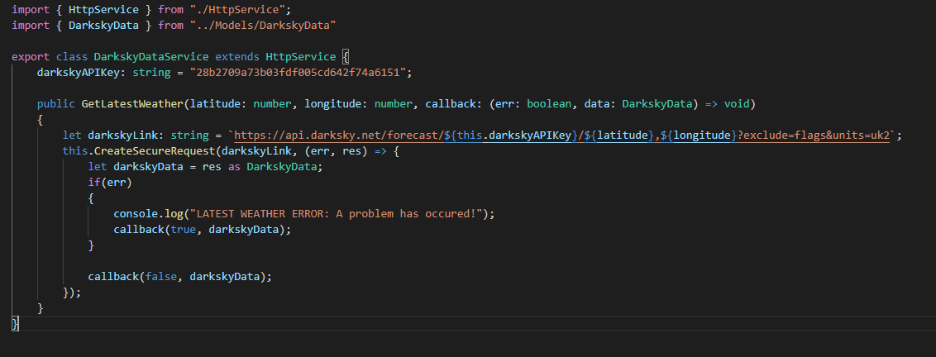

Weather Service Module (9.5)
The weather service module is the main component of all the connections between the API’s and data. This module is the central controller that allows data to be sent out from the webserver and be collected, ready to be parsed back to the client with the weather updates. It combines both the Darksky Module and Mapbox Module so that they can both wait for each other before proceeding with the next step in functionality.
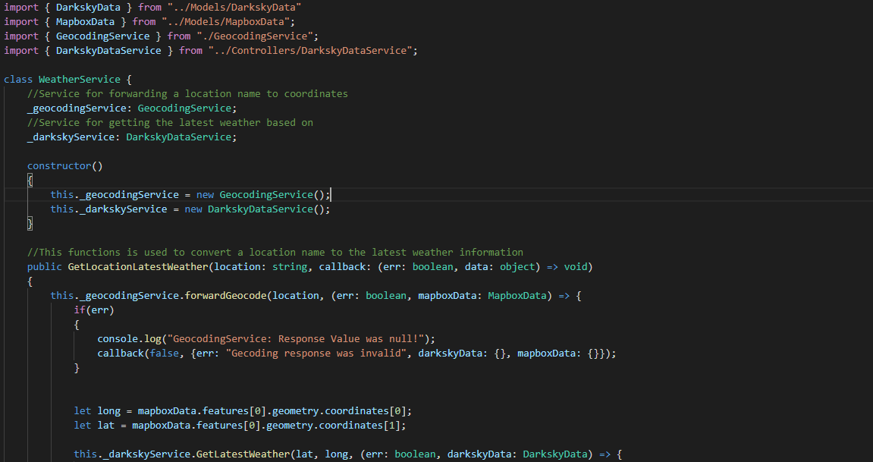

Final Look (9.6)
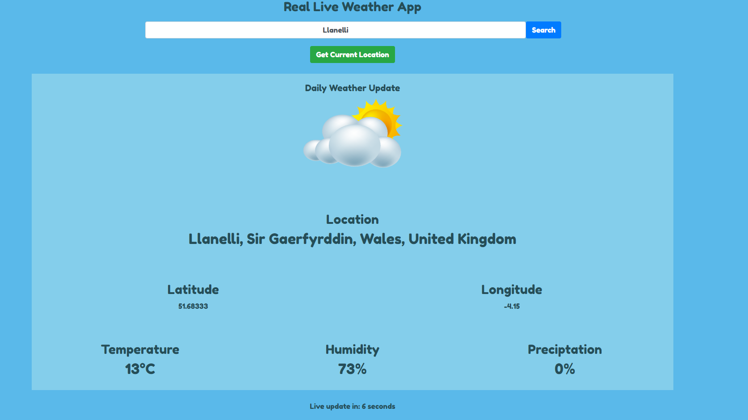
The overall look of the web app was effortless to both read and interacted with, and the information displayed was accurate and could quickly identify what the weather was like in the current location being searched.

Conclusion (10)
In conclusion, we looked at testing methodologies, specifically white and black box testing, and the advantages and disadvantages of both and what the potential differences are and how they affect the software development process.
Secondly, we delved into Behavioural Driven Development, and how it affects both the development cycle and work environment, we also looked at the productivity changes that would have to take place for this method to be introduced and what the developer must do to implement this method of development.
Thirdly, we looked at Jasmine, a test framework that is widely used in businesses and how unit tests are both created and integrated with source code. The main components of the test framework were looked at and why a company or developer might choose to take on the context as their principal tool for unit testing in their product.
Finally, we got shown what the student had developed for their task and looked at the requirements that would be needed for the job to be developed and deployed. Overall, it seems that the student in question learned a lot during this development process as they had to deal with a large number of web services and integrate them so they can work efficiently without any knock-on effects.

References (11)
[1] W3schools.com. (2019). W3Schools Online Web Tutorials. [online] Available at: https://www.w3schools.com/.
‌[2] Inviqa. (2015). The beginner’s guide to BDD (behaviour-driven development). [online] Available at: https://inviqa.com/blog/bdd-guide [Accessed 18 Apr. 2020].
[3] Feguson, J. (2015). BBD in Action. 1st ed. Manning Publications, pp.15, 16.
[4] Feguson, J. (2015). BBD in Action. 1st ed. Manning Publications, pp.17, 18.
[5] Dows, M., Mcdonald, J. and Schuh, J. (2006). The Art of Software Security Assessment - Identifying and Preventing Software Vulnerabilities. Addison Wesley Professional, pp.26, 27.
[6] Rongala, A., Manager, Development, B., Marketing and Technologies, I. (2015). What is White Box Software Testing: Advantages and Disadvantages. [online] Invensis Technologies. Available at: https://www.invensis.net/blog/it/white-box-software-testing-advantages-disadvantages/ [Accessed 18 Apr. 2020].
‌

‌

‌

‌

‌

