Tania Vaninna Zalazar Poletti
Student number: 2021161
Abstract
CertHE in Skills for the Workplace.
Problem Solving and Decision Making.
BMSW4004.
Lecturer: Yajesh Kumar.
academic report
PRS Task 2

Contents
Introduction. 1
The problem. 1
Possible solutions. 2
Final Solution. 3
Monitoring Plan. 3
Conclusion. 4
Reference list. 4
Attachments. 5

Introduction.
Please report is made to define my problem-solving tools and techniques and two proposed different solutions to a specific problem developed in my workplace. For this report I will be using a problem that happened in my previous workplace. I will explain the problem and all the consequences that it can bring, I will analyse furtherly the problem to be able to find the root of it to start developing solutions using the tools learned through this module. Once the solution is defined, I will create a plan to monitor the solution to make sure it is successful, and the problem doesn’t occur again.

The problem.
Let's start by defining what a complex problem at work is, a complex problem is when a situation is not showing the desired results and it needs to be changed to get where the company wants it to be. In this case the example used will be based on the manager I had on my previous workplace. The main problem here was the bad management, which was bringing lack of organisation, communication and recognition throughout the whole company. In the attachment will be found a fishbone diagram with the different consequences that the bad management was bringing to the company. We can cite a few like the loss of motivation from the employees, reduce productivity and an increased turnover. All these problems, if accumulated, could bring to the company less clients, therefore less sells, therefore fewer working hours which could lead to the shortening of staff and after, closure of the company. If the employees are not satisfied, they will not have a proper productivity which will lead to the crumbling of the company.
According to Allen (2019), people leave their jobs usually because of their supervisors, managers, or people above them, and “the loss of a talented employee costs the organization one and a half times the employee’s annual salary in replacement costs and lost productivity”. In this situation, this is a very small company which only has 8 employees, a manager and the owners, and the loss of staff obviously shakes the balance of the whole company. The consequences of losing staff because of bad management will be bigger This company than the impact that it has in bigger companies which has a higher number of employees.
Also, according to Deeb (2011), bad management has led to closure of companies, the misuse of fundings and the bad planning of budget will result in the inability to cover losses and the company will inevitably fall. These are just some of the biggest consequences this can have, but it is very important to remember that it is all a process, and this will not happen in a night, all of it takes time and it is crucial to be very focused on the signs to stop this on time and keep your company from failing. We can cite some of these problems, like the loss of motivation of the employees which will lead to more absences, which can result in the extra amount of work for the staff that does show up to work. There is also the unsatisfaction of the clients, the less effective the employees are, the slower the service is, therefore, there is a bad service and unsatisfied customers.

Possible solutions.
There is a wide range of possible solutions to this specific problem that have been proved to work. It is usually the first option to speak to the people above these managers or supervisors to try and get to talk with these people, give them a warning so they can change their behaviour and stop the problem, set up some goals for him to follow and track his progress to determine if this behaviour can be changed for the better (Workopolis, 2015), as the easiest alternative is to try and solve the problem internally first. If this does not work and this person is still presenting bad behaviour and wrong use of their power, it will be necessary to remove this person from the current position and begin a process to cover it.
If the company gets to this situation, there are two different ways to decide this situation, I said before the company will always try to solve this problem internally first, so one of the options is to train and promote one of the existing employees. This option can be very viable because it promotes growth within the company and also there is a higher chance that this person will understand what is needed and how to handle the situations at this company given the fact that he has come from the very beginning of the hierarchy and already knows how the system works from its base given his previous experience with the system and the familiarisation with the staff and the internal processes. Although it has its positive side, this can also be very time consuming as the trainings can take very long and can also be quite expensive.
The other option would be to hire a new manager from the outside. This is also a very viable option, but it has its risks, in this situation will be needed to give a full training on the whole system of the company and it will take time for this new person to get familiarised with the company and the way it works. It will be expected from the prospectus to have previous experience, which limits the search, but this will also ensure the capability of the new person taking the responsibility. It will also be needed a trial period for this new employee, as well as a monitoring process and a follow up to make sure that the mistakes are not repeated.
Once any of the options have been chosen, it is key to make sure to measure the performance of the employees, the managers, and the company itself, and choose a permanent solution to avoid the growth and accumulation of further problems in the future.

Final Solution.
In this case the taken solution was to promote an employee from the inside to take the position of management. A SWOT analysis of this option has been attached at the end of this report. This decision has been made based on the fact that a warning has been given to the previous manager and he did not comply with the measurements provided by the examination board and the situation ended on the termination of contract of the manager and the gap of this position was left to be refilled by someone else. After considering all the possible options to cover this position, it was established that given the experience and years of hard work of some employees, training will be provided by the company to offer growth and learning opportunities to these people. This will not only prove that recognition is present in this company, but it will also motivate the other employees to work harder with the possibility of getting a higher position with a bigger salary in the future.
Research done by Bleich (2019), has shown that these are very necessary trainings for new managers:
- Industry-specific regulations
- Creating an inclusive workforce
- Conflict resolution
- Cybersecurity
- Hiring and firing
- Nurturing talent, coaching, and employee retention
- Emergency procedures
- Identifying training needs
- Accessibility requirements
- What it means to manage
All of this is to ensure that successful managers are created from now on, to avoid more problems in the future. People expect managers to arrive fully conscious of the needs of a proper manager, when in reality it is our responsibility to mould them according to the company’s needs and wants.
All this training will be provided and fully paid by the company.
This will be informed to the stakeholders through a face-to-face meeting in which all of this analysis will be presented as well as the approval and support of the counsellor and the owner of the company.

Monitoring Plan.
Madjoski (2016), tells us that the first step to ensure that our new system works and succeed is to set targets. It is very important to make sure that these targets are measurable, otherwise, the target is useless. It is crucial to determine our Key Performance Indicators, as well known as KPIs, as this is what we will be controlling. “Some examples of KPIs are revenue ($), income ($), market share (%), number of new products on market (number), customer churn (%), employee fluctuation (%), employee satisfaction (index) etc.”
Along with all of this, is important to find the source of the information, which could be taken from the financial reports, or the notes taken during the meetings. Once this is done, a schedule has to be set up to keep track and monitor properly. In this specific case, most of the targets will be measured every 2 weeks, but a part of it will require a daily follow up. Lastly, we need to set up the material to be used for this objective. A budget for training will be set up and a list will be developed with all the necessary people, money and material to be used during the monitoring period. When all of this is being determined, a person has to receive the responsibility of keeping records of all the information. It is important to be open to changes and give room to improvement.
For this company has been decided that a budget of £10.000 will be used for the purpose of training. The operational manager will be responsible for the data collection during the monitoring process and 2 people will be trained first. There will be a 3-month period for training a month period for trial after the training is done. In this trial time, performance of the trainee will be assessed, as well as the sales of the company, and the satisfaction levels of the employees and clients. External companies will be hired to provide the training and given the current covid situation, most if not all of the training will be given online.

Conclusion.
This report has been very useful to explore in a deeper range the abilities and tools learned through this module. I was able to define a complex problem at my own workplace and to identify all the problems attached to it. Through this report I was able to use different problem-solving methods to identify the main consequences that this problem can bring. I also used brainstorming to identify 3 different solutions, explained them completely and compared them in detail; and lastly, to use some decision-making tools, I developed a SWOT analysis to define which one out of the 3 solutions was the best option to finally solve the problem. I then proceeded to explain the analysis and why I ended up choosing that specific option, laying out all the factors and also citing the different tools and methods to be used in this process. To finalise the report, I explained the definition of a monitoring plan and developed one myself to ensure the success and thrive of the new plan, laying out the approximate time this would take, as well as the budget and material to be used during this process. Thanks to this report I was able to reread all the tools and information given and I was able to expand my knowledge about problem solving as well as sharpen my decision-making abilities. This report has helped me to develop a whole new plan for a difficult situation and has boosted my confidence to take action to resolve problems in the near future when they become present in my life.

Reference list.
- Allen, M. (2019) The real costs of bad management and what you can do about it, Graziadio Business Review.
- Bleich, C. (2019) 10 topics to include in your new manager training in 2020, EdgePoint Learning.
- Deeb, C. (2011) What Happens to an Organization with Bad Management? Small Business - Chron.com.
- Workopolis (2015) How to fix a management team that sucks, Workopolis Hiring.

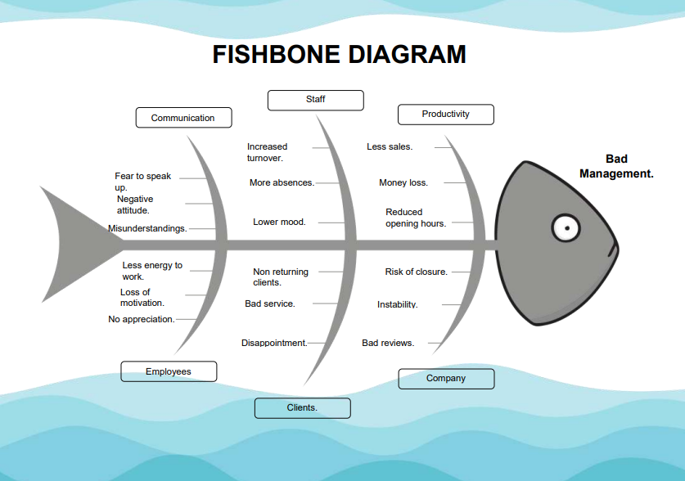
Attachments


