

communication skills for success within the workplace.

Student: Faiza Razak
Student ID: 2020832
EFFECTIVE TEAMWORKING AND COMMUNICATION
BNSW4002_LON GROPE 6
Lecturer name Timothy Hopkins

Table of Contents

1 Introduction 3
2.Communication models 4
2.1 Shannon-Weaver communication model ….................................................................... 4
2.2. Case study 6
2.3. Berlo model of communication 1960 7
2.4 case study 8
2.5 Schramm’s communication model....................................................................................9
3 communication in the world of work...................................................................................10
4. communication methods..................................................................................................11
Conclusion 12
6 Referencing 13
7. Appendix 1 15
7.1 Appendix 2 16

1.Introduction
This report focuses on communication skills and communication method. Scholars have created numerous models to explain the social process of communication., The three most well-known communication models explain in this report with cases Stady. And this report shows the importance of communication in the workplace.
What is communication?
Making, interpreting, and negotiating meaning is the process of communication. Verbal, nonverbal, and textual communication are all options. It could be auditory, visual, or even bodily in nature. Despite the fact that communication takes many forms, it is always a learnt behaviour. People must learn to communicate via codes, symbols, and linguistic systems, despite the fact that most humans are born with the physical capacity to speak, hear, see, and so on. In this sense, communication is a group activity in which people develop and interpret meaning through the use of symbols.

Effective workplace communication is a critical component of a company's success; it improves internal and external relationships, as well as employee engagement and a team's overall effectiveness.

(J.zambas 2021)

2. communication models

2.1Shannon-Weaver communication model
The communication process is studied using a variety of models and theories. We'll look at one of the most well-known here: the Shannon-Weaver model. It was first published in 1948 and has since been adapted, updated, and developed in several ways. Warren Weaver was a scientist, while Claude Shannon was a mathematician. They were especially concerned in “machine translation,” or the transmission of information by early computers, radios, and televisions. The idea, however, is equally applicable to human communication, and it continues to have a great influence in modern social sciences. It is also referred to as "the mother of all models" because it is the cornerstone of most current communication theories.
The Shannon-Weaver model divides the communication process into five stages:
Sender, encoder, channel, decoder, and receiver

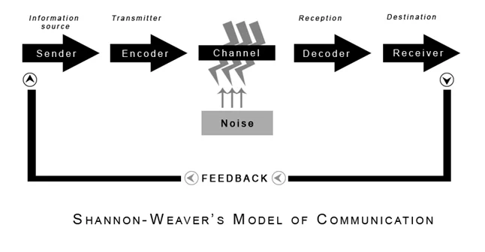
The sender is the individual, group, or organisation who comes up with the idea for the message they intend to transmit.

This message is translated into signals by the encoder. To put it another way, this is the language we use to communicate ourselves. It could be expressed in writing or speech, as well as through signing or body language. Using gifs and emojis is also a type of encoding.
The method by which the communication is delivered is referred to as the channel. This could be sound transferred over the airways in a spoken discussion, or binary data sent by email or text. Of course, the transmitter and recipient may require equipment such as phones or laptops, depending on the channel.
The communication must be decoded when it comes. This stage outlines how the communication is interpreted and translated into language by the receiver. This might be a machine that does this electrically using binary data, or it could be our brains picking up on all the language and communication data, such as words, pictures, intonation, and so on, that make up a communication transaction.
Finally, the receiver receives the message, which their brain interprets into something meaningful.
There was a huge difficulty when this approach was first introduced: there was no feedback. Weaver later developed the feedback element, which is the decoder's response to the encoder message to demonstrate that they have correctly understood the information.
Lecturer Timothy Hopkins delivered a case study, which was explained using this communication model. Maria and Pedro, Maria told Pedro to bring a chicken home, but the noise source caused an interruption, and he mistook this for the kitchen because there was no feedback, and they were unable to clarify the original message.
Refer to Appendix 1 Maria and Pedro

2.2 Case study
I was in the winter Wonderland with my kids when I phoned my husband up and I asked him to meet us there,
Husband: where do you want me to meet you?
Me: near the big wheel
After 10 minutes my husband called me back and asked me
Husband: where are you, I'm near the big wheel
Me: we are near the big wheel in winter wonderland
Husband: oh, I am at the London eye
I told my husband to come to winter Wonderland big wheel, but the noise source or Bluetooth device caused an interruption, he missed out winter wonderland, there was no feedback, I was unable to clarify the original message.
This case study belongs to Shannon-Weaver communication model, feedback is taken as less important in comparison to the messages sent by sender

2.3 Berlo's Model of communication 1960
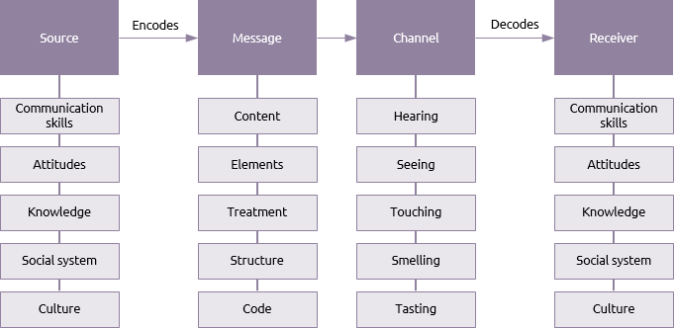
In 1960 guess study page #6 number 6 okay, David Berlo presented his communication theory. Because of the four components: source, message, channel, and receiver, it is also known as the SMCR (Source Message Channel Receiver) model.
This model was created by Berlo and is based on the Shannon-Weaver communication model (1949). He discussed certain factors that improve the effectiveness of communication.
According to Berlo 1960, if the sender has good communication skills, the message is more likely to be comprehended than if the sender does not have good communication abilities. To understand the message, the receiver will also require solid communication skills. Individual attitudes, knowledge, social systems, and culture all have an impact on how a message is presented and received; for example, something may be regarded very offensive in one society but widely acceptable in another. This factor can cause interference or noise in the communication process. The source should make sure the message has the right content. Berlo also discusses five cents and how they play a role in delivering the message, not just about oral language

An activity to do in class The professor had a different background than the village people, so he chose words that they couldn't understand. In this exercise, I used both Berlo and Shannon -weaver models to explain how the professor had a different background than the village people, and he chose words that they couldn't understand the social system, knowledge, and communication All played a role in this, since he should have used straightforward language to communicate his needs to his audience.
Refer to Appendix 2 professor and village people
2.4 case study
my friend has a garage and one of his employees Victer’s second language is English that's why he has a language barrier. One day a customer came to have a bulb changed victor change the light bulb and then he asked the other mechanic to open the light and check it and then victor rushed off to the bathroom when victor got back, he realised that the mechanic had dismantled the whole light. victor said why did you take apart the light the other mechanic had realised what had happened and he said to Viktor you should have told me to switch on the light and not open it.
In this case study victor does not have good communication abilities in English

2.5 Schramm’s Communication Model

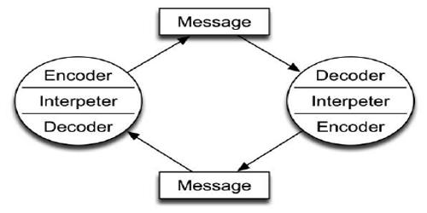

Wilbur Schramm in 1954, where he suggested that communication is a two-way process where both sender and receiver take turns to send and receive a message.
Coding and decoding are the two basic steps of effective communication, according to Schramm's communication model. He goes on to say that communication isn't complete until the sender receives reply from the recipient. (biznews 2021)

This is the first communication model this is not a linear one. This model believes communication to be a bilateral process rather than a unilateral one, making it a circular model. This paradigm allows both the sender and the receiver to create and transmit the message to the other person, allowing them to take on the role of the other.
According to Schramm, an individual's culture or background can influence how a message is interpreted, and this acts as noise because a single word can have multiple meanings. As a result, a person's cultural or background differences can influence how they understand a message, resulting in misunderstandings. This paradigm can be used to eliminate misunderstandings by requiring the receiver to confirm that they comprehended the original message.

3. Communication in the world of work
When a message is transmitted and received correctly, it is said to be effective communication. (A. Cheng.2020) Just because you think you are sharing ideas and information properly in your company does not imply it is working.
Communication can improve teamwork and project collaboration. It can be applied to almost any sector.
The basic truth is that effective communication entails more than just the ability to deliver information and ideas more precisely and succinctly. It's also about more than just reducing conflict and improving team morale. Sales, customer connections, team development, corporate culture, employee engagement and buy-in, and creative thinking all require effective communication.

A company succeeds when it communicates effectively both internally and internationally. Most businesses require effective communication not only among staff, but also with vendors, clients, consumers, and the public. Companies that transmit confused messages, whether through confusing marketing, poor customer service, or a slow response time, suffer from a lack of effective communication in the long run.

4. communication methods
A method of communicating messages, thoughts, or information from one person to another is known as communication. Oral communication, written communication, verbal, non-verbal communication, and visualizing are all examples of communication methods.
Verbal communication
Verbal communication is described as the act of communicating or conveying thoughts, ideas, or any other piece of information between two or more people or groups through sounds or words. Modes of communication include television, radio, and cell phones.
Oral communication
One of the ways it does this is through oral communication. Oral communication refers to any interaction that takes place via the use of spoken words.
Nonverbal communication
Body language, posture, facial expression, eye contact, space touch, and gesture are all examples of nonverbal communication.

Written communication
Written communication is the act of conveying information by writing, typing, or printing symbols such as letters and numbers. (Indeed Editorial Team.2021)
Any corporate communication, written communication is the most significant and effective. Written communication includes Memos, Reports, Emails, Internet websites, Letters, and Instant messages act.
Visual communication
The practise of graphically displaying information to create meaning efficiently and effectively is known as visual communication.
Visual communication can be used in a variety of settings, including conferences and trade exhibits, websites, social media posts, workplace presentations and meetings, and more.

5. Conclusion
Effective communication allows people to send and receive messages. It is critical to acquire this skill for both professional and personal reasons to avoid misinterpretation and misunderstandings. This report examines communication in a business setting, discussing communication theories and how miscommunication can be avoided. These examples demonstrate that effective communication skills in a business setting are critical, and that following communication processes leads to a productive outcome. Communication should be tailored to the audience and is essential.

A. Mann (2018) 5 top tips for creating an

6. references

A.Cheng. (dec 17 2020) Available at: The importance of effective communication in the workplace.
https://www.ringcentral.com/us/en/blog/the-importance-of-effective-communication-in-the-workplace/ (Accede 17.8.2021)

C. Drew, (February 23, 2020) All 8 Models of Communication, Explained! Available at: https://helpfulprofessor.com/communication-models/ (Acceded 13/8/2021)

H. Bhasin (April 29, 2021) Schramm’s Model of Communication | Elements, Advantages & Limitations Available at: https://www.mrketing91.com/schramms-model-of-communication/ Acceded (11.08.2021)

Indeed Editorial Team (April 23, 2021) 4 Types of Communication and How to Improve Them Available at:https://www.indeed.com/career-advice/career-development/types-of-communication Acceded (22.08.2021)

J. Zambas (4 august 2021)
The Importance of Effective Communication in the Workplace. Available at: The Importance of Effective Communication in the Workplace (careeraddict.com) (Acceded 16.8.2021)

A.Maud. M.Shriek. And P.K.Tinkler (2017) certificate in higher education skills for the workplace in student yearbook. LONDON Sage.

M.C. Novak (April 8, 2019) Everything You Need to Know About Communication Theory. Available at: https://www.g2.com/articles/communication-theory (Accede 12/08/2021)

P.Bosworth . (May 13, 2021) The Power of Good Communication in the Workplace. Available at: https://leadershipchoice.com/power-good-communication-workplace/ (Acceded 17.08.2021)

7. Appendix 1

MARIA and PEDRO

Pedro works on a building site and Maria is his wife.
One day Maria phoned Pedro. ‘Hello, Pedro, when you’re coming home, see if you can get me a chicken.’ ‘Okay,’ replied Pedro.
When he got home, Pedro took off his boots and coat and went into the kitchen.
Maria, where are you?’ He said.
‘Here – in the sitting room,’ she said.
When Pedro went into the sitting room, Maria said, ‘Where is the chicken?’
‘What Chicken?’ Asked Pedro.
The one I asked you to get on your way home.
’ Oh, no! I thought you said when I come home I will see you in the kitchen!
Q: Why do you think Pedro misunderstood Maria?
Q: Whose Model of Communication explains this confusion and why?
Q: How could this have been prevented?
Q: Whose Model of Communication explains how it could have been avoided

appendix 2
A Professor of English at a well-known Welsh University lived in a large house not far from a little village. He never went into the village, but shopped in the town near the University because he had nothing in common with the village people, who were mostly not educated, but did manual jobs.
One night, the professor fell asleep while smoking his pipe and the pipe fell onto the carpet and started a fire.
When the professor awoke and saw the house on fire, he rushed into the village, screaming:
‘The edifice is being consumed by a great conflagration!’ ‘The edifice is being consumed by a great conflagration!’
The village people looked at him and continued doing what they were doing ‘Don’t you understand?’
He said. ‘‘The edifice is being consumed by a great conflagration!’ They ignored him.
When the Professor returned home, he saw that his house had been completely destroyed. He sat down on the ground and wept.
The next day, he went into the village crying. ‘Why, oh why didn’t you help me? My home has been destroyed by the fire. I came and begged you last night.’ He wept.
‘But Professor, why didn’t you say that your house was on fire? We would have helped.’

Q: Why didn’t the village people help the Professor?
Q: What should he have done to get them to help him?
Q: Whose model of communication do you think can explain this situation?

