

Manufacturing Design and Technology
Polymer Processing Plant – Precious Plastics Report

Aaron Pritchard
P151481

1. Executive Summary
This report looks to expand on the initial start-up ideas that Precious Plastic has created to provide accessible possibilities to recycle plastics domestically on a global scale. Precious Plastic have created four machines designed to fit within a shipping crate so that not only are their ideas universally accessible, but also conveniently sized to fit in the majority of working areas. Factors that are considered to further enhance Precious Plastics current designs are those such as the improvement of cycle times, process efficiencies and how the current designs could be improved to increase educational opportunities with improved Health & Safety. Material selection is given careful consideration so that wherever you are in the world, components can be locally sourced while maintaining low costs.

Contents
1. Executive Summary 1
2. Introduction 3
3. Current Design Compared to an Industrial Based Design 5
3.1 Costs 9
3.1.1 Bill of Materials (BOM) 9
3.1.2 Engineering Costs 10
3.1.3 Energy Usage and Efficiency 11
3.2 Ease of Assembly 11
3.3 Cycle Times 12
4. Design Specification 13
4.1 House of Quality 13
4.2 Product Design Specification 16
5. Appraisal of Concept Designs 20
5.1 Concept Design One – Structural Column 22
5.2 Concept Design Two – Reduced Cycle Times 23
6. Final Design Solution 25
6.1 Improved Structure Rigidity 25
6.2 External Compression Design 26
6.3 FMEA 28
7. Conclusion 29
7.1 Areas for Future Consideration 29
8. Bibliography 32

2. Introduction
Precious Plastic was started in 2013 by Dave Hakkens in an attempt to find a solution to plastic pollution on a global scale. Hakkens idea consists of hundreds of people around the globe providing the knowledge, tools and techniques required in order to create workspaces where plastic recycling could be accessible by everyone (Precious Plastic, 2018). Precious Plastic share all of their designs, equipment and plans online, for free to try to encourage individuals or groups around the world to create their own polymer plastic recycling machines on a smaller more communal level with materials that are readily accessible all around the world.
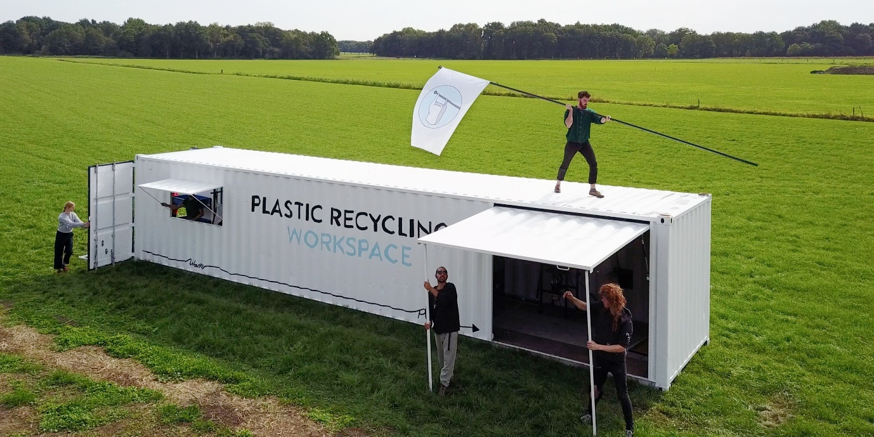
Working independently, the company relies on donations from its global community around the world to continue to share their vision and guidance. With this funding, Precious Plastics have been able to create four space saving processes which can all fit within a large shipping container with dimensions of 40ft x 8ft x 8.5ft, allowing the entire recycling process to be completed by the public. Figure 1 demonstrates one of these shipping containers.
Figure 1 - (DDW, 2017)

Precious Plastic has four machine types which it provides material lists and guidance to build on its website. These machines are:
- Shredder machine – Plastic waste is shredded into small flakes which can then be used as raw material to produce other products.
- Extrusion machine – The extrusion machine allows the plastic flakes to be inserted into a hopper and heated up while force extruded into a line of plastic stock material.
- Injection machine – Plastic flakes can once again be heated and injected into a mould using this machine whereby the mould can create new products. Precious Plastics advise how moulds can also be made by the consumer.
- Compression machine – Plastic, not just flakes, can be heated inside an oven like device and then slowly pressed into a mould using a simple tool such as a car jack in order to create larger, recycled plastic products.
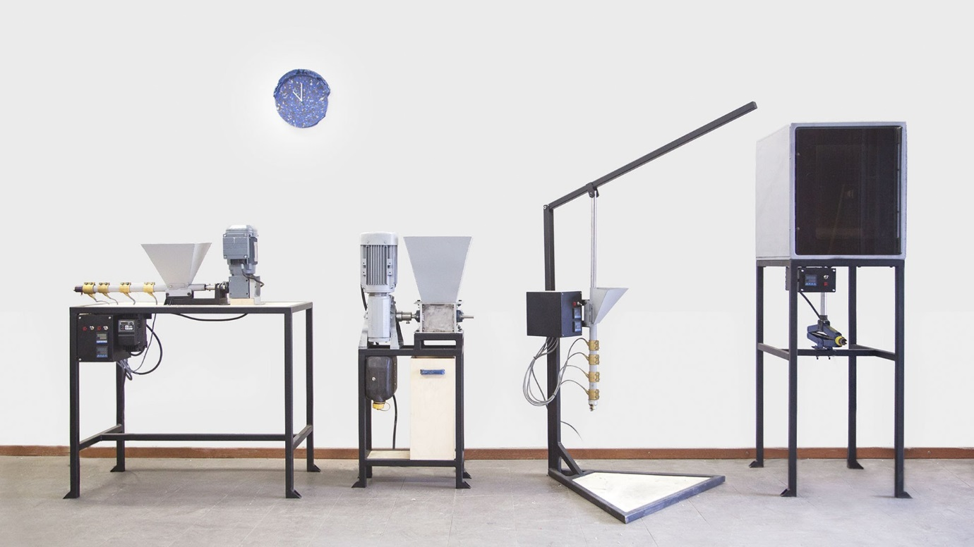

Figure 2 - (Dave Hakkens, 2016)

3. Current Design Compared to an Industrial Based Design
Precious Plastic’s oven based compression machine is one that I feel can be improved greatly. The compression machine is designed to heat, mould and house the finished product until it cools down and forms the recycled plastic object. One report by Lenkiewicz (2017) for Waste Aid expands on developing products one-step further with polymer melt compressed moulds by making paving tiles or bricks for walls. Lenkiewicz explains how the products are non-water absorbent, ensuring clean water storage possibilities and how bricks made with these materials are good insulators resulting in walls that keep you warm in winter and cool in summer. The possibility of including sand into the polymer melt mix for these products also make them fire retardant as once the outer layer of plastic has melted, the sand is left which is not flammable, resulting in a slower spread of the fire through the brick.
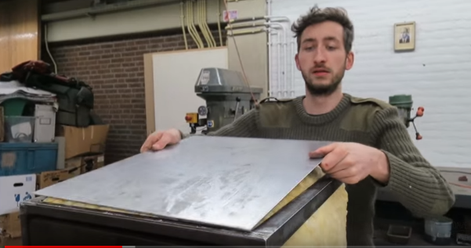
When comparing this domestic machine to an industrial scale machine, there are many shortcomings understandably. From an initial stand point, the most concerning area needing consideration are the Health and Safety aspects. When considering Precious Plastic’s homemade device, there are no guards in place except the mild steel plated insulation panels on the side of the oven housing as shown in Figure 3.
Figure 3 - (PreciousPlastic, 2016)
An industrial scale compression moulding machine is much larger and is regulated by industry recognised Health and Safety Laws whereby sufficient guarding must be in place to protect the operator whilst the machine is in operation. Continuing with this idea, an industry machine would be fitted with an emergency stop (E-Stop) button as required by workplace laws. An E-stop allows the machine to be powered down immediately in an emergency. The UK Government legislation website (2018) states that a control device must be located outside the danger zones, except an emergency stop when necessary. This statement highlights the importance that this control device has with safety. This power outage feature is not possible with Precious Plastic’s design and would ultimately result in more complicated engineering abilities and cost, resulting in a less accessible model for customers of all skillsets. Due to the design of the compression machine requiring an oven that holds large amounts of heat energy even if an E-stop was to be activated, over dangerous aspects still require attention from a health and safety stand point.
Health and safety covers operational hazards such as requiring an E-stop press but also for any process hazards present to the operator such as extreme temperatures, moving parts or resultant occurrences from the process itself such as fume production. The Canadian Centre for Occupational Health and Safety state how fumes are solid particles generated by condensation from the gaseous state from a melted substance often accompanied by a chemical reaction such as oxidation. They expand further to explain how fumes are different to vapours or gases which both are present during room temperature states, unlike fumes. It is well documented across a variety of different studies, however WECF (2015) who gain support from the European Commission make the following statement regarding the concerns of fumes created when burning plastics such as PVC on their website:
“The most dangerous emissions can be caused by burning plastics containing organochlor-based substances like PVC. When such plastics are burned, harmful quantities of dioxins, a group of highly toxic chemicals are emitted. Dioxins are the most toxic to the human organisms. They are carcinogenic and a hormone disruptor and persistent”
According to Physics Stack Exchange (2013), an informative science-based website, it is important to consider that burning plastics and melting them will provoke very different reactions. Melting plastics involves heating the solid material up to a liquid stage where you can change its shape and re-set it back to a solid without the reaction to an external substance such as Oxygen. This happens prior to burning due to the lack of reaction with an external substance and the dangers come from burning plastic as this provokes a chemical reaction. What happens when a domestic compression oven is forgotten about and the plastic inside begins to burn, this is when the dangers present themselves. It is stated by the UK Government website that the burning of plastic materials creates poisonous fumes and can have damaging health effects on people which is covered in the Environmental Protection Act 1990 (Plasticisrubbish, 2008). The report on Plastic Is Rubbish’s website proceeds to state the dangers associated with certain plastics, it acknowledges how;
“Burning these plastics can release dioxins. Dioxins are unintentionally, but unavoidably produced during the manufacture of materials containing chlorine, including PVC and other chlorinated plastic feedstocks. Dioxin is a known human carcinogen and the most potent synthetic carcinogen ever tested in laboratory animals. A characterization by the National Institute of Standards and Technology of cancer causing potential evaluated dioxin as over 10,000 times more potent than the next highest chemical (diethanol amine), half a million times more than arsenic.”
Therefore although considered far less dangerous or if at all dangerous, fumes are however unavoidable during the melting down of plastics and therefore the health risks cannot be ignored. On an industrial scale there are three main legislations regarding fume extraction according to BOFA, a world leader in fume extraction technology. BOFA (2018) states that these three legislations consider that:
- The safety and suitability of the extractors is the responsibility of the manufacturer.
- The safety of the workers using the equipment is the responsibility of the employer.
- Hazardous waste is the responsibility of the end user and any particulate, fume or vapour captured by the filters in the extractor may cause the spent filters to be classified as Hazardous waste.
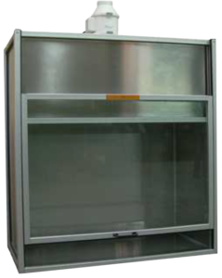
Precious Plastic have not included a fume extraction unit in their compression oven design. This poses several health risks to the user and although the device is created domestically at home so holds no responsibility to Precious Plastic for people recreating their devices, it is still an area of concern. Many ovens, the main component for the compression device, exhaust fumes as standard which poses a problem. The fumes are not controllable unless the machine itself is placed inside an extraction chamber during operation to prevent any fumes escaping as shown in figure 4.
Figure 4 - (SMT, 2018)

An extraction chamber is not an ideal solution for domestic machines, therefore an alternative idea would be required. My proposal would be an independent extraction unit placed in the room the oven is operating in. An independent extraction unit with filters would purify the air within the controlled environment such as an outbuilding and consequently would increase the safety aspects considerably. A problem would arise if the oven is operating outside a controlled environment as fumes would not be contained and therefore could escape into the atmosphere, posing environmental risks.

3.1 Costs
For any business plan to succeed, costs need to be an area of focus. There are different areas of the project where cost needs addressing.

3.1.1 Bill of Materials (BOM)
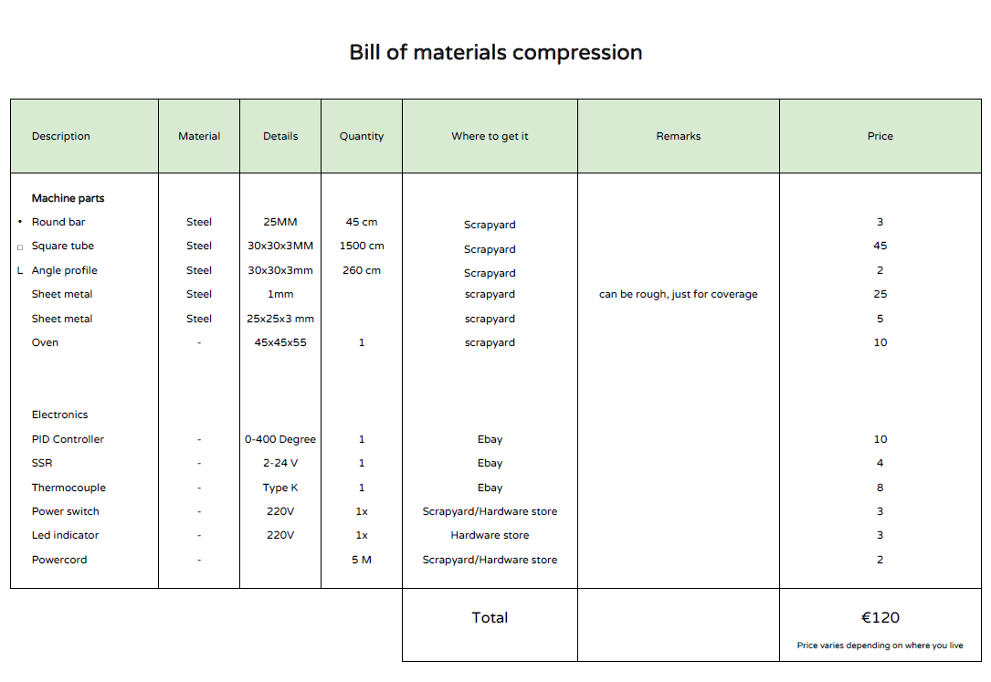
Initially, the first cost that is incurred is purchasing the materials needed to create a machine. Precious Plastic includes a Bill of Materials (BOM) list on their website so that consumers can easily access all the data needed to create their own device. As shown in Figure 5 Precious Plastic’s BOM gives a total cost of €120 for the compression oven which is a far more affordable than an industrial grade compression oven system. Although the cost of a new industry machine is not readily available due to variations from the manufacture to accommodate the customer’s needs, it would not be unreasonable to assume that costs would run into the hundreds of thousands and even millions of GBP for larger machines.
Figure 5 - (Precious Plastic, 2018)

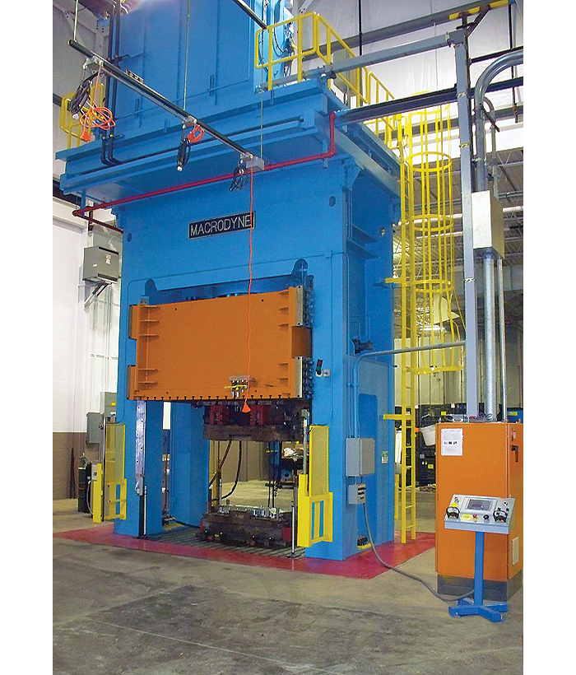
When considering the cost of both machines on different scales, the performance is understandably far apart. Precious Plastic claim that their machine is able to compress up to 25kg of plastic whereas an industrial compression moulding press from Macrodyne’s manufactures, as shown in Figure 6, can compress up to 2000 tonne. The Macrodyne is impressively great at compressing large loads however it is far too large for recycling on a domestic basis.

Figure 6 - (Macrodyne, 2018)

Once the machine is built, running costs become a crucial factor to evaluating how efficient the compression machine is. I believe improvements could be made here by reducing the cycle time to produce a part. If efficiency improvements were made, then the machine would be able to produce parts faster than before. A solution to this would be to include engineering designs with as minimal engineering costs physically possible to improve both the operational process while increasing the efficiency of the machine.

3.1.2 Engineering Costs
Furthermore, engineering costs, such as welding the framework together, can become expensive. Welding is a skill that not everybody has and therefore consumers may require to either hire their own welding equipment or pay labour costs for trained personal to complete this stage for them. These unanticipated costs can result in the project costly far more than the costs initially described in the BOM. On consideration, an alternative approach to this assembly stage is to secure the framework using an easier and more accessible method, discussed further in this report.

3.1.3 Energy Usage and Efficiency
According to Friends of the Earth (2008) the UK’s waste is currently still being buried in landfill sites across the country which results in climate change gases being released which pollute the soil and water. Precious Plastic state how they aim to reduce plastic landfill waste on a global scale by working towards a solution to plastic pollution (Precious Plastic, 2018). If this is Precious Plastics aim, they would not wish for their current or future designs to offset their attempts to reduce harm to the planet by creating further damages in other sectors, such as energy consumption and poor, expensive operating efficiencies.
Considering this, the energy consumption and efficiency of machines created by Precious Plastic’s need to align with these ideologies. When analysing the current design, efficiency could be improved by reducing the cooling time of which the current compression machine requires. Furthermore, if cooling times can be improved, then more moulds would be possible in a shorter period of time while the oven is already heated requiring the use of less energy to heat the oven up again in future. This will be my main design solution which is expanded further in the report.

3.2 Ease of Assembly
Assembly ease is the key to provide access to consumers who wish to successfully recreate one of these projects. Much as that on an industry scale where modular design and assembly can minimise the number of components in the product and by increasing pre-assembly and common interfaces the cost of assembly can reduce dramatically (Gershenson, 1997). Although this is not directly appropriate for a domestic homemade device, it still provides an understanding that regardless of scale, ease of assembly is important for both consumer and manufacturer. Considering this, an area of this project that increases the difficulty of the assembly stage is the welding involved. As mentioned previously, the skill of welding successfully to ensure the strength and safety aspects are met is crucial. An alternative approach which is more consumer friendly and easy to access by the majority is likely to be an improvement. A method of being able to secure the framework and oven by the use of brackets and bolts would be preferred. The new assembly method of brackets and bolts would only require a drill. Drills are easy to operate and very accessible tools in comparison to welding tools.

3.3 Cycle Times
Precious Plastic states in its compression tutorial video on YouTube that’s the process from start to finish when melting and moulding the plastic, takes between two to three hours, a cycle time which could be improved if the cooling stage was reduced. If the oven was instead used to melt the plastic, and then in fact removed from the oven and either compressed externally in a similar fashion or poured into a mould outside of the oven instead, the cooling times of the plastic would reduce and therefore improve the total cycle time. Removing the melted plastic would also allow the oven to be reused again to melt another batch of plastic while the initial mould cools. Precious Plastic states that the whole process with their machine will take approximately 2-3 hours, a cycle time which has a large room for improvement. An area I considered with reducing cycle times was the productivity aspect, as if a machine like this was to be created for a communal access then the amount of recycling possible would improve, something that Precious Plastic’s workshops would benefit from.

4. Design Specification

4.1 House of Quality
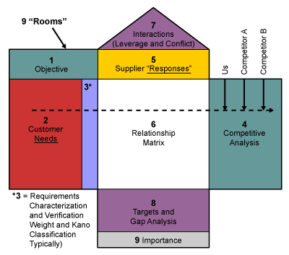
In order to create a design specification that is suitable for the project it is important to consider a variety of factors that will either improve the products throughput, reliability, costs or cycle time. Christie (2016) states that the process of creating a Design Specification with very particular and detailed specifications is the key to creating successful physical products. A design specification should be a helpful guide to the design team and ensure nothing is omitted from the product during its development. It is stated by Biglarbeigi (2018) that many Six Sigma practitioners use the QFD tool to interpret the customer needs into a product specification. Expanding on this, Biglarbeigi explains how when considering product design in the early stages it is important to consider the KANO model as this feeds into the House of Quality Model which is the first stage of Quality Function Deployment (QFD). Figure 7 portrays the areas of the HOQ that require filling for the tool to work. Room 2 of the model requires customer needs be acknowledged and that is where the Kano model becomes effective.
(Figure 7 - (Biglarbeigi, 2018))

The Kano Model is an insightful representation of 3 main categories of needs for any product or service which must be addressed in order to survive in a competitive market (Verduyn, 2013). The categories for customer satisfaction in the Kano model are;
- Must-be Requirements
- One-dimensional Requirements
- Attractive Requirements
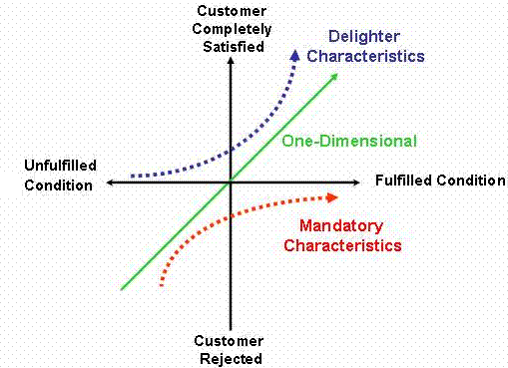
Therefore when considering factors that I would seek to optimise during my design specification for the compression machine, I decided the most beneficial solution in my research would be the reliability of compression due to a weakness in design of the support allocated under the jack and also reducing cooling time of the mould to increase cycle time and efficiency of operation. It is stated by Heflo (2018) that when one-dimensional requirements are present, they satisfy the customer, more so that the higher their performance, the more satisfied customers will be. Therefore, as shown in Figure 8 One Dimensional requirements show how the customer satisfaction and a fulfilled condition are linked highlighting their importance.
Figure 8 - (Heflo, 2018)

In order to make decisions that address areas for improvement while balancing the importance to improve that area, a Pugh Matrix is a decision making tool that can aid in determining which solutions are more important or beneficial than others. It will also consider the voice of the customer (VOC) and therefore fulfilling which one-dimensional requirements will have the biggest impact. By implementing this tool it helps the manufacturer score each concept and therefore prioritising which design features need inclusion above others. A Pugh Matrix according to iSixSigma (2018) is a disciplined, team-based process which scores both weaknesses and strengths in order to gain a balanced score which is weighted by importance, resulting in a thorough decision process. Concept solutions included in the Pugh Matrix for comparison to Precious Plastics current design of the compression oven are;
- Improved rigidity on the compression.
- Bracket and bolt assembly instead of welding.
- Improved cooling/cycle times with outside compression with guarding.
- Fume extraction unit.
Scale  Weak – 1  Best - 10 | Original Design | Original Design incl. Concept 1 | Original Design incl. Concept 2 | Original Design incl. Concept 3 | Original Design incl. Concept 4
Feasibility | 9 | 9 | 6 | 7 | 4
Cost | 9 | 10 | 8 | 9 | 1
Long Term Benefit | 6 | 9 | 8 | 9 | 10
Availability of Resources | 8 | 9 | 8 | 9 | 3
Health & Safety Requirements | 4 | 5 | 6 | 6 | 10
Educational Aspects | 5 | 5 | 5 | 7 | 7
Total | 41 | 47 | 41 | 47 | 35
Table 1 – Pugh Matrix

The results of the Pugh matrix indicate that the highest weighted areas for improvement are Concept 1 and Concept 3. These results will be carried forward when future engineering design concepts are created on CAD to result in potentially incorporating both concepts into the same design.

4.2 Product Design Specification
- Performance
  - Must be able to sufficiently heat, compress and mould the plastic sufficiently.
  - The plastic mould must be compact and in one piece.
  - Suitable for operation in an out building/outside temperatures.
  - Cycle time must be improved from original design of 2-3 hours

2. Maintenance
2.1 The compression oven must be made of easily accessible modular designed parts to maintain over its working life.
2.2 Design for Manufacture and Assembly mentality when considering all aspects

3. Cost
3.1 Cost of the compression oven must be in line with Precious Plastic’s original design or cheaper
3.2 Safety is not to be compromised by cost saving
3.3 BOM has not changed from original design except bracket and bolt assembly which would be offset by lack of welding and associated costs that would be required.

4. Size
4.1 Sizing must ease storage of compression machine in place of use
4.2 Must be accessible to adults of below or above average height

5. Weight
5.1 Compression Oven must be light enough to be portable but also heavy enough to stand freely and safely.

6. Testing
6.1 Testing of all components would be required initially once the machine was built prior to plastic being melted down.
6.2 Compression testing would be important to ensure overfilling of plastic mould did not occur.

7. Safety
7.1 Minimal fume release during operation is important, extraction filtration is recommended
7.2 Safety guards are not present, Perspex safety box surround while oven in operation with interlock style mechanism on door is recommended.
7.3 Heat resistance gloves must be worn during operation of the compression oven.

8. Customer
8.1 Must be safe during operation
8.2 Requires safety aspects be communicated thoroughly by manufacturer.
9. Storage
9.1 Sizing will take into consideration storage solutions.
9.2 For long term storage framework is joined using bolts and brackets so can be dismantled for future ease.

10. Materials
10.1 All materials can be sourced cheaply from new or recycled options
10.2 Minimal cost is important while ensuring condition of materials used is safe and secure.

11. Quality and Reliability
11.1 Compression Oven must operate correctly every time in use.
11.2 Quality of moulded block and reliability of compression needs to be met.

12. Environment
12.1 Fume extraction needs to be addressed to ensure minimal release into the environment during compression.
12.2 Insulation required to ensure heat energy is contained instead of released into the environment requiring more electrical energy to generate further heat.

13. Ergonomics
13.1 Compression and oven element all within reachable height for average female and male users measuring 5’5”-5’10” respectively.

14. Manufacturing Facility
14.1 Must be able to manufacture at home or using local environments/facilities.

15. Standards and Specifications
15.1 Electrical elements for oven must be UK specification and run off 240V mains.

5. Appraisal of Concept Designs
In order to score the possible solutions a Pugh Matrix was created, with each concept scored accordingly. The Pugh Matrix highlighted that the strongest scoring concepts were improved rigidity on the compression process and external mould and cooling design to improve cycle times. The weakest scoring concept was engineering a fume extraction unit mainly due to its cost implications and the availability of extractor units affecting its feasibility. After considering these results the design solution chosen for improvement was the reduced cooling/cycle times by placing the compression unit under the oven so that another plastic melt can begin simultaneously. After designing and creating the modified solution, it was decided that a column support under the jack situated within the frame structure could be included into the design process with minimal cost or engineering difficulties.
Considering the results of the Pugh Matrix, it was important to feed the results into a more in-depth model to consider the implications of each design concept. Part of a design specification is a Quality Function Deployment (QFD). A QFD is a structured approach to defining customer needs and translating them into specific plans to produce products that meet those needs (Crow, 2018). In order to improve success and balanced consideration for all of the requirements, QFD involves a team or departmental input. A HOQ considering all QFD aspects for the conceptual designs for the oven compression machine can be found at Figure 9.

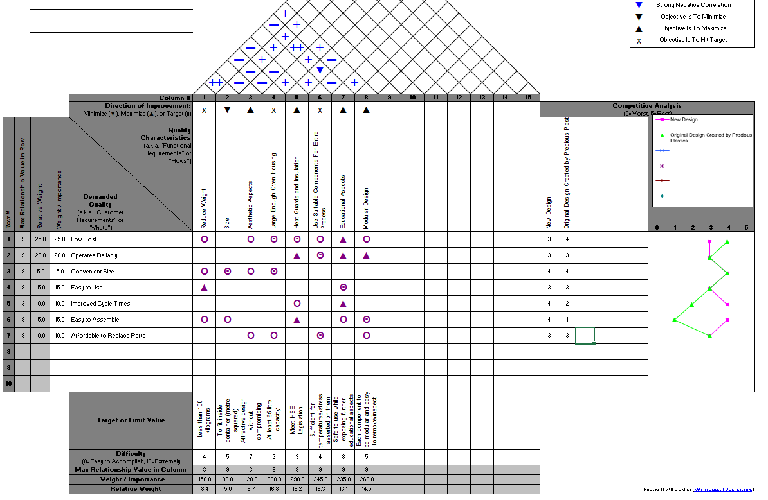
(Figure 9 – New QFD Created for Concept Designs)
The HOQ/QFD results show that the most weighted/important areas are,
- The parts used being suitable for the process and associated stresses exerted on them.
- The oven housing being large enough which would benefit educational and producitvity outcomes.
- The design be modular so that parts can be maintanined or replaced easily.

5.1 Concept Design One – Structural Column
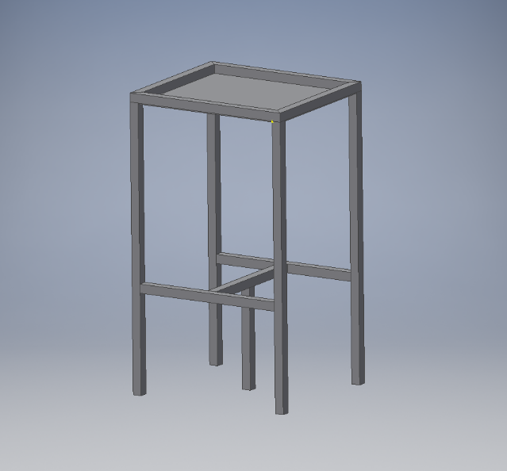
The new design uses very similar amounts of material and components to the original, and therefore the BOM, weight and sizing of the compression machine would remain relatively similar, which is a positive as Precious Plastic’s BOM is affordable. Seen in Figure 10, the new frame design providing the structural reinforcement of the horizontal beam can be seen. According to Designing Buildings Wiki (2018) a column in a construction approach is a vertical structural member intended to transfer a compressive load. Therefore, due to the maximum load being placed in the middle of the beam, where the jack sits, this column will provide a far greater strength under compressive load when the jack is in force.

Figure 10 – Custom Autodesk Inventor Image

5.2 Concept Design Two – Reduced Cycle Times
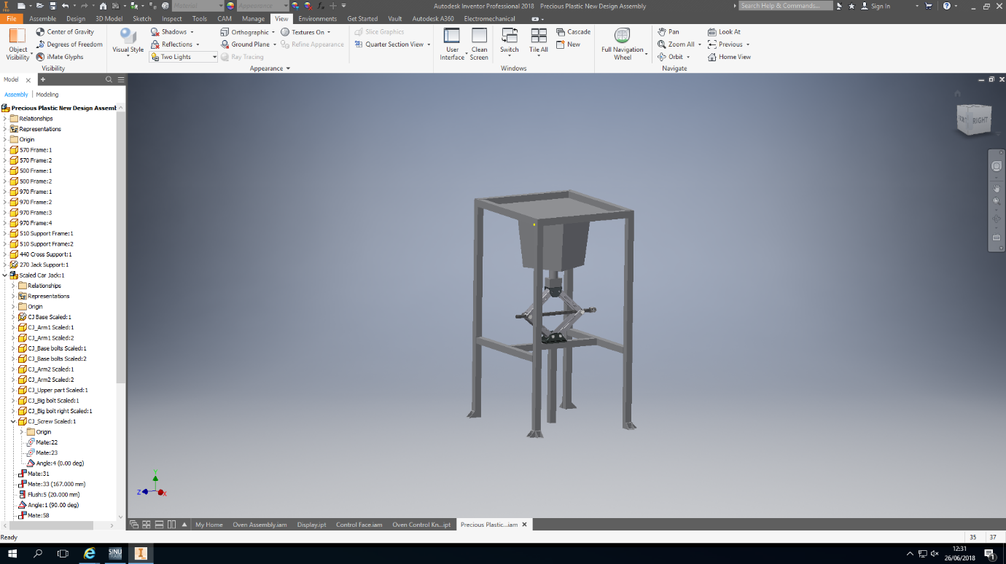
In order to reduce cycle times, the slowest part of the process was targeted. This was the cooling stage and therefore as shown in Figures 11 and 12 the cooling and compression aspect has been moved to an external location directly under the oven where the original jack mechanism was placed, therefore reducing the amount of work needed to make the modfication.

Figure 11 - Custom Autodesk Inventor Design

The original design from Precious Plastic allows the plastic to reach a melting temperature and after said time turns the oven off to allow the plastic to cool down inside the mould which itself remains in the oven. This firstly increases cycle time during the long cooling period and also increases power use when the oven needs to be heated up again for the next cycle. If the mould could be removed from the oven prior to being compressed or post compression, and cooled separately, then another plastic mould tool could be placed inside the pre heated oven and begin compressing on the next cycle. This in force would also reduce the cooling period for the first block as it was removed from the heat source inside the oven. The mould tool itself is made of metal, which TATA (2015) states is a good conductor of heat due to metallic bonds being made form a lattice of ions in a cloud of free electrons resulting in heat conducting very well, thus heat energy would transfer from the plastic to the metallic mould tool and finally into the outside atmosphere quicker.
Educational aspects of the compression oven can be enhanced further with a larger oven. The guarding and heat/insulation plates are a required component due to the efficiency and safety aspects, however a larger glass door with an internal oven light would allow a viewing window. However, with the new design incorporating the compression aspect to the outside of the oven, educational possibilities are increased as the melted plastic can be seen during all stages of the process.
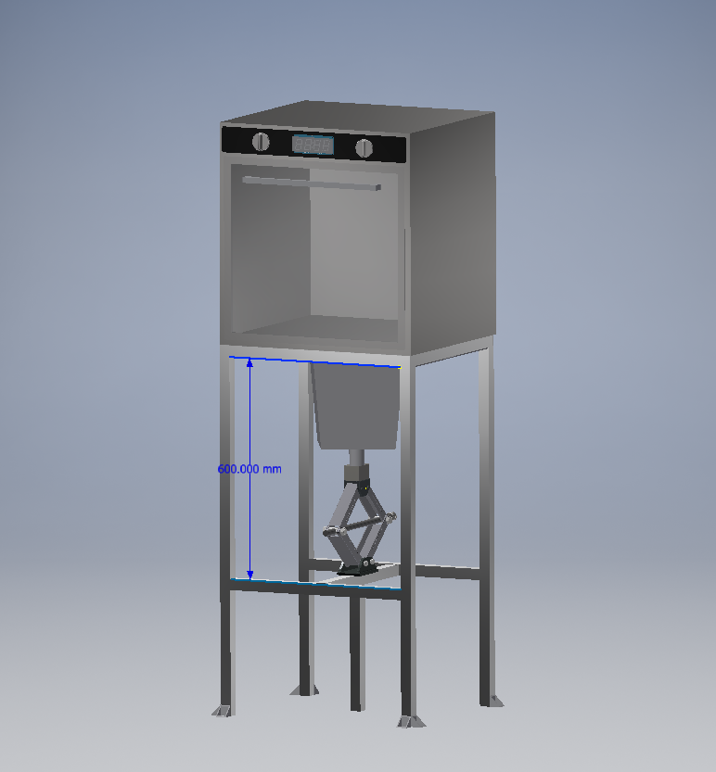
Figure 12 – Custom Autodesk Inventor Design

6. Final Design Solution
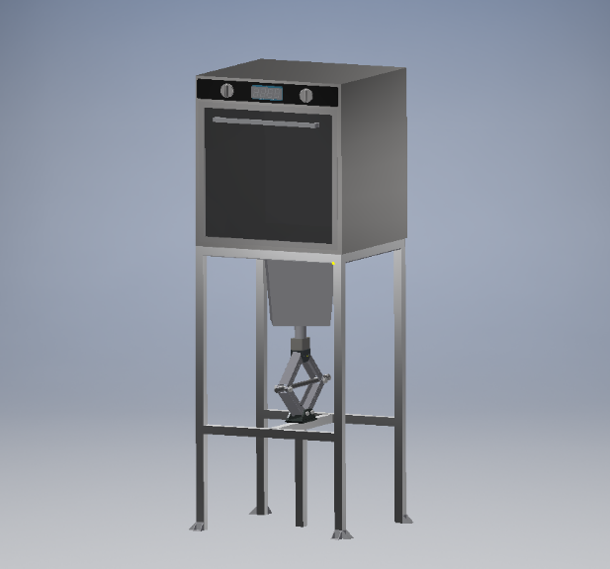
Shown in this section of the report are the concept CAD models and drawings for the chosen modifications. Discussed is also further analysis on the design solutions to highlight any strengths or weaknesses highlighted during this CAD model stage.
The final design incorporates improved structure rigidity under the jack and also a re-design for the placement of the compression mould.

Figure 13 – Final Design, Custom Autodesk Inventor Design

6.1 Improved Structure Rigidity
The plastic melt will require a strong mount of force in order to hold the mould shape for the required cooling time to ensure the quality of the mould is sufficient for its use when formed back into a solid state. In the previous design the jack did not have the extra support underneath and therefore once the pressure exerted by the jack was greater than the strength of the beam it is sat on, the beam would begin to bend, thus reaching maximum exertion. The new design ensures that the pressure exerted by the jack does not force the beam to bend as the support is against the floor underneath as shown in Figure 14. This will ensure a repetitive higher pressure can be placed on the mould and therefore continuity on every cycle as the original design would start to show signs of deflection and therefore require being swapped out for a new support.
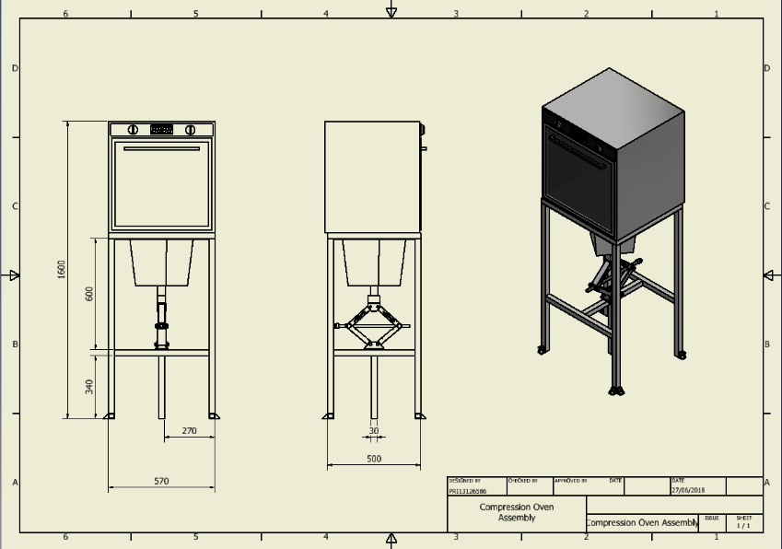
Figure 14 - Custom Autodesk Inventor Design

6.2 External Compression Design
One of the original designs drawbacks was its slow cycle times. Precious Plastic state a cycle can take up to 2-3 hours and therefore limited moulds can be made per day. One of the contributing factors is the cooling time required while the mould sits inside of a heated oven which itself is insulated and therefore will cool down very slowly. By removing the melt from the oven and placing it into a steel mould directly under the oven housing the melt will be removed from the surrounding heat and therefore can be moulded and cooled quicker. The steel mould design shown in this concept is a good conductor of heat as mentioned previously and therefore heat loss from the mould can be rapid in comparison to before.
In order to ensure the strength of the compression face against the oven housing is sufficient, this design also incorporates a steel plate on the opposite side of the frame to the oven bed. This ensures that the compression happens against this face instead of the external oven wall and therefore eliminating damage to the more expensive component and instead any potential damage will be caused to a relatively cheap sheet of 3mm steel. This modular design would also not require the oven to be removed in order to replace the steel sheet which is secured by drilled and tapped holes on the underside of the frame and easily accessible.
In order for the compression mould housing to be secured to the jack, a support block was designed to sit on top and the pipe on the bottom of the mould tool would sit inside deep enough to provide a square and stable fit. This design ensures a larger surface area is pressing against the jack while allowing a deep housing of the mould tool pipe to eliminate it moving out of position when under stress. The support block would therefore not require any welding or fixing to the jack as long as the frame had been made square so that the force is parallel to the frame legs, thus continuing a modular design should the jack or block need replacing.
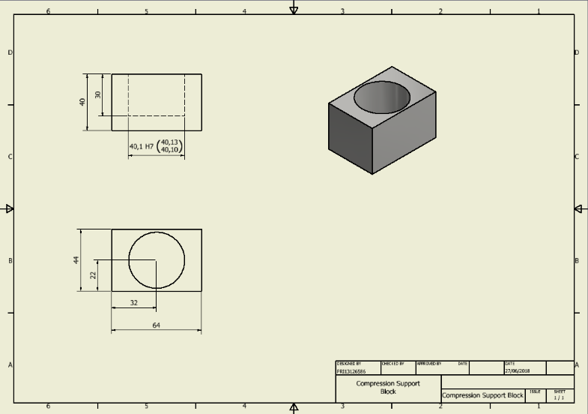
Figure 15 shows the design drawings for the support block proposed. The tolerance on the hold size is a guide to ensure minimal play is present when the mould tool is sat inside.
Figure 15 – Custom Autodesk Inventor Design

6.3 FMEA
Failure modes and effects analysis (FMEA) is explained by Tague (2004) as a structured approach used to identify any potential drawbacks of failures in a design, whether manafacturing, assembly or process, that can be improved to reduce the chance of failures occuring and the severity of their consequences.
The tool compiles potential failures, causes of failures, design solutions and recommendations and rates the severity, probability and detectability of each problem. The three scores are scored from 1-10 and all thre results are multiplied together to provide a weighting for an associated Risk Priority Number (RPN). The RPN then indicates which problem could potentially cause the largest problems in future for the design in question and where areas of improvement are required. Actions taken are then implemented and each weighting is recalculated to provide a new RPN once the solution has been considered, the target is to reduce the RPN as much as possible.
The FMEA for the design concept of the compresion oven is shown in Table 2 and is also available as an attached document through the link below for a larger or amendable view. It highlights that the biggest problem for concern is fume extraction, mainly weighted by the severity of a malfunction and the detectability of such an issue typically being post escape of fumes, causing potential harm to operators. Due to the cost implications of adding a fume extraction unit, while compromising the low BOM from Precious Plastics design, a recommendation was made in this report however not included in the design concepts chosen for this alteration.
The next highest RPN was that of the compression of the plastic mould. This is an issue dealt with in the design concept wherby compression rigidity is improved with the supporting column and the reliability of the jack is tested prior to assembly. Therefore supporting the need for the design incorporated as all RPN after action was taken were reduced and therefore can be deemed a success according to the FMEA tool.

Table 2 – FMEA Table Created For Conceptual Design

7. Conclusion
When implementing any change of an existing design, it is vital that the manufacturer have a thorough plan in place to cover all potential drawbacks or failures so that the changes can provide a successful outcome. By using multiple tools in this report such as HOQ/QFD, FMEA and CAD software, analysing and appraising new concept designs was supported strongly. Due to the design changes proposed, one main consideration was either maintaining or reducing the BOM for the customer. In order to successfully improve the current design, the BOM could not be reduced but due to some engineering changes it was able to be maintained. Highlighting potential issues using tools such as FMEA allows reassurances that should any problems arise during the manufacturing stage, they can be resolved quickly and thoroughly.

7.1 Areas for Future Consideration
When considering multiple design concepts one that was excluded due to cost was the extraction unit. If an extraction unit could be made more affordable, while maintaining the DFMA mentality, it would rapidly reduce the severity and possibility of serious health problems occurring in future. An alternative, and cheaper approach for the customer would be to ensure the correct breathing apparatus was worn during operation, a further cost which becomes unavoidable during this matter. However, once implemented the educational and health aspects would both be greatly improved as students could not only learn about the process itself, but also the dangers of such with minimal exposure.
One further consideration would be a wider foot at the base of the supporting column under the jack. This would ensure a larger surface area for the pressure to be exerted against. Potential damage to the floor, supporting column and any sharp edges from burrs over time would be eliminated with this design change. To demonstrate this, the surface area of the existing design and a potential enhancement are shown in Figure’s 16 and 17. The area the existing design covers is far smaller and therefore providing a smaller area for the forces to be spread across. To demonstrate this an example calculation has been created below.
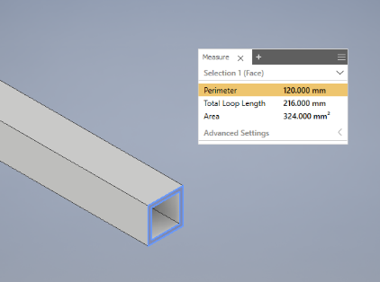
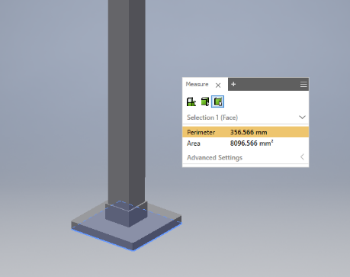
Figure 16 – Exisiting Design Figure 17 – Proposed Recommendation
Explained by the equation to calculate the amount of pressure being exerted when a force is acting perpendicular to the surface area is;
Pressure = Force / Area
Therefore a force of 100N is used to compare the pressure applied per millimetre squared of each design with the idea of reducing the amount of pressure placed upon the supporting column over each of the millimetre squared of surface area.
Exisiting Design Pressure = $\frac{100}{324}=0.3086N/{mm}^{2} =308,600N/m^{2}$
Proposed Recommendation Pressure = $\frac{100}{8096.566}=0.01235{N/mm}^{2}=12,350N/m^{2}$
As shown in the equations above, when the same amount of force is placed on to the smaller surface area the pressure is far greater and therefore increases the risk of damage or failure to the acting component, in this instance the base of the column. In the prosed idea the force is placed upon a much larger surface area dramatically reducing the pressure placed over the same millimetre squared area and therefore ensuring longevity of the foot and column is increased.
Further consideration could be given to the safety aspects of the machine. For instance, to improve the educational aspects when moulding the plastic melt, transparent guarding could be fitted to the frame legs around the whole structure from the oven to the ground. This would require an access panel however would enable students to still witness the mould process happening while not being exposed to the initial high temperatures of the mould tool itself as it began its cooling cycle. The cost would increase on the BOM but the safety aspects and educational benefits would justify such costs to an establishment looking to benefit from this and it is very possible to retrofit at a later date if required.
On reflection it is apparent that Precious Plastic have created a blueprint which meets their target of making plastic recycling widely accessible on a global scale. Their forward-thinking strategy of balancing low-cost components with high availability across the globe provides a stable base for future engineers to further develop their machines. As cost is a factor that affects all companies and organisations differently, it is possible for any organisation to build their own compression oven machine to suit their need and their budgets. Due to the modular design and ease of assembly the further development at a later date is also an option should an organisation wish to amend their design to suit future needs too, resulting in endless possibilities.
Such as all forward-thinking inventions, as technological advances in engineering improve so do the possibilities. There was once a cassette player, calculator, personal computer, camera and television and many more products which can now all be compiled into a mobile phone at an affordable budget, something deemed impossible only thirty years ago. If we truly harness technology and adapt our current thought process and designs accordingly, there are endless opportunities in the future for Precious Plastics and any other businesses who share their vision of “a solution to plastic pollution”.

8. Bibliography
Biglarbeigi, S., 2018. Designing Profitable Products Using QFD and Kano Model. [Online]
Available at: https://www.isixsigma.com/tools-templates/kano-analysis/designing-profitable-products-using-qfd-and-kano-model/
BOFA, 2018. Legislation. [Online]
Available at: http://www.bofa.co.uk/legislation.asp
Crow, K., 2018. Quality Function Deployment, California: PD-Trak Solutions.
Dave Hakkens, 2016. Precious Plastic V2 - Promo. [Online]
Available at: https://www.youtube.com/watch?v=8J7JZcsoHyA
DDW, 2017. Precious Plastic Container. [Online]
Available at: http://www.ddw.nl/en/event/1565
Friends of the Earth, 2008. Recycling - Why it's important and how to do it. [Online]
Available at: https://friendsoftheearth.uk/sites/default/files/downloads/recycling.pdf
Gershenson, J., 1997. Product Modularity and its effect on Service and Maintenance, Tuscaloosa: University of Alabama.
Heflo, 2018. Kano Model Examples. [Online]
Available at: https://www.heflo.com/blog/customer-service/kano-model-examples/
Institution of Civil Engineers, 2018. Types of Column. [Online]
Available at: https://www.designingbuildings.co.uk/wiki/Types_of_column
iSixSigma, 2018. Pugh MAtrix. [Online]
Available at: https://www.isixsigma.com/dictionary/pugh-matrix/
Lenkiewicz, Z., 2017. How to Transform Plastic Waste into Paving Tiles, s.l.: Waste Aid.
Macrodyne, 2018. Hydraulic Presses & Automation. [Online]
Available at: http://www.macrodynepress.com/
Massey, C., 2016. The Importance of Product Specifications. [Online]
Available at: https://www.mindtheproduct.com/2016/05/importance-product-specifications/
Physics Stack Exchange, 2013. Burning Vs Melting. [Online]
Available at: https://physics.stackexchange.com/questions/86801/burning-vs-melting-what-is-the-relation-in-the-atomic-molecular-structure
[Accessed 22 June 2018].
Plasticisrubbish, 2008. A Guide to Living Plasticless. [Online]
Available at: http://plasticisrubbish.com/2008/06/02/dioxins-why-you-dont-want-to-be-burning-plastic/
Precious Plastic, 2018. Mission. [Online]
Available at: https://preciousplastic.com/en/mission.html
PreciousPlastic, 2016. Build the Compressor. [Online]
Available at: https://www.youtube.com/watch?v=ogI8kt0w43Y
SMT, 2018. Smoke Extraction Chamber. [Online]
Available at: http://www.smtworldwide.com/index.php/smoke-extraction-chamber/
Tague, N., 2004. Failure Modes and Effect Analysis. The Quality Toolbox, pp. 236-240.
TATA, 2015. Structuring and Bonding. [Online]
Available at: http://resources.schoolscience.co.uk/Corus/16plus/steelch1pg2.html
UK Government Legislation, 2018. The Supply of Machinery (Safety) Regulations 2008. [Online]
Available at: http://www.legislation.gov.uk/uksi/2008/1597/schedule/2/made
Verduyn, D., 2013. Discovering the Kano Model, Michigan : Kanomodel.com.
WECF, 2015. Dangerous Health Effects of Home Burning of Plastics and Waste`. [Online]
Available at: http://www.wecf.eu/cms/download/2004-2005/homeburning_plastics.pdf

