Student Name & course info added here

Reflection on Academic and Employability Skills
ACCA4016

Table of Contents
1. Introduction 2
2. Presentation 2
2.1. Brief Overview of presentation 2
2.2. Screengrabs from presentation 2
2.3. Reflection 4
2.4. Lessons learn 4
2.5. Areas for improvement 5
3. Skills evaluation 6
3.1. Academic key skills 6
3.2. Employability skills 6
3.3. Self-assessment 7
3.3.1. Personality types 7
3.4. Academic skills 7
3.5. Employability skills 8
3.6. Career suggestions 9
3.7. Conclusion 9
4. Long and short terms goals 9
4.1. Short term goals 10
4.2. Long term goals 10
4.3. Smart Goals 11
4.4. Action plans 11
5. Application 13
5.1. Looking after your data 13
5.2. What to back up 13
5.3. Backup storage 13
5.4. Local backup 13
5.5. External Drive Backup 14
5.6. Cloud Based Backup 14
5.7. Backup strategy 15
5.8. Possible disaster scenarios 16
5.9. Ransomware 16
6. Time management and self-organisation 17
7. Conclusion and Evaluation 18
7.1. Further learning/reading 18
8. References 18
9. Bibliography 21
10. Appendices 22
10.1. Appendix 1 – Presentation feedback 22
10.2. Appendix 2 – Personality type 24
10.3. Appendix 3 – Self evaluation 25
10.4. Appendix 4 - Personal Competency 27
10.5. Appendix 5 – Career test result https://www.123test.com/career-test 28
10.6. Appendix 6 – Creating your horizon 31
10.7. Appendix 7 – SWOT analysis for Ethical Hacking 32
10.8. Appendix 8 - Cryptowall report 33
10.9. Appendix 9 - E-Portfolio 55
10.10. Appendix 10 - Curriculum Vitae 58

Introduction
This report will provide a reflection of the academic and employability skills learnt for this part of the ACCA4016 module.

Presentation

Brief Overview of presentation
The author prepared and presented an introductory PowerPoint presentation to a group of peers. The author was tasked to produce a 5 minute PowerPoint presentation that included the following:
- Briefly describe yourself to the others in your group.
- List your likes and dislikes. Hobbies etc.
- Describe the type of personality you think you are.
- What do you consider your strengths and weaknesses to be?
- Then describe what you hope to get out of your course, and where you would like to see yourself in the next 5-10 years.

Screengrabs from presentation
Below are four screengrabs from the initial presentation.
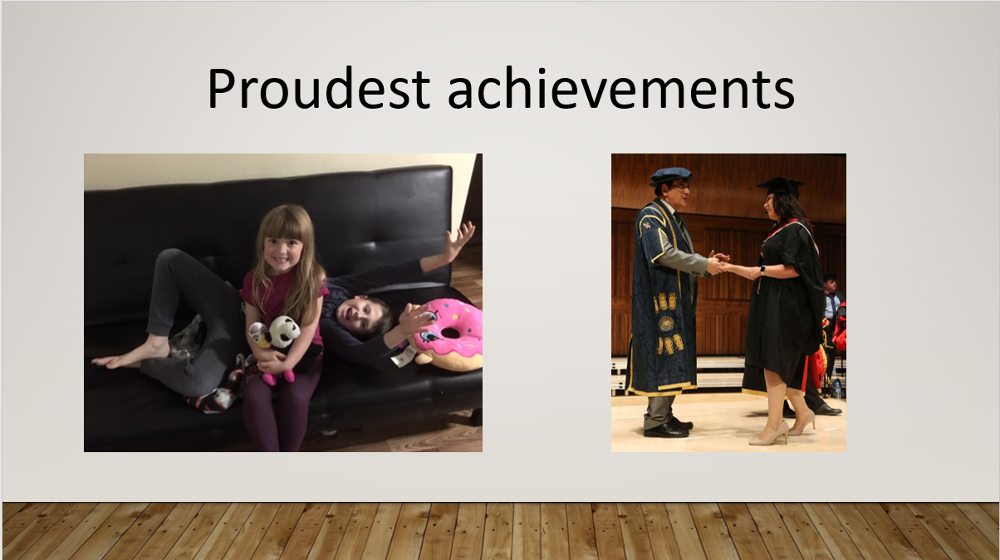
Fig 1: proudest achievements, a photo of the author’s two children and graduation ceremony.

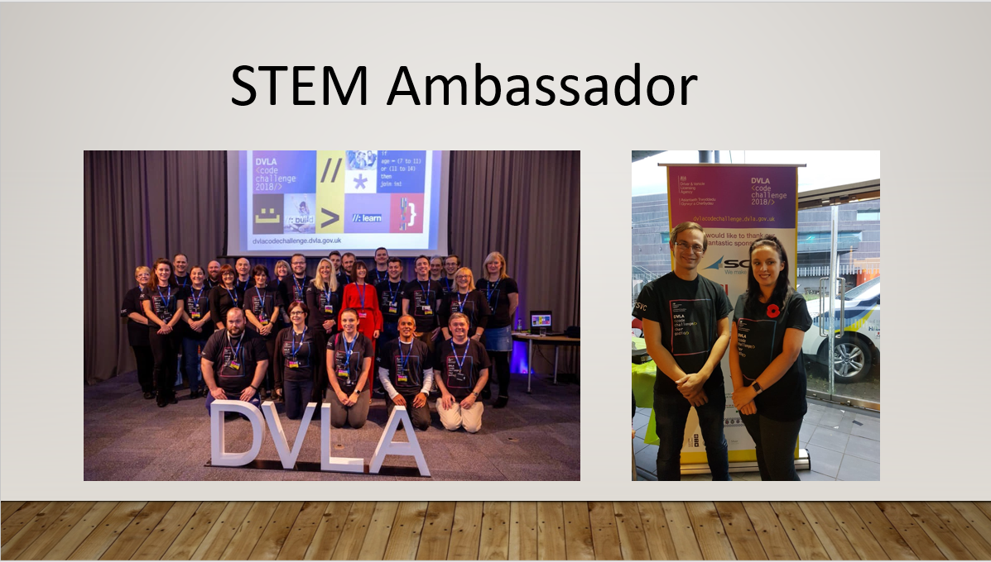
Fig 2: Images of STEM ambassador activities

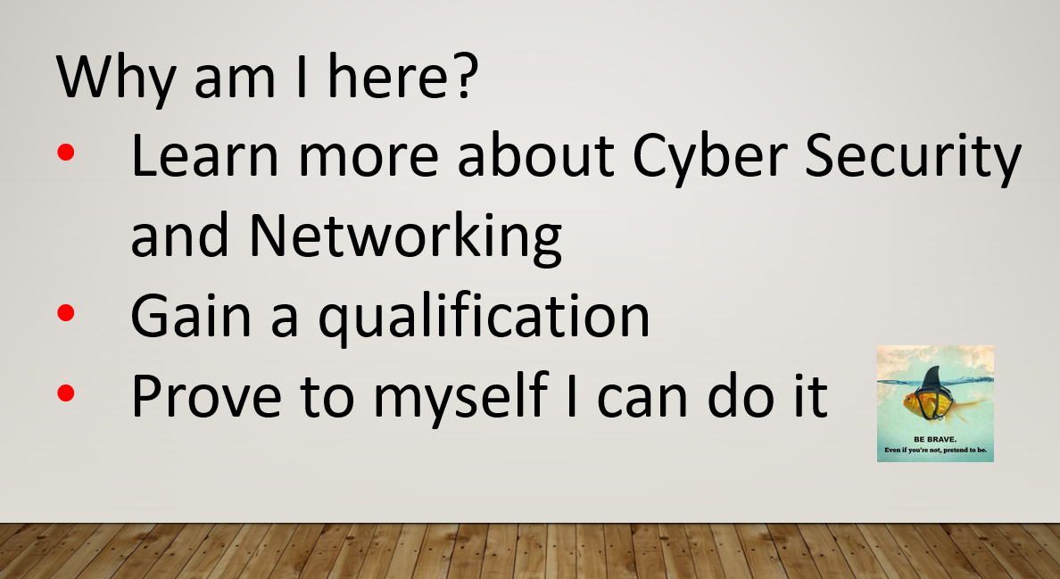
Fig 3: initial aims

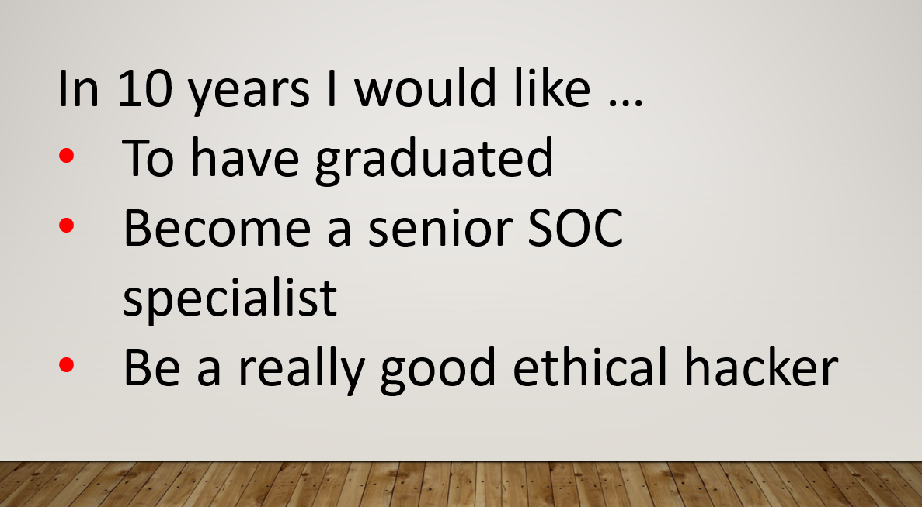
Fig4: Long term goals

Reflection
This exercise provided the author the opportunity to introduce themselves to and learn more about the fellow students on the digital degree apprenticeship.
The presentation was carefully planned in order to meet the objectives set out in the assignment whilst creating a logical structure and abiding to the time limit.
The structure of slides, images and backgrounds where carefully considered. A simple template was used to keep the slides looking clean, clear and professional.
The author was careful to consider the size and colour [1] of the text to cater for the inclusion and diversity requirement of the audience.
The slides contained key information only.
During the week before the presentation the author rehearsed the presentation several times, adding and rearranging the slides as appropriate until the correct length and content was achieved.
The author made good eye contact and engaged with the audience.
The author kept to time but neglected to ask for any questions.
See appendix 1 for lecturer’s feedback.

Lessons learn
When preparing for a presentation [2]:
- Consider evaluations and lessons learnt from previous presentations
- Prepare, decide what the objective of the presentation will be
- Consider the needs of the audience
- Research and reference sources
- Structure the presentation, focus on key points, include an introduction, middle and end
- Check timings
- Practice, Practice, Practice
- Time the presentation to ensure it’s to target
- Check equipment is compatible and accommodation is suitable

When creating the structure of the slides it is important to consider the following [1]:
- Inclusion and diversity of the audience (for example colour blindness, short sightedness etc.)
- Emotional meanings of colours as some can be considered to be too passive or too aggressive
- Carefully consider colour combinations. Combinations to avoid include:
  - Red & Green – these two colours clash and are very hard to read.
  - Orange & Blue –as the colours seem to vibrate against one another
- Use the Coblis (Color BLIndness Simulator) tool on https://www.color-blindness.com/coblis-color-blindness-simulator/ to see how images or whole slides would appear to people with different degrees of colour blindness
- Background graphics should be clear and simple so not to deter from the text
- Dark backgrounds should have light text and light backgrounds should have dark text to make it easier for the audience to read the information on the slides.
When conducting a presentation [3]:
- Arrive early to set up
- Wait until the audience is settled before starting
- Make eye contact with the whole audience, breathe and smile
- Watch pace of delivery
- Consider body language
- Remember to breathe
- Do not read from the slides verbatim
- Offer to answer questions
- Deal with nerves

Areas for improvement
The presenter may suffer from a condition known as Gossophobia [4] which is the fear of public speaking. This needs to be looked into further to establish effective coping strategies.
The following techniques [5] can help deal with the symptoms:
- Practice deep breathing
- Sip water
- Smile
- Practice visualisation techniques to create a calm and positive mind
- Speak more slowly
The origins of the images used within the presentation must be recorded otherwise it could be presumed that the presenter owned the image. This could leave the presenter open to actuations of image plagiarism.
The presentation would have benefited from a question and answer section to improve engagement with the audience.

Skills evaluation

Academic key skills
Academic skills are essential [6] to enable students study and learn more effectively [7]
Research [8] [9] [10] [11] [7] suggests that the following key skills are required to become an effective learner and leave university with the best results possible:
- Organisation
- Time management
- Research skills
- Writing styles
- Effective reading
- Note taking
- Academic referencing
- Revision skills
- Presentation skills

Employability skills
Key skill are the first things employer look for [12] on applicants Curriculum Vitae’s.
Research [13] [14] [15] [12] suggests employers favour the following core skills:
- Creativity
- Persuasion
- Collaboration
- Adaptability and Flexibility
- Data Literacy
- Critical Thinking
- Emotional Intelligence
- Leadership Skills
- Problem solving

Self-assessment

Personality types
The initial presentation described the author’s personality type as an extroverted introvert:
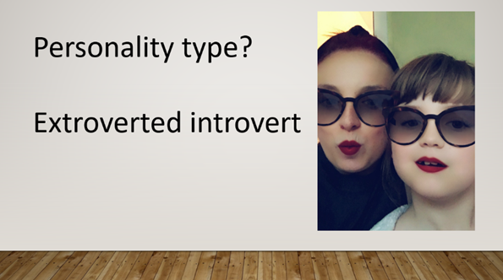
Fig 5: personality type from presentation.
Research describes the author as an introvert (appendix 2).

Academic skills
To optimise learning it is important to understand learning styles. Research suggest that the author’s main learning style is Kinesthetic. This suggests the author learns better by doing, rather than reading or watching [16].
In order to establish strengths and weaknesses the author conducted several online evaluations (see appendix 3) and produced the following SWOT analysis [17] from the results.

Strengths  - Reading  - Note taking  - Planning and organisation  - Time management  - Ability to work under pressure  - Communication  - Flexibility  - Perseverance and motivation  - Dedication  - Interpersonal skills  - Team working | Weaknesses  - Speed reading – risk of miss something important  - Memorising facts  - Numeracy – lacking in confidence  - Can be shy with new people or in large groups  - Anxiety and self-doubt  - Spelling
Opportunity  - Academic report writing  - IEEE Referencing  - Problem solving  - Library skills – researching  - Exam preparation strategies  - Critical and analytical thinking  - Reflective writing  - Backup strategy (was a weakness as I used to only use a USB which I would often misplace but now use the 3:2:1 strategy) | Threats  - Presentation skills  - Work/University/home balance  - Confidence  - Listening – unable to hear properly in large lectures when there is a lot of background talking
Fig 6: Academic Skills SWOT analysis

Employability skills
Online evaluations (see appendices 3 and 4) were used to produce the following SWOT analysis [17] from the results.

Strengths  - Time management  - Planning and organising  - Self-management  - Continuous learning  - Report writing  - Collaboration and team working  - Negotiation and persuasion  - Ability to work under pressure  - Mentoring and Coaching  - People Management  - Networking  - Communication  - Flexibility  - Emotional intelligence  - Resilience | Weaknesses  - Presentation skills  - Listening – need to practice active listening  - Interview skills – need to prepare more  - Numeracy – lacking in confidence
Opportunities  - Adaptability  - Creativity  - Problem solving/analytical reasoning  - Artificial intelligence and machine learning  - Cloud Computing  - Commercial awareness  - Contract management | Threats  - Confidence  - Public speaking
Fig 7: Employability Skills SWOT analysis

Career suggestions
The author has worked as a Civil Servant for the Driver and Vehicles Licensing Agency [18] since October 2000 and is currently working as a Cyber Security Analyst within the Cyber Security Team.
Research suggests the author is best suited for a medical or science related field (see appendix 4)

Conclusion
Research has shown that a number of academic skills are transferable. Whilst academic and business report writing is slightly different, learning how to use appropriate language and structure is easily transferable. Willingness, motivation and determination skills are important skills for both academic and career success.
As expected, the authors’ personality type has been shown to be introverted. Whist this is very true the author works hard to be more extraverted.
A number of weaknesses and threats are present within both the academic and employability skills evaluation. However, both of these are related to self-confidence. This will improve with time, using goal setting techniques and some confidence building practice [19].
Presentation skills in particular would also benefit from additional training into reducing presentation anxiety [5] [20].

Long and short terms goals
Goals are an important part of every aspect of life by providing a sense of direction and motivation towards something aim for. First you need to find out what is important before developing the goal (appendix 6)
Goal setting is considered important [11] [7] [21] [21] [22] to:
- Improve performance
- Motivation and focus
- Increase confidence
- Fulfilment
- Purpose

SMART goal methodology [23] is used to help guide goal setting and improve the chances of achieving the goal. SMART is an acronym that stands for Specific, Measurable, Achievable, Realistic, and Timely.
Once SMART goals have been developed the following [24] can help further improve the chances of achieving the goal:
- aim for progress not perfection
- display the goals where they can be seen
- regularly review and adjust goals as required
- reward successes and don’t punish setbacks
- seek support when needed
- reflect

The skills needed for successfully goal setting and achievement include [24] :
- planning and organising
- time management
- motivation
- self-regulation
- flexibility
- commitment
- focus

Short term goals
There are two types of short term goals; standalone goals or mini goals for larger longer term goals. Short term SMART goals are achieved more frequently, which will help maintain motivation whilst working towards the bigger long term goal.

Long term goals
While short term goal provide direction, long term goals can provide vision.
As per the initial presentation the author’s long term goal is to become a certified ethical hacker. The following SWOT analysis (appendix 7) was carried out to identify SMART smaller goals to work towards this aim.

Smart Goals
SMART goal methodology [23] is used to help guide goal setting and improve the chances of achieving the goal. SMART is an acronym that stands for Specific, Measurable, Achievable, Realistic, and Timely.
Once SMART goals have been developed the following [24] can help further improve the chances of achieving the goal:
- aim for progress not perfection
- display the goals where they can be seen
- regularly review and adjust goals as required
- reward successes and don’t punish setbacks
- seek support when needed
- reflect

Action plans
SMART [25] action plans are essential to achieve short and long term goals.

Strengths, skills and qualities
- Making clear notes
- Time management skills
- IT skills
- Organised

What I need to work on, develop or improve
- Delivering oral presentations
- Confidence
- Writing academic reports and referencing
- Memory techniques

My Priorities: What I am going to do, When and How
What? | When? | How?
- Learn memory techniques | Beginning of January for Computational thinking, Information Engineering exams for University and UWS cloud practitioner certification for work. | Courses on Udemy, YouTube videos, practice exercises and research
- Improve academic report writing skills | Reassess in 3 months after feedback is received from assignments (Feb/Mar 2020) | Carefully read module guide, make my own notes and follow guide while drafting reports.
- Conquer IEEE referencing | As above | As above
- Improve confidence delivering oral presentations | After semester two | Speak to line manager about creating and delivering a presentation for work (DMARC or Tufin?)

How will I measure if I have improved?
- Compare feedback from Networks assignment and Academic and Employability skills assignment

- Improved confidence with fact retention before/during and after exams, results and remembering things easier.

- Compare ‘Engagement with literature’ feedback for assignments

- Conduct an initial self-assessment beforehand. Ask for 360° feedback for presentation from attendees and conduct another self-assessment afterwards and compare results.

Application

Looking after your data
There are two types of backups: specified files and folders or a full system image backup. The full system image will back up everything but they are larger and take much longer to create.

What to back up

File type | Description
Documents | Anything you do not want to lose. For example, assignments, reports, spreadsheets, power point presentations, projects, research notes for university etc.
Application data | Apps create and maintain data files such as e-mail messages, browser favorites, calendar entries and contacts. These are stored within the user personal files in a hidden folder called AppData.
Media | Photo, music and video files. These are large files that may require a separate backup location.
Memories | Important family photos, documents and videos that are irreplaceable and may need additional protection.
System files | Disaster recovery back up can be used to restore the system to a known good state without having to reinstall the operating system and losing data.

Backup storage
There are three main types of home backup storage:
- Local backup
- External drive backup
- Cloud based backup

Local backup
Where copies of files are kept on the same device they were made on. This could be done by keeping duplicate copies, enabling shadow copies (or time machine on MAC) or using an incremental backup tool and saving locally.

Advantages | Disadvantages
Easy to restore after accidental deletion | Single point of failure, Data would be lost if device fails, damaged or stolen
Useful for reverting unwanted changes | Data is only accessible from the machine
Useful for comparing changes | No redundancy
Fig 8: Advantages and disadvantages of local backup solutions

External Drive Backup
Copies of files are stored on an external drive. This could be done by using an USB drive, external hard drive or Network Attached Storage (NAS) device.
Advantages | Disadvantages
Data would not be compromised if original device fails | Data would be lost if backup device fails or is lost
More expandability than the same machine backup option | Potentially the same singe location issue as the same machine option
Potentially portable (depending on external backup system used) | Can be expensive (depending on external backup system used)
Can offer redundancy (depending on system used) | Can be complicated
Can be stored away from the original device
Fig 9: Advantages and Disadvantage of external drive backup solution

Cloud Based Backup
Copies of files are uploaded to the cloud providers server and can be accessed anywhere with an internet connected device and internet connection.
Advantages | Disadvantages
Off-site backup | Reliant on internet connection
Backups are independent from | Can be time and bandwidth consuming if uploading a large amount of data
High scalability, availability and accessibility | No complete control of security
Backups can be done in real time | Potential for provider to go out of business and losing all the data
Control costs | Cost will increase as storage requirements increase
Fig 10: Advantages and Disadvantages of cloud based backup solutions

Backup strategy
The United States Computer Emergency Readiness Team (US-CERT) [26] recommends the use of Peter Krough’s [27] 3-2-1 backup strategy to provide a layered approach for all computer users:

- keep 3 copies of any important file (the original copy plus at least two backups)
- keep the files on 2 different media types
- store 1 copy offsite

Following research the author has implemented the following 3-2-1 backup strategy to provide an appropriate level of data protection.

Type of data | Schedule | Manual or automatic | 1st | 2nd | 3rd
Creating/  editing documents  Regularly save working documents | At least every 30 minutes | Manual | Device | N/A | N/A
Personal Files  C:\\Windows\adminuser | Daily | Automatic | Device | External Drive#1 | Google Drive
Personal Files  C:\\Windows\adminuser | Weekly | Manual |  | External Drive#2
Important photos  C:\\Windows\adminuser | As required | Automatic | Device | External Drive#1 | iCloud
Application data  Within hidden AppData folder and will be backup as part of the personal files | Daily | Automatic | Device | External Drive#1 | Google Drive
System files  Windows Disaster recovery | 3 monthly | Automatic | Device | External Drive#2 | As above

Possible disaster scenarios
- Hardware or system failure
Hardware and systems will fail over time. By using the 3-2-1 backup strategy the data will still be available in the other mediums.

- Human error
If a file is deleted or corrupted a backup version will be available in the other mediums.

- Software failure
By saving the document regularly a software crash will not be too problematic.

- Natural disaster (including fire)
If the on-site location is not accessible a backup copy of the data will be accessible from the 3rd backup site (cloud) from anywhere with an internet connection.

- Theft
Should the original device be stolen the data will still be available using the other back up methods. Whilst the 2nd copy should be kept on site for ease of restoration it should not be kept alongside the original storage to prevent it from also being compromised.

- Cyber attack
If the original device is infected, data can be restored from the alternative on-site backup. Automatic backups to the cloud spread the infection. A separate off-line backup such as the external drive would mitigate this risk.

Ransomware
McAfee [28] describes Ransomware as malware that encrypts a victim’s information using asymmetric encryption and demand a ransom. Only the private key held by the attacker can decrypt the victim’s information. A report on the Cryptowall Ransomware variant can be found within appendix 7.

Time management and self-organisation
Time management and organisation skills are important academic and employability skills.
Stephen Covey once said “The key is not to prioritize what's on your schedule, but to schedule your priorities.”
It is essential to manage your time in order to meet your goals.
The ‘Zeigarnik effect’ [29] suggests that the unconscious mind needs the conscious mind to have a plan.

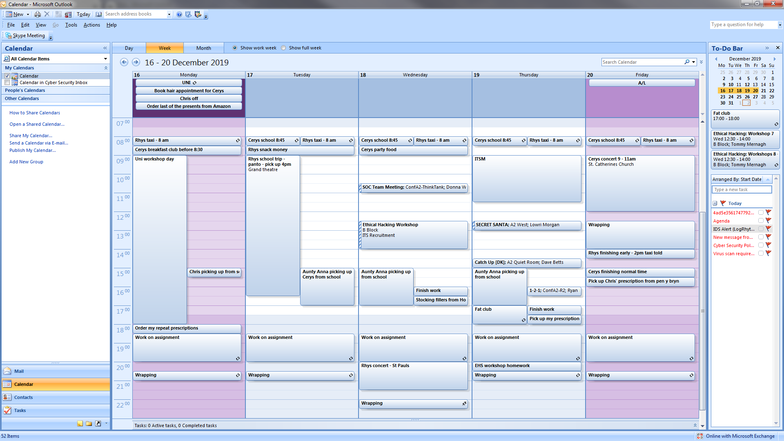
Fig 11: screenshot of the author’s electronic calendar planning the week ahead

Time management and self-organisation plan:
- Make to-do lists, set realistic mini goals, stick to them and mark them off when complete.
- Eat the Frog. Get the biggest/worse task over first and mark it off the list
- Don’t multitask. Focus on one task at a time. Peter Drucker explains “If there is any one ‘secret’ to effectiveness, it is concentration. Effective executives do first things first, and they do one thing at a time.”
- Exercise and eat healthily
- Have a designated, organized and uncluttered study space
- Create a clear e-portfolio window file structure to save important document. This file structure is adaptably, expandable and easily transferable for backup strategy (appendix 8)
- Maintain and up-to-date Curriculum Vitae (appendix 9)

Conclusion and Evaluation
A number of academic skills are also skills sought after by employers. Therefore, a number of employability skills can also be transferred into academic skills for use within further education, continuous learning and professional development.
Presentation skills training and additional practice may help reduce anxiety when public speaking.
Additional short term goals need to be developed in order to reach the long term goal of qualifying as an Ethical Hacker and progressing within the Security Operations Centre (SOC).
The new data backup strategy has been implemented and is a significant improvement. The author initially relied solely on USB storage. USB storage will now only be used for transportation as a backup if cloud storage is unavailable.
It is important to maintain the e-portfolio structure created as this will improve organisation and reduce stress.
Since researching this module the author has taken steps to improve weight management and physical exercise.

Further learning/reading

H. Arksey, I. Marchant and C. Simmill (1994), Juggling for a Degree: Mature Students' Experience of University Life’. Lancaster University: School for Independent Studies.
Emden, J. and Becker, L. (2010) 2nd edition, Presentation Skills for Students, Palgrave Macmillan.
International Journal for Academic Development
Journal of the International Consortium for Educational Development

References

[1] | D. Paradi, “Choosing Colors for Your Presentation Slides,” [Online]. Available: https://www.thinkoutsidetheslide.com/choosing-colors-for-your-presentation-slides/. [Accessed 10 October 2019].
[2] | “Skills hub - Preparing for a presentation,” [Online]. Available: http://www.sussex.ac.uk/skillshub/?id=310. [Accessed 5 December 2019].
[3] | “Skills Hub - Delivering a presentation,” [Online]. Available: http://www.sussex.ac.uk/skillshub/?id=314. [Accessed 5 December 2019].
[4] | “Oxford Dictionary,” [Online].
[5] | D. Dalton, “How to Reduce Presentation Anxiety,” 18 June 2018. [Online]. Available: https://www.improvepresentation.com/blog/reduce-presentation-anxiety. [Accessed 3 December 2019].
[6] | J. S. Maribeth Gettinger, “Contribution of study skills to academic competence,” School Phychology review, vol. 31, no. 3, pp. 350-365, 2002.
[7] | S. Cottrell, The Study Skills Handbook, 4 ed., Palgrave Macmillan, 2013.
[8] | “Core Skills,” [Online]. Available: https://help.open.ac.uk/topic/study-skills/category/core-skills. [Accessed 1 January 2020].
[9] | J. F. Bob Smale, How to Suceed at University, an essential guide to academic skils and persona development, Sage Study Skills, pp. 103 - 194.
[10] | “Infoskills Programme,” [Online]. Available: https://www.uwtsd.ac.uk/library/infoskills/. [Accessed 1 December 2019].
[11] | C. Dawson, The mature student's study guide, How To Books.
[12] | “What skills should I include on my CV,” [Online]. Available: https://www.monster.co.uk/career-advice/article/what-skills-should-i-include-on-my-cv. [Accessed 1 January 2020].
[13] | B. Marr, “The 10+ Most Important Job Skills Every Company Will Be Looking For In 2020,” 28 October 2019. [Online]. Available: https://www.forbes.com/sites/bernardmarr/2019/10/28/the-10-most-important-job-skills-every-company-will-be-looking-for-in-2020/#3c35bf6e67b6. [Accessed 15 December 2019].
[14] | “Essential Employability Skills,” [Online]. Available: https://www.wjec.co.uk/qualifications/essential-skills-wales/essential-employability-skills. [Accessed 15 December 2019].
[15] | P. Petrone, “The Skills Companies Need Most in 2019 – And How to Learn Them,” 1 January 2019. [Online]. Available: https://learning.linkedin.com/blog/top-skills/the-skills-companies-need-most-in-2019--and-how-to-learn-them. [Accessed 15 December 2019].
[16] | “VAK Learning Styles,” [Online]. Available: https://www.mindtools.com/pages/article/vak-learning-styles.htm. [Accessed 30 December 2019].
[17] | “SWOT Analysis - Definition, Advantages and Limitations,” [Online]. Available: https://www.managementstudyguide.com/swot-analysis.htm. [Accessed 30 December 2019].
[18] | Driver and Vehicle Licencing Agency.
[19] | “Building Self Confidence,” [Online]. Available: https://www.mindtools.com/selfconf.html. [Accessed 3 January 2019].
[20] | “Top Tips for Effective Presentations,” [Online]. Available: https://www.skillsyouneed.com/present/presentation-tips.html. [Accessed 5 December 2019].
[21] | “Why goal setting for students is important,” 29 July 2016. [Online]. Available: https://organisingyou.com.au/2016/07/why-goal-setting-for-students-is-important/. [Accessed 28 December 2019].
[22] | E. A. L. Gary P Latham, “Self-regulation through goal getting,” Organizational Behavior and Human Decision Processes, vol. 50, no. 2, pp. 212-247, 1991.
[23] | K. B. Lawlor, “Smart Goals: How the Application of Smart Goals can Contribute to Achievement of Student Learning Outcomes,” Developments in Business Simulation and Experiential Learning: Proceedings of the Annual ABSEL Conference , vol. 39, pp. 259-267, 2012.
[24] | E. Houston, “What is Goal Setting and How to Do it Well,” 29 November 2019. [Online]. Available: https://positivepsychology.com/goal-setting/. [Accessed 3 January 2020].
[25] | “SMART Goals,” [Online]. Available: https://www.mindtools.com/pages/article/smart-goals.htm. [Accessed 30 December 2019].
[26] | “Data Backup Options,” [Online]. Available: https://www.us-cert.gov/sites/default/files/publications/data_backup_options.pdf. [Accessed 2 December 2019].
[27] | P. Krough, The DAM Book: Digital Asset Management for Photographers, 2nd ed., O'Reily Media, 2009, p. 207.
[28] | “What Is Ransomware?,” [Online]. Available: https://www.mcafee.com/enterprise/en-us/security-awareness/ransomware.html. [Accessed 2 December 2019].
[29] | “The Zeigarnik Effect Explained,” [Online]. Available: https://www.psychologistworld.com/memory/zeigarnik-effect-interruptions-memory. [Accessed 30 December 2019].

Bibliography
www.uwlax.edu/globalassets/offices-services/urc/juronline/pdf/2011/swenson.cst.pdf
Anita Moorman. ‘Copyright Infringement and Embedded Photos: A Photo of Tom Brady Goes Viral and Raises Challenging Copyright Issues for Publishers’, Sport Marketing Quarterly Jun 2018, Vol. 27 Issue 2, p135

https://steemit.com/blog/@dmcamera/how-to-avoid-copyright-violation-and-image-plagiarism-how-to-effectively-use-google-images
Parrish, D. and Noonan, B. (2009) ‘Image Manipulation as Research Misconduct’, Science & Engineering Ethics, 15(2), pp. 161–167

Dave Paradi (2010) 102 Tips to Communicate More Effectively Using PowerPoint

Stella Cottrell, ‘Skills for Success: Personal Development and Employability’

http://www.skills4study.com

http://www.palgrave.com/skills4study

http://www.how-to-study.com

https://www.technotification.com/2018/11/skills-for-ethical-hacker.html

https://www.csestack.org/ethical-hacking-prerequisites-skill/

https://www.findcareerinfo.com/ethical-hacking-career-path/

Appendices

Appendix 1 – Presentation feedback

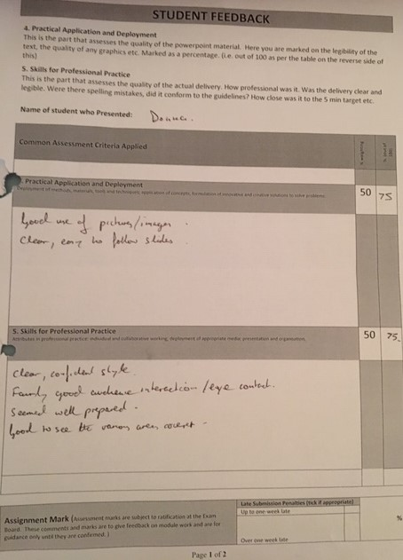

Appendix 2 – Personality type
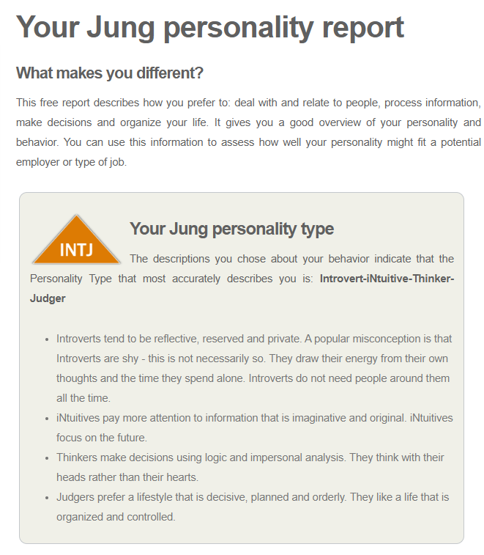
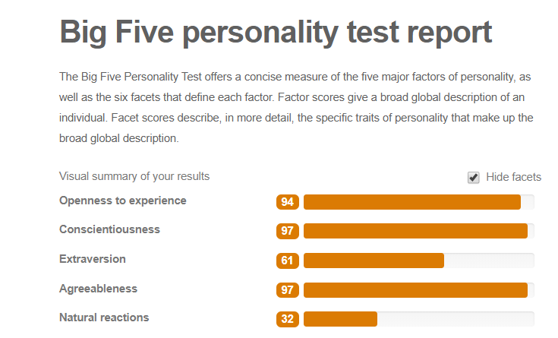

Appendix 3 – Self evaluation

Skill
 | 5 | 4 | 3 | 2 | 1
I have the confidence to try new things and express my ideas
I am self-motivated and will persevere with difficult tasks
I am organised and can meet set deadlines
I am able to find information from different resources easily
I can read complicated texts and understand the general meaning
I am able to select what is relevant and what is irrelevant in text
I can compare different opinions and decide what are the best grounds for deciding who is right
I can write things in my own words
I am able to reflect and evaluate my own work
I have good strategies for starting a new task/assignment
I have good time management skills and can organise my workload effectively
I am able to make, store and find my notes
I am able to manage a range of writing skills appropriately
I am able to think critically and analytically, and evaluate arguments
I have good memory strategies
I know how to use IT to help academic study
I am confident at preparing and delivering oral presentations

Appendix 4 - Personal Competency
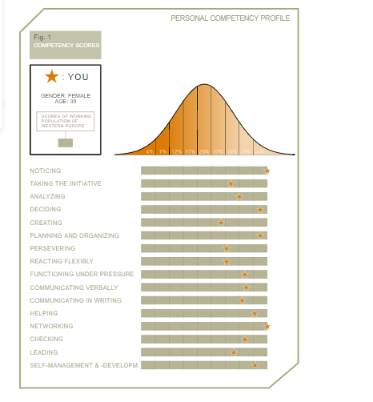

Appendix 5 – Career test result
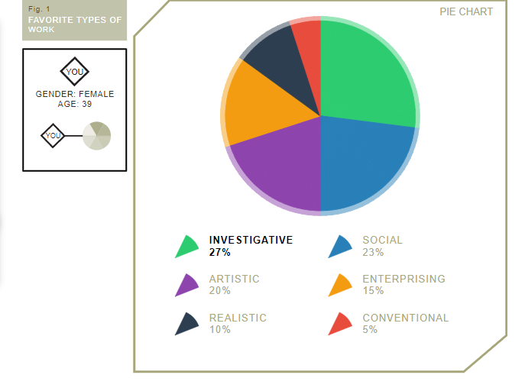

Your personality type
You preferred 'Investigative' the most, followed by 'Social' and 'Artistic'. Your six letter personality type is 'ISAERC'. Your personal preference is also shown in a graph below.

Your jobs
Here is a list of jobs that fit your Holland code ISAERC. The list is only part of all jobs that fit your personality. You should use this list of occupations as prototypical examples. A total of 20 occupations are suggested based on your score.
Your list of suggested occupations
Psychologist
96%
Psychologists study the behaviour and mental processes in humans. They provide services to clients who deal with mental health issues and life issues such as bereavement, relationship difficulties, domestic violence, and sexual abuse. They also provide counselling for mental health issues such as eating disorders, post-traumatic stress disorders, and psychosis in order to help the clients rehabilitate and reach a healthy behaviour.
Dietitian
92%
Dietitians assess specific nutritional requirements of populations or individuals throughout their lives and translate this into advice which will maintain, reduce risk to, or restore people’s health. Using evidence-based approaches, dietitians work to empower individuals, families and groups to provide or select food which is nutritionally adequate, safe, tasty and sustainable. Beyond healthcare, dietitians improve the nutritional environment for all through governments, industry, academia and research.
Political scientist
84%
Political scientists study political behaviour, activity and systems, including the elements that fall therein. Their study of the field ranges from the origins and evolution of various political systems to topical matters such as decision-making processes, political behaviour, political trends, society, and power perspectives. They advise governments and institutional organisations on governance matters.
Immunologist
82%
Sociologist
80%
Audiology technician
80%
Orthoptist
80%
Specialised doctor
80%
Optometrist
80%
Podiatrist
80%
Anthropologist
78%
Audiologist
77%
Speech and language therapist
73%
Pharmacologist
70%
Social worker
70%
Soil scientist
70%
Agronomist
70%
Tutor
67%
Health and safety officer
67%
Pharmacist
67%

Appendix 6 – Creating your horizon

You:
- What you truly Love & Enjoy? Spending time with my family (when the children are not arguing). Going to the beach and listening to the waves.
- What you enjoy doing? Doing something as a family (without the children arguing or complaining), seeing new places and exploring. Learning something new, listening to music and singing along (badly). Reading a good book, while drinking a nice mug of hot chocolate and finding a new author I like. Taking the dogs for a nice long walk.
- What kind of person do you want to be? Happy and healthy.
- With your family? Loving and patient.
- With your friends? Loyal and supportive.
- At work? Successful, hardworking, trustworthy and reliable.

Your Profession:
- What you would truly love to do as a Career? Ethical hacker.
- What would be your Dream job? Running my own company.
- How could you achieve it? First become qualified.
- How would you feel doing that job? Empowered.
- What would be your daily activities? Hopefully managing and developing staff.
- What would you love most about your job? Doing something that fascinates me.

Your Life:
- What would your ideal life be like? Consider what different aspects of your life would be like? Happy, healthy children who do not argue or answer back. A nice house, nice car, pleasant family holidays and not having to worry about money. Being 3 inches taller and 3 stone lighter.
- What would you love most about your life? Spending more time as a family

Appendix 7 – SWOT analysis for Ethical Hacking

Strengths  - Understand cryptographic principles  - Social engineering  - Understand importance of remaining within the terms and conditions of the agreement  - Flexibility  - Determination  - Curiosity  - Learning | Weaknesses  - Understanding of Database Management  - Limited understanding of enough programming languages (want PHP, HTML , JavaScript, SQL, Python, Perl, C and C++)  - Lack of patience  - Frequency of workshops (once every 3 weeks)  - Confidence to practice on my own
Opportunities  - Already part of an Ethical Hacking workshops to learn principals, tools and processes in a safe and legal environment  - Work with certified ethical hackers  - Learning Linux (enrolled in Udemy online training courses and created Linux VM)  - Already understand basics of networking and IT security (CompTIA Security+ certified)  - Learning digital forensics  - Logical thinking | Threats  - No qualifications (want CEH as minimum)  - No certification (want CREST)

Appendix 8 - Cryptowall report

Contents
1. Introduction 35
2. Trojans and Viruses 35
2.1. Threat actors 36
2.2. Threat vectors 36
2.3. Symptoms of malware infections 37
3. Ransomware 38
3.1. General overview 38
3.2. Threat vectors 39
3.3. What impact does ransomware have? 39
3.4. How to limit the impact of a ransomware attack 39
3.5. What to do if the organisation has been infected with ransomware 40
4. The Cryptowall Trojan 40
4.1. Specifics of this threat 40
4.2. Infection methods 41
4.3. File types vulnerable to CryptoWall encryption 41
4.4. Procedures of eradication 41
4.5. Payment 42
5. Examples of good practice 42
5.1. Backup procedures 43
5.2. Backup methods 44
5.3. Backup rotation schedules 44
5.4. Store backup data separately 45
5.5. Make backing up part of your everyday business strategy 45
6. Conclusion 45
7. References 45
8. Bibliography 48
9. Appendices 48

- Introduction
Information systems security is the act of protecting the systems that hold and process data from unauthorised access, unlawful modification, disruption and disclosure [1].
Malware continues to be one of the biggest cyber security threats to businesses today [2].
Ransomware is one of the most destructive types of malware attacks. In 2016, over 638 million computer networks were affected by ransomware in 2016. Over $5 billion was lost due to global ransomware in 2017 [3].
Ransomware attacks currently account for nearly 24 percent of incidents where malware was used [4].
One type of ransomware, CryptoWall 3.0 is thought to have caused nearly £250,000,000 in damages [5]
This report provides a brief overview of different types of malware, ransomware and Cryptowall.
- Trojans and Viruses
Trojans and viruses are examples of Malware. Malware is malicious software designed to infiltrate a computer system and damage it without the user’s knowledge or consent [2]. Other types of Malware include [5]:
- Worms
- Ransomware
- Spyware
- Rootkits
Viruses are malicious code that runs on a machine without the user’s knowledge and infects the computer when executed [6]. There are several different types of viruses but they all require a user action in order to reproduce and spread. Examples of viruses include [7]:
- Boot sector viruses are stored in the first sector of a hard drive and are loaded into memory upon boot up
- Macro viruses are embedded into a document and is executed when the document is opened by the user
- Program viruses infect an executable or application
- Multipartite are a type of virus that combines boot and program viruses to first attach itself to the boot sector and system files before attacking other files on the computer
- Polymorphic viruses are an advanced version of an encrypted virus that changes itself every time it is executed by altering the decryption module to a avoid detection
- Metamorphic virus is an advanced version of a polymorphic virus. It is able to rewrite itself entirely before it attempts to infect a file
- Armoured viruses have a layer of protection to confuse a program or person analysing it.
A Trojan Horse is a malicious software that disguises itself as a piece of harmless or desirable software [6]. They perform desired functions and malicious functions.
A Remote Administration Trojan (RAT) [8] (also known as Remote Access Trojan) [9] provides the attacker with remote control of a victim computer and is the most common type of malware [10].

  - Threat actors
A threat actor [11] is an individual (or group of individuals) that attempts to or successfully conducts malicious activities against an IT system, whether intentionally or unintentionally. To proactively defend systems it is important to understand the different types of threat actors, their capabilities, tactics and motivation.
The four main types of threat actors are [12]:
- Script kiddies - hackers with little or no skill and use pre-built tools and exploits
- Hacktivists - hackers who are driven by a cause for example, political agenda, social change or terrorism
- Organised crime - hackers who are part of a criminal group that is well-funded and highly sophisticated
- Advanced Persistent Threats (APT) - highly trained and funded group of hackers (often by nation states).

  - Threat vectors
A vulnerability [13] is a specific weakness in the code, system or control which if exploited would have an impact of the confidentiality, integrity or availability of data, information systems or services.
Threat vectors [14] are the routes that malicious attacks may take to get past your defences to exploit the vulnerability and infect your network.
The following chart shows the threat vectors used by the top 10 malware attacks (May 2019 to October 2019) [15].

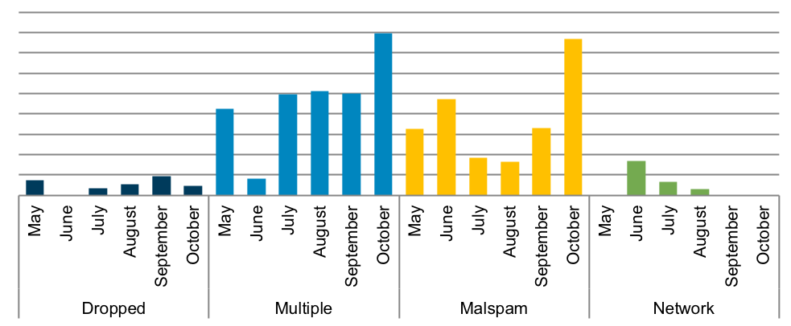
Fig 1: threat vectors used by the top 10 malware attacks (May 2019 to October 2019) [15].
Dropped – Malware delivered by other malware already on the system, an exploit kit, infected third-party software, or manually by a threat actor. For example Gh0st malware. [15].
Multiple – Malware that uses at least two vectors. For example TrickBot, ZeuS and CryptoWall malware. [15].
Malspam (Malicious Spam) – Phishing emails which either direct users to malicious web sites or trick users into downloading or opening malware. For example Emotet, Dridex, Kovter, NanoCore, Tinba, and Cerber malware. [15].
Network – Malware introduced through the abuse of legitimate network protocols or tools, such as SMB protocol or remote PowerShell. For example WannaCry. [15].

  - Symptoms of malware infections
Symptoms of malware infection include (but is not limited to):
- System is slow on start-up, slow opening applications or behaving unusually slow. Malware is known to significantly slow down applications and greatly impact general computer performance [16]
- An unusual browser toolbar or redirecting to different websites. Generally, this variant of malware is used to generate advertising revenue for attackers but it can also be used to registering credit card information or leaving back doors for ransomware to access your system [16]
- Annoying Pop-ups. This is a typical sign of malware, the advertisements themselves could conceal more malware within them [16]
- New Desktop Icons/Potentially Unwanted Programs (PUPs) that can collect private information, spy on browsing experience, add pop-ups and toolbars on the browser [16]
- Hard Drive Issues. Loud noises, excessive activity and unexpected disk storage use. It is common for malware to target and use up all available free space on a hard drive [16]
- Crashing systems, programs or the infamous Blue Screen of Death is a common effect of a malware infection [16]
- Double file extensions are being displayed, such as textfile.txt.exe [17]. New files and folders have been created or files and folders are missing, renamed, corrupted or encrypted [18]
- Security is disabled. If your antivirus solution doesn’t seem to work, or the update module within the software appears broken this could be a self-defence mechanism of the malware that is infecting your system [16]
- Restricted access to the Control Panel, Task Manager, Registry Editor or Command Prompt are other common defence tactics for malware [16]

- Ransomware
  - General overview
Ransomware is a type of malware that restricts access to a victim’s computer system until a ransom is paid [19].
Ransomware exploits a vulnerability to gain access to the system and then encrypts the files.
There are two types of ransomware [20]; one locks a user’s screen and the other encrypts the files on a computer/network. Both types require users to make a payment (the 'ransom') to be able to use the computer normally again. The ransom is often demanded in a cryptocurrency such as Bitcoin [21].
Ransomware has been a major threat to businesses since 2016 [20] so it is important to understand and mitigate against this risk [22]. However, since 2018 ransomware attacks have become more targeted [19].

  - Threat vectors
Ransomware attacks against Windows operating systems have been well publicised for many years [23] Mac and Linux systems can also be vulnerable to this threat [20] [24].
The methods for infecting systems with ransomware are similar to those used with other malware. Ransomware attacks have been seen against Windows, Mac and Linux operating systems [20].
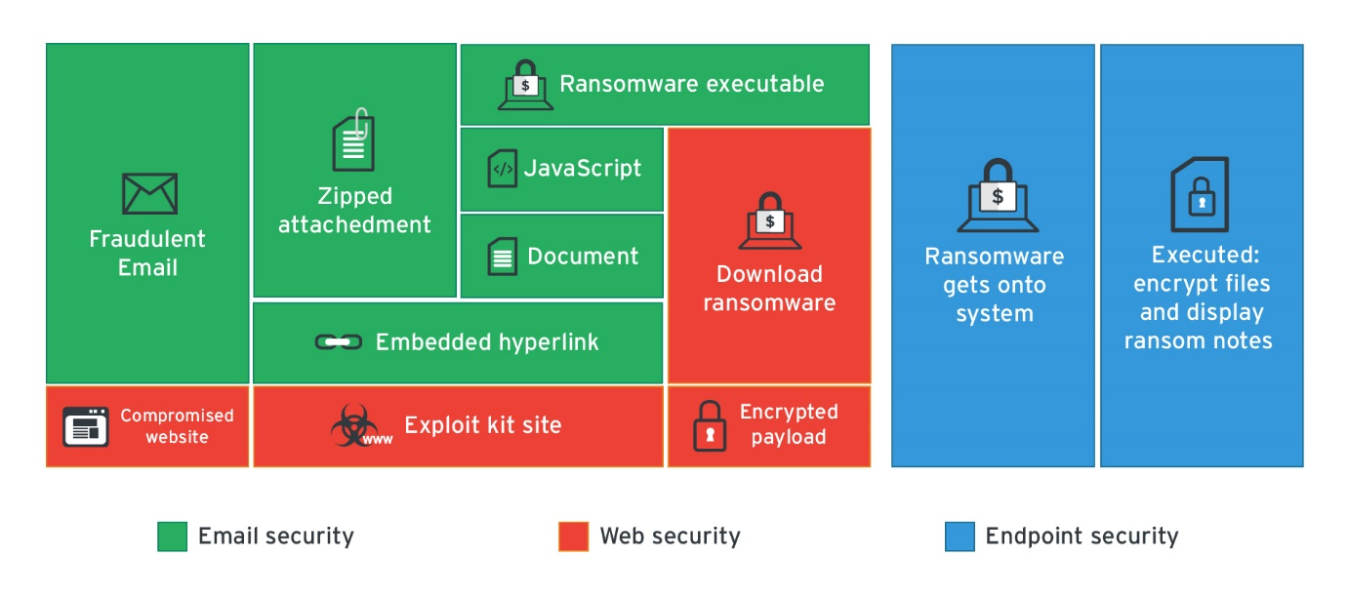
Fig 2: Different threat vectors [25]
  - What impact does ransomware have?
Ransomware will prevent access to systems or data until a solution is found [19]. If systems are delivering critical services, this can have serious reputational, financial and safety impacts on affected organisations and their customers.
Even if the victim has a recent backup of their system, it may still take considerable time to restore to normal operations. During this time, organisations may have to invoke their Business Continuity processes.

  - How to limit the impact of a ransomware attack
NCSC [20] recommends the following measures to help limit the impact of an attack:
- Implement a good access control policy
- Implement a least privilege policy
- Implement a good, fully tested data backup policy. Although this will not prevent an attack it will help recover from one. For further information on protecting bulk personal data please see https://www.ncsc.gov.uk/collection/protecting-bulk-personal-data

  - What to do if the organisation has been infected with ransomware
The National Crime Agency [28] encourages anyone who thinks they may have been subject to online fraud to contact Action Fraud at www.actionfraud.police.uk.
The National Cyber Security Centre (NCSC) runs a commercial scheme called Cyber Incident Response, where certified companies provide crisis support to affected organisations.
The Cyber Security Information Sharing Partnership (CiSP) offers organisations in the UK a safe portal in which to discuss and share intelligence that can assist the community and raise the UK's cyber resilience.

- The Cryptowall Trojan
  - Specifics of this threat
CryptoWall is a file-encrypting ransomware that first released in April 2014. Cryptowall has been through a number enhancements with CyptoWall 4.0 as the latest variant released in November 2015 [21].
Upon successful infection, CryptoWall will scan the system for drive letters, network shares, and removable drives. CryptoWall runs on both 32-bit and 64-bit systems [15].
CryptoWall attacks pose a serious risks to a company’s confidential data. Small/medium size businesses (SMB) are the most targeted [26].
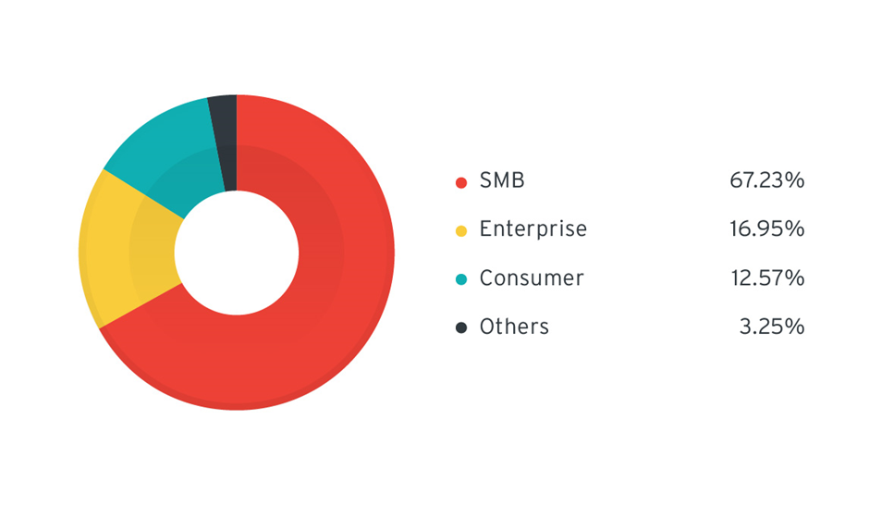
Fig 3: CryptoWall-related URL distribution by segment (June-July 2015) [26]

This ransom note is located in every folder which contains encrypted files as well as in the users Startup folder. This ensures the random not is displayed when a user logs in. The file names for this ransom note are HELP_YOUR_FILES.PNG, HELP_YOUR_FILES.HTML, HELP_YOUR_FILES.TXT.
  - Infection methods
Like other ransomware attacks, CyptoWall uses the following attack vectors:
- Phishing Email: CryptoWall attacks use social engineering to target business users. Phishing emails (see appendix 3 for examples) try to trick users into clicking a link which downloads malware onto their computer. CryptoWall attackers have been seen to send out their spam runs in the early hours of the morning (of the time zone of the intended victims) [27].
- Exploit Kits: The next most common attack vector is as part of an exploit kit, which take advantage of security vulnerabilities to deploy malware needed to execute the attack [27].
- Compromised websites: CryptoWall also uses compromised websites (see appendix 4 for examples of landing pages) [27].
- Malicious Ads: Cybercriminals purchase or hack internet advertisements to deliver malware.

  - File types vulnerable to CryptoWall encryption
The following are examples of common vulnerable file types:
- Excel spreadsheets (.xsl)
- PDF (.pdf)
- Microsoft Word Document (.doc)
- PowerPoint Presentation (.ppt)
- Graphical Interchange Format File (.gif)
- JavaScript File (.js)
- Plain Text File (.txt)
- Joint Photographic Experts Group (.jgp)

  - Procedures of eradication
- Immediately disconnect the infected computers, laptops or tablets from network.
- Turn off your Wi-Fi and unplug any Ethernet or network carrying cables.
- Connect the device to a clean network in order to download, install and update the OS and all other software.
- If you have a recent and clean System Restore point, you can restore, if not:
  - Boot your computer into Safe Mode with Networking
  - Download and install a malware removal application.
  - Run malware removal app and scan all of your files
  - Install, update, and run antivirus software.
- Reconnect to your network.
- Monitor network traffic and run antivirus scans to identify if any infection remains.

  - Payment
In many cases, the ransom amount is quite small [27]. This is designed to make paying the ransom the quickest and cheapest way to return to normal business operations. However, there is no guarantee that the key will be provided to decrypt the files if the ransom is paid [21].
The National Crime Agency advises business not to pay the ransom [28]. If you do pay:
- You may not get access to your data/device
- you will need complete extensive clean-up activities to remove the malware infection
- you may be more likely to be attacked again in the future
- you will be funding criminal groups

- Examples of good practice
It’s unlikely that you’ll get your files back after a ransomware attack [21]. Prevention is better than a cure:
- Keep systems and servers patched and up to date [30]
  - Malware uses known vulnerabilities in software to move to new computers. If you leave those vulnerabilities unpatched, you’re effectively leaving an open door for the cybercriminals to enter. If you keep the OS and all of your applications patched to the latest releases, you stand a better chance of avoiding malware infections.
- Use anti-virus [30]
  - Anti-virus solutions, when updated regularly, can protect you from several kinds of malware attacks. They quarantine known malware and prevent them from executing
- Use a firewall [30]
  - As well as preventing known malware to come through a local firewall can protect you from some connections that malware uses, like to the Command and Control server. The CryptoWall ransomware, in particular, depends on a connection to home base to continue the attack. A local firewall may be able to prevent the malware from making that connection and killing the attack.
- Maintain whitelists [30]
  - This stops users form downloading apps not authorised by the business.
- Control the use of USB and removable media [30]
  - This is a known attack vector to insert malware onto a computer or network
- Don’t click the links [28]
  - Don’t click links or download files from suspicious emails.
- Enable popup blockers [28]
  - Popups are regularly used by criminals to spread malicious software. To avoid accidental clicks, it's best to prevent them from appearing in the first place.
- Practice safe browsing habits [28]
  - Make sure the browser is up to date, use the highest level of encryption possible, and turn off ads and JavaScript by default.
- Back up your files [28]
  - Always keep a backup copy of business critical files.
- Maintain a least privilege model [30]
  - This allows users to access only what they need for their role whilst limiting the spread of an infection. Users with elevated rights should have a separate standard user account for normal day-to-day activities including accessing the internet and sending emails.
- User education [31]
  - Users are often the last defence against social engineering attacks and the weakest link.
  - Backup procedures
All businesses need to take regular, secure backups of their important data [32] to minimise the impact to the availability, confidentiality or integrity of data following an attack [33].
Maintaining a good backup is crucial to disaster recovery. It is important to have a clear backup strategies [33]. When creating a backup strategy you need to consider the following:
- What data needs to be backed up? [30]
- What is the sensitivity of the data involved?
- How much data will need to be backed up? How much storage is required?
- How often do you need to take the backups? [33]
- What is the process of conducting the backups? Will it be a manual or automatic process?
- How quickly you need to be able to access the data following an incident? How quickly can you restore from the backup?
- Where to store the backups? [34]
- How to secure the backups? [34]

  - Backup methods
There are four type of data backup:
- Full backup – all the contents of a drive are backed up [35]
- Incremental backup – only conducts a backup of the contents of a drive that have changed since the last full of incremental backup [35]
- Differential Backup – only conducts a backup of the contents of a drive that have changed since the last full backup. Differential backups take more time to create but are the quickest to restore from [35]
- Snapshots backups - commonly used with virtualised systems. They are used to capture the entire operating system image including applications and data.

  - Backup rotation schedules
There are three main types of tape rotation:
- 10 Tape Rotation – each tape is used once per day for two weeks and then the entire set is reused
- Grandfather-father-son – uses three sets of backup tapes where the son is used daily, the father is used weekly and the grandfather is used monthly [33]
- Towers of Hanoi – also uses three sets of backup take which are rotated in a more complex way than the Grandfather-father-son technique [35].

  - Store backup data separately
Ransomware (and other malware) can often move to attached storage automatically, which means any such backup could also be infected, leaving you with no backup to recover from.
For more resilience, backups should be stored at a physically separate location.
When considering a cloud based backup solution it is important to consider the sensitivity and criticality of the data. Please see www.ncsc.gov.uk/collection/cloud-security for guidance on how to secure cloud services.

  - Make backing up part of your everyday business strategy
The majority of network or cloud storage solutions now allow you to make backups automatically. Automated backups save time and ensures the latest version of your files are available whenever needed.
Many off-the-shelf backup solutions are easy to set up and are affordable considering the business-critical protection they offer.
- Conclusion
Ransomware poses a significant risk to ongoing business continuity.
An independent risk assessment should be conducted to establish how to mitigate against the risk of ransomware and other malware.

- References

[1] | "Securing your information," Gov.uk, 21 May 2018. [Online]. Available: https://www.gov.uk/service-manual/technology/securing-your-information. [Accessed 10 December 2019].
[2] | M. Kleczynski, "Breaking Down Malware: Why It's Still One Of The Biggest Threats Facing Businesses," Forbes Technology Council, 28 September 2018. [Online]. Available: https://www.forbes.com/sites/forbestechcouncil/2018/09/28/breaking-down-malware-why-its-still-one-of-the-biggest-threats-facing-businesses/#20fcd3a7fe1a. [Accessed 10 December 2019].
[3] | E. Hernandez, "The 16 Most Common Types of Cybercrime Acts," VoIP Shield, 14 February 2018. [Online]. Available: https://www.voipshield.com/the-16-most-common-types-of-cybercrime-acts/. [Accessed 1 December 2019].
[4] | "2019 Data Breach Investigations Report," Verizon, [Online]. Available: https://enterprise.verizon.com/resources/reports/dbir/. [Accessed 28 December 2019].
[5] | "Lucrative Ransomware Attacks:," Cyber Threat Alliance, October 2015. [Online]. Available: https://www.cyberthreatalliance.org/wp-content/uploads/2018/02/cryptowall-report.pdf.
[6] | M. Erbschloe, in Trojans, Worms and Spyware: A Computer Security Professional's Guide to Malicious Code, Butterworth-Heinemann, 2004, pp. 17-30.
[7] | "Virus basics," Department of Homeland Security, [Online]. Available: https://www.us-cert.gov/publications/virus-basics. [Accessed 30 November 2019].
[8] | E. Hernandez, "20 Common Types of Viruses Affecting Your Computer," VoIP Shield, 15 May 2019. [Online]. Available: https://www.voipshield.com/20-common-types-of-viruses-affecting-your-computer/. [Accessed 1 December 2019].
[9] | "What is a Remote Administration Tool (RAT)?," Mcafee, 16 February 2015. [Online]. Available: https://www.mcafee.com/blogs/consumer/what-is-rat/. [Accessed 1 December 2019].
[10] | "What is a Trojan? Is it a virus or is it malware?," Norton, [Online]. Available: https://us.norton.com/internetsecurity-malware-what-is-a-trojan.html. [Accessed 2 December 2019].
[11] | A. D. Rayome, "The 10 most common types of malware, and how to avoid them," [Online]. Available: https://www.techrepublic.com/article/the-10-most-common-types-of-malware-and-how-to-avoid-them/. [Accessed 1 December 2019].
[12] | "COMPUTER SECURITY RESOURCE CENTER," NIST, [Online]. Available: https://csrc.nist.gov/glossary/term/threat-actor. [Accessed 30 November 2019].
[13] | "Cyber Threat Source Descriptions," Department of Homeland Security, [Online]. Available: https://www.us-cert.gov/ics/content/cyber-threat-source-descriptions. [Accessed 30 November 2019].
[14] | "COMPUTER SECURITY RESOURCE CENTER," [Online]. Available: https://csrc.nist.gov/glossary/term/vulnerability. [Accessed 30 November 2019].
[15] | E. Conrad, S. Misenar and J. Feldman, CISSP study guide, 1 ed., Syngress, 2010, pp. 393-394.
[16] | "Top 10 Malware October 2019," CIS Center for Internet Security, October 2019. [Online]. Available: https://www.cisecurity.org/blog/top-10-malware-october-2019/. [Accessed 10 November 2019].
[17] | "7 Warning signs of malware infection," TechAdvisory.org, 29 March 2016. [Online]. Available: https://www.techadvisory.org/2016/03/7-warning-signs-of-malware-infection/. [Accessed 30 November 2019].
[18] | "How to Avoid Malicious Files with Double Extensions," Bitdefender, 30 August 2018. [Online]. Available: https://www.bitdefender.com/blog/consumer/avoid-malicious-files-double-extensions/. [Accessed 1 December 2019].
[19] | "Frequently Asked Questions - Ransomware," Berkeley Information Security Office, [Online]. Available: https://security.berkeley.edu/faq/ransomware/. [Accessed 30 November 2019].
[20] | "Protecting Against Ransomware," Department of Homeland Security, 11 April 2019. [Online]. Available: https://www.us-cert.gov/ncas/tips/ST19-001. [Accessed 1 December 2019].
[21] | "Protecting your organisation from ransomware," NCSC, 20 November 2018. [Online]. Available: https://www.ncsc.gov.uk/guidance/protecting-your-organisation-ransomware. [Accessed 1 December 2019].
[22] | "Crypto Ransomware," Deptartment of Homeland Security, 30 September 2016. [Online]. Available: https://www.us-cert.gov/ncas/alerts/TA14-295A. [Accessed 1 December 2019].
[23] | S. Morgan, "Ransomware damage costs predicted to hit $11.5B by 2019," CSO, 20 November 2017. [Online]. Available: https://www.csoonline.com/article/3237674/ransomware-damage-costs-predicted-to-hit-115b-by-2019.html. [Accessed 15 November 2019].
[24] | J. D. Groot, "A History of Ransomware Attacks: The Biggest and Worst Ransomware Attacks of All Time," Digital Guardian, 24 October 2019. [Online]. Available: https://digitalguardian.com/blog/history-ransomware-attacks-biggest-and-worst-ransomware-attacks-all-time. [Accessed 30 November 2019].
[25] | "Can Macs get ransomware and how to stop a ransomware attack," MacWorld, [Online]. Available: https://www.macworld.co.uk/how-to/mac/ransomware-3659100/. [Accessed 30 November 2019].
[26] | "How Endpoint Solutions Can Protect Businesses Against Ransomware," Trend Micro, 18 July 2016. [Online]. Available: https://blog.trendmicro.com/trendlabs-security-intelligence/how-endpoint-solutions-can-protect-businesses-against-ransomware/#gallery-1. [Accessed 30 November 2019].
[27] | P. P. (. A. J. O. (. Architect), "Businesses Held for Ransom: TorrentLocker and CryptoWall Change Tactics," [Online]. Available: https://blog.trendmicro.com/trendlabs-security-intelligence/businesses-held-for-ransom-torrentlocker-and-cryptowall-change-tactics/ .
[28] | "CryptoWall and HELP_DECRYPT Ransomware Information Guide and FAQ," Bleeping Computer, July 2014. [Online]. Available: https://www.bleepingcomputer.com/virus-removal/cryptowall-ransomware-information#ransom. [Accessed 1 December 2010].
[29] | "Mitigating malware," NCSC, 8 February 2018. [Online]. Available: https://www.ncsc.gov.uk/guidance/mitigating-malware#section_1. [Accessed 30 November 2019].
[30] | J. Petters, "The State of CryptoWall in 2018," Varonis , 6 January 2018. [Online]. Available: https://www.varonis.com/blog/cryptowall/. [Accessed 30 November 2019].
[31] | P. Pajares and J. Oliver, "Businesses Held for Ransom: TorrentLocker and CryptoWall Change Tactics," 22 September 2015. [Online]. Available: https://blog.trendmicro.com/trendlabs-security-intelligence/businesses-held-for-ransom-torrentlocker-and-cryptowall-change-tactics/. [Accessed 30 November 2019].

- Bibliography
Best Practices for Continuity of Operations (Handling Destructive Malware) https://www.us-cert.gov/ics/tips/ICS-TIP-15-022-01
The Diamond Model of Intrusion Analysis http://www.activeresponse.org/wp-content/uploads/2013/07/diamond.pdf
The Basics of Cloud Computing https://www.us-cert.gov/sites/default/files/publications/USCERT-CloudComputingHuthCebula.pdf
The basics of ISO 22301 https://advisera.com/27001academy/what-is-iso-22301/?icn=free-what-is-iso-22301&ici=top-what-is-iso-22301-txt

- Appendices

Appendix 1 – List of file types vulnerable to cryptowall ransomware attacks [29]
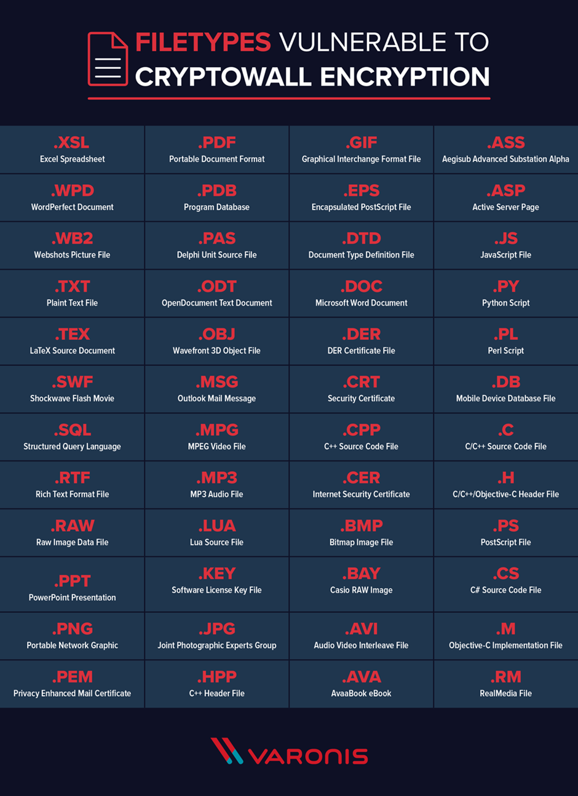

Appendix 2 – examples of CryptoWall 4.0 phishing emails [27]
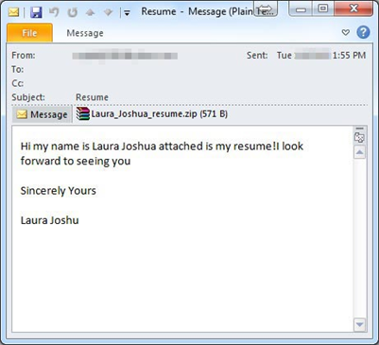
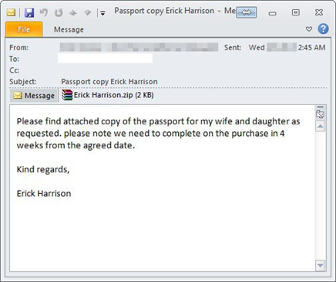

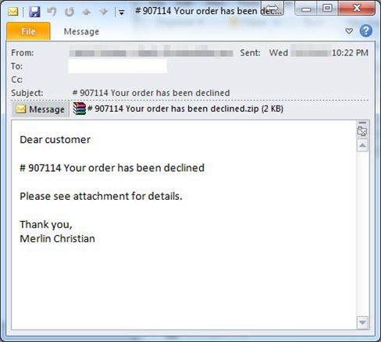

Appendix 3 – examples of landing pages of compromised websites [27]. These websites show no indication that anything is wrong.
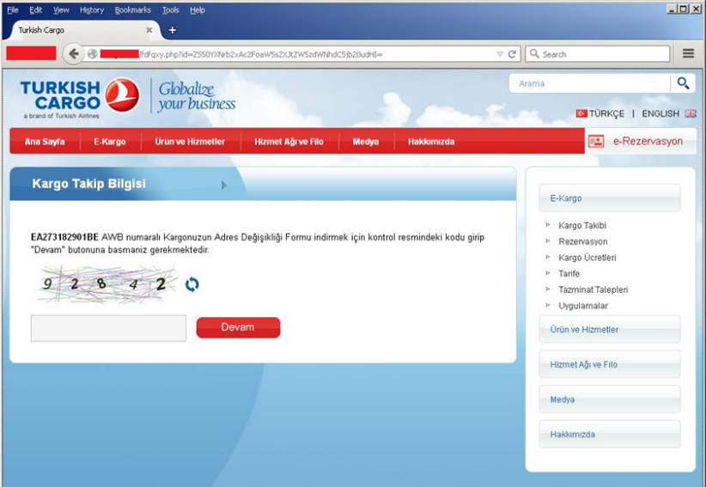

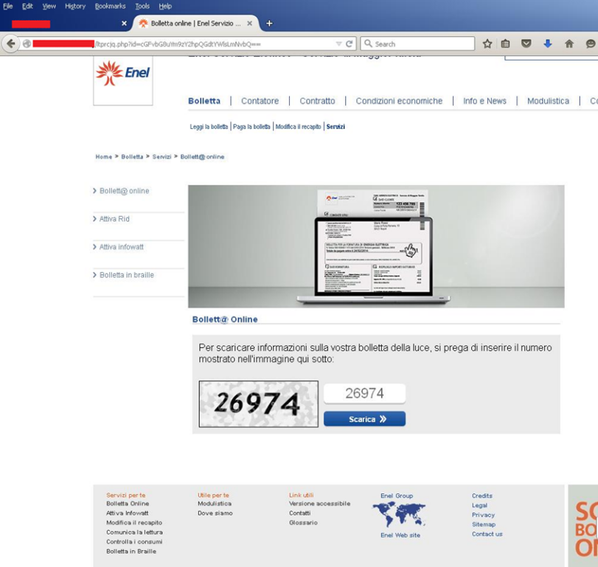
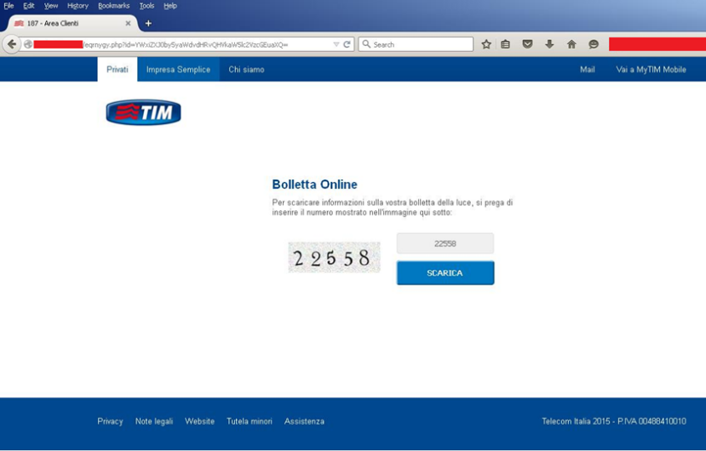

Appendix 4 – example of CryptoWall 4.0 ransom demand [27]
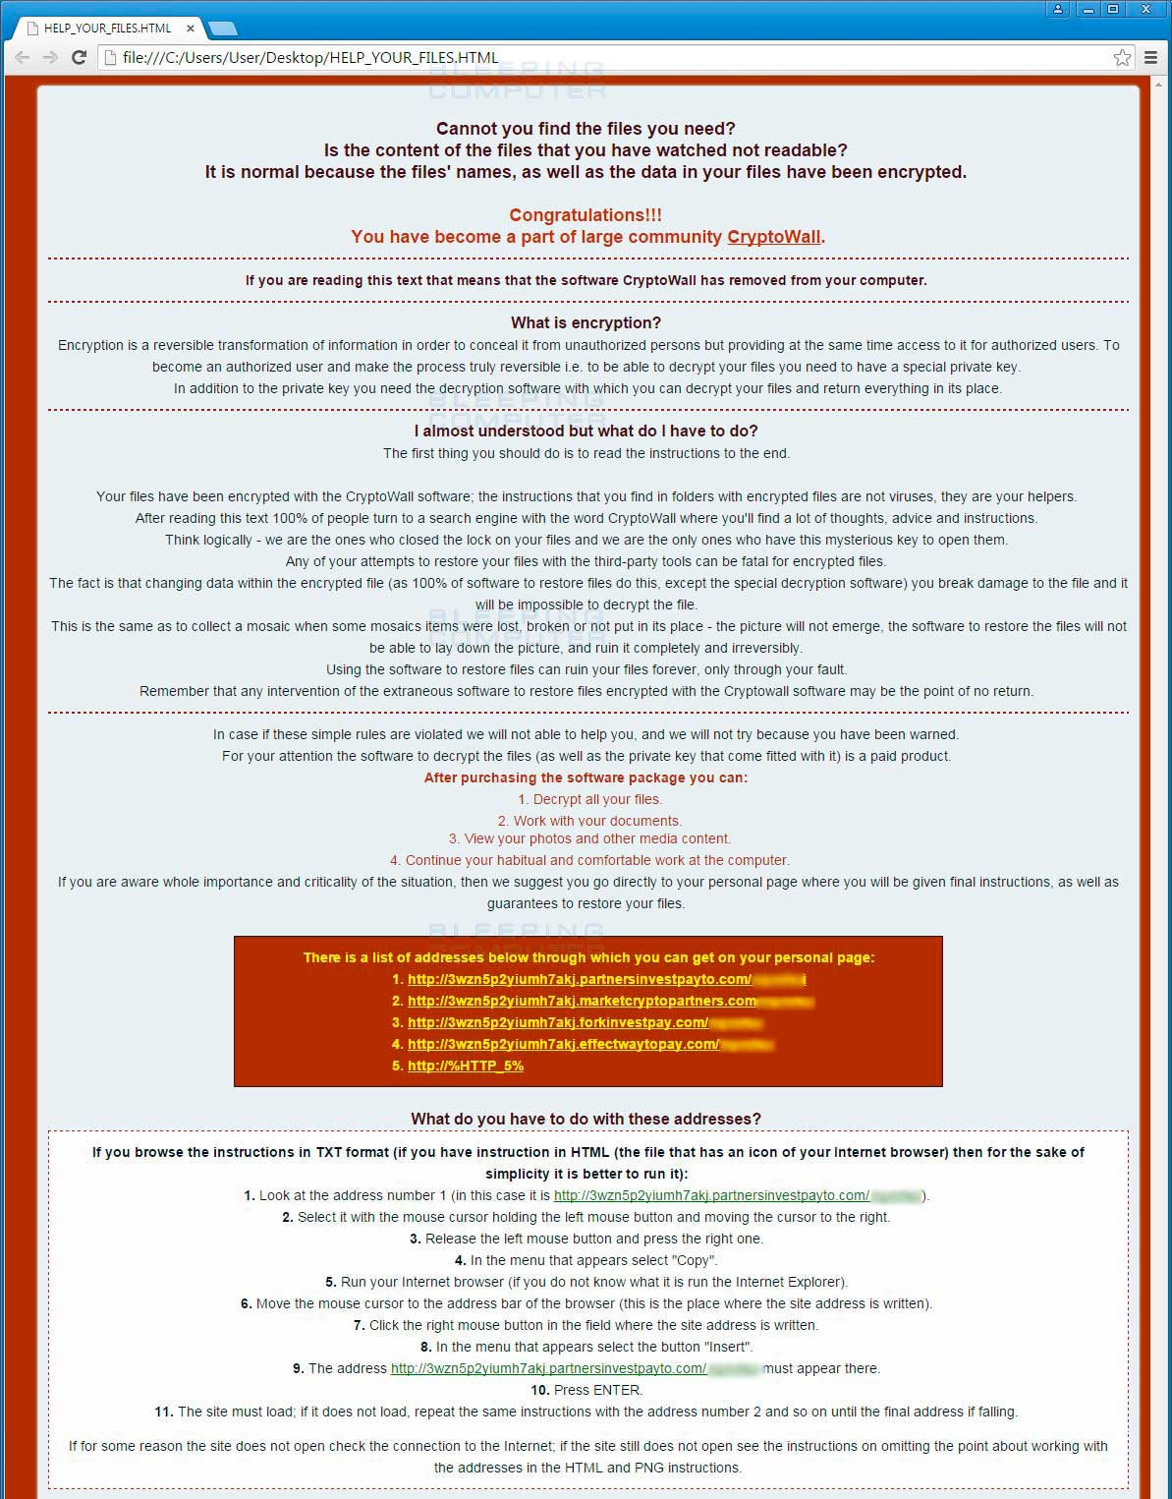
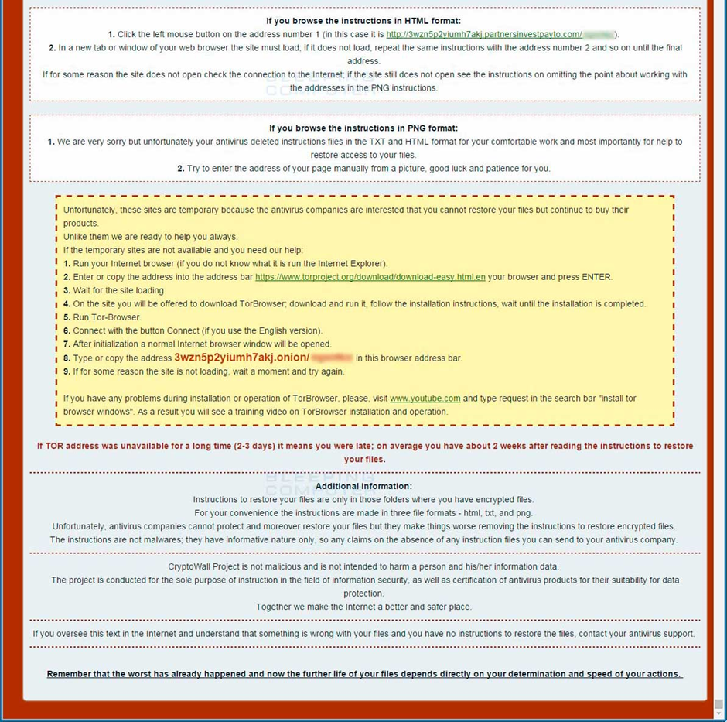

Appendix 9 - E-Portfolio

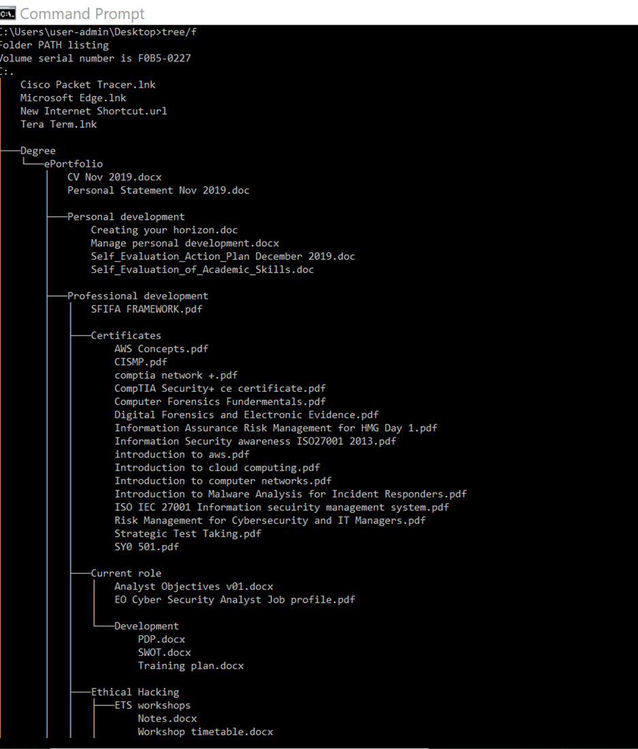
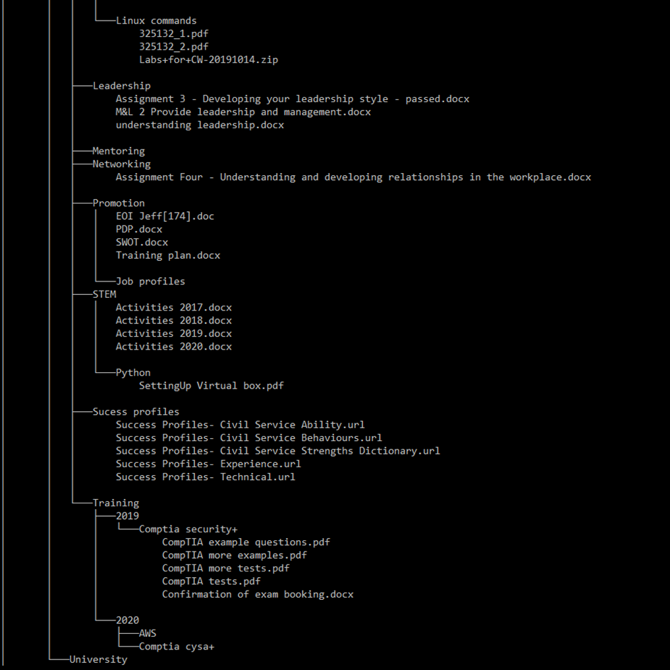
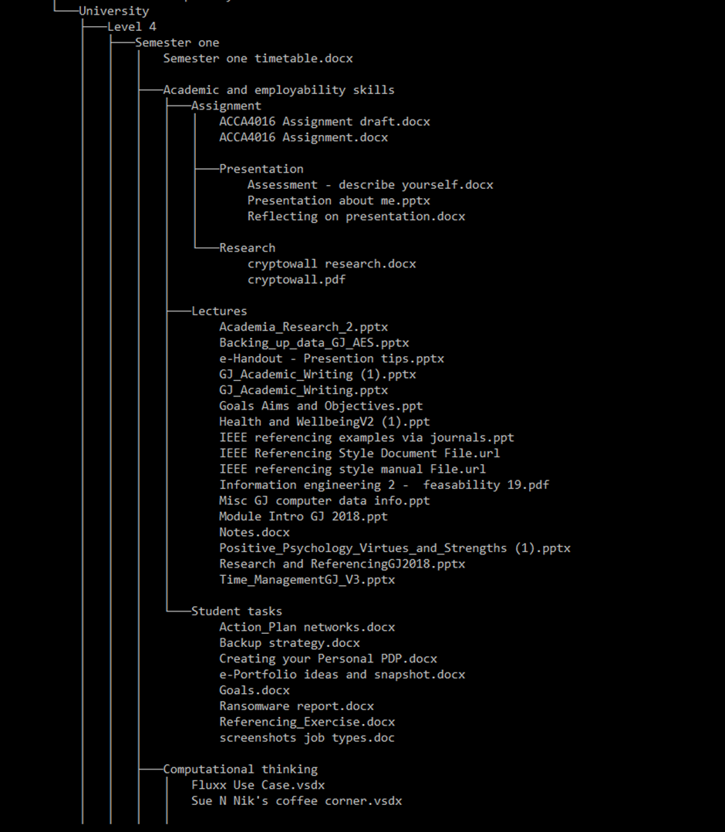

Appendix 10 - Curriculum Vitae

Donna Kennett | Cyber Security Analyst
Location: DVLA
Telephone: 01792 662603
Email: donna.kennett@dvla.gov.uk
IT/Technical skills
- LogRhythm  - Tufin  - F5 Silverline | - Service Now  - ClearSwift  - Palo Alto | - Drupal  - Coding/Programming
Career summary
May 2018 – Present Cyber Security Analyst
Key responsibilities
- Conduct Protective and Technical monitoring of DVLA systems
- Manage security change control approval and making recommendations to reduce risk
- Review threat intelligence to determine impact to the agency and take mitigating actions
- Provide expert advice and guidance to all areas of the business
- Provide coaching and mentoring to new staff members and work shadow placements
- Investigate and resolve incidents
- Promote good Cyber Security practice and proactively keep up to date on cyber security issues
- Improve and streamline services – e.g. taking laptop abroad web form and accompanying article, laptop declaration form, Service Desk’s continued business need process, incident flowchart
Key achievement/projects
- Created the new Cyber Security Policy

March 2017- Present DVLA STEM (Science, Technology, Engineering and Mathematics) Ambassador
Key responsibilities
- Teach primary school children how to code and solve problems using basic computational thinking
- Facilitate Lego Mindstorm Robotic workshops
- Support DVLA Code Challenge

February 2017- October 2017 HR Corporate Health, Wellbeing and Attendance Team (Secondment)
Key responsibilities
- Managed internal and external recruitment campaigns
- Created and managed communication campaigns to promote health initiatives, including the flu program, health screening, Stop Smoking Classes, Money Advice, Life Matters Week and changes to the Attendance Management Policy
- Managed agency’s 2017 Flu vaccine program
- Resource and promotional procurement for Life Matters event, healthy pregnancy and bereavement support packs, ensuring best value for money and compliance to DVLA procurement policies and procedures
- Provide support to Occupational Health Contract Manager

April 2016 – September 2018 DVLA Ability Staff Networking Group
Key responsibilities
- Manage resources to support the strategic plans of the group and the Agency
- Managed all communication and recruitment campaigns
- Managed all committee and champion training requirements
- Act on behalf of the chairperson in her absence
- Created and managed the 2018 Ability Groups’ Diversity and Inclusion Plan which fed into the DVLA and DfT action plans
- Designed, launched and led the Buddy Network and Crisis Intervention Program
- Facilitated mental health awareness workshops

Jan 2005 – May 2018 Operational Casework
Key responsibilities
- People and Task management responsibility of a busy operational multi-disciplined team
- Leading and supporting team though several periods of change and uncertainty
- Manage team training and mentoring requirements
- Conduct independent reviews to streamline processes and create new operating instructions
- Subject Matter Expert – historic, kit built, kit converted, radically altered and rebuilt vehicles
- Manage cross-command multi-skilling training program
- Facilitate knowledge sharing, performance, accuracy and process improvement workshops
- Coach and mentor

Mar 2010 – Feb 2017 Communication and Engagement Champion
- Senior CAEG Communication and Engagement Champion
- Support the Communication and Engagement Manager
- Lead and manage 15 communication champions
- Manage training and mentoring requirements of the communication champions
- Support People Survey, encourage participation and facilitate workshops to create engagement plans
- Editor of CAEG’S weekly newsletter and chair weekly newsletter workshops
- Collaborate with Communication and Engagement Champions from other directorates
- Support Summer Fetes and charity of choice activities

Education and qualifications
- BSC Degree in Cyber Security and Networking – Ongoing
- Introduction to AWS – Acloud Guru - 2019
- CISMP – BCS – 2019
- Information Assurance Risk Management for HMG – QA – 2018
- ISO/IEC 27001. Information Security Management System – Udemy – 2018
- Risk Management for Cybersecurity and IT Managers – Udemy – 2018
- Intelligence Analyst Certification – Udemy -2018
- Introduction to Malware Analysis for Incident Responders – Udemy – 2018
- AWS Concepts – Udemy – 2018
- CompTIA Networks+ - Udemy – 2018
- Computer Forensics Fundamentals – Udemy - 2018
- Digital Forensics and Electronic Evidence – Udemy- 2018
- Information Security Awareness ISO27001 – Udemy – 2018
- Introduction to Cloud Computing – Udemy – 2018
- Introduction to Computer Networks – Udemy – 2018
- VTCT Certificate in Computing – Swansea University – 2017
- NVQ Leadership and Management (Level 4)– NPTC Group – 2017
- NVQ Information Technology (level 2) – Gower College – 2016
- NVQ Team Leading (Level 2) – Neath College – 2015
- NVQ Customer Service (Level 2) – Neath College - 2010
- A level Computing – Neath College – 2000
- NVQ Italian – Neath College – 1998
- GCSE Mathematics, Double Award Science, English Language, English Literature, Geography, IT, French, Art (Grades A* – C) – Cefn Saeson - 1997

