Hotel Handbook for Intercultural Competence

POPA ANCA
2126967
Cultural Awareness (BMIH5003)
Luciana Suardi

Executive Summary

The aim of this report is to conduct a comprehensive investigation and evaluation of the dissimilarities in culture between Italy and Qatar. The main goal is to enable the staff of Hotel Artemide to provide exceptional services to their Qatari guests by considering the cultural differences between the two countries. In the hospitality industry, cultural awareness is of utmost importance as it contributes significantly to creating memorable experiences for guests. Given the significant cultural differences between Italy and Qatar, it is imperative that the hotel staff tailor their services to ensure that their Qatari guests have an unparalleled experience during their stay.
Contents
1 Introduction 4
1.1 Country A – Qatar 4
1.2 Country B – Italy 5
2 Country Analysis 5
3 Hotel Handbook 7
3.1 Dos and Don’ts for the Staff of the Hotel Artemide 7
4 Conclusion 9
5 References 10

Introduction
A comprehensive report has been developed to aid the team at Hotel Artemide in effectively handling guests from Qatar during their stay in Italy. The report is designed to utilize the Hofstede model to carefully analyse and pinpoint any cultural disparities. The results will be condensed into the hotel's handbook, providing a convenient and quick reference tool for the staff to consult when needed.

Country A – Qatar
The Qatari culture is deeply entrenched in the traditional customs and practices of the Arab region, which are closely linked to their religious beliefs. Even though Islam is the predominant religion, other religions are also held in high regard (TRADOC, 2006).
As per Hofstede's dimensions, Qatar places great value on hierarchical orders and centralization, emphasizing the need to demonstrate respect towards superiors. This reflects a collectivist society, where loyalty is held in high esteem.
The society is noted for its assertiveness and decisiveness, with moderate muscularity. Furthermore, Qatar places great emphasis on adherence to strict codes of beliefs and behaviors (Alsuwaidi, 2020).
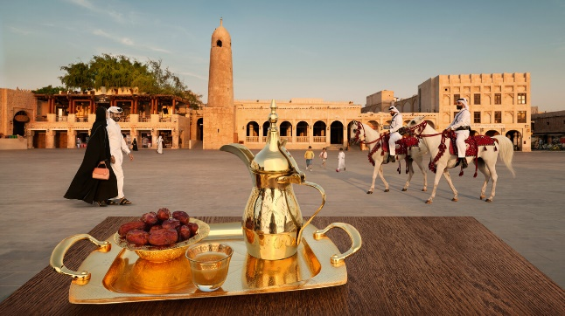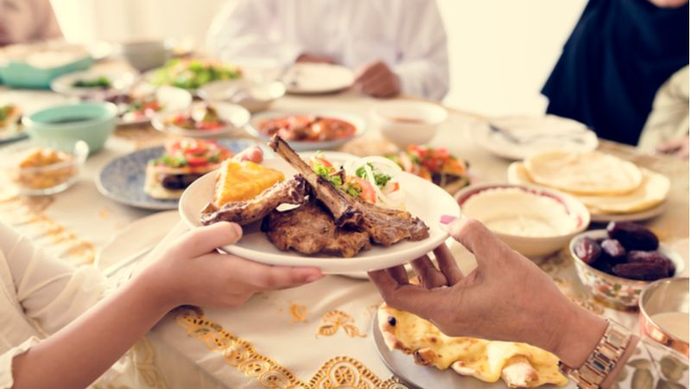

Country B – Italy
Italy boasts a rich cultural heritage with roots tracing back to the Roman Empire, resulting in a distinctive legacy that places high value on the arts, family, architecture, food, and music (Gordon and Zimmermann, 2022).
The culture emphasizes equity and decentralization of power and decision-making, while also displaying individualistic tendencies, as individuals hold their own personal ideas and objectives.
Success, competition, and achievement are highly prized in Italian society. Furthermore, Italians prefer clear situations over ambiguity, while the overall culture is pragmatic and considers contextual factors such as time and situational considerations (Aboramadan et al., 2020; Hofstede Insights, 2023).
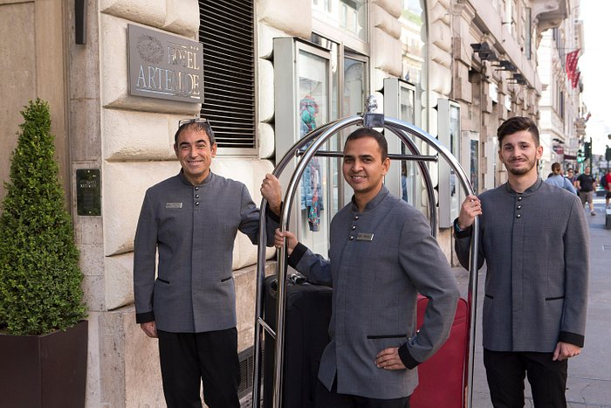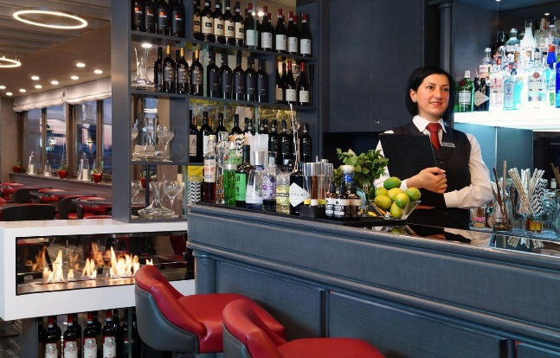

Country Analysis
In evaluating the hospitality industry of two nations, a comparative analysis may be conducted utilizing the chart depicted below. Notably, cultural context plays a pivotal role in this examination, as it is an acquired and collective phenomenon that may hold varying connotations within diverse settings (Minkov and Kaasa, 2021).
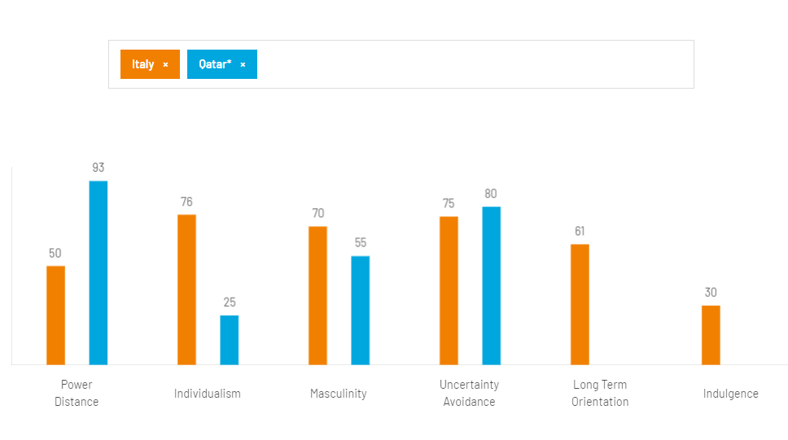
Figure 1: Comparison between Italy and Qatar
Source: Hofstede Insights (2023)

The Arab culture values faith and family highly, and places great emphasis on collectivism. Likewise, Italians are renowned for their warm and affectionate greetings. With appropriate training and preparation, accommodating guests from Qatar should not pose a significant challenge.
In Italy, while individualism is highly valued, the importance of spending quality time with one's family through frequent gatherings is also prioritized. When receiving guests from Qatar at Hotel Artemide, it is essential to acknowledge their subjective perceptions and social orientation as noted by Peleg and Messerschmidt-Grandi (2019). The various departments of the hotel should fulfill their respective responsibilities accordingly. For instance, the front office, housekeeping, and management departments must focus on accommodating guests' requests without openly declining them.
In Qatar, it is customary to exchange handshakes as a form of greeting, farewell, and gesture of respect, like the culture in Italy. It is worth noting that in Arab culture, certain forms of interpersonal contact between individuals of different genders may be perceived as inappropriate. Furthermore, whereas Italians tend to maintain strict adherence to schedules, Arabs may view a hurried approach as disrespectful (Alberti and Iannuzzi, 2020).
It is crucial to acknowledge that guests from Qatar may strongly prefer traditional ideas and behaviors and may firmly follow their beliefs. Additionally, individuals of Arab descent place great importance on security protocols when traveling to foreign destinations (Peleg and Messerschmidt-Grandi, 2019).
The Hotel Artemide's security department will play a crucial role in upholding a positive perception of security personnel and surveillance cameras located within the hallways. To cater to Arab guests, it is highly recommended to provide serene accommodations as well as activities and programs that are culturally appropriate and child friendly.
The role of Italian cuisine in Italian culture is deeply ingrained and holds the utmost significance (Del Chiappa et al., 2021). However, in consideration of the varied food preferences of guests hailing from Qatar, it may be prudent to incorporate Arabic dishes into the menu. Additionally, translating the room service menu and directories into Arabic would offer valuable assistance. While individualism may hold high value in Italy, Qatar places greater emphasis on relationships and perceives them through a moral lens (De Boni and Forleo, 2019; Mehrez, 2019).

Hotel Handbook

Dos and Don’ts for the Staff of the Hotel Artemide
To provide exemplary service as a staff member of our hotel, it is important to be mindful of cultural differences when interacting with guests from Qatar. The table below offers guidance on recommended actions and things to avoid. All staff members will utilize it during their interactions with our esteemed guests. This will showcase their commitment to creating a hospitable and courteous atmosphere for all visitors.
Dos | Don’ts
Greetings and farewells with handshakes | Never be in a hurry to meet and greet; it might be considered offensive
Emphasise eye contact during discussions with male members | Long eye contact with a female is not encouraged
Prefer friendliness and generosity | Do not talk aggressively or loudly
Arabs usually speak their own language or English. Therefore, the staff attending guests should be able to address them in English. | It would not be suitable to speak Italian.
Conversations should be long with proper descriptions so that they don’t appear to be disrespectful or uninterested. | Do not decline any request too bluntly
Offer first-class service, which is always expected by Arabs | Make no compromise on guest services and performance
Be diplomatic and tolerant at the same time, as guests can be demanding | Strive to be punctual in catering to issues as such guests are usually dependable
Be aware of the local customs and Arab way of life.  Also, respect their religion | The use of humor can be quite challenging.  Be very reserved and steer clear of impoliteness

Conclusion
Following a thorough analysis, it has been discerned that significant differences exist in the culture and traditions of Italy and Qatar. To provide guests with an exceptional experience, it is imperative that hotel personnel remain cognizant of Arab cultural preferences. It is paramount that friendliness and generosity are prioritized throughout all departments. Moreover, it is essential to place a high priority on meeting Arab guests’ high expectations, as they are known to have discerning tastes. Another imperative measure is to have a comprehensive understanding of local Arabic customs, including preferences for accommodations, activities, programs, and cuisine, to make informed decisions that will enhance their experience.

References
Aboramadan, M., et al. (2020) Narcissistic leadership and behavioural cynicism in the hotel
industry: the role of employee silence and negative workplace gossiping. International
Journal of Contemporary Hospitality Management, 33(2), pp.428-447.
Alberti, G. and Iannuzzi, F.E. (2020) Embodied intersectionality and the intersectional
management of hotel labour: The everyday experiences of social differentiation in customer
oriented work. Gender, Work & Organization, 27(6), pp.1165-1180.
Alsuwaidi, M.S. (2020) The employability of qatari citizens in the hospitality sector: Current challenges and future prospects, College of Business and Economics. Available at: https://www.academia.edu/99597855/The_Employability_of_Qatari_Citizens_in_the_Hospitality_Sector_Current_Challenges_and_Future_Prospects# (Accessed 10 June 2023).
De Boni, A. and Forleo, M.B. (2019) Italian halal food market development: drivers and
obstacles from experts’ opinions. Journal of Islamic Marketing. 27(6), pp.1165-1180.
Del Chiappa, G. et al. (2021) The impact of COVID-19 on Italian accommodation: A supply
perspective. Journal of Tourism, Heritage & Services Marketing (JTHSM), 7(1), pp.13-22.
Gordon, J., and Zimmermann, K.A. (2022) Italian culture: Facts, Customs & Traditions.
[online] LiveScience. Available at: https://www.livescience.com/44376-italian-culture.html
(Accessed 10 June 2023).
Hofstede Insights (2023) Country comparison tool. [online] Hofstede Insights. Available at:
https://www.hofstede-insights.com/country-comparison-tool?countries=italy%2Cqatar*
(Accessed 10 June 2023).
Hotel Artemide, S. (2023) Hotel Artemide - Rome. [online] Official Website. Available at:
https://www.hotelartemide.it/en/ (Accessed 10 June 2023).
Mehrez, A. (2019) Investigating the effectiveness of practicing knowledge management in the
hospitality industry: The case of Qatar. International Journal of Knowledge Management
Studies, 10(2), pp.101-117.
Minkov, M. and Kaasa, A. (2021) A test of Hofstede's model of culture following his own
approach. Cross Cultural & Strategic Management, 28(2), pp.384-406.
Peleg, O. and Messerschmidt‐Grandi, C. (2019) Differentiation of self and trait anxiety: A
cross‐cultural perspective. International Journal of Psychology, 54(6), pp.816-827.
TRADOC (2006) Arab Cultural Awareness: 58 factsheets - Federation of American Scientists.
[online] TRADOC. Available at: https://irp.fas.org/agency/army/arabculture.pdf (Accessed 10
June 2023).

