

Problem Solving
and Decision Making
(BMSW4004_LON)

Romulo Santillan S/N 1906875
Lecturer: Dr. Mushfiqur Rahman

Table of Contents
1.Introduction 3
2. Problem at my workplace: Lack of Employee/Staff Training 3
2.1 Definition of Staff Training 3
2.2 Analysis, reasons and information on the identified problem 3
2.3 Advantages and Disadvantages of Staff Training 4
3. Resolving Lack of Employee Training 4
4. Decision Making, Tools and Techniques 5
4.1 Definition of Decision Making 5
4.2 Tools and Techniques affecting Good Decision Making 5
4.2.i PESTLE 5
4.2. ii. SWOT (Strengths, Weaknesses, Opportunities and Threats) Analysis 7
4.2.iii Fishbone or Ishikawa Diagram Analysis 7
4.2.iv PMI (Plus, Minus, Interesting) 8
4.2.v Porter’s Five Force 9
5. Proposed Solutions 9
6. Evaluation of proposed solutions 10
7. Implementation plan for proposed solutions 10
8. Monitor and Review of Implementation Plan 11
9. Gantt Chart: Generalized Activity Normalization Timetable 11
10. Conclusion 11
11. References 12
12. Appendix 13

1.Introduction

Problem solving refers to cognitive processing directed at achieving a goal when the problem solver does not initially know a solution method. A problem exists when someone has a goal but does not know how to achieve it.(Mayer,R.2013). In this assignment, I will discuss a problem at my workplace which is lack of employee/staff training. I will define the complex problem and I will provide solutions and alternative solutions through using problem solving tools and techniques that I have learned in this module, this is in order to come up with a good decision making. I will evaluate, monitor and review the proposed solutions in a certain set of time goals which is to have all employees an adequate training and development, this can be extremely beneficial and productive to both employees and to the organisation.

2. Problem at my workplace: Lack of Employee/Staff Training

2.1 Definition of Staff Training
Staff training is the process of training the current staff/employee of the organisation for enhancing the performance of the staff as well as the productivity of the organisation.(Reddy,C.2020).

2.2 Analysis, reasons and information on the identified problem
Training plays a vital role in developing skills of employees and lack of it can be frustrating. Employees feel they are not developing, no progress to their personal and professional career,it decreases staff morale and can result in poor job performance.
It is one most common problem in an organisation and I identified it at my work place and when it was raised to me by my colleagues as well.The organisation itself can be less productive and can have bad reputation due to lack of staff training.Employers should provide staff training to their employees for the growth and progress of the organisation.(Reddy,C.2020).

I am working at The Travellers Club in London as a Front Desk Supervisor and one of the issue is lack of staff/employee training.There are various aspects and reasons as to why it is happening,like for example staff are not motivated,it cost money for the organisation,waste of time, staff schedules,staff unable to adapt with new technolgy and system. One scenario is, one of my colleague has failed to use the ESP system due to his less capable adaptation into new training in I.T. skills in our workplace to make a bedroom reservation for guest, thus created a mistake and further problem to the organisation. Some grounds are not acceptable because staff recognise that they are not valued and on another angle staff should attend compulsory and mandatory training provided by the organisation as it is a legal requirement.

2.3 Advantages and Disadvantages of Staff Training

Advantages | Disadvantages
Stay ahead of competitors | Loss if interest
Keep up with industry changes | Leave for new job
An opportunity to learn | Time requirement
Grabs in new talent | Control of training
Self- confidence | Too much of theory
Positive attitude | Waste of time and money
Group effort | Increased stress
Handles customers well
(Reddy, C. 2020)

3. Resolving Lack of Employee Training

As a Supervisor in our team, I focused on the main issue of the problem,I collect data to identify and determine the main problem,I analyse the cause and find out why this became a problem.I will then start solution planning and implementation, evaluate the effects and evaluation process. It is best to ask for feedback from employees or colleagues to achieve goals and employee’s satisfaction. For most companies,the highest priority when it comes to allocating training resources is increasing the effectiveness of training programs.(Andriotis,N.2018).

4. Decision Making, Tools and Techniques

4.1 Definition of Decision Making
Decision making - means analysing different alternatives and arriving at a decision in the face of a particular situation about what to do and what not to do. It this way decision-making means reaching a conclusion or final decision which can be implemented as a solution of a problem (Aayat, R. 2020).

4.2 Tools and Techniques affecting Good Decision Making
There are plenty of factors affecting good decision making such as a manager's unique style and strategies, solid knowledge and priceless experience, stress, money and a lot more.

In this problem identified- lack of employee training, I will discuss the tools and techniques affecting Decision Making.

4.2.i PESTLE Analysis
This analysis is used as a tool of situational analysis for business evaluation purposes and is one of the most used models in the evaluation of the external business environment that is highly dynamic. (Perera,R.2017).

Political - with Brexit and Covid-19 pandemic, there are some factors affecting our organisation, lack of employee training is one of those- all staff called up to come back and work again to our organisation has to do online training regarding covid-19 awareness which is required by the government. The only problem is not all employees can adapt into online training especially those who are quite elderly staff.

Economic - Due to Covid-19 pandemic,the economy was greatly affected including organisations and employees, staff on Furlough and business is going down.Beforehand, our business organisation is experiencing loss of profit and financial difficulties which restrict some expenses and that includes staff training.

Social - due to covid-19 pandemic, employees were restricted to do training face to face in the workplace which we normally do,it has a great impact to both employees and organisation but more especially on employees side due to non-progress and no development in personal and professional career.

Technology - Zoom meeting and MS team are popular in our workplace during covid-19, communication and connecting each other help to update in our business organisation however there are some staff that do not have smartphones and modern technology which affect them in a way.

Legal - Due to covid-19 pandemic, staff are required by the organisation to do Covic-19 Awareness training online. Yearly, we have Health and Safety Training in the workplace which was not organised by our organisation because of the same reason. Employers have a legal obligation to ensure a Health and Safety Environment in the workplace and should provide staff training.

Environmental - Couple of scenarios in our workplace, staff training was cancelled due to flooding in a specific place which the lecturer lives and transport is not possible.

4.2. ii. SWOT (Strengths, Weaknesses, Opportunities and Threats) Analysis
This analysis is a framework used to evaluate a company’s competitive position and to develop strategic planning. SWOT analysis assesses internal and external factors, as well as current and future potential. (Grant,M.2020).
Following identified problem- lack of employee training- I made a SWOT analysis below:
Strengths - employees are motivated to learn and to contribute in business organisation, employees learn - as they go on their shift and deal with the problem, some staff has more experience to play a part.
Weaknesses - lack of opportunity to attend training, lack of enthusiasm, less motivated, poor employee’s performance, decrease staff morale, customers unsatisfied.
Opportunities - searching elsewhere for professional development, look and search for external training which is relevant to professional development.
Threats - poor employee performance, employees are prone to make mistakes, unsatisfied customers, decrease staff morale, unhappy employees and tend to search for a new job and new organisation.

4.2.iii Fishbone or Ishikawa Diagram Analysis
A fishbone diagram is a cause-and-effect discovery tool that helps figure out the reason(s) for defects, variations or failures within a process. In other words, it helps break down, in successive layers, root causes that potentially contribute to an effect. Sometimes called an Ishikawa diagram or cause-and-effect analysis, a fishbone diagram is one of the main tools used in a root cause analysis (Trout,J.2020 ).

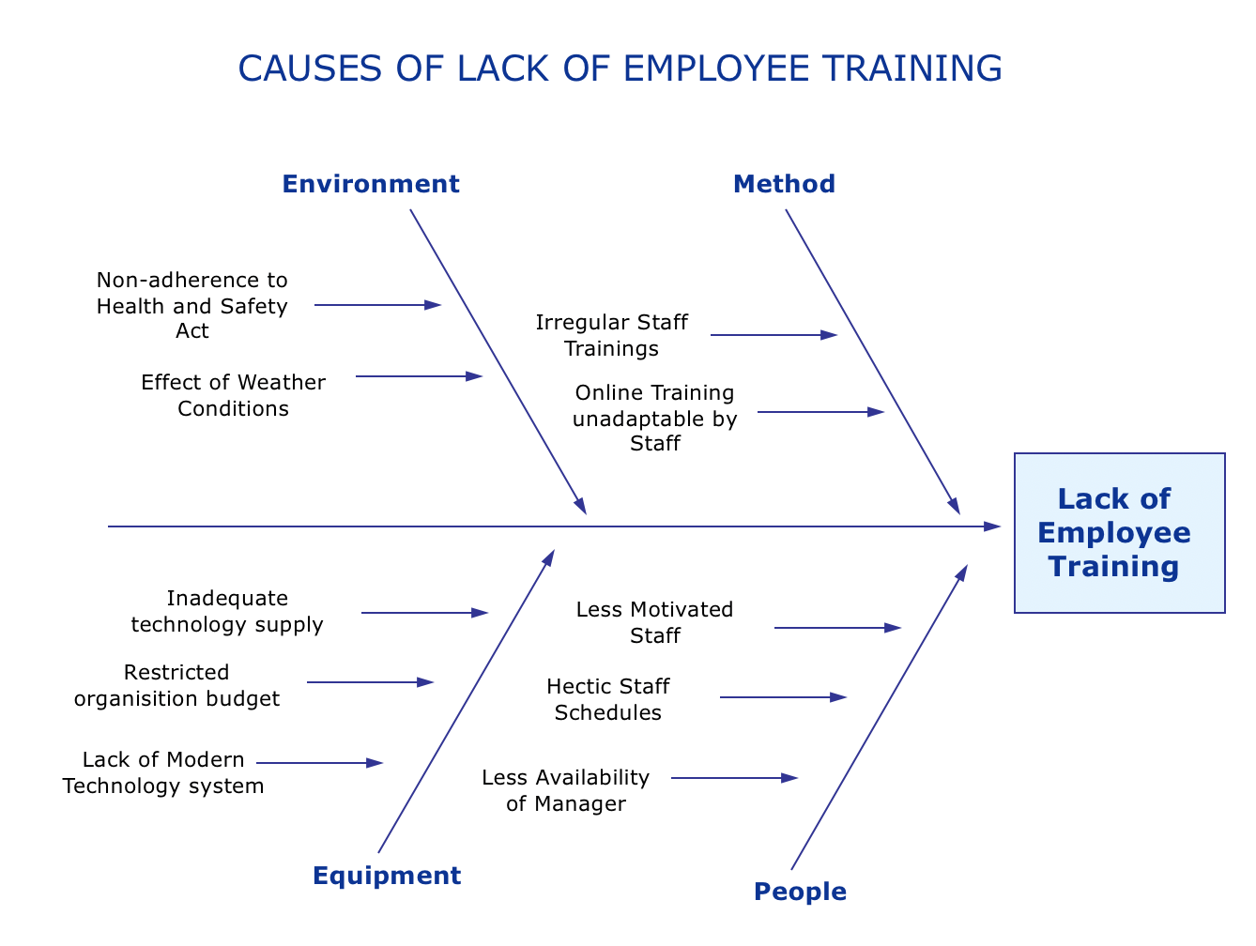
The fishbone diagram above highlights the cause and effect of lack of employee training. Some are due to staff who are not motivated and some are unable to use and unadapt on technology and the system used by organisation. Another cause is organisational budget restriction and environmental reason as well.

4.2.iv PMI (Plus, Minus, Interesting)
Another decision making tool which was developed by Dr.Edward de Bono.After watching the video ‘Paul demonstrate Plus-Minus-Interesting’, I have learned that PMI decision making tool requires agility of an individual as you need to do brainstorming, the most I like in the video is there are questions and answers between Paul who demonstrate PMI and Michael who is the author of the video. They have both solid knowledge in explaining ideas about PMI.
In this identified problem, I can link PMI which actually describe like this:
Staff Training: PMI
Plus- enhance staff performance, organisation is more productive and achieve business success, high staff morale, confidence in decision making.
Minus- it cost money for organisation, time requirement, too much theory,
Interesting- Attitude to learn, individual’s self motivation to progress

4.2.v Porter’s Five Force
This model, developed by Michael Porter, identifies and analyses five competitive forces that shape every industry and helps determine an industry’s weaknesses and strengths. These are; threats of new entrants, substitute threat, buyers’ power, suppliers’ power, and rivalry inside the industry (Chappelow, J.2020).

5. Proposed Solutions

Proposed Solution 1
- Organise regular mandatory training such as Health and Safety in working environment and motivate employees to comply with organisational legal requirement
- Consider employees schedules, arrange two training days if possible-if others are not available to adhere in organisational diary plan
- Introduce online training that employees can do at home or at work
- Arrange more important and relevant training that employees can be interested and motivated
- Organise more staff meetings such as weekly talk to gather feedback and collect data and information in general to overcome problem

Proposed Solution 2
- Offer overtime payment in work training hours
- Collaborate with other London Clubs if there are open slots for staff trainings
- Pairing less experienced staff with more experienced staff on shift
- More training days

6. Evaluation of proposed solutions

Solution 1 - is more on legal organisational responsibilities,more realistic,achievable by both organisation and employees.This is cost effective and implementation is more likely into action. On the other hand, employees need motivation and should have a positive attitude towards this.

Solution 2 - is another positive solution and actions,those employees who are more active in training and development will take advantage of this, in the business organisation side, it can be more costly and hectic schedules of employees could hinder this.

7. Implementation plan for proposed solutions

With the best decision making, solutions will be discussed and introduced to the stakeholders for them to review and make a comment and response. After consideration and consultation, the solution should be approved, supported and documented. The organisation can now do the action plan after approval and accepting the proposed solution to the problem, moreover implementation should be scheduled and put into action afterwards following legal requirements with evidence.

8. Monitor and Review of Implementation Plan

Feedbacks from the employees play a vital role if the solution works well and if the effect and outcome is for growth and productivity of organisation. Staff performance should be monitored from time to time, example is conducting staff appraisal every six months,recording and documentation of all the evidence that employees are receiving adequate training. If the proposed solution works extremely well, the employees will benefitted and the business organisation will become more productive and successful.

9. Gantt Chart: Generalized Activity Normalization Timetable
This is a graphical depiction of a project schedule in which project task durations are shown as horizontal bars (Roseke, B. 2018).

10. Conclusion
Overall picture of this task assignment, I identified the nature and the definition of problem in my workplace which is lack or inadequate training to employee, it has negative impact to both business organisation and employees and it needs serious attention, consideration and solution to make achieve a good decision making and further implementation,evaluation, monitoring and to review the action plan if effective and successful to achieve goals and objective. I managed to discuss, elaborate and explain the dynamic and solidity of the task description with support evidence and using proper Harvard referencing which I am satisfied with and content personally and professionally.

11. References
Aayat,R.(2020) Meaning of Decision Making.Available at:https://www.economicsdiscussion.net/decision-making/decision-making-meaning/31962#:~:text=Decision%2Dmaking%20is%20defined%20by,from%20two%20or%20more%20alternatives%E2%80%9D.(Accessed:23 August 2020).

Andriotis,N.(2018) Training and Development Challenges and Solutions in the Workplace [blog].11 April.Available at:https://www.talentlms.com/blog/training-challenges-solutions-workplace/(Accessed:25August 2020).

Cenkner,M.(2013)Paul Demonstrate Plus - Minus - Interesting[video].Available at:https://www.youtube.com/watch?v=6nZz6JNXqkU(Accessed:29 August 2020).

Chappelow,J.(2020) Porter’s 5 Forces. Available at:https://www.investopedia.com/terms/p/porter.asp (Accessed:29 August 2020).

Grant,M.(2020) Strength, Weakness, Opportunity, and Threat (SWOT) Analysis.Available at:https://www.investopedia.com/terms/s/swot.asp(Accessed:22 August 2020).

Maund, A. et al. (2015) Certificate in Higher Education: Skills for the Workplace Student Yearbook. London: Sage Publication.

Mayer,R. (2013) Problem Solving.Available at: https://www.oxfordhandbooks.com/view/10.1093/oxfordhb/9780195376746.001.0001/oxfordhb-9780195376746-e-48 (Accessed:29 August 2020).

Morgan, P. (2017) The Business Student’s Guide to Study and Employability. London: Sage Publication.

Perera,R.(2017) The Pestle Analysis.Available at:
https://books.google.co.uk/books/about/The_PESTLE_Analysis.html?id=ZWpLDwAAQBAJ&redir_esc=y (Accessed:29 August 2020).

Reddy,C.(2020) StaffTraining:Importance,Benefits,Advantages & Disadvantages.
Available at:https://content.wisestep.com/staff-training-importance-benefits-advantages-disadvantages/ (Accessed:25 August 2020).

Roseke,B. (2018) What is a Gantt Chart.Available at:https://www.projectengineer.net/what-is-a-gantt-chart/ (Accessed 29 August 2020).

Trout,J.(2020) Fishbone Diagram:Determining the cause and effect. Available at:https://www.reliableplant.com/fishbone-diagram-31877(Accessed:25 August 2020)

12. Appendix 1.

Class Exercise:

SWOT ANALYSIS: Untrained Staff in the workplace

Strengths  - Additional manpower  - Can still assist in daily task  - Less stress | Weaknesses  - Poor staff performance  - Decrease staff morale  - Inability to solve problem
Opportunities  - Search for external training  - Collaborate in training center personally  - Communicate with other professional | Threats  - Staff will look for another job  - Leaving the organisation without regret as staff is not progressing

Appendix 2.

Class Exercise - Portakabin - Case Study

PMI - Plus - Minus - Interesting

Plus - Ensure quality service, Put customer first, what they want and what is good for them. Highly competitive company, Has quality accommodation with modern design, rapid construction, Continue communication with customers.

Minus - Focus on quality itself ( should consider the overall and dynamic features of the company ),Motto - quality this time,next time,every time, accommodation with modern design(some customers would prefer classic or vintage style)

Interesting - Has high profile customers, warrantee of 5-10 years,

