Food and Beverage Operations

Name: Mohammad Abul Kalam Ali
Student ID: 2234300
Module: Food and Beverage, BMUH4002
Tutor: Ffion Cumberpatch

Table of Contents

PART 1: Restaurant Concept 3
Introduction 3
Restaurant Concept 3
Target Audience 3
Reasoning Behind Your Menu Choices 3
Conclusion 4
PART 2: Menu Design- Upscale restaurant 5
References 6

PART 1: Restaurant Concept

Introduction
The food and beverage industry is one of the most integral parts of the hospitality sector. It is a place of recreation and relaxation for people looking forward to a break in their hectic schedules. Hotels and restaurants are the hub of economic exchanges which contribute majorly to the profit of the hospitality sector.

Restaurant Concept
The restaurant belongs to a class of 4 star hotel named Hotel Trinity located in a posh area in the city centre. Therefore, the restaurant must be an upscale fine diner with full table service and high end pricing. Upscale restaurants provide a variety in choices of uniquely crafted food items which have exotic taste and immaculate presentation style (Schwark et al., 2020). The decoration and dinnerware are also notably distinguished compared to mid-scale or quick serve restaurants. The choice of ingredients used for preparation of unique dishes in these restaurants are of high quality which is intended to provide a luxurious dining experience for their customers (Yi et al., 2018). Fine diners are known for their focus on details such as ambience, music, smell, lighting which are meant to enhance the dining experience of their customers. The subtle aesthetics of upscale restaurants becomes a crucial part of the entire dining experience.

Target Audience
The target audience of HillTop Luxe Resto and Bar are the upper-class individuals who are economically well to do. The age group of the target audience is above 40 and they generally include business executives, or upper middle-class families living in the hotel (Jones et al., 2015). This is a upscale restaurant therefore the menu is designed according to the target audience who have a good amount of disposable income to spend on luxurious dining experience.

Reasoning Behind the Menu Choices
The Entrée, Main course and Desserts is carefully crafted for a comprehensive dining experience for the customers. The pricing technique used for the menu is gross profit margin, that is the price of the menu generates 60% profit. All the items used in the menu are cooked using seasonally available fruits and vegetables which are easily available in the market. All the items in the menu can also be availed in vegetarian, vegan and gluten free options. The items can also be customised according to the choice of the customers who have specific allergies or restrictions. The restaurant also provides a wide range of wines, champagnes, drinks, cocktails and mocktails according to the needs of the customer.

Conclusion
The above assignment discusses a restaurant concept, their target audience and menu choice which helps us understand an aspect of setting up a restaurant.

PART 2: Menu Design- Upscale restaurant
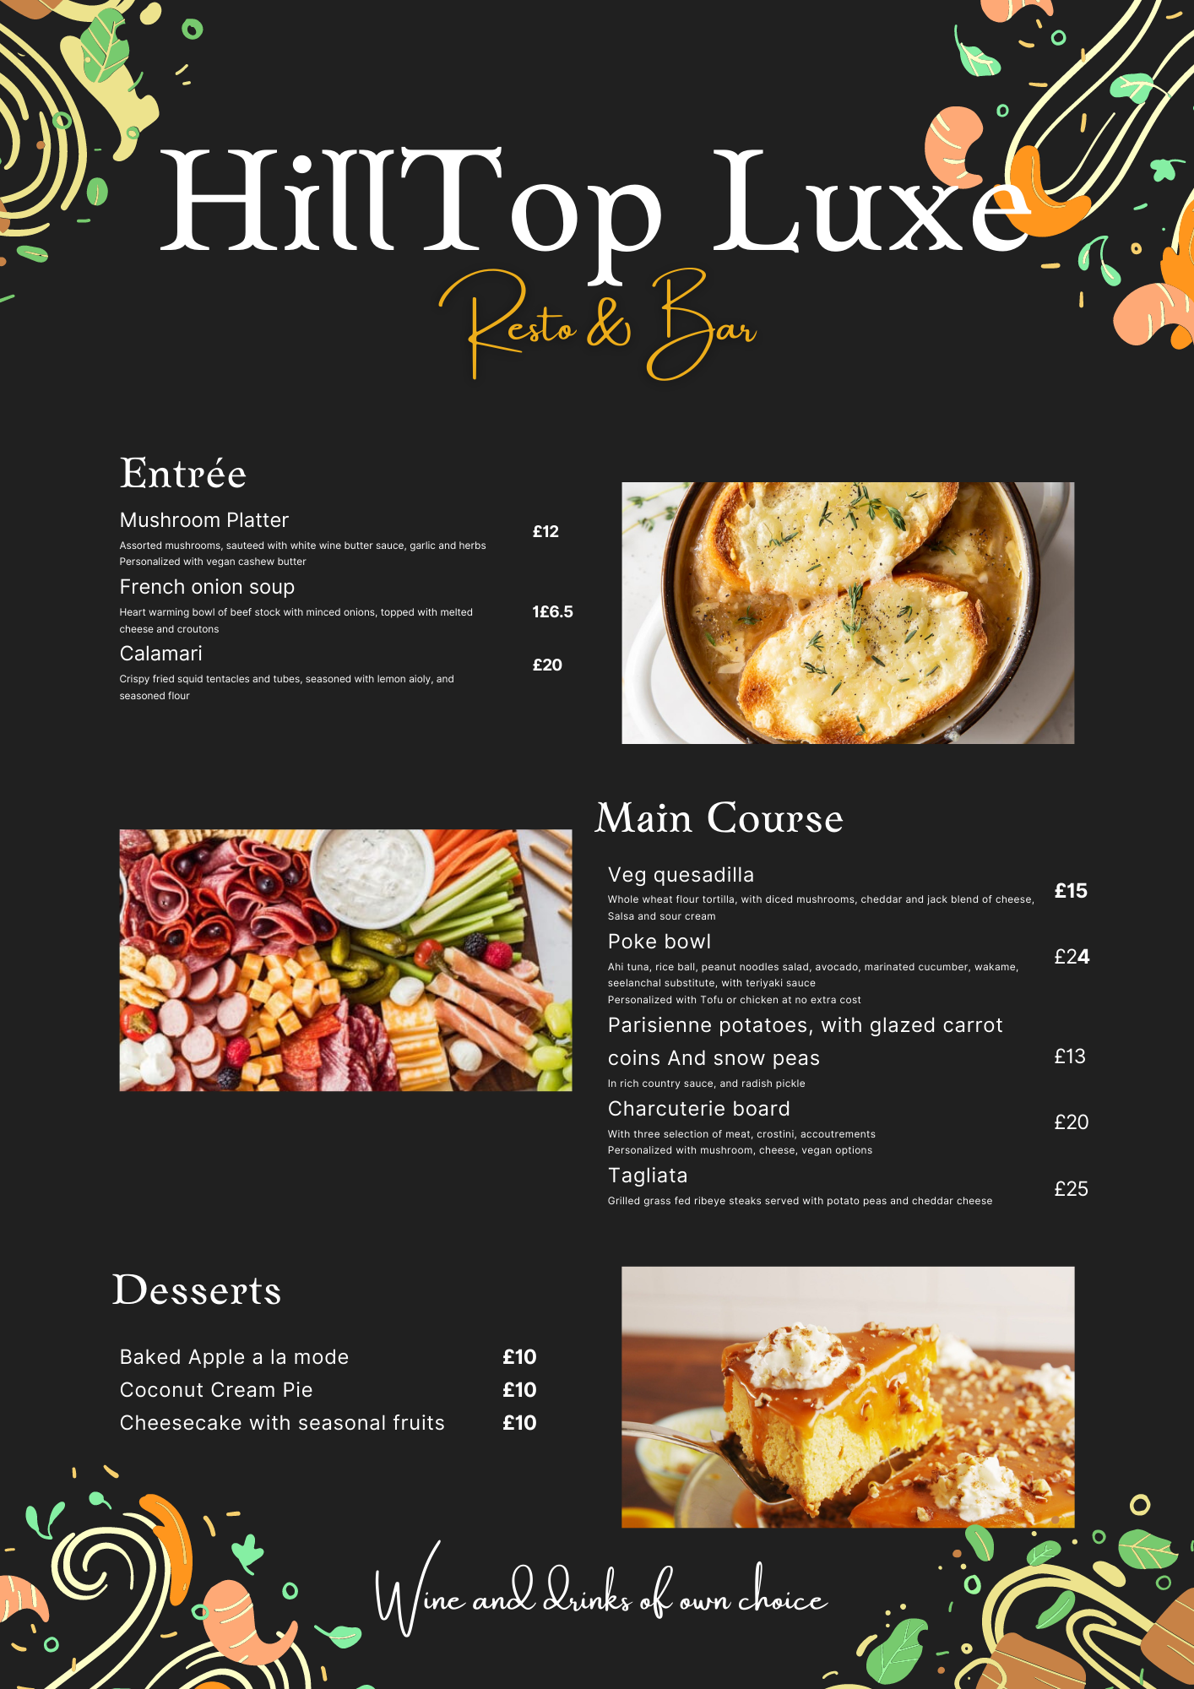

References
Jones, H., Neal, S., Mohan, G., Connell, K., Cochrane, A. and Bennett, K., 2015. Urban multiculture and everyday encounters in semi-public, franchised cafe spaces. The Sociological Review, 63(3), pp.644-661.
Schwark, N., Tiberius, V. and Fabro, M., 2020. How will we dine? Prospective shifts in international haute cuisine and innovation beyond kitchen and plate. Foods, 9(10), p.1369.
Yi, S., Zhao, J. and Joung, H.W., 2018. Influence of price and brand image on restaurant customers’ restaurant selection attribute. Journal of foodservice business research, 21(2), pp.200-217.

