University of Wales Trinity Saint David | Level 4
Accounting Fundamentals
(LCBB4001)

Rexon Nting

Elena Blagoeva
1913400
Ba business management (group1)
assesment 2
Contents
Task 1. 2
Capital expenditures 2
Revenue expenditures 2
The differences 3
Task 2. 3
A) 3
Cost accounting characteristic 3
Management accounting characteristic 4
Similarity between Cost Accounting and Management Accounting 4
Key Differences between Cost Accounting and Management Accounting. 5
B) 5
Connection between Cost accounting and Management accounting. 5
Task 3. 6
A responsibility center 6
Profit center 6
Cost center 7
Task 4. 7
Differences between management and financial accounting. 7
References 9

Figure 1 (Surbhi S, 2018) 2
Figure 2 (WallStreetMojo, 2020) 6
Figure 3 (Graduate Tutor, 2020) 8
Figure 4 (CFI, 2020) 9

Task 1.

Capital expenditures is for this items that should be productive assets which are expected to be for a long term of use and more specific for more than one year as revenue expenditures items are for less that year. Fixed assets goes to a balance sheet and depreciation expenses is claimed on them (Accounting Tools, 2020). Capital Expenditure is an expense made to acquire an asset or improve the capacity of the existing asset (Surbhi S, 2018).
Revenue expenditures goes to the profit and loss account and are written off in the current period. This mean that the costs are linked to specific transaction or operating periods, like the cost of sold goods, the cost of product, repair or maintenance expenses. Revenue expenditure is responsible for items which are for current period for example less than a year and are supposed to be used for a short period of time (Accounting Tools, 2020). Basically revenue expenditure is in charge only for things which are affecting only one financial year, current financial year.

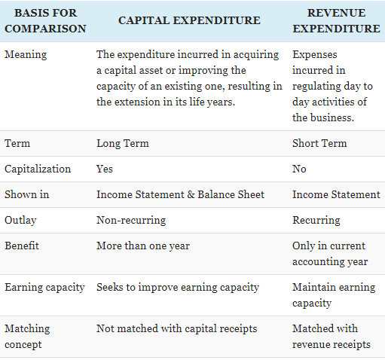
Figure 1 (Surbhi S, 2018)
The differences between these two types of expenditures are that the cost of capital expenditures are always larger amount and the reason for this is because an expenditure is only classified as a capital expenditure if it exceeds a certain threshold value. If not, it is automatically described as a revenue expenditure (Accounting Tools, 2020). The term for using is the other big difference in expenditures as the capital one is for long term based on more than one year and the revenue expenditures is for short term only in the current accounting year. The connection between capital expenditure and revenue expenditure is that the capital expenditure seeks to improving overall earning capacity of the concern, after that the revenue expenditure is maintaining the earning capacity (Surbhi S, 2018).

Task 2.

A)

Cost accounting and management accounting are part of accounting which are important for one organization and have completely different purpose and style but both are used from controlling the company’s policies (Cost Management, 2020).

Cost accounting characteristic
Cost accounting deal with the control and assessment of cost and expense to purchase or produce. It relates to calculation per unit cost using different costing techniques. Primary purpose is to facilitate managers in decision making (Cost Management, 2020). The main duty of cost accounting is every part of accounting which affect profit, revenue, production capacity and effectiveness of employees. The budget is planned in a systematic way that is usually unique to the company, as reports could not limited by principles of Generally Accepted Accounting Principles (GAAP) (Cost Management, 2020).
Some of the other responsibilities of cost accounting are to gather information on cost and activities that can be used as a basis to estimate future costs in preparation and reviewing budget estimates (Cost Management, 2020). Choose the fee or price for goods and services, cost accounting also is helping to decide a price with will be fare and competitive. Other part is to classify and break down cost for external reporting and internal profit measurement. Since cost is calculated on a detailed level, identifying profitable and unprofitable items or activities becomes easy (Cost Management, 2020).

Management accounting characteristic
Management accounting is responsible for providing a right information for managers to help the process of decision-making, future planning, cost control and performance on daily basis evaluation (Cost Management, 2020). Basically the reason for this department existing is to report and give advises to the management about the status of the company for latest and newest updates. It is also covering information about the activities of different departments on a regular basis and it is helpful to manage the time (Cost Management, 2020).
To ensure that company has control there are different techniques like budgetary control, standard costing that management accounting is using to be effective and to provide a proper control system to the management (Cost Management, 2020). Key point of management accounting is to processes information, which is collected form accounting data. With this method the information is provided in methodical way for managers to use it in future planning and taking decisions. Cash flow, fund flow, trend analysis, and comparative financial statements are the tools usually used by management accounting for analyse the accounting data (Cost Management, 2020).
Management accounting gives range of good different methods to motivating employees so they performance improves by set up a target and starting incentive schemes. A part from that management accounting is helping to coordinate the different departments in company by applying thorough functional budgeting and providing reports for the same to the management on a regular basis (Cost Management, 2020).
Every organization must agree and follow a tax system of the country they operate from. It is a challenge due to the ever-increasing complexity of the tax structure. The company need to calculate the right amount of tax and ensure timely deposit of tax (Cost Management, 2020). The management accounting takes role in that part as well. It is providing to the managers advises how to comply with the laws in a specific country.

Similarity between Cost Accounting and Management Accounting
This type of accountings has similar goals which is helping the company by providing information which will give opportunity for the managers for taking decisions. This information is important and definitely necessary for a company to achieve the goals they set up (Cost Management, 2020).

Key Differences between Cost Accounting and Management Accounting.
The accounting associated to the recording and analysing of cost data is cost accounting and provides quantitative information only. The accounting related to the producing information is management accounting but provides both quantitative and qualitative information. There are specific rules and procedure for preparing cost accounting information while there is no specific rules and procedures in case of management accounting information (Surbhi S, 2018).

B)

Connection between Cost accounting and Management accounting.

Basically cost accounting is supporting management accounting and management accounting is pushing cost accounting further depends of the management needs or requires. Because of this there is strong connection between both accountings and they are normally seen as one and the same nowadays according to (Cost Management, 2020).
Management accounting always turn the data into information, knowledge, and wisdom about a business entity’s operations. This is a step ahead than cost accounting. This type of accounting work in favour to know the reasons for profit or loss in one organization and analysing the factors that are influencing competence to help with this process call decision-making. Therefore, cause and effect is a significant feature of management accounting (Cost Management, 2020).

Task 3.

A responsibility center is an important part of an organization taking control of different departments in which centers the manager may have a degree of authority and responsibility. The company's detailed organization chart is a logical source for identifying responsibility centers. The most common responsibility centers are the numerous departments within a company (Averkamp, 2020). Every center has an individual responsibilities but still all the centers have connection between them and have to work together for succeed of an organization.
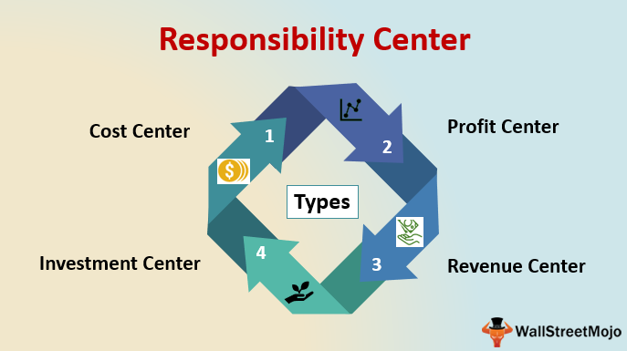
Figure 2 (WallStreetMojo, 2020)
Profit center is responsible for a combination of revenue and cost center and has direct connection with all type of centers (Averkamp, 2020). Because segmental earnings equal segmental revenues minus related expenses, the manager must be able to control both of these categories. The manager always have an authority to control selling prices, sales volume, and all reported expense items (Managerial Accounting, 2020). An example, for this is that company can have a customer products division and an industrial division to more successfully market the company's products. Each division's manager has responsibilities for sales and expenses. However, if the company's executive team makes all of the investment decisions, the divisions are considered to be profit centers (Averkamp, 2020).
Cost center is responsible only for costs and products no direct part is taken for cost from the sales of goods or services. Manager in cost center is held responsible only for specified expense items (Managerial Accounting, 2020). Examples of this center include a production department, maintenance department, accounting department, human resource department, etc (Averkamp, 2020). It is not excluded for a company to have several cost centers within one department. An example for this is each assembly line may be a separate cost center within one production department. Even a special machine could be a separate cost center. Cost centers are usually associated with the topics of decentralization, responsibility accounting, and planning and control (Accounting Coach, 2020). Even though the cost center has not direct connection and the responsibilities are only internal, the cost center is still affecting the work of other centers.

Task 4.

Differences between management and financial accounting.
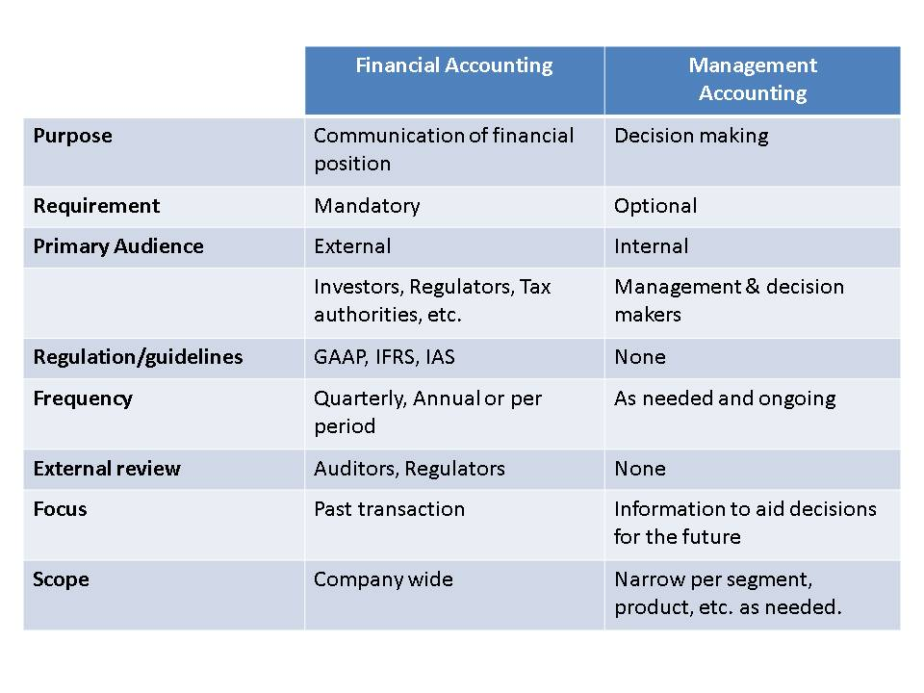
Figure 3 (Graduate Tutor, 2020)

Management and financial accounting are great tools to be used by company for successful business. The main difference between financial accounting and management accounting is that financial accounting in charge of preparation a financial statements based on ‘Generally Accepted Accounting Principles (GAAP)’ (Borad, 2019) for the analysis by the external user wanted to know the financial statement of the organization. Management accounting is in charge of preparation the financial reports but also is responsible for preparing non-financial information which is helping managers in making rules, plans and strategies for the company next move (WallStreetMojo, 2020).
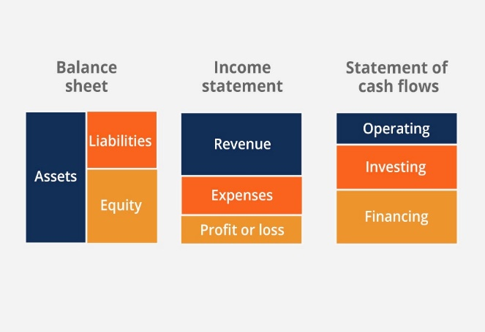
Financial accounting reports consist of profit and loss statements, balance sheet and cash flow statement (Borad, 2019).
Figure 4 (CFI, 2020)

Management accounting is more extensive than financial accounting in helping management because the department “management accounting” is created especially to serve the management. On the other hand, financial accounting is an important part that is helping management with organizations financial statement and how it is going (WallStreetMojo, 2020). Though financial accounting is based on providing information for stakeholders and potential investors who can check the book of financial accounts and decide by themselves if they would want to invest in the company or not and also it is an accurate picture for the government and the existing shareholders. The purpose of management accounting, on the other hand, is to facilitate the management in making effective decisions on behalf of the shareholders (WallStreetMojo, 2020).
Management accounting gathers data and information from financial accounting and deals with both quantitative and qualitative data, while financial accounting is independent of management accounting and only talks about quantitative data (WallStreetMojo, 2020).

References
Accounting Coach, 2020. What is a cost center?. [Online]
Available at: https://www.accountingcoach.com/blog/what-is-a-cost-center
[Accessed 06 May 2020].
Accounting Tools, 2020. The difference between capital expenditures and revenue expenditures. [Online]
Available at: https://www.accountingtools.com/articles/the-difference-between-capital-expenditures-and-revenue-expe.html
[Accessed 04 May 2020].
Averkamp, H., 2020. What is a responsibility center?. [Online]
Available at: https://www.accountingcoach.com/blog/what-is-a-responsibility-center
[Accessed 04 May 2020].
Borad, S. B., 2019. Difference between Financial and Management Accounting. [Online]
Available at: https://efinancemanagement.com/financial-accounting/difference-between-financial-and-management-accounting
[Accessed 08 May 2020].
CFI, 2020. Accounting fundamentals course overview. [Online]
Available at: https://courses.corporatefinanceinstitute.com/courses/learn-accounting-fundamentals-corporate-finance
[Accessed 08 May 2020].
Cost Management, 2020. What is cost and management accounting?. [Online]
Available at: https://www.costmanagement.eu/blog-article/what-is-cost-and-management-accounting
[Accessed 04 May 2020].
Graduate Tutor, 2020. Differences between Financial Accounting and Managerial Accounting. [Online]
Available at: https://www.graduatetutor.com/accounting-tutors/difference-between-financial-accounting-managerial-accounting/
[Accessed 08 May 2020].
Managerial Accounting, 2020. 9.4 Responsibility Centers. [Online]
Available at: https://courses.lumenlearning.com/sac-managacct/chapter/responsibility-accounting-in-business-environments/
[Accessed 04 May 2020].
Surbhi S, 2018. Difference Between Capital Expenditure and Revenue Expenditure. [Online]
Available at: https://keydifferences.com/difference-between-capital-and-revenue-expenditure.html
[Accessed 06 May 2020].
Surbhi S, 2018. Difference Between Cost Accounting and Management Accounting. [Online]
Available at: https://keydifferences.com/difference-between-cost-accounting-and-management-accounting.html
[Accessed 06 May 2020].
WallStreetMojo, 2020. Financial Accounting vs Management Accounting. [Online]
Available at: https://www.wallstreetmojo.com/financial-accounting-vs-management-accounting/
[Accessed 06 May 2020].
WallStreetMojo, 2020. What is the Responsibility Center?. [Online]
Available at: https://www.wallstreetmojo.com/responsibility-center/
[Accessed 08 May 2020].

