Processes and stages of marketing including the role of the marketing mix

- Student name: Ventsislava Kostadinova (202358)

- Lecture name: Hossein Shokri

- Submission date: 26/04/21

Table of Contents
Introduction 3
Definition of marketing 3
Importance of marketing 3
Stages of marketing process 4
Segmentation, targeting and positioning 5
Marketing mix 6
Product 6
Price 7
Promotion 8
Place 10
Conclusion 10
References 11

Introduction
Marketing is often one of the most important functions of business organisations. The majority of industries are mature and highly-penetrated and this situation typically leads to a higher level of rivalry among competitors. Marketing is one of the main sources of competitive advantage and has the power to attract consumers, engage them and increase their loyalty towards the brand. Marketing is one of the main tools to build a brand identity, maintain image and reputation and create value for consumers. The integration of marketing activities with other functions of organisational activity is crucial for the success of the business in the selected market of operation.
The current paper aims to critically assess marketing processes, marketing mix and the way they integrate with the rest of organisational functions and operations.

Definition of marketing
Marketing is defined as activity, set of institutions and processes which aim at creating, communicating, delivering and exchanging offerings which deliver customer value, as well as benefit other stakeholders, such as business partners and members of society (AMA, 2021).

Importance of marketing
Marketing is one of the most important functions of a business which also defines and affects its performance in the marketplace. It allows the company to establish and maintain relationships with consumers, identifies and addresses their needs and directly contributes to sales revenue and growth (Gross, 2016). Effective marketing is also associated with a positive impact and contribution to organisational performance; hence, it is considered as a driver of development (Wirtz et al., 2014). For the purposes of critical analysis, it should be noted that the effectiveness of marketing activities depends on the resources of the company, its goals and other strategic functions (Wirtz et al., 2014). However, if properly implemented, marketing can be a driver of success and continuous growth. Moreover, marketing is focused on establishing profitable customer relationships and creating value for buyers.

Stages of marketing process
Potential benefits are achieved through implementing all stages of marketing process, which is graphically represented below.
Figure 1 – Marketing process
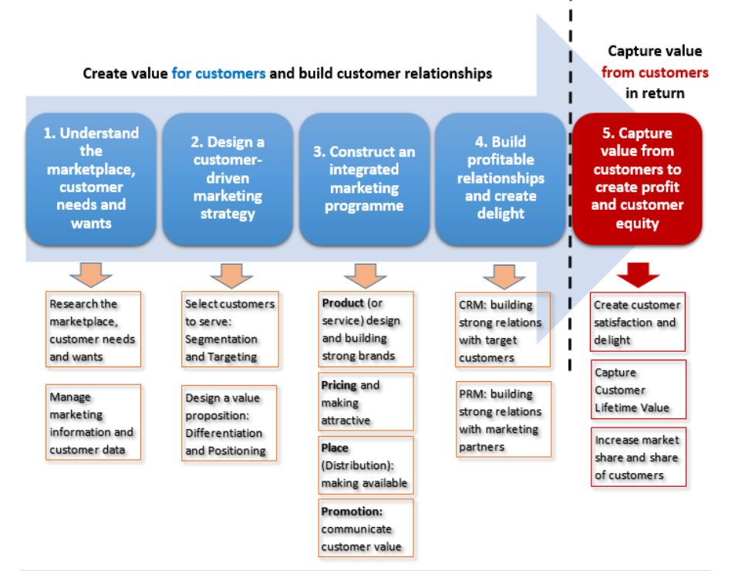
Source: Claessens (2015)
The marketing process can be generally divided in two main parts – activities focused on creating value for consumers and activities aiming at capturing value from consumers in return (Claessens, 2015). Prior to entering the marketing process, an organisation should have clear mission and vision statements which provide rationale for its existence in the marketplace and guidance when approaching prospect customers (Kotler and Keller, 2012).
The first step of the process is the identification of the marketplace and researching customer needs and wants. This is achieved through conducting a detailed market research and processing data collected. Often, PESTEL analysis is conducted with the idea of understanding the relevant external factors which determine the environment and consumer preferences (Johnson et al., 2017). For example, a given company may be interested in exploring the political environment, which determines the business climate, relevant economic factors with impact on consumer demand or social factors shaping consumer demand patterns (Johnson et al., 2017). This information is of value for devising attratcive marketing offers and making strategic decisions. The SWOT framework is another framework with strategic importance in the marketing process. The strengths and weaknesses of a given organisation are analysed with the idea of identifying the prospects for performance in a given market (Worthington and Britton, 2006). The SWOT framework also takes into consideration the relevant external factors from the PESTEL analysis in order to identify relevant external opportunities and threats for a given organisation (Worthington and Britton, 2006).
Then, based on obtained information, a customer-driven marketing strategy is created. This involves processes like segmentation, targeting and positioning (Claessens, 2015). At this stage, a company is able to propose specific marketing-related decisions based on the information about the external environment and marketplace (Kotler and Armstrong, 2013).

Segmentation, targeting and positioning
Market segmentation is the process of identifying different segments of dividing the market into different segments which are previously identified and consisting of both existing and potential customers (Kotler and Keller, 2012). Different segments are defined on the basis of commonly shared characteristics of consumers, such as gender, age, income, lifestyle and many more. Segmentation assumes that different customer segments require various marketing techniques as diverse customers have various preferences, needs and expectations from the brand (Kotler and Keller, 2012). Once, segments are identified, the brand has to decide appropriate targeting strategies in the desired segments. This is then transformed into a foundation for positioning. Product positioning is associated with identifying the position the company wants to occupy in target customers’ minds and perceptions (Kotler and Keller, 2012). Based on all this, the company then develops an integrated marketing strategy, including four main elements explained in greater detail in the following section – product, price, promotion and place.
Then, this strategy is used to establish profitable relationships with consumers through customer and relationship management with partners (Claessens, 2015). All this results in creating value for consumers and serves as a baseline for the next step focused on capturing value back from them. This stage is related to creating customer satisfaction and delight, capturing customer lifetime value and increasing market share through various marketing strategies and techniques (Claessens, 2015).

Marketing mix
As stated above, the marketing mix consists of four main elements – product, price, promotion and place.

Product
Product element of the marketing mix is associated with decisions regarding the offering of the company and focus on the specific product portfolio offered, quality, features, usability and other similar perspectives (Constantinides, 2006). The product is one of the main concerns of consumers and a significant determinant of their attitudes towards the brand and purchasing patterns. However, in order to be successful, the product should be the ‘right’ one and thus, directly address and reflect the needs and preferences of consumers (Constantinides, 2006). This is why the development of new products and decisions regarding portfolio are based on substantial and in-depth research of market trends and consumer demand. Successful products create continuous demand and assist the company in building a positive brand image which in turn creates customer loyalty (Constantinides, 2006).
Marketing decisions regarding products are not universal. They vary according to the stage of product life cycle in which the offering is. Product life cycle is a concept which is tightly relevant to marketing and one of the considerations incorporated in marketing strategies which define their effectiveness. As shown below, product life cycle consists of four stages, including introduction, growth, maturity and decline (Bhambi, 2015).

Figure 2 – Product life cycle
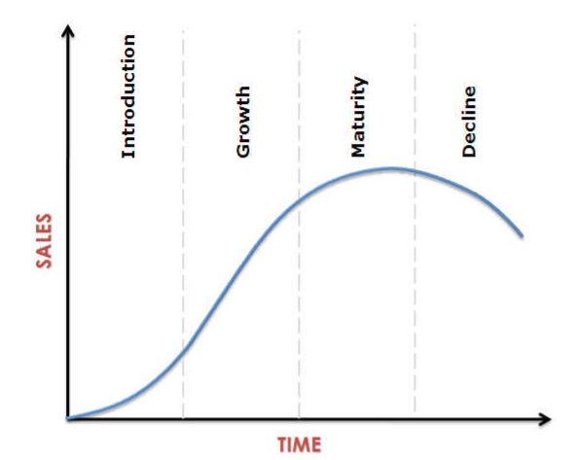
Source: Bhambi (2015)
Different stages of the cycle require various marketing decisions and the use of different tools. For example, products in the introduction stage which are just released on the market need a focus on marketing activities which would increase awareness (Bhambi, 2015). In the growth stage, marketing strategies emphasise on persuasive tools stressing on differentiation of the product against rivals’ offerings are more appropriate (Bhambi, 2015).

Price
Price is also a crucial element of the marketing mix. Especially in rival industries, price is among the main factors of influence on customer decision making and directly affect their final choice of which brand to purchase from (Burnett, 2011). There are many different pricing strategies which can be used, such as penetration, skimming and competitive pricing.
Skimming pricing strategy is associated with setting a relatively high price of the product offered (Du and Chen, 2017). This approach is usually used for premium and/or unique products which are differentiated on the market and are distinctive when compared to rivals.
Penetration pricing is related to setting the price of the product relatively lower than rivals and similar products which are already traded on the market (Du and Chen, 2017). This approach is often used for pricing new products launched on the market. The main aim of this strategy is to attract customers and create a greater interest to the product.
Competitive pricing is a strategy in which the price of the product is set similar to competitors’ offerings (Du and Chen, 2017). It is used for both new and existing products and is usually adopted for items which are not distinctively differentiated.
It should be noted that pricing decisions and strategies are not isolated choices. They depend on a wide variety of factors, some of which are the quality and features of products, the target customer segments and company’s resources (Burnett, 2011). In addition to that, businesses need to consider whether the product is new or innovative, whether it satisfies a need or a want, what the degree of competition is and the availability of existing substitutes, whether the company has an established brand image and the nature of corporate objectives (Burnett, 2011).

Promotion
Promotion is associated with marketing activities and decisions focused on establishing strong and sustainable relationships with consumers (Kotler and Armstrong, 2013). These activities emphasise on informing and persuading customers on a regular basis. The main decisions related to promotion are the ones focused on advertising, sales promotion, public relations and direct marketing (Kotler and Armstrong, 2013). Effective promotion decisions result in higher brand loyalty, awareness, improved image and perceived quality, as shown on the next figure (Karunanithy and Sivesan, 2013).
Figure 3 – Promotional mix
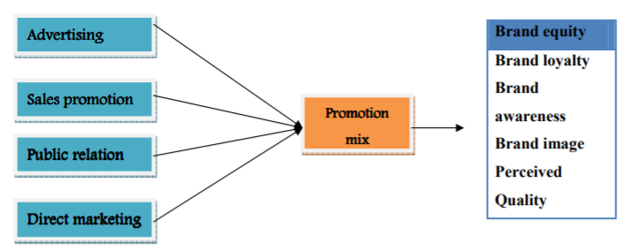
Source: Karunanithy and Sivesan (2013)
Advertising decisions are related to paid-for communication activities which use conventional and unconventional channels to inform and persuade consumers (Karunanithy and Sivesan, 2013). The most commonly addressed channels of communication nowadays include TV, printed ads, social media, billboards and digital advertising. It should be noted that the choice of specific channels of communication and advertising tools would depend on the target customers and segments, as well as nature of product offered and established policies of the company.
Advertising can be one of two main types – informative or persuasive. Informative advertising provides information about the product to consumers (Karunanithy and Sivesan, 2013). This is a very common tool used for new products which are now launched on the market and customers are still not fully aware for their existence and/or features. Persuasive advertising, on the other hand, emphasises on convincing consumers to choose the specific brand over rivals and provides a justification for consumers to do so. It is based on stressing on the main benefits and competitive advantages of the product.
Sales promotion decisions are related to providing incentives used to encourage short-term increases in sales revenue (Karunanithy and Sivesan, 2013). Sales promotion choices depend on a wide variety of factors, such as the target group of customers and segment’s preferences towards incentives which would trigger their purchase. Alternative incentives include money-off coupons, gift vouchers, point of sale displays, loyalty cards, giveaways and many more (Karunanithy and Sivesan, 2013).
Public relations decisions focus on activities conducted by business organisations aiming at promoting the brand image of the company and developing sustainable long-term relationships with stakeholders. Such activities include press releases, all forms of publicity, regular posting on social media and many more (Karunanithy and Sivesan, 2013).
Direct marketing consists of direct communication between the company and its consumers (Karunanithy and Sivesan, 2013). Examples of channels of direct communication include e-mail, social media, website contact forms or direct chats and other alternatives (Karunanithy and Sivesan, 2013). The specific choice of a direct marketing channel also depends on the nature of corporate operations and target customer segments’ preferences.

Place
Place element of marketing mix is related to decisions regarding channels of distribution used. As stated by Galkin (2015), delivery channels are among the main factors of influence on customer decision making in consumer markets and significant sources of competitive advantage. Distribution channels vary across business and industries and include direct sale, use of intermediaries, as well as physical and digital sales channels (Galkin, 2015).
Nowadays, the majority of consumer markets are marked by technological profess and development, as well as continuously increasing preferences of consumers towards e-commerce platforms. Thus, more and more companies are shifting towards offering different types of digital sale channels, such as websites, e-stores and online shops integrated in social media platforms. This is why businesses need to analyse in greater depth the specific customer segments, targeting and product positioning in terms of consumer preferences and willingness to use digital channels of communication with the brand and purchasing products from it.

Conclusion
To sum up, marketing function is one of the most important areas of operation of businesses nowadays. Especially in cases where more competitive industries are considered, marketing can be crucial to persuade and convince customers which brand to purchase from. It also affects customer engagement and the establishment of sustainable relationships between customers and the company under consideration. Marketing is also identified as a continuous process, starting with researching the market and potential customers and followed by segmentation, targeting and positioning. The current report also revealed that these processes have a direct influence on marketing mix decisions which, in turn, comprise marketing strategy used to improve performance on the market.

References
American Marketing Association (AMA) (2021) Definitions of Marketing, [online] Available: https://www.ama.org/the-definition-of-marketing-what-is-marketing/ [Accessed: 19 April 2021]
Bhambri, S. (2015) Product Life Cycle, International Journal of Business Management, Vol. 2(1), pp. 781-785.
Burnett, J. (2011) Introducing Marketing. BCcampus
Claessens, M. (2015) The Marketing Process – All Aspects of Marketing at One Glance, [online] Available: https://marketing-insider.eu/marketing-process/ [Accessed: 7 April 2021]
Constantinides, E. (2006) The Marketing Mix Revisited: Towards the 21st Century Marketing, Journal of Marketing Management, Vol. 22(3), pp. 407-438.
Du, P. and Chen, Q. (2017) Skimming or Penetration: Optimal Pricing of New Fashion Products in the Presence of Strategic Consumers, Annals of Operations Research, Vol. 257(1), pp. 1-21.
Galkin, A. (2015) Distribution Channels Management in Different Regions, American Journal of Economics, Finance and Management, Vol. 1(2), pp. 92-96.
Gross, J. (2016) Why Marketing is So Important? [online] Available: https://movingtargets.com/blog/business-marketing/why-marketing-is-so-important/#:~:text=Marketing%20is%20important%20because%20it,is%20especially%20true%20for%20SMBs. [Accessed: 7 April 2021]
Johnson, G., Whittington, R., Scholes, K., Duncan, N. and Regner, P. (2017) Exploring strategy. 11th edition, London: Pearson
Karakaya, F. and Kerin, R. (2007) Impact of Product Life Cycle Stages on Barriers to Entry, Journal of Strategic Marketing, Vol. 15(4), pp. 269-280.
Karunanithy, M. and Sivesan, S. (2013) An Empirical Study on the Promotional Mix and Brand Equity: Mobile Service Providers, Industrial Engineering Letters, Vol. 3(3), pp. 1-10.
Kotler, P. and Armstrong, G. (2013) Principle of Marketing. 15th edition, Prentice Hall
Kotler, P. and Keller, K. (2012) Marketing Management. 14th edition, Pearson Education
Nurmartiani, E., Sucherly, M., Hasan, M., Komaladewi, R. and Huda, M. (2020) Marketing Mix Performance and Customer Relationship in Improving Trust of Indihome Customer, Journal of Critical Reviews, Vol. 7(2), pp. 275-282.
Thabit, T. and Raewf, M. (2018) The Evaluation of Marketing Mix Elements: A Case Study, International Journal of Social Sciences and Educational Studies, Vol. 4(4), pp. 100-109.
Wirtz, J., Tuzovic, S. and Kuppelwieser, V. (2014) The Role of Marketing in Today’s Enterprises, Journal of Service Management, Vol. 25(2), pp. 171-194.
Worthington, I. and Britton, C. (2006) The Business Environment. 5th edition, Pearson Education

