
MUHAMMAD HARITH SETH (2226197)

Changemakers: Creativity and Value Creation

Content Page
Task 1 – Research Question…………………………………………. Pg.1
Task 2 – Research Techniques………………………………………Pg.2
Task 3 – Presentation of Idea………………………………………. Pg. 3
Task 4 – Data Analysis…………………………………………………. Pg. 4
References

Task 1 – Research Question
- Produce a written statement of 1,000 words that considers the following:

Introduction
In the modern-day globalized business surroundings, multinational businesses (MNCs) regularly stumble upon challenges associated with coping with culturally diverse teams. Effective go-cultural control is crucial for making sure clean conversation and efficient control practices throughout exceptional cultural contexts (Meyer, E, 2020). This research seeks to cope with the query: "How do cultural variations impact communication and management practices in multinational companies?" The importance of this inquiry lies in its ability to beautify organizational effectiveness with the aid of offering deeper insights into how cultural variations affect workplace dynamics (Taras, V., Kirkman, B. L., & Steel, P, 2021). By investigating this query, the studies ambitions to offer practical suggestions that can improve verbal exchange, reduce conflicts, and foster higher collaboration inside multinational groups. This knowledge is crucial for corporations aiming to maintain aggressive gain and operational performance inside an increasing number of interconnected worldwide market.
Value Creation
The value of this studies extends beyond instructional contribution to offer tangible advantages for multinational businesses. Understanding how cultural variations impact communication and management practices can result in extra powerful strategies for dealing with diverse groups (Leung, K., & Morris, M. W, 2020). For multinational companies, this research presents actionable insights into:
Enhanced Communication: By figuring out the ways wherein cultural variations have an effect on conversation patterns, groups can develop tailored communication strategies that bridge cultural gaps and improve readability and effectiveness in interactions.
Conflict Reduction: Recognizing the resources of capacity conflicts springing up from cultural misunderstandings allows agencies to implement struggle decision mechanisms that are touchy to cultural nuances.

Improved Team Collaboration: Insights into how one-of-a-kind cultures method teamwork and decision-making can assist corporation’s layout management practices that beautify collaboration and leverage the strengths of a culturally numerous bodies of workers.

Strategic Advantage: Companies that efficaciously control cultural diversity are higher positioned to conform to international marketplace demands, innovate, and maintain a competitive facet.
In precis, these studies will make contributions to the sector of International Business with the aid of providing evidence-based totally hints for reinforcing pass-cultural management practices, in the long run main to more a hit and harmonious multinational operation (Kittler, M. G., Rygl, D., & Mackinnon, A, 2020).
Theoretical Framework
To body this studies, Hofstede’s Cultural Dimensions principle could be practised. This framework offers a systematic approach to expertise cultural differences through the following dimensions (Kirkman, B. L., Lowe, K. B., & Gibson, C. B, 2020).
Power Distance: This measures the quantity to which much less effective contributors of businesses assume and accept unequal distribution of power García-Gallego, et al, 2020). Cultures with high distance power generally tend to have greater hierarchical systems and centralized decision-making methods. Understanding this dimension is crucial for assessing how power dynamics have an effect on communication and management practices inside multinational companies.
Individualism vs. Collectivism: This aspect suggests how a whole lot people value their very own objectives over those of the organization. Collectivist cultures prioritize community cohesiveness and welfare as an entire, whereas individualistic cultures place greater emphasis on personal autonomy and accomplishment. This component is crucial to understand how organizational conduct, management strategies, and teamwork are impacted with the aid of cultural values.
This research will investigate how those elements effect management approaches and conversation styles in multinational companies with the use of Hofstede's framework. The framework offers an organized technique for studying cultural variations in addition to a theoretical foundation for verifying the suggested hypotheses.

Hypotheses
The following theories, which are based on Hofstede's Cultural Dimensions, will guide the research:
Hypothesis 1: “High power distance cultures typically talk in a more hierarchical way, which has an effect on how international companies make selections and decisions."
According to this concept, cultures with high power distances tend to just accept hierarchical systems and centralized decision-making extra effortlessly, which may have an effect on managerial efficacy and communication flow.
Hypothesis 2: " Collaborative control techniques are much more likely to be adopted via collectivist cultures, which improves cooperation in worldwide organizations."
According to this theory, cultures that prioritize peace and cooperation in the institution are much more likely to undertake management strategies that inspire collaboration and collaborative decision-making.
The utility of these theories in multicultural actual-global contexts can be accessed via checking out them towards secondary data, that is generated from Hofstede's dimensions.
Research Approach
A deductive approach will be used for this research, suitable for evaluating certain hypotheses which can be drawn from widespread thoughts. With this approach, the theoretical framework (Hofstede's Cultural Dimensions) is step one, and the hypotheses are then methodically tested to ascertain their viability. Clear and verifiable consequences can be obtained through the use of the deductive approach, which gives an organized process for inspecting how cultural variations have an effect on management and conversation techniques.
This examine will verify if theoretical expectations and actual proof from secondary data sources are steady by targeting predetermined hypotheses. This method ensures that the research is based on nicely-mounted theories and gives a methodical approach to comparing and assessing the effect of cultural disparities.

Data Collection Method
Secondary data amassing will be the primary method because of time restrictions. Analysing preceding research papers, scholarly publications, and case research which are pertinent to pass-cultural management is a part of this system. Important secondary data sources include:
Academic Journals: Comprehensive evaluations of cultural variations and how they affect management strategies may be observed in peer-reviewed studies papers and research which might be posted in respectable scholarly courses. These assets include theoretical thoughts and proven scientific results.
Industry Reports: Practical viewpoints on the difficulties and solutions faced with the aid of multinational organizations in go-cultural control may be observed in reviews and white papers from alternate institutions and consulting companies.
Case Studies: In-depth case studies of world organizations will provide examples of the way cultural variations have an effect on control styles and communication within the actual international. These case studies provide beneficial facts and lessons discovered in many organizational settings.
In order to assure that the examine attracts from large and dependable resources, secondary data might be selected primarily based on high-quality and relevance. Within the allotted duration, this approach makes data amassing and analysis efficient.
Sampling Method & Sample Size
The sampling technique for secondary data studies includes choosing pertinent papers, case research, and research depending on how nicely they cope with the observe trouble and hypotheses. The availability of pertinent secondary data will dictate the sample size, with an emphasis on consisting of a variety of viewpoints to assure an intensive viewpoint.
The study will supply precedence to reliable and pertinent assets with a view to provide a radical hold close of the way cultural variations affect management and verbal exchange techniques. The reliability of the assets, the content's usefulness to the studies hypotheses, and the findings' applicability to the latter will all be considered within the choice process.

Conclusion
In conclusion, the uses of Hofstede's Cultural Dimensions framework to observe how cultural variations affect management and verbal exchange techniques in worldwide companies. Through using a deductive methodology and the exam of specific theories approximately power distance and individuality in opposition to collectivism, this research project will yield considerable understandings into a success cross-cultural management technique (Dhingra, N., Gupta, V., & Gupta, P, 2020). Utilizing secondary data will make it less complicated to complete the studies within the allotted time, in order to deepen our understanding of go-cultural dynamics and offer useful hints for enhancing management strategies in international corporate environments.

Task 2 – Research Techniques
- In no more than 300 words, select an appropriate research technique and conduct Primary and Secondary Research based on your chosen research approach from Task 1.

Both primary and secondary studies methods might be used in this research to provide an intensive understanding of ways cultural versions have an effect on control and communication techniques in global corporations.
Secondary Research:
One of the main strategies for engaging in secondary research might be a review of the literature. This involves methodically going over previous research initiatives, scholarly writings, and business reviews pertinent to Hofstede's Cultural Dimensions and how they have an effect on control approaches. Important resources will include:
- Academic Journals: Peer-reviewed research on how cultural elements have an effect on management and communication.
- Industry Reports: Reports from exchange associations and consulting groups that provide useful advice on a way to deal with pass-cultural control troubles.
- Case Studies: Thorough examinations of global companies showcasing realistic implementations of cultural management strategies.
Primary Research:
In order to supplement the secondary research, primary data might be accrued the usage of a survey. The reason of the ballot is to get critiques on cross-cultural management from experts employed with the aid of worldwide organizations. Important additives of the survey consist of:
- Survey Design: The survey will ask questions about how cultural variations affect managerial techniques, choice-making processes, and communication patterns.
- Distribution: The poll is supposed for people with relevant experience main or working in ethnically diverse groups, and it will be disseminated via professional networks like LinkedIn.

- Data Collection and Analysis: The purpose of the evaluation of the responses is to find ordinary topics and trends approximately how cultural versions have an effect on control techniques.
Through the combination of primary data from a survey and secondary data from a literature analysis, this study aims to offer a comprehensive comprehension of the ways wherein cultural disparities impact control and communication strategies in global agencies.

Task 3 – Presentation on Ideas
- Produce a 3-minute video elevator pitch that presents your area of research to identified stakeholders and obtain feedback that should be reflected upon in no more than 200 words.

After handing over my elevator pitch, I was given a few insightful enter from stakeholders, and that helped me refine my studies method. The feedback made it obvious that even though the examine issue and its significance have been offered successfully, there has been nevertheless a want to emphasise the findings' realistic effects similarly. The studies findings' capacity direct application to beautify pass-cultural control approaches in multinational corporations piqued the interest of stakeholders.
The feedback on the pitch's delivery cautioned that whilst it became thrilling, a more particular description of the research method and the way it fits into the theoretical framework might have advanced it. In order to answer this, I will go into further depth on how the have a look at the expectations and its hypotheses are formed with the aid of Hofstede's Cultural Dimensions.
Overall, the feedback has emphasised how vital it is to make sure certain approach is satisfactorily defined and to offer a clean connection among the study difficulty and actual-global applications. To improve readability and impact, those insights might be covered inside the latter components of the examine presentation.

Task 4 – Data Analysis
- In no more than 500 words create a conference poster that demonstrates the initial analysis of your findings and highlights key conclusions drawn from your research.
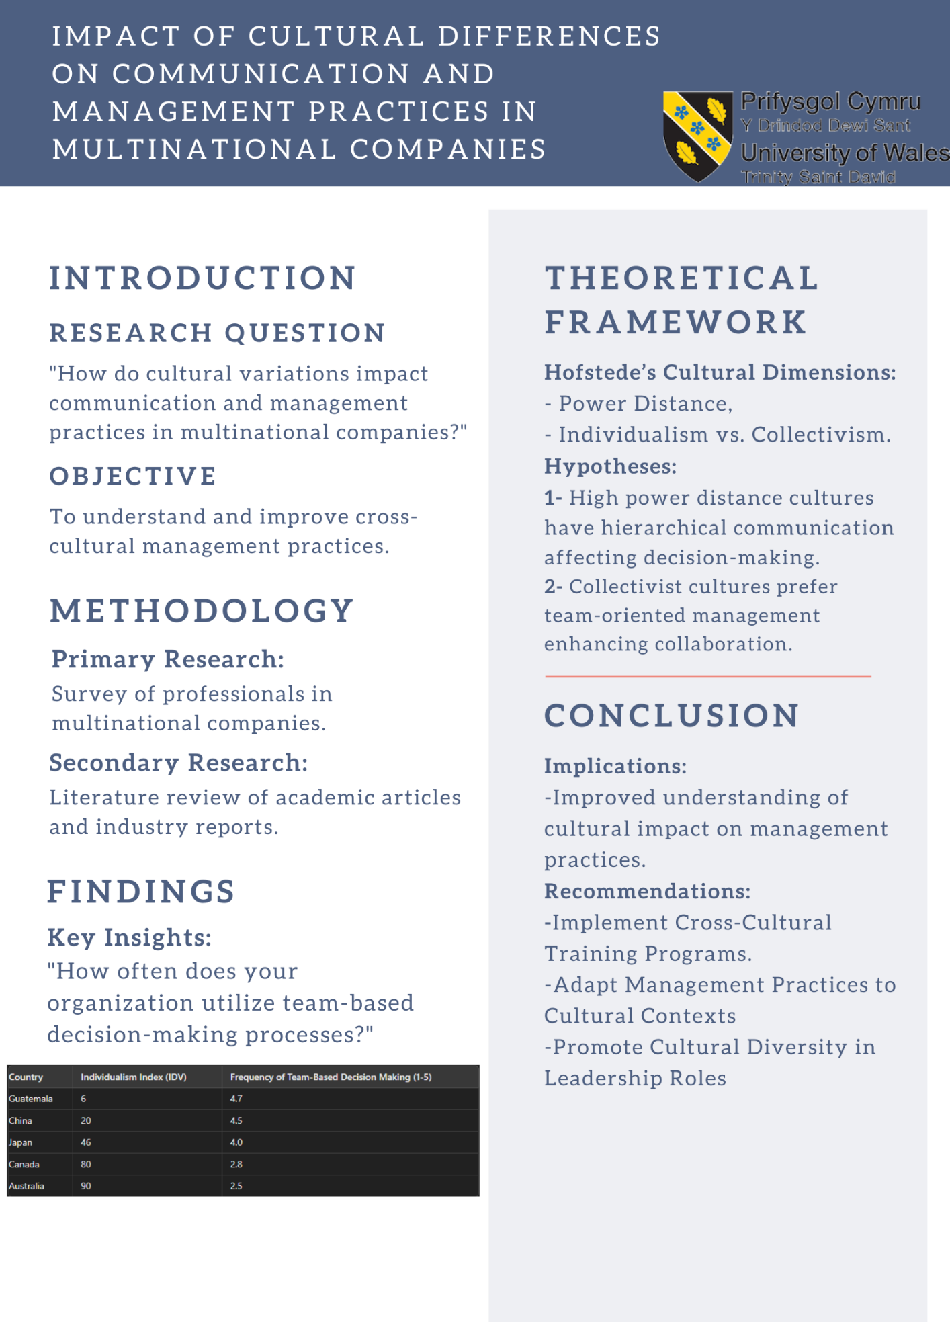

References
Kirkman, B. L., Lowe, K. B., & Gibson, C. B. (2020). A quarter-century of culture’s consequences: A review of empirical research incorporating Hofstede’s cultural values framework. Journal of International Business Studies, 51(1), 111-133. https://doi.org/10.1057/s41267-019-00220-4
García-Gallego, A., Georgantzís, N., Martín-Montaner, J., & Pérez-Amaral, T. (2020). Power distance and individual preferences for international trade. Journal of Business Research, 110, 125-135. https://doi.org/10.1016/j.jbusres.2020.01.017
Meyer, E. (2020). The culture map: Breaking through the invisible boundaries of global business (Updated edition). PublicAffairs.
Taras, V., Kirkman, B. L., & Steel, P. (2021). Does national culture predict conflict management style? A meta-analysis across 114 studies. Organizational Behaviour and Human Decision Processes, 164, 135-153. https://doi.org/10.1016/j.obhdp.2021.04.002
Leung, K., & Morris, M. W. (2020). Values, schemas, and norms in the culture-behavior nexus: A situated dynamics framework. Organizational Behavior and Human Decision Processes, 160, 62-75. https://doi.org/10.1016/j.obhdp.2020.04.002
Kittler, M. G., Rygl, D., & Mackinnon, A. (2020). Understanding cultural dynamics: The four layers of culture framework. International Business Review, 29(5), 101710. https://doi.org/10.1016/j.ibusrev.2020.101710
Dhingra, N., Gupta, V., & Gupta, P. (2020). Cultural intelligence as a predictor of negotiation styles in the context of cross-border mergers and acquisitions. Cross Cultural & Strategic Management, 27(1), 113-138. https://doi.org/10.1108/CCSM-11-2018-0181

