
APPENDIX GA36a

LEVEL 4 ASSESSMENT SPECIFICATION

Student name: | Natalia Schwenk | Student ID number: | 2514150
Programme: | DA Program - BSC in Supply Chain and Logistics
Module: | Organization Management
Module code: | ACMA 4020 | Contribution to Overall Module Assessment (%): | 50%
Lecturer: | Dr Moutushi Tanha | Internal Verifier: | Dr Irina Neaga
Assignment Title: | Essay on Management Practices of Organisations | Word count (or equivalent): | 1500 words
Submission deadline: | 01/06/2026 | Return date of provisional marks & written feedback: | 30 working days after submission
Submission method: | All written assessments, where practical and possible, must be submitted via Turnitin unless otherwise instructed by the Lecturer. (Please DO NOT put this assessment specification into Turnitin or it will match many similarities with other students’ submissions.)  Alternative submission method (if applicable):  Late submission of the assessment will result in a late penalty mark:  Work which is submitted up to 1 week late will be capped at 40% for the first attempt and will be awarded a mark of 0% for re-assessment. Late submission penalties may be lifted only if there is an approved extenuating circumstances claim.  Work submitted more than 1 week late will be considered as a non-submission and will not be marked. The work may be considered as a submission for reassessment if offered by an Examining Board or if there is an approved extenuating circumstances claim.
Academic honesty / referencing: | Academic honesty is required. In the main body of your submission you must give credit to authors on whose research and ideas your work is based. Append to your submission a reference list that indicates the books, articles, etc. that you have used, cited or quoted in order to complete this assessment.

Module Learning Outcomes
(from module syllabus)
Upon the successful completion of this module, the student should be able to:
- Describe applied knowledge and understanding of theories of organisation management.
- Acquire knowledge of leadership theories and develop leadership skills in Supply Chain Management or Logistics Operations.

TASK DESCRIPTION

Use of Generative AI in Assessment

RESEARCH | For this assessment, you can use Generative AI to support you in research, including searching for bibliography, using tools to summarise, compare and interrogate materials. | Yes ☒  No ☐
STRUCTURE | For this assessment, you can use Generative AI to support you in structuring your submission, including creating a draft argument structure, identifying parts and headings, etc. | Yes ☒  No ☐
PROOFREADING | For this assessment, you can use Generative AI to check your own text/creation for grammatical and syntactical mistakes, including rephrasing of your own work within specific standards. | Yes ☒  No ☐
WRITING | For this assessment, you can use Generative AI to create text for submission. | Yes ☐  No ☒
CREATIVE | For this assessment, you can use Generative AI to create creative materials, such as images. | Yes ☐  No ☒
PROGRAMING | For this assessment, you can use Generative AI to create and check code. | Yes ☐  No ☒
NONE | For this assessment, you are not allowed to use any type of Generative AI support. This includes research support, structure support, writing/proofreading support and creative support. | Yes ☐  No ☒

AI Acknowledgement

I confirm that I have not present any AI-generated materials as my own work in this portfolio.
However, I acknowledge that I have used or may have used the AI in the research and proofreading of my portfolio.

Name:..Natalia Schwenk.............
Student ID..... 2514150.........


An Evaluation of Management Practices within Cytiva: Planning, Organising, Leading and Controlling

Natalia Schwenk
2514150

Degree Apprenticeship in Logistics and Supply Chain Management

20/05/2026

Organization Management ACMA 4020

Word count: 1649

Table of Contents

- Executive Summary
- Introduction
- Planning
3.1 Strategic Objectives for Long-Term Success
3.1.1 Improve Master Data Accuracy and Process Efficiency
3.1.2 Reduce Operational Lead Times and Process Bottlenecks
3.1.3 Enhance Digital Integration and Automation
3.2 Evaluation of Planning Approach
- Organising
4.1 Designing a 24/7 Customer Care Workforce
4.2 Work Package Model and Guidelines
- Leading
5.1 Critical Reflection on Personal Leadership Experience
5.2 Critical Evaluation of Leadership Style
5.3 Leadership Development Action Plan
- Controlling
6.1 Control Measures for Individual Employee Efficiency and Effectiveness
6.2 Performance Indicators for Overall Unit Performance
6.3 Justification of Control Measures and Performance Indicators
- Conclusion
- References

List of Tables and Figures
Figure 1: The Planning Process in Organisational Management
(Source: Robbins and Coulter, 2022)
Figure 2: Key Strategic Objectives for Organisational Success
(Adapted from Johnson, Scholes and Whittington, 2020)
Figure 3: Continuous Master Data Quality Improvement Process
(Source: Adapted from MIT Total Data Quality Management (TDQM) framework)
Figure 4: Workflow Bottleneck Identification Process
(Source: Flowster, n.d.)
Figure 5: Steps to Supply Chain Digitisation
(Source: Appinventiv, n.d.)
Figure 6: Management by Objectives (MBO) Planning Process
(Adapted from Drucker, 1954)
Figure 6a: Operational Impact of MSI Implementation. Source: Author's workplace observations (2026).
Figure 7: Global Workforce Organisation for Continuous Service Delivery
(Source: Adapted from Robbins and Coulter, 2022)
Figure 8: Shift Scheduling and Rotation Styles for a 24/7 Workforce Model
(Source: Buddy Punch, n.d.)
Figure 9: Flexible Working Arrangements within a 24/7 Workforce Model
(Adapted from Armstrong and Taylor, 2023)
Figure 10: Leadership Styles and Workplace Influence
(Adapted from Northouse, 2022)
Figure 11: Leadership and Team Collaboration during Organisational Change
(Source: Adapted from Northouse, 2022)
Figure 12: Comparison of Leadership Styles in Workplace Practice
(Source: Adapted from Northouse, 2022)
Figure 13: Leadership Development Action Plan (Author’s own illustration)
Figure 14: Leadership Development and Continuous Improvement Cycle
(Source: Adapted from Northouse, 2022)
Figure 15: Management Control and Performance Monitoring Process
(Adapted from Robbins and Coulter, 2022
Figure 16: Employee Performance Indicators for Measuring Efficiency and Effectiveness
(Source: Adapted from Robbins and Coulter, 2022)
Figure 17: Supply Chain Key Performance Indicators for Measuring Departmental Performance
(Source: Adapted from SlideModel, n.d.)
Figure 18: Balanced Approach to Performance Measurement and Organisational Control
(Source: Adapted from Kaplan and Norton, 1996)

- Executive Summary
This essay critically evaluates management practices within Cytiva by examining the four core management functions: planning, organising, leading and controlling. The discussion explores how effective management contributes to organisational performance, operational efficiency and long-term success within a global healthcare and life sciences organisation.
The planning section identifies three strategic objectives considered essential for Cytiva’s long-term success, including process efficiency, digital integration and operational performance improvement. Strategic and operational actions are evaluated, alongside an assessment of the organisation’s planning approach through the application of Management by Objectives (MBO).
The organising section analyses the design of a globally distributed workforce capable of providing continuous 24/7 customer care coverage. Consideration is given to flexible working arrangements, employee wellbeing and work-life balance, with practical guidelines proposed for implementation.
The leading section critically evaluates personal leadership experience within the workplace using relevant leadership theories to assess leadership style, strengths and areas for development. A structured action plan is presented to support future leadership effectiveness.
Finally, the controlling section examines suitable control measures and performance indicators used to assess employee efficiency and departmental effectiveness. Overall, the essay demonstrates how effective organisational management practices support productivity, employee performance and sustainable organisational success.

2.0 Introduction
Effective organisational management involves planning, organising, leading and controlling resources to achieve organisational objectives efficiently (Robbins and Coulter, 2022). In competitive and complex industries, effective management is essential for maintaining operational performance, employee engagement and long-term success.
This essay critically evaluates management practices within Cytiva, a global life sciences organisation, through the four core management functions: planning, organising, leading and controlling. It examines strategic planning, workforce organisation, leadership practices and performance control measures, assessing how these contribute to organisational effectiveness and continuous improvement.

3.0 Planning
Planning is a core management function that enables organisations to set objectives, allocate resources and respond to future challenges. It provides a framework for decision-making and aligns operational activities with strategic goals (Robbins and Coulter, 2022). Within the highly regulated life sciences sector, effective planning is essential to ensure compliance, efficiency and continuous improvement. As a global organisation, Cytiva relies on planning to maintain operational performance and adapt to changing business demands. The following section evaluates three strategic objectives considered critical to Cytiva’s long-term success and the planning approach used to achieve them.

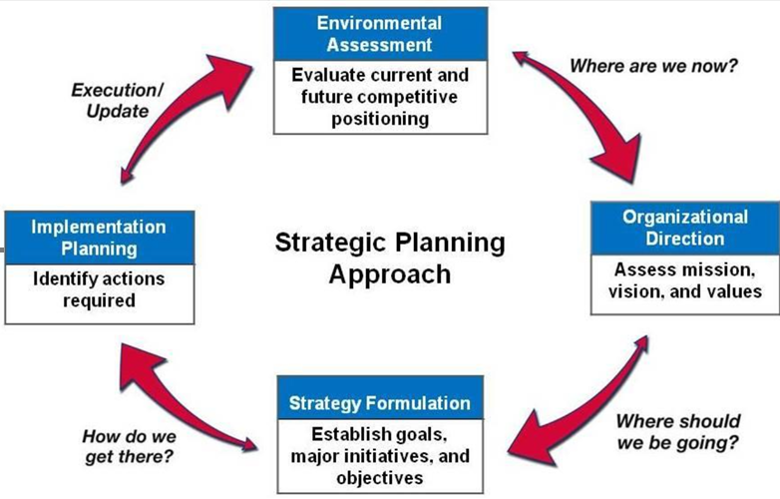

Figure 1: The Planning Process in Organisational Management

3.1 Strategic Objectives for Long-Term Success
Strategic objectives provide direction, support organisational focus and contribute to sustainable competitive advantage (Johnson, Scholes and Whittington, 2020). For Cytiva, operating within the life sciences sector requires a strong emphasis on accuracy, efficiency and continuous improvement. Three objectives are considered critical to long-term success: improving master data accuracy, reducing operational lead times and enhancing digital integration and automation.
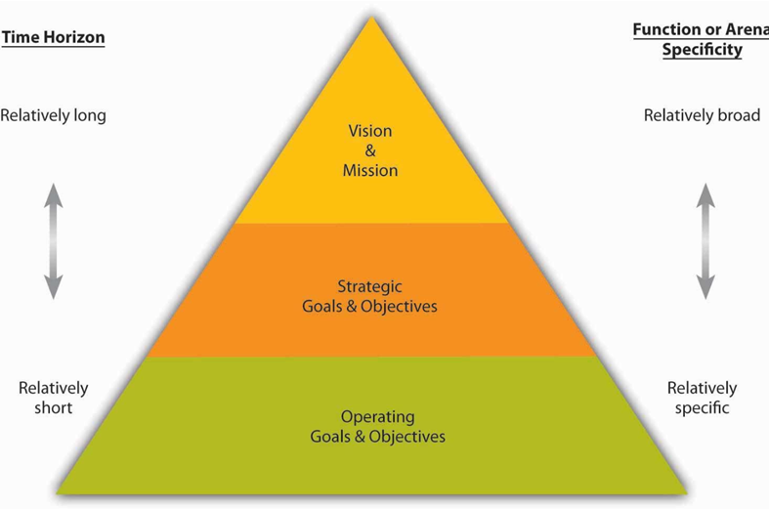

Figure 2: Key Strategic Objectives for Organisational Success

3.1.1 Improve Master Data Accuracy and Process Efficiency
Improving master data accuracy is a key strategic objective for Cytiva. As the organisation relies on SAP and Magic for product and bill of materials (BOM) data, inaccuracies can increase costs and reduce efficiency. Strategically, Cytiva should strengthen data standardisation and continuous improvement initiatives, supported operationally through regular audits, employee training and standardised procedures. Slack and Brandon-Jones (2023) argue that accurate data and efficient processes are essential for reducing waste and improving organisational performance.
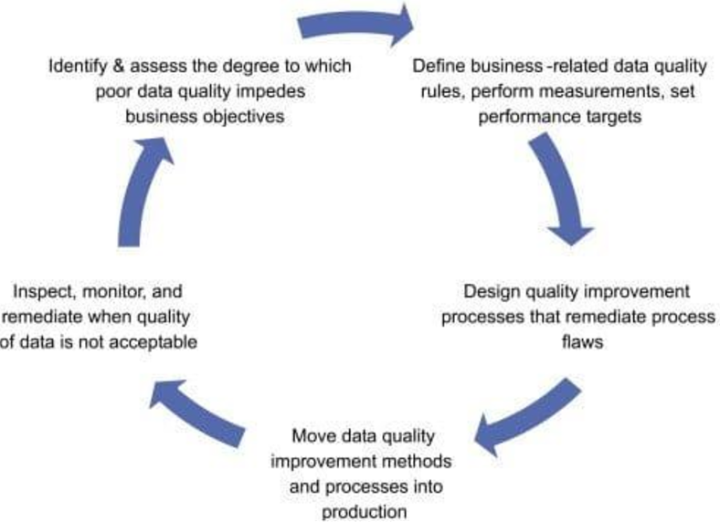
Figure 3: Continuous Master Data Quality Improvement Process

3.1.2 Reduce Operational Lead Times and Process Bottlenecks
Reducing operational lead times and bottlenecks is a key objective for Cytiva, as delays can affect service quality and operational performance. Following digital integration, workflows require ongoing monitoring and refinement to maintain efficiency. Strategically, Cytiva should streamline approval processes and strengthen cross-functional collaboration. Operationally, workflow reviews, improved communication and KPI monitoring can help identify bottlenecks and improve responsiveness (Robbins and Coulter, 2022).
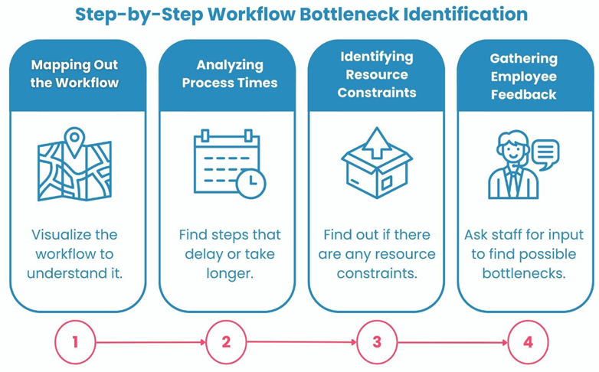
Figure 4: Workflow Bottleneck Identification Process

3.1.3 Enhance Digital Integration and Automation
Enhancing digital integration and automation is a key strategic objective for Cytiva. Digital transformation can improve efficiency, reduce manual errors and support decision-making. Strategically, Cytiva should continue investing in integrated digital systems, while operational actions should focus on process automation, system optimisation and employee training to improve adoption. Heizer, Render and Munson (2023) highlight digital integration as a driver of operational control and organisational flexibility.
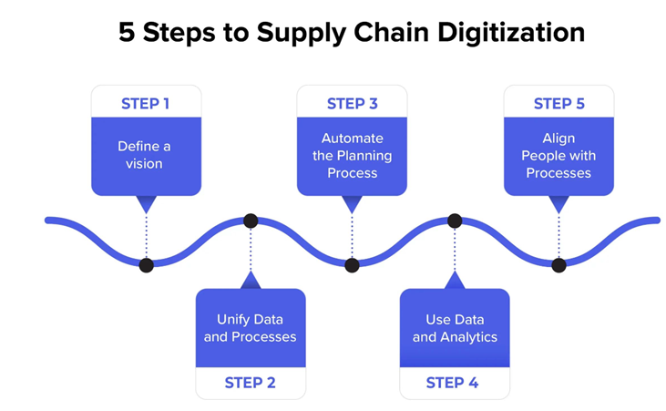

Figure 5: Steps to Supply Chain Digitisation

3.2 Evaluation of Planning Approach
Cytiva’s planning approach aligns most closely with Management by Objectives (MBO), developed by Drucker (1954). MBO focuses on establishing clear organisational goals linked to measurable targets and employee performance. Within Cytiva, planning is driven by operational objectives, key performance indicators (KPIs), service level agreements (SLAs) and continuous improvement initiatives, reflecting an objective-based approach.
A key strength of MBO is its ability to provide direction, accountability and performance visibility through measurable targets. Within Cytiva, objectives relating to master data accuracy, lead time reduction and process efficiency support operational consistency and performance monitoring. Robbins and Coulter (2022) argue that measurable objectives enable organisations to align employee efforts with strategic goals and evaluate progress effectively.
However, an excessive focus on measurable targets may reduce organisational flexibility when unexpected operational challenges arise. Following the implementation of MSI, operational lead times increased and workflows required significant adaptation, demonstrating that performance metrics alone may not fully capture the impact of organisational change. While traditional planning approaches provide greater managerial discretion and flexibility, MBO is more suitable for Cytiva due to its reliance on KPIs, SLAs and process performance measures. Nevertheless, a hybrid approach that combines measurable objectives with managerial judgement may provide a more balanced planning framework.
Overall, Cytiva’s planning approach reflects MBO through its emphasis on measurable performance, accountability and continuous improvement. However, maintaining flexibility alongside objective-based planning is essential to support effective decision-making in a rapidly changing operational environment. As illustrated in Figure 6a, MSI implementation increased operational complexity and lead times, highlighting the limitations of relying solely on performance targets during periods of organisational change. This supports the need for managerial judgement alongside objective-based planning.

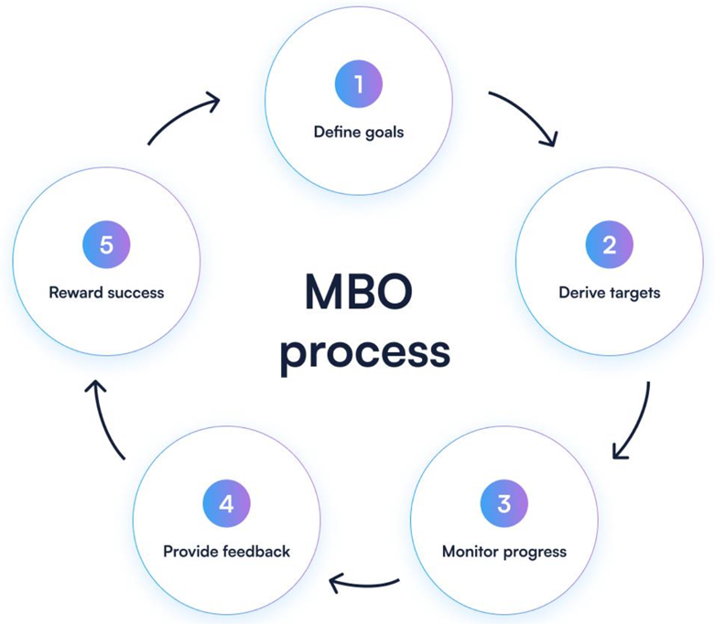
Figure 6: Management by Objectives (MBO) Planning Process

Performance Measure | Before MSI | After MSI
Average lead time | 3 days | 8 days
Daily Handovers | 7 | 12
Duplicate processing | low | increased
Workflow complexity | Moderate | High
Figure 6a: Operational Impact of MSI Implementation

4.0 Organising
Organising involves coordinating resources, assigning responsibilities and structuring activities to achieve organisational objectives effectively. Effective organisational structures support operational continuity, efficiency and service quality (Robbins and Coulter, 2022). For global organisations, workforce organisation is particularly important when continuous customer support is required. The following section evaluates a 24/7 customer care workforce model designed to balance operational coverage, employee wellbeing and organisational effectiveness.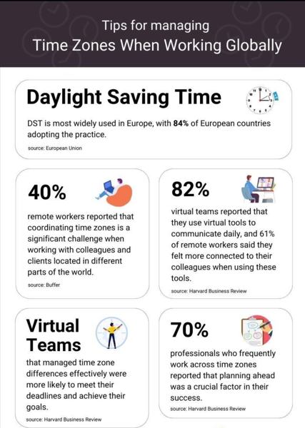

Figure 7: Global Workforce Organisation for Continuous Service Delivery

4.1 Designing a 24/7 Customer Care Workforce
A globally distributed workforce model is more effective for providing continuous customer support than relying solely on local overnight shifts. Within Cytiva, teams in the United Kingdom, United States and Asia enable service coverage across multiple time zones, reducing employee fatigue while maintaining operational continuity.
This approach also supports employee wellbeing by aligning work schedules with regional working hours and accommodating external commitments. Additional flexibility can be provided through hybrid working, job sharing and compressed hours. Armstrong and Taylor (2023) argue that flexible working arrangements improve employee motivation, wellbeing and organisational commitment.
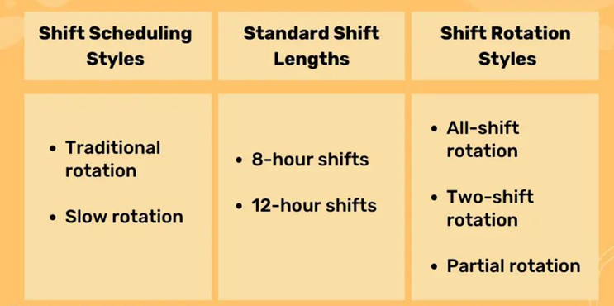
Figure 8: Shift Scheduling and Rotation Styles for a 24/7 Workforce Model

4.2 Work Package Model and Guidelines
A suitable work package model should combine clear shift responsibilities with flexible working arrangements to support continuous service delivery. Teams across different regions can operate within standard working hours while collaborating to provide seamless customer support across time zones. Flexibility may be achieved through adjusted start times, compressed hours and shared responsibilities.
Successful implementation requires clear guidelines for managers and employees. Managers should ensure fair workload distribution, effective communication and employee wellbeing, while employees must adhere to schedules and support cross-team collaboration. Robbins and Coulter (2022) emphasise the importance of communication and role clarity in maintaining organisational performance.

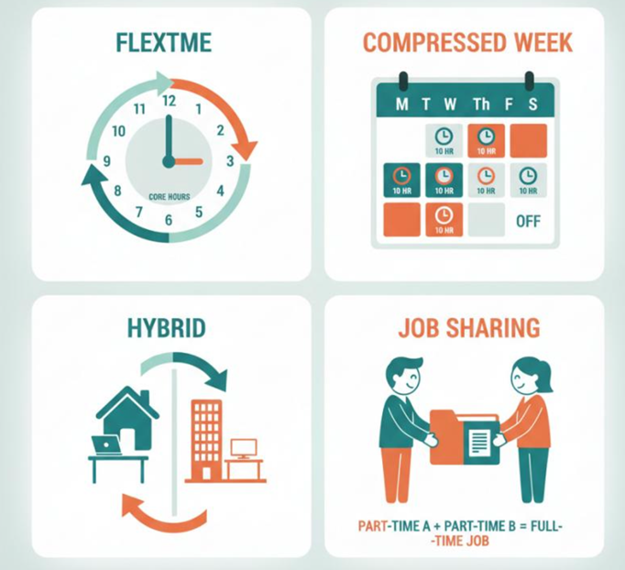

Figure 9: Flexible Working Arrangements within a 24/7 Workforce Model

5.0 Leading
Leading is an essential management function that focuses on motivating employees, influencing behaviour and guiding teams towards achieving organisational objectives. Effective leadership contributes to employee engagement, improved communication and operational performance within organisations (Robbins and Coulter, 2022). In complex organisational environments, leaders must demonstrate adaptability, communication skills and the ability to support employees during periods of change. The following section critically evaluates personal leadership experience within the workplace and analyses leadership effectiveness through the application of relevant leadership theories.
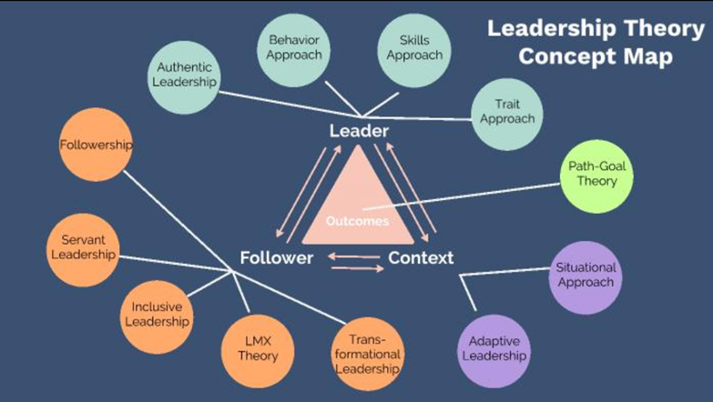
Figure 10: Leadership Styles and Workplace Influence

5.1 Critical Reflection on Personal Leadership Experience
Within Cytiva, leadership has been demonstrated through involvement in process improvement and the Magic-SAP Integration (MSI) project. During organisational change, responsibilities included supporting colleagues, providing process guidance and helping resolve workflow challenges associated with new systems and increased workloads.
Leadership was also demonstrated through cross-functional collaboration and proactive communication to improve process understanding and address operational issues. Although no formal managerial authority was held, leadership behaviours were evident through initiative, teamwork and supporting others during change. Northouse (2022) argues that leadership involves influencing and supporting others to achieve shared goals.
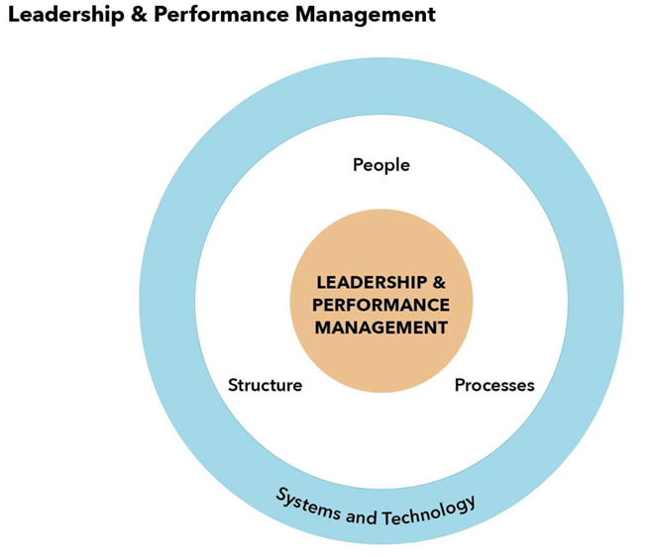
Figure 11: Leadership and Team Collaboration during Organisational Change

5.2 Critical Evaluation of Leadership Style
Based on workplace experience, a combination of transformational and democratic leadership styles best reflects personal leadership behaviour. Transformational leadership focuses on motivating employees during change and encouraging continuous improvement (Bass and Riggio, 2006). This was evident during system and process changes at Cytiva, where supporting colleagues helped manage operational challenges.
A democratic leadership style was demonstrated through encouraging feedback and involving colleagues in problem-solving. This approach can enhance engagement and participation in decision-making. However, it may be less effective in situations requiring rapid decisions or when managing conflict and resistance to change. Although both styles were effective, transformational leadership had the greatest impact during MSI implementation, where supporting colleagues through uncertainty and change was critical to maintaining operational effectiveness.
According to Hersey and Blanchard’s Situational Leadership Theory, leadership effectiveness depends on adapting leadership approaches to employee needs and workplace circumstances (Northouse, 2022). Therefore, further development in decision-making, delegation and conflict management would enhance leadership effectiveness.

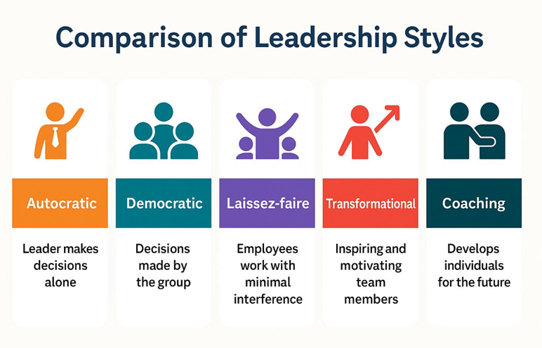
Figure 12: Comparison of Leadership Styles in Workplace Practice
5.3 Leadership Development Action Plan
To further enhance leadership effectiveness, a structured development plan is required to address areas identified through critical reflection. Although strong communication, teamwork and collaborative problem-solving skills have been demonstrated, further development is needed in decision-making confidence, delegation and conflict management. Strengthening these competencies will improve leadership adaptability and effectiveness while supporting progression into future management roles within Cytiva.
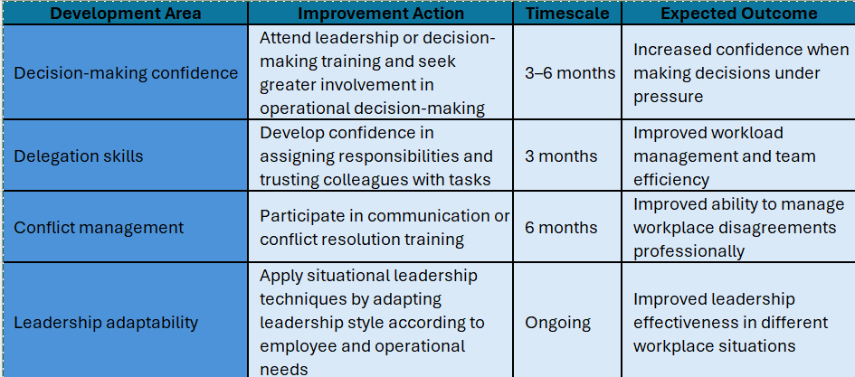
Figure 13: Leadership Development Action Plan

The implementation of this action plan is expected to strengthen leadership effectiveness by improving confidence, adaptability and communication skills. According to Northouse (2022), leadership development is an ongoing process that requires continuous reflection, learning and adaptation to changing workplace demands.

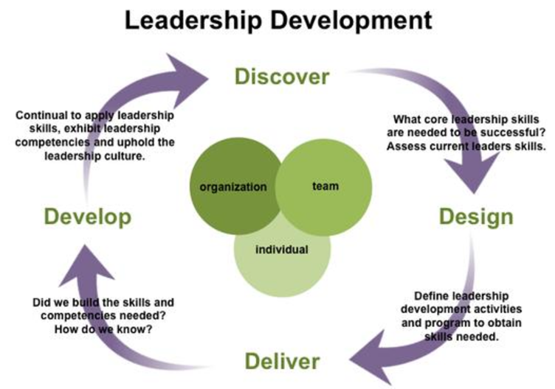
Figure 14: Leadership Development and Continuous Improvement Cycle

6.0 Controlling
Controlling involves monitoring performance, evaluating outcomes and ensuring organisational objectives are achieved effectively. Through performance measurement, managers can identify inefficiencies and implement corrective actions to improve productivity (Robbins and Coulter, 2022). The following section evaluates control measures and performance indicators used to assess individual employee performance and overall departmental effectiveness.
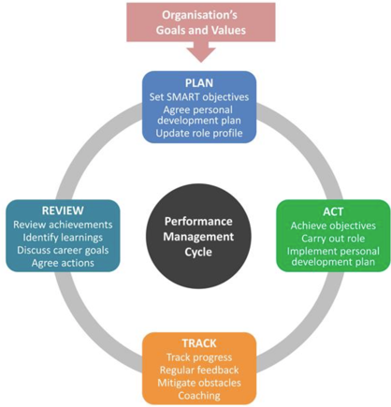
Figure 15: Management Control and Performance Monitoring Process

6.1 Control Measures for Individual Employee Efficiency and Effectiveness
Several control measures can be used to assess employee efficiency and effectiveness. Accuracy rates are particularly important in environments where data quality and operational precision are critical, as they help identify training needs and reduce errors. SLA compliance and task turnaround times can be used to measure whether work is completed within expected timeframes, while productivity may be assessed through workload completion and quality outcomes. Robbins and Coulter (2022) argue that effective performance monitoring improves accountability and organisational performance.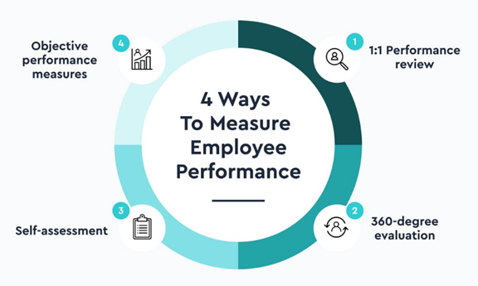
Figure 16: Employee Performance Indicators for Measuring Efficiency and Effectiveness

6.2 Performance Indicators for Overall Unit Performance
Departmental performance should be measured using key performance indicators (KPIs) that reflect efficiency and service quality. Relevant measures include lead times, backlog volumes, customer satisfaction, error reduction and process completion times. Lead times and backlog levels help identify operational inefficiencies and resource constraints, while customer satisfaction provides insight into service quality. Kaplan and Norton (1996) argue that a balanced range of performance indicators provides a more comprehensive assessment of organisational effectiveness.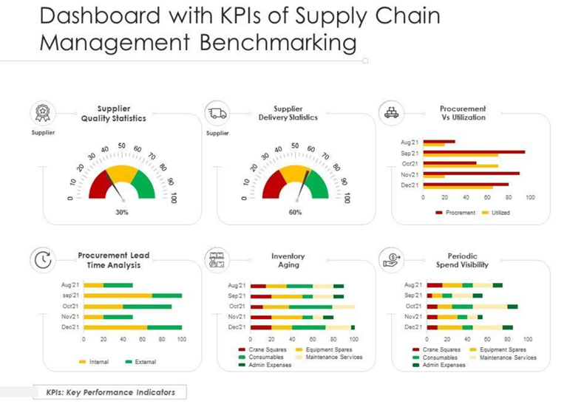
Figure 17: Supply Chain Key Performance Indicators for Measuring Departmental

6.3 Justification of Control Measures and Performance Indicators
The selected control measures are appropriate because they provide measurable evidence of employee and departmental performance. Accuracy, turnaround times and productivity support accountability and identify operational inefficiencies, while KPIs such as lead times and customer satisfaction inform decision-making and continuous improvement. However, organisations should avoid relying solely on quantitative measures. A balanced approach combining quantitative performance data with qualitative feedback provides a more accurate assessment of employee and departmental effectiveness, particularly during periods of organisational change.
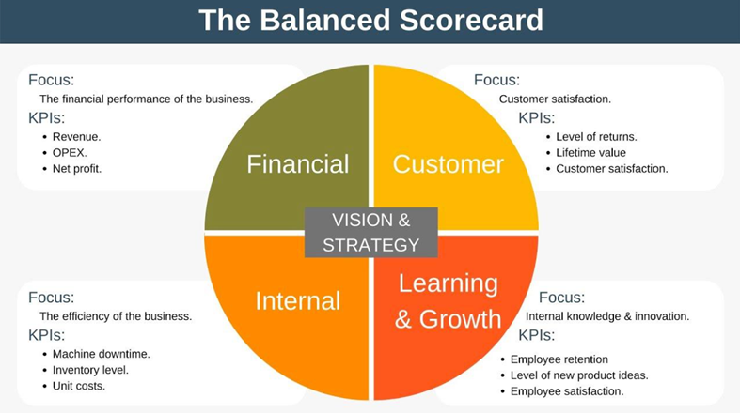
Figure 18: Balanced Approach to Performance Measurement and Organisational Control

7.0 Conclusion
Effective organisational management is essential for achieving organisational objectives and supporting long-term success. This essay evaluated the four management functions of planning, organising, leading and controlling within Cytiva. The analysis highlighted the importance of strategic planning, effective workforce organisation, adaptive leadership and performance monitoring in improving organisational effectiveness. It also demonstrated how applying management and leadership theories can support continuous improvement, employee performance and operational efficiency within a global organisation.

References

Robbins, S.P. and Coulter, M. (2022) Management. 15th edn. Harlow: Pearson Education.

Heizer, J., Render, B. and Munson, C. (2023) Operations Management: Sustainability and Supply Chain Management. 15th edn. Harlow: Pearson.

Johnson, G., Scholes, K. and Whittington, R. (2020) Exploring Corporate Strategy. 12th edn. Harlow: Pearson.

Slack, N. and Brandon-Jones, A. (2023) Operations and Process Management: Principles and Practice for Strategic Impact. 7th edn. Harlow: Pearson.

Massachusetts Institute of Technology (MIT) (n.d.) Total Data Quality Management (TDQM) Program. Available at: https://web.mit.edu/tdqm/www/ (Accessed: 28 May 2026).

Flowster (n.d.) Step-by-Step Workflow Bottleneck Identification. Available at: https://flowster.app/identify-bottlenecks-in-processes/ (Accessed: 19 May 2026).

Appinventiv (n.d.) 5 Steps to Supply Chain Digitization. Available at: https://appinventiv.com/blog/supply-chain-digitization/ (Accessed: 20 May 2026).

Drucker, P.F. (1954) The Practice of Management. New York: Harper & Row.

Armstrong, M. and Taylor, S. (2023) Armstrong’s Handbook of Human Resource Management Practice. 16th edn. London: Kogan Page.

Buddy Punch (n.d.) Shift Scheduling Styles and Rotation Models. Available at: https://buddypunch.com/rotating-shift-schedules/ (Accessed: 20 May 2026).

Bass, B.M. and Riggio, R.E. (2006) Transformational Leadership. 2nd edn. Mahwah, NJ: Lawrence Erlbaum Associates.

Northouse, P.G. (2022) Leadership: Theory and Practice. 9th edn. Thousand Oaks, CA: Sage Publications.

Kaplan, R.S. and Norton, D.P. (1996) The Balanced Scorecard: Translating Strategy into Action. Boston, MA: Harvard Business School Press.

SlideModel (n.d.) Dashboard with KPIs of Supply Chain Management Benchmarking. Available at: https://slidemodel.com/ (Accessed: 28 May 2026).

