

GROUP
PRESENTATION
- Module: Managing
Enterprise in the 21st Century
- Module code: BMSW4006
- Tutor: Zainab Atta
- Alexandra Florica 2029869
(Group leader)
- Theodora Maria Petrean 2029740
- Temenuzhka Marionova 2030125

SUMMARY




Alexandra: Executive Summary, Business Concept
(Slides 1-10)
Theodora: Market Analysis and Marketing Plan
(Slides 11-15)
Temenuzhka: Financial Plan, Operation and Management Plan
(Slides 15-20)

COVER LETTER
- We choose a Start Up Loan from the government
- We want to open a friends food trailer at London Kings Cross
- 25,000£ amount
- Alexandra – Marketing and Operation, Theodora – Financial Department,
Temenuzhka – Human Resources
- Contact number: +441234567890
- Email: healthybites@gmail.com

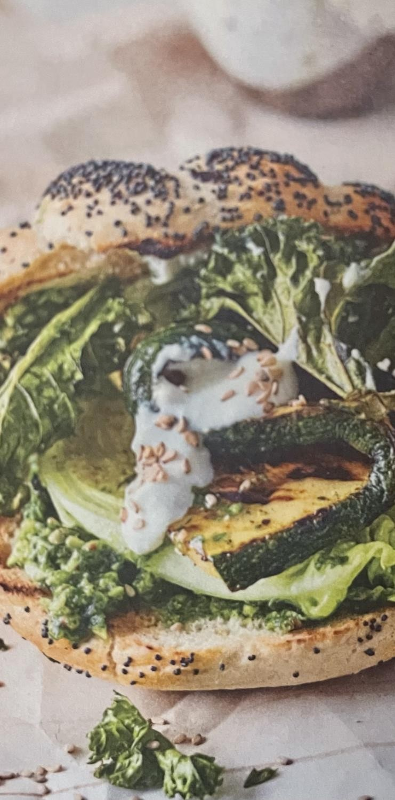
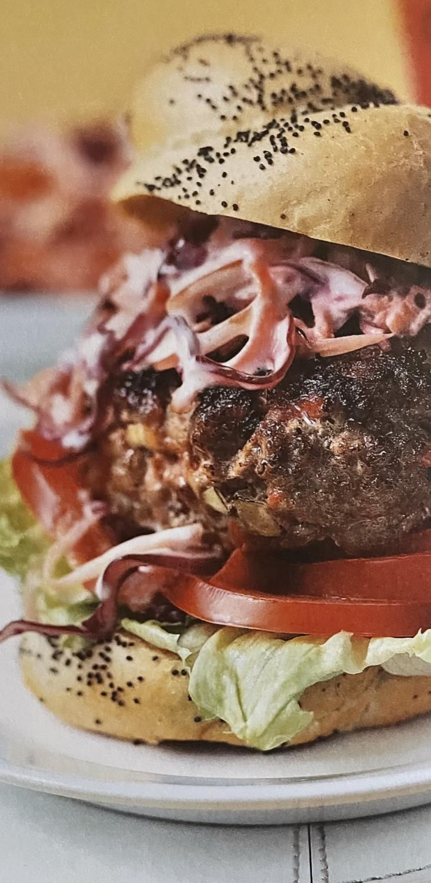

P RO D U C T
D E S C R I P T I O N (PA RT 1)
- We offer burgers with
homemade bread (gluten free), minced beef, fresh vegetables, and homemade sauces. We will offer 5 different types of burgers; we will also have the option for vegetarians.

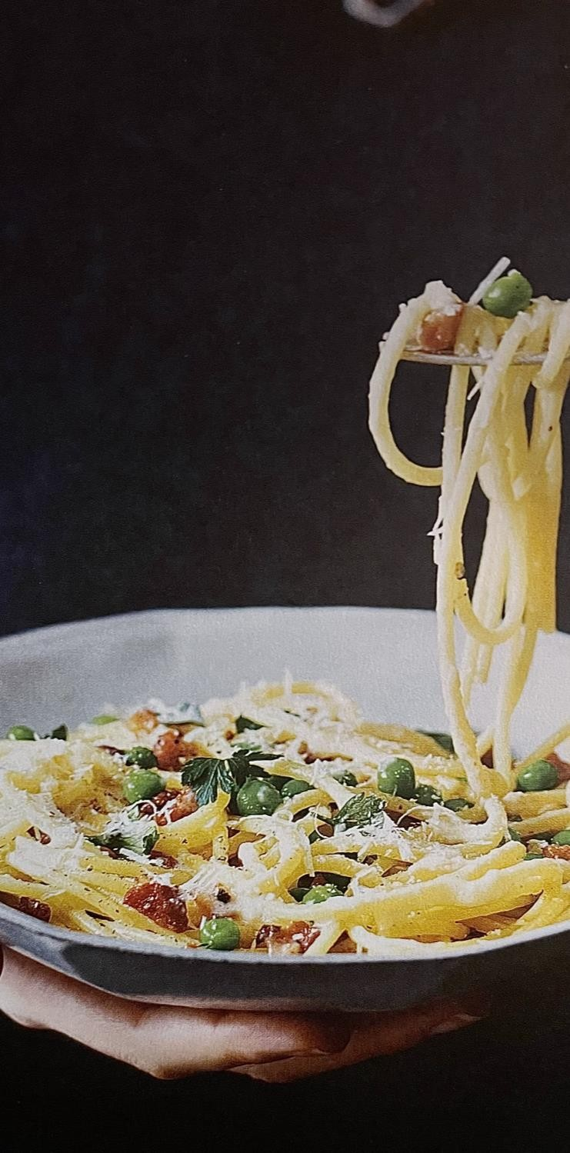
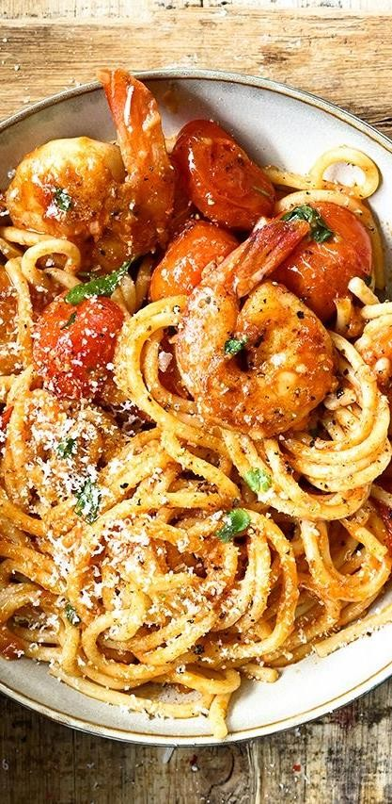

P RODUCT
DE SCRIP T ION (PART 2)
- We will also have 3 types of spaghetti: with chicken breast in garlic butter, a
variant for lovers of seafood (garlic shrimp) and a variant for vegetarians, with fresh vegetables in tomato sauce or garlic.

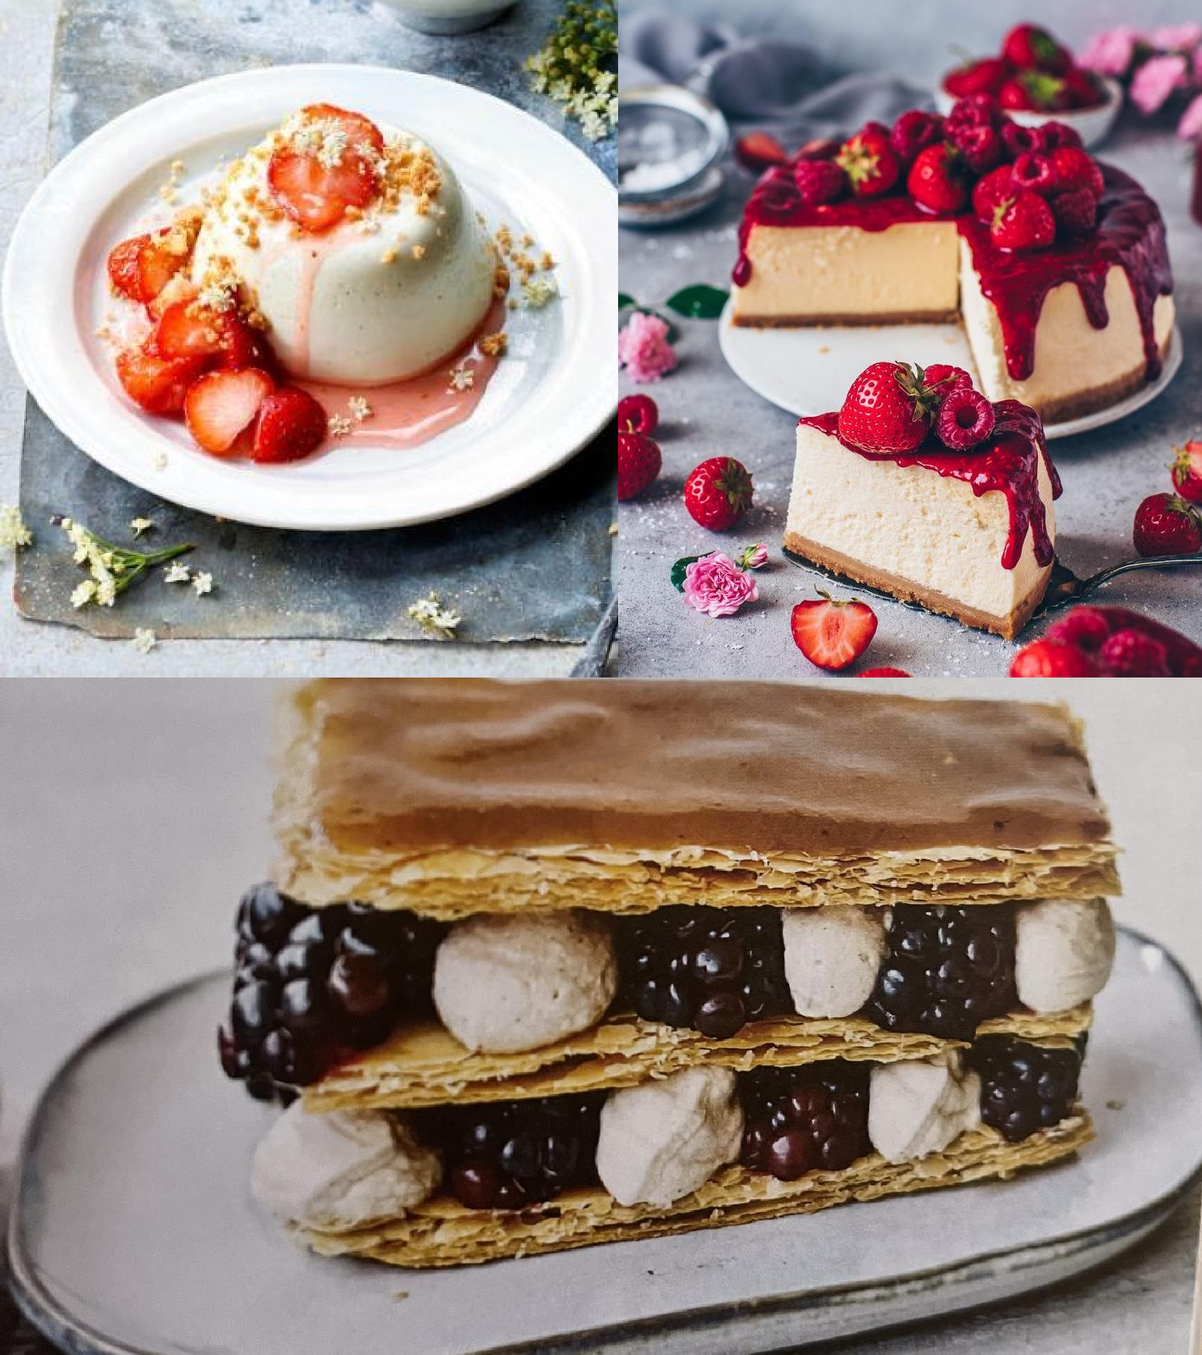

P RO D U C T
D E S C R IP T IO N (PA RT 3)

- Every day we will have a cake, prepared by us. All ingredients will be fresh. We will prepare cheesecake, tiramisu, panna cotta and much more.

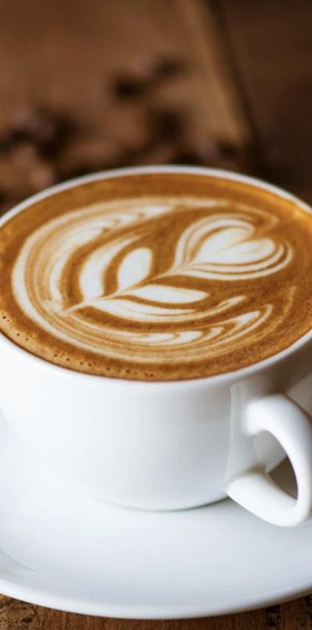
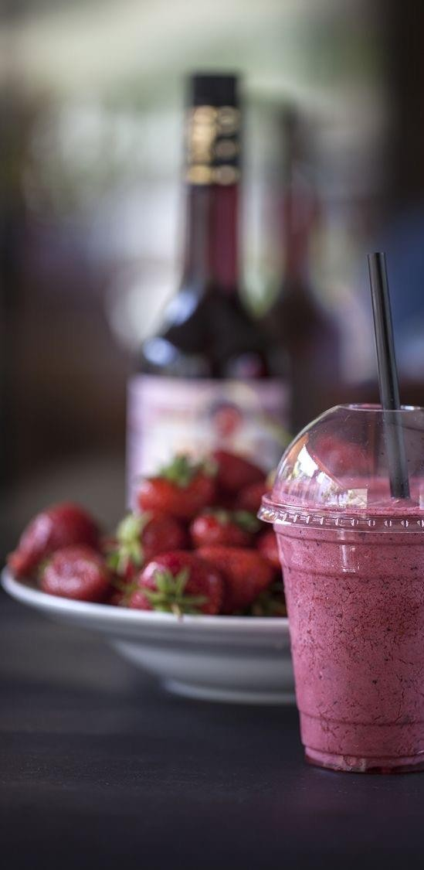

COFFEE AND DRINKS
- Latte
- Flat White
- Cappuccino
- Classic Espresso
- Hot Orange and Lemon Tea
  - Still and Sparkling Water
    - Fresh Orange Juice
- Smoothies with Apple and
Carrot, Blueberry and Banana, Strawberry and Banana

EQUIPMENT LIST

  - Unox Cheftop Mind Maps ZERO 5 Convection Oven 1/1GN -
£2,299
  - Adventys Double Induction Hob GL2 6000 F - £2,259
  - Polar G – Series Prep Counter Fridge 390Ltr - £1,099
  - Nespresso Professional Coffee Machine - £3,000
  - Mobile Unite, Catering Container, Mobile Kitchen - £8,000

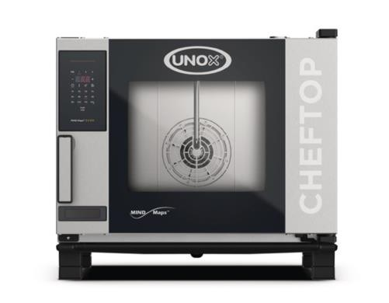
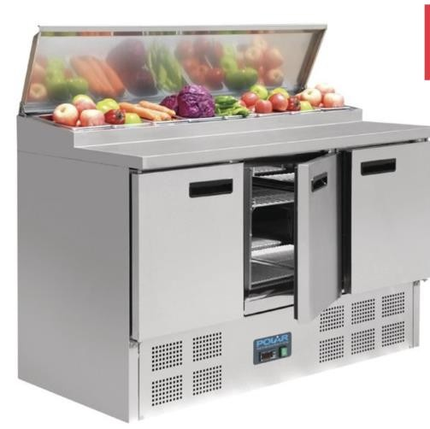
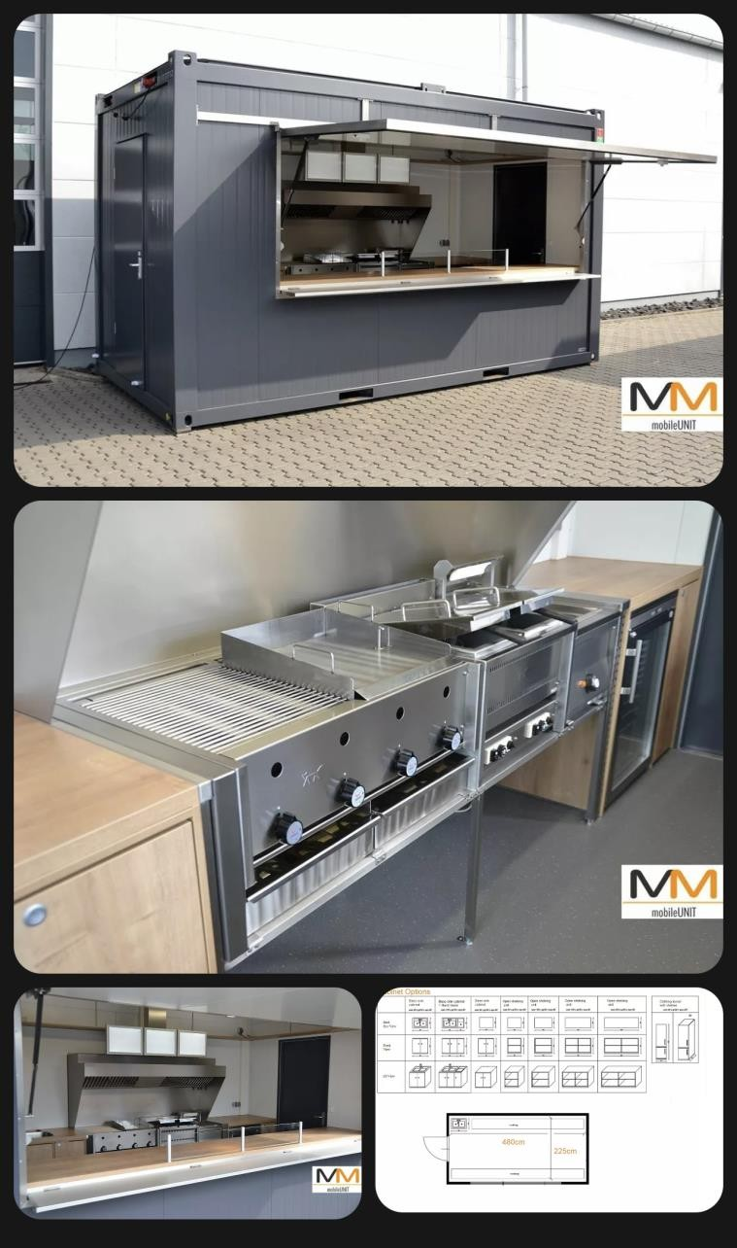
EQUIPMENT PICTURES

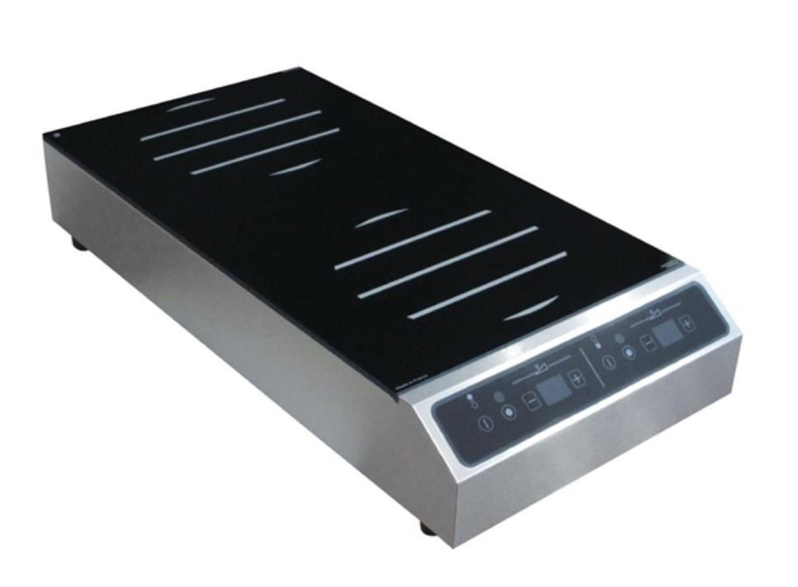
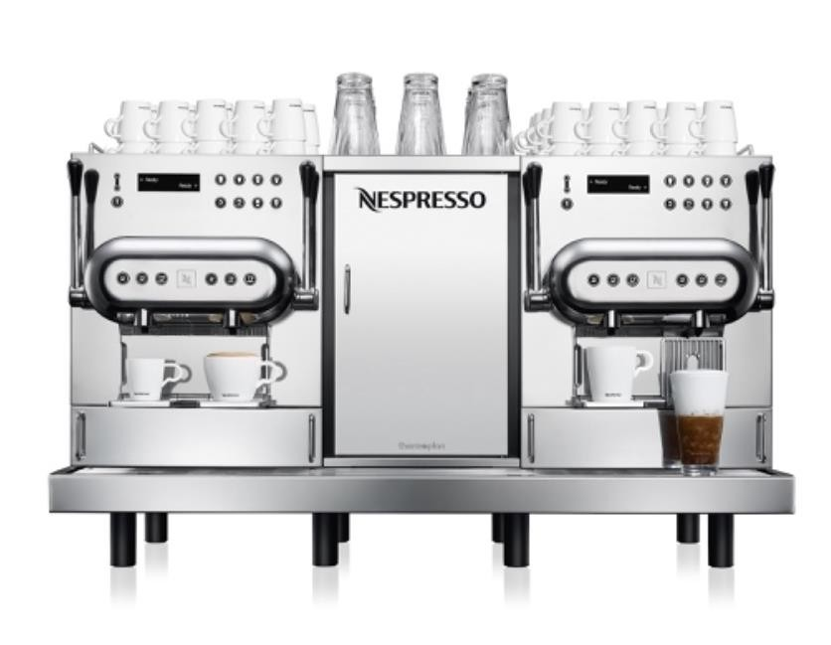

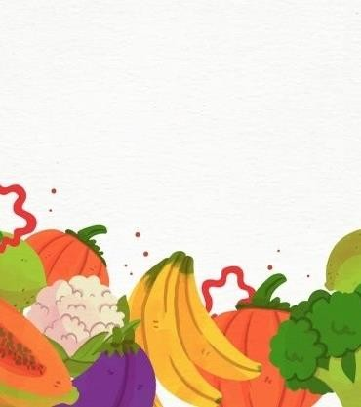

HEALTHY BITES

B U S IN E SS C O N C E P T
- Food market business/catering
container
- Based on London
- All our products are fresh and homemade with high quality
- All our products for takeaway
are recyclable
- Professional working team

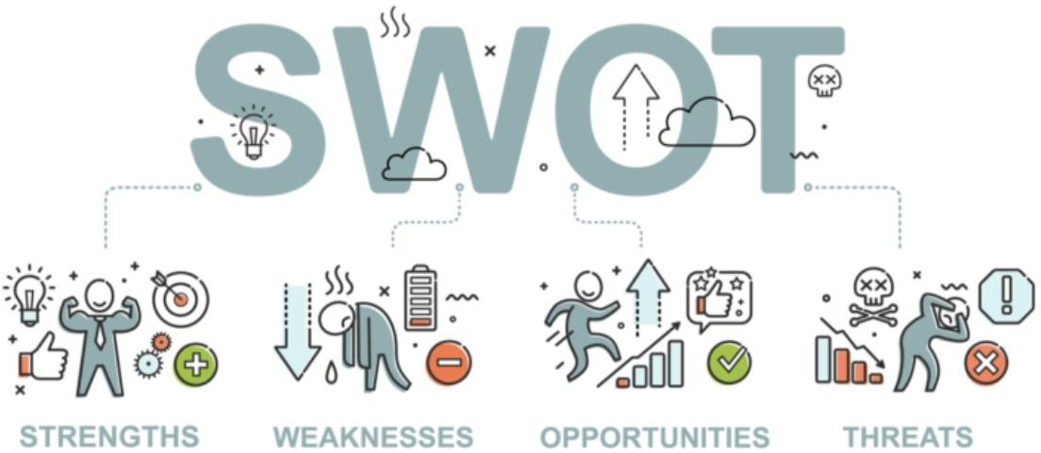

STRENGHTS: Fast
Service, Fresh Food, Cheap Prices/Deals, Saves Renting Coast.

WEAKNESSES: Poor
Customer Service, Long Time Waiting, Prices, Takeaway Service.

OPPORTUNITIES:
Program extension, Food for Travelers and students, Professional Barista, Location.
THRAEDS: Competition, Because of the pandemic a lot of people working from home, Contamination, Weather.

MARKETING PLAN
  - Our potential clients are travelers, office workers and the students. Our location is at the London King Cross, is one of the biggest stations in London.
  - Our product will be fresh with fast service.
  - We will have new deals every week.

OUR PRICES

    - Breakfast deal: 1 coffee with 1 smoothie for £4 and you will receive a free croissant.
    - Lunch deal: 1 burger with 1 water for £4 and you will receive a free muffin.
    - Diner deal: 1 pasta with 1 water for £5 and you will receive a free tiramisu.
    - All the drinks will cost £3, except for water which will cost £1.
    - All the burgers will cost £4.
    - All the pasta will cost £5.
    - All the deserts will cost £3.

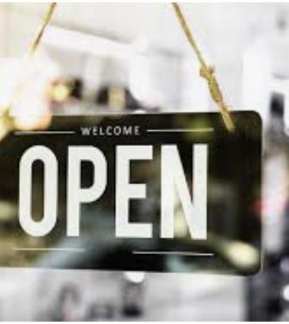

OPENING HOURS
      - Monday – Friday
      - 6am – 10am (1h break)
      - 11am – 3pm (30 min break)
      - 3:30pm – 6pm
      - Saturday: 7am – 1pm
      - 1 day off

SOCIAL MEDIA MARKETING INSTAGRAM AND FACEBOOK
  - Videos on how to prepare our products – Customers will see our fresh ingredients and our experience.
  - Videos on how we make the coffee and the smoothies.
  - In every morning we will post the deal of the day.
  - We will post all the time pictures will all the products.
  - Customers can order by text on Instagram and Facebook. They can call us, or they can order online on our web site: www.healthybites.co.uk

S TA F F / P O S I T I O N S

- Friends Business
- No hiring people, will not wasting money for
licenses and wages.
- For us it’s not necessary to provide a training because we already have all the necessary calcifications and trainings.
- Alexandra will be our chef; she has 8 years
experience.
- Theodora will be our barista; she has a bartender certificate.
- Temenuzhka will take the orders from the customers. She will also take care of Financial Sector and HR.

Street trading
license.
Food business
registration.
Food premises
approval.

Commercial gas safety certificate.

LICENSES AND
REQUIERED DOCUMENTS
Food hygiene certificate.



DAILY SALES
ANALISYS
Sales
9%
10%
23%
58%
Daily sales number Daily sales price by unit Daily sales total revenue
Daily sales total cost

DAILY SALES

Product | Number | Price by  Unit | Material  Cost by Unit | Total  Revenue | Total Cost | Profits
Coffee | 500 | £3.00 | £0,42 | £1,500.00 | £210.00 | £1,290.00
Water | 50 | £1.00 | £0,73 | £50.00 | £36,50 | £13.50
Smoothie | 25 | £3.00 | £0,23 | £75.00 | £5,75 | £69.25
Burgers | 100 | £4.00 | £0,85 | £400.00 | £85.00 | £315.00
Pasta | 40 | £5.00 | £0,53 | £200.00 | £21,2 | £178.80
Sweets | 12 | £3.00 | £0,65 | £36.00 | £7,8 | £28.20
Total | £727.00 | £19.00 | £3,41 | £746.00 | £366,25 | £379.75

WORKERS

Employee | Pays | Hours | Total Pays
Employee 1 | £12.00 | 10h, 30 min | £126
Employee 2 | £12.00 | 10h, 30 min | £126
Employee 3 | £12.00 | 10h, 30 min | £126
Total | £36.00 | 31h, 30 min | £378

MONTHLY EXPENSES

Water | £25.00
Internet | £30.00
Electricity | £45.00
Insurance | £140.00
Licensing | £70.00
Others | £180.00
Total | £490.00

  - www.gov.uk

REFERENCES

  - www.nbcnews.com/better/amp/ncna1096031
  - http://pin.it/ScpfNxe
  - http://pin.it/6BNgTGN
  - http://pin.it/3ZPz4MH
  - www.searchenginejournal.com/seo-swot-analysis-how-to/395830/
  - www.amazon.com
  - www.nisbets.co.uk
  - www.nespresso.co.uk
  - www.ebay.com
  - Kathryn Bruton (2018) Skinny Desserts
  - Ryland Peter & Small (2017) 101 Burgers & Sliders
  - Julia Azzarello (2018) Skinny Pasta



Thank You!

