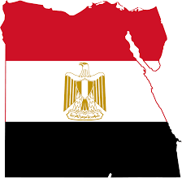
Destination Egypt
A look into tourism
Kathryn Marshall 1804648
Egypt is considered one of the six ‘cradle of civilization’ meaning that it was one of the first areas to abandon nomadic life and forge a city. It was the beginning of farming, technology, language, and social context which began around 3150 BC. The Pharaonic culture was the original Egyptian culture which can still be seen today in the form of art, architecture, and clothing. Egyptian architecture can be seen all over the world such as the pyramid at the Louvre Museum or the obelisk of Washington Monument. The Greeks also took with them the grid the Egyptians used to make their own statues so much of the Greek art shows similarities to Egyptian art. (Tyldesley, 2011) Fashion designers all over the world use Egyptian patterns and motifs when creating clothes as well. (Egyptian Streets, 2018) 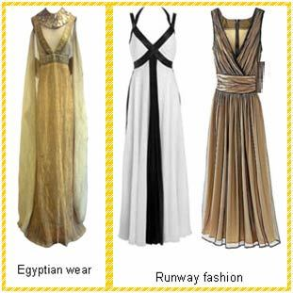
Some of this original culture has been lost through the migration of peoples or the invasions of countries. This is why Egypt is now considered a ‘melting pot’ of cultures with bits and pieces from other cultures such as Hellenism, Christianity, Islamic, and Roman as well as others. For example, Cairo has one of the most incredible collections of Islamic architecture in which some of the structures have survived since 640 AD. Another example is with language. Egypt
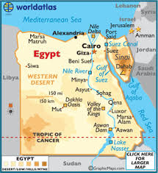
was occupied for nearly seventy years by the British allowing for English to be the second most spoken language behind Egyptian Arabic. Although Egyptian food has influences of Mediterranean flavors, some of their recipes are still from the Ancient times and sets them apart from traditional Mediterranean foods. For example, their version of the falafel is not made with the traditional chickpeas but with broad beans giving them a unique flavor in which others have said ‘it’s the best way to make it’. (Yogerst, 2020) 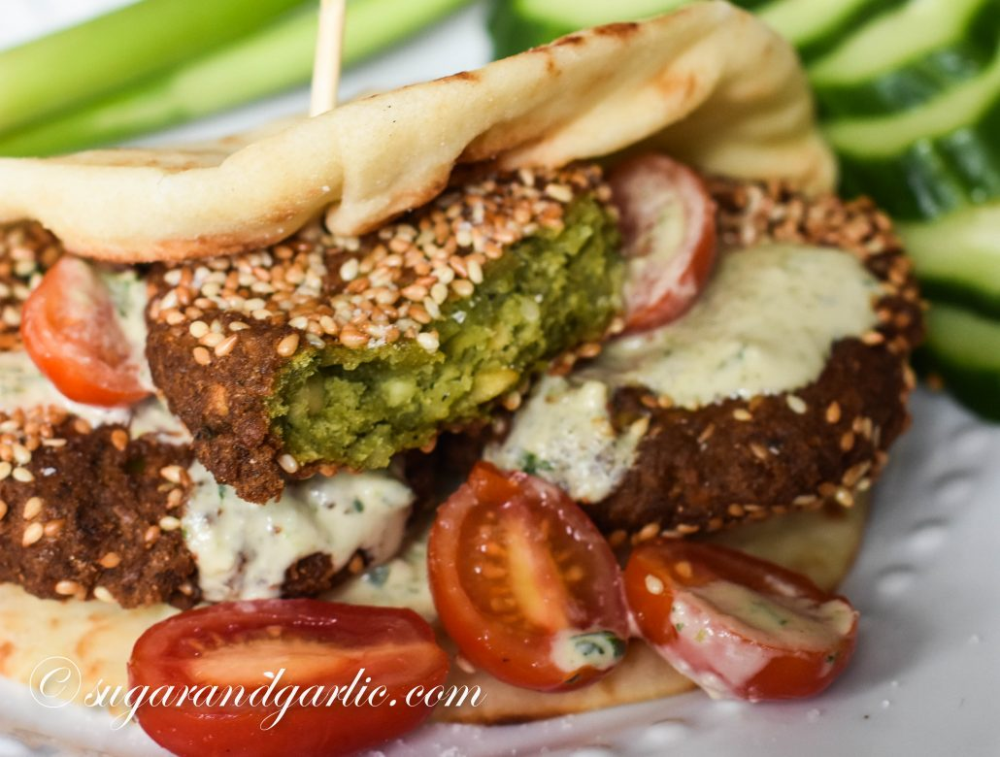
Even since the Ancient times, Egyptians loved feasts and festivals reserving some of their dishes for these special occasions such the birth of a new baby or a significant religious event. (Assem, 2015) These special occasions also show how important family and religion is to Egyptians. They value family life highly which includes more than just the immediate family but the extended ones as well making it a collectivist society. The family’s needs are more important than the individual family members need and often multiple generations live underneath one roof. Religion plays a large part in Egypt, not only with attending prayer and feasts that go along with religious dates, but it often influences politics and laws. About ninety percent of Egyptians are Sunni Muslim with the nearly ten percent remaining being of Coptic Catholic. (Cultural Atlas, 2020)With all the influence and the thousands of years in existence the Egyptian culture has developed into a unique culture to be witnessed and shared throughout the tourism industry.
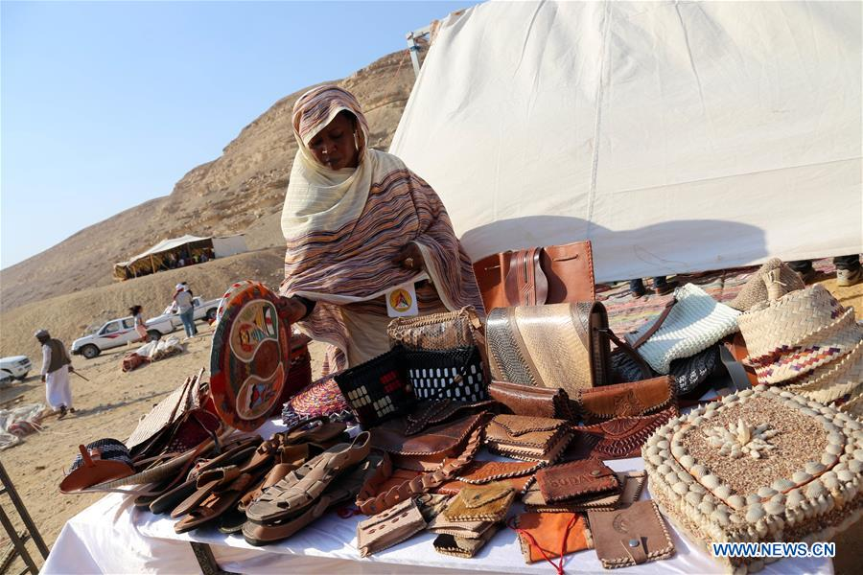

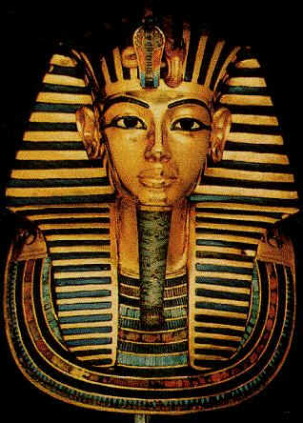
Despite being a unique culture, Egypt represents a fusion of culture. An important factor contributing to this fusion of culture is the geographical location of Egypt especially with regards to the Ancient world where there were important trade and shipping routes through the country. (Mark, 2017) Egypt is situated in the North East corner of Africa bordering not only the Mediterranean Sea but also the Red Sea as well as the countries of Libya and Sudan. A triangular piece of land that connects Africa to Asia which is also part of Egypt is the Sinai Peninsula which borders Palestine and Israel.
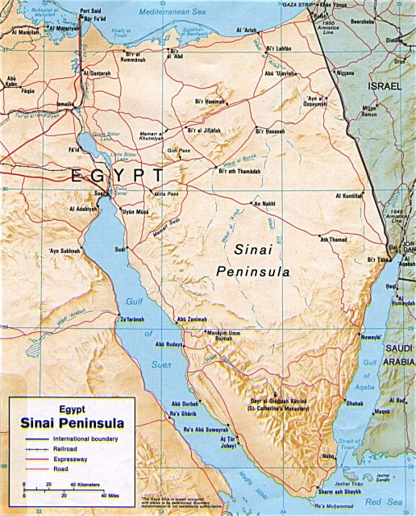
The Nile River, which is the longest river in the World, runs throughout the entire country splitting it into two regions, the Western and Eastern Desert on either side of the river. The Nile ends in the North connecting with the Mediterranean Sea in an area called the Delta which makes up the third major region of the country. The last and fourth region is the Sinai Peninsula. Although ninety percent of the land is made up of desert, there are other geographical features such as lakes, plateaus, depressions, oases, and mountain regions specifically on the Sinai Peninsula, where it is believed that Moses received the 10 Commandments. There are some interesting formations visible in these vast deserts, however. In the Western Desert which very few living creatures live, there is an area known as the Great Sea Sand. On these shores of the sea near the Libyan border there are incredible pieces of glass that had developed well before civilization some of the pieces weighing up to ten pounds.
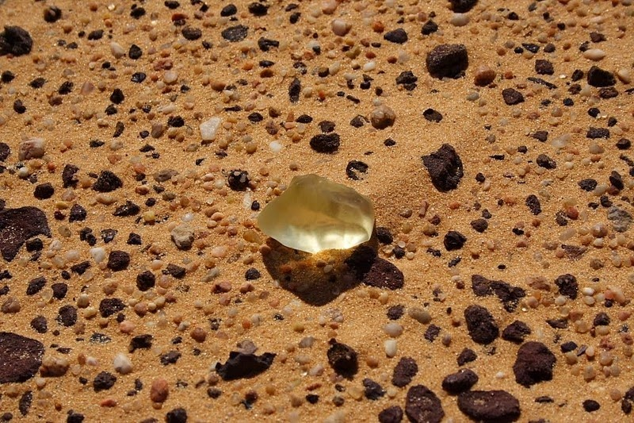
It’s a peculiar occurrence that scientists believe that the heat from a meteor must have caused these glass formations. This particular type of glass can even be seen in jewelry as early as a necklace that King Tut wore.
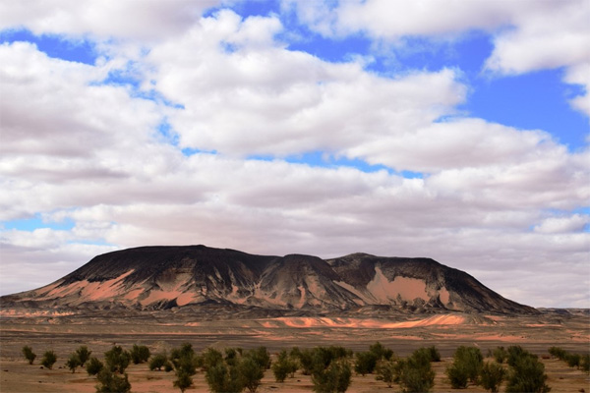

There is also the black desert which consists of small volcanic stones on the desert sand giving off quite a dark color to the landscape and the White Desert that consists of limestone formations that give the area a chalky color. If wandering is on the list of things to do in Egypt checking out these areas of this vast desert can easily be attained by booking a tour guide. It’s no wonder Egypt secured a top spot on the United States Tour Operators Association for emerging or ‘off-the-beaten-path’ destinations of 2020.
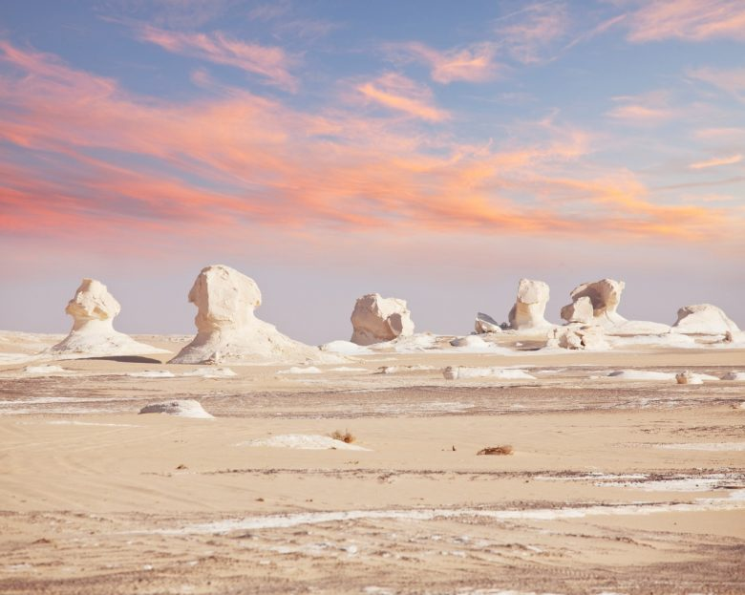

Location has made Egypt one of the top tourist destinations in the world and in 2019 reached the number one destination in all of Africa. This location gives Egypt a hot summers and mild winters allowing for tourism to happen all year around. Tourism is basically just an umbrella term with all the different tourism sectors Egypt has to offer such as cultural, archeological, heritage, recreational, beach, religious, dive, therapeutic, ecotourism, sports, golf, safari, desert, yacht, maritime, festival, and on more of the business side conference and exhibitions tourism. These specific types of tourisms could be the reason why eighty-eight percent of tourists visit for leisure whilst the remaining twelve is there on business. (Puri-Mirza, 2020) Through this variety of tourism Egypt has some unique selling experiences and features. Archeological tourism might be the most popular with the most iconic symbol being the Pyramids of Giza which are the last of the seven wonders of the Ancient world still in existence but also other palaces, tombs, and temples that have also been excavated. 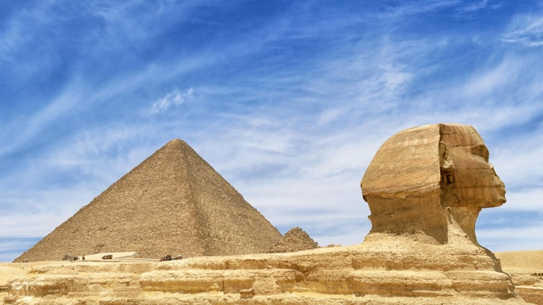
For dive tourism, the Egyptian Red Sea has the number four, five, and eight of the top dive sites in the world. Numbers four and five are Thistlegorm and the Shark & Yolanda Reef which have shipwrecks and beautiful reefs. Number eight is the Big Brother dive site and not for the faint of heart as there is a high probability for interactions with sharks. (Dive In, 2020) Regardless of where the diving occurs, it is the same water where two world dive records were broken which are the longest and deepest dives in 2015. Thousands of years ago the Greek and Roman doctors took the medical skills from the Egyptians because even at that time, they were advanced and famous for their medical practices. In an attempt to revive medical tourism, campaigns were started in order to treat certain viruses such as Hepatitis C, where tourists spend a small percentage of what they would pay in their home country to get the necessary treatment. 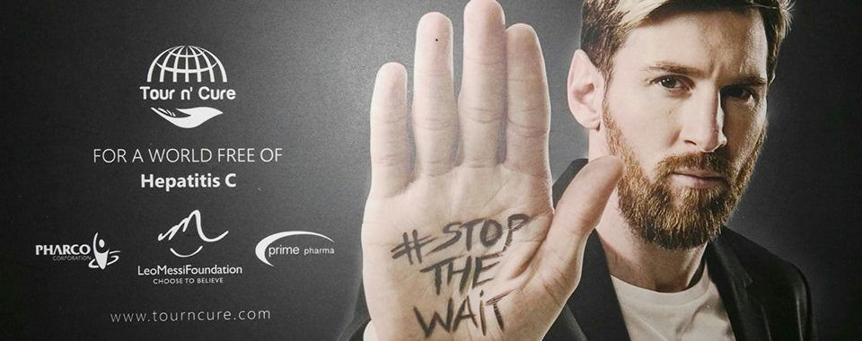
For example, instead of paying the equivalent of $176,000 for the treatment in the UK, the cost is $8,000 in Egypt. Plus, the added benefit of staying in the country for a week, touring the cities, and experiencing their hospitality. It is quite a creative way to not only treat tourists but to also positively promote Egypt. (Reda, 2018) The country is even developing ways to mix these tourism segments i one event or experience. For example, last year in August, they put together the first annual three-day festival that not only promoted ecotourism, but also culture and heritage. (Xinhau, 2019) Those are just the tip of the iceberg so to speak with the amount of attractions and experiences Egypt has to offer. They are also trying to diversify an already diverse tourism market to develop new tourism segments such as bird watching and increase conference tourism.

Whichever part of Plog’s continuum a tourist fits on whether it be wanders or repeaters, Egypt has the ability to not only amaze but also surprise tourists especially with the level of hospitality the country has. Often when tourists ask questions, they not only are ready to help but sometimes involve other locals to ensure that the correct course of action is taken allowing for almost a sense of belonging as Maslow would describe it. There have been some challenges in the past few years beginning with the Egyptian Revolution of 2011 through some other issues such as the threat of terrorism up until around 2016. This time period showed a huge decline in tourism and drastic loss in revenue. To bounce back and overcome these challenges the government has made quite a few changes. They increased security at all tourist sites as well as hotels including x-ray machines, security scanners, and checkpoints by guards. They launched the Egypt Tourism Reform Program which put together a plan as to how to develop tourism in the areas such as marketing, developing infrastructure, and more training of staff to raise an already high level of hospitality. On the marketing side, they have collaborated with international media, such as CNN, the Chinese Ctrip company, and Expedia in order to show the world that the country is a safe place with endless possibilities for new and unique experiences. They have also had social media bloggers and famous individuals come to the country to promote the country as well as increase their social media presence. This campaign, entitled ‘This Is Egypt’ can be seen on Instagram at #thisisEgypt to get an up-close and personal account of people’s current experiences in the country. 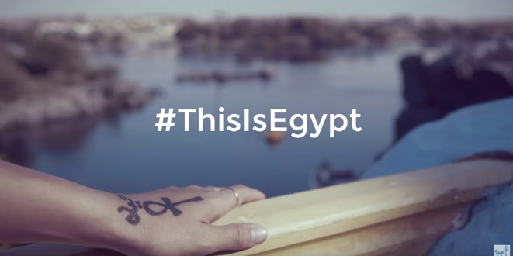
The motivation behind the campaign could be that there is smaller portion of expected arrivals of the younger generations compared to the 60% of baby boomers. (Enterprise The State Of The Nation, 2019)They also allowed for visa free entry from key source market countries such as the UK, Spain, Japan, Italy, Canada, Russia, and China. There has also been a devaluation of the Egyptian pound which has led to an increase in tourism numbers as the value to visit has increased because of the decrease in currency depending on which country tourists are coming from. (Duqeil, 2020) The government is also looking at ways to invest in their own country such as the Grand Egyptian Museum (GEM), opening in 2020, which is the largest investment they have ever made to cultural tourism ($1 billion). It will house never before seen on display artifacts from excavations such as King Tut’s and have the biggest collection of antiquities in the world. (Travel Daily News, 2020)
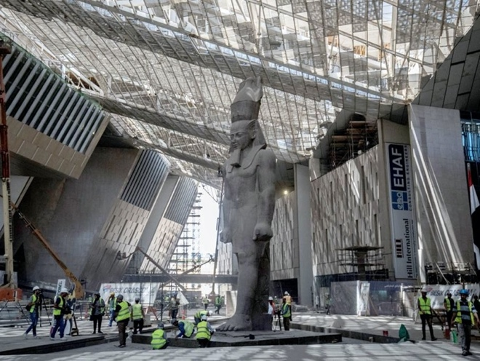

Additionally, The Arabian Travel Market (ATM) projects an almost fifty percent increase in tourists by 2022. The current impact tourism has on the country is it makes up fifteen percent of the country’s GDP from the record breaking 13.6 million tourists, which is a sixty seven percent increase from last year. (Duqeil, 2020) This increase in visitors is going to lead to increased mass tourism both individual with guides or organized in whole groups as Cohen would suggest. The country recognizes that this amount of people can be a struggle when it comes to airports and congestion especially after the GEM is opened. To alleviate this stressful situation, Egypt has opened a new international airport near the Great Pyramids called the Sphinx International Airport. 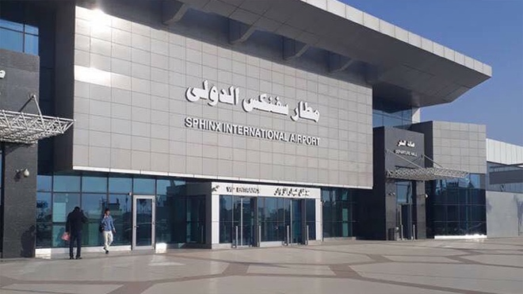
This should reduce the number of passengers going through the Cairo International Airport making it easier for them to get to their final destinations. Additionally, new flight routes or more flights per week have opened up from Canada, the UK, Russia, Italy, China, and the US. (Oxford Business Group, 2019) This is great news for future travelers as flying into the country is the best and easiest way to visit. Once in the country it is important to have a place to stay so the government has reported that by 2022 there will be an extra 48,000 new hotel rooms developed. (Fox, 2019) While building new hotels and structures the government also realizes the importance of the items already built. The Central Bank of Egypt will be investing a total of 5 billion Egyptian pounds to the restoration and renovation of hotels and tourist sites in order to preserve what is already there. (Reda, 2018) With these new hotel rooms and the current ones in existence, Egypt is working with the UNWTO to meet the standards of hotel classifications as well as developing a ‘secret shopper’ team to ensure these standards are met. This will not only create jobs for local individuals but allow for tourists to make a more informed decision when booking their next holiday. (Al-Mashat, 2018) The future of the tourism industry in Egypt is quite bright with the possible to excite and awe its visitors as well as lower the unemployment rate and enhance the economy. 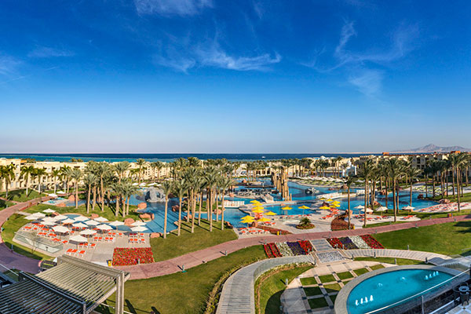

To further illustrate that Egypt is in the rejuvenation phase, as Butler’s Model would state, the World Economic Forum and Competitiveness in Travel and Tourism Report ranked Egypt as the fourth highest growth rate in regard to global performance. They have also won a few awards in 2019. The World Travel & Tourism presented them with the ‘Global Champion Award’, the World Travel Market handed them the ‘Outstanding Contribution to the Industry, and the London Stock Exchange gave them the ‘International Leadership Award’ for their global tourism contributions.
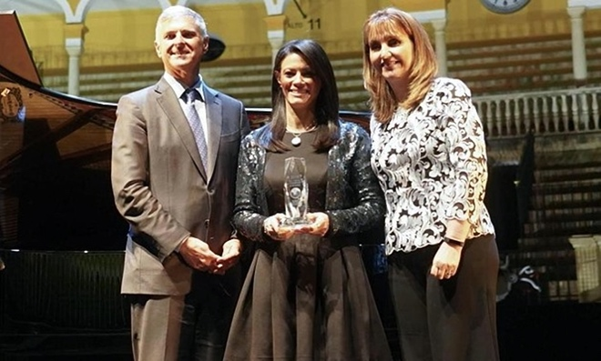

It wouldn’t be a current article in 2020 if the Coronavirus was not at least mentioned. Egypt has a lower rate of the Covid-19 compared with other countries such as the UK, Iran, or Sweden. This could be surprising considering, with the population of about 100 million people, ninety-five percent of residents live off five percent of the land. Social distancing was not as feasible as it is elsewhere, however, other steps were made to prevent the spread of the virus such as shortening prayer time, curfews, and a public gathering ban. Furthermore, the government made 5.2 billion GBP fund available to ‘combat the consequences of the virus’. It is believed that 10 months after the elimination of the virus, tourism will return back to their record breaking numbers in Egypt according to the World Tourism Organization as well as the Council for Tourism and Travel.

So, if it’s fun in the sun, view thousands of years of history, sample local and unique cuisine, scuba diving ancient ruins, or floating down the Nile in a traditional fellucca like they did in Ancient times, Egypt has the ability to appeal to every guest traveling to this incredible country. In the following pages are highlights and pictures from the major cities of Egypt to help with the planning of an Egyptian holiday!

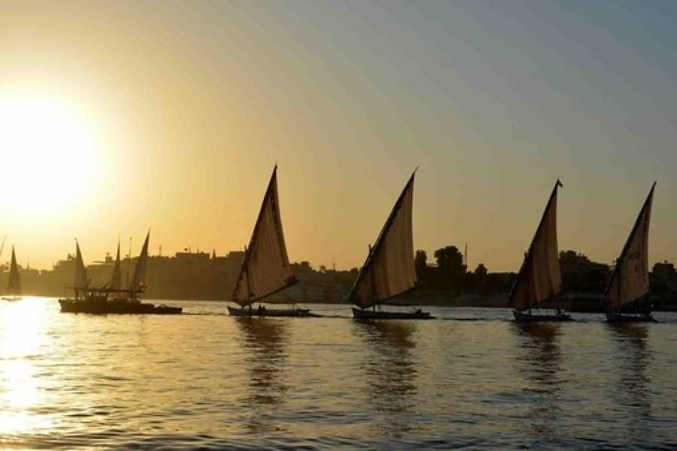

Popular Cities with Attractions -
Cairo

The Pyramids of Giza

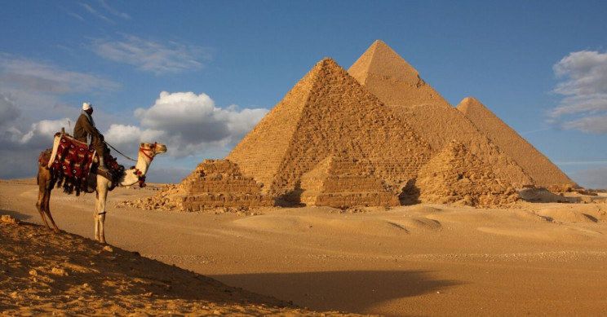
- The Great Pyramid of Khufu, his son Khafre’s Pyramid with the Sphinx, and other smaller Pyramids such as Menkaure’s
Egyptian Museum
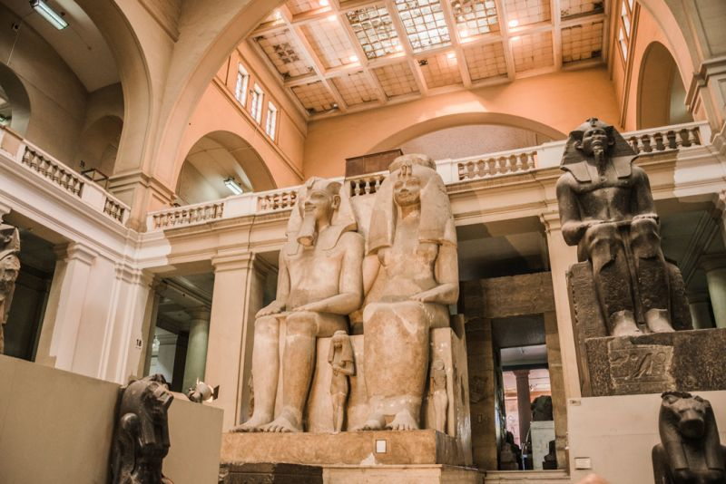
- Housing Egyptian artifacts up to 3,000 years old
Old Cairo (Coptic Cairo)
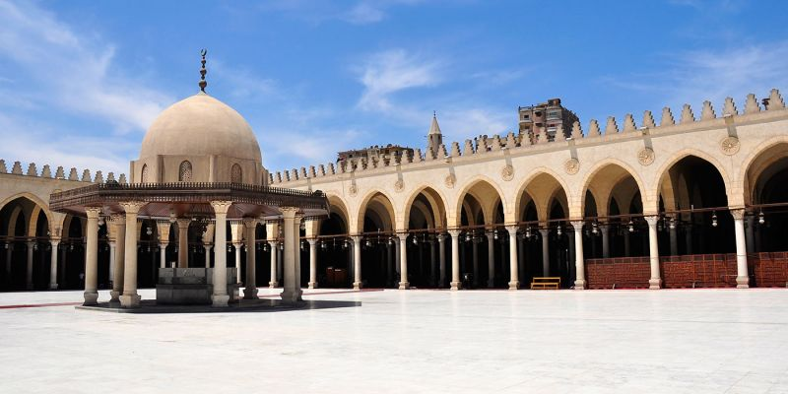
- Where three Abrahamic Religions meet

Khan el-Khalili
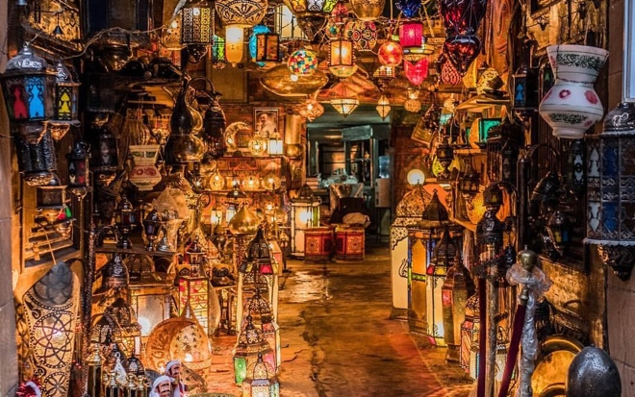
- Large bazaar with a variety of crafts and food
Nilometer
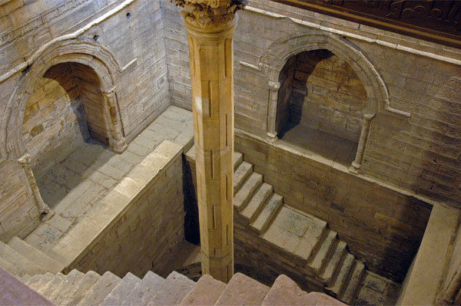
- Ancient instrument used to measure the Nile to see there was going to be flooding or drought
Alexandria
Bibliotheca Alexandrina
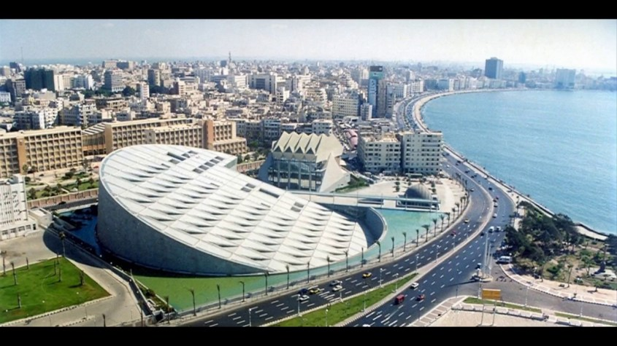
- 11 story library with 4 million books; was built to restore the lost library of Alexander the Great
Alexandria National Museum
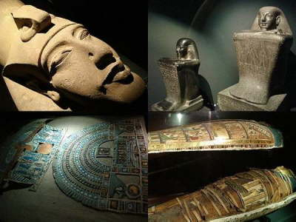

- All about the city of Alexandria

Fort Qaitbey
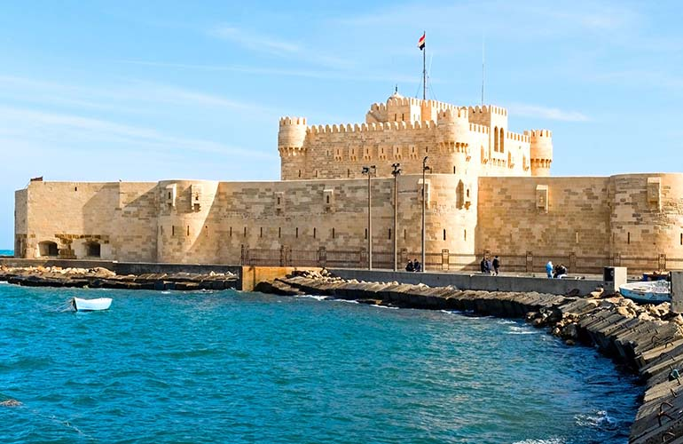

- 15th century fortress; built on what used to be one of the Ancient seven Wonders of the World – The Lighthouse of Alexandria
Montazah Gardens
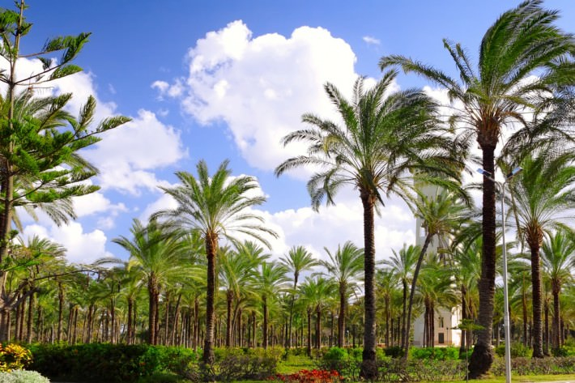

- The Royal gardens of the last Egyptian monarch, King Faruk

Main Souk Area
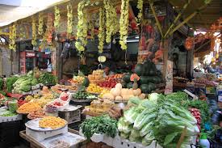

- ‘Souk’ is an open are market; has a plethora of foods, cafes, and stalls selling a variety of items
Luxor
Valley of the Kings
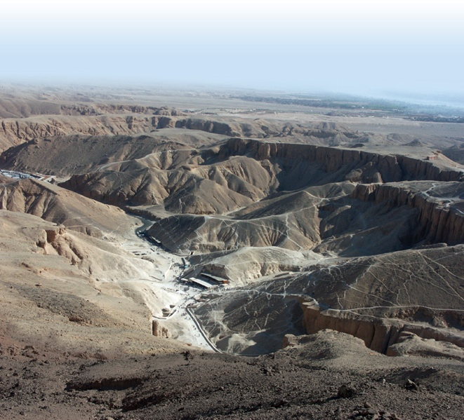

- 18th, 19th, and 20th dynasties burial grounds for pharaohs and other elites
Temple of Deir al-Bahri (Queen Hatshepsut’s Temple)
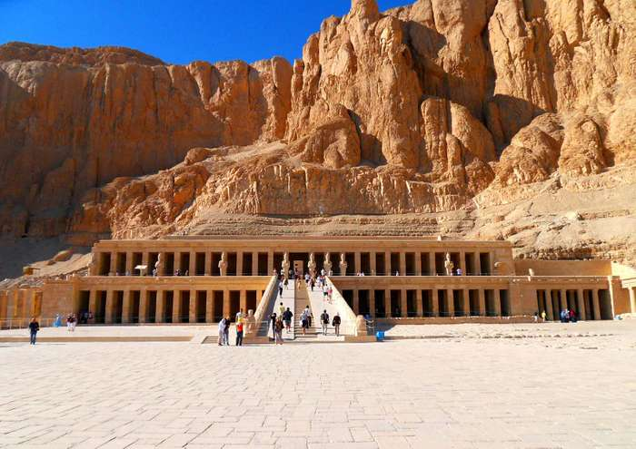

- 7th century monastery with Kings and Queen funerary temples
Felucca Ride
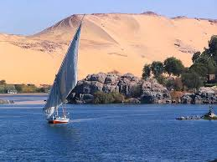

Hot Air Balloon Ride
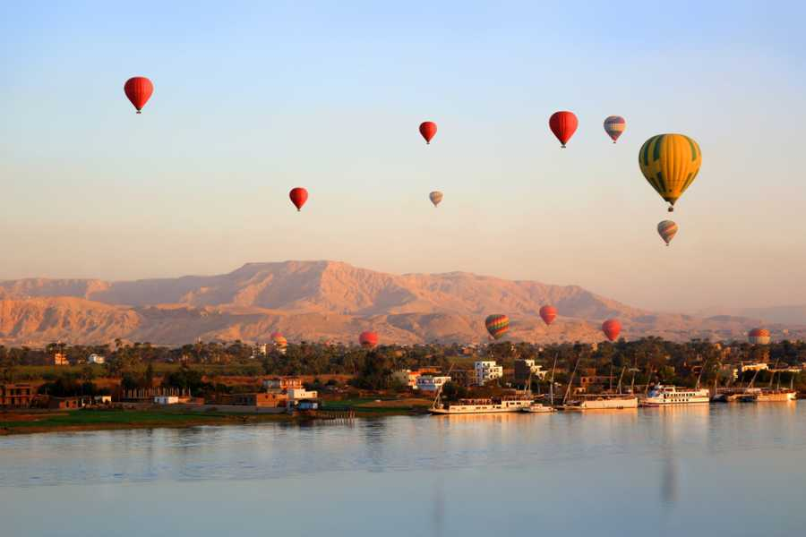

Colossi of Memnon
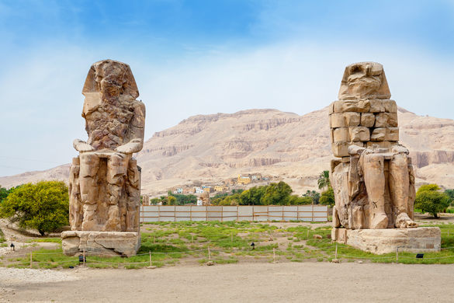

- What is left of what was built to protect Amenhotep III’s (1386-1353 BCE) mortuary

Aswan

Elephantine Island
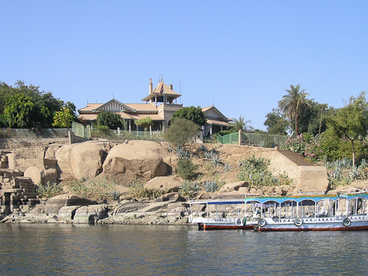

- ‘main cult center of the ram-headed god Khnum’; oldest inhibited part of Aswan
Nubian Museum
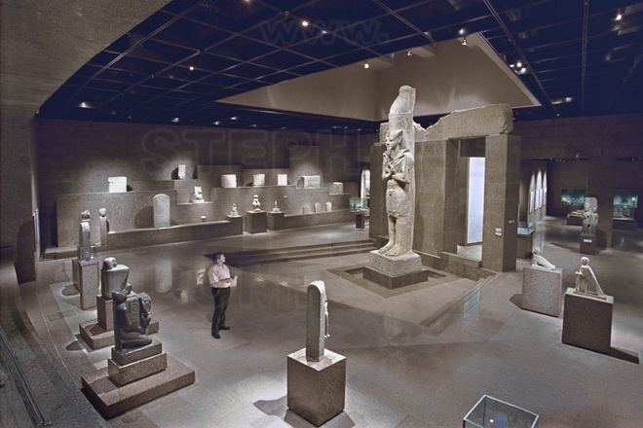

- Showcases the history and culture of one of the early Egyptian civilizations

Day Trip to Abu Simbel
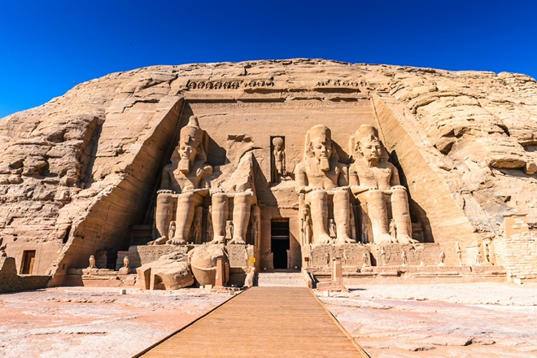

- temples built by King Ramses II

Unfinished Obelisk
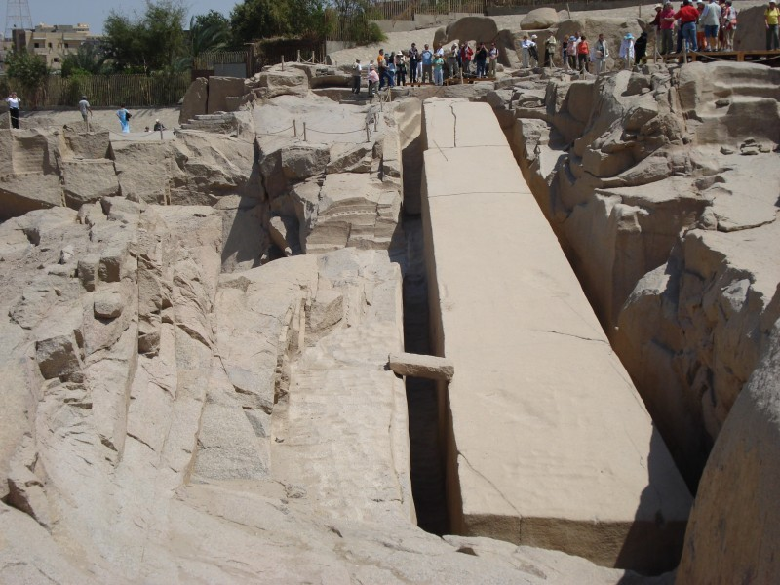

- would have been the largest obelisk in the whole world
Aswan High Damn
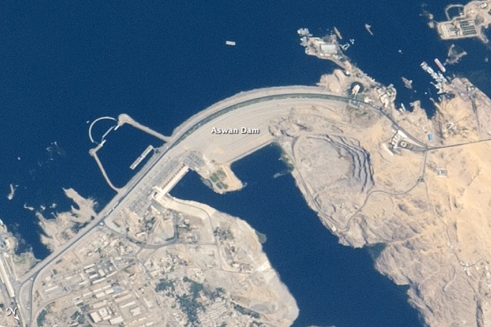

- World’s largest dam, to prevent flooding which has damaged structures of the years
Other Incredible Experiences
Scuba Dive the Red Sea
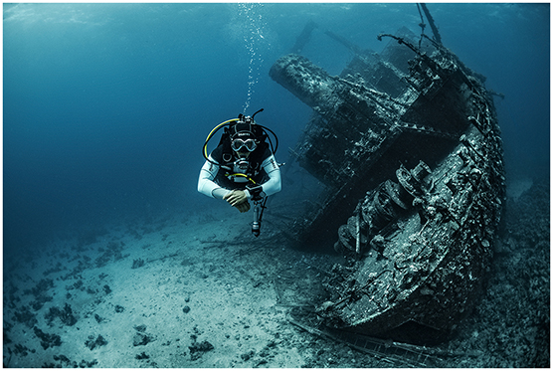

Camp in the White Desert
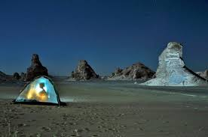

Watch Traditional Sufi Dance
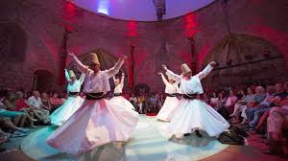
Eat at Koshary Abou Tarek
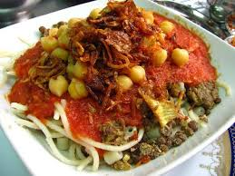

Kayak along the Nile
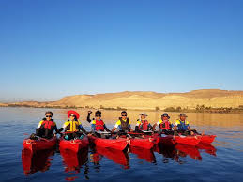

Gianaclis Vineyards
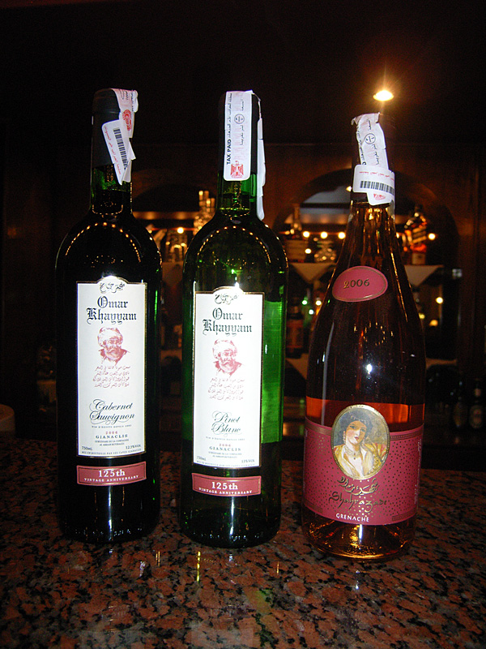

Bibliography
Aboud, T., 2009. Libyan Desert Glass: Has The Enigma Of Its Origin Been Resolved?. Physics Procedia, Volume 2, pp. 1425-1432.
Accor Live Limit, 2020. Sofitel. [Online]
Available at: https://sofitel.accor.com/united-kingdom/index.en.shtml
[Accessed 14 May 2020].
Allonsy, A., 2018. The Culture Of Egypt. [Online]
Available at: https://traveltips.usatoday.com/culture-egypt-32949.html
[Accessed 12 May 2020].
Al-Mashat, D. R., 2018. Egypt - Tourism Reform Program. [Online]
Available at: http://egypt.travel/media/2338/egypt-tourism-reform-program.pdf
[Accessed 15 May 2020].
Asharq Al-Awsat, 2019. Egypt Tourism Industry Continues Its Revival. [Online]
Available at: https://english.aawsat.com//home/article/2026196/egypt-tourism-industry-continues-its-revival
[Accessed 12 May 2020].
Assem, P., 2015. 8 Egyptian Celebrations Where Food Steals The Show. [Online]
Available at: http://www.travelstart.com.eg/blog/8-egyptian-celebrations-where-food-steals-the-show/
[Accessed 14 May 2020].
Atlas Obscura, 2020. All Places In Egypt. [Online]
Available at: https://www.atlasobscura.com/things-to-do/egypt/places
[Accessed 14 May 2020].
Cairo Airport Company, 2018. Culture & Lifestyle. [Online]
Available at: https://www.cairo-airport.com/en-us/Visit-Egypt/Culture-Lifestyle
[Accessed 12 May 2020].
Cultural Atlas, 2020. Egyptian Culture. [Online]
Available at: https://culturalatlas.sbs.com.au/egyptian-culture/egyptian-culture-religion#egyptian-culture-religion
[Accessed 15 May 2020].
Dive In, 2020. Top 10 Dive Sites In The World. [Online]
Available at: https://www.divein.com/articles/top-10-dive-sites-in-the-world/
[Accessed 15 May 2020].
Duqeil, H., 2020. Reality Of Tourism In Egypt Bet. WTTC And Government. [Online]
Available at: https://en.eipss-eg.org/reality-of-tourism-in-egypt-bet-wttc-and-government/
[Accessed 15 May 2020].
Egyptian Streets, 2018. How Ancient Egypt Introduced Ideas Of Beauty And Fashion To The World. [Online]
Available at: https://egyptianstreets.com/2018/09/29/how-ancient-egypt-introduced-ideas-of-beauty-and-fashion-to-the-world/
[Accessed 14 May 2019].
Ensher, E., 2019. Maslow's Pyramid Of Needs Meets The Pyramids Of Egypt. [Online]
Available at: https://ellenensher.com/maslows-pyramid-of-needs-meets-the-pyramids-of-egypt/
[Accessed 12 May 2020].
Enterprise The State Of The Nation, 2019. 2020 Looks Bright For Egypt's Tourism Industry. [Online]
Available at: https://enterprise.press/stories/2019/12/29/2020-looks-bright-for-egypts-tourism-industry-9208/
[Accessed 15 May 2020].
Fathy, F., 2017. Traditions And Cultures Of Egypt. [Online]
Available at: https://www.globalizationpartners.com/2017/01/17/traditions-and-cultures-of-egypt/
[Accessed 12 May 2020].
Fayed, H., 2017. 15 Things You Should Know About Egyptians. [Online]
Available at: https://www.egypttoday.com/Article/9/15384/15-things-you-should-know-about-Egyptians
[Accessed 11 May 2020].
Fox, J. T., 2019. With Egypt's Tourism Rebounding, Hotelier Government Debt Comes Due. [Online]
Available at: https://www.hotelmanagement.net/own/tourism-rebounding-egypt-s-hoteliers-must-pay-government
[Accessed 15 May 2020].
Frommer's, 2020. Architecture In Egypt. [Online]
Available at: https://www.frommers.com/destinations/egypt/in-depth/architecture
[Accessed 12 May 2020].
Kim, H., Chang, H. & Huh, C., 2020. The Relationship Between Types Of Tourist And Destination Authenticity. [Online]
Available at: https://scholarworks.umass.edu/cgi/viewcontent.cgi?article=1161&context=gradconf_hospitality
[Accessed 12 May 2020].
Litvin, S. W., 2006. Revisiting Plog's Model of Allocentricity And Psychocentricity... One More Time. Cornell Hospitality Quarterly, 47(3), pp. 245-253.
Maged, M., 2019. Egypt's Ministry Of Tourism Wins World Travel Market 2019 Award For "Outstanding Contribution To The Industry". [Online]
Available at: https://egyptindependent.com/egypts-ministry-of-tourism-wins-world-travel-market-2019-global-leaders-award-for-outstanding-contribution-to-the-industry/
[Accessed 11 May 2020].
Maged, M., 2020. Over 15 Million Tourists To Visit Egypt In 2020: WTO Economic Advisor. [Online]
Available at: https://egyptindependent.com/fifteen-million-tourists-to-visit-egypt-in-2020-wto-economic-advisor/
[Accessed 11 May 2020].
Mapscaping, 2018. Mapped: The 6 Cradles Of Civilization. [Online]
Available at: https://mapscaping.com/blogs/geo-candy/mapped-the-6-cradles-of-civilization
[Accessed 12 May 2020].
Mark, J. J., 2016. Ancient Egyptian Architecture. [Online]
Available at: https://www.ancient.eu/Egyptian_Architecture/
[Accessed 12 May 2020].
Mark, J. J., 2017. Trade In Ancient Egypt. [Online]
Available at: https://www.ancient.eu/article/1079/trade-in-ancient-egypt/
[Accessed 14 May 2020].
Michaelson, R., 2020. Egypt: Rate Of Coronavirus Cases 'Likely To Be Higher Than Figures Suggest'. [Online]
Available at: https://www.theguardian.com/world/2020/mar/15/egypt-rate-coronavirus-cases-higher-than-figures-suggest
[Accessed 10 May 2020].
Mohamed, H., 2020. Egypt's Tourism Sector Hits $13.03B; Highest Revenues Ever. [Online]
Available at: https://www.egypttoday.com/Article/3/83207/Egypt-s-tourism-sector-hits-13-03B-highest-revenues-ever
[Accessed 12 May 2020].
Neagu, F.-S., 2018. The Influence of Geopolitical Events On Tourism In Egypt. Proceedings Of The International Conference On Business Excellence, 12(1), pp. 662-670.
Osama, O., 2017. Alexandria: Top Religious Tourism Destination. [Online]
Available at: https://www.egypttoday.com/Article/9/33237/Alexandria-top-religious-tourism-destination
[Accessed 12 May 2020].
Oxford Business Group, 2019. New Infrastructure And Diversified Source Markets Make Egyptian Tourism Resilient. [Online]
Available at: https://oxfordbusinessgroup.com/overview/resilient-and-rising-new-infrastructure-and-diversified-source-markets-breathe-life-tourism-sector
[Accessed 15 May 2020].
Pavelka, J., 2013. Taking Tourism Theory To Practice. A Journal Of Leisure Studies And Reccreation Education, Volume 2, pp. 42-48.
Puri-Mirza, A., 2020. Tourism Industry Egypt - Statistics & Facts. [Online]
Available at: https://www.statista.com/topics/5767/tourism-industry-of-the-egypt/
[Accessed 14 May 2020].
Reda, L., 2018. Bringing Tourists Back: A Look At Initiatives And Policies Launched. [Online]
Available at: https://www.egypttoday.com/Article/3/44535/Bringing-Tourists-Back-A-look-at-initiatives-and-policies-launched
[Accessed 15 May 2020].
Rosenthal, V., 2018. Hilton Adds Another Leg to Egyptian Hotel Expansion Strategy. [Online]
Available at: https://www.hotelmanagement.net/development/hilton-adds-another-leg-to-egyptian-hotel-expansion-strategy
[Accessed 10 May 2020].
SAFE (Saving Antiquities For Everyone), 2018. Cultural Heritage At Risk: Egypt. [Online]
Available at: https://smarthistory.org/cultural-heritage-egypt/
[Accessed 11 May 2020].
Saleh, H., 2018. Tourists Return To Egypt As Prices Fall And Security Improves. [Online]
Available at: https://www.ft.com/content/7553fce6-5451-11e8-b3ee-41e0209208ec
[Accessed 10 May 2020].
Sattin, A., 2020. Everything We Know About Cairo's New Grand Egyptian Museum. [Online]
Available at: https://www.cntraveler.com/story/grand-egyptian-museum-cairo-everything-we-know
[Accessed 9 May 2020].
State Information Service, 2016. Tourism In Egypt. [Online]
Available at: https://www.sis.gov.eg/Story/1042/Tourism-in-Egypt?lang=en-us
[Accessed 13 May 2020].
Transition Report 2019-20 Better Governance, Better Ecoonomics, 2020. Country Assessments: Egypt. [Online]
Available at: http://www.ebrd.com/documents/oce/transition-report-201920-egypt.pdf
[Accessed 11 May 2020].
Travel Daily News, 2020. Tourism Numbers In Egypt Expected To Rise Significantly In Coming Years. [Online]
Available at: https://www.traveldailynews.com/post/tourism-numbers-in-egypt-expected-to-rise-significantly-in-coming-years
[Accessed 15 May 2020].
Travelling Intellect, 2019. What Is Self-Actualisation?. [Online]
Available at: https://travellingintellect.com/2019/04/25/what-is-self-actualisation/
[Accessed 12 May 2020].
Tyldesley, D. J., 2011. Ancient Egypt And The Modern World. [Online]
Available at: http://www.bbc.co.uk/history/ancient/egyptians/egypt_importance_01.shtml
[Accessed 12 May 2020].
Xinhau, 2019. Egypt Launches Environmental Festival To Promote Ecotourism. [Online]
Available at: http://www.xinhuanet.com/english/2019-08/23/c_138330216.htm
[Accessed 15 May 2020].
Yogerst, J., 2020. Food In Egypt: 13 Delicious Dishes And Drinks You Shouldn't Miss. [Online]
Available at: https://edition.cnn.com/travel/article/egypt-food-and-drink/index.html
[Accessed 14 May 2020].

Picture References
Atlas Obscura. 2020. The Singing Statues Of Ancient Egypt. [online] Available at: <https://www.atlasobscura.com/places/colossi-of-memnon> [Accessed 15 May 2020].
Cleopatra Egypt Tours. 2020. Citadel Of Qaitbey. [online] Available at: <https://www.cleopatraegypttours.com/travel-guide/alexandria-attractions/fort-qaitbey/> [Accessed 15 May 2020].
Compoint, S., 2020. Nubian Museum. [online] Stephanecompoint.com. Available at: <http://www.stephanecompoint.com/41,,,29959,en_US.html> [Accessed 15 May 2020].
CTV Egypt News. 2019. Alexandria Library - Bibliotheca Alexandrina - CTV Egypt News. [online] Available at: <https://www.ctv-egypt.com/articles/alexandria-library-bibliotheca-alexandrina/> [Accessed 15 May 2020].
Earthobservatory.nasa.gov. 2020. Aswan High Dam. [online] Available at: <https://earthobservatory.nasa.gov/images/85992/aswan-high-dam> [Accessed 15 May 2020].
El Sharkawy, N., 2020. Egyptian Falafel, The Best Recipe Out There (T'aamiya) - Sugar & Garlic. [online] Sugar & Garlic. Available at: <https://www.sugarandgarlic.com/egyptian-falafel-best-recipe-taamiya/> [Accessed 15 May 2020].
El Wardani, L., 2019. Exploring Egypt: The Black And White Desert - News - Travel. [online] Ahram Online. Available at: <http://english.ahram.org.eg/NewsContent/8/27/340734/Travel/News/Exploring-Egypt-The-Black-and-White-Desert-.aspx> [Accessed 15 May 2020].
Egypt Deaf Travel. 2015. Alexandria National Museum. [online] Available at: <http://egyptdeaftravel.com/?page_id=698> [Accessed 15 May 2020].
Egyptian Monuments. 2020. Elephantine Island. [online] Available at: <https://egyptsites.wordpress.com/2009/01/31/elephantine-island/> [Accessed 15 May 2020].
EMO TOURS EGYPT. 2020. Short Felucca Boat Trips In Luxor - Book Egypt Cheap Tours,Sightseeing Trips,Activities,Best Things To Do. [online] Available at: <https://www.emotoursegypt.com/en/activity/40579/short-felucca-boat-trips-in-luxor> [Accessed 15 May 2020].
Encyclopedia Britannica. 2020. Dayr Al-Baḥrī | Archaeological Site, Egypt. [online] Available at: <https://www.britannica.com/place/Dayr-al-Bahri> [Accessed 15 May 2020].
English, T., 2020. The Engineering Behind The Great Pyramids Of Giza. [online] Interestingengineering.com. Available at: <https://interestingengineering.com/the-engineering-behind-the-great-pyramids-of-giza> [Accessed 15 May 2020].
En.wikipedia.org. 2020. Egyptian Wine. [online] Available at: <https://en.wikipedia.org/wiki/Egyptian_wine> [Accessed 15 May 2020].
Fibre2fashion.com. 2009. Fashion Trend In Egypt | Influence Of Egypt Attire In The Modern Fashion | Fibre2fashion. [online] Available at: <https://www.fibre2fashion.com/industry-article/3863/contemporary-fashion-from-the-land-of-pharaohs> [Accessed 15 May 2020].
Gebril, M., 2020. Adventurous Shopping In Khan El Khalili, Egypt’S Oldest Bazaar. [online] Osiris Tours - Luxury Travel | Private Guided Tours. Available at: <https://www.osiristours.com/adventurous-shopping-khan-el-khalili-egypts-oldest-bazaar/> [Accessed 15 May 2020].
Geography.name. 2020. Sinai Peninsula. [online] Available at: <https://geography.name/sinai-peninsula/> [Accessed 15 May 2020].
James, R., 2017. Facts You Never Knew About The Pyramids Of Giza. [online] Architectural Digest. Available at: <https://www.architecturaldigest.com/story/facts-never-knew-about-pyramids-of-giza> [Accessed 15 May 2020].
Journey To Egypt. 2020. Luxor Air Balloon Ride - Journey To Egypt. [online] Available at: <https://www.journeytoegypt.com/en/activity/135009/luxor-air-balloon-ride> [Accessed 15 May 2020].
Mada Masr. 2020. Lionel Messi Arrives In Egypt For Medical Tourism Campaign. [online] Available at: <https://madamasr.com/en/2017/02/21/feature/politics/lionel-messi-arrives-in-egypt-to-promote-awareness-of-hepatitis-c-in-medical-tourism-campaign/> [Accessed 15 May 2020].
Mahallati, A., 2020. Montazah Palace And Royal Gardens [Simply Amazing]. [online] Egypt Tours Plus. Available at: <https://www.egypttoursplus.com/montazah-palace/> [Accessed 15 May 2020].
Masr, M., 2017. Lionel Messi Arrives In Egypt For Medical Tourism Campaign. [online] Mada Masr. Available at: <https://madamasr.com/en/2017/02/21/feature/politics/lionel-messi-arrives-in-egypt-to-promote-awareness-of-hepatitis-c-in-medical-tourism-campaign/> [Accessed 15 May 2020].
Masriya, A., 2016. #Thisisegypt Campaign Prompts Mixed Reactions As Egypt Struggles To Attract Tourists | Egyptian Streets. [online] Egyptian Streets. Available at: <https://egyptianstreets.com/2016/01/02/thisisegypt-campaign-prompts-mixed-reactions-as-egypt-struggles-to-attract-tourists/> [Accessed 15 May 2020].
Memphistours.co.uk. 2020. The Egyptian Museum In Cairo. [online] Available at: <https://www.memphistours.co.uk/Egypt/Egypt-Travel-Guide/Cairo-Attractions/wiki/The-Egyptian-Museum-in-cairo> [Accessed 15 May 2020].
Patowary, K., 2020. The Mysterious Libyan Desert Glass. [online] Amusing Planet. Available at: <https://www.amusingplanet.com/2015/04/the-mysterious-libyan-desert-glass.html> [Accessed 15 May 2020].
Safareya. 2020. Sphinx Airport Receives Its First International Charter Flight From Jordan. [online] Available at: <http://www.safareya.com/En/Travel/AtoZ/Sphinx-Airport-Receives-First-International-Charter-Flight-from-Jordan> [Accessed 15 May 2020].
Sameer, M., 2018. Egypt's Hidden Treasures "White Desert". [online] Travelstart Egypt's Travel Blog. Available at: <http://www.travelstart.com.eg/blog/white-desert-egypt-hidden-treasures/> [Accessed 15 May 2020].
Saratprojesi.com. 2018. A Salvage Operation That Inspired The World: Abu Simbel And The World Heritage. [online] Available at: <https://www.saratprojesi.com/en/resources/sarats-features/a-salvage-operation-that-inspired-the-world-abu-simbel-and-the-world-heritage> [Accessed 15 May 2020].
Streets, E., 2020. Egypt Receives 'Global Champion Award' For Reforming Its Tourism Industry | Egyptian Streets. [online] Egyptian Streets. Available at: <https://egyptianstreets.com/2019/04/04/egypt-receives-global-champion-award-for-reforming-its-tourism-industry/> [Accessed 15 May 2020].
Streets, E., 2020. In Pictures: Why You Should Visit Egypt's White Desert This Year | Egyptian Streets. [online] Egyptian Streets. Available at: <https://egyptianstreets.com/2019/04/08/in-pictures-why-you-should-visit-egypts-white-desert-this-year/> [Accessed 15 May 2020].
Tradearabia.com. 2020. Rixos Plans Three New Hotels In Egypt. [online] Available at: <http://www.tradearabia.com/news/TTN_353796.html> [Accessed 15 May 2020].
Traditions1, A., 2020. Egyptian Culture Rich Cultural Egyptian Television And Film Industry Arabic Music Contradiction. [online] Facts About Ancient Egyptians. Available at: <https://ancientegyptianfacts.com/ancient-egyptian-culture-and-traditions1.html> [Accessed 15 May 2020].
Tripadvisor. 2020. KOSHARY ABOU TAREK, Cairo - Updated 2020 Restaurant Reviews, Photos & Phone Number - Tripadvisor. [online] Available at: <https://www.tripadvisor.co.uk/Restaurant_Review-g294201-d1508799-Reviews-Koshary_Abou_Tarek-Cairo_Cairo_Governorate.html> [Accessed 15 May 2020].
Tripadvisor. 2020. Nile Kayak Club (Cairo) - 2020 All You Need To Know Before You Go (With Photos) - Cairo, Egypt | Tripadvisor. [online] Available at: <https://www.tripadvisor.co.uk/Attraction_Review-g294201-d10685925-Reviews-Nile_Kayak_Club-Cairo_Cairo_Governorate.html> [Accessed 15 May 2020].
Vuckovic, P., 2020. Scuba Diving Adventure - Red Sea/Egypt :: Predrag Vuckovic, Extreme Photographer. [online] http://www.extreme-photographer.com/. Available at: <http://www.extreme-photographer.com/en/news-blog/scuba-diving-adventure-red-sea-egypt-338.html> [Accessed 15 May 2020].
World Archaeology. 2020. The Valley Of The Kings Revisited - World Archaeology. [online] Available at: <https://www.world-archaeology.com/features/the-valley-of-the-kings-revisited/> [Accessed 15 May 2020].
World Atlas. 2020. [online] Available at: <https://www.worldatlas.com/webimage/countrys/africa/eg.htm> [Accessed 15 May 2020].
Yalav-Heckeroth, F., 2020. Whirling Dervishes Of Istanbul: When And Where To Find Them. [online] Culture Trip. Available at: <https://theculturetrip.com/europe/turkey/articles/whirling-dervishes-of-istanbul-when-and-where-to-find-them/> [Accessed 15 May 2020].

