Module: Food & Beverage Operations
Module code: BMIH4002
Name: Anisha Suleman Anwar
Lecturer: Jaliya De Silva

Part 1: Restaurant Concept, target audience, and the reasoning behind your menu choices

The proposed restaurant concept is a contemporary Mediterranean fusion establishment, intended to provide a distinctive culinary encounter for patrons of Hotel Trinity. The eatery will feature a serene and cosy atmosphere, characterised by subdued illumination, inviting hues, and an exposed culinary workspace. The eatery is poised to provide a remarkable dining encounter for both the hotel patrons and nearby inhabitants.

The intended demographic for this dining establishment comprises individuals who appreciate robust and savoury cuisine, emphasising the use of recently sourced components and distinctive flavour pairings. The objective is to provide a heterogeneous selection of cuisine featuring a range of options to accommodate varying palates and nutritional needs. The menu will be curated to incorporate alternatives for vegetarians and individuals with gluten intolerance, guaranteeing that all patrons will have a selection to relish.

The Mediterranean culinary tradition is characterised by its amalgamation of diverse cultural influences, rendering it a distinctive and adaptable cuisine. The restaurant's menu will comprise a blend of traditional Mediterranean cuisine with contemporary adaptations, alongside innovative culinary inventions that highlight the establishment's fusion gastronomy. The culinary preparations will be made utilising the most recently harvested components and current agricultural yields, thereby guaranteeing that the tastes are vivid and genuine.

The primary objective of our menu selection is to provide patrons with an unparalleled gastronomic encounter that is exclusive to our establishment. The menu will showcase distinctive culinary offerings, including lamb kofta complemented by tahini sauce and roasted beetroot hummus, chicken shawarma accompanied by garlic yogurt and pickled vegetables, and a seafood paella enhanced with saffron and lemon aioli. The cuisine will be showcased in a contemporary and aesthetic manner, emphasising both gustatory and visual aspects.

To conclude, our contemporary Mediterranean fusion restaurant idea is designed to serve patrons seeking an exceptional and unforgettable culinary encounter. The menu will exhibit diversity, emphasising the use of fresh ingredients, distinctive flavour pairings, and aesthetically pleasing presentation. The establishment's atmosphere is designed to be cosy and informal, fostering a welcoming and comfortable environment for patrons.

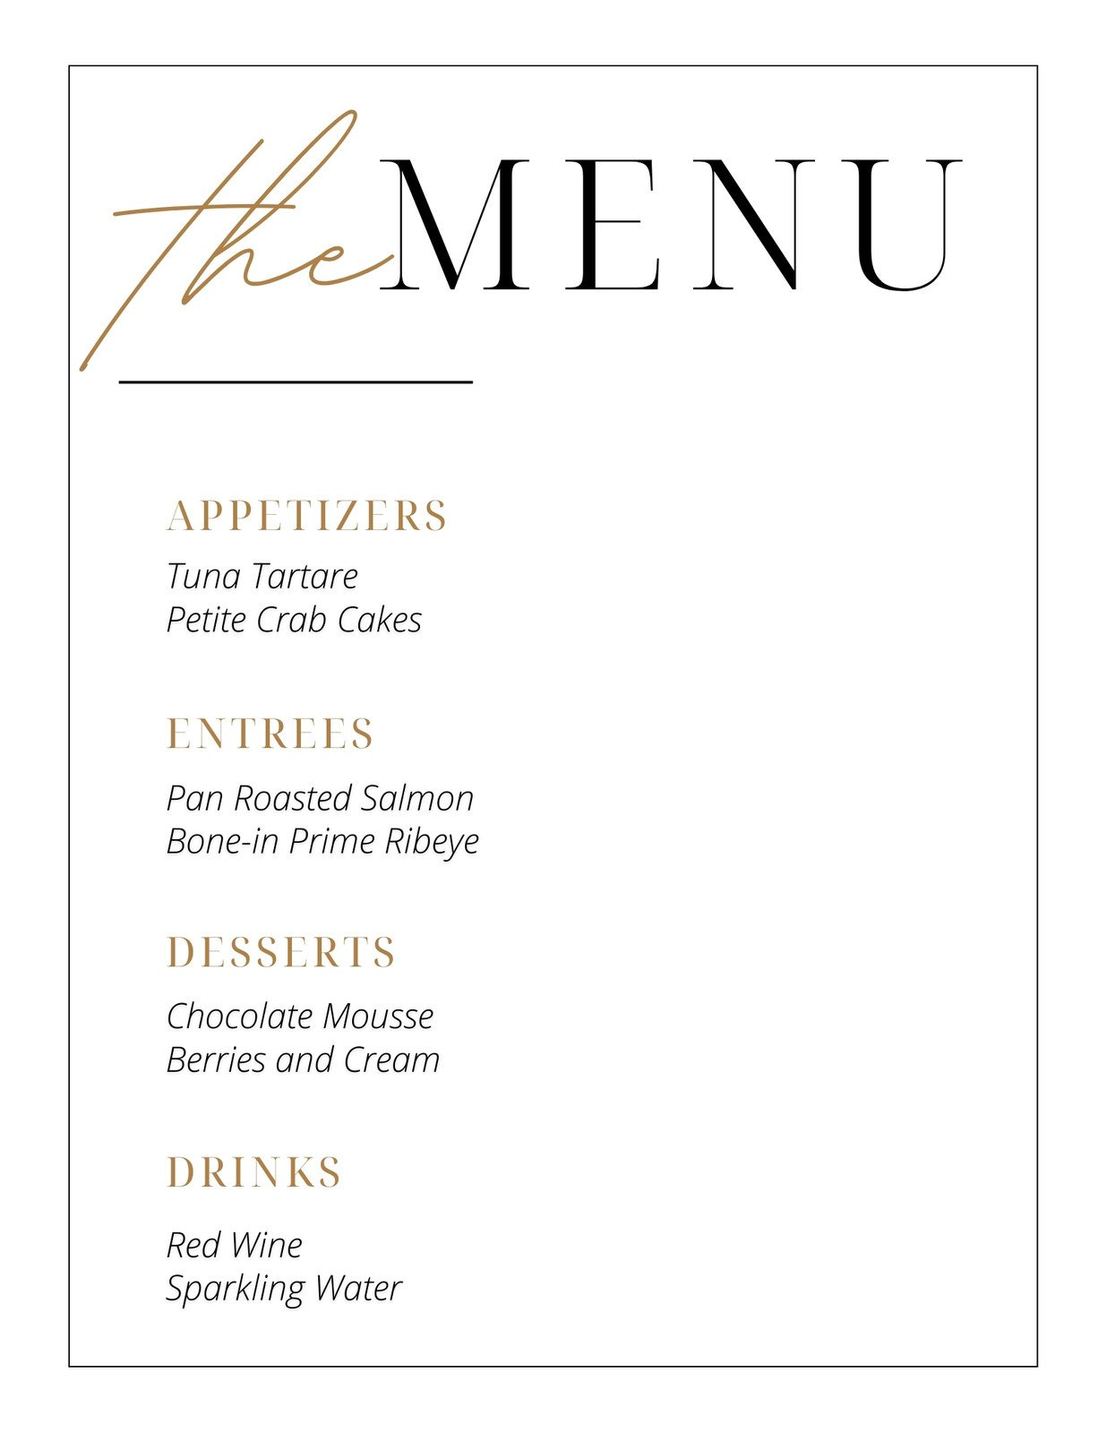
APPETISERS
Beef Carpaccio with Soy Sauce Dressing……………………………………………. £8.00
Juicy tender flavourful beef pieces with homemade soy sauce dressing leave a mouth-watering taste. (Halal)
Prawn and Chive Dumplings………………………………………………………… £9.00
Handpicked succulent prawns with rich chive dumplings perfect for seafood lovers.

ENTREES
Slow-Roasted Duck Breast with Five Spice and Orange Glaze…………………….. £15.00
Pink roasted duck breast fused with Indian spices and mums’ special homemade orange glaze. (halal)
Sesame Crusted Salmon with Wasabi Mash………………………………………… £12.00
Oven-baked salmon filet with a crispy sesame crust paired with light fluffy textured mash. (halal)
Stir-Fried Mixed Vegetables with Cashew Nuts…………………………………….. £10.00
Packed with colourful vegetables infused with Thai flavours and supreme quality nuts. (Veg)
Pumpkin and Sweet Potato Curry…………………………………………………….£10.00
A perfect blend of sweet and savoury spices with juicy pumpkin flavours with a touch of Indian spices. (Veg)

DESSERTS
Matcha Green Tea Cheesecake………………………………………………………. £7.00
A unique creamy rich cheesecake infused with Japanese matcha green tea for tea lovers (Gluten-free)
British Sticky Toffee Pudding with Caramel Sauce…………………………………. £6.00
A popular delicious caramel toffee-infused pudding with mums’ homemade sweet caramel sauce

DRINKS
Cocktails………………………………………………………………………………£5.00
A variety of cocktails is available please ask staff members about availability.
Mocktails……………………………………………………………………………... £4.50
Mouth-watering Alcohol-free mocktails are available please ask staff members about availability.
References:
Gray, R. (2022) The secret tricks hidden inside restaurant menus, BBC Future. Available at: https://www.bbc.com/future/article/20171120-the-secret-tricks-hidden-inside-restaurant-menus (Accessed: 4th June 2023).
How to create a menu: The Complete Guide (no date) UK Shop. Available at: https://www.allianceonline.co.uk/blog/2016/11/how-to-design-a-menu-that-does-your-dishes-justice/ (Accessed: 2nd June 2023).
How to create a restaurant menu (and optimize it for takeout and delivery) BentoBox. Available at: https://www.getbento.com/blog/how-to-create-a-restaurant-menu-optimize-it-for-takeout-and-delivery/ (Accessed: 2nd June 2023).
How to make a restaurant menu from scratch in 10 steps. Available at: https://pos.toasttab.com/blog/on-the-line/how-to-make-a-restaurant-menu (Accessed: 3rd June 2023).
Pat (2023) What makes Mediterranean food a worldwide craving?, Miss Pickle 1971. Available at: https://misspickle.com.au/what-makes-mediterranean-food-a-worldwide-craving/ (Accessed: 4th June 2023).
Rodriguez, D. and Daniela Rodriguez Always interested in learning more. Daniela loves languages (2021) What is Mediterranean cuisine?, Arctic Gardens. Available at: https://www.arcticgardens.ca/blog/what-is-mediterranean-cuisine/ (Accessed: 4th June 2023).
Simon (2023) Mediterranean cuisine : Everything you need to know, Mediterranean unique food selection. Available at: https://mmmediterranean.com/mediterranean-cuisine/ (Accessed: 5th June 2023).
Target market of your restaurant (no date) RestoHub. Available at: https://www.restohub.org/gb/operations/planning/defining-your-restaurant-target-market/ (Accessed: 3rd June 2023).
Thacker, K. (no date) What is target market analysis for restaurants?, Backbar Academy. Available at: https://academy.getbackbar.com/what-is-target-market-analysis-for-restaurants (Accessed: 3rd June 2023).
The factors that influence our food choices (no date) Eufic. Available at: https://www.eufic.org/en/healthy-living/article/the-determinants-of-food-choice (Accessed: 3rd June 2023).

