
Investigating the impact of automation process on quality control in apparel manufacturing: The case of YOUNGONE footwear production company in UK.

Dissertation
Name: Mehedi Hasan
Student ID: 2427252

Submission Date: 3/2/2026

Abstract
Aim: This research aims to investigate the impact of the automation process on the quality control of YOUNGONE's shoes in the UK.
Methodology: This study applies positivism research philosophy due to the researcher has intention to apply quantitative method. As a result, the researcher also applies deductive approach to focus on scientific method. In this context, the researcher collects data from 100 respondents through closed-hand questionnaire. Even the researcher also uses frequency analysis and descriptive statistics analysis through SPSS.
Findings: This study finds out that majority of the respondents has idea regarding automation approach including AI technology, RPA. Even the researcher also finds out that respondents believe that automation improves quality of products.

Keywords: Automation, Quality control, manufacturing, footwear, YOUNGONE, UK.

Acknowledgement
I am very much thankful to my lord due to I have completed the task on time.
I am also thankful to supervisor because of I found several problems in my dissertation. However, I have solved the issues with the help of my supervisor.
I also need to acknowledge the support of all the respondents who participated in this survey.

Table of Contents
Abstract 2
Acknowledgement 3
List of figures 7
Abbreviations 7
Chapter 1: Introduction 8
1.1 Topic introduction 8
1.2 Overview of organisation 8
1.3 Rationality of the study 9
1.4 Research aim and objectives 11
1.4.1 Research aim 11
1.4.2 Research objectives 11
1.4.3 Research questions 11
1.5 Research significance 11
1.6 Applied research method 12
1.7 Dissertation structure 12
1.8 Summary 13
Chapter 2: Literature review 14
2.1 Introduction to Automation in Apparel Manufacturing 14
2.1.1 Definition of Automation 14
2.1.2 Role of Automation in Apparel Manufacturing 15
2.2 Theoretical Framework 16
2.2.1 Automation Theory 16
2.2.2 Technology Acceptance Model (TAM) 16
2.2.3 Diffusion of Innovations Theory 17
2.2.4 Quality Control Theories 18
2.2.5 Total Quality Management (TQM) 18
2.2.6 Six Sigma 19
2.3 Types of Automation in Apparel Manufacturing 19
2.3.1 Robotic Process Automation (RPA) 19
2.3.2 Automated Cutting Systems 20
2.3.3 Automated Sewing 20
2.3.4 AI and Smart Inspections 20
2.4 Empirical review 21
2.4.1 Automated Cutting Systems improve quality control in apparel manufacturing 21
2.4.2 Robotic Process Automation (RPA) improves quality control in apparel manufacturing 22
2.4.3 Automated Sewing improves quality control in apparel manufacturing 23
2.4.4 AI and Smart Inspections improve quality control in apparel manufacturing 24
2.5 Research gap 25
2.6 Summary 25
Chapter 3: Research methodology 27
3.1 Research philosophy 27
3.2 Research approach 28
3.3 Research strategy 28
3.4 Research choice 29
3.5 Time horizon 30
3.6 Research technique 30
3.7 Research ethics 34
Chapter 4: Findings, analysis and discussion 36
4.1 Introduction 36
4.2 Findings and analysis 36
4.3 Discussion 56
4.4 Conclusion 65
Chapter 5: Conclusion and recommendations 66
5.1 Introduction 66
5.2 Justification of achieving research objectives 66
5.3 Recommendations 67
5.4 Further study 68
5.5 Limitations of the study 69
5.6 Summary 69
Reference list 70
Appendix 81
Literature review (Mind-map) 81
Questionnaire 82
Raw data 85
Data analysis (SPSS) 85

List of figures
Figure 1: Logo of YOUNGONE 9
Figure 2: Automative quality inspection AI System Market size 2025 to 2035 10
Figure 3: Dissertation structure 13
Figure 4: Automation in manufacturing 15
Figure 5: TAM Model 17

Abbreviations
AI : Artificial Intelligence
QC : Quality control
RPA : Robotic Process Automation
TAM : Technology Acceptance Model

Chapter 1: Introduction

1.1 Topic introduction
Apparel and footwear manufacturing industry has been revolutionized radically in the past two decades (Bottani, Matteo & Monferdini, 2025). It is the rapid technological progress that fuels international competition in particular, competition that has intensified (Marslev & Whitfield, 2025). Meanwhile, Hammad et al. (2025) addressed that the forces are being exerted on manufacturers to quickly produce high quality products, however, the organisation needs to be cost effective, and production is so tight, compliance is tipped heavily against global quality standards. Rana (2025) pointed out that, in response to these challenges, automation has grown as a strategy. These manufacturing activities can be more productive as the accuracy and quality control is improved through automation.
Nayak, Quang and Pal (2025) stated that footwear manufacturing has been labour-intensive because the manufacturing process involves manual cutting, assembling, stitching and inspection. When manufacturing, the part can be set up manually and provides freedom but it also increases variance. Manual quality control is found to be ineffective if demand for higher categories of position and uniformity in global brands are increasing (Rahaman, Khan and Pranta, 2025). Enterprises are embracing automation technologies including RPAs, automated cutting and sewing mechanisms as well as AI-driven inspection tools to address such challenges.
Papavasileiou, Michalos and Makris (2024) stated that in footwear manufacturing, quality control is particularly important because even small defects such as stitching, bonding and material alignment can impact on things such as production durability, consumer satisfaction etc. Mansour et al. (2025) discuss how automated quality control, data-driven monitoring, and standardized inspection routines can lead to real time defect detection. In the global shoe market, automation is playing a key role in retaining competitiveness.

1.2 Overview of organisation
YOUNGONE, a leading multinational company known worldwide for best quality production in apparel footwear and outdoor category. Company of South Korean origin that has more than 5,000 outlets across Asia and Europe (Oishe, 2025). The business provides footwear and clothing to major international brands including Nike, Adidas, Puma and The North Face. Its operations are characterized by large-scale production, export-oriented manufacturing and strict adherence to international quality standards, sustainability practices (Oishe, 2025).

Figure 1: Logo of YOUNGONE
Source: (IANS, 2019)
The company is part of the UK’s global supply chain. Efforts are made to reduce high value footwear operations, as well as quality control, insurance and coordination with European brand partners. Oishe (2025) said that the YOUNGONE has been heavily investing in automation in its production facilities for many years. It's also full of automated cutting machines, robots handling material, programmable sewing systems and the like.
The implementation of automation is paramount to the company as it encompasses it with prevailing quality methodologies such as TQM (Total Quality Management) and Six Sigma. Automated system allows the company to store digital data and trace down the cause of error. But it also brings with it challenges for the company to adapt to automation. The drawback lies in heavy capital costs, skilled technical manpower requirement and periodic maintenance of the system etc.

1.3 Rationality of the study
The motivation for this work is both academic as well as practical. Literature on automation in general manufacturing and garments has been extensive (Qudus, 2025). Nonetheless, such researches on the quality control of footwear are rare especially in shoe making. Ghalambor and Firozpour (2025) observed that foot wear production is a highly sophisticated multicomplex production processes requiring high level of precision which is probably different from the general business equipment in the government manufacturing. This dearth of literature warrants a specific study.

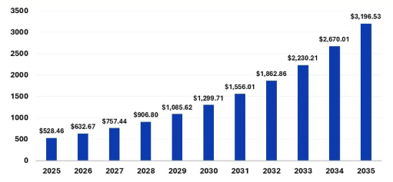
Figure 2: Automative quality inspection AI System Market size 2025 to 2035
Source: (Precedence Research, 2026)
From an academic point of view, there are some researches on the single automation technology including AI inspection, automated cutting. The interaction between the technologies has not been evaluated with respect to quality control. Further, the research studies more toward productivity and cost effectiveness, with less emphasis on direct link between automation and quality of outcomes (Ghalambor and Firozpour 2025; Marslev and Whitfield 2025). The purpose of this research, therefore, is to fill the void by analysing the overall impact of automation on defect detection, product reliability and consistency in footwear manufacturing.
The industry is coming under increasing pressure from global brands and consumers to produce virtually perfect products with zero defects. Reputational damage, quality fails, contact termination, etc are the results (Marslev and Whitfield, 2025). Efficient quality control is vital for a company like YOUNGONE, which deals on fiercely competitive global markets. Quality control can be better to facilitate evidence-based decision-making at management level.
Another essential issue related to automation is the transformation of labor. The introduction of automated systems has lessened the errors in manual procedures (Bagnardi, 2025). However, Ghalambor and Firozpour (2025) argues that the prize depends on staff acceptance, good system integration and tactical nous. A few companies try to balance the tension of the pace of technology with coming into work force. The research enlightens the effect of automation on quality control results and emphasizes the role of training and human-machine interaction.

1.4 Research aim and objectives

1.4.1 Research aim
This research aims to investigate the impact of the automation process on the quality control of YOUNGONE's shoes in the UK.

1.4.2 Research objectives
- To assess the role and extent of automation in YOUNGONE’s shoe production.
- To analyse the consumer perception of automation on the quality of the shoes of YOUNGONE.
- To generate suggestions for the management of YOUNGONE PLC based on insight.

1.4.3 Research questions
- What is the current state of the automation process in YOUNGONE’s shoe production?
- What is the consumer perception of automation on the quality of the shoes of YOUNGONE??
- What are the challenges and opportunities at YOUNGONE to maintain a strategic transformation process via automation?
- What kind of recommendations and suggestions can be made to help improve the quality management process for YOUNGONE PLC?

1.5 Research significance
The study has broader implications for various stakeholders. It adds to the scarce academic literature in the context of automation and quality control in footwear manufacture. The result offers practical implications to manufacturing managers, policy makers and quality engineers when determining the optimal automation policy. The results could also reinforce human resource management policies through the examination of training and technology acceptance. Theoretical evaluation is performed, which is important to study the effect of automated methods on defect detection accuracy, quality, traceability and consistency of production in footwear manufacturing.
At the managerial and organizational level, this study offers implications for YOUNGONE’s decision makers. Managers can use this research to determine whether automating initiatives produce significant improvement in defect reduction, accurate inspection, and uniform production. The research guides strategic planning by demonstrating how automation may be integrated with long-term quality aspirations and global compliance demands. The findings have important implications to the international footwear industry. The authors show how automation can improve quality assurance without reducing efficiency and thus enable competitiveness on export-driven markets.

1.6 Applied research method
This research applied quantitative research method while the researcher relies on primary sources of data. This study aims to focus on structured method of study, so this research needs to collect data from the consumers of YOUNGONE. As a result, this study applies closed-hand questionnaire to collect data from the respondents. Even this research uses SPSS to analyses the data.

1.7 Dissertation structure
- Chapter 1 address the key background of the study, research aim and objectives, significance of the study.
- Chapter 2 reviews the relevant literature for the study and the theoretical frameworks.
- Chapter 3 outlines the research methodology, indicating how the data were collected and evaluated for the study.
- Chapter 4 presents findings, analysis, and discussion of the collected data to demonstrate the research activity.
- Chapter 5 concludes the study and provides recommendations according to the findings.

Figure 3: Dissertation structure
Source: (Self-made, 2026)

1.8 Summary
The background to this study was laid in the chapter as an introduction highlighting the increased importance of automation in quality control for footwear manufacturing. The report demonstrated how the pressure of global competition, growing quality demands and constraints of traditional manual production meant that manufacturers are being pushed towards automation-based products. This chapter has shown that competition in the footwear industry depends on a crucial aspect of quality control. However, the smallest defect can also cause huge impact on durability and customer satisfaction. A background of YOUNGONE was carried out to describe the study in a real manufacturing setting. The company’s international scale and the fact that it invested in cutting-edge automation technologies provided for interesting case-study examples.
The study was well justified and important, as reflected by the justification for the research based on the identified gaps in the literature. Rationale was offered for the importance of this research to draw attention to the fact that empirical, organisation-specific evidence is required to explore both technology and human factors.

Chapter 2: Literature review

2.1 Introduction to Automation in Apparel Manufacturing

2.1.1 Definition of Automation
Automation has made a significant contribution to the global transformation of apparel manufacturing, according to Elhajjar, Yacoub and Yaacou (2023). Competition within the market is growing and so as the demand of consumers (Elhajjar et al., 2023). Documenting a precise production process is remarkably crucial so manufacturers can perform their operations efficiently. Vu, Leopold and van (2025) also mentioned that apparel production was formerly extremely labour intensive. Jamwal, Agrawal and Sharma (2023) stated that the inception of Industry 4.0, intelligent manufacturing methods and smart factory, as well as advanced robotics push the industry toward automation-based technologies. Haq et al. (2025) state that product quality assurance has become of paramount importance and there are measurable benefits in automation. Furthermore, at facilities like YOUNGONE Footwear large scale production gets affected by procedures.
Automation is defined as a strategic transformation process involving the adoption of robotics as well as machines (Singh, 2025). Deterministic rationality accretion is an ancient concept, automation being the most prominent manifestation of the machine learning and robotics technology fusion (Singh, 2025). Moreover, automated stitching, AI-based computer vision, data-based inspection system, and laser cutting are quality related technologies as mentioned by Taoufik (2025). Taoufik (2025) and Dias, Petry, & Rocha (2024) discussed that the use of technology also contributes to the accuracy, overcoming human failures. Such is constructional precision in the cutting, sewing and pattern positioning side of footwear manufacturing that end use durability and visual aesthetics are affected.
Automated QC processes are also critically important to increase efficiency (Islam et al., 2024). AI inspection systems, automated swing solutions and robotic handling have played a key role (Haq et al., 2025). However, Singh (2025) asserts that automation decreases reliance on labour. It needs skills too as you replace repetitive, accuracy-stressing manual tasks. On the other hand, Islam et al. (2024) observe that one of the objectives of automation is to remove human factors in inspection, with its attendant errors, and ensure control over quality levels.

2.1.2 Role of Automation in Apparel Manufacturing
According to Bao et al. (2026) and Haq et al. (2026), many sides of automation in garment manufacturing can improve accuracy in relevant tasks. Amal (2023) says it is not possible to separate cutting and stitching from the “human inaccuracy”, automation has made this process more accurate. Islam et al. (2024) maintained quality and pattern alignment, which are important considerations in the shoe quality control course. In addition, Thi et al. (2025) assert that productivity is increased when admission allows firms to follow fast speed market movements without losing quality. YOUNGONE can manage quick market cycles while maintaining their high standards of quality by choosing the automation solution. Furthermore, automated AI-based inspection adds a layer of quality control.

Figure 4: Automation in manufacturing
Source: (Kiron, 2021)
However, Haq et al. (2025) arguably claim that automation is not just about increasing operational efficiency. This is also backed by the findings of Kumar A. (2025), compliance to international quality standards, as required by such clients are Nike and Adidas etc. Even YOUNGONE determines the quality standards by maintaining the automation process. Elhajjar, Yacoub, and Yaacoub (2023) noted that sustainability goals are supported by minimizing material waste and optimizing resource use. Even though there are challenges with the automation process. Skilled technicians are required, and measurement gaps arise when technological complexity is present. Even potential job displacement concerns exist among the individuals. Nevertheless, thinks that the addition of automation needs to be balanced with technological efficiency to achieve the expected goal.

2.2 Theoretical Framework

2.2.1 Automation Theory
According to Bao et al. (2025), automation Theory implies that technological systems replace human labour by performing tasks more accurately and efficiently, and in a consistent manner. Huang and Sahari (2025) claim that the theory argues that machines eliminate human variability and lead to predictable outcomes. The outcomes are significant in maintaining quality control. Focus is given to reducing human error, increasing process reliability, developing standardisation, and reducing defect rates. Notably, Huang and Sahari (2025) argue that automation’s unintended consequences are highlighted by automation theory. A greater reliance on machines can increase the risk of system breakdowns and the loss of confidential data. In addition, poor implementation of an automation system can harm the process of software orientation and lead to AI-powered misjudgements as well.

2.2.2 Technology Acceptance Model (TAM)
This can be seen in the research study by Mastour, Yousefi, and Niroumand (2025) that the Technology Acceptance Model (TAM) influence on user adoption of technology is based on two determinants. The first of them is perceived value, and it represents the idea that begum patients believed upon automation to improve on performance and quality level. The second is perceived ease of use which refers to the belief that a technology will be effective and easy to use. Song, Qiu, and Liu (2025) argued that TAM also supports the production of garments by finding out how machine operators, quality control inspectors and supervisors respond to automation. On the other hand, Wasudawan, Weissmann & Nwobodo (2025) claimed that several workers initially struggle with the implementation of automation because of fear for job loss and low technological knowledge. But as workers become more acquainted and trained, they will embrace automaton to make them more efficient.
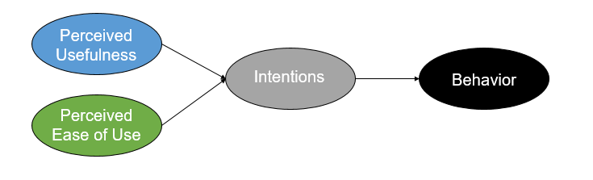
Figure 5: TAM Model
Source: (Song, Qiu, and Liu, 2025)
Quality control automation, especially in AI inspection, is highly important and the acceptance of personnel also cannot be ignored. The theory emphasizes the role of training, communication and ability to successfully implement the purpose of technology application, thereby enhancing quality control and efficacy.

2.2.3 Diffusion of Innovations Theory
The Diffusion of Innovations Theory explains how technologies get picked up different sectors. In practice, the theory includes related factors such as relative advantage, compatibility, complexity, trialability, and observability (Assidi et al., 2025). The theory suggests that diffusion has been slower in apparel manufacturing than in the electronics and automobile industries because of high labour availability. The cost of advanced machinery, low strategic literacy, and traditional production processes are major considerations for assessing the burden. However, Ayu, Khusna, Herliana (2025) argue that global brands press for quality and tight compliance consistent with the direction of adopting acceleration. The theory explains why diffusion of technologies such as automated cutting systems and AI inspections is more rapid. These factors offer significant advantages in terms of material utilization and defect detection.
The theory is crucial for prospects of YOUNGONE Footwear, as early adoption of automation provides a significant competitive advantage. However, the theory also relies on organizational culture, client requirements and investment capability.

2.2.4 Quality Control Theories
This is corroborated by Kumar (2024), who points out that a certain quality control theory seeks to achieve similarity in products through its design and operation systematic thinking process, together with the elimination of defects. They stress standardization of processes, continual monitoring, error-proofing methods, statistical process control, documentation. Lim et al. (2025) advocates that quality control theory is perfected as it becomes automated. A process of monitoring driven by data enters the picture, together with inspection based on sensors. Add to that, even machine learning algorithms to identify faults more rapidly are used. And do so more accurately. Nevertheless, Shafa (2025) contends that QC theories stress the importance of identifying root causes. Automation facilitates practical identification, tracking, and prediction.

2.2.5 Total Quality Management (TQM)
Dezi and his colleagues (2022) found out that TQM promotes a constant culture of quality improvement at all levels of the organization. For the purpose is to deliver the best-quality product to customers so that requirements can be successfully met. This theory aims to eliminate process variation thus ensuring accuracy and consistency. It also reveals greater product yields, lower defect rates and increasingly satisfied customers. However, Urbański et al. (2025) contend that TQM focuses on determining participation and organisational culture. TQM can be effectively delivered by providing training for employees, promoting a sense of quality, requiring managers to take their responsibilities seriously and encouraging extensive joint work across functions. Determining the operations of YOUNGONE Footwear, TQM is integrated with automation. Ahinful et al. (2024) said that the process determines and guarantees compliance with global brand standards while minimizing manual quality control bottlenecks. In addition, TQM warns that overlap in technology can disrupt human judgment, it is difficult to persist in making the same judgments as they would make if they were relying on their own judgment alone. Yet Urbański et al. (2025) argue that TQM, when coupled with automation, guarantees compliance and can accomplish the standardization of global brands whilst reducing manual QC bottlenecks.

2.2.6 Six Sigma
The six sigma is an approach that uses DMAIC methodology to minimize process variations and defects. Measuring, defining, analyzing, improving, and control are the five parts of measurement. The theory is influenced and rigorous in its approach by precise system of management, real-time data, automation defects to offset reduced human responsibility. Gomaa (2025) Automation advances Six-Sigma project by bringing with technology, such as precise measurement instruments, real -time data capability, automatic defect detection systems, and lightens cognitive burden on people.
Cutting and stitching significantly affect the automated process and introduce dimensional errors. Quality control systems detect stitching faults, colour divisions, and surface defects with high accuracy. A critical analysis indicates that data-driven natural methods perfectly align with Six Sigma automation. Colour divisions and service defects can be maintained with high accuracy by ensuring efficiency.
Cutting and stitching significantly affect the automated process and introduce dimensional errors. Quality control systems detect stitching faults, colour divisions, and surface defects with high accuracy. Based on the above analysis, the best way to achieve Six Sigma automation is combining both methods (Haq et al., 2025). The colour boundaries and service defects can even now be kept very accurately.

2.3 Types of Automation in Apparel Manufacturing

2.3.1 Robotic Process Automation (RPA)
In the apparel production are integrated a variety of automated technologies, including robotics and AI, such as their influence on quality control can be identical. From the perspectives of operational complexity and product type, the Kotte (2025) divided the overall product automation into three gradually deepening stages. Robotic process automation refers to the use of programmable robots to perform repetitive tasks. Sorting components, labelling, material handling, packing, as well as for the coordination of workflows are all numbers of jobs that are repeated in robotic process automation. Farmakis, Elena, and Doukidis (2025) discuss that labour is rendered obsolete the present, which we live in, see This type of automation reduces the human intervention needed and thus reduces human handling errors. Robotic arm insurance can be taken to illustrate the process of making right the place for footwear parts. Even contamination, misalignment can be minimized by automated conveyors. Nonetheless, Lee, Zo, and Jeong (2025) argue that robotic process automation indirectly raises quality control through enhancement of workflow stability and Elimination of bottlenecks. Nonetheless, this kind of automation process has disadvantages like high maintenance costs and difficulty dealing with complexity.

2.3.2 Automated Cutting Systems
Using laser-cutting and automation, the precision of clothes and shoes made in is unprecedented (Kotte et al. 2025). The automated systems are immensely important for they can reduce cloth waste (Tariq, 2025). However, the system itself does not create human measurement mistakes. Kotte et al. (2025) asserted that one key benefit of automated cutting is that it raises accuracy levels in producing upper parts for footwear and lining material. The laser cutting device is distortion-free, while CNC cutting has still the potential for considerable dimensional error. However, Taoufik (2025) contends that by eliminating manual variability automated cutting improves the control of quality. But it does require skilled operators. Skilled programming personnel and maintenance specialists do the work, but people who do not have the professional knowledge will lead to inefficient results.

2.3.3 Automated Sewing
The integration of digital stitch control, programmable patterns, and AI technology into automated sewing achieves a consistently efficient result. It has been suggested by Ahamad et al. (2025) that this point is valid. An AI-powered sewing machine has an automatic stitch length, and so the manufacturing process can be more efficient. Error-proof devices can be set up by means of automatic retraction. This is very important technological project will play an increasingly significant role in increasing national power and maintaining food safety for the long-term future. Automated sewing makes for uniform quality, which is also important with intricate designs However, machines can detect a missed stitch and real time be used to judge if a needle is faulty in contrast, Wai (2025) asserts that automated sewing does indeed improve quality control but has difficulties with uneven fabric; human adaptability still wins out largely. As a result, we need to work out a hybrid system for YOUNGONE.

2.3.4 AI and Smart Inspections
Accordingly, Suprajeni, Yopan and Fitriati (2025) have reported that AI-based inspection systems are equipped with computer vision to identify the fabric imperfections, colour contrast defects, stitching failures and misalignments. The quality control powered by AI is done in fraction of a second and identifies the defects quicker than the person on the device would notice them, so it corrects orientation precisely. Data storage can be evaluated for feasibility, and predictive analytics can also be optimized. Bagherian and Kondala (2025) add that AI inspections help detect flaws in food, such as soul bonding, and help identify texture mismatches that manual quality control misses. However, Suprajeni, Yopan, and Fitriati (2025) argue that AI-based human detection accuracy is surface-level, as it lacks human aesthetic judgment. AI cannot determine emotional attachment, so accurate orientations cannot be maintained. Even AI-powered tools can misclassify acceptable variations as defects, causing unnecessary rework. Nevertheless, Bagherian and Kondala (2025) believe that AI and smart inspections are highly significant for the footwear and apparel manufacturing process, enabling the identification of issues and strengthening the optimisation process.

2.4 Empirical review

2.4.1 Automated Cutting Systems improve quality control in apparel manufacturing
Wai (2025) stated that quality control in Apple manufacturing can be improved by integrating automated cutting systems. The scenario has been identical across empirical studies, demonstrating how automated cutting systems, particularly laser and CNC cutters, can revolutionise quality outcomes. Superior accuracy has been achieved by automated cutting technology compared to manual cutting. Tariq (2025) adds that disrespect has historically been prone to inconsistency due to human fatigue and subjective judgment. Large organizations have reported achieving up to 95% improvements in cutting position by adopting automated cutting systems. However, Kong (2025) argues that there is a requirement for high capital investment. Empirical studies have highlighted that small factories struggle with the implementation costs, which determine the initial orientation of their activities.
However, Kong (2025) suggests that the empirical evidence strongly indicates the place of automated subtraction as a tool for transformation, even though “concealing hypotactic cutting” will remain. A new approach for quality control improvement is proposed, applicable to the large-scale producers such as YOUNGONE Footwear. Liang (2025) also mentions that automated systems can have perfect pattern shapes, and with such designs it is cheaper to produce shoes. Machine cutting keeps all 1000's of units consistent with each other and between all pieces. In a different way, the manual cutting provides differences across issues contributing as well in the non-alignment of issues. Even Panyaram and Kotte (2025) advocate the implementation of computerized nesting algorithms in automatic cutters. It is the best process based on minimization of material waste. Taoufik (2025) argues that it is thanks to better utilisation of the material that factories save costs and ensure a more sustainable production. Even the elimination of West is also a big part of maintaining quality.

2.4.2 Robotic Process Automation (RPA) improves quality control in apparel manufacturing
Robotic process automation can enhance the quality control of apparel manufacturing. Thus, using program-controlled robots to perform repeated labour intensity operations is one part of this process. Activities include material handling, component sorting and packaging, and several ways in which RPA, both directly and indirectly, contributes to demonstrating quality control according to the orientation of empirical studies (Pasupuleti, 2024). Ansari (2025) then, provides that the benefits are the same including more accurate handling. Sensors with robotic hands are equipped for handling and dispensing fabrics and components with constant pressure. Problems may then be reduced, including material stretching and distortion. Ayu, Khusna and Herliana (2025), again endorse this view--pointing at RPS to improve productivity as well as cutting down on human errors. Human operators can give products a bad press because of exhaustion, distraction and wrong techniques used. Furthermore, RPA ensures that consistent grape strength may be calculated by controlling gradual adjustment in the state of the product at each subsequent stage. Bao et al. (2025) continue that machine-handling will eliminate bottlenecks and insure production flows smoothly through cutting, sewing and assembly lines. 7.3 This leads to time-urgent errors, including aggressive drying delays. On a larger scale, Elhajjar, Yacoub and Yaacoub (2023) point out that many RPS systems are integrated with barcoding and RFID technology at factories. These systems record each product's movement step-by-step, so that defect origins can be tracked down for quality control teams like bowling pins in sequence. Even contamination of dust, oil and moisture will be less using the same logic. Therefore, how to implement RPA is very critical. Due to lower human contact, contamination risks are reduced as well.
On the other hand, yet Gomaa (2025) claims that material flexibility issues which robots cannot handle are in soft and elastic objects, while human tactile sensitivity is extremely superior to any machine in existence. Despite irregularly shaped components which can cause programming limitations, advanced programming and sensor calibration must be carried out. And yet, RPA remains a pivotal orientation for improving quality control in the view of Huang and Sahari (2025). This is especially true where manual handling inconsistencies can be eliminated. Therefore, improve the efficiency of the workflow and assistance in tracing movements become even more common outcomes.

2.4.3 Automated Sewing improves quality control in apparel manufacturing
Automated sewing improves quality control in Apple manufacturing, and the aspect is identical (Wai, Ning, and Ho, 2025). Song, Qiu, and Liu (2025) support this, adding that the system is among the most impactful automation technologies, which is a critical quality determinant in footwear. Strength, stitch balance, and patterned elements significantly influenced durability and aesthetics, which are critical quality determinants in footwear. The study by Lenk and Taesler (2025) found that automated alignment influences durability and aesthetics, and empirical researchers can support this view by maintaining automated scenarios. There is a requirement for superior stitch consistency when using automated sewing machines. Uniformity is maintained, including stitch length, superhero six consistency, and reduced needle and trade errors. Issues can be detected and corrected within automated systems. An improper decision-making process can be enabled in real time, without a focus on reducing needle-and-thread errors. The accuracy of the enhanced pattern is a significant factor in programming sewing machines. The aspect relates to continuing along the production line.
Technavio (2025) believes that a 30% to 45% increase in stitching output is associated with an automated quality control issue. The company enhanced production speed without compromising quality. Automated systems can reduce reliance on highly skilled individuals. This aspect determines the strategy for reducing the number of highly skilled manual teachers and addresses skill gaps. However, Suprajeni, Yopan, and Fitriati (2025) present empirical studies. Material-handling limitations are identical, as automated sewing machines may struggle with teak and multi-layered elastic materials. Automated systems cannot require regular calibration and maintenance; higher load orientation can be minimized to reduce defecting scenarios. Even limited flexibility is another unique style, with regular shapes and decorative stitches.

2.4.4 AI and Smart Inspections improve quality control in apparel manufacturing
AI-driven inspection systems are among the most advanced quality control technologies currently used in the apparel manufacturing process. Hasan et al. (2025) add that AI-powered computer vision systems are being developed to determine highly effective tool orientation. Kong (2025) adds that AI-powered computer vision systems are significant for providing effective tools and detecting many defects.
It has been identical in the high-defect-accuracy orientation. Computer vision systems achieve 98% accuracy in identifying fabric flaws and addressing stitching issues. Event real-time and don't stop inspections are conducted, unlike human inspectors. AI systems do not experience fatigue and can operate 24x7 without performing decline. On the contrary, AI-powered traceability and data-driven orientation can digitally store inspection data, allowing teams to track defect patterns. This aspect is conducted without compromising any performance efficiency.
Kong (2025) adds that objective, standardized judgments are necessary because human inspection is subjective and varies by individual. Objective criteria orientation can be enabled by AI systems, enabling effective quality control decisions.
Continuous learning is associated with machine learning models developing over time as they evaluate more examples of defects. Human inspections require regular training, but machine learning models do not, because they are enabled with advanced language models.
However, Liang (2025) argues that AI systems can identify acceptable variations as defects, leading to unnecessary rework or rejection. Qualitative judgments are required, such as artistic stitching and aesthetic appeal, which are very complex for an AI-generated system. Lee, Zo and Jeong (2025) support this and further argue that advanced inspection systems based on artificial intelligence require investment in devices including cameras and sensors -- even communication infrastructure. Because of funding problems and high costs of introduction, small organizations cannot ascertain their efficiency. In addition, Panyaram and Kotte (2025) add that the system will not be effective if poorly-quality datasets are delivered. Poor-quality data can lead to incorrect classification of faults, whereas the system works only in high-quality data. Nevertheless Singh (2025) says that the effectiveness of AI-based inspection in terms of quality control is equal, although he also points out some limitations. In the garment and shoe industry, companies can achieve labour efficiency by introducing AI-based smart inspections.

2.5 Research gap
The researcher found that much insight in smoking very retail thus Automation is widely used in the apparel industry. The researcher found gaps in database field studies, especially in footwear research. Despite all this effort, there are no studies concerning footwear. Most of the studies on apparel manufacturing are generalist. Few lean practitioners are engaged in production management nor towards footwear manufacturing. However, there is little in the literature about lean production in this area of production. Footwear is a multi-layered assembly process as well as higher particular requirements. So, research must be conducted into how automatic control affects the quality of footwear. The researchers discovered that there is no such thing a} non-objective test on the station Analysis. Few studies see how automation affects quality control, but to the exclusion of differences that these limit their applicability.
The researcher identified that there is minimal discussion on workforce readiness. The successful implementation of an automation system depends heavily on the workforce's acceptance and competency. Most studies overlook insights from the Technology Acceptance Model regarding work attitudes. Even though there is limited longitudinal evidence, most studies have used a cross-sectional design. Even though there is limited research on AI limitations, this research will be very significant for critically evaluating the shortcomings of the AI implementation process.

2.6 Summary
This chapter critically addressed the existing literature on automation in apparel manufacturing. Theoretical models and frameworks were linked to address technological developments and empirical findings. TAM, Diffusion of Innovations, Six Sigma, and TQM provide the conceptual basis for understanding why and how the influence of automation on manufacturing precision can be determined. It was reported in the literature that the automation process using advanced cutting systems and robotic process automation is identical. Dimensional precision can be enhanced by an automated cutting system, where RPA minimizes handling inconsistencies. The technology is collectively deriving better outputs and enhancements that reduce human error. The adapter also highlighted gaps in the existing literature. The researcher found that empirical research is heavily skewed towards apparel rather than Footwear manufacturing. The identified research gaps highlighted a significant aspect of evaluation to support an in-depth study.

Chapter 3: Research methodology

3.1 Research philosophy
The researchers' beliefs in conducting research philosophy are determined by its own research philosophy according to Bryman and Bell (2019). Khan Adil and Ahmad (2025) posit that there are two main kinds of research philosophy such as positivism and interpretivism. The two research philosophies differ fundamentally in their views of knowledge. Alik (2024) says Positivism maintains that there is an independent reality which can be measured. Rather its goals are independent, and emphasis is placed on the scientific method. According to Dulal (2025), quantitative techniques such as statistical analysis are the main means for testing hypotheses and identifying trends. The methodological tools of hope investigation concern itself only with proving causal relationships among variables.
Conversely, Chitwood (2024) points to the use of interpretivist research philosophy that assumes that reality is socially constructed. Since reality is subjective, qualitative methods are utilized to assess human interactions and experiences. Abubakar (2024) contends that data is collected in qualitative ways through observations and interviews. Interpretivism focuses on depth and context, unlike positivism, which is concerned with generalization.
This research was conducted using positivist approach since it is good for testing the effect of automation technologies on shoes' quality control in YOUNGONE in UK. In this study, measurable results were in the spotlight because objective indicators can monitor automation of quality control. Intensity is based on product accuracy, defect rates, inspection and cost effectiveness. Roll numbers, quality records etc. of all production were open to the investigator for recording of numerical data and evaluating the impact. Alik (2024) highlighted that this process of investigation was important for the researcher to maintain reliability and objectivity. The positivism paradigm was chosen by the researcher to guide the study, to build a strong framework for making inferences based on evidence from the research. No qualitative methods were included for the purpose of in-depth analysis which was why the researcher had opted out of an interpretivist research philosophy. So, the use of positivist research philosophy could be seen.

3.2 Research approach
The research approach influences the data collection process and evaluation by comparing theories and models (Saunders, Lewis, and Thornhill, 2019). According to Kumar (2024), the deductive and inductive research approaches are the most widely applied, differing mainly in the direction of their reasoning. According to Fife and Gossner (2024), the deductive research approach begins with existing theories and models and develops specific hypotheses. Hypothetical testing purpose can be maintained using empirical data as the researcher follows a structured process (Gamage, 2025). The researcher moves from general principles to specific observations where quantitative methods are applied. In contrast, Krueger et al. (2024) claim that the inductive research approach begins with observations rather than a predefined theory. The researcher applies a qualitative methodology to build new theories or frameworks based on in-depth and experiential insights.
This research followed a deductive approach, as it was suitable for investigating the impact of automation technologies on the quality control of shoes at YOUNGONE in UK. The topic was related to well-established theories. Automation, operations management, and quality control theories are very common and can be aligned with the research purpose to understand the organization's quality control. Accuracy and consistency can be improved through automated processes and by defining a defect-detection process. Using a directive approach allowed the researcher to formulate clear hypotheses. The researcher went forward with hypothetical testing using quantitative data. The method allowed the researcher to conduct a systematic analysis of the research outcomes. The researcher did not apply inductive reasoning because no new theories or models were applied. A deductive research approach was applied in this study.

3.3 Research strategy
Research strategy indicates the determination of the research process by applying methods to describe or explore the outcomes. Exploratory and descriptive research strategies serve the purpose of the research process (Saunders, Lewis, and Thornhill, 2019). This is based on the study by Singh et al. (2024); an exploratory research strategy is applied when the research problem is relatively new and not clearly defined. The aim is to gain some preliminary insights and identify main drivers. The approach is valuable not only for what it can answer, but as a way of getting below the surface. This approach is flexible since it refers to the qualitative data and methodology. On the contrary, Villamin et al. (2024) elucidate the use of a descriptive research strategy, aimed at obtaining an accurate depiction of the characteristics and situation of X. This approach decides how the questions are to be addressed in structured form, full survey and then a statistical treatment.
This study used a descriptive approach to assess the effects of automation technologies on quality control. The intent of the researcher was to determine how automation affects current QC practices and results. The screw is a given, and was permitted to gather engineered data on defects, inspection accuracy, and production consistency. A narrative approach was employed to provide an in-depth description of quality performance. The researcher promoted the clarity and comparability of the research results to be used for practical support. The author did not take on an exploratory research strategy because the author evaded from discovering new aspects of the research. The descriptive approach was crucial for identifying and assessing concrete research results.

3.4 Research choice
There are different means of gathering and analysing data. Quantitative methodology is used, with emphasis on numerical data analysis. The academic researcher uses statistical analysis to explore how one variable relates to another (Bell, Bryman & Harley, 2019; Saunders, Lewis & Thornhill, 2019). Formal instruments are employed for developing objectives and results. According to Dagilienė, Varaniūtė and Banionienė (2024) qualitative research concentrates on non- numerical value to describe opinions, experiences or meanings. Information is gathered through processes like focus groups, observations and interviews. Qualitative techniques allow more depth in the study.
This research used a quantitative research design, as it was well-suited to investigating the impact of automation technologies. The study required objective measurements of performance outcomes. The effectiveness of quality control can be analysed using numerical indicators such as rejection percentage, inspection time, defect rates, and cost savings. The researcher used a quantitative approach to collect data on production and quality control reports. The researcher applied statistical techniques to test hypotheses and evaluate the strength of the relationships. Those were the main reasons the researcher chose to proceed with a quantitative research design. The researcher did not apply a qualitative research design to avoid collecting qualitative data. It was effective in determining the relationships between the variables, which could not be achieved through a qualitative research approach. A quantitative research design was used in this study.

3.5 Time horizon
The time horizon in research refers to the time frame within which the data samples are used for the research purpose. The cross-sectional and longitudinal time horizons are the two most widely applied time-horizon processes. A cross-sectional time horizon involves collecting data at a single point in time (Saunders, Lewis, and Thornhill, 2019). The researcher mainly determines and provides a snapshot of the phenomenon. This approach is appropriate for comparison of variables and maximization of associations. The technique is useful for assessing an existing situation but cannot provide a monitoring function over time (Bell, Bryman, and Harley 2019).
On the other hand, longitudinal power in research, is at each point of data collection based on an attribution logic. The idea is to look at trends and long-term patterns. This approach is more informative, since trends might vary through time (Saunders, Lewis, and Thornhill, 2019).
The researcher adopted a cross-sectional time horizon as it was suitable to investigate the impact of automation techniques on quality control at YOUNGONE in UK. The objective of this scholar was to assess existing quality performance. Q.C. records are treated as data in addition to production reports for a given period. The author measured the effect of automation on defect rates, inspection productivity, and quality. The technique was inexpensive and robust with which the appropriate result could be identified. The manner was also important for presenting credible evidence. The researcher did not focus on the long term because it would have been too costly in terms of time and resources.

3.6 Research technique
Source of data: Data is the main element of the entire research activity, and it is crucial to specify the type of data used. Kruger and Mitchell (2022) stated that data can be collected from primary and secondary sources based on the origin of the information. The researcher collects primary data as the first and basic source, and the purpose of the study is to determine the original nature. The researcher mainly uses surveys, questionnaires, interviews, and experiments to collect primary data. In contrast, Goddard and Melville (2021) claim that secondary data is collected by dealing with existing scenarios. Other researchers have already collected this sort of data for different purposes, and it can be found in journal articles, company reports, and even websites. There are also government publications that provide significant secondary data. The secondary data collection process is cost-effective, but it can also lead to issues of not fully aligning with the specific objectives.
The researcher collected data from primary sources because an existing investigation of the impact of automation technologies was significant. The researcher used structured questionnaires to assess the organization's quality control. The researcher collected data following up-to-date orientation on defect rates, if you see improvements, and so on. Collecting data from primary sources enhanced the relevance and reliability of the findings. The researcher did not apply or use secondary data to address authenticity and data quality concerns. Secondary data would be used for research purposes, but the researcher did not focus on this method because it wouldn’t be significant to maintaining the research process's accuracy. The researcher collected data from secondary sources for this research.
Data collection method: The method by which the researcher collects and analyses data. Kruger and Mitchell (2022) said that the survey method can be applied, which involves collecting data from many respondents, and the method can be structured with a closed-ended questionnaire. This approach is useful in providing quantitative data as measurements can be easily obtained. Face to face interviews as communication interaction between researcher and respondents Saunders, Lewis and Thornhill (2019) noted that data can be obtained from face-to-face interviews. Data can even itself be document as when the researcher utilizes a secondary source.
The survey method was employed by the researcher in this research, as it was an appropriate technique for assessing of automation technology impact on shoe quality control at YOUNGONE in UK. The analysis centred on counting to which more than one person must contribute. The production and quality control was recorded by the investigator. The investigator provided standardized questionnaires of quality evaluation and evaluated the quality. Because the research was of a quantitative character, the researcher did not interview while collecting data. A greater number of responses was gained by survey; and it minimized researcher bias and allowed for statistical analysis to identify the most viable technique. In this study data was collected through survey design.

Research tools: Distinct instruments are employed for gathering and analysing data. Data can be organized by asking specific questions in a questionnaire, open-ended or close-ended. Even more importantly, the data distribution is desired to be characterized explicitly for a research need (Villamin et al., 2024).
Data were collected from the respondents, using a structured questionnaire with close-ended questions. It was the researcher's tool used for data collection. The researcher provided respondents with answers to choose from, for example multiple choice. This tool codebook was a critical element of the research process for the researcher to sustain the quantitative analysis, as it provided stability and reduced respondent ambiguity. The investigator gathered data focused on ubiquity across a large sample; an important aspect for comparing findings. The researcher collected data from the respondents, administered Google Forms
. The questionnaire includes following categories of questions.
- Demographic: This study asks sex, age related information from the respondents.
- Current State of Automation in YOUNGONE’s Shoe Production: This study asks several questions to the respondents regarding automation in YOUNGONE’S shoe production. The questions are arranged to meet first research objectives.
- Consumer Perception of Automation’s Impact on Quality Control: This study also asks to the respondents regarding their perception about impact of automation on quality control. The questions are arranged to meet second research objectives.
- Suggestions for Management at YOUNGONE: The questionnaire also includes some questions to take suggestion from the respondents for the YOUNGONE regarding how to improve quality through automation.
Since, this study applies quantitative research method, Likert-scale (1-5) is used to take response from respondents.
Strongly Agree | Agree | Neutral | Disagree | Strongly Disagree
5 | 4 | 3 | 2 | 1

This method was enhanced to determine the efficiency and accessibility of the data collection process. The researcher was able to determine a rapid distribution to respondents and reduce manual errors. The researcher then exported the collected data directly into SPSS for statistical analysis. This was suitable for determining descriptive statistics and performing reliability tests. The researcher-maintained integration between the closed-ended questionnaire, survey method, Google Forms, and SPSS tools to ensure objectivity and reliability in the research. The tools allowed the researcher to assess the impact of automation technologies and conclude the research activity properly.
Sampling method and sample size: Sampling techniques is the method that researcher use to select can do good respondent from population for his research work. Saunders et al., (2019) adds that random sampling can be used since you are gas choosing samples randomly. This procedure allows for a fair chance of selection for each subject. The approach is important in mitigating selection bias, and increasing the representativeness of the sample. The selection procedure is predominantly applied to quantitative investigations, intending to generalize the results to a wider population.
On the other hand, purposive sampling is a nonprobability sampling method where respondents are selected with respect to some characteristic. This technique is particularly applicable to non-property sampling methods, since the researcher who is conducting the sampling has definite options regarding whom to select. The orientation of the research makes some decisions for the researcher when choosing respondents.
In this study, random sampling was adopted to investigate the impact of automated technologies, for amendment purposes. The sample size is 100. In this way, the researcher had a random selection of respondents and minimized sample bias. The research guaranteed that the variety of view were evenly represented without prejudice by conducting a random selection process. This approach improved the trustworthiness of the findings. Yet even this approach enabled the researcher to exploit SPSS statistical facilities for data analysis. The approach used for high-throughput experiments was quite efficient at filtering the results to select those that are good enough to take forward for a definitive test. The researcher did not use purposive or non-probability sampling as he was not guided by any specific choice or attribute in selecting data from the respondents for analysis. This study adopted random sampling method.
Data analysis: Clearly, specifying data analysis approach is highly critical to understand what really happens in the research design. Weippl, Klemenjak, Tseng (2018) pointed out that frequency analysis, descriptive statistics and regression are frequently used in quantitative return analysis. The methods are used to interpret the results of numerical data analyses of nature. The count based on the method of frequency analysis is used to compute sequential and concurrent response in the data set. The researcher employed this methodology to get distinct perception of friends and trends. The researcher also employed the descriptive statistics to report and narrate the data that is loaded with statistics like mean, SE of mean, standard deviation, kurtosis, skewness. This gave the researcher a chance to examine the distribution in general and at the central tendency. A regression analysis was as well used to test the variables. The techniques turned out to be particularly useful in determining how often the organization's quality checks are improved. The author did not use thematic analysis procedures as the text has no bearing on qualitative evidence. Real results were extracted by applying frequency analysis, descriptive statistics and regression analysis.

3.7 Research ethics
Ethics of research It is important to ensure that the study is carried out in a responsible manner with respect for rights of participants. Ethics in research the integrity and reliability of research findings relies upon certain ethical considerations. It begins with planning and data gathering, passes through analysis and reporting. The researcher followed legal requirements and ethical considerations to preserve the purpose of the study.
The investigator obtained consent from all data survey participants, including full disclosure of the research purpose, procedures and use of the data. All participants consented to be part of the study by accepting that they could opt out at any time and without prejudice. The author has written consent from the participant for the sake of clarity.
The privacy of the respondents was preserved and maintained to the highest level by the researcher. To protect the privacy of participants, the identity of the individual respondents was not disclosed to the researcher. The researcher encrypted digital data and kept it safe in password-protected documents. This direction ensured that the respondents feel comfortable to reveal their true opinion.
This study had measures in place to protect the respondents from any psychological and professional harm. The researcher also took care not to include any sensitive information in the questionnaire. Even if the researcher performed the process correctly and did not fabricate. The author did not falsify the findings of the study in order to preserve integrity and trustworthiness. The author cited/referenced the works of other people and institutions in his or her paper for ethical considerations.

Chapter 4: Findings, analysis and discussion

4.1 Introduction
This chapter of the research report addresses analysis and evaluation of primary data collected to examine the role of automation in improving quality control in YOUNGONE’S shoe production processes. Data was collected using a structured questionnaire designed to capture perceptions of respondents and the impact on product quality, defect detection, error reduction and managerial strategies. The purpose of this chapter is to transform data into meaningful insights which address the research objectives and research questions of the study.

4.2 Findings and analysis

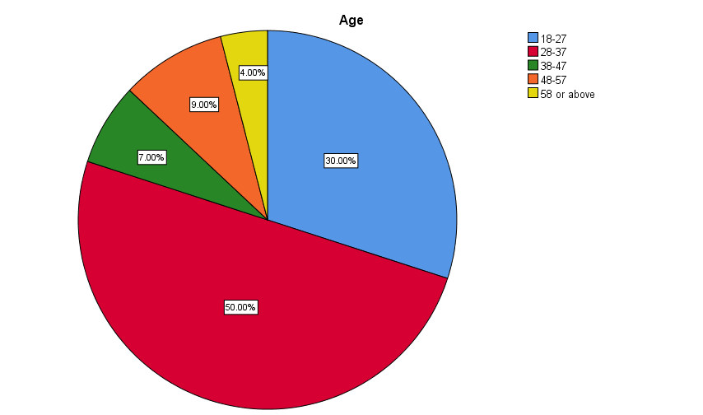
The researcher collected data from the respondents to perform the study and it was found that most of the respondents were from the age group of 48-57 as this specific group represents 96% of the total respondents. Even there were 87% respondents from the age group of 38- 47. Only 30% respondents were from the group of 18-27. As a result, this study claims that the respondents are different categorised in age. Likely, YOUNGONE has different consumers in terms of age.
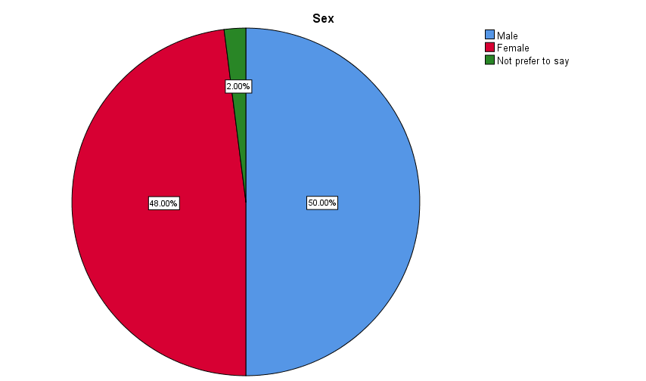
The output indicates that the number of male and female respondents for the survey was almost same as male represents 50% of the total respondents and female respondents 48% of the total respondents. It indicates that this research provide equal opportunity to all types of respondents in terms of gender. Even YOUNGONE offers shoes to all kinds of consumers.
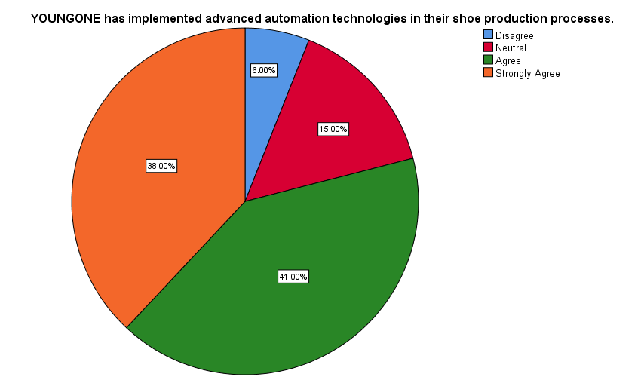
Frequency analysis: The researcher placed a statement to the respondents such as “YOUNGONE has implemented advanced automation technologies in their shoe production processes” to obtain information from the respondents and it was found that most of the respondents provided positive feedback. A combination of 79% respondents as 41% of the respondents agreed and another 38% of the responders strongly agreed with the researcher. 6% of the respondents did not agree with the researcher and 15% of the total respondents remained in neutral position as they did not provide their opinion.
N | Mean |  | Std. Deviation | Skewness |  | Kurtosis
Statistic | Statistic | Std. Error | Statistic | Statistic | Std. Error | Statistic | Std. Error
100 | 4.11 | .087 | .875 | -.772 | .241 | -.062 | .478

Descriptive statistics analysis:
The results indicate a positive perception of automation technologies within shoe production process of YOUNGONE. The mean score of 4.11 suggests agreement among respondents that advanced automation technologies are implemented within the organization. The standard division of 0.875 shows moderate level of variation in responses including some differences as well. The kurtosis value indicates a near normal distribution suggesting that responses were evenly spread without extreme outliers. The skewness value implies a slight concentrated towards the higher end of the scale.
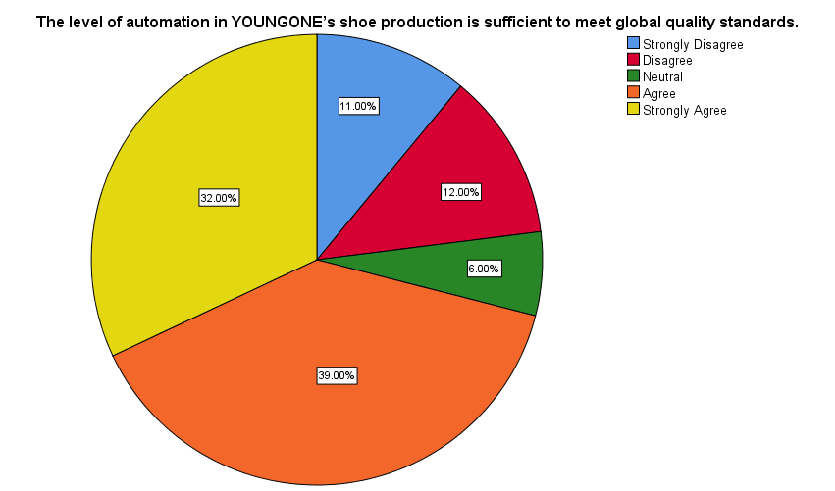
Frequency analysis: The researcher asked “The level of automation in YOUNGONE’s shoe production is sufficient to meet global quality standards” to obtain proper information from the respective respondents and it was found that a combination of 71% of the total respondents presented the shoe production process of YOUNGONE. 12% and another 11% totalling to 23% respondents did not agree with the researcher and only 6% respondents remained in neutral position in this case.
N | Mean |  | Std. Deviation | Skewness |  | Kurtosis
Statistic | Statistic | Std. Error | Statistic | Statistic | Std. Error | Statistic | Std. Error
100 | 3.69 | .133 | 1.331 | -.878 | .241 | -.461 | .478
Descriptive statistics analysis:
The mean value of 3.69 reflects moderate agreement among respondents regarding the sufficiency of automation in meeting global quality standards. However, the standard deviation of 1.331 signifies noticeable variability. The skewness value was -0.878 shows a slight tendency toward agreement while the kurtosis value was -0.461 indicates a flattered distribution implying diverse viewpoints among the respondents.
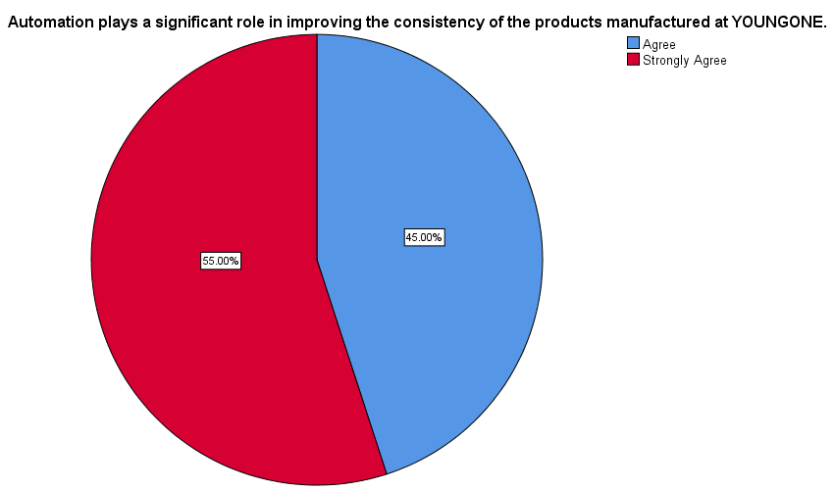
The researcher intended to know if automation place a significant role in improving the consistency of the products manufactured at YOUNGONE. The researcher found that a combination of 100% respondents was there regarding the positive agreement because of there was no disagreed respondent in this case.
N | Mean |  | Std. Deviation | Skewness |  | Kurtosis
Statistic | Statistic | Std. Error | Statistic | Statistic | Std. Error | Statistic | Std. Error
100 | 4.55 | .050 | .500 | -.204 | .241 | -1.999 | .478

Descriptive statistics analysis:
The mean value was higher demonstrating strong agreement associated with the question. The standard deviation was lower indicating strong consistency in respondents’ perception. The skewness value shows that responses are slightly concentrated at the higher end of the scale and the kurtosis value indicates that the responses were widely spread but still heavily oriented toward agreement.
The researcher specified discussion to understand if automation within production process of the company reduces human error in the final product. The researcher found that most of the respondents agreed with the research because of 44% of the total respondents strongly agreed with the researcher because of the thing that the production process of YOUNGONE reduces human error. Even 2% of the total respondents remained in neutral position.
N | Mean |  | Std. Deviation | Skewness |  | Kurtosis
Statistic | Statistic | Std. Error | Statistic | Statistic | Std. Error | Statistic | Std. Error
100 | 4.40 | .059 | .586 | -.676 | .241 | 1.267 | .478

Descriptive statistics analysis:
The mean score of 4.40 indicates strong agreement as the automation of the organization is sufficient to meet global quality standards. The standard deviation of 0.586 reflects lower variability. The negative skewness implies that most responses were clustered toward agree and strongly agree. There was the indication regarding a moderately peak distribution from the kurtosis value of 1.267.

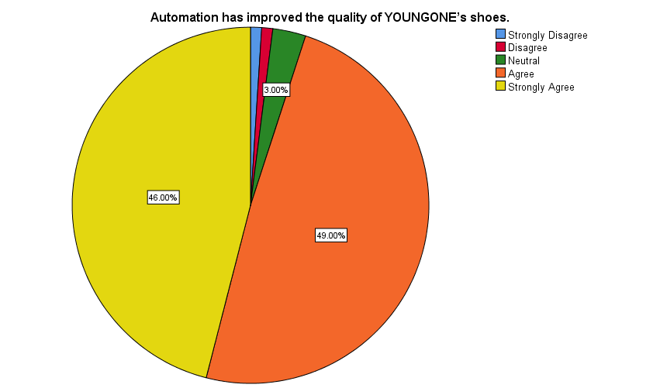
The researcher asked “Automation has improved the quality of YOUNGONE’s shoes” to obtain the perception of the respondents regarding the role of automation in improving quality of the shoes of YOUNGONE. The researcher found that 46% of the total respondents strongly agreed and another 40% of the true respondents also agreed because of automation has improved quality of the shoes of YOUNGONE.
N | Mean |  | Std. Deviation | Skewness |  | Kurtosis
Statistic | Statistic | Std. Error | Statistic | Statistic | Std. Error | Statistic | Std. Error
100 | 4.38 | .069 | .693 | -1.601 | .241 | 5.338 | .478

Descriptive statistics analysis:
The mean value of 4.38 indicates that respondents strongly believe the improvement of the quality of the shoes of YOUNGONE. Standard deviation suggests limited dispersion in responses. There was a highly negative skewness indicating that responses are heavily concentrated at the upper end of the scale. The high kurtosis value determines the sharply big distribution highlighting strong consensus among the respondents.
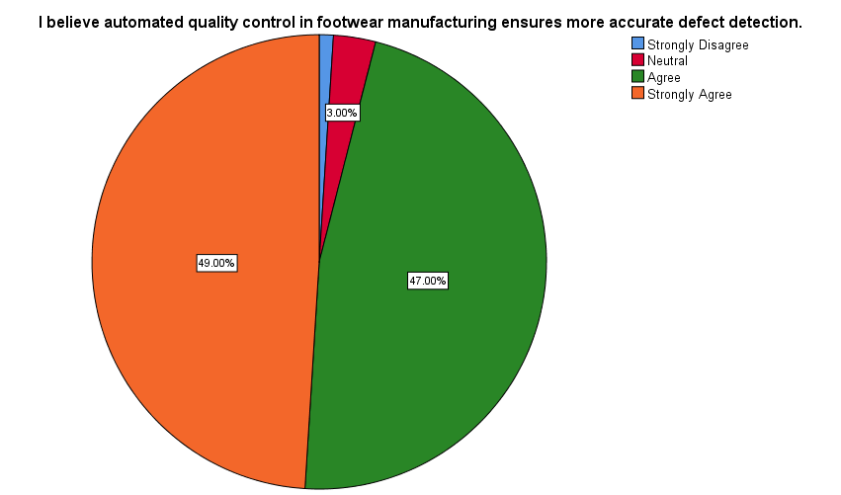

The researcher “I believe automated quality control in footwear manufacturing ensures more accurate defect detection” to the respondents to assure that automated quality control in footwear manufacturing ensures accurate defect detection. A combination of 96% of federal respondents was there regarding positive agreement according to the findings. Only 1% of respondents disagreed with the researcher in this case.
N | Mean |  | Std. Deviation | Skewness |  | Kurtosis
Statistic | Statistic | Std. Error | Statistic | Statistic | Std. Error | Statistic | Std. Error
100 | 4.43 | .066 | .655 | -1.604 | .241 | 6.088 | .478

Descriptive statistics analysis:
The mean score of 4.43 reflects strong agreement regarding the automated quality control in footwear manufacturing regarding defect detection. The standard deviation was low indicating consistent responses. The skewness value was -1.604 suggesting strong clustering of responses towards agreement. The kurtosis value 6.088 indicates a leptokurtic distribution confirming a high level of agreement.
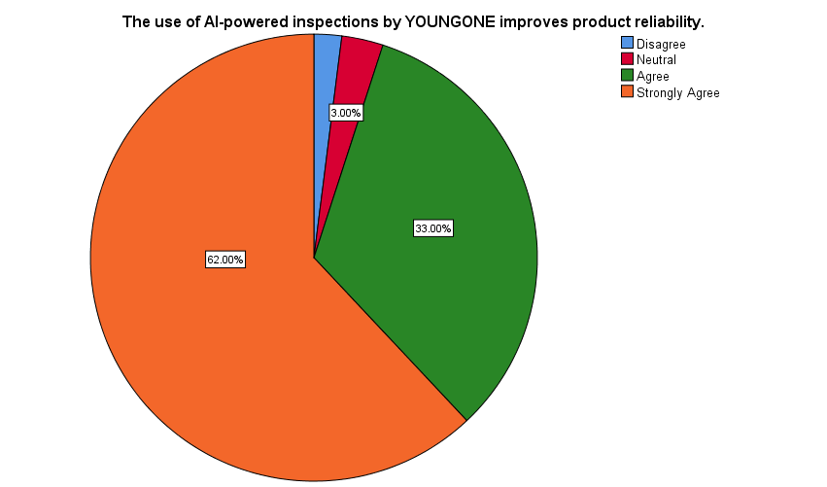
The researcher found that most of the respondents believe on the use of AI powered inspections by YOUNGONE for improving product quality. A cumulative orientation of 95% of the total respondent’s egg feet with the fact and only 3% of respondents were in neutral position.
N | Mean |  | Std. Deviation | Skewness |  | Kurtosis
Statistic | Statistic | Std. Error | Statistic | Statistic | Std. Error | Statistic | Std. Error
100 | 4.55 | .066 | .657 | -1.605 | .241 | 3.091 | .478

Descriptive statistics analysis:
The mean value was high indicating strong agreement regarding improvement of product reliability from the AI powered inspections. The standard division was 0.657 reflecting low variability. The skewness value was -1.605 suggesting a moderately peaked distribution reinforcing strong consensus.
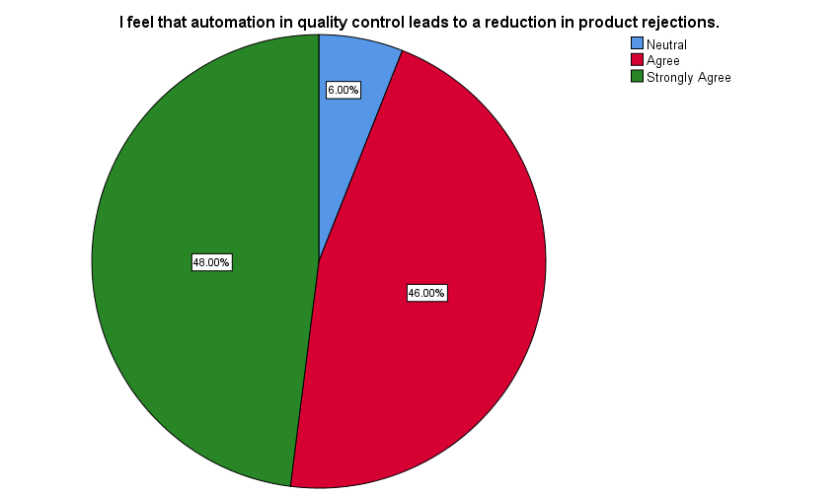
The researcher intended to know the perception of the respondents regarding the role of automation in quality control to a reduction in product rejections. A combined orientation of 94% of the respondents agreed regarding the role of automation in quality control leading to a reduction in product rejections. There was no disagreed respondent however 6% of respondents did not provide their opinions.
N | Mean |  | Std. Deviation | Skewness |  | Kurtosis
Statistic | Statistic | Std. Error | Statistic | Statistic | Std. Error | Statistic | Std. Error
100 | 4.42 | .061 | .606 | -.520 | .241 | -.606 | .478

Descriptive statistics analysis:
The mean score of 4.42 indicates strong respondent agreement whereas the standard division of 0.606 reflects limited dispersion in responses. The skewness value was -0.520 indicates a slight concentration towards agreement. Whereas, the kurtosis value indicates relatively flat distribution with minimal extreme responses.
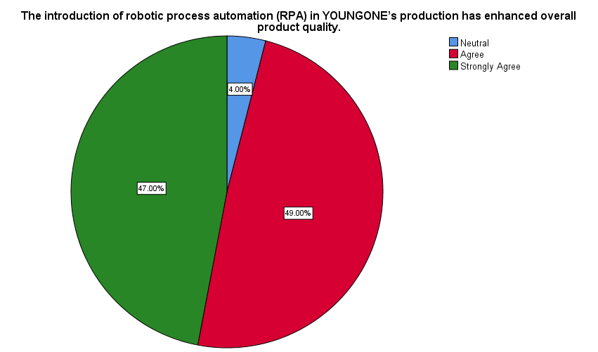
The researcher found that almost all the respondents believe on the introduction of robotic process automation in production of YOUNGONE for enhancing overall product quality because of there was no disagree respondent. However, 4% of respondents did not provide their opinions.
N | Mean |  | Std. Deviation | Skewness |  | Kurtosis
Statistic | Statistic | Std. Error | Statistic | Statistic | Std. Error | Statistic | Std. Error
100 | 4.43 | .057 | .573 | -.377 | .241 | -.768 | .478

Descriptive statistics analysis:
The findings show a mean value of 4.43 signifying the agreement of the respondents. The standard deviation was low suggesting strong consistency in responses. The skewness value was -0.377 indicates responses are moderately concentrated toward agreement. The negative kurtosis value suggests a flatter distribution.
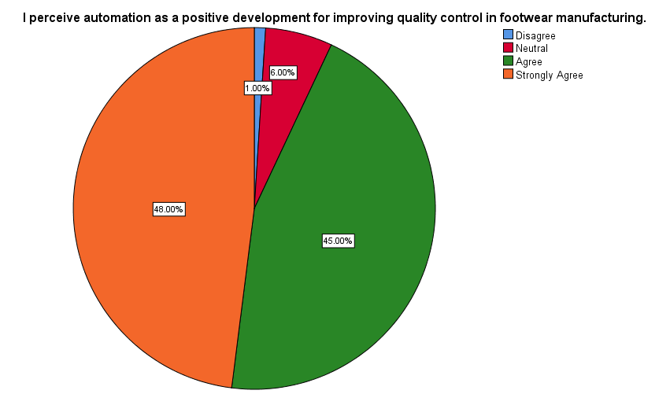
It was found that almost all the respondents perceive automation as a positive development for improving quality control in footwear manufacturing because of only 1% of respondents disagreed with the researcher.
N | Mean |  | Std. Deviation | Skewness |  | Kurtosis
Statistic | Statistic | Std. Error | Statistic | Statistic | Std. Error | Statistic | Std. Error
100 | 4.40 | .065 | .651 | -.850 | .241 | .699 | .478

Descriptive statistics analysis:
The mean score of 4.40 demonstrates strong agreement among respondents regarding the view of automation as a positive development. The lower standard division of 0.651 suggests limited variation in responses. The skewness value was -0.850 shows a negative skill signifying that responses were concentrated towards the higher end of the scale. The kurtosis value indicates a moderately peaked distribution reflecting a strong clustering of responses around the mean.

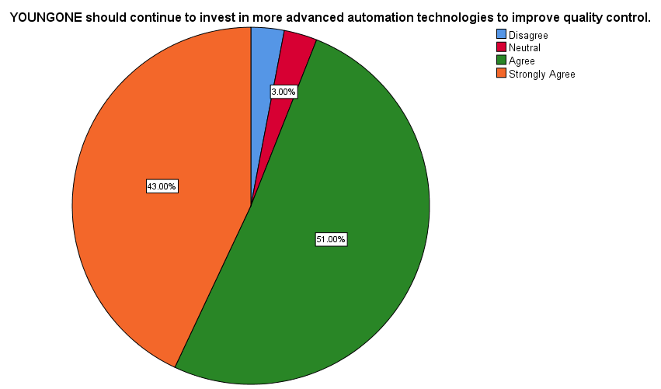
The researcher found that a combined aspect of 94% of respondents believe to invest in more advanced automation technologies by the company for improving quality control. 51% of the respondents agreed and another 43% of the respondents is strongly agreed the fact.
N | Mean |  | Std. Deviation | Skewness |  | Kurtosis
Statistic | Statistic | Std. Error | Statistic | Statistic | Std. Error | Statistic | Std. Error
100 | 4.34 | .068 | .685 | -1.132 | .241 | 2.197 | .478

Descriptive statistics analysis:
The mean value reflects a high level of agreement confirming that most respondents perceive further investment in automation process. The lower standard deviation suggests that responses were closely clustered around the mean. The skewness value was -1.132 demonstrates negative skew showing that responses were significantly concentrate towards the agree and strongly agree categories.
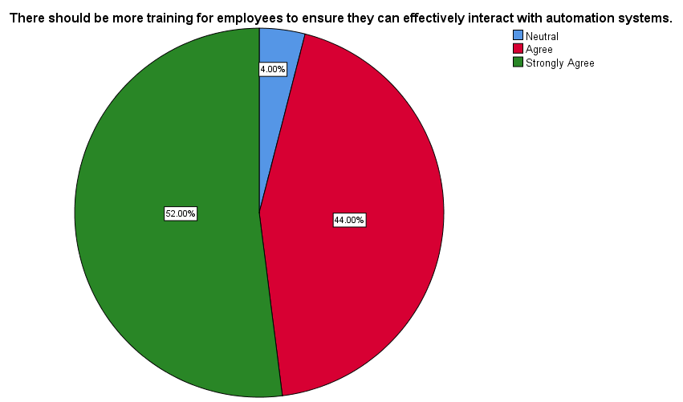
Almost all the respondents believe that more training for employees must be there to ensure they can effectively interact with the automation systems. Only 4% of the respondents did not make any opinion about the fact.
N | Mean |  | Std. Deviation | Skewness |  | Kurtosis
Statistic | Statistic | Std. Error | Statistic | Statistic | Std. Error | Statistic | Std. Error
100 | 4.48 | .058 | .577 | -.565 | .241 | -.641 | .478

Descriptive statistics analysis:
The mean value was high indicating that respondents significantly supported enhanced training initiatives. The low standard deviation suggests a high level of consistency in responses. The skewness value of -0.565 indicates the moderate negative skew. The kurtosis value of -0.641 indicates are slightly Kurtosis distribution.
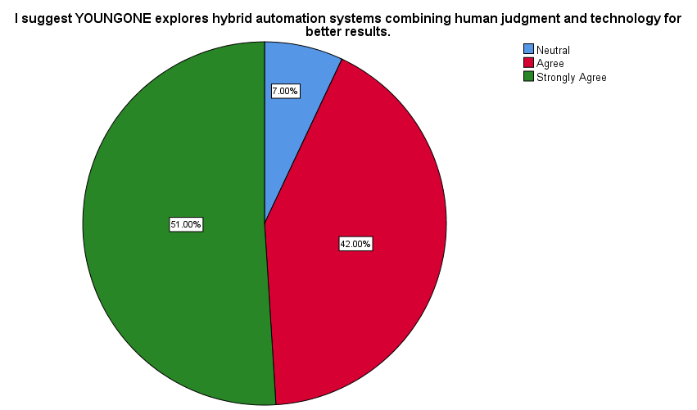
It was found that YOUNGONE can explore hybrid automation systems combining human judgment and technology for better results because of no disagreed respondent was there.
N | Mean |  | Std. Deviation | Skewness |  | Kurtosis
Statistic | Statistic | Std. Error | Statistic | Statistic | Std. Error | Statistic | Std. Error
100 | 4.44 | .062 | .625 | -.656 | .241 | -.508 | .478

Descriptive statistics analysis:
The mean score of 4.44 reflects a high level of agreement whereas the low standard deviation of 0.625 suggest limited variability in responses. The skewness value of -0.656 shows a negative skill meaning responses were concentrated toward the higher end of the scale. The kurtosis value of -0.508 indicates a slightly Kurtosis distribution.
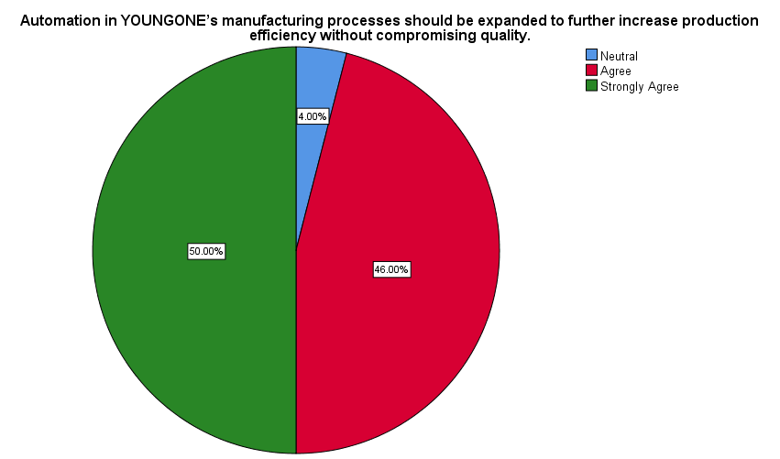
Almost all the respondents believe that automation in the manufacturing process of YOUNGONE should be expanded for further increasing production efficiency as a combination of 96% of respondents believe this.
N | Mean |  | Std. Deviation | Skewness |  | Kurtosis
Statistic | Statistic | Std. Error | Statistic | Statistic | Std. Error | Statistic | Std. Error
100 | 4.46 | .058 | .576 | -.488 | .241 | -.705 | .478

Descriptive statistics analysis:
The mean score indicates that respondents significantly support the expansion of automation initiatives. The low standard deviation also supports this aspect. The skewness value indicates a negative skew showing that responses were concentrated towards the higher end of the scale. The kurtosis value indicates a relatively even spread of responses without extreme outliers. 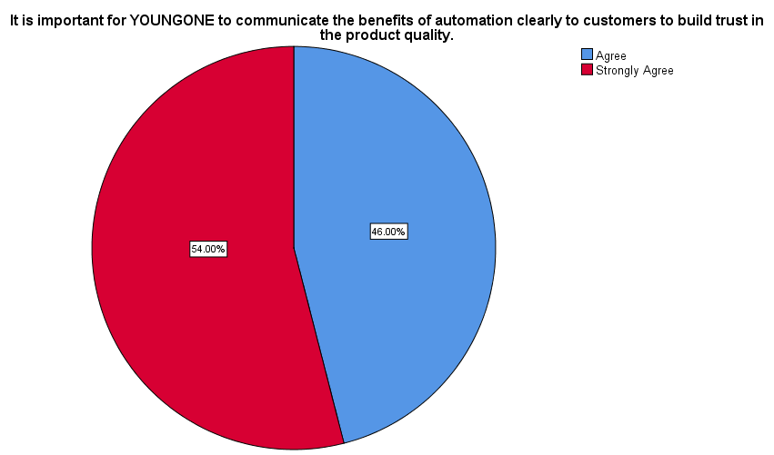The findings indicate that it is significant for the company to communicate the benefits of automation so that customers can build trust in the product quality. All the respondents agreed with the scenario because of there was no disagreement. Even 54% of the total respondents strongly agreed with the scenario.
N | Mean |  | Std. Deviation | Skewness |  | Kurtosis
Statistic | Statistic | Std. Error | Statistic | Statistic | Std. Error | Statistic | Std. Error
100 | 4.54 | .050 | .501 | -.163 | .241 | -2.014 | .478

Descriptive statistics analysis:
The mean value was high reflecting strong overall agreement confirming that respondents perceive transparent communication about automation as a critical factor. The low standard deviation suggests a high level of consistency in responses. The skewness value was -0.163 shows a slight negative orientation as responses were concentrated the upper end of the scale. The kurtosis value was -2.014 indicating a Kurtosis distribution.
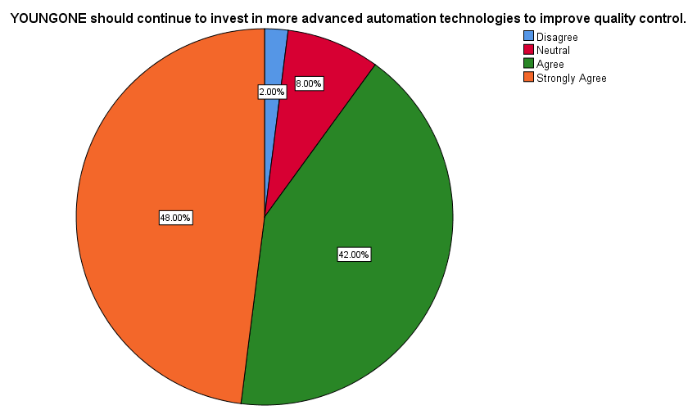

The researcher found that a combination of 90% of respondents believe that YOUNGONE should continue to invest in more advanced automation technologies for improving quality control. Only 8% of respondents did not make the opinions and another 2% of respondents disagreed with the researcher.
N | Mean |  | Std. Deviation | Skewness |  | Kurtosis
Statistic | Statistic | Std. Error | Statistic | Statistic | Std. Error | Statistic | Std. Error
100 | 4.36 | .072 | .718 | -.996 | .241 | .871 | .478

Descriptive statistics analysis:
The mean value of 4.36 indicates a high level of agreement confirming that most of the respondents perceive further automation investment as necessary for quality enhancement. The standard division was 0.718 indicating a moderate level of variability in responses. The skewness indicates a pronounced negative skew and the kurtosis value indicates a moderately peaked distribution.

4.3 Discussion
- Current State of Automation in YOUNGONE’s Shoe Production
YOUNGONE has implemented advanced automation technologies in their shoe production processes.
It is significant to focus highly on implementing advanced automation technologies as significant features to produce competitive footwear (Forlini et al., 2024). Global market orientation includes the necessity of executing advanced technologies so that competitive advantage can be obtained (Elhajjar, Yacoub, and Yaacoub, 2023). Suprajeni, Yopan, and Fitriati (2025) stated automation technologies including automated cutting, robotic systems, AI-driven inspection and programmable sewing machines enable organizations to determine standardization process of production through which operational reliability can be enhanced. Repetitive manual tasks are replaced with machine-based systems for improving precision and reducing variability. Footwear manufacturing signifies that dimensional accuracy can be obtained by maintaining material consistency where expectations of consumers can be met.
To obtain information from the respondents, “YOUNGONE has implemented advanced automation technologies in their shoe production processes” was asked. It was found that there was strong support from the respondents within the context of YOUNGONE. There was 79% of respondents as per combined agreement or strongly agreement that YOUNGONE has implemented advanced automation technologies in the shoe production process. The perception was reinforced by a high mean score of 4.11 which indicated that there was a strong consensus among respondents. Only 6% respondents disagreed to the scenario where 15% remained neutral suggesting that most of the respondents recognize the significance of automation within the production system of the company.
The level of automation in YOUNGONE’s shoe production is sufficient to meet global quality standards.
Singh (2025) mentions that organizations must maintain effective standard in terms of determining shoe production for the prospect of meeting global expectations and maintaining competitive advantage. Sufficiency mass predetermined effectively in that case to maintain global quality standards especially in relation to export oriented food we are manufacturers (Kotte et al., 2025). International brands must adopt automation to comply with related quality, safety and consistency requirements. Several theoretical aspects are maintained including Six Sigma frameworks (Gomaa, 2025), Total Quality Management and so on which highlight that automated system should support compliance by assuring standardized workflows (Shafa, 2025). Adequate automation signifies that manufacturers can maintain uniform quality across large scale orientations of production process.
To obtain information, I was placing this statement such as “The level of automation in YOUNGONE’s shoe production is sufficient to meet global quality standards” and it was found that the respondents perceived positive orientation regarding the automation process of YOUNGONE which is adequate for meeting global quality standards. Almost all the respondents provided positive orientation with the statement. The mean value was 3.69 which reflected a positive but slightly more moderate level of agreement compared to other automation indicators. Because of 23% of respondents disagreed suggesting that automation is largely viewed as sufficient but there remains scope for further enhancement for fulfilling the satisfaction.
Automation plays a significant role in improving the consistency of the products manufactured at YOUNGONE.
Maintaining production consistency is a fundamental orientation of automation-based manufacturing system (Risanty and Buwono, 2026). The Six Sigma principles indicate that consistency can be achieved by minimizing process variation through real-time control mechanisms (Bao et al., 2025). The automated cutting and sewing systems reduce discrepancies in maintaining component alignment and dimensions which are common sources of inconsistency regarding production of footwear. The theory of automation supports the orientation that machine-controlled processes overperform manual operations identically.
To obtain the information from the respondents, the researcher asked “Automation plays a significant role in improving the consistency of the products manufactured at YOUNGONE”. The researcher found that all the respondents provided positive agreement as automation improves consistency of product at YOUNGONE. There was a reflection in an exceptionally high mean score of 4.55 from the anonymous agreement. There was absence of neutral or negative response demonstrating their consistency improvements driven by automation it's quite positive and sufficient as automation place and effective role of the products manufactured at the company.
I believe that automation in YOUNGONE’s production process reduces human error in the final product.
Human error is a significant deal which disrupts the efficiency of automation process within the company (Korostin, 2025). Skill variability, subjective judgment and fatigue significantly enhance error rates in manual inspection and production processes (Lee, Zo, and Jeong, 2025). Automation theory determines that repetitive and precision-based activities are asserted for minimizing errors. Footwear manufacturing process is influenced from automated inspection and robotic handling process through which defects can be reduced. Even automated inspection and robotic handling are significant to maintain efficiency.
It was found that a combined 97% of respondents either a great or strongly agreed that automation reduces error of human in the final products of YOUNGONE. The company maintains advanced orientation of production process and technology through which human error is not intensified (IANS, 2019). There was a mean score of 4.40 which indicates a high level of confidence in terms of determining the automation process. There was only 3% of respondents expressed neutrality confirming that automation is widely perceived as an effective solution for minimizing human related quality defects.
- Consumer Perception of Automation’s Impact on Quality Control
Automation has improved the quality of YOUNGONE’s shoes.
Footwear manufacturing companies have the intention to improve quality so that they can obtain competitive advantage and ensure long-term growth in the market (Oliveira, Pereira and Oliveira, 2025). Automation enhances aesthetic quality as well as functional efficiency by ensuring proper stitching, reliable assembly and accurate cutting (Hasan et al., 2025). According to the theoretical aspect of Diffusion of Innovation, consumers are associated with technological aspects regarding advanced production process through which superior quality and durability can be maintained (Kong, 2025). Automation-driven Quality improvements positively influenced perception of brand and initial customer satisfaction.
It was found that almost all the respondents provided positive responses because of a substantial 95% of respondents either agreed or strongly agreed. They agreed to the aspect that the quality of young one shoes has been improved. The company focuses on maintaining high quality in terms of determining the production process of shoes. Even mean value was 4.38 indicating strong overall agreement. Only 5% of respondents expressed neutrality or disagreement indicating that automation-driven quality improvements are both noticeable and positively perceived.
I believe automated quality control in footwear manufacturing ensures more accurate defect detection.
It is significant to determine accurate defect detection for obtaining advantage of automated quality control systems (Dimitriou and Georgiou, 2025). Several technologies are included in this orientation including AI powered inspection system (Kong, 2025). Micro level defects can be consistently observed through the automated system. Continuous monitoring process can be determined effectively through which detection accuracy and reducing defective outputs can be improved in an identical manner.
I have found strong support regarding the claim. When it is asked “automated quality control in footwear manufacturing ensures more accurate defect detection” that the combination of 96% of respondents regarding agreement or a strong agreement that automated quality control ensures more accurate defect detection. Defect detection can be significantly influenced from the automated process and the study was reinforced by a high mean error of 4.43. that was minimal orientation of neutral or negative response confirming that respondents perceive automated inspection systems as highly reliable at YOUNGONE.
The use of AI-powered inspections by YOUNGONE improves product reliability.
It is significant to maintain product reliability orientation according to the prospect of maintaining efficiency and operational advancement. Proper inspection must be conducted in an effective way through which product reliability can be improved (Hasan et al., 2025). AI powered inspections signify reliability by detecting defects early and providing proper support for the prospect of improving efficiency. There are other technological aspects which can bring efficiency by reducing defects.
The findings provided significant aspect of strong support regarding this viewpoint. A combination of 95% of respondents who agreed or strongly agreed against the statement “The use of AI-powered inspections by YOUNGONE improves product reliability”. AI powered inspections improve reliability of product at YOUNGONE. Even the mean value was also high which was 4.55 highlighting strong confidence in AI based quality systems and the contribution to obtain long-term product performance.
I feel that automation in quality control leads to a reduction in product rejections.
Organizations focus significantly to reduce deficiency and maintain quality control which results to a reduction in product rejections (Tariq, 2025). Reduction of product rejection is highlighted significantly as a major benefit of automation-based quality control systems. The theoretical aspect of Six Sigma determines that defect prevention can be conducted through automated monitoring and process control. Manufacturers are allowed to detect deviations by maintaining automation process at earlier stages through which defective products can be prevented from progressing towards the production process (Pasupuleti, 2024). Automated inspections are very significant in footwear manufacturing through which inconsistencies can be reduced in association with stitching, bonding and material alignment.
To obtain information from the respective respondents, the researcher asked “Does automation in quality control leads to a reduction in product rejections”. The findings strongly supported the theoretical perspective. A combination of 95% agreement of respondents comprising 46% agreement and 48% is strong agreement. The respondents agreed that automation in quality control results to a reduction in product projections at YOUNGONE. The perception is supported by a high mean value of 4.42 indicating that the company focuses highly on maintaining automation in quality controls for reducing the product rejections. It was identical from the respondents that automated quality control is perceived significant in terms of minimizing rejection rates.
The introduction of robotic process automation (RPA) in YOUNGONE’s production has enhanced overall product quality.
Robotic process automation is a significant deal in maintaining efficiency and quality in overall production process. RPA enhances quality by ensuring stabilization in production workflows through which handling related errors can be reduced by ensuring consistency. Robotic handling systems reduce contamination risks and misalignment which are very significant in maintaining quality. Final product quality can be made and effectively by determining and signifying handling conditions. Overall quality enhancement is supported by RPA which is identical (Pasupuleti, 2024).
To obtain information from the respondents, the researcher asked this question “Does the introduction of robotic process automation (RPA) in YOUNGONE’s production has enhanced overall product quality” to them. It was found that positive role is played by RPA within the production system of YOUNGONE. Almost all respondents provided positive agreement because of there was high mean value of 4.43 indicating a strong consensus among respondents. It was acknowledged from the scenario that the company maintained robotic process automation in production process to ensure efficiency in the production system. There was no disagreement from the respondents suggesting the recognition of the contribution of RPA to determine quality improvement.
I perceive automation as a positive development for improving quality control in footwear manufacturing.
Automation signifies a strategic orientation in modern manufacturing process. Quality control can be enhanced by automation process through ensuring accuracy and variability in production process (Kong, 2025). Positive perception is determined from scenario in maintaining successful implementation of automation process to improve quality control in footwear manufacturing process.
To obtain information from the respondents, the researcher asks “Does automation as a positive development for improving quality control in footwear manufacturing”. It was found that automation determines a strategic and positive orientation because of a substantial 93% of respondents either a great or strongly agreed that automation is a positive development orientation for improving quality. Even mean value was also significant in supporting the strong agreement.
- Suggestions for Management at YOUNGONE
YOUNGONE should continue to invest in more advanced automation technologies to improve quality control.
Organizations must maintain proper investment in automation through which quality control can be improved. Long-term orientation of quality improvement can be signified by focusing on continuous investment process. Technological advancements require organizations to continuously upgrade the automation capabilities so that the purpose of ensuring efficiency in production process can be successful (Jamwal, Agrawal, and Sharma, 2023). Better defect detection and predictive maintenance can be conducted from the implementation of advanced technology which can be obtained by investing highly.
To obtain information, the researcher asked “YOUNGONE should continue to invest in more advanced automation technologies to improve quality control” to the respondents. It was found from the respondents that deposit positive orientation of agreement that proper investment must be continued by YOUNGONE in advance automation technologies for improving quality control. This was reinforced by the mean score of 4.34 indicating a high level of consensus. There was lower disagreement from respondents suggesting that continuous automation investment is widely significant and essential for ensuring quality.
There should be more training for employees to ensure they can effectively interact with automation systems.
Urbański et al. (2025) said that employees are the most significant individuals to ensure that the implementation of automation process in the system is successful. Employees play the most effective role because of without obtaining better performance from the employees, the purpose of developing the production system cannot be successful. According to Wasudawan, Weissmann, and Nwobodo (2025), the viewpoint of Technology Acceptance Model, percept is of use and user competence directly influence the effectiveness of automation systems. Employees must be provided with adequate training so that they can understand the requirement and improve efficiency according to the requirement.
To obtain information, the researcher asked this question to the respondents. The researcher found that the respondents think positive aspect of providing advanced training programs. Researcher found that the employees must be provided with regular and advanced trading facilities so that they can be able to improve skills and efficiencies. Effective interaction with automation systems can be ensured properly by signifying and maintaining proper training facilities. It was supported by the high mean value of 4.48 reflecting strong agreement.
I suggest YOUNGONE explores hybrid automation systems combining human judgment and technology for better results.
Automation system can be enabled and have loved by the combination of human judgment and technology for better results. The value of hybrid automation systems integrating Technological position with human judgment is positively signified (Haq et al., 2025). Accuracy can be maintained in a consistent way by focusing on human operations and tactical aspects (Jamwal, Agrawal, and Sharma, 2023). Aesthetic evaluation can be maintained positively particularly in footwear manufacturing process. Organizations are allowed to benefit from both machine efficiency and human expertise for enhancing overall quality outcomes.
The researcher asked the respondents this question to obtain proper information. Was found that a substantial combination of 93% respondents either agreed or a strongly agreed that YOUNGONE must explore hybrid automation systems. It was supported by a high mini score of 4.44 indicating that strong endorsement of the approach must be signified. There was very lower orientation of respondents regarding utility highlighting broad support for Making a balance of automation with human judgment.
Automation in YOUNGONE’s manufacturing processes should be expanded to further increase production efficiency without compromising quality.
Automation process must be expanded because of quality and efficiency can be simultaneously maintained according to the requirement of the organization. Scalable automation can enhance efficiency throughout the requirement of consistent quality standards (Haq et al., 2025). Real time monitoring process can be signified by expanding the automation process as firms are allowed to meet the standards. Defect rates can be reduced because of quality control helps organizations to determine proper mechanisms.
The researcher addressed “Automation in YOUNGONE’s manufacturing processes should be expanded to further increase production efficiency without compromising quality” to obtain information from the respondents. It was found that strong agreement was demonstrated from the combination of 96% of respondents according as they a great or strongly agreed that automation must be expanded in terms of increasing production efficiency. Even the mini score of 4.46 was very high to determine strong confidence in automation scalability. It was found that only 4% of respondents selected the neutrality option suggesting that automation expansion is signified as beneficial for the organization.
It is important for YOUNGONE to communicate the benefits of automation clearly to customers to build trust in the product quality.
Customers must be informed about the facilities and benefits of maintaining automation so that the organization can be able to build trust and transparency in assuring product quality. Value information should be increased so that the customers can trust the process (Shafa, 2025). Higher quality and consistency can be made and effectively by delivering proper information and maintaining clear communication system in terms of assuring quality control mechanism.
The researcher addressed this statement “It is important for YOUNGONE to communicate the benefits of automation clearly to customers to build trust in the product quality” to the respondents for obtaining proper information. It was found from the scenario that the process was supported from the findings because of 100% respondents either agreed or strongly agreed. They think that YOUNGONE should communicate clearly regarding the benefits of automation to customers so that customers can have proper orientation of transparency. Even high min value of 4.54 also reflects the significance of maintaining proper communication process.
YOUNGONE should continue to invest in more advanced automation technologies to improve quality control.
Organizations must focus on investing highly in more advanced automation technologies to improve quality control. It is a critical driver of effective college control in terms of maintaining efficiency in manufacturing process. Organizations are allowed to improve defect detection and accurate orientation by responding proactively (Haq et al., 2025). Advanced automation systems including AI driven inspection and predictive maintenance tools are significant for proper monitoring. Ongoing automation investment must be signified for sustaining compliance with international standards.
The researcher placed this statement such as “YOUNGONE should continue to invest in more advanced automation technologies to improve quality control” to the respondents to obtain the information. It was found that there was a strong support of this recommendation in the context of YOUNGONE. A combined 94% of respondents either agreed or strongly agreed that the company should focus on investing in more advanced automation technologies for improving quality control. The strong level of agreement was reflected by a high mini score of 4.34 indicating broad conscious among the respondents. It was suggested that the automation investment must be high for improving quality control within the organization.

4.4 Conclusion
This chapter demonstrated the role of information in improving quality control within shoe reduction process of YOUNGONE. Data collected from the respondents was interpreted through relevant theoretical and empirical findings. The quantitative findings proper evidence regarding perceptions of respondents of automation adoption and the impact on product quality as well as the role in enhancing operational effectiveness. The findings were discussed according to the data collection process for establishing the relation in association with the theories of automation, quality management, technology acceptance and so on. The outcomes revealed that YOUNGONE has made substantial progress in implementing advanced automation technologies across the production processes. Most of the respondents determined positive acknowledge the presence of automation and perceive the process as sufficient to support global quality standards. The respondents recognized automation process widely for its ability to improve product consistency and reduce human error as well as ensure accurate detection of defects. The outcomes closely align with quality management orientations through which efficiency in production process can be maintained.

Chapter 5: Conclusion and recommendations

5.1 Introduction
This chapter ends the research on the influence of automation procedures over quality control in the footwear industry, centring on YOUNGONE. This chapter summarizes the conclusions inferred from the initial phases of data collection and analysis. The other objective is to discuss the findings in relation to the research objectives and questions and make recommendations for management based on evidence that emerged from this study. The study's limitations have also been discussed in this chapter, with implications for further research.
Automation has been a strategic requirement for the global footwear manufacturing industry as quality requirements, cost pressures and international competition have increased. The study investigated the impact of automation technologies such as automatic cutting systems, robotic process automation, automatic sewing and AI-based inspection on quality control outcomes in YOUNGONE. The results show how in line automation is essential to improved product consistency, human error reduction and global quality compliance.

5.2 Justification of achieving research objectives
The research results present empirical evidence about the performance and efficiency of automation and footwear quality control.
The first objective of the research was to evaluate how much and what kind of automation use goes in shoe manufacturing sector while processing in YOUNGONE. Based on the results of this study, the company introduced state-of-the-art automation in majority production and quality control lines. The actions include automated cutting solutions, robotic process automation, programmable sewn automation and AI inspection tools.
The poll suggests a powerful case that automation is firmly entrenched in the company's factories. This study believes the high means and high levels of agreement also reflect the fact that automation is not applied in isolation, but is purposefully integrated to support consistent processes, precision manufacturing, and quality outputs. This perception verifies that automation is not a supporting tool at YOUNGONE, but an indispensable and efficient one. The results even correspond to the automation theory that machine-based processes are more reliable and less variable than manual ones. The level of automation developed by the company has reached a mature level and can now satisfy high-volume production requirements in compliance to global quality standards.
A second objective was to investigate perceptions about automation and shoe quality from YOUNGONE. The results show favourable attitudes among respondents, especially workers whose tasks involve directly in production-related areas and quality-inspecting work. People for the most part agree that automation allows better consistency of a product, lower likelihood of human-induced error, and better accuracy in defect detection. Thus, overall product reliability can be improved. The efficiency of the automation system in enhancing product uniformity was appreciated by all and forms an essential part of it. An exceptionally large percentage of respondents also concurred those automated inspections and those utilising AI enabled more accurate defect detection. The results reveal high reliance on automation to support quality controls, they support the development of quality control mechanisms and, that automation has changed for the better conventional inspection and evaluation traditions.
The attitudes are in line with those of the Technology Acceptance Model, whereby participants reported a high perceived usefulness of automation for quality outcomes. The positive outlook illustrates that employees consider automation as an innovation that optimizes rather than disrupts. The acceptance is important as well due to the fact that successful quality assurance automation depends not only on actual usability of the system by users, but also technological abilities to trust the automated systems.
The third research objective was the development of evidence-based recommendations for the management of YOUNGONE, which are performed here:

5.3 Recommendations
According to the study's findings, the following recommendations were implemented for YOUNGONE'S management.
- It is recommended to enhancing training and capacity building of workers despite the intervention of automation, which lessens dependence on blue-collar. The business will have to make substantial investments in running a permanent training program on machine use, data interpretation, AI system management and maintenance. A more efficient approach to the system's use can then be achieved, with greater employee competency and reduced downtime
- The integration of automation can be enhanced and the automated cutting, robotic handling and mechanics, vision inspection should all be better integrated. When developing a secure code, there is always the trade-off between tracing all steps in production and speeding up root cause analysis, seamless data flow between production stages can be achieved by addressing the improved traceability.
- This is to recommend to establish the collaboration between humans and machines, human judgment currently plays an indispensable role in aesthetic rating and sophisticated problem-solving. A hybrid approach to quality control is necessary, where automated inspections are supplemented with human oversight by experts.
- It is recommended to upgrade AI inspection capabilities to avoid misclassifying acceptable variations. AI models should be continuously refined using high-quality, diverse training data. It is also recommended to establish periodic calibration and system validation to improve accuracy.
- This is to suggest that AI inspection should be updated to avoid misidentifying acceptable variations. AI models need to be continuously updated with heterogeneous, high-quality training data. Semi-regular calibration and system validation are also encouraged to enhance accuracy.

5.4 Further study
Further studies can be performed with mixed methods use of qualitative and quantitative data. Information can be extracted by interviews or observation to obtain deeper understandings of automation. For objectiveness, only quantitative data has been considered in the study. Further research could be pursued by eliciting Qualitative insights from production managers, Quality engineer s and operators to gain a deeper understanding regarding the Human mission interaction, reluctance against automation and actual use problems. The analysis and the backing up would be made reflection of to allow for broader conclusions.
Longitudinal studies also could add to understanding of the effect of automation on quality performance. The study design was cross-sectional, and one time point of perceptions and quality outcomes were captured. A cohort design would be important to understand perspectives and quality results from different perspective mirrors and times. It would have been stronger causal evidence from their pros on how automation effects quality control over time.

5.5 Limitations of the study
The study is not without limitations. The study is cross-sectional in nature, and therefore measures opinions and practices at one point in time only. More definitive information on the long-term effects of automation should be revealed by a long-term trial. The research was based on a survey a data was quantities, with no possibilities to explore experiences of employees and how managers perceived this. Also, the concentration on one organization allows for generalizability to other shoemakers. Nevertheless, the demonstration and analysis were successful, and might reflect what other firms in this industry do or think.

5.6 Summary
The chapter finally drew the entire study to a close by testing and integrating the research findings to fulfil the research objectives. And practical proposals were offered in this chapter for YOUNGONE. The research has validated speeches that automation in the food and drinks industry delivers better quality through consist product with high defect detection accuracy and less human interferences. There was strong employee confidence also revealed in the empirical findings (robotic process automation, automated cutting system, AI-enabled inspection etc.). The tech is important because it helps quality control evolve from a mostly manual approach and a reactive process into something proactive and data-driven. The study also demonstrated automation proves to be effective only when complemented by factors as competent workforce development, system integration and continuous improvement. The results highlighted the need for a complementary technique using technology and human expertise.

Reference list
Abubakar, A.S. (2024) ‘Adopting Digital Technology to Drive Resource Efficiency in Manufacturing’, Apollo (University of Cambridge) [Preprint]. Available at: https://doi.org/10.17863/cam.108569 (Accessed: 1 December 2025).
Adil, A., Khan, A. and Ahmad, P. (2025) ‘Comparative Analysis of Positivism and Interpretivism in Social Science Research’, SSRN Electronic Journal [Preprint]. Available at: https://doi.org/10.2139/ssrn.5071639 (Accessed: 1 December 2025).
Ahamad, M., Uddin, S., Priya, Gayatri and Biradar, A. (2025) ‘AUTOMATIC HANDOPERATED SEWING MACHINE FOR DIFFERENTLY ABLED PEOPLE USING SOLAR POWER AND MOTOR WITH SOME SPECIAL ADDED FEATURES LIKE LIGHTING AND CHARGING CAPACITY’, JOURNAL OF ADVANCE AND FUTURE RESEARCH, 3(2), pp. 80–8580–85. Available at: https://rjwave.org/jaafr/viewpaperforall.php?paper=JAAFR2502012 (Accessed: 1 December 2025).
Ahinful, A.A., Mensah, A.O., Koomson, S., Cobblah, C., Takyi, G. and Kwarteng, A.H. (2024) ‘Achieving banking industry innovation performance using total quality management: an empirical study’, The TQM journal [Preprint]. Available at: https://doi.org/10.1108/tqm-10-2023-0327 (Accessed: 1 December 2025).
Ali, I.M. (2024) ‘A Guide for Positivist Research Paradigm: from Philosophy to Methodology’, Idealogy Journal, 9(2), pp. 187–196. Available at: https://doi.org/10.24191/idealogy.v9i2.596 (Accessed: 1 December 2025).
Amal, A. (2023) ‘Smart Systems And The Fashion Industry: The Shift From Manual Labor To Automated Systems’, Cuestiones de Fisioterapia, 54(3), pp. 3145–3150. Available at: https://doi.org/10.48047/zqgp8670 (Accessed: 1 January 2026).
Ansari, Md.A.A. (2025) ‘Adoption of RPA in Audit Practices: Comparative Insights From Bangladesh’s Key Export Sectors’, Journal of Economics, Business, and Commerce, 2(1), pp. 181–199. Available at: https://doi.org/10.69739/jebc.v2i1.549 (Accessed: 13 December 2025).
Assidi, S., Omran, M., Rana, T. and Borgi, H. (2025) ‘The role of AI adoption in transforming the accounting profession: a diffusion of innovations theory approach’, Journal of Accounting & Organizational Change [Preprint]. Available at: https://doi.org/10.1108/jaoc-04-2024-0124 (Accessed: 16 December 2025).
Ayu, K.R., Khusna, I.H. and Herliana, M. (2025) ‘Diffusion of Innovation Strategy to Preserve Traditional Culture’, Jurnal Riset Komunikasi (JURKOM), 8(1), pp. 37–50. Available at: https://doi.org/10.38194/jurkom.v8i1.1136 (Accessed: 16 December 2025).
Bagherian, A. and Kondala, M. (2025) ‘Smart factory technologies and their transformative implications: a Blavaan and Bayesian SEM’, Total Quality Management & Business Excellence, pp. 1–24. Available at: https://doi.org/10.1080/14783363.2025.2458257 (Accessed: 19 December 2025).
Bagnardi, F. (2025) ‘Garment-footwear industry and the devaluation of labour: uneven and combined production networks in Europe’s peripheries’, Edward Elgar Publishing eBooks, pp. 145–160. Available at: https://doi.org/10.4337/9781035347940.00017 (Accessed: 23 December 2025).
Bao, N., Yang, Y., Fan, Y. and Simeone, A. (2025) ‘Optimising apparel production in Industry 5.0 using a human-centric flexible manufacturing approach’, The International Journal of Advanced Manufacturing Technology, 139(3-4), pp. 1881–1895. Available at: https://doi.org/10.1007/s00170-025-15987-w (Accessed: 14 December 2025).
Bell, E., Bryman, A. and Harley, B. (2019) Business Research Methods. 5th edn. Oxford University Press.
Bottani, E., Matteo and Monferdini, L. (2025) ‘Evolution of Industry 4.0 in the Fashion Sector: A Comparative Analysis Before and After COVID-19’, Procedia Computer Science, 253, pp. 2889–2898. Available at: https://doi.org/10.1016/j.procs.2025.02.013 (Accessed: 12 January 2026).
Chitwood, I.J. (2024) ‘Digital Thesis Room: UNDERSTANDING WORK: A CRITICAL EXPLORATION OF INDUSTRY 4.0 TECHNOLOGIES IN ADVANCED MANUFACTURING’, Athabascau.ca [Preprint]. Available at: http://hdl.handle.net/10791/463 (Accessed: 5 December 2025).
Dagilienė, L., Varaniūtė, V. and Banionienė, J. (2024) ‘Cultivating a sustainable and circular economy: The role of institutional logics in manufacturing companies’, Journal of Cleaner Production, 434, pp. 140363–140363. Available at: https://doi.org/10.1016/j.jclepro.2023.140363 (Accessed: 7 December 2025).
Dezi, L., Hysa, X., Calabrese, M. and Mercuri, F. (2022) ‘Open Total Quality Management in the Circular Economy age: a social enterprise perspective through the case of Patagonia’, Total Quality Management & Business Excellence, 36(3-4), pp. 1–15. Available at: https://doi.org/10.1080/14783363.2022.2051698 (Accessed: 11 December 2025).
Dias, P.A., Petry, M.R. and Rocha, L.F. (2024) ‘The Role of Robotics: Automation in Shoe Manufacturing’, 2024 20th IEEE/ASME International Conference on Mechatronic and Embedded Systems and Applications (MESA), pp. 1–8. Available at: https://doi.org/10.1109/mesa61532.2024.10704834 (Accessed: 14 December 2025).
Dimitriou, E. and Georgiou, A. (2025) ‘Automatic Inspection Systems Cut Quality Control Costs by 60%’, National Journal of Quality, Innovation, and Business Excellence, 2(1), pp. 23–33. Available at: https://theeducationjournals.com/index.php/NJQIBE/article/view/147 (Accessed: 7 December 2025).
Dulal, T.D. (2025) ‘Application of Positivism and Post Positivism approach in Contemporary Research’, International Journal of Applied Research and Sustainable Sciences, 3(4), pp. 305–314. Available at: https://doi.org/10.59890/ijarss.v3i4.22 (Accessed: 13 December 2025).
Elhajjar, S., Yacoub, L. and Yaacoub, H.K. (2023) ‘Automation in business research: systematic literature review’, Information Systems and E-business Management, 21, pp. 675–698. Available at: https://doi.org/10.1007/s10257-023-00645-z (Accessed: 18 December 2025).
Farmakis, T., Eleni, A. and Doukidis, G. (2025) ‘Implementing Digital Transformation Through Robotic Process Automation’, Palgrave Studies in Cross-disciplinary Business Research, In Association with EuroMed Academy of Business, pp. 25–47. Available at: https://doi.org/10.1007/978-3-031-89798-6_2 (Accessed: 21 December 2025).
Fife, S.T. and Gossner, J.D. (2024) ‘Deductive Qualitative Analysis: Evaluating, Expanding, and Refining Theory’, International Journal of Qualitative Methods, 23(1), pp. 1–12. Available at: https://doi.org/10.1177/16094069241244856 (Accessed: 23 December 2025).
Forlini, M., Ciccarelli, M., Carbonari, L., Papetti, A. and Palmieri, G. (2024) ‘Smart automation in luxury leather shoe polishing: a human centric robotic approach’, International Journal of Computer Integrated Manufacturing, 38(9), pp. 1–15. Available at: https://doi.org/10.1080/0951192x.2024.2421313 (Accessed: 24 December 2025).
Gamage, A.N.K.K. (2025) ‘Research design, philosophy, and quantitative approaches in scientific research methodology’, Scholars Journal of Engineering and Technology, 13(02), pp. 91–103.
Ghalambor, M.A. and Firozpour, A. (2025) ‘Future-proofing footwear: Scenario-based sustainable innovation for SDG alignment in Iranian MSMEs within the textile industry’, Journal of the International Council for Small Business, pp. 1–25. Available at: https://doi.org/10.1080/26437015.2025.2502044 (Accessed: 24 December 2025).
Goddard, W. and Melville, S. (2021) Research Methodology. 2nd edn. Juta & Co., Repr.
Gomaa, A.H. (2025) ‘Leading with excellence: Critical leadership dimensions in Lean Six Sigma for business excellence’, Human Resources Management and Services, 7(2), p. 4399. Available at: https://doi.org/10.18282/hrms4399 (Accessed: 14 December 2025).
Hammad, M., Panaousis, M., Ali, H. and Khan, W.A. (2025) ‘Smart Manufacturing in Automotive Industry’, Springer Series in Advanced Manufacturing, pp. 47–85. Available at: https://doi.org/10.1007/978-3-032-00214-3_3 (Accessed: 21 December 2025).
Haq, U.N., Rahman, M., Khan, A.M., Hasanuzzaman, Md. and Hossain, M.R. (2025) ‘Global initiatives for industry 4.0 implementation and progress within the textile and apparel manufacturing sector: a comprehensive review’, International Journal of Computer Integrated Manufacturing, pp. 1–26. Available at: https://doi.org/10.1080/0951192x.2025.2455655 (Accessed: 13 January 2026).
Hasan, M.M., Kasedullah, M., Baki, M. and Khan, H. (2025) ‘AI-Driven Quality Control in Manufacturing and Construction: Enhancing Precision and Reducing Human Error’, Applied IT & Engineering, 3(1), pp. 1–10. Available at: https://doi.org/10.25163/engineering.3110270 (Accessed: 26 December 2025).
Huang, Z. and Sahari, F. (2025) ‘Implications of fit customization in the apparel industry: an analytical study’, Research Journal of Textile and Apparel [Preprint]. Available at: https://doi.org/10.1108/rjta-04-2025-0078 (Accessed: 12 December 2025).
IANS (2019) Why Youngone is Keen to Setup its facility in Telangana?, siliconindia. Available at: https://www.siliconindia.com/news/general/why-youngone-is-keen-to-setup-its-facility-in-telangana-nid-211460-cid-1.html (Accessed: 29 January 2026).
Islam, M.R., Hossain, Z., Rayed, Md.E., Kabir, M.M., Mridha, M.F., Nishimura, S. and Shin, J. (2024) ‘Deep Learning and Computer Vision Techniques for Enhanced Quality Control in Manufacturing Processes’, IEEE Access, 12, pp. 1–1. Available at: https://doi.org/10.1109/access.2024.3453664 (Accessed: 29 December 2025).
Jamwal, A., Agrawal, R. and Sharma, M. (2023) ‘Challenges and opportunities for manufacturing SMEs in adopting industry 4.0 technologies for achieving sustainability: Empirical evidence from an emerging economy’, Operations Management Research [Preprint]. Available at: https://doi.org/10.1007/s12063-023-00428-2 (Accessed: 2 January 2026).
Kiron, M.I. (2021) Global Scenario of Automation in Garment Manufacturing Industry, Textile Learner. Available at: https://textilelearner.net/automation-in-garment-industry/ (Accessed: 29 January 2026).
Kong, R.W.M. (2025) ‘Innovative Automated Stretch Elastic Waistband Sewing Machine for Garment Manufacturing’, International Research Journal of Modernization in Engineering Technology and Science [Preprint]. Available at: https://doi.org/10.56726/irjmets70275 (Accessed: 29 January 2026).
Korostin, O. (2025) ‘Analysis of AI Effectiveness in Reducing Human Errors in Processing Transportation Requests’, arXiv.org [Preprint]. Available at: https://doi.org/10.5281/zenodo.13786097 (Accessed: 14 January 2026).
Kotte, K.R., Thammareddi, L., Kodi, D., Anumolu, V.R., Kumar K, A. and Joshi, S. (2025) ‘Integration of Process Optimization and Automation: A Way to AI Powered Digital Transformation’, pp. 1133–1138. Available at: https://doi.org/10.1109/ce2ct64011.2025.10939966 (Accessed: 15 January 2026).
Krueger, J.I., Grüning, D.J., Heck, P. and Freestone, D. (2024) ‘Inductive Reasoning Model’, Psychological Inquiry, 35(1), pp. 11–25. Available at: https://doi.org/10.1080/1047840x.2024.2366766 (Accessed: 14 January 2026).
Kruger, F. and Mitchell, B. (2022) Research methodology. Oxford University Press.
Kumar A, D. (2025) ‘Factors that Influence Customer Intention to Buy Adidas Product’, Brand Strategy Quarterly, 1(1), pp. 15–31. Available at: https://doi.org/10.64229/4m31qy83 (Accessed: 9 January 2026).
Kumar, D. (2024) ‘From tradition to technological advancement: embracing blockchain technology in family businesses’, Journal of Family Business Management, 15(2). Available at: https://doi.org/10.1108/jfbm-08-2024-0161 (Accessed: 4 January 2026).
Kumar, S. (2024) ‘INDUCTIVE AND DEDUCTIVE APPROACHES TO QUALITATIVE RESEARCH’, IJMER, 13(4), pp. 58–63. Available at: http://ijmer.in.doi./2024/13.1.69.
Lee, K., Zo, H. and Jeong, M. (2025) ‘Understanding user acceptance of robotic process automation: the user resistance perspective’, Industrial Management & Data Systems, 125(3), pp. 1000–1022. Available at: https://doi.org/10.1108/imds-07-2024-0628 (Accessed: 5 January 2026).
Lenk, D. and Taesler, J. (2025) ‘Quality Control during the Sewing Process’, pp. 192–204. Available at: https://doi.org/10.1201/9781003293071-10 (Accessed: 29 January 2026).
Liang, H. (2025) Generative AI in fashion design process: Insights from Chinese practitioners, Aalto.fi. Available at: https://aaltodoc.aalto.fi/items/513a68dc-cac4-4c10-ab2d-e96013ec265e (Accessed: 2 December 2025).
Lim, A.-F., Ooi, K.-B., Lee, V.-H., Tan, G.W.-H. and Sohal, A. (2025) ‘Examining the nexus: supply chain quality management, knowledge sharing, organizational innovation and strategic business performance’, Industrial Management & Data Systems, 125(5). Available at: https://doi.org/10.1108/imds-05-2024-0441 (Accessed: 2 December 2025).
Mansour, H., Abohashima, H., Elkhouly, H. and Harraz, N. (2025) ‘Smart quality control: integrating six sigma, machine learning and real-time defect prediction in manufacturing’, International Journal of Lean Six Sigma, 16(6), pp. 1415–1447. Available at: https://doi.org/10.1108/ijlss-07-2024-0150 (Accessed: 6 December 2025).
Marslev, K. and Whitfield, L. (2025) ‘Why do labor regimes change? Worker power, the supplier squeeze, and structural transformation in the global apparel industry’, Journal of Economic Geography [Preprint]. Available at: https://doi.org/10.1093/jeg/lbae049 (Accessed: 3 December 2025).
Mastour, H., Yousefi, R. and Niroumand, S. (2025) ‘Exploring the acceptance of e-learning in health professions education in Iran based on the technology acceptance model (TAM)’, Scientific Reports, 15(1). Available at: https://doi.org/10.1038/s41598-025-90742-5 (Accessed: 2 December 2025).
Nayak, R., Quang, H.T. and Pal, R. (2025) ‘Recent Trends in the Role of Digital Technologies in Fashion and Textile Manufacturing’, Springer series in fashion business, pp. 1–23. Available at: https://doi.org/10.1007/978-981-97-7528-6_1 (Accessed: 2 December 2025).
Oishe, F.J. (2025) ‘Exploring Indigenous Female Migrant’s Experiences of Harassments: A Qualitative Study’, International Journal of Research and Innovation in Social Science, 9(11), pp. 5715–5722. Available at: https://doi.org/10.47772/ijriss.2025.91100447 (Accessed: 21 December 2025).
Oliveira, J., Pereira, C. and Oliveira, A. (2025) ‘The impact of exogenous shocks on strategy, business models and product development in the Portuguese footwear industry’, International Journal of Organizational Analysis [Preprint]. Available at: https://doi.org/10.1108/ijoa-08-2024-4706 (Accessed: 23 December 2025).
Pan, D. (2025) ‘Strategic Assessment of Crocs, Inc.: Navigating Market Challenges and Leveraging Growth Opportunities’. Available at: https://doi.org/10.2139/ssrn.5125201 (Accessed: 2 December 2025).
Panyaram, S. and Kotte, K.R. (2025) ‘Leveraging AI and Data Analytics for Sustainable Robotic Process Automation (RPA) in Media’, Advances in Business Strategy and Competitive Advantage, pp. 249–262. Available at: https://doi.org/10.4018/979-8-3693-9750-3.ch013 (Accessed: 2 December 2025).
Papavasileiou, A., Michalos, G. and Makris, S. (2024) ‘Quality control in manufacturing – review and challenges on robotic applications’, International journal of computer integrated manufacturing, pp. 1–37. Available at: https://doi.org/10.1080/0951192x.2024.2314789 (Accessed: 28 December 2025).
Pasupuleti, S. (2024) ‘Robotic Process Automation for Enhancing Workflow Automation in Multi-System Environments’, Zenodo [Preprint]. Available at: https://doi.org/10.5281/zenodo.14598763 (Accessed: 22 December 2025).
Precedence Research (2026) Automotive Quality Inspection AI System Market Size to Hit USD 3,196.53 Million by 2035, Precedenceresearch.com. Precedence Research. Available at: https://www.precedenceresearch.com/automotive-quality-inspection-ai-system-market (Accessed: 29 January 2026).
Qudus, L. (2025) ‘Leveraging Artificial Intelligence to Enhance Process Control and Improve Efficiency in Manufacturing Industries’, International Journal of Computer Applications Technology and Research, 14(2), pp. 18–38. Available at: https://doi.org/10.7753/ijcatr1402.1002 (Accessed: 17 December 2025).
Rahaman, Md.T., Khan, Md.S.H. and Pranta, A.D. (2025) ‘Sustainable approaches to fashionable denim fading: New perspectives on conventional and modern garment washing techniques’, Coloration Technology [Preprint]. Available at: https://doi.org/10.1111/cote.70043 (Accessed: 23 December 2025).
Rana, M. (2025) ‘INTEGRATING AGILE PROJECT MANAGEMENT AND LEAN INDUSTRIAL PRACTICES A REVIEW FOR ENHANCING STRATEGIC COMPETITIVENESS IN MANUFACTURING ENTERPRISES’, ASRC Procedia: Global Perspectives in Science and Scholarship, 01(01), pp. 895–924. Available at: https://doi.org/10.63125/0yjss288 (Accessed: 22 December 2025).
Risanty, R.D. and Buwono, H.K. (2026) ‘INTELLIGENT AUTOMATION-BASED MANUFACTURING SYSTEM OPTIMIZATION IMPROVES THE PRODUCTION EFFICIENCY OF MEDIUM-SCALE INDUSTRIES’, Journal of Scientia Technologiae , 1(1), pp. 1–18. Available at: https://ejournal.grafindoscience.com/jst/article/view/62 (Accessed: 31 January 2026).
Saunders, M., Lewis, P. and Thornhill, A. (2019) Research Methods for Business students. 8th edn. Pearson.
Shafa, H. (2025) ‘ARTIFICIAL INTELLIGENCE-DRIVEN BUSINESS INTELLIGENCE MODELS FOR ENHANCING DECISION-MAKING IN U.S. ENTERPRISES’, ASRC Procedia: Global Perspectives in Science and Scholarship, 01(01), pp. 771–800. Available at: https://doi.org/10.63125/b8gmdc46 (Accessed: 14 December 2025).
Singh, H. (2025) ‘Artificial Intelligence and Robotics Transforming Industries with Intelligent Automation Solutions’, SSRN Electronic Journal [Preprint]. Available at: https://doi.org/10.2139/ssrn.5267868 (Accessed: 16 December 2025).
Singh, K., Yadav, M., Singh, Y., Barak, D., Saini, A. and Moreira, F. (2024) ‘Reliability on the Internet of Things with designing approach for exploratory analysis’, Frontiers in Computer Science, 6. Available at: https://doi.org/10.3389/fcomp.2024.1382347 (Accessed: 16 December 2025).
Song, Y., Qiu, X. and Liu, J. (2025) ‘The Impact of Artificial Intelligence Adoption on Organizational Decision-Making: An Empirical Study Based on the Technology Acceptance Model in Business Management’, Systems, 13(8), p. 683. Available at: https://doi.org/10.3390/systems13080683 (Accessed: 13 December 2025).
Suprajeni, M.R., Yopan, M. and Fitriati, R. (2025) ‘Innovation Through AI Integration: A Study of AI Technology Adoption for the Maritime Inspection and Consulting Sector using Soft System Methodology’, Golden Ratio of Social Science and Education, 5(1), pp. 238–244. Available at: https://doi.org/10.52970/grsse.v5i1.1174 (Accessed: 24 December 2025).
Taoufik, E.F. (2025) ‘Optimizing Quality Control with AI-Powered Machine Vision in Manufacturing : A Study of Machine Vision Technology in Manufacturing’, Theseus.fi [Preprint]. Available at: http://www.theseus.fi/handle/10024/891731 (Accessed: 2 December 2025).
Tariq, M.U. (2025) ‘AI-Powered Business Process Automation’, Advances in finance, accounting, and economics book series, pp. 199–224. Available at: https://doi.org/10.4018/979-8-3693-7357-6.ch010 (Accessed: 2 December 2025).
Technavio (2025) Automation Market Analysis - US, China, India, Pakistan, Germany - Size and Forecast 2024-2028, www.technavio.com. Available at: https://www.technavio.com/report/automation-market-in-textile-industry-analysis (Accessed: 2 December 2025).
Thi, L., Thi, H., Do, L.T., Huynh, T.V., Ta, T.D. and Thi, A. (2025) ‘The Advancement of Computer-Aided Design and Computer-Aided Manufacturing in the Fashion Apparel Industry: Toward a Sustainable Development’, Springer series in fashion business, pp. 125–166. Available at: https://doi.org/10.1007/978-981-97-7528-6_7 (Accessed: 2 December 2025).
Urbański, M., Haque, A.U., Lang, J.W. and Kozlovski, E. (2025) ‘The impact of total quality management and business networks on company export performance in emerging vs. developed economies: evidence from furniture enterprises in Pakistan and the UK’, European J of International Management, 25(2), pp. 257–284. Available at: https://doi.org/10.1504/ejim.2025.143863 (Accessed: 14 December 2025).
Villamin, P., Lopez, V., Thapa, D. and Cleary, M. (2024) ‘A Worked Example of Qualitative Descriptive Design: A Step‐by‐Step Guide for Novice and Early Career Researchers’, Journal of Advanced Nursing, 81(8). Available at: https://doi.org/10.1111/jan.16481 (Accessed: 14 December 2025).
Vu, H., Leopold, H. and van (2025) What is Business Process Automation Anyway?, arXiv.org. Available at: https://arxiv.org/abs/2506.10991 (Accessed: 2 December 2025).
Wai, R. (2025) ‘Automated Seam Folding and Sewing Machine on Pleated Pants for Apparel Manufacturing’, arXiv.org [Preprint]. Available at: https://doi.org/10.5281/zenodo.16607787 (Accessed: 21 December 2025).
Wai, R., Ning, D. and Ho, T. (2025) ‘AI Intelligent learning for Manufacturing Automation’, International Journal of Mechanical and Industrial Technology, 13(1), pp. 1–9. Available at: https://doi.org/10.5281/zenodo.15159741 (Accessed: 23 December 2025).
Wasudawan, K., Weissmann, M.A. and Nwobodo, S. (2025) ‘Small and medium-sized enterprises perceived trust towards social media: applying the extended technology acceptance model’, Journal of Asia Business Studies, 19(4), pp. 1085–1103. Available at: https://doi.org/10.1108/jabs-12-2024-0701 (Accessed: 24 December 2025).
Xo’jabekovich, X.O. and Shaxlo, X. (2025) ‘Design and Management Structure of Garment Enterprises Based on Digital Technologies’, International Conference of Economics, Finance and Accounting Studies, 16, pp. 107–111. Available at: https://top-conferences.us/index.php/ICEFAS/article/view/1673 (Accessed: 1 December 2025).

Appendix

Literature review (Mind-map)

Questionnaire
This is to inform you (Respondents) that this study is doing only for academic purposes. I do not have any intention to share this report/finding to social media platform or any publisher. As a result, you will be anonymised here. No personal information will be asking here excluding age, sex.
- Age:
- 18-25
- 26-35
- 36-45
- 46-55
- 55 or above
- Sex:
- Male
- Female
- Current State of Automation in YOUNGONE’s Shoe Production
Statement | Strongly Agree | Agree | Neutral | Disagree | Strongly Disagree
- YOUNGONE has implemented advanced automation technologies in their shoe production processes.
- The level of automation in YOUNGONE’s shoe production is sufficient to meet global quality standards.
- Automation plays a significant role in improving the consistency of the products manufactured at YOUNGONE.
- I believe that automation in YOUNGONE’s production process reduces human error in the final product.

- Consumer Perception of Automation’s Impact on Quality Control
Statement | Strongly Agree | Agree | Neutral | Disagree | Strongly Disagree
- Automation has improved the quality of YOUNGONE’s shoes.
- I believe automated quality control in footwear manufacturing ensures more accurate defect detection.
- The use of AI-powered inspections by YOUNGONE improves product reliability.
- I feel that automation in quality control leads to a reduction in product rejections.
- The introduction of robotic process automation (RPA) in YOUNGONE’s production has enhanced overall product quality.
- I perceive automation as a positive development for improving quality control in footwear manufacturing.

- Suggestions for Management at YOUNGONE
Statement | Strongly Agree | Agree | Neutral | Disagree | Strongly Disagree
- YOUNGONE should continue to invest in more advanced automation technologies to improve quality control.
- There should be more training for employees to ensure they can effectively interact with automation systems.
- I suggest YOUNGONE explores hybrid automation systems combining human judgment and technology for better results.
- Automation in YOUNGONE’s manufacturing processes should be expanded to further increase production efficiency without compromising quality.
- It is important for YOUNGONE to communicate the benefits of automation clearly to customers to build trust in the product quality.
- YOUNGONE should continue to invest in more advanced automation technologies to improve quality control.

Raw data


Data analysis (SPSS)



