Student name: Samita Andreea Ciodar
Student code: 2409229
Module name: Sustainable Hospitality
Module code : BMIH4011
Lecture’s name : Daniel Payne
Green Haven Hotel – Concept
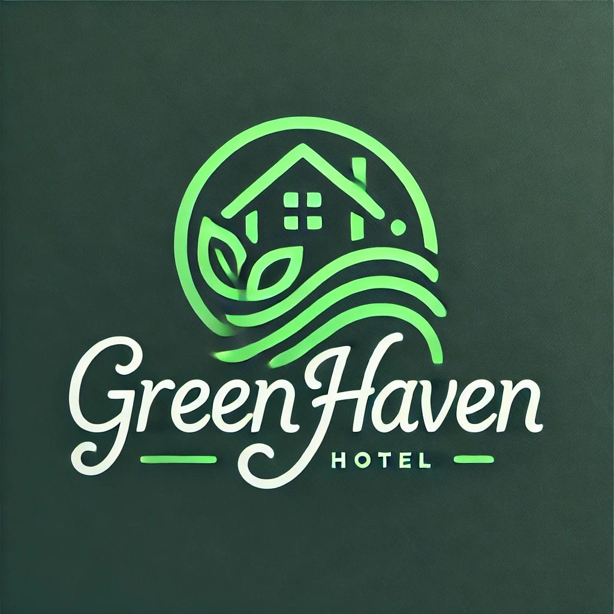
I confirm that I have not used any AI tools in the research and creation of this assignment. I confirm that I have not presented any AI generated materials as my own work. I confirm I have copies of my drafts, notes, and other resources I used, which I may be asked to provide in evidence.

Contents
Hotel Overview 3
Sustainability Vision 3
Sustainability Mission Statement 4
Unique sustainable features 4
Sustainable Practices and Strategies 5
Guest Experience 8
Conclusion 9
Reference List 10

Hotel Overview
Green Haven is an environmentally conscious riverside hotel located in Giurgiu, Romania, along the Danube River. With its historical charm and proximity to Bucharest, Giurgiu offers a unique blend of urban life and natural beauty, making it an ideal location for both local and international visitors. The hotel combines the convenience of city infrastructure with a strong commitment to sustainability, ensuring its presence positively contributes to the city’s development without harming the environment.
Designed for families and eco-tourists, Green Haven provides a welcoming atmosphere for travellers who value sustainability. The hotel offers family-friendly amenities, including spacious rooms, educational programs, and activities focused on environmental awareness (Impact Hotels, 2024). Families can engage in nature walks, birdwatching, sustainability workshops, and enjoy organic, locally sourced meals that support local agriculture and reduce the carbon footprint (Martinez, 2025).
Eco-tourists are drawn to Green Haven’s commitment to responsible tourism, with its energy-efficient systems, water conservation practices, and sustainable materials (GGI Insights, 2024). Guests can participate in eco-tours, boat rides along the Danube (Adventure-life, 2025), and guided tours of local conservation efforts, promoting environmental stewardship and providing a deeper understanding of the region's ecosystems.
Green Haven serves as a hub for relaxation and education, allowing guests to experience the natural beauty of the Danube River and surrounding landscapes while embracing sustainable tourism practices.

Sustainability Vision
The vision of Green Haven Hotel is to become the leading eco-friendly hotel in Romania, setting new standards for sustainable tourism while enriching the local community and inspiring responsible travel for future generations (Zafar, 2025).
Green Haven Hotel is dedicated to providing an eco-conscious, sustainable hospitality experience that minimises environmental impact while offering guests a comfortable and enriching stay (Business Conceptor, 2025). By prioritising local sourcing, reducing waste through a zero-waste philosophy, and offering educational eco-tours, Green Haven aims to inspire guests to embrace sustainability in their own lives (Martinez, 2025). The hotel strives to create a harmonious balance between modern hospitality and environmental stewardship, ensuring that every aspect of its operations contributes positively to the planet and the communities it serves (Harper, 2024).

Sustainability Mission Statement
The Green Haven Hotel’s mission is to provide a welcoming atmosphere where guests can enjoy personalised service while experiencing the best of both modern amenities and nature(Pearson, 2024). The hotel aims to lead by example in responsible tourism by implementing energy-efficient systems, water conservation practices, and sustainable building materials (Williams, 2024).
The hotel strives to create spaces where guests can unwind in an eco-friendly environment, all while learning about sustainability and environmental stewardship (The Hospitality Daily, 2023). By offering eco-tourism activities, educational programs, and nature-based experiences, Green Haven encourages its guests to connect with the environment in a meaningful way (Brooking, 2025). Through these efforts, the hotel aims to provide not just a stay, but an opportunity for guests to become more conscious of their ecological footprint, helping to foster a greater appreciation for sustainable living and the natural world (EHL Insights, 2025).
Green Haven Hotel strives for excellence in sustainable hospitality and is committed to meeting the highest industry standards. In line with its mission, the hotel is working towards achieving green certification, such as Green Key (Green Key, 2025) or LEED (Usgbc, 2022), to officially recognise its dedication to reducing environmental impact and promoting responsible tourism (Sustainable Hospitality Alliance, 2021).

Unique sustainable features
In developing Green Haven Hotel's sustainability initiatives, a distinctive feature that sets it apart from existing accommodations in Giurgiu is the integration of a green living wall (Rubens Hotels, 2022). This vertical garden not only enhances the aesthetic appeal of the hotel's interior spaces but also offers significant environmental benefits, such as improving air quality and promoting biodiversity (The Mind of Griff, 2024).
Green Haven Hotel also takes an initiative-taking approach to waste management by implementing a composting system for organic waste generated by its kitchens and gardens. This system transforms food scraps, garden trimmings, and other organic materials into valuable compost, which can then be used to enrich the soil for future planting and landscaping projects. By diverting organic waste from landfills, the hotel reduces its environmental impact while contributing to a circular economy, which keeps materials and products in circulation for as long as possible (EPA, 2024).
This initiative not only helps minimise waste but also supports sustainable gardening practices, ensuring that Green Haven’s green spaces continue to thrive. Through this composting system, Green Haven demonstrates its commitment to environmental stewardship and reinforces its role as a leader in sustainable tourism in Giurgiu.

Sustainable Practices and Strategies
Green Haven Hotel adopts a comprehensive approach to sustainability, embedding eco-conscious practices throughout its operations to minimise environmental impact while providing guests with an exceptional and responsible hospitality experience.
By integrating innovative technologies and engaging with the local community, the hotel not only offers an eco-friendly stay but also fosters a deeper connection between guests and sustainable practices. The hotel's sustainability strategy spans across the three pillars of sustainability: environment, social and economic (Simon, 2024).
- Energy Efficiency
Green Haven Hotel is committed to reducing its energy consumption through the integration of solar panels on the roof (Morch, 2023). These solar panels harness renewable energy to supplement the hotel's power needs, reducing its reliance on conventional energy sources and lowering its carbon footprint (April, 2024). To further enhance energy efficiency, the hotel has installed energy-efficient LED lighting throughout the property, ensuring that lighting is bright yet consumes minimal power. Additionally, smart thermostats and motion sensors are used in guest rooms and public spaces, ensuring that energy is used only when needed. These systems work together to optimise energy consumption, significantly cutting down on waste while maintaining a comfortable environment for guests (Child, 2023).
- Water Conservation
Water conservation is a priority at Green Haven Hotel. To promote responsible water use, the hotel has implemented a rainwater harvesting system, capturing rainwater for non-potable purposes such as irrigation and toilet flushing (Impact Hotels, 2024). This system reduces the demand for municipal water and decreases the hotel's overall water consumption. In addition, the hotel has installed low-flow faucets, shower heads, and toilets in all guest rooms and shared areas, which help minimise water waste while maintaining an excellent guest experience. These measures not only help conserve water but also demonstrate the hotel’s commitment to sustainable practices (Earth site, 2025).
- Waste Reduction
Green Haven Hotel follows a strict zero-waste policy designed to reduce its environmental footprint. All recyclable and compostable materials are diverted from landfills to be processed in-house (EHL Graduate School, 2024). The hotel has implemented an efficient composting system that manages organic waste, including food scraps from the kitchen and garden trimmings. This waste is converted into rich compost, which is then used to improve the soil in the hotel’s gardens (Hollak, 2022). By reducing waste in this way, the hotel supports a circular economy, ensuring that materials are reused and reintroduced into the system rather than discarded.
- Materials and Construction
The construction and design of Green Haven Hotel were carefully planned with sustainability in mind. The hotel priorities the use of locally sourced materials, such as reclaimed wood, which reduce the environmental impact associated with transportation and promote the use of renewable resources (UrDesign, 2024). The hotel’s commitment to energy efficiency extends to its green roofing and insulated windows, which minimise heat loss and enhance the building’s overall thermal performance (Floricic, 2020). One of the hotel’s standout features is its green living wall, a vertical garden that provides aesthetic value, improves indoor air quality, and serves as a natural insulator, reducing the need for additional heating and cooling (Rubens Hotel, 2022).
- Food and Beverage
In its commitment to sustainability, Green Haven Hotel supports local agriculture by sourcing food from nearby organic farms. This practice not only supports the local economy but also reduces the carbon footprint associated with long-distance transportation of food (Capella Hotels, 2023). The hotel emphasises sustainable fishing practices, sourcing fish from eco-conscious suppliers who are dedicated to preserving aquatic ecosystems, which aligns with the SDG 14 - Life Below Water, which is about conserving and sustainably using the oceans, seas and marine resources (Klein, 2019; UN ORG, 2025). To further reduce waste, the hotel offers a zero-waste menu that focuses on portion-controlled dishes and sustainable cooking methods. Any food scraps are composted to contribute back to the hotel’s gardens, ensuring that nothing goes to waste (Hilton, 2024).
- Community Engagement
Green Haven Hotel is deeply committed to engaging with and supporting the local community. The hotel collaborates with environmental organisations to promote sustainability initiatives and works to raise awareness of eco-tourism practices in the region (CBRE, 2023). The hotel regularly hosts educational workshops for both guests and locals, covering topics like eco-tourism, renewable energy, and waste reduction. These workshops empower individuals with the tools they need to make more sustainable choices in their everyday lives, contributing to the broader community’s environmental consciousness (Hotelchamp Team, 2023).
- Sustainable Transportation
To further its commitment to sustainability, Green Haven Hotel promotes eco-friendly travel. The hotel offers electric vehicle (EV) charging stations for guests traveling with electric cars, reducing the need for fossil fuels (Montgomery, 2024). Additionally, guests are encouraged to explore the beautiful surroundings of Giurgiu in an environmentally responsible manner with bicycle rentals, making it easy and enjoyable to travel around the area in a sustainable way (Vasiliu, 2024).
By embedding these sustainable practices into every aspect of its operations, Green Haven Hotel not only provides an environmentally responsible hospitality experience but also empowers its guests to participate in and learn about sustainability (Goswami, 2023). Through its energy-efficient systems, water-saving measures, waste-reduction strategies, and community engagement, the hotel is setting new standards in sustainable tourism, while providing a relaxing and enriching stay for all visitors.

Guest Experience
At Green Haven Hotel, the sustainable practices not only minimise the hotel’s environmental impact but also enrich the guest experience, offering a unique and meaningful stay. By implementing eco-friendly practices such as solar energy, rainwater harvesting, and locally sourced food, guests are immersed in a hospitality experience that prioritises sustainability without compromising comfort or luxury (Mise en place, 2025). The hotel's green living wall, which serves as both an aesthetic feature and a natural air purifier, enhances the environment, providing a serene and refreshing atmosphere that guests can enjoy while exploring the hotel’s sustainable spaces (Ecobrooklyn, 2025).
Guests will benefit from the opportunity to engage directly with sustainability through various educational initiatives designed to raise awareness and foster a deeper connection to the local environment (Nagy, 2022). Eco-tours will guide guests through the hotel’s green spaces, explaining the benefits of the rainwater collection system, composting initiatives, and sustainable materials used in the building’s construction. These tours will also highlight local conservation efforts and the importance of sustainable tourism in the region (Greenify Hub, 2024).
In addition, Green Haven Hotel will offer guests the chance to participate in volunteer programs focused on environmental stewardship. These could include activities like helping with garden maintenance or participating in community clean-up events (Darmstadt, 2024). Guests have the opportunity to engage in volunteer activities within the nearby Comana Natural Park, such as habitat restoration and conservation projects (Comana Park, 2025).
As part of the broader Danube region's conservation efforts, guests can join activities like the Danube Volunteers Day, where they can assist in nature protection tasks alongside local communities. This initiative not only supports regional biodiversity but also connects guests with like-minded individuals enthusiastic about environmental preservation (Danube Parks, 2020).
By encouraging guests to take part in these programs, the hotel fosters a sense of responsibility and connection to the natural world, helping guests become active participants in sustainability efforts.

Conclusion
Green Haven Hotel is a pioneering sustainable hospitality destination situated in Giurgiu, Romania, blending modern comforts with environmentally responsible practices. By focusing on energy efficiency, water conservation, waste reduction, and community engagement, the hotel offers a unique experience for families and eco-tourists. With features like solar panels, a green living wall, and composting initiatives, Green Haven goes beyond just providing accommodation - it offers guests a meaningful opportunity to engage with sustainability.
Overall, Green Haven Hotel strives to create an immersive and educational experience that allows guests to enjoy a sustainable stay while learning how to incorporate eco-friendly practices into their own lives, long after they have checked out (Mise en place, 2025).
The hotel’s dedication to local sourcing, eco-tours, and volunteer programs further enhances its commitment to environmental preservation (Goswami, 2023). Green Haven Hotel not only provides a comfortable and educational stay but also encourages guests to adopt sustainable practices in their own lives, contributing to a more responsible future for tourism in Romania.

Reference List
Adventure-life (2025) Giurgiu Danube River Cruises, Trips, & Tours. Travel made your way. Available at: https://www.adventure-life.com/romania/giurgiu (Accessed: 20 March 2025)
April, L. (2024) Solar and the Hospitality Industry: Hotels Leading the Green Movement. Available at: https://www.energymatters.com.au/renewable-news/solar-and-the-hospitality-industry-hotels-leading-the-green-movement/ (Accessed: 28 March 2025)
Brooking, F. (2025) 10 Rewarding Ecotourism Activities to Do Around the World. Available at: https://littlelosttravel.com/ecotourism-activities/ (Accessed: 20 March 2025)
Business Conceptor (2025) Building an Eco Hotel: A Comprehensive Guide with Examples. Available at: https://businessconceptor.com/blog/business-guides/eco-hotel-complete-guide/#:~:text=An%20eco%20hotel%20focuses%20on%20sustainability%2C%20using%20eco-friendly,a%20lodging%20facility%20that%20prioritizes%20environmentally%20responsible%20operations (Accessed: 20 March 2025)
Capella Hotels (2023) Capella Hotel Group’s Properties Herald Earth Day with Implementation of Sustainable Food and Beverage Initiatives and Expansion of Existing Programs. Available at: https://capellahotels.com/assets/docs/global/Capella_Hotel_Group_Earth_Day_Initiatives_2023.pdf (Accessed: 03 April 2025)
CBRE (2023) Sustainability and ESG Adoption in the Hotel Industry: A Global Status Update. Available at: https://www.cbre.com/insights/reports/sustainability-and-esg-adoption-in-the-hotel-industry (Accessed: 03 April 2025)
Child, N. (2023) How energy efficiency in the hotel industry is reshaping the guest experience. Available at: https://bdcmagazine.com/2023/11/how-energy-efficiency-in-the-hotel-industry-is-reshaping-the-guest-experience/ (Accessed: 03 April 2025)
Comana Park (2025) Proiecte. Available at: https://comanaparc.wixsite.com/parc-comana/projects (Accessed: 15 April 2025)
Danube Parks (2020) Danube Volunteers Day. Available at: https://danubeparks.org/initiatives/danube-volunteers-day (Accessed: 15 April 2025)
Darmstadt (2024) Social Projects that change Lives: Sustainable Hotels serving the Community. Available at: https://www.greenpearls.com/newsroom/en/hotels-serving-the-community-social-projects-that-change-lives/# (Accessed: 15 April 2025)
Design (2024) Guide to sustainable hotel design. Available at : https://www.urdesignmag.com/a-2024-guide-to-sustainable-hotel-design/ (Accessed: 03 April 2025)
Designhub1610 (2023) Sustainable Hospitality: A Guide to Eco-Friendly Design for Hotels and Resorts. Available at: https://designhub1610.com/sustainable-hospitality-a-guide-to-eco-friendly-design-for-hotels-and-resorts/ (Accessed: 20 March 2025)
Earth site (2025) Sustainable water management (irrigation, urban use). Available at: https://www.earth-site.co.uk/Education/sustainable-water-management-irrigation-urban-use/ (Accessed: 03 April 2025)
Ecobrooklyn (2025) Living Walls for Hotels: 5 Eye-Catching Examples of Green Hospitality. Available at: https://ecobrooklyn.com/living-wall/living-walls-for-hotels/ (Accessed: 15 April 2025)
EHL Graduate School (2024) Hotel sustainability: Challenges and solutions. Available at: https://hospitalityinsights.ehl.edu/hotel-sustainability-challenges-and-solutions (Accessed: 03 April 2025)
EHL Insights (2025) Sustainability Trends in Hospitality: Strategies and Examples. Available at: https://hospitalityinsights.ehl.edu/hotel-sustainability-trends (Accessed: 21 March 2025)
EPA (2024) What is a Circular Economy?. Available at: https://www.epa.gov/circulareconomy/what-circular-economy (Accessed: 07 May 2025)
Floricic, T. (2020) Sustainable Solutions in the Hospitality Industry and Competitiveness Context of “Green Hotels”. Available at: https://www.researchgate.net/publication/341843864_Sustainable_Solutions_in_the_Hospitality_Industry_and_Competitiveness_Context_of_Green_Hotels (Accessed: 03 April 2025)
GGI Insights (2024) Sustainable Tourism: Balancing Travel with Environmental Preservation. Available at: https://www.graygroupintl.com/blog/sustainable-tourism (Accessed: 20 March 2025)
Goswami, S. (2023) Enhancing Hotel Success Through Community and Business Collaborations. Available at: https://www.ezeeabsolute.com/blog/hotels-collaboration-with-local-businesses-community/ (Accessed: 15 April 2025)
Green Key (2025) Unlocking sustainability in the hospitality industry. Available at: https://www.greenkey.global/ (Accessed: 21 March 2025)
Greenify Hub (2024) Eco Friendly Ideas for Hotels: Embrace Sustainability in 9 Steps. Available at: https://greenifyhub.com/green-living/eco-friendly-ideas-for-hotels-embrace-sustainability-in-9-steps/#Closing_Thoughts (Accessed: 15 April 2025)
Harper, S. (2024) Hospitality Design Trends 2025 from Wimberly Interiors. Available at: https://hoteldesigns.net/industry-news/hospitality-design-trends-2025-wimberly-interiors/ (Accessed: 20 March 2025)
Hilton (2024) Hilton Launches Zero Waste Menus Across Flagship UK Hotels. Available at : https://stories.hilton.com/emea/sustainability/hilton-launches-zero-waste-menus-across-flagship-uk-hotels (Accessed: 03 April 2025)
Hollak, M. (2022) Green Hospitality: A Guide to Successful Composting in Hotels. Available at: https://www.mundea.com/post/green-hospitality-a-guide-to-successful-composting-in-hotels (Accessed: 03 April 2025)
Hotelchamp Team (2023) 5 reasons why hotels should engage with their local community. Available at: https://www.hotelchamp.com/blog/5-reasons-hotels-engage-local-community (Accessed: 03 April 2025)
Impact Hotels (2024) Eco-Friendly Accommodations for Family Travel: Sustainable Stays for an Impactful Experience. Available at: https://www.impacthotels.co/post/eco-friendly-family-accommodations (Accessed: 20 March 2025)
Impact Hotels (2024) Water Conservation in Hotels: Innovative Solutions for Sustainable Travel. Available at : https://www.impacthotels.co/post/water-conservation-hotels-sustainable-travel (Accessed: 03 April 2025)
Klein, J. (2019) This international hotel’s attempt to move to sustainable fish is a lesson in the hard path to sustainability. Available at: https://www.fastcompany.com/90421348/this-international-hotel-groups-attempt-to-move-to-sustainable-fish-is-a-lesson-in-the-hard-path-to-sustainability (Accessed: 04 April 2025)
Martinez, D. (2025) Eco-Conscious Outdoor Activities for Families: Tips for Planning Low-Impact Adventures with Kids. Available at: https://www.wastefreewilderness.com/articles/eco-outdoor-activities-families (Accessed: 20 March 2025)
Mise en place (2025) Sustainable Hospitality: Building an Eco-Friendly Hotel Experience. Available at: https://traininghotels.com/2025/04/10/sustainable-hospitality-implementing-eco-friendly-practices-in-hotels/ (Accessed: 15 April 2025)
Montgomery, J. (2024) EV Charging Stations for Hotels (Full Guide). Available at: https://evsegeek.com/ev-charging-stations-for-hotels/ (Accessed: 03 April 2025)
Morch, A. (2023) Implementing renewable energy in hotels. Available at : https://insights.ehotelier.com/insights/2023/04/17/implementing-renewable-energy-in-hotels/#:~:text=This%20technology%20uses%20photovoltaic%20%28PV%29%20panels%20to%20convert,batteries%20for%20use%20during%20periods%20of%20low%20sunlight (Accessed: 28 March 2025)
Nagy, A. (2022) How to engage guests and visitors on your sustainability journey. Available at: https://greenstep.ca/how-to-engage-guests-and-visitors-on-your-sustainability-journey/ (Accessed: 15 April 2025)
Pearson, N. (2024) Best Sustainability Statements: 7 Examples For Inspiration. Available at: https://peaksci.com/blog/sustainability-statements (Accessed: 21 March 2025)
Rubens Hotel (2022) Celebrating 10 years of our green living wall. Available at: https://rubenshotel.com/discover/make-travel-matter/celebrating-10-years-of-our-green-living-wall?utm_source=chatgpt.com (Accessed: 21 March 2025)
Simon (2024) 3 Pillars Of Sustainability Explained (Guide & Examples). Available at: https://sustainability-success.com/three-pillars-of-sustainability/ (Accessed: 07 May 2025)
Sustainable Hospitality Alliance (2021) Hotel sustainability certifications. Available at: https://sustainablehospitalityalliance.org/wp-content/uploads/2021/06/Certifications-factsheet.pdf (Accessed: 21 March 2025)
The Hospitality Daily (2023) Sustainability in the Hospitality Industry: A Comprehensive Guide. Available at: https://thehospitalitydaily.com/sustainability-in-hospitality-industry/ (Accessed: 07 May 2025)
The Mind of Griff (2024) Vertical Gardens: Transforming Urban Spaces with Living Walls and Botanical Libraries. Available at: https://www.msn.com/en-us/urban-infrastructure/environmental-sustainability/vertical-gardens-transforming-urban-spaces-with-living-walls-and-botanical-libraries/ar-AA1u19iB#:~:text=Vertical%20gardens%2C%20also%20known%20as%20living%20walls%20or,but%20also%20offers%20numerous%20environmental%20and%20health%20benefits (Accessed: 28 March 2025)
UN ORG (2025) Goal 14 Conserve and sustainably use the oceans, seas and marine resources. Available at: https://www.un.org/sustainabledevelopment/oceans/ (Accessed: 07 May 2025)
Usgbc (2022) What is LEED certification? Available at: https://support.usgbc.org/hc/en-us/articles/4404406912403-What-is-LEED-certification#:~:text=LEED%20%28Leadership%20in%20Energy%20and%20Environmental%20Design%29%20is,framework%20for%20healthy%2C%20efficient%2C%20and%20cost-saving%20green%20buildings (Accessed: 21 March 2025)
Vasiliu, O. (2024) Via Danubiana: A new ecotourism route along the Danube unveiled in Giurgiu County. Available at: https://business-review.eu/sustainability/community-involvement/via-danubiana-a-new-ecotourism-route-along-the-danube-unveiled-in-giurgiu-county-275440 (Accessed: 03 April 2025)
Williams, T. J. (2024) Mission and Vision Statements for Hotels: 19+ Examples. Available at: https://businessplannerhq.com/mission-and-vision-statements-for-hotels/ (Accessed: 20 March 2025)
Zafar, S. (2025) The Role of Transformative Green Hotels in Sustainable Tourism. Available at: https://www.ecomena.org/role-of-transformative-green-hotels-in-sustainable-tourism/ (Accessed: 20 March 2025)

