The CIPD introduced its Profession Map in 2009 revamping its standards and delivering a new approach to career development (Berry, 2009). The map was revised in 2013, and a new, updated map has just been launched in November 2018. The Profession Map is a navigation tool that helps the HR professional get from where they are now to where they want to be. HR professionals must have business knowledge and be credible if they are to have any impact on the culture and values of an organisation. The Profession Map is a framework which details the competencies and sets out the standards they need to operate and progress throughout their careers i.e. the activities, knowledge and behaviours needed for success. (CIPD, 2015; Orme, 2009; Woodhams, Perkins and Wilkinson, 2016).

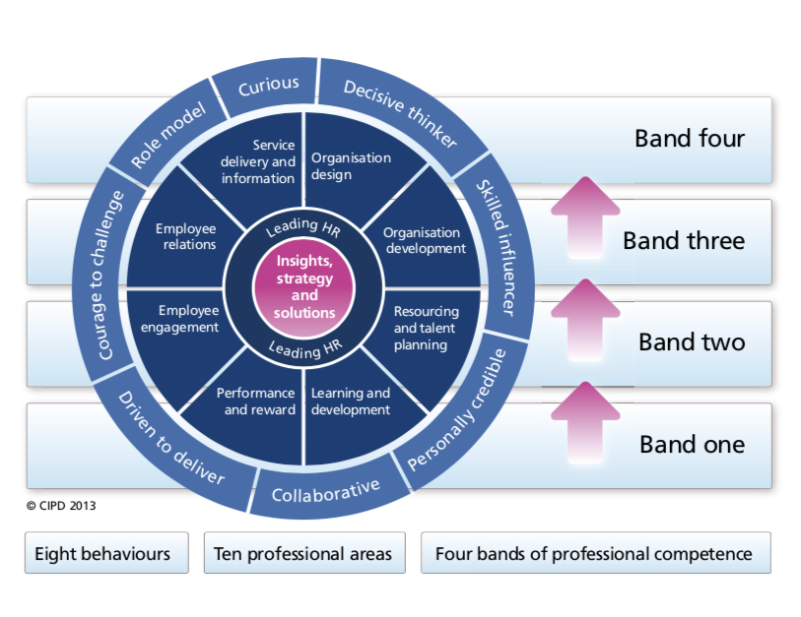The CIPD Profession Map, (CIPD, 2015, p.4).

The map consists of ten professional areas, eight behaviours and four bands of professional competence. It can be used to help professional development and plan the careers of all professionals regardless of their role or level within an organisation, from those at the start of their careers through to the most senior leaders (CIPD, 2015). “The professional areas cover what you need to know and what you need to do it. The behaviours cover how you need to do things” (Orme, 2009, p.41). The four bands of professional competence define what professionals need to do at each stage of their career, what they need to do to make the transition to the next band and progress their career by providing focus and guidance on developmental planning and activities (CIPD, 2015).

The Profession Map helps to identify strengths and areas for development against the required knowledge, skills and behaviours and allows the practitioner to assess themselves in the areas relevant to their current role or a future role they would like to move into (CIPD, 2018). In this way, the map is essential for professional growth and is a key framework for Continuous Professional Development (CPD). CPD is about investing in ourselves, building up our own knowledge and expertise and managing our own learning and growth so that we can add value to our organisation and keep at the forefront in a continuously changing environment (CIPD, 2018; Woodhams, Perkins and Wilkinson, 2016).

Of the ten professional areas, two are at the heart of the map: Insights, strategy and solutions and Leading HR. Insights, strategy and solutions considers the knowledge, skills and behaviours needed to develop an understanding of the organisation and are used to meet the needs of the organisation. Leading HR requires the professional to act as a role model to maximise the contribution that HR makes throughout the organisation, not only through their own efforts but by developing and supporting others (CIPD, 2015; Woodhams, Perkins and Wilkinson, 2016). The other eight professional areas will be relevant to individuals depending on their specific role in the organisation. For example, those involved with recruitment will find Resourcing and Talent Planning more relevant than Performance and Reward. In this way, the CIPD Profession Map accommodates the diversity of the HR profession. Also, the map defines the activities in these ten professional areas and describes the transition through the bands of professional competence from junior to senior roles (Woodhams, Perkins and Wilkinson, 2016). The map is interactive and allows the user to choose which professional areas and behaviours they wish to assess and at which level of professional competence. This feature promotes a focused approach to development by delivering feedback and suggested learning through small, manageable objectives.

The Profession Map also describes in detail the eight behaviours required by the HR professional to carry out activities to affect business outcomes. They are important because they describe how the professional can perform credibly and effectively. Each behaviour has a set of contra-indicators which highlight negative aspects of the behaviour. This helps the individual assess how they demonstrate each of the behaviours to others and provides an awareness of where they need to focus their energies to develop further (Meintjes, 2010). Clarke (2010) adds that understanding how to develop these behaviours can help keep the HR professional one step ahead. The map is a valuable tool for development as it helps the HR professional understand what they need to do, where they need to develop, and how they need to behave to progress from one level to the next throughout their career. It allows the professional to identify their own behaviour and start to build a plan of improvement to advance up the career ladder (Meintjes, 2010).

Many organisations have a Code of Conduct, or Code of Ethics, which set out the standards of behaviour and professionalism expected of their employees by customers and other stakeholders. It defines actions and behaviours which are acceptable and unacceptable to ensure and enhance the organisation’s credibility, integrity and reputation. An organisation with an ethical culture improves morale, enhances its reputation and will outperform its peers financially in the long term (Institute of Business Ethics, 2017). HR professionals have a key role in facilitating an ethical culture and have a responsibility to their organisation, and the profession, to uphold ethical standards. Courage to challenge is one of the eight behaviours of the HR Profession Map and HR professionals are required to challenge bad behaviour or unethical conduct (CIPD, 2012).

The eight behaviours identified and included in the HR Profession Map are essential for professional development and both personal and professional credibility. HR professionals are able to embed them into the development of their own personal standards and professionalism. They are able to learn how to improve and develop over time as they progress from one band of professional competence to the next. They provide the framework for behaviour for all professionals at all levels from those starting their career in HR and as they advance to more senior roles (Woodhams, Perkins and Wilkinson, 2016).

References
Berry, M. (2009) ‘CIPD revamps standards with HR profession map’, Personnel Today, Apr 28, 2009; p. 14. Available from: https://search-proquest-com.ezproxy.uwtsd.ac.uk/docview/229927429/fulltextPDF/A9596D72F5584206PQ/1?accountid=130472 (Accessed 4th November 2018)

CIPD (2012) ‘CIPD’s new code of conduct reflects stewardship role of HR in upholding organisational standards’. People Management Magazine. April 2012, p.13. Available from: http://eds.b.ebscohost.com/eds/pdfviewer/pdfviewer?vid=2&sid=8326f1a6-b146-4eb0-a9ce-385f88495f30%40sessionmgr102 (Accessed 8th November 2018)

CIPD (2015) CIPD Profession Map [online]. Chartered Institute of Personnel and Development. Available at: http://www.cipd.co.uk/binaries/the-cipd-profession-map_2015.pdf (Accessed 4th November 2018)

CIPD (2018) My CPD Map [online]. Chartered Institute of Personnel and Development. Available at: www.cipd.co.uk/learn/cpd/map (Accessed 9th November 2018)

Clarke, R. (2010) ‘How to Boost Your Personal Credibility’. People Management Magazine, 9th December, 2010, p.52. Available from: http://eds.a.ebscohost.com/eds/pdfviewer/pdfviewer?vid=8&sid=806866e7-47de-47b7-ad39-fb7369fb6234%40sdc-v-sessmgr06 (Accessed 8th November 2018)

Institute of Business Ethics (2017) ‘Business Ethics and the Role of HR’, Chartered Institute of Personnel and Development, 14th June, 2017. Available from: https://www.cipd.co.uk/knowledge/culture/ethics/role-hr-factsheet#23800 (Accessed 8th November 2018)

Meintjes, R. (2010) ‘An Inquiry into Being Curious’. People Management Magazine, 30 September, 2010, P.40. Available from: http://eds.a.ebscohost.com/eds/pdfviewer/pdfviewer?vid=6&sid=806866e7-47de-47b7-ad39-fb7369fb6234%40sdc-v-sessmgr06 (Accessed 8th November 2018)

Meintjes, R (2010) ‘Make the Right Career Choice’. People Management Magazine, 14th October, 2010, p.58. Available from: http://eds.a.ebscohost.com/eds/pdfviewer/pdfviewer?vid=19&sid=806866e7-47de-47b7-ad39-fb7369fb6234%40sdc-v-sessmgr06 (Accessed 8th November 2018)

Orme, J. (2009) ‘Mapping out the future’, Training Journal, October 2009; pp. 38-41. Available from: https://search-proquest-com.ezproxy.uwtsd.ac.uk/docview/202953957/abstract/2F3495FDB8F841E6PQ/1?accountid=130472 (Accessed 4th November 2018)

Woodhams, C., Perkins, G. and Wilkinson, K. (2016) ‘Developing the Knowledge and Skill of the HR Professional’ in Taylor, S. and Woodhams, C. (eds.) Studying human resource management. 2nd ed. London: Chartered Institute of Personnel and Development.

