Independent project
Saffron Carthew

Title: How do Beauty Standards and Social Media effect mental health and body image in women?

Name: Saffron Carthew

Student Number: 1907206

Programme: independent project
Code: ADAA6000

Module: Independent Inquiry

Supervisor: Professor Sue Williams

Date of submission: 10/12/2021

Word count: 5340
(not including titles, title page, illustration list, subheadings, references, bibliography, table of contents)

Table of contents

Table of contents; Pg.3

List of illustrations; pg.4-6

Introduction; Pg 7-8
(Word count = 501)

Chapter 1: The evolution of beauty standards; Pg 9-17
(Word count= 1441)

Chapter 2: Social media effects on beauty and body image; Pg 18-21
(Word count= 833)

Chapter 3;Case study 1: Orlan. Pg 22-24
(Word count= 585)

Case study 2;Jenny Saville: Pg 25- 28
(Word count = 613)

Case study 3: Cindy Sherman. Pg 29-31
(Word count= 539 )

Chapter 4: Case study 4: Pg 32
(Word count=281 )

Conclusion: Pg 33-34
(Word count = 550)

Bibliography: Pg 35- 38
(Word count= 421)
List of illustrations

Figure 1: Venus of Willdendore c. 24,000-22,000 B.C.E., limestone 11.1 cm high (Naturhistorisches Museum, Vienna).
Available At:
https://www.khanacademy.org/humanities/prehistoric-art/paleolithic/paleolithic-objects/a/venus-of-willendorf
(Assessed October 23rd 2021)

Figure 2; Marble Statue of Aphrodite 1st or 2nd Century A.D. (Sculpture) (On view at The Met Fifth Avenue in Gallery 162)
Available At:
https://www.metmuseum.org/art/collection/search/254697
(Assessed October 23rd 2021)

Figure 3: Antonio del pollaiuolo. Portrait of a young women. 1465. (Oil painting on poplar wood)
(View at Gemäldegalerie, Staatliche Museen zu Berlin)
Available at: https://artsandculture.google.com/asset/profile-portrait-of-a-young-lady-antonio-del-pollaiuolo/PQEa2M3YbdqfcA?hl=en
(Assessed October 26th 2021)

Figure 4; Manson Leoty 1891 (Corset). (Photograph, not on view) France.
Available at: https://www.metmuseum.org/art/collection/search/82433
(Assessed October 26th 2021)
Figure 5; The Flapper Movement Photography. 1920s. (Screenshot)
Available at: https://historydaily.org/how-flappers-invented-the-modern-woman
(Assessed October 29th 2021)

Figure 6; Marilyn Monroe on beach. 1957. (Photograph)
Available at; https://www.demilked.com/marilyn-monroe-beach-photoshoot-sam-shaw/
(Assessed November 1st 2021)

Figure 6: Kim Kardashian Met Gala (Photography 2019).
Available at; https://metro.co.uk/2019/05/07/kim-kardashian-entirely-ignores-camp-met-gala-theme-slays-dripping-latex-9422909/
(Assessed November 1st 2021)

Figure 7; Grandassa Models at the Merton Simpson Gallery, New York (c. 1967). (Photograph)
Available at; https://edition.cnn.com/style/article/kwame-brathwaite-black-is-beautiful/index.html
(Assessed 3rd November 2021)

Figure 8; Survey Results for social media and adverts. (2020). (Screenshot)
Available at; https://publications.parliament.uk/pa/cm5801/cmselect/cmwomeq/805/80502.htm
(Assessed 5th November 2021)

Figure 9; A BoomBod ad from Katie Price’s Instagram page.(2019) (screenshot)
Available at; https://www.itv.com/news/2019-10-23/weight-loss-product-ads-on-celebrity-instagram-accounts-banned
(Accessed 5th November 2021)

Figure 10; “Sourire de plaisir”, Photograph. (November 23rd 1993).
Available at: http://www.artnet.com/artists/orlan/sourire-de-plaisir-hDl1FUW4pWtxNHD1K04iQg2
(Accessed 5th November 2021)

Figure 11; Saville 1994, “Strategy” (oil on canvas painting).
Available at : https://www.thebroad.org/art/jenny-saville/strategy
(Accessed 10th November 2021)

Figure 12; “Propped” (oil painting, 1992).
Available at; https://gagosian.com/artists/jenny-saville/
(Accessed 15th November 2021)

Figure 14; “Sun Tan” (Self Portrait, 2003. Photography). UNTITLED.
Available at; https://www.artsy.net/artwork/cindy-sherman-untitled-self-portrait-with-sun-tan-8
(Accessed November 23rd 2021).

Introduction

“Beauty is no quality in things themselves: It exists merely in the mind which contemplates them; and each mind perceives a different beauty...”(Hume 1757, 136)

Beauty and what is seen as beautiful has been widely discussed for centuries, it is a consistently evolving topic that differs from culture to culture. These days it is extremely difficult envision a world where idealised female imagery is not displayed everywhere, constantly engraved into our minds. However, this is a relatively new occurrence and before mass media the ideas of beauty were restricted. In 1989 photography was introduced, which allowed people to become exposed to real life images of the face and body. As time has progressed from this we have developed as much more developed understanding to technology, including the internet. Today in 2021, young women are bombarded with a certain type of beauty and standards that can be difficult to manage for some. The expectation to maintain a somewhat “barbie doll” look are proving to be detrimental to their health and have harmful consequences to their self esteem and even development growing up. According to survey across 10 countries out of 3300 girls, a staggering 90% of women aged 15-65 wish to change one aspect of their physical appearance, with body weight ranking the highest ( Etcoff, Orbach, Scott & D’Agostino 2004). This quite clearly shows anxiety within women and a distorted perception of not only their own appearance but what they see as beautiful.

This discussion will provide a in depth analysis of social media and beauty standards and the effect it has on women’s perception of beauty and its link to mental health. The issues surrounding this topic will be explored through a series of chapters that will show a development of the argument through research, including research of the evolution of beauty standards throughout the centuries and the drastic measures we now go to; in an attempt to achieve the desired look of today. It will include philosophers and writers such as Plato and Aristotle, Naomi Wolf, Marianne Williamson, Florence Given ; as-well as visual artists such as Orlan, Jenny Saville, and Cindy Sherman.
Case studies will also be analysed as-well as a personal case study conducted by myself to study the effects from a more personal and relevant point of view; this will generate a number of sub questions such as “can we change social media and the display of beauty standards standards to improve mental health?” “What lengths will we go to achieve today’s desired look?” These will form a conclusion for this investigation.

It is important to note that this discussion will focus mainly on western culture and Eurocentric female standards. Different countries have their own standards of beauty and trends and it would be inaccurate not to make note of this. However there is some essential links I will make between black culture and western cultures as they cannot be ignored as they play a huge role and influence in beauty standards today of western culture.

Chapter 1 – The Evolution Of Beauty Standards

Firstly, my aim of this chapter is to study and analyse the evolution and progression of beauty standards and briefly discuss the idea of beauty throughout the centuries in regards to the female form. I will form through critical analysis how overtime the ideas of what makes a women beautiful and how women have been portrayed dependent on the era.
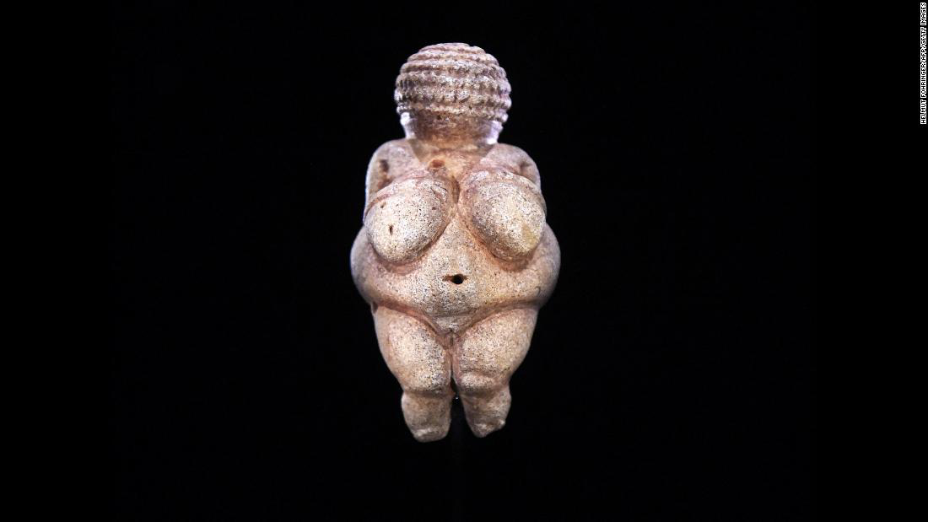

Figure 1: Venus of Willdendore

It’s important to begin with the first era that humans left behind carvings and artworks; The Palaeolithic Era around 2.5 million years ago. The Venus of Willendorf produced in 24,000- 22,000 BCE was the female figure carving left behind in Austria. The sculpture holds a volumptious figure with large breasts hips and stomach, however is faceless. It is said by historians and researchers that the focus on her reproductive organs concludes it had may have had something to do with fertility and femininity. If this is true the sub question that arises is, is female beauty determined by the male gaze?
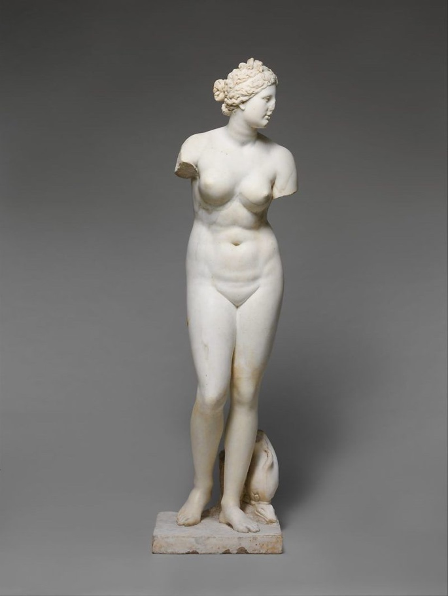

Figure 2; Marble Statue of Aphrodite 1st or 2nd Century A.D

Moving on from this era is to the ancient Greeks. During this period the female ideal was “plump” and fair skinned. It is also known that men also had a higher standard of beauty than women. Women’s body were considered “disfigured” versions of men. Above is a image of the marble statue of Aphrodite. The statutes displays a nude female with a toned flat stomach and by no means “plump”. She shows a fairly fit figure with curves. This was the female ideal of this era and the term “plump” signifies “fat”. During this time in Ancient Greece, “fat” signified wealth, due to consuming and having more access to food.

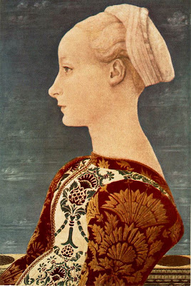

Figure 3: Antonio del pollaiuolo. Portrait of a young women

Fast forwarding down the timeline we come to the renaissance era (14th-17th century). During this time art was at a all time high. Many artists created work of women that portrayed a particular perception of the beauty ideal. This can suggest that what we see in the paintings from this time may not be accurate as the male artists are painting their own preferences and desires. As seen above in a painting by Antonio Del Pollaiuolo, Blonde hair, a pale complexion and a high forehead were all characteristics of the perfect women of this era. Some women would go to extreme lengths to achieve this beauty ideal by plucking their hairline to achieve the high hairline.

During this time also it was a wife’s duty to reflect her husbands status within her appearance and behaviour. A skinny figure would imply that they were poor and could not afford food. Women’s roles in life and beauty were heavily surrounded by men and every effort was made to attract them. This concept of achieving a certain style of beauty has been carried through the centuries and is clear today in society. Naomi wolf (1990) writes in her book The Beauty Myth, “A culture fixated on female thinness is not an obsession about female beauty, but an obsession about female obedience.” It is becoming evident that beauty standards are a product of male desires and are a perspective of the male gaze. John Berger also writes “Women see themselves through men’s eyes.” (Berger 1972).
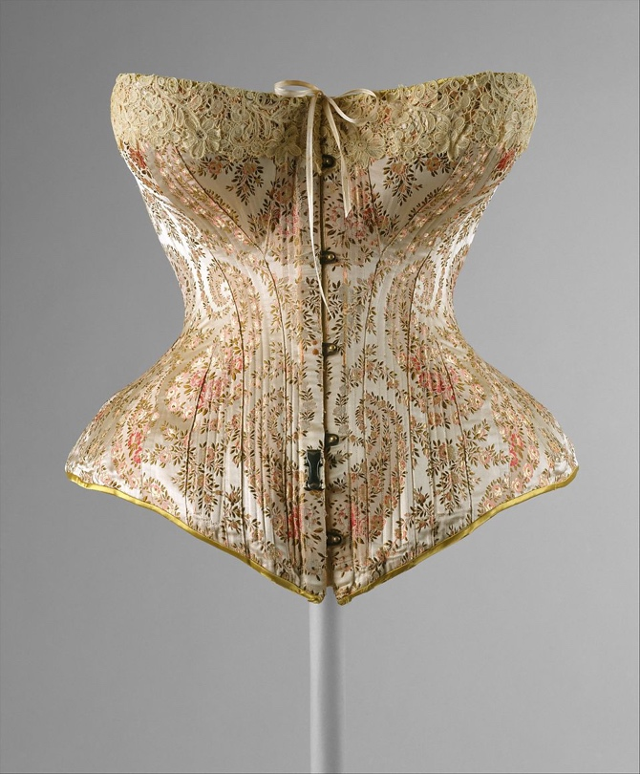

Figure 4; Manson Leoty 1891 (Corset)

One major female ideal that has been carried throughout the centuries has been curves. This was carried all the way through to the Victorian era in England (1837-1901). Corsets became a popular garment to enhance and achieve the hourglass figure and tiny waist. These became a huge trend and would extend past the women’s waist.. Becoming heavily integrated into women’s fashion and lives; It became a common practice for women to continuously wear them. Not only was the corset responsible for pulling in a women’s torso; by quite literally crushing and squeezing her organs, it also raised women’s breasts extremely high and pulled back their shoulders blades for a “perfect” posture.
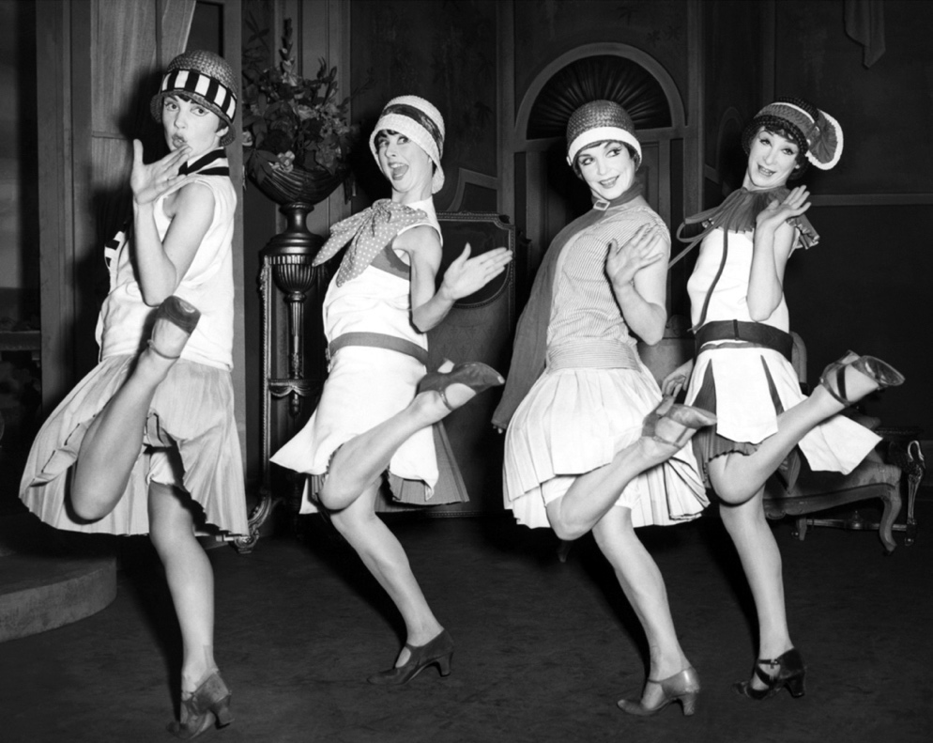

Figure 5; The Flapper Movement Photography

During the 1910s women began hitting the workforce during world war 1, but this independence did not diminish after the war. In 1920 women were allowed to vote and the power women began to feel was at a all time high. They were no longer going to settle for a dominated male ideal of high riser breasts and tight corsets. Since women began to get more of a taste of men’s power. Finally, the voluptuous shape for women that persisted through the early part of the twentieth century, eventually being replaced by the slender flapper of the 1920s (Mazur, 1986). Skirts were pulled up high above the knees. Although this was a major turning point for women it also had a flip side to it as it began the obsession with a skinny frame that we commonly know today in modern times. The purchasing of weighing scales meant women could finally see their true size. This ignited a body obsession and anorexia started to become discussed as-well as a start of body dysmorphia.
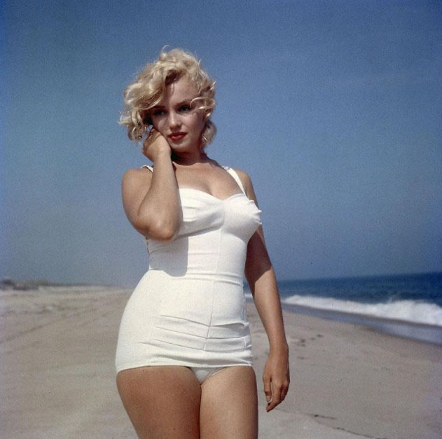

Figure 6; Marilyn Monroe on beach. (Photograph)

As we jump down the timeline we come to the 1960s. This was the golden age of Hollywood and a true beauty and sex symbol was Marilyn Monroe, who single handedly changed the women beauty standards again. The “blonde bombshell” who once was a size 4-6, soon became a size 12. Although it’s important to note there is absolutely nothing wrong with this, it created the frenzy of curves for women to begin again. She was labelled a “plus-size”. This term can be detrimental to women’s mental health and perspective of themselves, and it proved to be during this time as women continuously compared themselves to her and thought of themselves as “obese” if they did not fit her standards of figure.

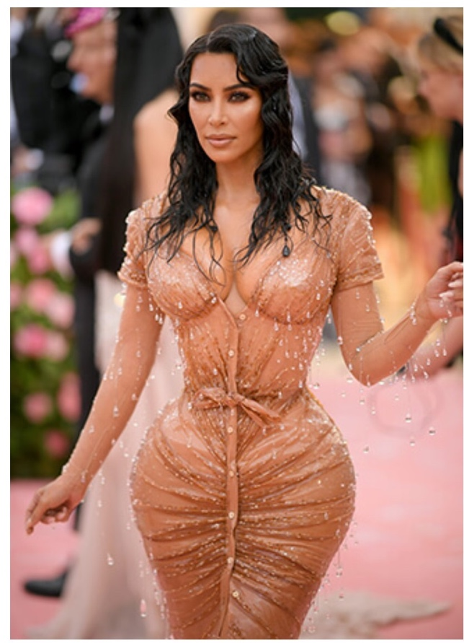

Figure 6: Kim Kardashian Met Gala (Photography 2019

Norms of feminine beauty in Western culture, however, have varied considerably over time (Goodman, 1995; Seid, 1989; Wolf, 1992). Only until recent times the standard of women to be “stick thin” with no fat was the most common standard throughout the 2000s. On the contrast, in 2020 the normal beauty ideal now is a new emergence of a “slim thick” figure. A slim body shape is associated with success personally, professionally and socially (Bruch, 1978). Women are expected to have a small waist with large hips and a large plump rear, but also large breasts. Kim Kardashian is the most ideal women of today and the influential to by women and the younger generation. It’s common for many women to now use plastic surgery to achieve this look and permanently alter their bodies through drastic measure to achieve the modern standard of beauty. A clear understanding of women’s beauty standards throughout history have made it evident that women are under a lot of pressure to look a certain way. A structure of dominating standards prove to be detrimental to women and their perception and reflection of themselves.

Naomi Wolf (1990) States that “Low self-esteem may have a sexual value to some individual men, but it has a financial value to all of society”. This is evident that beauty standards are not only a pressure of women to conform but also a financial gain, after all people will pay to feel happy within themselves.
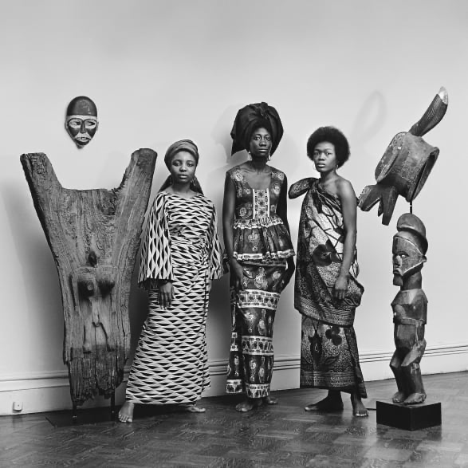

Figure 7; Grandassa Models at the Merton Simpson Gallery, New York (c. 1967)

As mentioned these are standards of Eurocentric culture. In Africa, beauty standards depend on the tribe and country. However, ear stretching, lip plating and hair styling were just a few of the beauty traditions. It was common for African women to use their hair to signify their marital status and even if they were royalty within a tribe. It’s a common misconception of western culture ideals is that white is the main focus of beauty. However in 1969 the Black is Beautiful movement began, giving black women the power to express and embrace their beauty. Many natural features of black women such as big lips, curves, and dark skin and curly hair were celebrated and shown off with pride. Comparing these features Kim Kardashian it is clear that she has gained profit off common features of black women and used these to her advantage of creating a “new” beauty ideal for white women, this is commonly argued that it is insulting to black women and takes away their possession of these features that once were ignored and classed a not as high of a standard of white beauty ideals.

Chapter 2: Social media’s effects on beauty and body image.

Media, meaning the mass of communication, such as radio, television, newspapers and magazines, has over the years become a huge factor of our everyday lives and seemingly is something we cannot escape as its forever growing. In 1997 the first social media platform was launched. Social media refers to the use of websites to create or share content and participate in social networking. Technology has risen and the use of smartphones, tablets and social media platforms like Instagram and Facebook are consistently expanding, making communication now easier than ever. According to the Pew Research Center in 2018, 95% of 13 to 17 year-olds either own or have access to a smartphone, 72% use Instagram, and 41% use Snapchat (Monica Anderson et al, 2018). Influencers on these platforms often starve themselves and take great risks to achieve the standards of today which results in unhealthy habits and dangerous medical effects. These are the people young women idolise and emulate. However, social media has also been used to push and set beauty standards of today. The constant bombarding of a particular standard is proving to affect women’s mental health drastically as-well as development of young girls. This use of media has resulted in women going to extents such as body modifications to adjust their physical self and conform to today’s ideal of beautiful.

These days it’s impossible to read a magazine or open Instagram without becoming consumed by the idea of “perfection”. Diet regimes, workout plans, weight loss pills and even cosmetic surgery are the topic everywhere you look, the suffocating effects of this chase for the ideal beauty alters women’s perceptions of what’s normal. In fact, a study of mass media magazines discovered that women’s magazines had 10.5 times more ads and articles promoting weight loss than men’s magazines (Mayo Clinic, 2010). However, the altered perception of what’s normal can be the result of the availability heuristic. This is when people make judgments based off of how easy it is to recall particular instances of something from memory, (Schneider, Gruman, & Coutts, 2010). For a lot of people waking up these images are the first thing they see, they mindlessly scroll but the subconscious mind soaks up all that is seen and eventually those “perfect” form of bodies and unattainable ideals become a standard in which we measure everything on our selves. Below is a segment from a survey that was conducted by The Women and Equalities Committee. It studies body image with over 7700 participants in July 2020. It is evident by the graph that social media imposes a intense view of body image and “solutions” to these ideals if not fitting the standard. Cosmetic surgery being the most used and advertised.
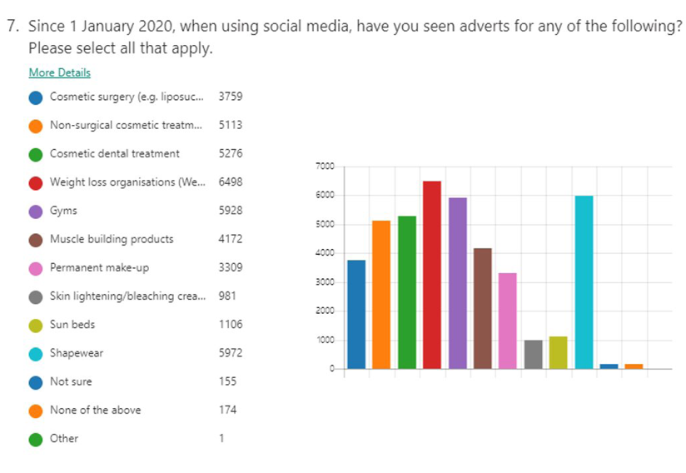

Figure 8; Survey Results for social media and adverts. (2020)

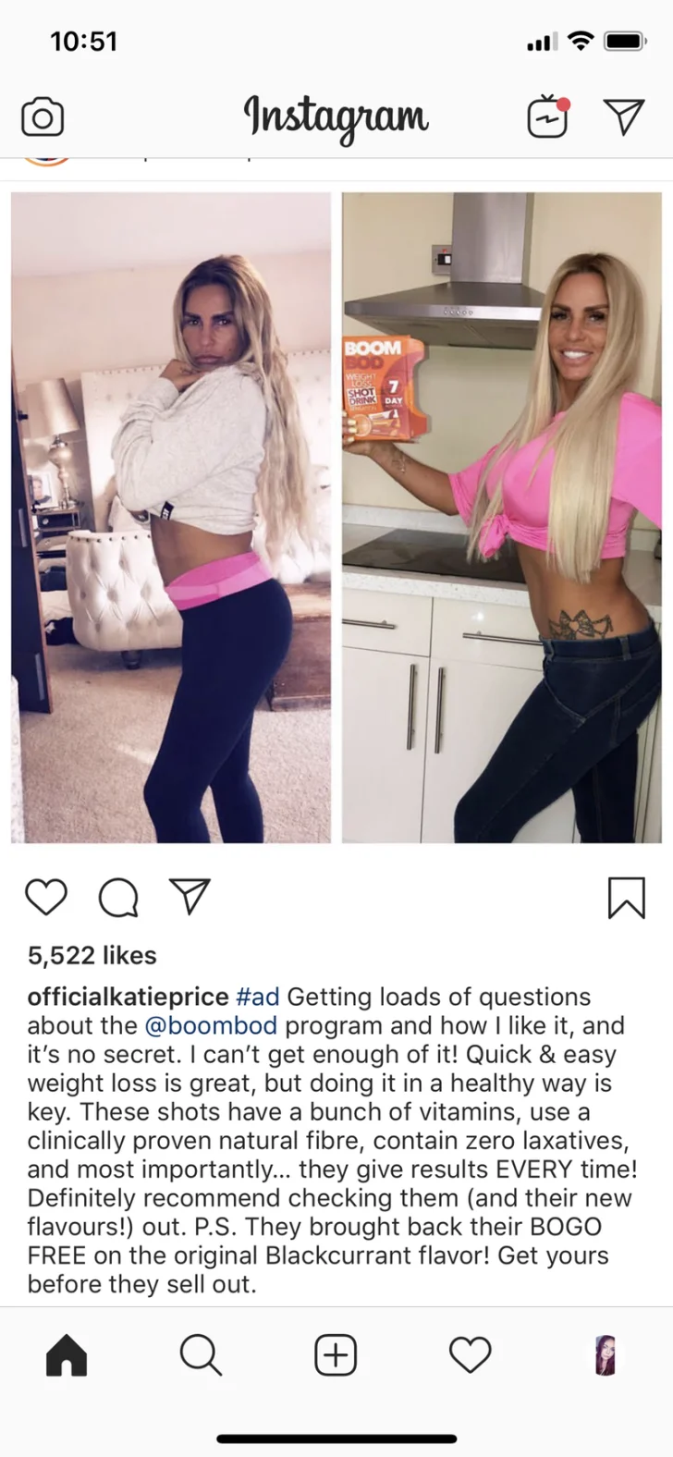

Figure 9; A BoomBod ad from Katie Price’s Instagram page.(2019)

Repeatedly viewing slim models, airbrushed skin or things like cosmetic surgery on celebrities/influencers, make it seem like the norm. Especially as they’re praised on these aspects. However, It implements a false narrative and personal view to the audience and can result in mental health issues such as Anorexia and intense body dissatisfaction. Shown above is a screenshot from a Instagram post from Katie Price, who is boasting of a quick weight loss trick. This is just one of many ads by influencers that can manipulate the mind of developing girls or women by making them believe that a extra bit do weight is a bad thing. The use of language within the post such as “quick and easy weight loss is great” is extremely harmful and can approve and motivate women to apply quick fixes to a “issue” just like cosmetic surgery.

In the United States, a survey of over 2,500 schoolgirls aged between 13 and 18 found that more than three-quarters said they wanted to lose weight and two-thirds had dieted in the past year to lose weight (Whitaker et al., 1989). Even more poignantly, 8 per cent of this sample reported that they had vomited during the past year to lose weight, 2 per cent had used diuretics and 17 per cent, diet pills. This research shows a clear correlation between social media and women’s body image, the use of intense social media tactics to push beauty ideals is proven to be detrimental and results in dangerous habits to achieve these norms. It is scary to see the lengths females will go to feel like they fit in. It raises the sub question of how far will they go to achieve these looks?

Naomi Wolf writes “The likelihood is that diagnosed eating disorders may only be the visible tip of a contemporary obsession with body shape that engenders addictive and/or destructive behaviours as a means of weight and shape control. Smoking, drug use, over-exercise, and cosmetic surgery” (Wolf, 1992).

It’s also important to note that these issues are not just among westerner culture. A study conducted among young women in South Africa found that eating disorders linked to body self-esteem were prevalent across black, white and Asian women (Wassenaar et al., 2000).

Chapter 3:
Case Study 1

In relation to the previous graph showing cosmetic surgery being the most advertised, it creates a correlation between cosmetic surgery adverts and beauty image. Women consistently seeing liposuction, lip fillers, boob jobs or Brazilian butt lifts; A medical procedure Kim Kardashian flaunts and normalises; creates a negative perception of a women’s self image. It can result in more use of cosmetic surgery to women and developing girls to alter their natural forms and become somewhat artificial. I will now discuss artists who have addressed the issues of beauty ideals and reacted within their work against the extreme pressures to follow guidelines that are in place to become classed as “beautiful”.

Orlan a french performative artist, challenges the notion of current beauty standards as her core practise. In particular through her series titled “The reincarnation of Saint Orlan.”
Undergoing a series of cosmetic procedures, she challenges the ideology of beauty norms and reconstructs her face; but not for the normal use of plastic surgery, instead to fight against beauty standards that are set for women. Using her face as part of her art, She doesn’t necessarily enhance her beauty with surgery but instead transforms herself in such a way that it questions traditional perceptions of beauty. Orlan states

“ I have been the first artist to use aesthetic surgery in another context - not to appear younger or better according to the designated pattern. I wanted to disrupt the standards of beauty” (1947).
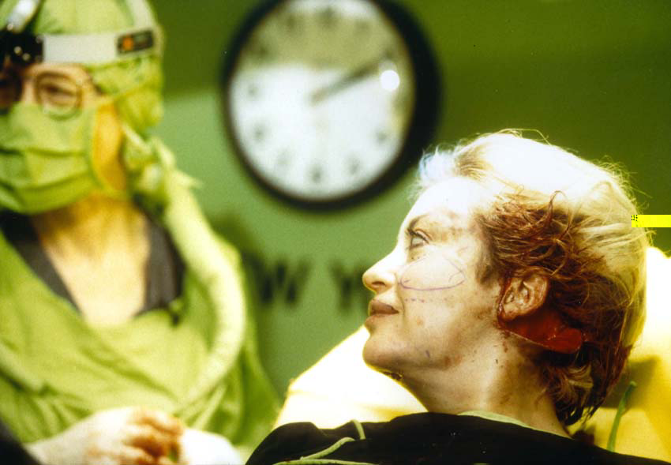
Figure 10; “Sourire de plaisir”, Photograph. (November 23rd 1993).

Reflecting on a sub question ‘how far will women go to achieve beauty ideals?’ Orlans grotesque persona challenges the quest for perfection of beauty and is a rebellious act against social constructs that once was. She shows a dark side to the physical modification that women undergo to achieve desirable looks. The mutilation of Orlans face completely destroys traditional rules and exposes the extreme lengths that are suggested by western culture; a permanent fix to a false perception of body image quite simply.

Marianne Williamson writes in her book A Women’s Worth “Society programs us, through the subliminal messages of popular culture, to believe that we’re not truly desirable as women unless we adhere to the current standards of physical beauty” (1993). Orlan evidently retaliates against this social matter and her performance project holds a relevant correlation to current issues today in regards to beauty standards. Due to the consistent exposure to beauty standards women feel they need to have surgery in some cases. “Body modification refers to the deliberate or permanent altering of an individual’s human anatomy or appearance”

A current ideal is to be slim. Liposuction is a common result of this standard and women feel the need to remove excess skin to achieve a skinny and in shape form. Women learn to reconstruct themselves…. Over the past 30 years they have gone further than ever before in this process. They can re-arrange some of the organic material that is their body-sometimes without any harm, sometimes with devastating consequences.”(Wykes and Gunter, 2005). Orlan however uses surgery as the main practise to reconstruct and alter her skin; by pulling and misshaping features rather than perfecting them to follow in line with social norms.

This form of art and retaliation to current beauty ideals leads me onto my next case study, Jenny Saville. On the contrast to Orlan, Saville instead admires excess skin and “fat” people. She celebrates the natural form within her paintings, exhibiting powerful angles and magnifying the raw details of bodies.

Case study 2

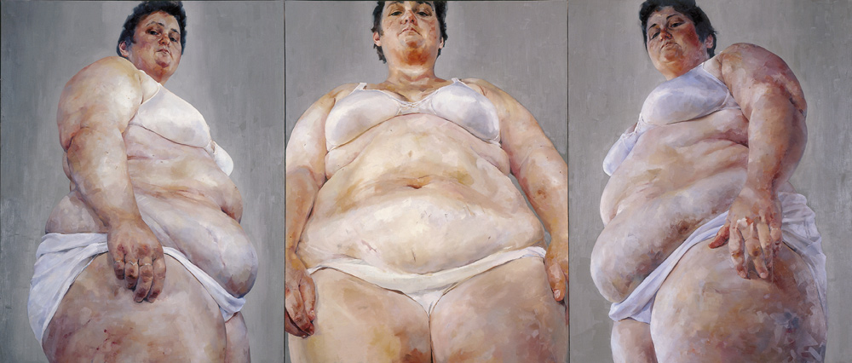
Through research and exploration of beauty standards, cosmetic surgery and it’s effects on the perspective of a Individuals body image, Orlan has been used as a powerful artist with her performance project. However, in contrast to Orlan, is a key practitioner and contemporary British painter Jenny Saville. Similarly to Orlan, Saville fights against the current beauty ideals and the pressures that are set to adhere to them. Saville takes a stand against the social construction of the “perfect body” and normalises features that are conventionally covered, hidden or are looked at with a negative attitude. A formal discussion of Savilles observations of “normal” bodily features and creating a positive impression on them will be explored.

Figure 11; Saville 1994, “Strategy” (oil on canvas painting)

When we look back at previous artworks of women they often posses a elegant, tender look that conforms to a certain beauty notion of that time. Savilles work however, holds a much more grotesque, dark emotional perspective. Her monumental scaled paintings, are rich with raw details that dominate the canvas. Intensely large drooping breasts, layers of fat that form delicate rolls, cellulite and lumps and bumps within the flesh that overwhelm the viewer. The painting above is named “Strategy”, it depicts a plus size female in powerful angles. The female is staring at the viewer directly in the eyes which gives a dramatic effect but also a empowering persona. It demands your attention, not to ignore the beauty and rawness of her form; instead accept her as she is. Saville states

“It’s flesh and the paint itself is the body… the theory behind each one is as important as the painting. I’m trying to make people discuss, look at how women have been made by man. What is beauty? Beauty is usually the male image of the female body. My women are beautiful in their individuality.” (Saville 1994 independent interview)

This statement is a key factor is what our society and social constructs of beauty have become, simply man made. This particular piece by Saville is a turning point in social beauty standards, it allows viewers to not be so negative in their own perception of body image as this women is quite literally a work of art. It celebrates her figure and is a extremely powerful message to spread to women and young girls that could result in a more positive attitude to their own body image.

Her painting named “propped” shown below, is another one of her many intense artworks with a influential and significant message.

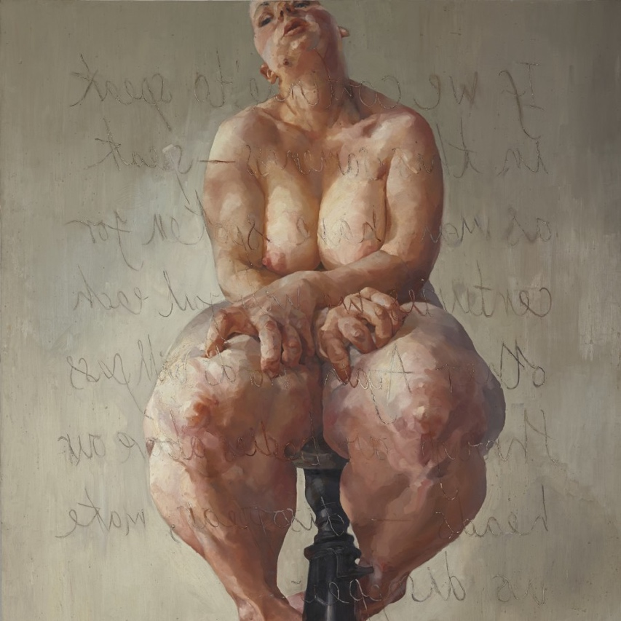

Figure 12; “Propped” (oil painting, 1992)

The figure in this artwork shows a women clawing at her thick flesh, struggling to conform and exist in a society that confines roles to her by a patriarchal society. Saville has placed a mirror opposite this artwork in the gallery so that when you turn to read the inscription on the canvas in the mirror you are confronted by your own body image. Upon studying Savilles work it’s inevitable to not become aware of ones body image, it creates a discussion as a result of the emotion they portray and their large scale. There is no escaping or ignoring it. Her use of exaggerated features correlates to mental health and body dysmorphia, what we see in the mirror sometimes isn’t what others see. It shows the dangers of self judgment and stern beauty standards.

Throughout Saville’s work she focused on female bodies. However, her interest into bodies slowly led into surgery in 2004. This correlates well with the current issue of cosmetic surgery as well as Orlans work, Savilles work shows the influence upon women and young girls as she shows the reality of surgery.

Case study 3
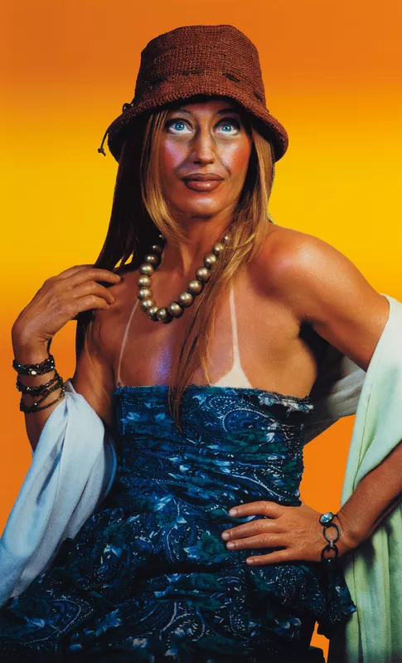
Upon research it is evident that the exterior social constructs for beauty have become heavily unrealistic and challenging to conform to. This leads me onto my next artist Cindy Sherman, who addresses these extreme standards by showing them in a ridiculous way to reveal their true absurdity. In comparison to Orlan who uses performance art, and Saville who is a painter, Cindy is a photographer and visual artist. This discussion of her work will correlate to my question of exploration and allow a different perspective with the use of art against beauty standards.

Figure 14; “Sun Tan” (Self Portrait, 2003. Photography)

Cindy Sherman’s creation of 69 photographs depicts herself reenacting pop culture clichés about women . She takes on the issue of class and image by creating versions of herself as women in outrageous and artificial styles. Her work is described as “the encyclopaedia of female stereotypes” (Eva Respini 2015).

Above is one of her 69 photographs “Sun Tan”, it depicts Sherman herself in a drastic amount of fake tan that not only darkens her skin but also dramatically alters the ageing and structural contours of her face. Sherman interprets a perception of a middle aged women, By using a intense amount of blusher and white highlights under her eyes, dark bronze lipstick and heavy eyeshadow. She creates the idea of a woman who is perhaps aged by the weather (e.g. the Sun), or simply her excessive amount of makeup. This image contributes to the issues of today with beauty standards as it effectively shows the ridiculous lengths women go to in order to fit social ideals.

Tanning was influenced by CoCo Chanel back in the 1920s in Britain.. If you were tanned and glowing it was seen as exotic, and healthy and major indicator of beauty and attractiveness. However despite this, in western beauty culture to have naturally darker skin, meant you was branded with being lesser than by white skin. In modern beauty standard of today tanning has risen drastically and with fake tan industry is worth $1 billion globally in 2017. Different uses to get that tan such as injections has risen and the use of sun beds have become a major health risk. There is clear obsession with tanning in the 21st century and it is directly profiting off black culture. Sherman evidently shows this in her work and this is just on of the many absurd and extreme standards that are influencing women today.

On the contrast to white people tanning, it’s important to note how black culture also address the issues of skin colour and beauty standards. Skin bleaching occurs among people of colour in North America, Africa, the Caribbean, Europe, and Asia (Charles, 2003a; Hall, 1999). This has been around for centuries and has everlasting, dangerous effects as-well as detrimental mental health issue in regards to their body image. Charles wrote in the Caribbean Journal of Psychology, “the three main reason for skin bleaching were wanting a lighter complexion, looking beautifully and getting rid of imperfections.” Many women stated that they were given more compliments after bleaching their skin. This is quite clearly a major issue, and evidently from research western culture is partly to blame for the dominance of white beauty.

Chapter 4: Personal Case Study

Finally to investigate further with my exploration of topic, a study has been conducted on Instagram with a range of questions to gain a deeper more personal understanding to the perspective of body image and effects of beauty standards and mental health to individuals. The platform “Instagram” was used as this is one of the most influential and popular social media sites today in 2021, with roughly 1 billion users. As of October 2021, roughly 32 percent of global Instagram audiences were aged between 25 and 34 years (Statista Research Department 2021). The study had over 300 people responses to a series of questions. Out of 300 people 69% responded to the question “do you love yourself” with “No”. The question that followed was “are you happy with your body image” also had a high response of 78% stating “No”. When questioned why, the respondents had a range of issues such as “don’t like my stomach or legs” “I have a big nose” and “it would simply be quicker to list what I like than what I don’t like.”
77% of participants stated they agree that “Instagram and social media push you to look a certain way”. When asked how they feel social media does this some of the responses were as follows, “constantly see so many stunning girls with nice figures” “pushes one type of beauty” and “images are photoshopped so gives a false perception of how to look.”

These responses and results are strong evidence for the detrimental effects that social media and beauty ideals that are forced upon women today. The results of the study was also 100% female, which raises the question, “are men effected by beauty ideals?.”

Conclusion

The overall purpose of this thesis was to discuss and study the effect of social standards of beauty on females and the mental health issues it can cause as a result of mass media and manipulation. It is a known issue that Beauty standards can have a great impact on females mindsets. The pressure they feel to adhere to these unrealistic social standards of physical beauty can hinder negative thoughts and result in problems such as self-esteem, feeling of worthlessness, body dysmorphia and anorexia. The media constantly exposes women to these certain looks such as skinny waist, clear skin, no stretch marks and even pushes the normality of plastic surgery. The findings within this essay have given a brief overview of the evolution of beauty standards all the way from The Palaeolithic Era to the present. It concludes that regardless of how many years ago beauty standards originated it is still relevant today and the results to mental health are proving to be detrimental to women.

Throughout the chapters I have studied the evolution of beauty standards and their origins, as-well as mass media and the tactics used towards pushing beauty standards of today. Some contemporary female artists have responded strongly to the unrealistic look. Orlan took a extreme approach to the notion of plastic surgery however and actually went under the knife herself to challenge traditional perceptions of beauty. This can be applied to women of today and show the drastic measures we take to alter our physical beauty and abide social norms.

Jenny Saville observed “fat” women in malls, which triggered her interest in plastic surgery, this influenced her painting practice heavily and contributed to the fight against physical beauty standards as-well as challenging body norms.

Cindy Sherman’s series of self portraits also address today’s current issues. Her photography shows the construction of the female gender and the position of females in society along with the extreme looks we undergo as women. Her photograph “Sun Tan” was a major contribution to today’s issues with beauty standards and showed how ridiculous some of these social constructs can be.

The final case study conducted clearly shows a correlation between mass media and its effects of women’s mental health and their perception of beauty. The use of media and social media is forever growing and it amplifies the issue of how the media needs to change its approach with body image and acceptance of body norms,

The continuous exposure to the beauty social standards in our day to day lives wether it be through media or by trend are proving to be more and more absurd . It begs the question will we ever go back to inner beauty? The notion of female perfection is something that has been engraved in our minds for centuries and these contemporary female artists participate in the fight against it within their works. It’s clear that being a female in this day and age is not just psychologically hard but also financially and physically. At what point do we stop these socially constructed standards and allow women to be free and content within their own skin.

Women should not be warped into a distorted image of themselves, mental health is rising and it’s time to change the social construction of beauty for the future generations.

Bibliography

Grube, G. (1927). PLATO'S THEORY OF BEAUTY. The Monist, 37(2), 269-288. Retrieved
Available at: http://www.jstor.org/stable/27901113
(Accessed October 22nd 2021)

2004. Media and body image. SAGE Publictaions Ltd; first edition (18th December 2004).
Berger, J., 2008. Ways of seeing. London: Penguin.
ISBN - 9780761942481

Brown.uk.com. 2021. [online] Available at: http://brown.uk.com/eatingdisorders/wassenar.pdf [Accessed 8 November 2021].

Clubofamsterdam.com. 2021. Findings of the Global Study on Women, Beauty and Well-Being. [online] Available at: https://www.clubofamsterdam.com/contentarticles/52%20Beauty/dove_white_paper_final.pdf Accessed 22 October 2021].

Mazur, A., 1986. U.S. trends in feminine beauty and overadaptation. Journal of Sex Research, 22(3), pp.281-303.

Pew Research Center: Internet, Science & Tech. 2021. Teens, Social Media & Technology 2018. [online] Available at: https://www.pewresearch.org/internet/2018/05/31/teens-social-media-technology-2018/ [Accessed 5 November 2021].

Publications.parliament.uk. 2021. Body Image Survey Results - Women and Equalities - House of Commons. [online] Available at: https://publications.parliament.uk/pa/cm5801/cmselect/cmwomeq/805/80502.htmn [Accessed 6 November 2021].

Research, I. and Marriott, B., 2021. Lessons from Eating Disorders. [online] Ncbi.nlm.nih.gov. Available at: https://www.ncbi.nlm.nih.gov/books/NBK232464/ [Accessed 29 October 2021].

Uk.sagepub.com. 2021. If looks could kill. [online] Available at: https://uk.sagepub.com/sites/default/files/upm-assets/9710_book_item_9710.pdf [Accessed 26 October 2021].

Williamson, M., 2013. A woman's worth. New York: Random House.
ISBN - 97080345386571

Wolf, N., 1990. The beauty myth. Naomi Wolf.
ISBN- 9780099861904

Schneider, F. W., Gruman, J. A., & Coutts, L. M. (Eds.). (2012).
Applied Social Psychology: Understanding and Addressing Social and Practical Problems.
Thousand Oaks, CA: SAGE Publications, Inc.
ISBN- 9781412976381

beauty?, 1., 2021. Why were high foreheads once considered a sign of beauty? - New York City Art Museum Tours. [online] New York City Art Museum Tours. Available at: https://www.shadyladiestours.com/why-were-high-foreheads-once-considered-a-sign-of-beauty/ [Accessed 6 November 2021].

BOOM! by Cindy Joseph. 2021. How Our Idea of Beauty Has Changed Throughout History. [online] Available at: https://www.boombycindyjoseph.com/blogs/boom/how-our-idea-of-beauty-has-changed-throughout-history [Accessed 5 November 2021].

Charles, C., 2003. Skin Bleaching, Self-Hate, and Black Identity in Jamaica. Journal of Black Studies, 33(6), pp.711-728.

Gagosian. 2021. Jenny Saville | Gagosian. [online] Available at: https://gagosian.com/artists/jenny-saville/ [Accessed 6 December 2021].

Marie Claire Magazine. 2021. Why Black Women in a Predominately Black Culture Are Still Bleaching Their Skin. [online] Available at: https://www.marieclaire.com/beauty/a27678/skin-bleaching-epidemic-in-jamaica/ [Accessed 8 December 2021].

Oddity Central. 2021. Orlan - The French Performance Artist Who Used Plastic Surgery to Challenge Beauty Standards. [online] Available at: https://www.odditycentral.com/news/orlan-the-french-performance-artist-who-used-plastic-surgery-to-challenge-beauty-standards.html [Accessed 22 November 2021].

Publications.parliament.uk. 2021. Body Image Survey Results - Women and Equalities - House of Commons. [online] Available at: https://publications.parliament.uk/pa/cm5801/cmselect/cmwomeq/805/80502.htm [Accessed 25 November 2021].

Scarlett Newman, C., 2021. Kwame Brathwaite's powerful photos of the 'Black is Beautiful' movement. [online] CNN. Available at: https://edition.cnn.com/style/article/kwame-brathwaite-black-is-beautiful/index.html [Accessed 14 November 2021].

Statista. 2021. Instagram: age distribution of global audiences 2021 | Statista. [online] Available at: https://www.statista.com/statistics/325587/instagram-global-age-group/ [Accessed 2 December 2021].

Appendices

Instagram Questionnaire
Conducted: December 1st 2021

Age:
Gender:

Question 1: Do you love yourself?
Yes or No

Question 2: Are you happy with your image?
Yes or No

If answered “No” please write why
……………………………………..

Question 3: Do you love your flaws?
Yes or No

Question 4: Do Instagram/society push you to look a certain way?
Yes or No

If answered “Yes” please write why/how
…………………………

Question 5: Do you like your figure?

If answered “No” please write why.
…………………………..

Question 6: If you could change one thing about yourself what would it be and why?

………………………………

