- Design the state diagram for a 4 bit counter, that counts from sequentially 0000 to 1111 when signal S is asserted and holds its count when signal S is de-asserted.

- Design the state diagram only for a circuit that counts 0, 2, 5, 6 continually if an input I = 1 but counts 0, 1, 3, 4, 7 continually if I=0. If I changes in the middle of a sequence then the circuit will return to 0 first and continue on the new count sequence.

- Identify the class of FSM shown below.
- Generate the expressions for each of the d flip-flop inputs.
- Generate a present/next state map for the circuit.
- Develop a state diagram to graphically illustrate the circuit’s state to state behaviour.
- Is there a problem with this circuit, if so what is it?

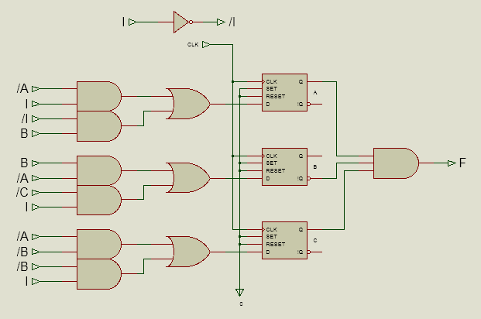

4. Consider the finite state machine represented by the state diagram below and design a VHDL behavioral model for this system.


